General Instructions
- A Budget Amendment must be used if a grantee proposes to increase (+) or decrease (-) a category by more than 10%.
- For example: If there is $100,000 in the Administrator category, you would submit an amendment if you were moving more than $10,000 of those funds to another category.
- If the change is less than $10,000, then you would not need to submit an amendment. However, please email your program specialist about any changes you are making.
- All sections of the Budget Amendment must be completed and submitted to EEC at least 30 days prior to the proposed change and/or no later than April 28, 2023, for final budget amendments. Amendments received after April 28, 2023, will NOT be accepted.
- Please note that proposed changes may NOT be implemented until your Budget Amendment has been fiscally and programmatically approved.
- Grantees may only amend their budgets up to THREE times per year unless EEC has required a budget amendment.
- Any changes to grant budgets must continue to adhere to the total administration cost cap (no more than 10%).
- Grantees must adhere to Budget guidelines and Budget Amendment Instructions for their specified grant program.
- Proposed Programmatic changes: A Budget Amendment must be filed if the justification for programming and implementation of the grant will change significantly, even if there is no funding change on the line items.
- Please note: Please select any subcontractor(s) budget and/or PC+ budgets (CFCE only) even if you are not amending any subcontractor/PC+ budgets. The total cost of the amendment must equal the lead agency budget + the subcontractor(s) + PC+ budgets.
- The Budget Amendment will be reviewed programmatically by the assigned Policy Analyst in tandem with Grants Administration for approval of fiscal revisions. The approval will not occur until both have reviewed the requested changes.
- You must click the SUBMIT button for your Budget Amendment to be submitted to EEC. Once you click the submit button, there will be a SUBMISSION DATE and TIME at the top of each page.
- PLEASE DO NOT SEND ANY HARD COPIES OF YOUR BUDGET AMENDMENT UNTIL YOUR ELECTRONIC VERSION HAS BEEN APPROVED BY EEC.
- To complete a Budget Amendment, you must enter the Online Application by clicking Login to Online Application.

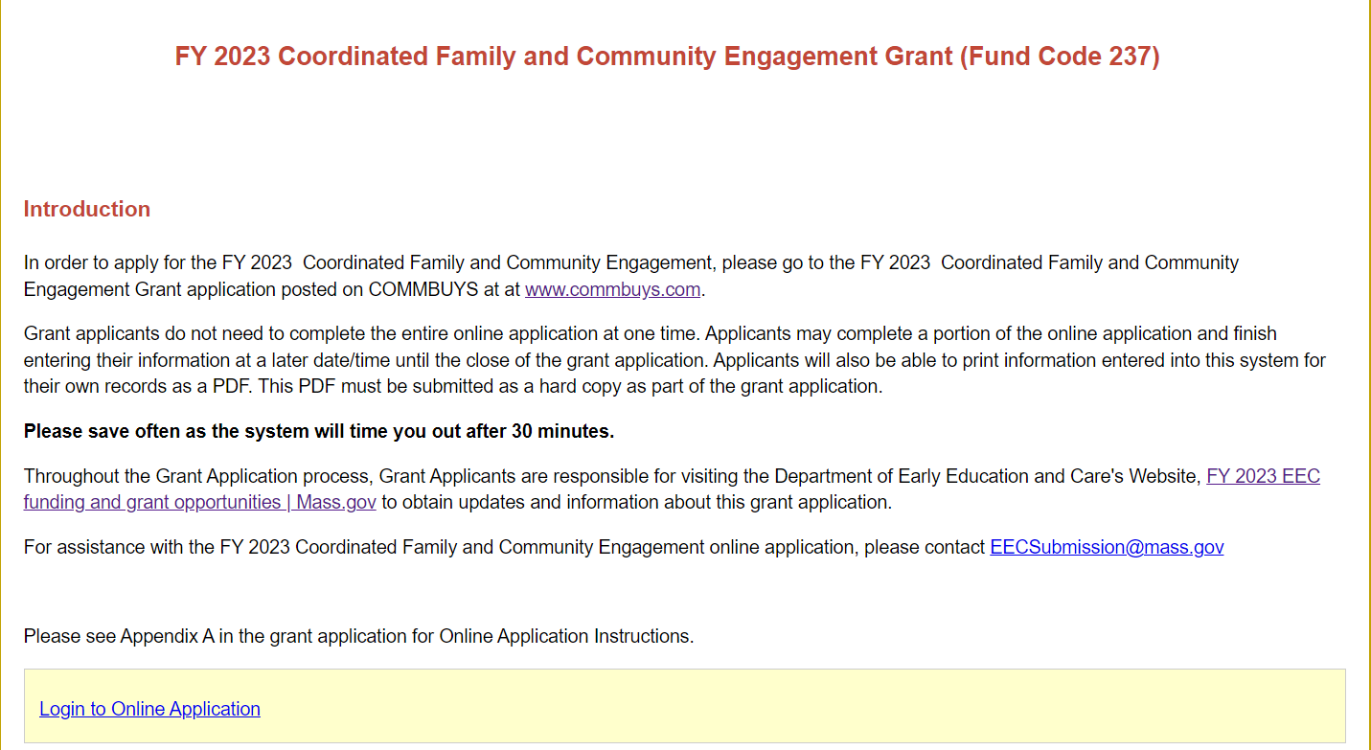

- Select your Agency from the drop-down menu.
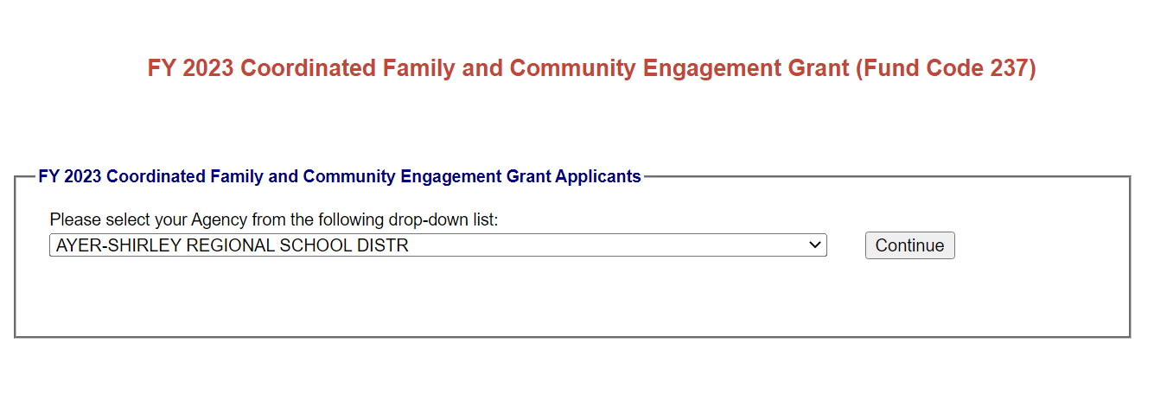

- For Grants that are Renewal/Continuation: Enter your existing password. If you need password assistance, please send an email to EECSubmission@mass.gov with the name of the grant in the subject line.
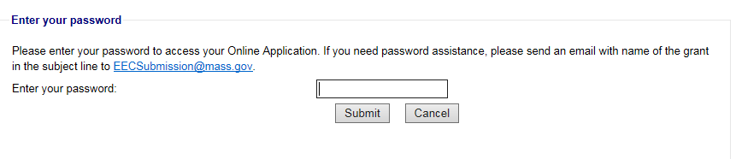

- HOME PAGE - All components on the home page have been disabled except for the Contact Information and the Print Summary button.

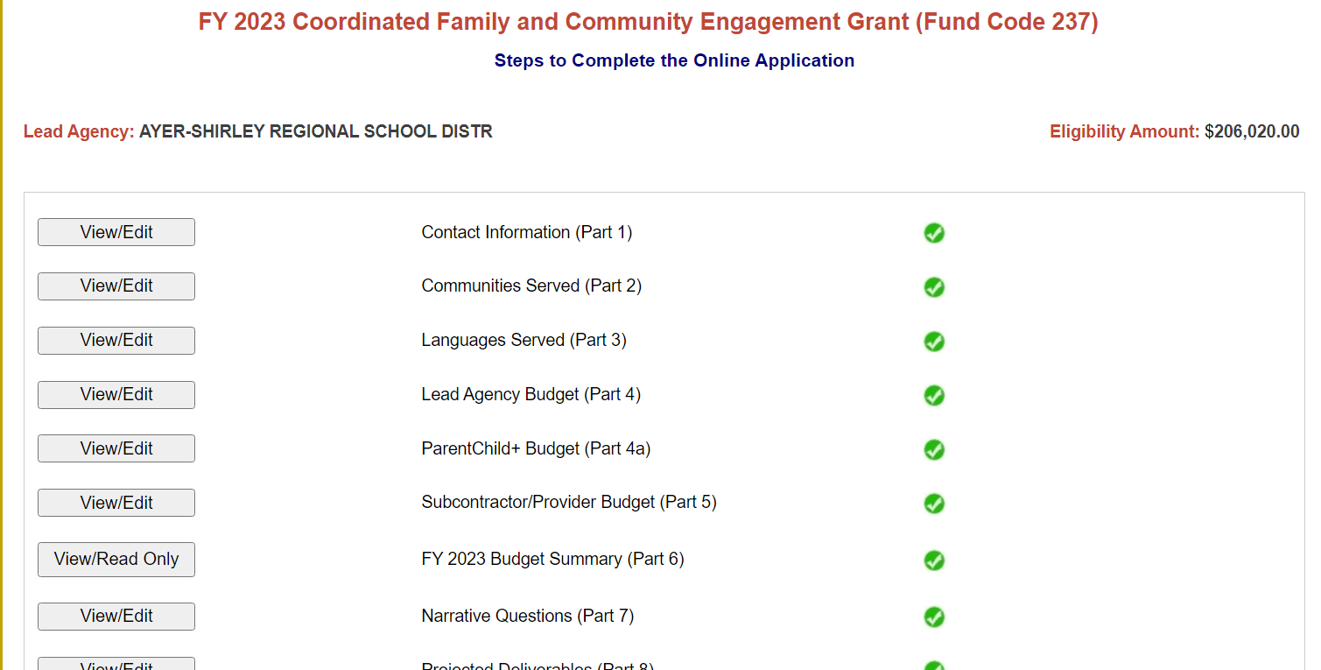

- CONTACT INFORMATION: Update any changes to your contact information, if applicable.
- Once the contact information has been updated, click Save and return to the home page.

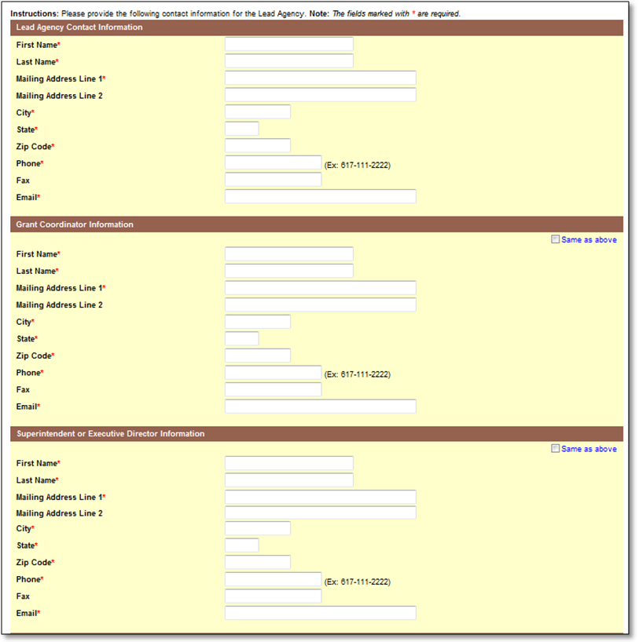

- To complete a Budget Amendment, scroll down to the bottom of the home page and click:
  - Budget Amendment # 1
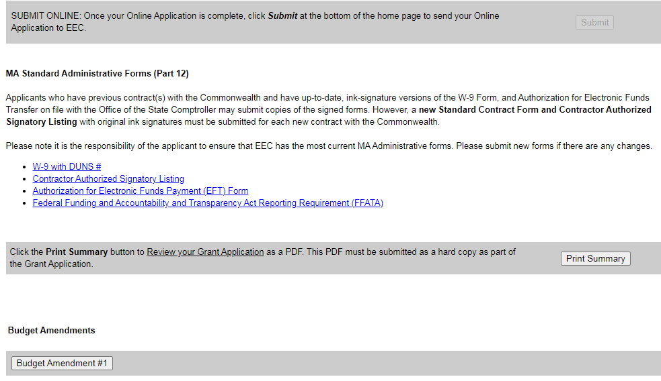

- Budget Amendment Home Page
  - To request a budget amendment for your Lead Agency budget, click the box that reads, “Add New Lead Agency Amendment.” However, even if you are not making changes to the Lead Agency, you still need to open this amendment and click save.
  - To requests a budget amendment for the ParentChild+ budget (for CFCE only), click the box that read,” Add New PC+ Amendment.” However, even if you are not making changes to the Lead Agency, you still need to open this amendment and click save.
  - To request a budget amendment for your Subcontractor budget from the drop-down list, click “Add New Subcontractor Amendment,” However, even if you are not making changes to the Subcontractor(s), you still need to open this amendment and click save.
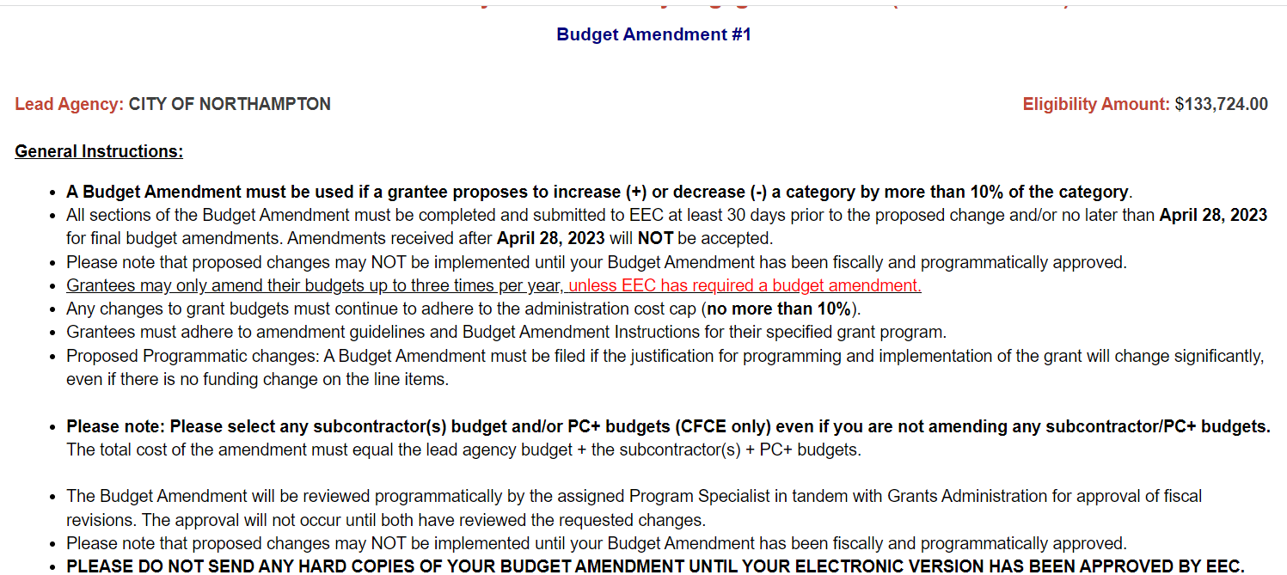

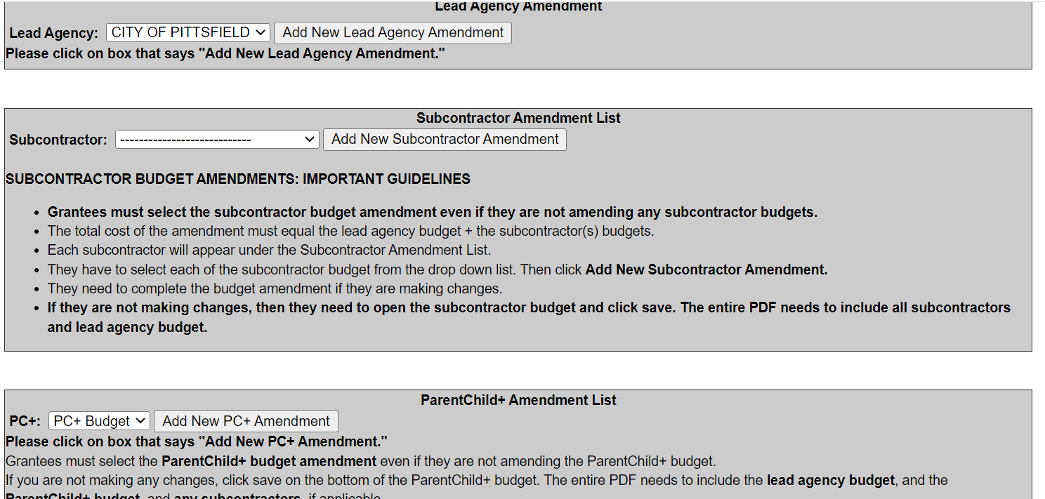

- If you need to make changes to the budget amendments, click the view/edit button.
If you need to delete the amendment, click delete.

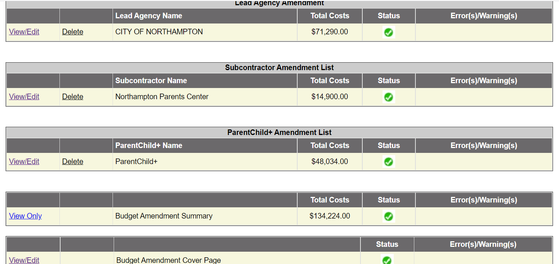

Lead Agency Budget Amendment

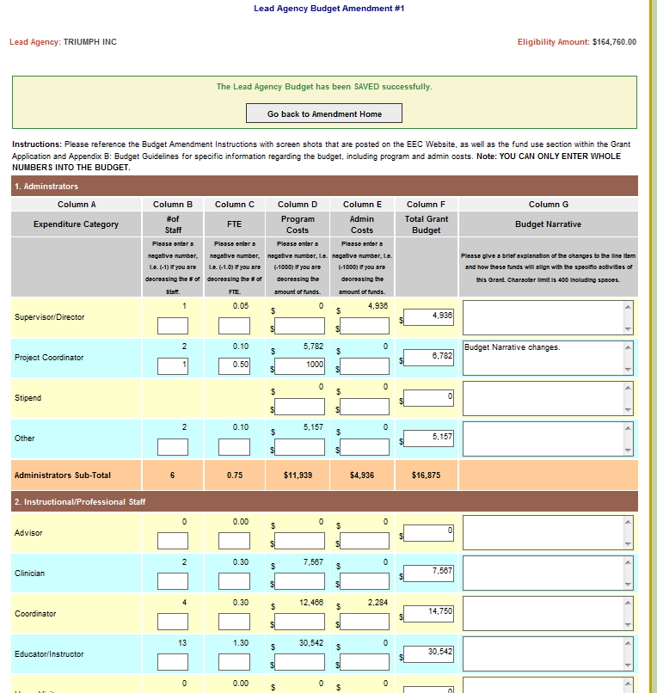
Latest Approved Budget by EEC (Read-Only)
Enter Budget Amendment changes and Budget Narrative changes.

LEAD AGENCY BUDGET AMENDMENT:
  - Your approved budget will appear above the text boxes.

  - Column B: If you are reducing the number of staff, please enter a negative number i.e. (-1).

  - Column C: If you are reducing the FTE, please enter a negative number i.e. (-1.0).

  - Column D & Column E: In order to reduce or add funds to a line item, funds must be entered in the Program or Admin column.
    - Use positive numbers to add funds and negative numbers to subtract funds. (You must put a minus sign (-) to enter negative numbers.)
  - Please reference the fund use section within the Grant Application and Appendix B: Budget Guidelines to follow specific guidelines regarding the budget for this grant, including program and admin costs.
    - Please note: All budget lines and columns are open to enter information. However, not all budget lines and columns are allowable under this grant.

  - Note: YOU CAN ONLY ENTER WHOLE NUMBERS INTO THE BUDGET.

  - Error messages will appear in RED at the top of the Lead Agency Budget Amendment. Errors are outlined in RED BOX (ES) for each item that has an error. A Budget Amendment cannot be submitted with any errors.

  - Column G: Please give a brief explanation of the changes to the line items and how these funds will align with the specific activities of this grant.

  - Category #4 Fringe Benefits: Please provide a narrative that includes the components of the fringe benefits, if applicable:
    - Federal Tax, State Tax, FICA, Mass Unemployment, Health Insurance, Worker's Compensation, Medicare, SUTA, Other Retirement Systems, Other.
    - If the amount is coming from another source, please provide the name of the source(s) in Budget Narrative.
  - If the 35% allocation for Fringe has been exceeded, a Warning will appear in blue, and a breakdown of fringe will need to be provided in the Budget Narrative.
    - If fringe is less or equal to 35%, provide breakdown of categories and percentages, if possible.

  - Category # 5 Contractual Services: Enter the new rate and select a new Hr/Day/Wk/Flat if you are changing this information.

  - Category # 10 Indirect Costs: Enter the new approved rate if there is a change in approved rate. If there is no change, leave this box empty.

- To save your lead Agency budget Amendment, you must click on the Save Lead Agency Budget Amendment button at the bottom of the page.

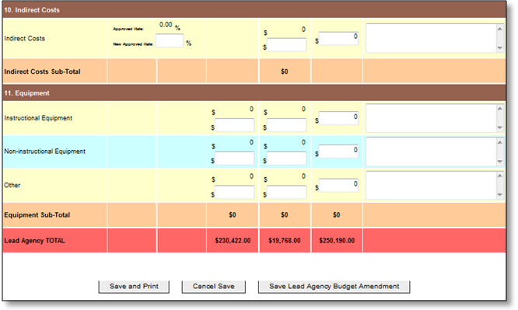

SUBCONTRACTOR BUDGET AMENDMENTS: IMPORTANT GUIDELINES
  - Please select the subcontractor budget amendment even if you are not amending any subcontractor budgets.
  - The total cost of the amendment must equal the lead agency budget + the subcontractor(s) budgets. Each subcontractor will appear under the Subcontractor Amendment List.
  - Select the subcontractor budget from the drop-down list. Then click Add New Subcontractor Amendment. Complete the budget amendment if you are making changes. If you are not making changes, then open the subcontractor budget and press save. The entire PDF needs to include all subcontractors.

Instructions:
Click on the box that reads, “Add New Subcontractor Amendment.”

Instructions:
- Grantees must select the subcontractor budget amendment even if they are not amending any subcontractor budgets.
- Please select the subcontractor from the dropdown list.
- If you are not making any changes, click save on the bottom of the subcontractor budget.
- The entire PDF needs to include all subcontractors and lead agency budget.

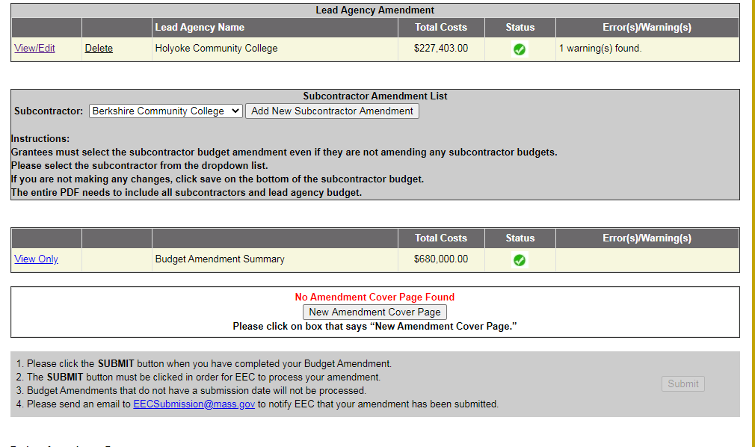

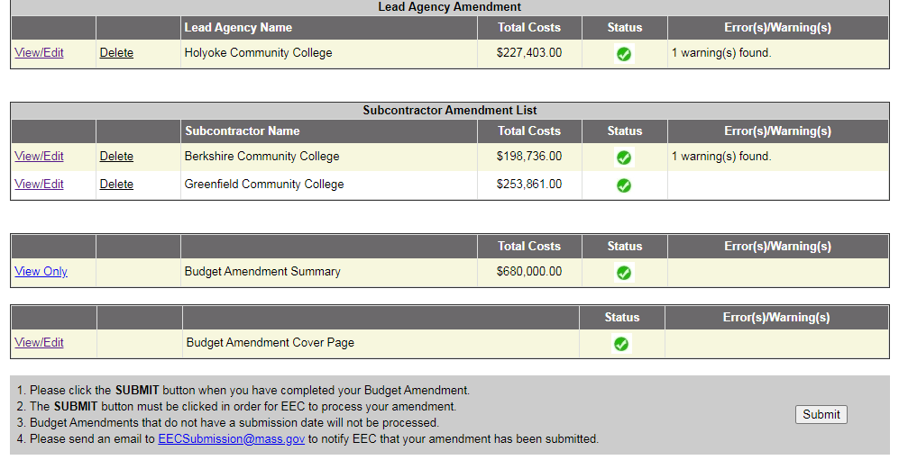

- Once you have completed the subcontractor budgets amendments, Go to Budget Amendment Summary.

BUDGET AMENDMENT SUMMARY
- The Budget Summary combines all line items requested in the Lead Agency Budget Amendment, PC+ Budget (CFCE only), and all Subcontractor Budget Amendments. (This is read-only document).

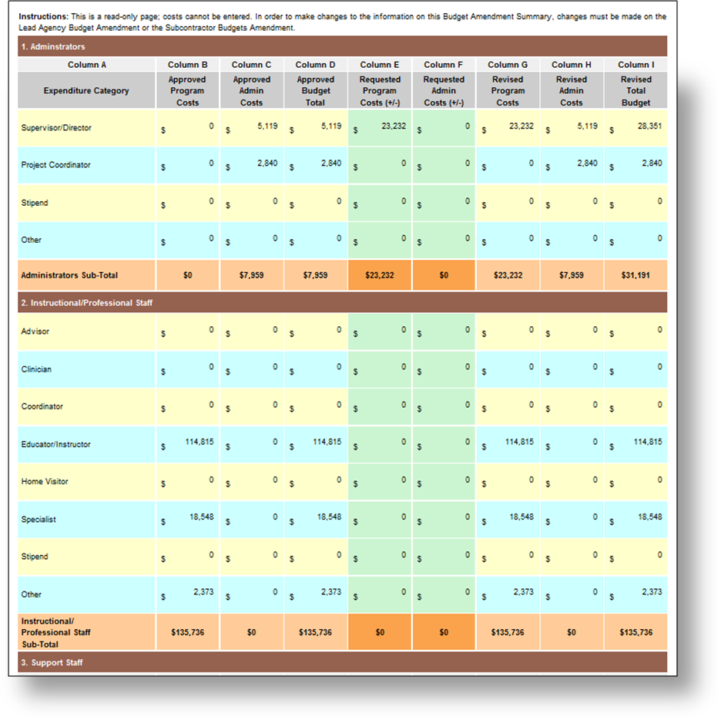
- If the Eligibility amount has been exceeded, an Alert will appear on the Budget Amendment Summary. CHANGES will need to be made to the Lead Agency or Subcontractor Budget Amendments so that the Eligibility amount has not been exceeded.
- If the EEC 10% ADMIN limit has been exceeded, an Alert will appear on the Budget Amendment Summary. CHANGES will need to be made to the Lead Agency or Subcontractor Budget Amendments so that the 10% Admin limit has not been exceeded.

BUDGET AMENDMENT COVER PAGE:
- Please click No Amendment Cover Page Found and complete the cover page.
- Please note: Once the PDF is printed, the Budget Amendment Cover Page must be signed with an original signature (in blue ink) by an authorized signatory.

The following is a screen shot of the Budget Amendment Cover Page. The person completing the amendment will enter their name, title, email address and phone number.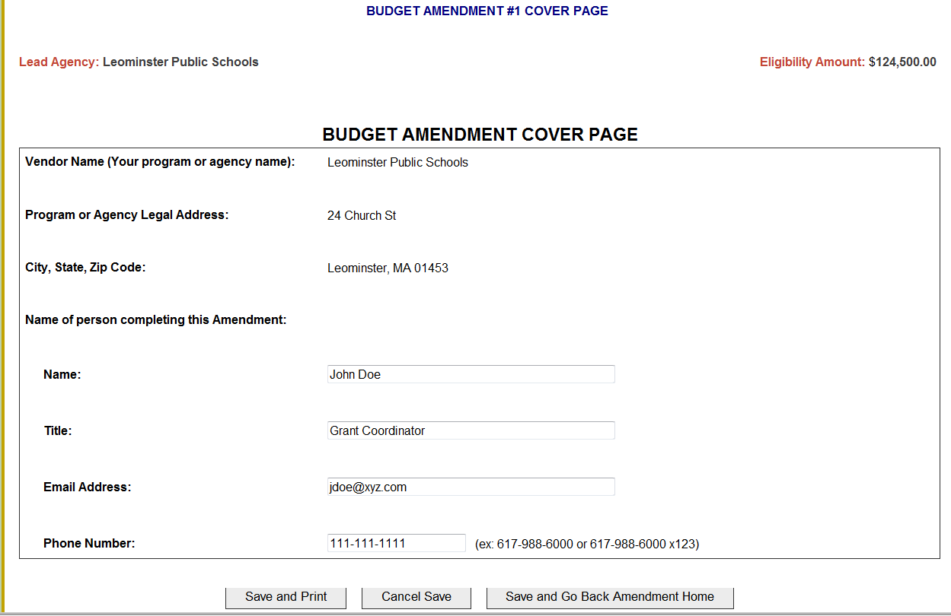

Below is a screen shot of the Budget Amendment Home Page. When the green checks appear in the status box, you can submit the grant.
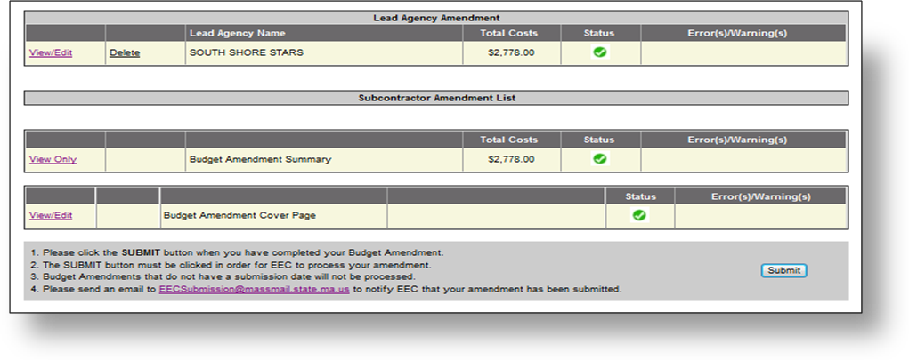
- SUBMIT ONLINE:

1. Please click the SUBMIT button when you have completed your Budget Amendment.
2. The SUBMIT button must be clicked in order for EEC to process your amendment.
3. Budget Amendments that do not have a submission date will NOT be processed.
4. Notify EEC: To alert EEC of your submission, please email EECSubmission@mass.gov with the subject line “FY 2023 Name of Grant Budget Amendment - Insert Your Agency Name”. Please note: We do NOT have an automated system that notifies us when you submit an amendment, so please send us an email.

- Once the Submit button has been clicked, the following screen will appear.

- Click the Print Summary button to review your Budget Amendment as a PDF. This PDF must be submitted as a hard copy with your Budget Amendment Cover Page once you receive your approval email back from EEC.

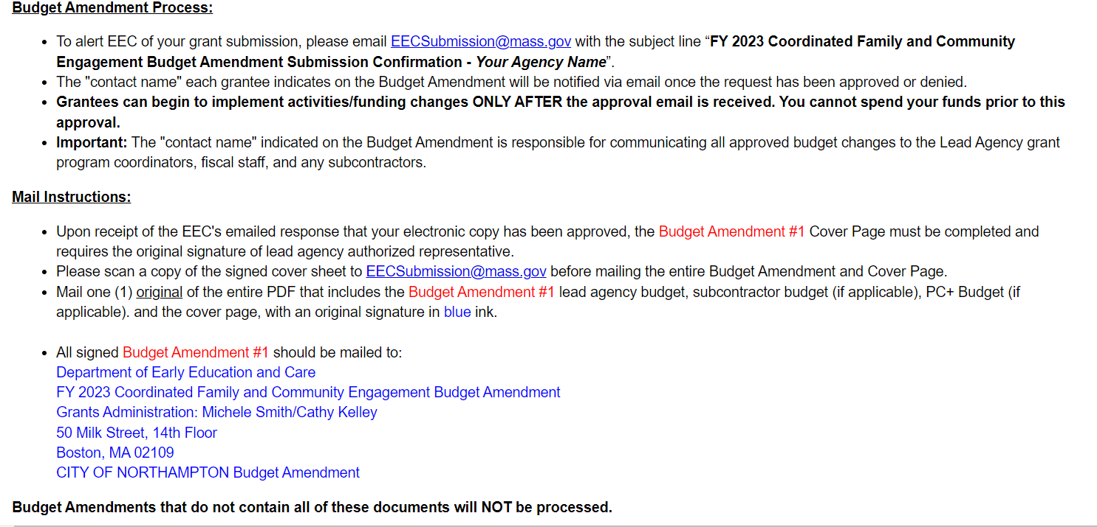

Budget Amendment Process
- To alert EEC of your grant submission, please email EECSubmission@mass.gov with the subject line “FY 2023 NAME OF GRANT Budget Amendment Submission Confirmation - Your Agency Name”.
- The "contact name" each grantee indicates on the Budget Amendment will be notified via email once the request has been approved or denied or if any follow up questions.
- Grantees can begin to implement activities/funding changes ONLY AFTER the approval email is received. You cannot spend your funds prior to this approval.
Important: The "contact name" indicated on the Budget Amendment is responsible for communicating all approved budget changes to the Lead Agency grant program coordinators, fiscal staff, and any subcontractors.

Mail Instructions:
- Upon receipt of the EEC's emailed response that your electronic copy has been approved, the Budget Amendment # Cover Page must be completed and requires the original signature of lead agency authorized representative. (all signatures in blue ink)
- Scan the cover page to EECSubmission@mass.gov before mailing the entire Budget Amendment document.
- Mail one (1) original of the entire PDF that includes the Budget Amendment #, lead agency budget, subcontractor budget (if applicable), PC+ Budget (if applicable). and the cover page, with an original signature in blue ink.

- All signed Budget Amendments # should be mailed to:
Department of Early Education and Care
FY 2023 Name of Grant Budget Amendment
Grants Administration: Michele Smith/Cathy Kelley
50 Milk Street, 14th floor
Boston, MA 02109
Budget Amendments that do not contain all these documents will NOT be processed.

Budget Amendment Cover Page PDF:
  - Below is a screen shot of the first page of the Budget Amendment PDF. Note the Submission date that is required for EEC to process your request. You must hit the Submit button for the submission date to appear.

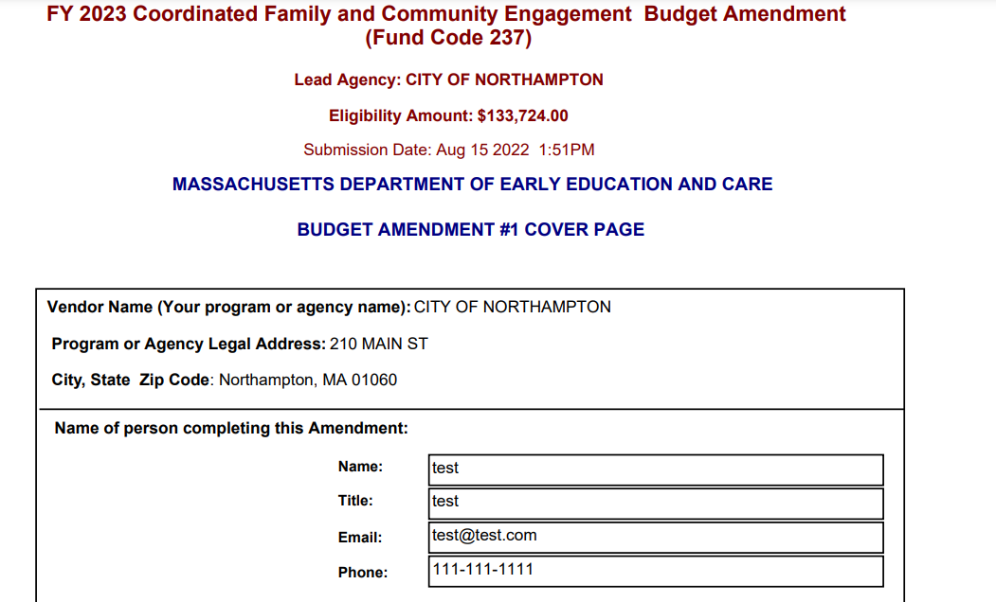

Once you have successfully submitted your amendment, please send an email to EECSubmission@mass.gov to let us know that the changes have been made in the Online Application.
Please make sure you are using the Budget Guidelines when revising the budget as this document lists the Program and Administrative expenses for this grant.
Please do not send in a hard copy until we have notified you that your budget amendment has been approved.

