Executive Office of Health and Human Services
Department of Public Health
Bureau of Health Care Safety and Quality
67 Forest Street, Marlborough, MA 01752

CHARLES D. BAKER
Governor
KARYN E. POLITO
Lieutenant Governor
MARYLOU SUDDERS
Secretary
MONICA BHAREL, MD, MPH Commissioner

Tel: 617-624-6000
www.mass.gov/dph

June 14, 2021

Harry Lemieux
Vice President of Operations
Harrington Healthcare System
100 South Street
Southbridge, MA 01550

Re: Harrington Hospital - Application to Add Psychiatric Beds at Webster Campus Pursuant to Order of the Commissioner of Public Health Regarding Determination of Need Approvals Related to COVID-19

Dear Mr. Lemieux:

The Department received the notification on June 8, 2021 requesting to modify the budget for the Inpatient Adult Behavioral Unit project that was approved by DPH on February 5, 2021.

Upon completing demolition of the existing space, several unknown building conditions were exposed and identified as need remediation and/or replacement. The additional cost will be $1,045,000 which will raise the total budget to $5,300,000. The additional items/costs do not change any operational or design components of the project as described in the original DoN submission.

This letter is to amend the budget for the Proposed Project to relocate fourteen (14) and add ten (10) psychiatric beds to Harrington’s Webster campus approved on February 5, 2021 from $4,255,000 to $5,300,000.

Sincerely,
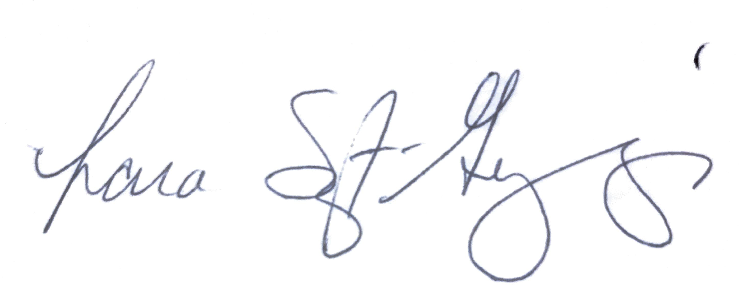
Lara Szent-Gyorgyi
Director, Determination of Need

cc: Sherman Lohnes, Division of Health Care Facility Licensure and Certification, DPH
Rebecca Rodman, Senior Deputy General Counsel, DPH
Elizabeth Kelley, Director Bureau of Health Care Safety and Quality, DPH

