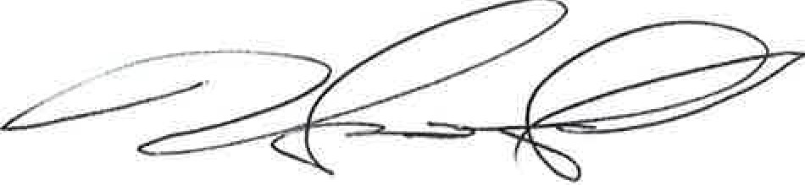
Harrington
HEALTHCARE SYSTEM
Compassionate Quality Care

June 8, 2021

To: Lara Szent-Gyorgyi, MPH - Director, Determination of Need Program From: Harry Lemieux, VP of Operations, Harrington Healthcare System
Re: Request to modify DoN approved budget- Inpatient Adult Psychiatric Unit

Dear Lara,

Harrington Hospital is requesting to modify the budget for the Inpatient Adult Behavioral Unit project that was approved by the DoN program on February 5, 2021.(letter attached) Upon completing the demolition of the existing space, several unknown building conditions were exposed and identified as needing remediation and/or replacement. Harrington is proposing a new project budget of
$5,300,000, which represents a $1,045,000 increase over the original project budget of $4,255,000. Below is a breakdown of cost overages identified for each category. These additional items/costs do not change any operational or design components of the project that were outlined in the original DoN submission.

Category | Additional Cost
HVAC | $265,000
Plumbing | $138,000
Electrical | $160,000
Building Envelope (Masonry, Glass, Roofing etc.) | $482,000
Total increase to project budget | $1,045,000

Thank you for your consideration and please let me know if you need further details.

Sincerely,

Harry Lemieux

