INDOOR AIR QUALITY BUILDING EVALUATION

New Salem Old Town Hall
15 South Main Street
New Salem, MA

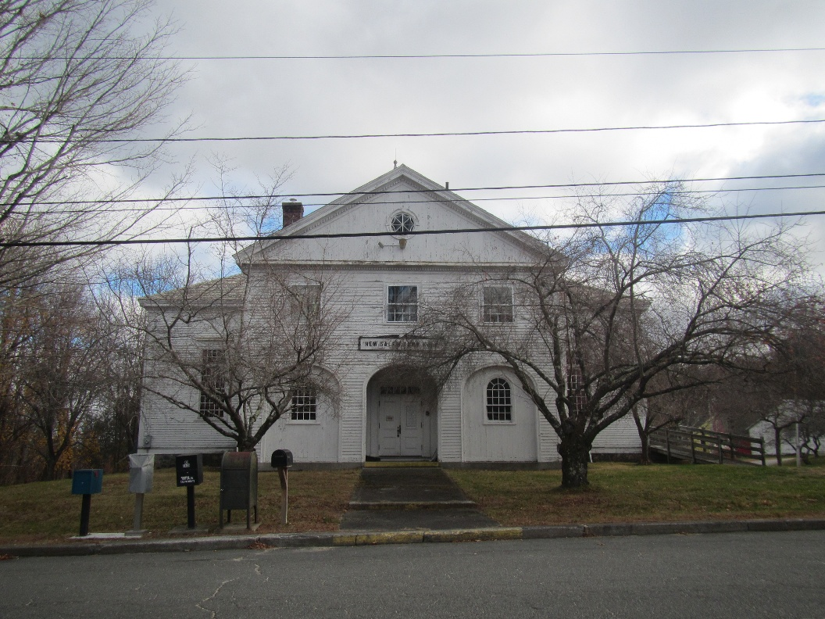

Prepared by:
Massachusetts Department of Public Health
Bureau of Climate and Environmental Health
Division of Environmental Health Regulations and Standards
November 2025

BACKGROUND
Building: | New Salem Old Town Hall
Address: | 15 South Main Street, New Salem, MA
Assessment Coordinated Through: | Matthew Fortier, Health Agent, and Emily Hill, Town Coordinator, New Salem
Reason for Request: | Potential reuse of an old town building that has been mostly unoccupied for years
Date of Assessment: | November 14, 2025
Massachusetts Department of Public Health, Bureau of Climate and Environmental Health, Division of Environmental Health Regulations and Standards (MDPH/BCEH/EHRS) Staff Conducting Assessment: | Ruth Alfasso, Environmental  Engineer, EHRS
Building Description: | The Old Town Hall is a small wood- framed and -sided building that was originally built in the 1930s. It has been mostly unoccupied for several years. It contains offices, a large meeting room, kitchen, and gymnasium. Windows in the building are openable.

BACKGROUND
The DPH Indoor Air Quality (IAQ) unit was asked to assist the town in determining the issues that would be involved with continued use or reuse of the building. The Old Town Hall has not been in regular use for many years, but it is still used for the town’s yearly Town Meeting as it is the only space in town large enough, and for storage of Town documents. The Town is still deciding whether this building should be renovated for reuse by the town, sold for another use, or razed. It was reported that the building inspector for the town believes the building is structurally sound.

METHODS
Please refer to the IAQ Manual for methods, sampling procedures, and interpretation of results (MDPH, 2015). No air testing was performed in this building because it is unoccupied.

RESULTS AND DISCUSSION

Ventilation
A heating, ventilating, and air conditioning (HVAC) system has several functions. First, it provides heating and, if equipped, cooling. Second, it is a source of fresh air. Finally, an HVAC system will dilute and remove normally occurring indoor environmental pollutants by not only introducing fresh air but also filtering the airstream and ejecting stale air to the outdoors via exhaust ventilation.
Due to the age and small size of this building, it primarily uses natural ventilation, including openable windows. The gym/stage room, has what appears to be a natural gravity circulation system. A vent exists in the wall under the stage (Picture 1) which is believed to be connected to a duct up on the side of the stage that uses the stack effect to move warm air from the gym area.
Radiators are found in some areas of the building (Picture 2). The boiler serving these radiators may be original to the building (1930s) and operates on propane via a tank on the exterior of the building. It is reported to be functional but not used recently. Not all areas appear to have radiators or other forms of heating.
There are two restrooms in the lower level of the building which is below grade. Restrooms have vents in the ceiling that look like residential-style bathroom exhausts; however, no fans were observed and it is unknown where the other end of the vents are. If these vents are connected through the building exterior (e.g., the roof), they will provide some exhaust ventilation, even with no fans, from the restrooms due to the stack effect and the impact of wind. However, these methods are likely not sufficient to remove odors and more importantly, excess moisture from the rooms. Ventilation via the stack effect requires a difference in temperature where warm air will rise into the vents. This works well when it is colder outside than inside, particularly when the building would have been heated in the winter, creating a strong updraft that can carry air from the restrooms up the vents. When either it is hotter outside than inside such as during the summer, or when the building is not occupied or heated and is similar in temperature to outside, the stack effect will not occur, and the vent will not function. This leads to conditions where moisture from the restrooms has nowhere to go and can lead to water damage and mold issues, as described in the Microbial/Moisture Concerns section below. Note that the restrooms do have openable windows.
The building has a kitchen area with relatively new appliances which appear to be in good condition. This equipment includes a vent hood over the stove/oven which is designed to remove products of combustion and cooking odors from use of the kitchen. According to the health agent, this vent may be too low a capacity for the equipment if it is fully in use. In addition, for a kitchen vent to operate effectively, it needs to have a supply of make-up air which can come through a dedicated wall vent, a window, or through an undercut in a door.

Microbial/Moisture Concerns
Significant areas of water damage were noted in the building. As noted above, there is water damage and mold growth on surfaces in the restrooms (Pictures 3 through 5). The locations of the water damage/mold on the walls and ceilings suggests that the source of water leading to these conditions is condensation and high humidity rather than a leak through the building envelope.
In an unused restroom without ventilation, water can evaporate from toilets and drain traps. Drain traps are p-shaped pipes that collect water from the drain and serve to seal the drain so that sewer gases do not enter occupied areas. If the drain trap is dry, gases from the sewer system, in this case a septic tank, can back up into the building. Sewer gas contains a variety of components, some of which smell bad and some of which are toxic; it also contains moisture. Because the restrooms have what appears to be passive vents as described above, and these vents would not function during summer or when the building is unoccupied in the winter, the moisture in the room can build up.
Condensation occurs when a surface is below the dew point of the air. The dew point is the temperature at which the air is fully saturated with water and will start condensing. Surfaces can be cooler than the dew point when they are, for example, in contact with the exterior of the building in winter, or in contact with an uninsulated floor or below-grade wall in summer. When this happens, moisture will condense on the surface.
Porous materials can be dried with fans and heating within 24 to 48 hours of becoming wet (US EPA, 2008). If porous materials are not dried within this time frame, mold growth may occur. Note that even where the base materials of the surface are mold-resistant (such as many paints or plasters), a layer of dust on the exterior can be enough to allow mold to grow. Less porous materials (e.g., plaster, hard wood) can often be cleaned or sanded down/refinished to remove mold, while porous materials (e.g., cloth, paper, cardboard, gypsum wallboard) typically need to be removed and discarded.
This cycle of evaporation and condensation appears to be the source of the mold growth in the restrooms. This may be exacerbated by the hot, humid summer weather that has become more common in Massachusetts due to climate change. Massachusetts has experienced hot, humid, and rainy summers in 2018, 2021, and 2023. July of 2021 was the wettest ever recorded in Massachusetts, and the three-month period from June through August, known as the meteorological summer, was the fourth wettest on record, according to the National Oceanic and Atmospheric Administration’s (NOAA) Centers for Environmental Information (NOAA, 2021). The summer of 2023 was measured as the second rainiest on record (WBUR, 2023). The summers of 2024 and 2025 also had significant stretches of hot, humid weather. These conditions are challenging for buildings, especially those without air conditioning.
Similarly, the water damage noted to the flooring in the main meeting room may also be from condensation (Picture 6). Given the age of the building, the cement underneath likely lacks any kind of insulation or a vapor barrier. This means the floor may become wet with condensation during hot, humid weather, because the ground is colder than the air. Water may also seep up from the ground during periods of high water table. Water exposure from either source has resulted in the floor tiles curling, lifting, and breaking. Note that due to the age and type, these floor tiles and associated mastic may contain asbestos and will need to be handled in accordance with all relevant laws and regulations.
Some other surfaces in the main meeting room also have spots of likely mold growth including on walls and furniture (Picture 7). Most of this mold appears to be growing on a layer of dust and can be cleaned.
Roof leaks have also occurred in this building leading to water damage in several areas on the upper floor (Picture 8). However, several rooms did not have any signs of water infiltration. Wooden flooring was also water-damaged (Picture 9), but this may be from use of the building during wet weather rather than a leak or condensation, and nothing in this area appeared moldy.
The exterior of the building was examined for sources of potential water issues to the building. The foundation of the building appears to be in good condition, with only a few areas of moss growth where sunlight cannot reach it to dry (Picture 10). The building’s wooden siding was mostly intact, however paint is flaking off across the building exterior (Pictures 11 and 12). Paint is protective as well as decorative, and once the paint is damaged, damage can more easily occur due to weathering, rot, and insects. Some windows and storm windows are damaged or missing (Picture 13), and one door shows damage (Picture 14). Openings in the building envelope can allow rodents and other animals access to the building. Rodents such as mice and squirrels can do a significant amount of damage to a building once they are inside. In addition, mouse urine is a common allergen and a sensitizer, so allergic reactions become more common with repeated exposures.
Two trees are present in front of the building (Picture 15). Lichen was noted growing on both trunks, which may be a sign that the trees are in poor condition. If the trees fall, they could potentially hit the building. Tree health should be evaluated during the spring and the trees trimmed or removed as needed.

Other IAQ Concerns
As noted above, floor tiles on the lower level and other materials may contain asbestos. Asbestos-containing materials (ACM) are not a hazard if they are in good condition, however any breaks, peeling, flaking, or other damage can release asbestos fibers and render it a hazardous material. Removal/abatement and any renovations done to ACM require permitting though the state’s Department of Environmental Protection (DEP) and Department of Labor Standards (DLS) and must be done by trained, certified personnel. All applicable laws, regulations, and guidance should be followed regarding abatement of asbestos/ACM. Lead may also be present in paint in the building, which is also a hazardous material.
Stored materials were found in several areas of the building (Pictures 16 through 20). Some of the material has signs of water damage. If no climate-controlled area in another building is available to store these items, they should be consolidated and moved to locations in the building without water infiltration or condensation. Items should be sorted during this process to discard anything no longer needed and items that are contaminated with mold. For protection from moisture, dusts, and pests, remaining items should be stored on shelves or in containers such as plastic bins with tight-fitting lids. Heavy-duty clear plastic bags can also be used to protect items.

CONCLUSIONS/RECOMMENDATIONS
Given that the building was determined to be structurally sound by the building inspector, this IAQ building assessment did not find any issues that would prevent the building from being used. The major issues found were water damage, particularly in the restrooms, and suspect ACM (floor tiles) that are in poor condition.
Note that this list is divided into short-term and long-term recommendations. Short-term recommendations will allow for occasional use of the building, and will decrease the rate at which further damage is occurring to the building. Whether or not a long-term recommendation will be relevant depends on the future planned uses of the building.

Short-term recommendations

Ventilation recommendations
- Determine if the vent in the gym is still connected in a manner that allows for some air circulation.
- Determine if there is a fan inside the restroom vents at all, and where the exit of the vents are located. If no fans exists, consider adding them. However, if the vents terminate inside the building, the vents should not be used.
- Smoke testing may be helpful to determine the function of these and any other vents or ducts in the building.
- Ensure at least some windows open easily and close tightly for air exchange in any room to be occupied. Openable windows should have intact screens.
- Determine to what extent the existing exhaust vent in the kitchen can be used with the existing equipment (e.g., only using part of the stove, or limitations on what can be cooked). When plans are made to start using this kitchen again, ensure these limitations are posted and communicated to users of the space. Ensure the vent has enough make-up air through, for example, opening a window or door into the space.

Water damage recommendations
- Some of the plaster/painted surfaces in the restrooms may be able to be cleaned/scrubbed to remove water stains and mold. Other surfaces will require stripping of an outer layer of material.
- Clean/remove loose paint, plaster, and damaged wood materials from areas of water damage on the upper floor. During cleaning, assess the condition of materials underneath to flag anything needing more intensive repairs to remove mold or allow proper function.
- Wash mold spots from non-porous surfaces, including furniture, on the lower-level meeting room, such as those shown in Picture 7.
- Clean up all water-damaged and mold-contaminated materials using the guidance in the US EPA’s “Mold Remediation in Schools and Commercial Buildings,” available at: http://www.epa.gov/mold/mold-remediation-schools-and-commercial-buildings-guide. Staff conducting cleaning should wear personal protective equipment to protect from irritating dusts.
- Floor tiles and associated mastic in the main meeting room may contain asbestos. Because this material is broken in some places it will need to be handled in accordance with applicable laws and regulations. Information on asbestos handling can be found here: https://www.mass.gov/guides/massdep-asbestos-construction-demolition-notifications. If encapsulation/covering of this material is chosen as a management method, ensure any materials used are water- and mold-resistant.
- Stored items should be consolidated and moved to a location in the building without signs of water infiltration. Porous stored items that have become water-damaged or very dirty should be discarded unless they are valuable enough to warrant special archival cleaning.
- The process of moving and examining all the materials stored in the building can allow for removal of items that are no longer needed. Remaining items should be stored in an organized manner, and protected from water damage, dust, and pests by use of shelving, plastic containers, plastic bags, or other methods.
- When possible, patches should be made to the roof to address the most prominent areas of leakage.
- Windows and doors should be rendered water-tight. Temporary repairs or sealing can be done to windows and doors that do not need to be used.
- Other gaps in the building envelope should be repaired or temporarily sealed to prevent water infiltration and pest access.
- To address ongoing condensation and water damage in the restroom areas, the following can be helpful:
  - When the building will not be used for long periods of time, turn the water off and drain the piping. Consult a plumber to make sure this will not lead to damage to pipes.
  - In all seasons, make sure drain traps are kept wet to avoid sewer gas entry, pouring water down periodically if needed. Use lids or cover the toilets to reduce evaporation from the bowl.
  - Use dehumidifiers in each restroom continuously, and drain them into a floor or sink drain. Clean them periodically to remove stagnant water and dirt build-up which can lead to odors. If electricity to the building will be turned off, consider using desiccant materials sold for removing moisture from indoor air and changing them when they are expended.
  - When the building is to be occupied, keep the windows open in each restroom. Ensure the windows are closed after the event.
- For prevention of water damage in the lower-level meeting room:
  - Prevention of condensation requires attention to dew point. Where materials are below the dew point of the air, such as an uninsulated floor or wall, condensation and water damage can occur.
  - Strategies for preventing mold growth in buildings without climate control can be found in https://www.mass.gov/info-details/preventing-mold-growth-in-massachusetts-schools-during-hot-humid-weather
  - Periodic cleaning of surfaces can remove dust that can be a mold growth medium and small spots of mold that may occur on walls and other less porous surfaces.
- Evaluate the health of the trees in front of the building once spring leaf-out has occurred. Trim or remove trees in poor condition.

Other short-term recommendations
- Ensure water leaks in the upper level have not compromised the electrical system, as water damage was noted near light fixtures.
- Refer to resource manual and other related IAQ documents located on the MDPH’s website for further building-wide evaluations and advice on maintaining public buildings. These documents are available at: http://mass.gov/dph/iaq.

Long-term recommendations
- Make comprehensive repairs to the roof.
- Repair and paint the exterior of the building.
- Install exhaust vent fans in the restrooms to remove moisture and odors during use.
- Replace or cover all damaged flooring.
- Refinish areas of water-damaged plaster and wood.
- If the building will be used regularly in the future, consider adding climate control to provide consistent heating in winter to occupied spaces, and cooling/dehumidification in the summer. This may include heating the building using electricity (e.g., wall-mounted mini-split units), allowing for the old boiler to be removed.
- Replace the kitchen exhaust hood if it is found to be insufficient for the appliance it serves. Ensure a make-up air supply is identified or created such as a window or wall-vent.
- Consider adding motion-sensitive lights and/or cameras to the exterior to prevent vandalism and deter wildlife entry.

REFERENCES
MDPH. 2015. Massachusetts Department of Public Health. Indoor Air Quality Manual: Chapters I-III. Available at: https://www.mass.gov/lists/indoor-air-quality-manual-and-appendices.
NOAA. 2021. Summer 2021 neck and neck with Dust Bowl summer for hottest on record. National Oceanic and Atmospheric Administration, 1401 Constitution Avenue NW, Room 5128, Washington, DC 20230 https://www.noaa.gov/news/summer-2021-neck-and-neck-with-dust-bowl-summer-for-hottest-on-record.
US EPA. 2008. “Mold Remediation in Schools and Commercial Buildings”. Office of Air and Radiation, Indoor Environments Division, Washington, DC. EPA 402-K-01-001. September 2008. Available at: http://www.epa.gov/mold/mold-remediation-schools-and-commercial-buildings-guide.
WBUR. 2023. “It's been a summer of rain and flooding misery in Mass.” WBUR local news. September 12, 2023. https://www.wbur.org/news/2023/09/12/summer-flooding-rain-massachusetts.

Picture 1
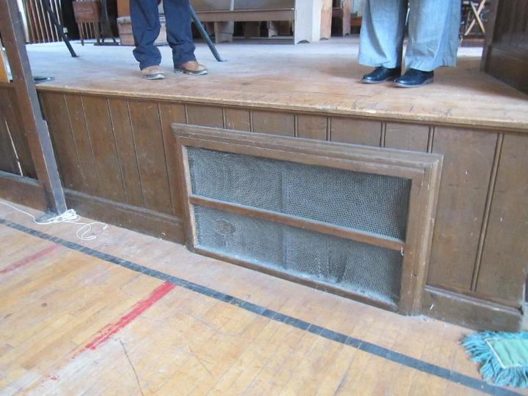
Vent under the stage
Picture 2
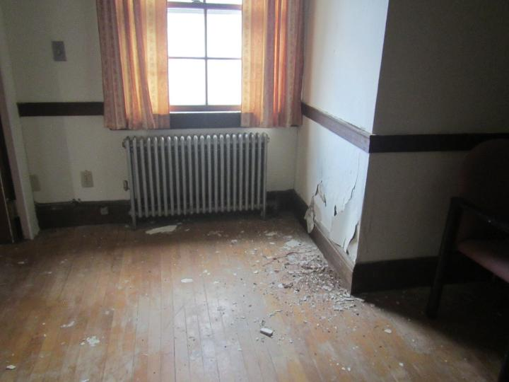
Radiator, note water-damaged peeling plaster and paint

Picture 3
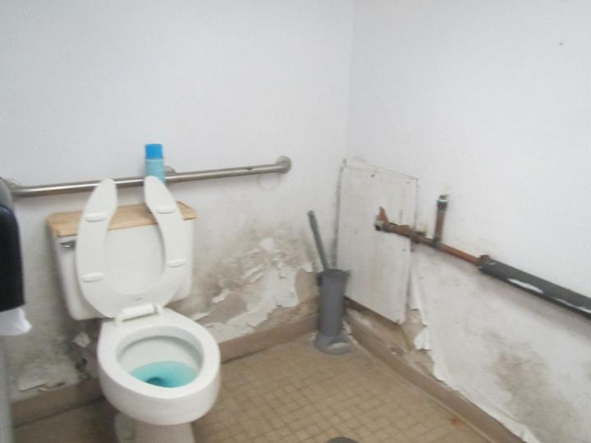
Water-damaged, moldy surfaces in a restroom
Picture 4
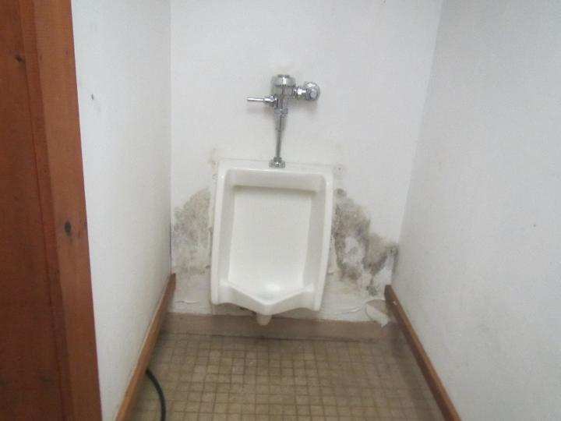
Water-damaged, moldy, surfaces in a restroom

Picture 5
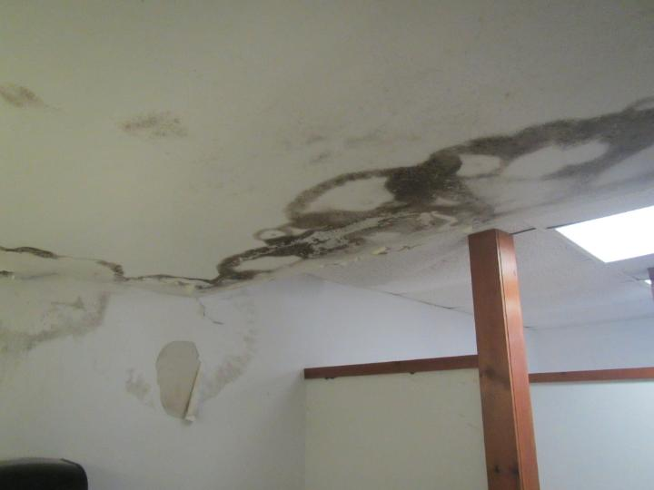
Water-damaged, moldy ceiling and wall in a restroom
Picture 6
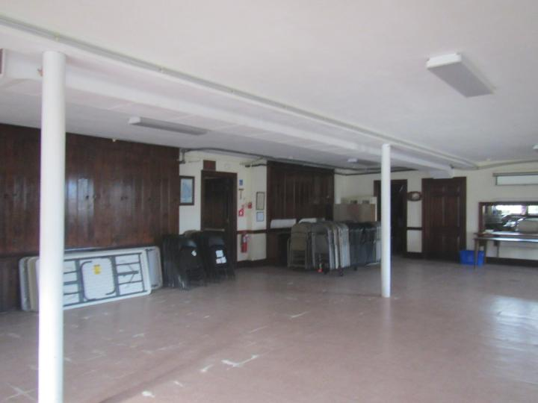
Meeting room with floor tiles, some of which are lifting or curled

Picture 7
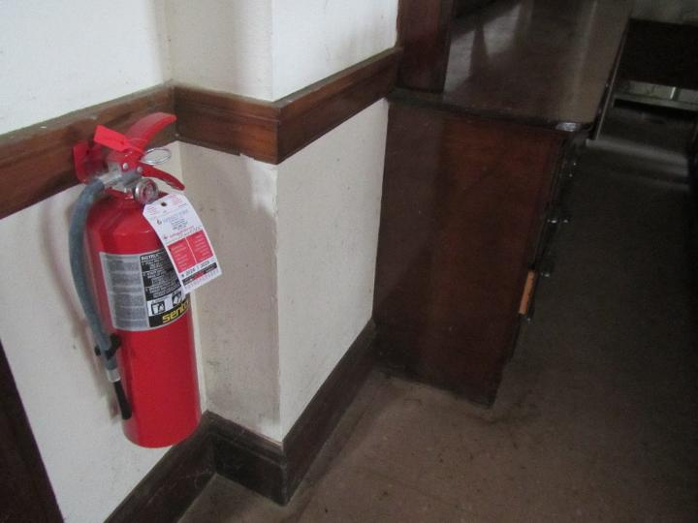
Likely mold spotting on walls in the lower level
Picture 8
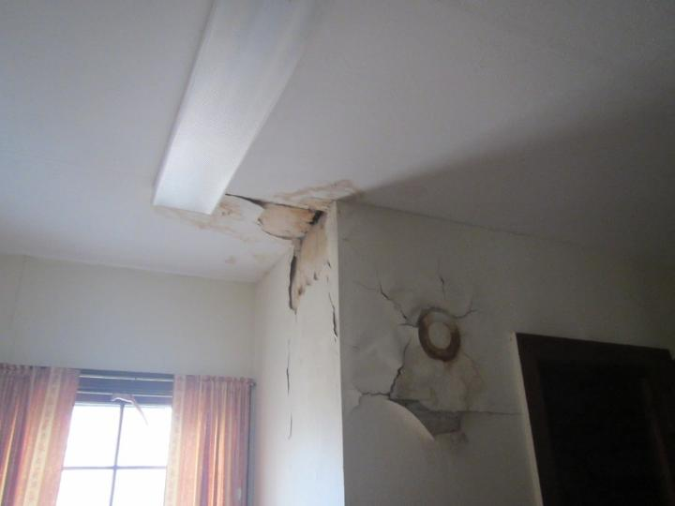
Water damage to paint/plaster on the upper level

Picture 9
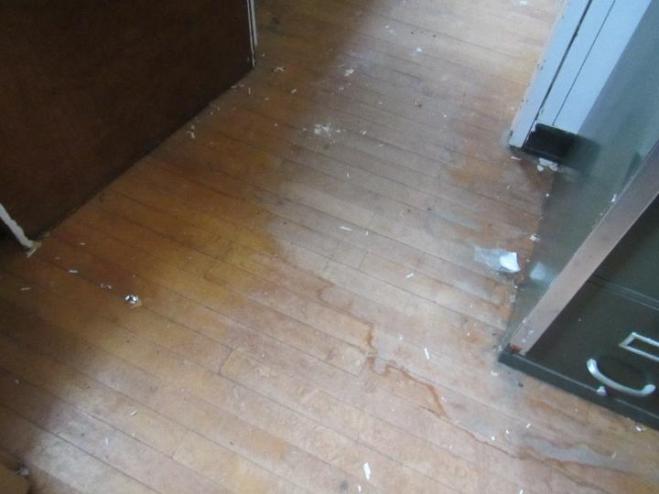
Water-damaged wooden flooring
Picture 10
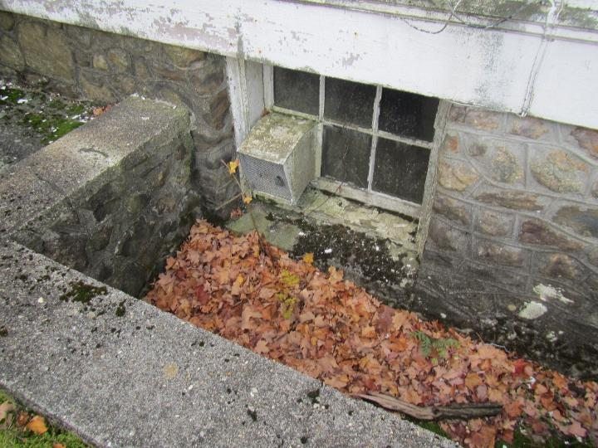
Moss growing on foundation in and next to window well

Picture 11
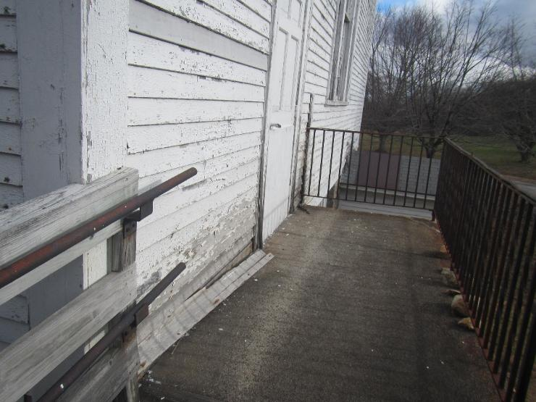
Damaged wooden siding and peeling/missing paint
Picture 12
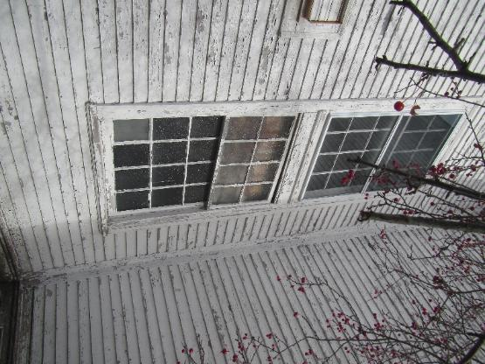
Peeling paint, damaged window frame, and damaged window

Picture 13
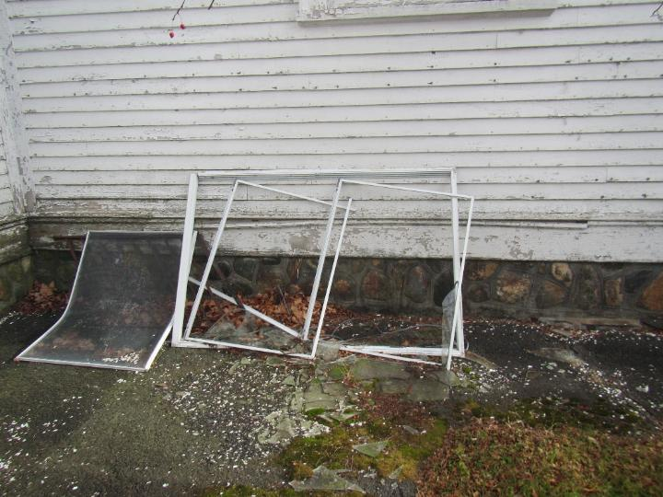
Broken, unattached, storm windows
Picture 14
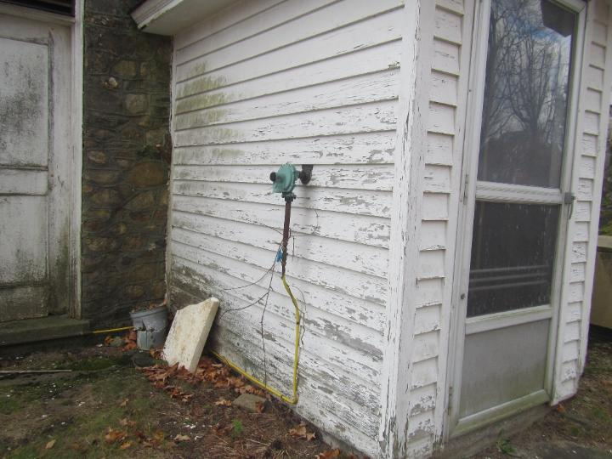
Damaged siding, door shown left side of picture is in poor condition

Picture 15
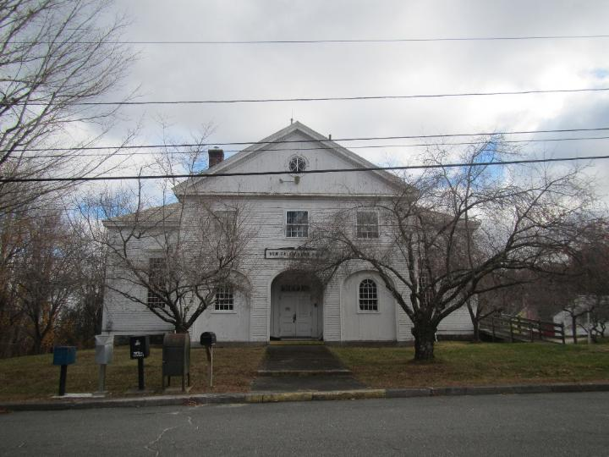
Trees in front of the building have lichen growing on them
Picture 16
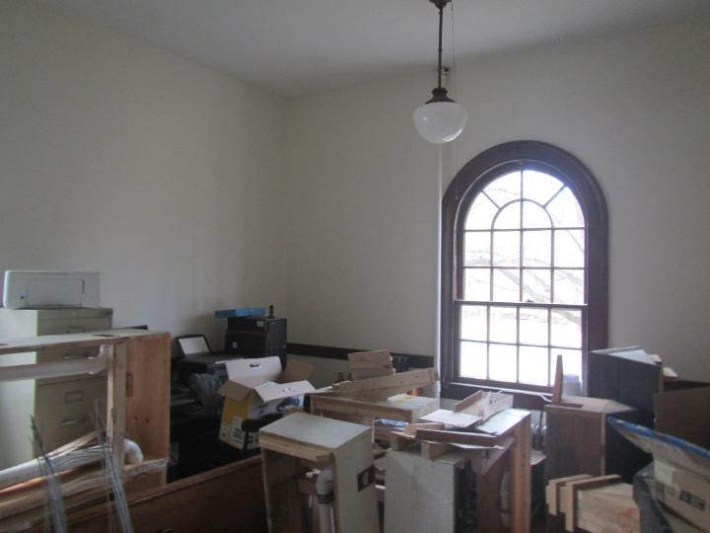
Stored items and office equipment

Picture 17
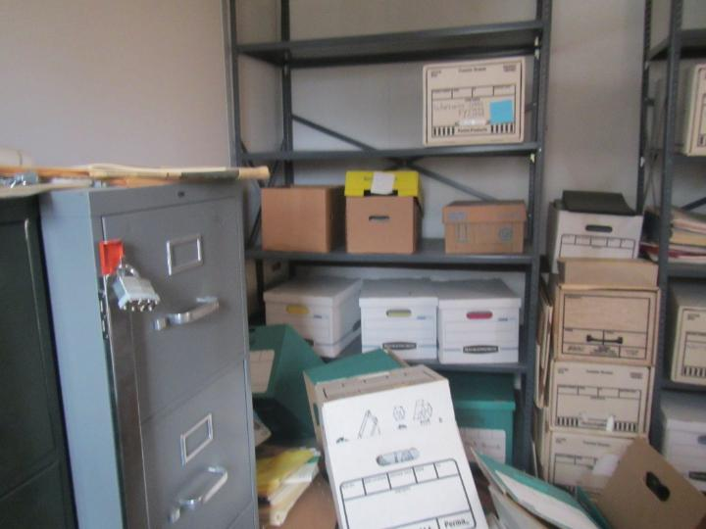
Stored items and office equipment
Picture 18
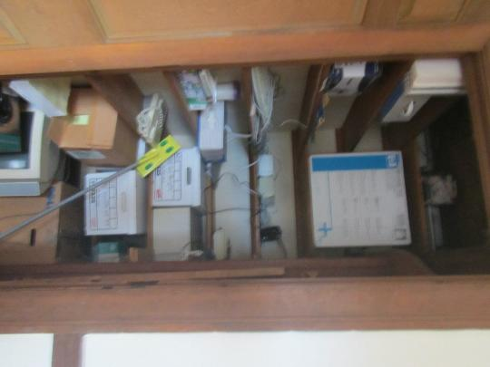
Stored items in a closet

Picture 19
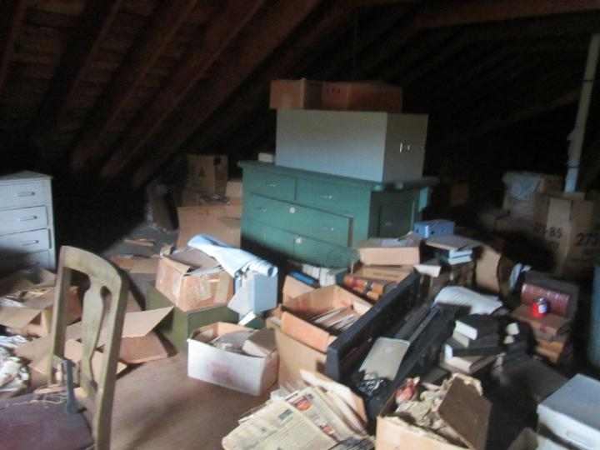
Stored items in the attic
Picture 20
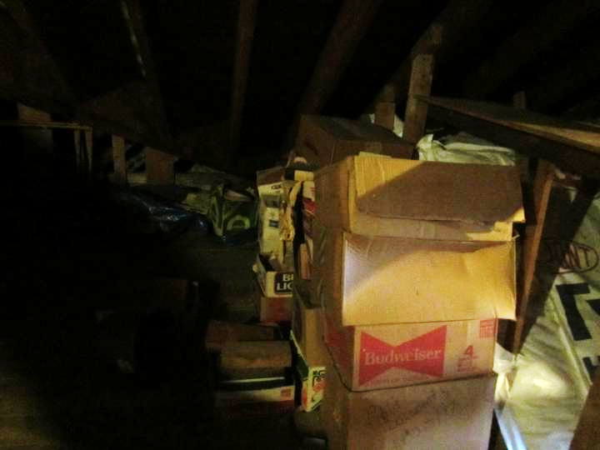
Stored items in the attic, some of which are water-damaged

