*A Think College Brief on Policy, Research, & Practice*

INSIGHT

## ISSUE NO. 26 • 2015

**Building Inclusive Campus Communities: A Framework for Inclusion**

*By Melissa M. Jones, Molly Boyle, Cynthia P. May, Seb Prohn, Jean Updike, & Catie Wheeler*

## INTRODUCTION



This Insight Brief provides a framework for inclusion of students with intellectual disabilities (ID) in higher education. It was developed by members of the Think College Special Interest Group Building Inclusive Campus Communities and collaborating partners from the Institute for Community Inclusion (ICI).To support implementation of this inclusive higher education framework, a series of reflective questions are provided for practitioners and administrators that they can consider when designing new or evaluating existing postsecondary education (PSE) programs at institutions of higher education (IHE).

## WHY A FRAMEWORK?

Opportunities for postsecondary education for students with ID are expanding across the United States (Grigal, Hart, Smith, Domin, Sulewski, & Weir, 2015; Hart, Grigal, Sax, Martinez, & Will, 2006), with over 240 programs listed in the Think College PSE programs database (Think College, June 2015). Many of these programs espouse an inclusive experience. A cursory review of these programs, however, demonstrates a vast array of practices, with some programs calling themselves inclusive while demonstrating aspects of segregated, non-inclusive environments and supports.These include specialized curricula separate from the college offerings; separate courses, clubs, and workshops only for students with ID;“reverse inclusion” options where typical students visit or instruct a class for students with ID; or having no affiliation with an accredited institution although the word “college” is included in the program title.

As higher education initiatives across the country become an increasing reality, illustrating what is meant by inclusive higher education becomes paramount. Many PSE programs are still in their infancy, and others are engaging in ongoing program

evaluation and refinement, so exploring what it means to be an inclusive college initiative is essential.

## A COLLABORATIVE EFFORT TO PROMOTE INCLUSION

To address the need for a framework for inclusive practices, faculty and program personnel of several PSE programs in the United States formed a Special Interest Group (SIG), Building Inclusive Campus Communities, under the guidance of Think College, the national coordinating center for the federal grant supporting Transition Programs for Students with Intellectual Disabilities (TPSID). Using Shanley’s (2011) definition of inclusive postsecondary education as a starting point, the SIG members developed a more comprehensive framework for establishing and evaluating the presence of inclusive practices in higher education.

While Shanley’s definition addressed key aspects of inclusive higher education, the proposed framework moves beyond the concept of physical presence and accessibility toward a belief and value system where individual difference, including difference in ability, is perceived as a strength and an integral part of any community. As Uditsky and Hughson (2012) pointed out, simply having a seat on a college or university campus is not equivalent to inclusion. Inclusion involves

pervasive attitudes of acceptance, belonging, value, and connection throughout the community—a social justice perspective that offers equality and dignity to all members of a higher education community (Hall, 2005; 2010).

The proposed framework is built on the premise that inclusive communities in higher education embrace a shared commitment to value all people and to provide equal

and authentic opportunities for individuals with various differences to interact, collaborate, and learn from one another.

Fostering positive and accepting attitudes about students

[www.thinkcollege.net](http://www.thinkcollege.net/)

INSIGHT: A Think College Brief on Policy, Research, & Practice • Issue No. 26

with intellectual disabilities and other differences is key, while acknowledging that difference is not synonymous with incompetence. An inclusive campus generates natural supports within the community to meaningfully involve all students in campus life. It provides students with disabilities the same opportunities and choices available to those without disabilities, never relegating students with ID to separate or segregated experiences.

Bearing this in mind, the SIG members generated the following framework for creating inclusive campus communities.

Developing this framework was an evolutionary process requiring continuous deliberation and revision as we challenged ourselves to think beyond our current practices, engaged stakeholders and leaders in the field in ongoing discussions, and paired our learning with reflections on

our own personal journeys of program development. The statements on inclusion within the framework encompass the philosophy and values of inclusive college and university communities, providing a foundation for the development and refinement of inclusive higher education opportunities. At the core of this framework is an underlying belief that

being a welcomed and valued member of a community is not charity or a gift, but a human right extended to everyone, regardless of perceived ability, gender identity, culture, socioeconomic status, race, or other forms of perceived difference.

## EVALUATING INCLUSIVE PRACTICES

How we develop postsecondary options demonstrates our understanding of and commitment toward the fostering of inclusive campus communities. Those involved in providing PSE access for individuals with ID can use this framework as a means for self-reflection and program evaluation. We created a checklist to assist program facilitators in this process.

The questions on the checklist prompt self-exploration, and are by no means exhaustive. The checklist provides key prompts for beginning an investigation, guiding inclusive higher education initiatives. If “yes” is checked, then that component of an inclusive campus has been realized.

When “no” is checked, program facilitators can begin to prioritize areas for further development toward an inclusive campus community.

**INCLUSION IS A HUMAN RIGHT.** It involves one belonging to a community, having access to equal opportunities, being free to choose one’s own life path, being actively engaged with and alongside others, and being valued for what one brings to the interaction.

**INCLUSION IS REALIZED WHEN THERE IS MUTUAL AND ONGOING BENEFIT** among people of varying abilities, gender identity, culture, socio-economic status, race, and other forms of diversity, with shared eagerness to create and sustain those relationships across all aspects of higher education.

**INCLUSION IS DEPENDENT ON INDIVIDUAL AND COMMUNAL PERSPECTIVES**, moving beyond benevolence, clinical/medical interests, or indifference to an attitude about and perception of ability that demonstrates a value placed upon difference throughout the higher education community.

**INCLUSIVE INSTITUTIONS OF HIGHER EDUCATION CELEBRATE INTELLECTUAL DIVERSITY** in the same way that they celebrate racial, gender, cultural, religious, and other forms of diversity. They recognize that diverse learners require and inspire pedagogical innovation, and that innovation benefits all students. They place value on experiences and perspectives of others, respect all forms of learning, and provide opportunities for all students to develop to their fullest potential.

# 2

**CHECKLIST FOR BUILDING INCLUSIVE HIGHER EDUCATION COMMUNITIES**

|  |  |
| --- | --- |
| **Definition of Inclusive Higher Education (Section 1)**  **Inclusion is a human right. It involves belonging to a community, having access to equal opportunities, being free to choose one’s own life path, being actively engaged with and alongside others, and being valued for what one brings to the interaction.** | |
| Questions for Reflection. Answer each question, either “Yes” or “No.” |
| Do students with ID take the same courses in the general course catalogue as other students on campus?  *(Check no if students take at least one course specifically designed for students with ID or choose from a limited list of courses.)* |
| Do students with ID choose their own courses, activities, jobs, and services with or without support?  *(Check no if program staff develop student schedules and opportunities.)* |
| Are students with ID physically on the same campus as students without disabilities?  *(Check no if program is off campus or on a separate campus.)* |
| Does enrollment of students with ID demonstrate natural proportions?  *(Check no if enrollment of students with ID at each campus setting exceeds the national average of 0.8%.)* |
| Do students with ID have access to all the activities and services available to other students?  *(Check no if some activities and/or student services are not accessible to students with ID.)* |
| Are students with ID enrolled at the college or university? *(Check no if students are enrolled in a separate program located on or off campus.)* |
| Are students with ID governed by the same policies as students without disabilities?  *(Check no if separate or different policies for students with disabilities exist.)* |
| Do students with ID participate in the IHE’s commencement/graduation ceremonies alongside their peers without disabilities? (*Check no if students do not participate in commencement/graduation ceremonies or if a separate graduation celebration is provided to students.)* |
| Do students with ID live in campus housing alongside peers without disabilities if the IHE has campus housing?  *(Check no if students with ID do not have access to campus housing or if they are in separate housing.)* |
| Do students have a choice with respect to their academic tutors or peer mentors?  *(Check no if students are assigned to those providing support.)* |
| Do students have the opportunity to refuse supports or request a change in tutors or peer mentors?  *(Check no if students are required to use the supports developed for them).* |
| **Definition of Inclusive Higher Education (Section 2)**  **Inclusion is realized when there is mutual and ongoing benefi among people of varying abilities, gender identity, culture, socio-economic status, race, and other forms of diversity, with shared eagerness to create and sustain those relationships across all aspects of higher education.** | |
| Questions for Reflection. Answer each question, either “Yes” or “No.” |
| Do students with and without disabilities independently initiate social interactions with one another?  *(Check no if prompting or structured environments or activities are needed to facilitate interactions.)* |
| Do students with and without disabilities identify each other as friends?  *(Check no if students with and without disabilities do not use the word “friend” to describe one another.)* |
| Do students with and without disabilities connect with one another via social media or texting?  *(Check no if students do not independently connect with one another via these channels.)* |
| Are the majority of interactions students with ID have with unpaid partners such a volunteer mentors or peers in their classes?  *(Check no if the majority of interactions are with paid tutors, mentors, or coaches.)* |
| Do students with ID have autonomy for how they spend their day on campus?  *(Check no if students with ID stay together in groups or follow a strict schedule monitored by program staff.)* |
| Do students with ID have daily opportunities to interact with nonpaid students without disabilities?  *(Check no if interactions with nonpaid students are limited or occasional.)* |
| Are students with ID free to have consensual romantic relationships with other adults?  *(Check no if rules or limits are set for students concerning their engaging in consensual relationships with other adults).* |

**3**

INSIGHT: A Think College Brief on Policy, Research, & Practice • Issue No. 26

**CHECKLIST FOR BUILDING INCLUSIVE HIGHER EDUCATION COMMUNITIES**

|  |  |
| --- | --- |
| **Definition of Inclusive Higher Education (Section 3)**  **Inclusion is dependent on individual and communal perspectives, moving beyond benevolence, clinical/medical interests, or indifference to an attitude about and perception of ability that demonstrates a value placed upon difference throughout the higher education community.** | |
| Questions for Reflection. Answer each question, either “Yes” or “No.” |
| Are students with ID included in campus conversations concerning diversity overall?  *(Check no if students with ID are not involved in campus conversations concerning diversity.)* |
| Do students with ID have a voice in program and campus decisions (Ex: surveys, interviews, advisory board membership)?  *(Check no if students with ID do not have formal opportunities to voice their opinions about program or campus decisions.)* |
| Are students with ID challenged to take academic courses based on their goals, strengths, and interests?  *(Check no if students are primarily enrolled in activity-based courses or if academic rigor is missing from the student’s schedule.)* |
| Are students active and engaged participants in the college courses they attend?  *(Check no if students do not participate in all or most class assignments.)* |
| When college staff speak or write about students with ID attending their college through an inclusive program, do they refer to students by name and/or as college students? *(Check no if students are referred to only by the name of the program.)* |
| Is person-first language, such as “the student with Down syndrome,” demonstrated in all written program information?  *(Check no if program information uses disability-first language, such as “the Down syndrome student.”)* |
| Do students have valued roles on campus as co-workers and peers?  *(Check no if students do not have valued work or roles on campus. Examples of such roles: co-worker at campus recreation center or bookstore; manager of men’s basketball team; member of student government; sorority sister.)* |
| **Definition of Inclusive Higher Education (Section 4)**  **Institutions of higher education celebrate intellectual diversity in the same way that racial, gender, cultural, religious, and other forms of diversity are celebrated. They recognize that diverse learners require and inspire pedagogical innovation, and that innovation benefits all students. They place genuine value on experiences and perspectives of others, respect all forms of learning, and provide opportunities for all students to develop to their fullest potential.** | |
| Questions for Reflection. Answer each question, either “Yes” or “No.” |
| Is the program integrated into an accredited two- or four-year IHE?  *(Check no if the program is a separate entity not directly connected to an established IHE.)* |
| Is Universal Design for Learning promoted and expected on campus to meet the needs of diverse learners?  *(Check no if UDL is not an institutionally promoted practice across campus.)* |
| Is campus administration supportive of inclusive PSE?  *(Check no if administrative barriers deter program development or student engagement.)* |
| Is disability given the same priority on campus as other forms of diversity, such as racial, gender, cultural, or religious diversity?  *(Check no if disability is not considered in the conversations concerning campus diversity).* |
| Does campus administration seek out the voices of students with ID and other disabilities?  *(Check no if there is no evidence that administration seeks out the voices of students with disabilities.)* |
| Is information available from the institution that explains the value of accepting differences?  *(Check no if the value of diversity and human difference is not formally disseminated on campus.)* |
| Is there a system in place to make sure the campus is inclusive for all?  *(Check no if no formal system has been established to monitor the inclusivity of the campus.)* |
| Do students with disabilities have the same access to grievance procedures as students without disabilities?  *(Check no if students with disabilities do not have access to established grievance procedures.)* |

**4**

**CONCLUSION**

While some believe that a program can be partially inclusive or can have levels of inclusion, this is not the case. The environment and ideologies supporting the inclusive endeavor either demonstrate the value of human difference, or they do not. Students with ID are either recognized as competent individuals worthy of challenge and opportunities for risk-taking, or are defined by their inabilities and deficiencies. Students with ID are either expected to contribute to a community in meaningful ways, or are viewed as recipients of support provided through the generosity of others.

Embracing a common philosophy to guide our practice provides us with a framework through which we can compare, contrast, question, and create as the work toward inclusive postsecondary education opportunities continues through our collective efforts. Having a common understanding of what an inclusive college community is benefits us all.

IHEs are inclusive when they celebrate intellectual diversity, place genuine value on the experiences and perspectives of others, respect all forms of learning, and provide

opportunities for students to develop to their fullest potential. As stewards of inclusive higher education, we must perpetually evaluate and update our PSE programs to

break through the barriers that hinder an authentic, inclusive higher education experience.

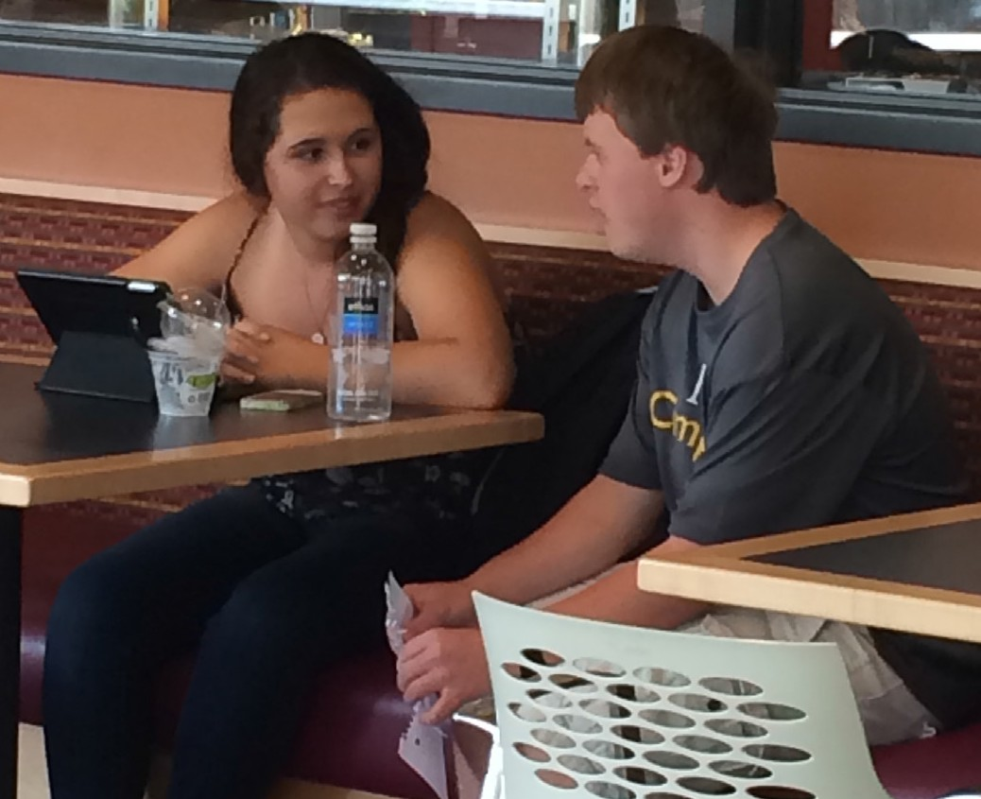

**REFERENCES**

Grigal, M., Hart, D., Smith, F. A., Domin, D., Sulewski, J., & Weir, C. (2015).Think College National Coordinating Center: Annual report on the transition and postsecondary programs for

students with intellectual disabilities (2013–2014). Boston, MA: University of Massachusetts Boston, Institute for Community Inclusion.

Hall, E. (2005).The entangled geographies of social exclusion/inclusion for people with learning disabilities. Health & Place, 11, 107–115.

Hall, E. (2010). Spaces of social inclusion and belonging for people with intellectual disabilities. Journal of Intellectual Disability Research, 54(1), 48–57.

Hart, D., Grigal, M., Sax, C., Martinez, D., & Will, M. (2006). Postsecondary education options for students with intellectual disabilities. Research to Practice, 45, 1–4. Retrieved from www.thinkcollege. net/administrator/components/com_resdb/ files/224_pse%20options.pdf

Shanley, J. L. (2011). Federal legislation increasing higher education access for students with intellectual disabilities. Impact: Feature issue on postsecondary education and students with intellectual developmental and other disabilities, 23(3), 8–11.

Think College. (2015). Find a college. Retrieved from [www.thinkcollege.net/college-search](http://www.thinkcollege.net/college-search)

Uditsky, B., & Hughson, E. (2012). Inclusive postsecondary education: An evidence-based moral imperative. Journal of Policy and Practice in Intellectual Disabilities, 9(4), 298–302.

U.S. Department of Education, National Center for Education Statistics. (2013). Digest of Education Statistics, 2012 (NCES 2014-015), Chapter 2.

For information on UDL, visit: [www.cast.org/our-work/](http://www.cast.org/our-work/) about-udl.html#.VY70wIWg4j4

**ABOUT THE AUTHORS**

Melissa M. Jones, PhD

*Professor of Special Education, Northern Kentucky University*

Molly Boyle, MA

*Project Coordinator, University of Massachusetts Boston*

Cynthia P. May, PhD

*Professor of Psychology, College of Charleston*

Seb M. Prohn, PhD

*Center on Transition Innovations, Virginia Commonwealth University*

Jean E. Updike, MSW

*Research Associate, Indiana University*

Catie Wheeler

*Center for Human Development, University of Alaska, Anchorage*

# INSIGHT, Issue No. 26, 2015



INSIGHT is a publication of Think College, a project of the Institute for Community Inclusion at the University of Massachusetts Boston, funded by the Office of Postsecondary Education (Grant No. P407B100002). The opinions contained in this document are those of the grantee and do not necessarily reflect those of the funders.

Recommended citation for this brief: Jones, M., Boyle, M., May, C., Prohn, S., Updike, J., & Wheeler, C. (2015). *Building Inclusive Campus Communities: A Framework for Inclusion*. Think College Insight Brief, Issue No. 26. Boston, MA: University of Massachusetts Boston, Institute for Community Inclusion

[www.thinkcollege.net](http://www.thinkcollege.net/) [www.facebook.com/thinkcollege](http://www.facebook.com/thinkcollege)

This publication will be made available in alternate formats upon request.