Massachusetts Department of Environmental Protection
Bureau of Resource Protection – Drinking Water Program
Bulk Water Questionnaire

Important: When filling out forms on the computer, use only the tab key to move your cursor - do not use the return key.  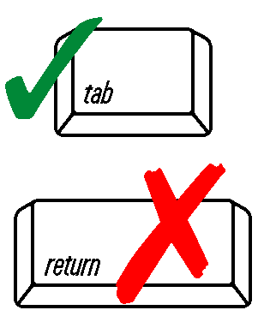 | A. Purpose
 | Please complete and return this questionnaire if you are interested in selling bulk potable water to Public Water Systems (PWS) in Massachusetts under short-term contracts. Under certain emergency situations, a PWS may have to purchase bulk water to supply to its customers for a short period while a permanent solution is being developed. MassDEP is soliciting information regarding bulk and bottled water suppliers that either currently sell bulk potable water or have an interest in doing so in the future. The information collected may be listed (with MassDEP approval) on the MassDEP website and made available to PWSs for use in emergency situations.
 | B. Provider Information
 | Name of Bulk or Bottled Water Company
 | Contact Name (First, Last) |  |  | Contact Phone Number
 | C. Bulk Order Requirements
 | gal./truckload gal./contract  Minimum Order Required |  |  | Maximum Capacity Available for Sale (gal./week)
 | D. Source Information
 | MassDEP DWP Policy #92-07 states “Only those Bulk sources/supplies, which have received MassDEP approvals as a PWS source may sell water to public water systems.” A complete version of this policy can be found at: https://www.mass.gov/files/documents/2016/08/qr/9207.pdf. If you have more than three sources, use additional questionnaire forms.
 | Source of Water |  | Approving Authority |  |  |  |  | Date of Approval
 | Source of Water |  | Approving Authority |  |  |  |  | Date of Approval
 | Source of Water |  | Approving Authority |  |  |  |  | Date of Approval
 | Contract for bulk water will be negotiated with (please check one): |  |  |  | Bulk or Bottled Water Company  Licensed Food-Grade Hauler
 | E. Hauler Information
 | If you indicated “Licensed Food-Grade Hauler” above, please provide the following:
 | Name of Hauler |  |  | Hauler Contact Name
 | Hauler Address |  |  |  |  | Contact Phone Number
 | F. Other Information
 | Use the remaining space below to provide any additional important information:
 | Please return completed form to:
 | By Mail:  MassDEP Drinking Water Program  Attn: Bulk Water  1 Winter Street, 5th Floor  Boston, MA 02108 | By Email:  program.director-dwp@mass.gov  Subject: Bulk Water

