INDOOR AIR QUALITY ASSESSMENT

Department of Public Health
Bureau of Health Professions Licensure
239 Causeway Street
4th and 5th floors
Boston, Massachusetts

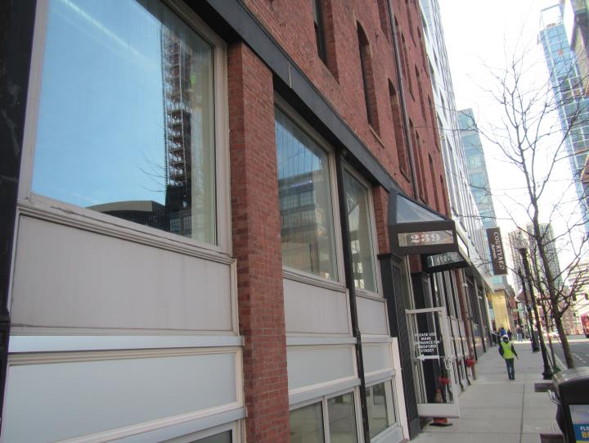

Prepared by:
Massachusetts Department of Public Health
Bureau of Environmental Health
Indoor Air Quality Program
March 2020

Background
Building: | Department of Public Health (DPH)  Bureau of Health Professions Licensure (BHPL)
Address: | 239 Causeway Street, Boston, MA, 4th and 5th floors
Assessment Requested by: | Yulanda R. Kiner, Esq.  Assistant Director of Diversity & Inclusion/ADA Coordinator  Massachusetts Department of Public Health
Reason for Request: | General indoor air quality (IAQ) and health concerns
Date of Assessment: | March 3, 2020
Massachusetts Department of Public Health/Bureau of Environmental Health (MDPH/BEH) Staff Conducting Assessment: | Ruth Alfasso, Environmental Engineer/Inspector, IAQ Program
Building/Site Description: | Five-story brick building located near North Station.
Windows: | Designed as openable in some places but may not be functionally able to be opened currently

Methods
Please refer to the IAQ Manual for methods, sampling procedures, and interpretation of results (MDPH, 2015).
Note that this building has been visited by the BEH/IAQ program previously, and those results are available on request or at https://www.mass.gov/info-details/indoor-air-quality-reports-cities-and-towns-b

IAQ Testing Results
The following is a summary of indoor air testing results (Table 1).
- Carbon dioxide levels were slightly above 800 parts per million (ppm) in over half of areas assessed on the 4th floor (9 out of 14) and below 800 ppm in all but one area out of 34 areas assessed on the 5th floor. This indicates that more fresh air could be supplied for the occupancy of the 4th floor areas.
- Temperature was within the recommended range of 70°F to 78°F in all areas assessed, however occupants reported temperature control issues.
- Relative humidity was below the recommended range of 40% to 60% in all areas assessed which is typical of the heating season in New England.
- Carbon monoxide levels were non-detectable in all indoor areas assessed.
- Fine particulate matter (PM2.5) concentrations measured were below the National Ambient Air Quality Standard (NAAQS) level of 35 μg/m³ in all areas assessed.

Ventilation
A heating, ventilating, and air conditioning (HVAC) system has several functions. First, it provides heating and, if equipped, cooling. Second, it is a source of fresh air. Finally, an HVAC system will dilute and remove normally occurring indoor environmental pollutants by not only introducing fresh air, but also filtering the airstream and ejecting stale air to the outdoors via exhaust ventilation. Even if an HVAC system is operating as designed, point sources of respiratory irritation may exist and affect symptoms in sensitive individuals. The following analysis examines and identifies components of the HVAC system and likely sources of respiratory irritant/allergen exposure due to water damage, aerosolized dust, and/or chemicals found in the indoor environment.
Fresh air is provided by air handling units (AHUs). Air from the AHUs is filtered, heated/cooled, and delivered to rooms via ducted supply vents (Picture 1). Air is returned/exhausted through ducted return vents (Picture 2). Note that some thermostats were found set to the “auto” position instead of the “on” position (Picture 3; Table 1). This means that the air circulation is only on whenever the system calls for temperature adjustment rather than continuously. It is recommended that thermostats be set to “on” during occupied periods to provide adequate air exchange.
It is recommended that HVAC systems be re-balanced every five years to ensure adequate air systems function (SMACNA, 1994). The date of the last HVAC balancing in this building was not available.

Microbial/Moisture Concerns
Water-damaged ceiling tiles were noted in a few areas (Picture 4; Table 1). Water-damaged ceiling tiles should be replaced when they are found and the source of the leak repaired.
Plants were observed in office areas (Picture 5, Table 1). Plants can be a source of pollen and mold, which can be respiratory irritants to some individuals. Plants should be properly maintained and equipped with drip pans to prevent water damage to porous materials. Plants should also be located away from air diffusers to prevent the aerosolization of dirt, pollen, and mold.
Small refrigerators were observed in carpeted areas (Picture 6, Table 1). These appliances may spill or leak and lead to carpet damage and microbial growth. It is recommended that these appliances be located in areas without carpeting or on waterproof mats. Refrigerators and cooking equipment should be kept clean and free of debris that may lead to smoke and odors or attract pests.

Other IAQ Evaluations
Exposure to low levels of total volatile organic compounds (TVOCs) may produce eye, nose, throat, and/or respiratory irritation in some sensitive individuals. BEH/IAQ staff examined rooms for products containing VOCs. BEH/IAQ staff noted cleaners, air freshener products, and dry erase materials in use within the building (Table 1). All of these products have the potential to be irritants to the eyes, nose, throat, and respiratory system of sensitive individuals.
Papers and items were noted on surfaces and floors in some offices (Picture 7). Excess items on surfaces make it more difficult to clean in these areas. Papers and accumulated items can be a source of dust and may become harborage for pests.
Most of the floors in the BHPL are carpeted. Carpeting should be cleaned annually or semi-annually in soiled high traffic areas as per the recommendations of the Institute of Inspection, Cleaning and Restoration Certification (IICRC, 2012).

Conclusions/Recommendations
Based on observations at the time of assessment, the following is recommended:
- Operate supply and exhaust ventilation in all areas during occupied periods including setting thermostats to the “fan on” setting.
- Check HVAC settings and fresh air dampers for the AHUs, particularly those serving the 4th floor, to see if changed settings can assist with fresh air supply.
- Make any necessary repairs of roof/plumbing and replace water-damaged ceiling tiles.
- Have the HVAC system balanced every 5 years in accordance with SMACNA recommendations (SMACNA, 1994).
- Ensure filters are changed in all AHU units a minimum of twice a year. Building managers should keep a log of filter changes to ensure this occurs. Filters with a MERV value of 8 or higher that properly fit the AHUs should be used.
- For buildings in New England, periods of low relative humidity during the winter are often unavoidable. Therefore, scrupulous cleaning practices should be adopted to minimize common indoor air contaminants whose irritant effects can be enhanced when the relative humidity is low. To control for dusts, a high efficiency particulate arrestance (HEPA) filter equipped vacuum cleaner in conjunction with wet wiping of all surfaces is recommended. Avoid the use of feather dusters. Drinking water during the day can help ease some symptoms associated with a dry environment (throat and sinus irritations).
- Keep indoor plants in good condition, avoid overwatering, and avoid placing them on porous items such as carpets or paper. Also, keep plants out of the air stream of supply vents.
- Consider locating refrigerators and water dispensers in non-carpeted areas or place on a waterproof mat. Clean refrigerator spills promptly and clean refrigerators out regularly to avoid odors and microbial growth.
- Reduce use of products containing VOCs.
- Reduce accumulated materials on flat surfaces and move periodically to allow for thorough cleaning.
- Clean carpeting in accordance with IICRC recommendations (IICRC, 2012).
- Refer to resource manual and other related IAQ documents located on the MDPH’s website for further building-wide evaluations and advice on maintaining public buildings. These documents are available at: http://mass.gov/dph/iaq.

References
IICRC. 2012. Institute of Inspection, Cleaning and Restoration Certification. Carpet Cleaning: FAQ.
MDPH. 2015. Massachusetts Department of Public Health. Indoor Air Quality Manual: Chapters I-III. Available at: http://www.mass.gov/eohhs/gov/departments/dph/programs/environmental-health/exposure-topics/iaq/iaq-manual/.
SMACNA. 1994. HVAC Systems Commissioning Manual. 1st ed. Sheet Metal and Air Conditioning Contractors’ National Association, Inc., Chantilly, VA.

Picture 1
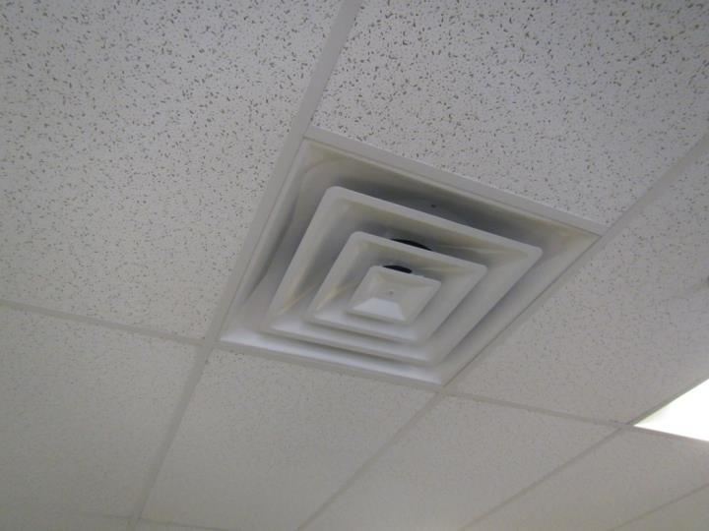
Typical supply vent
Picture 2
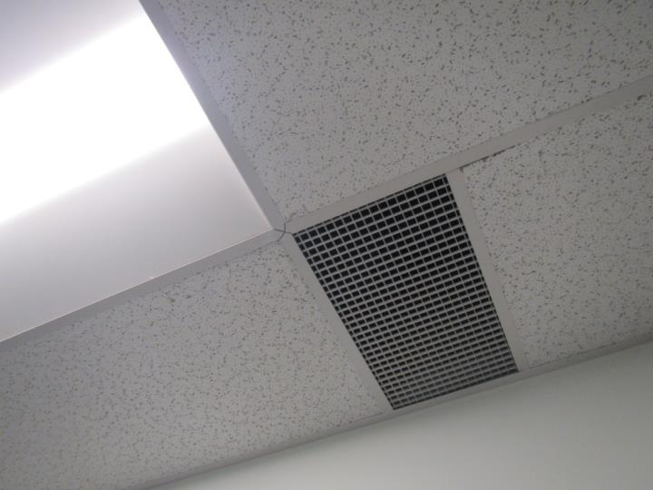
Typical return vent
Picture 3
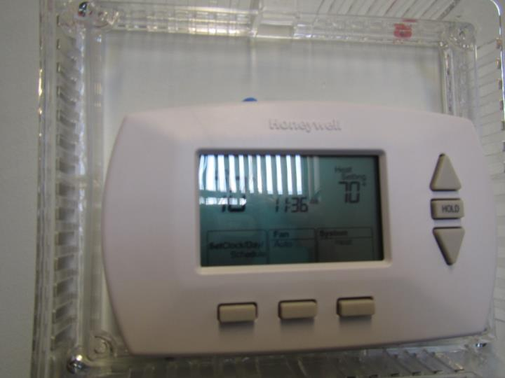
Thermostat set to “fan auto” (center bottom of display)
Picture 4
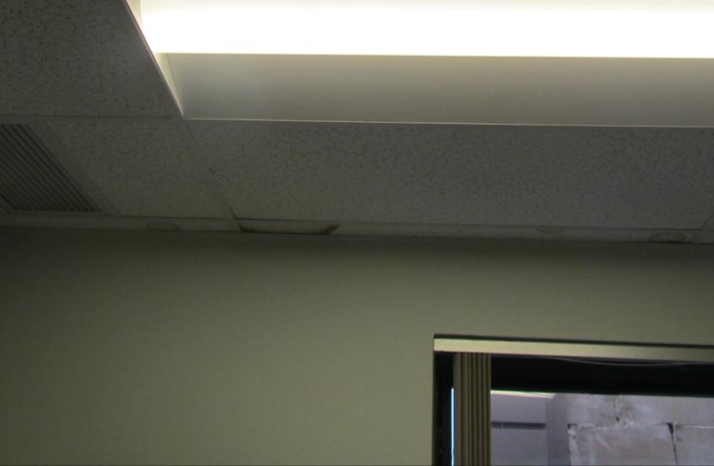
Water-damaged ceiling tile
Picture 5
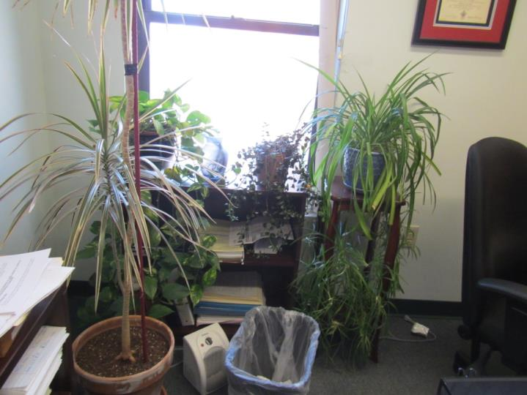
Plants in an office
Picture 6
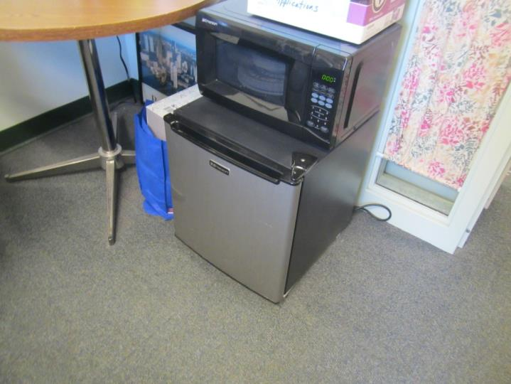
Refrigerator on carpet
Picture 7
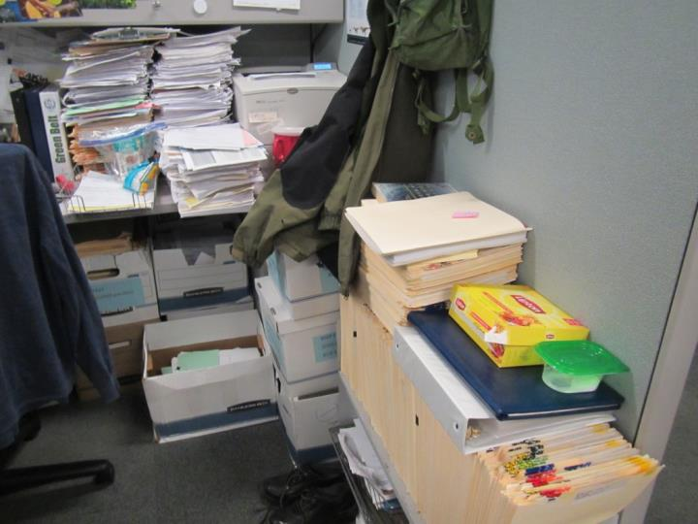
Papers and items on surfaces/floors

Location | Carbon  Dioxide  (ppm) | Carbon Monoxide  (ppm) | Temp  (°F) | Relative  Humidity  (%) | PM2.5  (µg/m³) | Occupants  in Room | Windows  Openable | Ventilation |  | Remarks
 |  |  |  |  |  |  |  | Supply | Exhaust
4th floor
Keene cube area | 868 | ND | 74 | 31 | 9 | 2 | Y | Y | Y | Plants
403 series cubes | 914 | ND | 74 | 29 | 9 | 2 | N | Y |  | Plants, AI, PCs
423 | 730 | ND | 75 | 29 | 10 | 0 | N | Y | N | Fridge on carpet, HS
422 staff kitchen | 715 | ND | 76 | 30 | 18 | 0 | N | Y | Y | Food odors
403 cube series other side | 870 | ND | 76 | 29 | 17 | ~4 | N | Y | Y | AI
406 | 912 | ND | 76 | 28 | 12 | 1 | N | Y | Y | Fridge on carpet
407 | 921 | ND | 76 | 28 | 10 | 1 | Y | Y | Y
408 | 882 | ND | 76 | 28 | 10 | 1 | Y | Y | Y | Plant, fridge
Kelley ½ wall office | 870 | ND | 76 | 27 | 10 | 0 | N | Y | N
410 | 909 | ND | 76 | 29 | 10 | 2 | Y | Y | Y | DEM
411 | 822 | ND | 76 | 27 | 10 | 0 | Y | Y | Y | “Fan auto” nearest thermostat
413 | 766 | ND | 76 | 27 | 10 | 1 | N | Y | Y | Fridge on carpet
Women’s restroom |  |  |  |  |  |  | N | Y | Y
Stairwell |  |  |  |  |  |  |  |  |  | Painting odors
421 hearing | 431 | ND | 74 | 30 | 12 | 0 | N | Y |  | WD CT in corner, DEM, “fan on” nearest thermostat
Hearing area waiting room | 421 | ND | 74 | 29 | 12 | 0 | N | Y |  | NC
5th floor
506B | 754 | ND | 73 | 31 | 10 | 0 | Y | Y | Y
506D | 767 | ND | 74 | 31 | 9 | 1 | Y | Y | Y
506A | 742 | ND | 74 | 30 | 9 | 1 | N | Y | Y | AI - paper on desk and floor
517 | 598 | ND | 74 | 26 | 9 | 0 | Y | Y | N | Confidential office, boxes on floor
506 series cube | 604 | ND | 74 | 27 | 9 | 0 | N | Y |  | PF
506 E-F | 641 | ND | 74 | 29 | 8 | 2 | N | Y
507 | 617 | ND | 74 | 29 | 9 | 1 | N | Y |  | DEM
508 | 669 | ND | 74 | 30 | 11 | 1 | N | Y | Y | UF, DEM, HS
533 | 650 | ND | 74 | 29 | 9 | 1 | N | Y | Y
511 | 560 | ND | 74 | 30 | 9 | 0 | Y | Y | Y | Plants, DEM, fridge on carpet
513 | 555 | ND | 74 | 29 | 10 | 0 | Y | Y | Y | Fridge on carpet, microwave
515 | 606 | ND | 74 | 29 | 8 | 0 | Y | Y | Y | DEM
516 | 573 | ND | 74 | 29 | 9 | 0 | Y | Y | N
533 series cubes | 580 | ND | 74 | 29 | 8 | 5 | N | Y | Y | Plants
526 | 573 | ND | 74 | 29 | 8 | 0 | N | Y | Y | Boxes on floor
527 | 561 | ND | 74 | 29 | 9 | 0 | N | Y | Y | 2 WD CT, flowers
528 | 575 | ND | 74 | 29 | 8 | 1 | N | Y | Y
505 | 592 | ND | 74 | 29 | 9 | 0 | N | Y | Y | plants
525 | 523 | ND | 74 | 29 | 8 | 0 | N | Y | Y | Food odors, crumbs in toaster oven
526A | 544 | ND | 74 | 28 | 8 | 1 | N | N | N | ½ wall office
518 | 584 | ND | 74 | 29 | 8 | 1 | Y | N | N | Plants
519 | 634 | ND | 74 | 29 | 8 | 1 | Y | Y | Y | 2 WD CT (reoccur over a year’s time)
521 | 567 | ND | 74 | 30 | 8 | 3 | N | Y | Y
524 | 557 | ND | 74 | 29 | 8 | 2 | N | Y | Y
Cubes outside 537A | 561 | ND | 74 | 29 | 9 | 0 | N | Y | Y
538 series cube area | 538 | ND | 74 | 28 | 8 | 3 | N | Y | Y
555 | 884 | ND | 73 | 29 | 9 | 0 | N | Y | Y | Stained carpet, DEM
539 | 628 | ND | 73 | 29 | 9 | 3 | N | Y | Y | Boxes on floor
541 cube area | 623 | ND | 72 | 29 | 8 | 5 | N | Y | Y | Skylight
546 | 601 | ND | 71 | 29 | 10 | 1 | Y | Y | Y
548 | 593 | ND | 71 | 31 | 8 | 1 | Y | Y | Y
550 | 591 | ND | 71 | 30 | 9 | 0 | Y | Y | Y | Boxes
553 | 584 | ND | 70 | 31 | 8 | 0 | N | Y | Y | PF on
Reception (internal) | 602 | ND | 71 | 32 | 9 | 1 | N | Y | Y | Mail machines, boxes
Women’s restroom |  |  |  |  |  |  | N | Y | Y

