INDOOR AIR QUALITY ASSESSMENT

Burke Elementary School
127 Birch Street
Peabody, MA

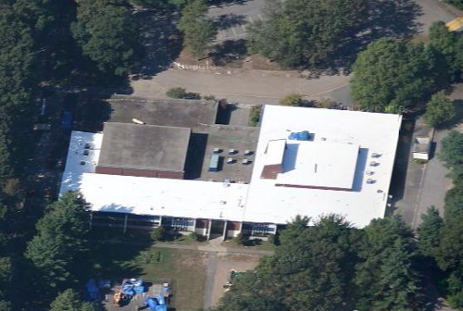

Prepared by:
Massachusetts Department of Public Health
Bureau of Environmental Health
Indoor Air Quality Program
September 2012

Background/Introduction
At the request of Sharon Cameron, Director, Peabody Health Department, the Massachusetts Department of Public Health, Bureau of Environmental Health conducted an indoor air quality (IAQ) assessment at the Burke Elementary School (BES), 127 Birch Street, Peabody, Massachusetts. On May 10, 2012, a visit was made to this school by Sharon Lee, an Environmental Analyst with BEH’s IAQ Program. This assessment was prompted by concerns related to a roof replacement project that began in September 2011. The project was completed a few days prior to the IAQ assessment. Ms. Lee was accompanied by Ms. Cameron and Tony Del Sonno, BES custodian, throughout the assessment.
Ms. Lee and Michael Feeney, Director of the IAQ Program had previously visited the BES on September 21, 2011 to provide recommendations regarding use of ventilation/air pressure methods to reduce opportunities for exposure to odors/materials related to the roofing project. The school had been occupied during throughout the roof replacement project; however, classrooms on the second floor of the school were vacated in January 2012 to reduce classroom disruption and to avoid exposure of classroom occupants to odors/materials from the roof project.
The BES was constructed in 1965. The school consists of 24 classrooms, as well as common spaces such as the cafeteria and gymnasium. Windows throughout the building are openable. These windows, which are original to the building, are scheduled to be replaced during the summer of 2012.

Methods
Air tests for carbon dioxide, carbon monoxide, temperature and relative humidity were conducted with the TSI, Q-Trak, IAQ Monitor, Model 7565. Air tests for airborne particle matter with a diameter less than 2.5 micrometers were taken with the TSI, DUSTTRAK™ Aerosol Monitor Model 8520. Testing for total volatile organic compounds (TVOCs) was conducted with a MiniRAE 2000 photoionization detector. BEH/IAQ staff also performed visual inspection of building materials for water damage and/or microbial growth.

Results
The BES serves approximately 330 students in kindergarten through fifth grade, and houses approximately 35 staff. As mentioned, second floor classrooms were not occupied at the time of assessment. All lower level classrooms and common spaces were occupied/in-use at the time of assessment. Test results appear in Table 1.

Discussion

Ventilation
It can be seen from Table 1 that carbon dioxide levels were above 800 parts per million (ppm) in seven of 19 occupied areas, indicating adequate air exchange most areas surveyed at the time of assessment. In some areas, ventilation equipment was found deactivated; therefore, no means of mechanical ventilation was being provided to these areas at the time of testing. It is also important to note that several areas were empty/sparsely populated, which can greatly reduce carbon dioxide levels. Carbon dioxide levels would be expected to increase with higher occupancy and windows closed.
Fresh air is supplied to classrooms by unit ventilator (univent) systems (Picture 1). A univent draws air from the outdoors through a fresh air intake located on the exterior wall of the building (Picture 2). Return air from the classroom is drawn through an air intake located at the base of the unit (Figure 1). Fresh and return air are mixed, filtered, heated and provided to classrooms through an air diffuser located in the top of the unit. As mentioned, univents were found deactivated in the majority of rooms/areas in the school at the time of assessment (Table 1). In addition, several univents were found obstructed by furniture and/or other items found on top of air diffusers and/or in front of return vents along the bottom of the units (Picture 3). In order for univents to provide fresh air as designed, they must remain “on” and operating while rooms are occupied. Furthermore, units must remain free of obstructions.
Exhaust ventilation for classrooms is provided by exhaust vents located in closets. The undercut closet door allows air to be drawn into the closet and exhausted from the building via rooftop-mounted exhaust fans (Pictures 4 to 6). In some areas, closet vents were blocked or air flow was hindered by materials stored in the closet. Some exhausts also appeared to be drawing weakly. As with supply ventilation, exhaust ventilation must be free of blockages and allowed to operate while the building is occupied. Rooftop exhaust fans should be examined periodically to ensure proper function. Consideration should also be given to keeping closet doors open to improve exhaust ventilation.
Note that the univents are original equipment, roughly 47 years old. Function of equipment of this age is difficult to maintain, particularly since compatible replacement parts are often unavailable. According to the American Society of Heating, Refrigeration and Air-Conditioning Engineers (ASHRAE), the service life for a unit heater, hot water or steam is 20 years, assuming routine maintenance of the equipment (ASHRAE, 1991). Despite attempts to maintain the univents, the operational lifespan of the equipment has been exceeded. Maintaining the balance of fresh air to exhaust air will become more difficult as the equipment ages and as replacement parts become increasingly difficult to obtain.
Mechanical ventilation for common areas (e.g., auditorium, cafeteria) is provided by rooftop air-handling units (AHUs) (Picture 6). Fresh air is distributed via ceiling-mounted air diffusers and ducted back to AHUs via ceiling or wall-mounted return vents. As with univents, AHUs should be activated and allowed to operate continuously during occupied periods.
To maximize air exchange, the MDPH recommends that both supply and exhaust ventilation operate continuously during periods of occupancy. In order to have proper ventilation with a mechanical supply and exhaust system, the systems must be balanced to provide an adequate amount of fresh air to the interior of a room while removing stale air from the room. It is recommended HVAC systems be re-balanced every five years to ensure adequate air systems function (SMACNA, 1994). The date of the last balancing of these systems was not available at the time of the assessment.
The Massachusetts Building Code requires that each room have a minimum ventilation rate of 15 cubic feet per minute (cfm) per occupant of fresh outside air or openable windows (SBBRS, 1997; BOCA, 1993). The ventilation must be on at all times that the room is occupied. Providing adequate fresh air ventilation with open windows and maintaining the temperature in the comfort range during the cold weather season is impractical. Mechanical ventilation is usually required to provide adequate fresh air ventilation.
Carbon dioxide is not a problem in and of itself. It is used as an indicator of the adequacy of the fresh air ventilation. As carbon dioxide levels rise, it indicates that the ventilating system is malfunctioning or the design occupancy of the room is being exceeded. When this happens, a buildup of common indoor air pollutants can occur, leading to discomfort or health complaints. The Occupational Safety and Health Administration (OSHA) standard for carbon dioxide is 5,000 parts per million parts of air (ppm). Workers may be exposed to this level for 40 hours/week, based on a time-weighted average (OSHA, 1997).
The MDPH uses a guideline of 800 ppm for publicly occupied buildings. A guideline of 600 ppm or less is preferred in schools due to the fact that the majority of occupants are young and considered to be a more sensitive population in the evaluation of environmental health status. Inadequate ventilation and/or elevated temperatures are major causes of complaints such as respiratory, eye, nose and throat irritation, lethargy and headaches. For more information concerning carbon dioxide, consult Appendix A.
Temperatures in the occupied areas ranged from 73°F to 76°F, which were within the MDPH recommended range in all areas surveyed (Table 1). The MDPH recommends that indoor air temperatures be maintained in a range of 70°F to 78°F in order to provide for the comfort of building occupants. In many cases concerning indoor air quality, fluctuations of temperature in occupied spaces are typically experienced, even in a building with an adequate fresh air supply. In addition, it is difficult to control temperature and maintain comfort without operating the ventilation equipment as designed (e.g., univents/exhaust vents deactivated/obstructed).
Relative humidity measurements in the building ranged from 42 to 56 percent at the time of assessment, which were within the MDPH recommended comfort range in all areas surveyed (Table 1). The MDPH recommends a comfort range of 40 to 60 percent for indoor air relative humidity. Relative humidity levels in the building would be expected to drop during the winter months due to heating. The sensation of dryness and irritation is common in a low relative humidity environment. Low relative humidity is a very common problem during the heating season in the northeast part of the United States.

Microbial/Moisture Concerns
Water-stained and damaged/broken ceiling tiles were observed in the building are likely from roof leaks (Picture 7). Ms. Cameron and school staff reported that the ceiling tiles may contain asbestos. As mentioned, a new roof was installed at the school. Since the source of water has been repaired, consideration should be given to replacing missing and damaged ceiling tiles as soon as possible.
At the time of assessment, BEH staff recommended that PPS contact the Massachusetts Department of Labor Standards’ (MDLS) Asbestos Program regarding any damaged tiles. Consideration should be given to replacing the asbestos-containing tiles during the window replacement project, since classrooms will be isolated for renovation.
Floor tiles, which appeared worn in some areas, may also contain asbestos. Intact asbestos-containing materials do not pose a health hazard. If damaged, asbestos-containing materials can be rendered friable and become aerosolized. Any damage to tile should be remediated by a licensed asbestos remediation firm in accordance with state and federal regulations. In 1986, the Asbestos Hazard Emergency Response Act [AHERA; Asbestos Containing Materials (ACM) in Schools, 40 CFR Part 763, Subpart E] was enacted. AHERA requires the inspection of schools for asbestos-containing building materials (location, type, and condition) and preparation of management plans which recommend the best way to reduce asbestos hazards (US EPA, 1986). Under AHERA, facilities are required to be inspected for asbestos containing material (visually every six months and comprehensively every three years by an accredited inspector). The MDLS provides technical assistance to schools in Massachusetts by reviewing management plans and conducting on-site assessments for compliance with AHERA. In addition, MDLS regulates asbestos abatement in schools and other buildings through its regulations, licensing, site visits, and enforcement.
The US Environmental Protection Agency (US EPA) and the American Conference of Governmental Industrial Hygienists (ACGIH) recommends that porous materials be dried with fans and heating within 24 to 48 hours of becoming wet (US EPA, 2001; ACGIH, 1989). If porous materials are not dried within this time frame, mold growth may occur. Water-damaged porous materials cannot be adequately cleaned to remove mold growth. The application of a mildewcide to moldy porous materials is not recommended.
Plants were observed in several areas, some of which were located on or directly adjacent to univents (Table 1; Picture 3). One classroom also had a terrarium (Table 1). Plants should be properly maintained and equipped with washable drip pans. Plants should be located away from ventilation sources to prevent aerosolization and distribution of dirt, pollen or mold. Plants should also not be placed on porous materials (e.g., paper or cardboard), since water damage to porous materials may lead to microbial growth.
A water dispenser was observed on carpeting in the teacher’s room. Spills/condensation from these appliances can be a source of moisture in carpeting that can lead to water damage and mold growth. When possible, these units should be located in tiled areas or placed on a waterproof mat.

Other IAQ Evaluations
Indoor air quality can be negatively influenced by the presence of respiratory irritants, such as products of combustion. The process of combustion produces a number of pollutants. Common combustion emissions include carbon monoxide, carbon dioxide, water vapor and smoke (fine airborne particle material). Of these materials, exposure to carbon monoxide and particulate matter with a diameter of 2.5 micrometers (μm) or less (PM2.5) can produce immediate, acute health effects upon exposure. To determine whether combustion products were present in the indoor environment, BEH/IAQ staff obtained measurements for carbon monoxide and PM2.5.

Carbon Monoxide
Carbon monoxide is a by-product of incomplete combustion of organic matter (e.g., gasoline, wood and tobacco). Exposure to carbon monoxide can produce immediate and acute health affects. Several air quality standards have been established to address carbon monoxide and prevent symptoms from exposure to these substances. The MDPH established a corrective action level concerning carbon monoxide in ice skating rinks that use fossil-fueled ice resurfacing equipment. If an operator of an indoor ice rink measures a carbon monoxide level over 30 ppm, taken 20 minutes after resurfacing within a rink, that operator must take actions to reduce carbon monoxide levels (MDPH, 1997).
The American Society of Heating Refrigeration and Air-Conditioning Engineers (ASHRAE) has adopted the National Ambient Air Quality Standards (NAAQS) as one set of criteria for assessing indoor air quality and monitoring of fresh air introduced by HVAC systems (ASHRAE, 1989). The NAAQS are standards established by the US EPA to protect the public health from six criteria pollutants, including carbon monoxide and particulate matter (US EPA, 2006). As recommended by ASHRAE, pollutant levels of fresh air introduced to a building should not exceed the NAAQS levels (ASHRAE, 1989). The NAAQS were adopted by reference in the Building Officials & Code Administrators (BOCA) National Mechanical Code of 1993 (BOCA, 1993), which is now an HVAC standard included in the Massachusetts State Building Code (SBBRS, 1997). According to the NAAQS, carbon monoxide levels in outdoor air should not exceed 9 ppm in an eight-hour average (US EPA, 2006).
Carbon monoxide should not be present in a typical, indoor environment. If it is present, indoor carbon monoxide levels should be less than or equal to outdoor levels. Outdoor carbon monoxide concentrations were non-detect (ND) at the time of the assessment (Table 1). No measureable levels of carbon monoxide were detected inside the building during the assessment (Table 1).

Particulate Matter
The US EPA has established NAAQS limits for exposure to particulate matter. Particulate matter is airborne solids that can be irritating to the eyes, nose and throat. The NAAQS originally established exposure limits to particulate matter with a diameter of 10 μm or less (PM10). According to the NAAQS, PM10 levels should not exceed 150 micrograms per cubic meter (μg/m³) in a 24-hour average (US EPA, 2006). These standards were adopted by both ASHRAE and BOCA. Since the issuance of the ASHRAE standard and BOCA Code, US EPA established a more protective standard for fine airborne particles. This more stringent PM2.5 standard requires outdoor air particle levels be maintained below 35 μg/m³ over a 24-hour average (US EPA, 2006). Although both the ASHRAE standard and BOCA Code adopted the PM10 standard for evaluating air quality, MDPH uses the more protective PM2.5 standard for evaluating airborne particulate matter concentrations in the indoor environment.
Outdoor PM2.5 concentrations the day of the assessment were measured at 6 μg/m³ (Table 1). PM2.5 levels measured inside the building ranged from 4 to 8 μg/m³ (Table 1), which were below the NAAQS PM2.5 level of 35 μg/m³. Frequently, indoor air levels of particulates (including PM2.5) can be at higher levels than those measured outdoors. A number of activities that occur indoors and/or mechanical devices can generate particulate during normal operations. Sources of indoor airborne particulates may include but are not limited to particles generated during the operation of fan belts in the HVAC system, use of stoves and/or microwave ovens in kitchen areas; use of photocopiers, fax machines and computer printing devices; operation of an ordinary vacuum cleaner and heavy foot traffic indoors.

Volatile Organic Compounds
Indoor air can be greatly impacted by the use of products containing volatile organic compounds (VOCs). VOCs are carbon-containing substances that have the ability to evaporate at room temperature. Frequently, exposure to low levels of total VOCs (TVOCs) may produce eye, nose, throat and/or respiratory irritation in some sensitive individuals. For example, chemicals evaporating from a paint can stored at room temperature would most likely contain VOCs. In order to determine if any remaining roof replacement related chemicals were present in the indoor environment, testing for VOCs was conducted. No measureable levels of VOCs were detected in either the indoor or outdoor environments (Table 1).
Please note, TVOC air measurements are only reflective of the indoor air concentrations present at the time of sampling. Indoor air concentrations can be greatly impacted by the use of TVOC containing products. In an effort to identify materials that can potentially increase indoor TVOC concentrations, BEH/IAQ staff examined classrooms for products containing these respiratory irritants. Several classrooms contained dry erase boards and dry erase board markers. Materials such as dry erase markers and dry erase board cleaners may contain VOCs, such as methyl isobutyl ketone, n-butyl acetate and butyl-cellusolve (Sanford, 1999), which can be irritating to the eyes, nose and throat.
Cleaning, sanitization and air-deodorizing products were observed in a number of rooms (Picture 8; Table 1). These products contain chemicals that can be irritating to the eyes, nose and throat of sensitive individuals. Cleaning products should be properly labeled and stored in an area inaccessible to children. In addition, a Material Safety Data Sheets (MSDS) should be available at a central location for each product in the event of an emergency. Consideration should be given to providing staff with school issued cleaning products and supplies to prevent any potential for adverse chemical interactions between residues left from cleaners used by the facilities staff and those left by other cleaners.
Fragrant air deodorizers contain chemicals that can be irritating to the eyes, nose and throat of sensitive individuals. Many air fresheners contain 1,4-dichlorobenzene, a VOC which may cause reductions in lung function (NIH, 2006). Furthermore, deodorizing agents do not remove materials causing odors, but rather mask odors that may be present in the area.
Hand sanitizers were observed in the majority of rooms. Hand disinfectant contains ethyl alcohol and fragrances, both of which can be eye and respiratory irritants for some individuals (Betco Corporation, 2007; Birchwood Laboratories, Inc., 2007; B4 Brands by AMA, 2006; Georgia-Pacific Consumer Products, 2007). According to MDPH recommendations concerning H1N1 Flu, protection from flu virus can be achieved by either washing your hands often with soap and water or using alcohol-based hand gel (Appendix B).

Other Conditions
Window caulking and sealant were in disrepair at the time of assessment (Pictures 9 and 10). As mentioned, windows were scheduled to be replaced during the 2012 Summer Vacation. Window caulking reportedly contains poly-chlorinated biphenyls (PCBs). Such materials should be addressed in accordance with US Environmental Protection Agency (US EPA) regulations; however, for additional information regarding PCBs in building materials and exposure/health concerns, please consult MDPH guidance (Appendix C). In the interim, to prevent the aerosolization of caulking dust/debris, duct tape can be used to enclose window caulking.
As mentioned, classrooms on the second floor were vacant during the roof replacement project; however, classroom items were observed stored in these areas. Staff indicated items would also be stored in these and other areas undergoing window replacement. Measures should be taken to ensure items stored are cleaned thoroughly prior to the beginning of the school year. Thorough cleaning would reduce the potential for exposure to dust/debris related to renovation projects.
Items were observed hanging from the ceiling tile system (Picture 11). These items can disrupt the ceiling system, allowing dust/debris that may have settled on ceiling tiles to enter the classroom area through dislodged/ajar or missing ceiling tiles. Items hanging from the ceiling tile system should be removed to ensure tiles are flush.

Conclusions/Recommendations
Based on conditions observed at the time of assessment, there were no odors or detectable VOCs remaining from the roofing project. However, BEH/IAQ staff observed other conditions that could contribute to indoor air quality concerns. In view of the findings at the time of the visit, the following recommendations are made:
- Refer to the MDPH guidance “Methods Used to Reduce/Prevent Exposure to Construction/Renovation Generated Pollutants in Occupied Buildings” (Appendix D) for recommendations for improving indoor air quality while conducting renovations when the school is occupied.
- Remediate asbestos-containing materials in conformance with Massachusetts asbestos remediation and hazardous waste disposal laws.
- Caulking and expansion joint sealants containing regulated materials should be addressed in accordance with EPA regulations; however, for further information on addressing PCB-containing materials in schools and exposure/health concerns, consult MDPH guidance (Appendix C).
- Seal broken ceiling tiles and window caulking with duct tape as a temporary measure for reducing exposure opportunities to regulated substances, such as asbestos and PCBs. Similarly, ensure floors are waxed appropriately to ensure a continuous seal to prevent damaging floor tiles.
- Ensure classroom furnishings are cleaned thoroughly to prevent exposure of students/staff to dust/debris that may have settled from the roof or window projects.
- Examine the exhaust system for function. This evaluation would include exhaust ventilation motor location, motor function and air flow through this system.
- Reduce the amount of materials stored below closet exhaust vents to allow for proper airflow. Consider removal of closet doors in classrooms where the doors block airflow to the exhaust vents.
- Operate all ventilation systems throughout the building (e.g., gym, cafeteria, classrooms) continuously during periods of occupancy independent of thermostat control to maximize air exchange.
- Examine if fresh air supply can be increased in areas where carbon dioxide levels were above 800 ppm.
- Ensure ventilation components are operational and free from obstructions (e.g., dry erase boards, classroom items, furniture) and are easily accessible for maintenance and repairs.
- Consider adopting a balancing schedule of every 5 years for all mechanical ventilation systems, as recommended by ventilation industrial standards (SMACNA, 1994).
- Use openable windows in conjunction with mechanical ventilation to facilitate air exchange. Care should be taken to ensure windows are properly closed at night and on weekends to avoid the freezing of pipes and potential flooding.
- Change/clean filters for air handling equipment (e.g., univents) as per the manufacturers’ instructions or more frequently if needed. The interior of units should be cleaned/vacuumed on a regular basis (e.g., during filter changes) prior to activation to prevent the aerosolization of dirt, dust and particulate matter.
- For buildings in New England, periods of low relative humidity during the winter are often unavoidable. Therefore, scrupulous cleaning practices should be adopted to minimize common indoor air contaminants whose irritant effects can be enhanced when the relative humidity is low. To control dusts, a high efficiency particulate arrestance (HEPA) filter equipped vacuum cleaner in conjunction with wet wiping of all surfaces is recommended. Avoid the use of feather dusters. Drinking water during the day can help ease some symptoms associated with a dry environment (throat and sinus irritations).
- Repair any existing water leaks and replace any remaining water-damaged ceiling tiles. Examine the area above these tiles for mold growth. Disinfect areas of water leaks with an appropriate antimicrobial, as needed.
- Routinely examine and clear roof drains of materials and debris to eliminate standing water from accumulating on roof and allow for proper drainage.
- Ensure plants are equipped with drip pans. Examine drip pans periodically for mold growth and disinfect with an appropriate antimicrobial, as needed. Move plants away from fresh air supply sources.
- Store cleaning products properly and out of reach of students. All cleaning products used at the facility should be approved by the school department with MSDS’ available at a central location.
- Refrain from using air deodorizing products.
- Remove items hanging from the ceiling tile system.
- Consider adopting the US EPA (2000) document, “Tools for Schools”, as an instrument for maintaining a good indoor air quality environment in the building. This document is available at: http://www.epa.gov/iaq/schools/index.html.
- Refer to resource manual and other related indoor air quality documents located on the MDPH’s website for further building-wide evaluations and advice on maintaining public buildings. These documents are available at: http://mass.gov/dph/iaq.

References
ACGIH. 1989. Guidelines for the Assessment of Bioaerosols in the Indoor Environment. American Conference of Governmental Industrial Hygienists, Cincinnati, OH.
ASHRAE. 1989. Ventilation for Acceptable Indoor Air Quality. American Society of Heating, Refrigeration and Air Conditioning Engineers. ANSI/ASHRAE 62-1989.
ASHRAE. 1991. ASHRAE Applications Handbook, Chapter 33 “Owning and Operating Costs”. American Society of Heating, Refrigeration and Air Conditioning Engineers, Atlanta, GA.
B4 Brands by AMA. 2006. Avant OriginalTM Instant Hand Sanitizer Materials Safety Data Sheet. B4 Brands by AMA., Nixa, MO.
BETCO Corporation. 2007. Clario Foaming Alcohol Instant Hand Sanitizer Material Safety Data Sheet. BETCO Corporation, Toledo, OH.
Birchwood Laboratories, Inc. 2007. Hand Wipe Take Alongs Materials Safety Data Sheet. Birchwood Laboratories, Inc., Eden Prairie, MN.
BOCA. 1993. The BOCA National Mechanical Code/1993. 8th ed. Building Officials and Code Administrators International, Inc., Country Club Hill, IL.
Georgia-Pacific Consumer Products. 2007. Cormatic® High Capacity Instant Hand sanitizer Material Safety Data Sheet. Georgia- Pacific Consumer Products, Atlanta, GA.
MDPH. 1997. Requirements to Maintain Air Quality in Indoor Skating Rinks (State Sanitary Code, Chapter XI). 105 CMR 675.000. Massachusetts Department of Public Health, Boston, MA.
NIH. 2006. Chemical in Many Air Fresheners May Reduce Lung Function. NIH News. National Institute of Health. July 27, 2006. http://www.nih.gov/news/pr/jul2006/niehs-27.htm
OSHA. 1997. Limits for Air Contaminants. Occupational Safety and Health Administration. Code of Federal Regulations. 29 C.F.R 1910.1000 Table Z-1-A.
Sanford. 1999. Material Safety Data Sheet (MSDS No: 198-17). Expo® Dry Erase Markers Bullet, Chisel, and Ultra Fine Tip. Sanford Corporation. Bellwood, IL.
SBBRS. 1997. Mechanical Ventilation. State Board of Building Regulations and Standards. Code of Massachusetts Regulations. 780 CMR 1209.0.
SMACNA. 1994. HVAC Systems Commissioning Manual. 1st ed. Sheet Metal and Air Conditioning Contractors’ National Association, Inc., Chantilly, VA.
US EPA. 1986. Asbestos Hazard Emergency Response Act. Hazard Emergency Response Act of 1986 (AHERA) Public Law 99-519, Oct 22, 1986. 15 USC Section 2651.
US EPA. 2001. “Mold Remediation in Schools and Commercial Buildings”. Office of Air and Radiation, Indoor Environments Division, Washington, DC. EPA 402-K-01-001. March 2001. Available at: http://www.epa.gov/iaq/molds/mold_remediation.html
US EPA. 2006. National Ambient Air Quality Standards (NAAQS). US Environmental Protection Agency, Office of Air Quality Planning and Standards, Washington, DC. http://www.epa.gov/air/criteria.html
Picture 1

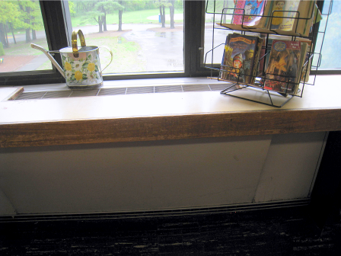

Classroom univent

Picture 2

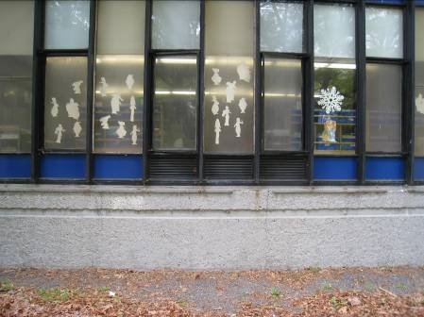

Univent fresh air intake

Picture 3

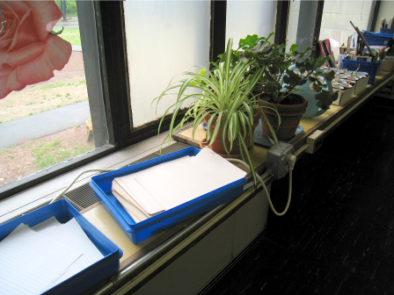

Items on univent, note proximity of plants to univent diffuser

Picture 4



Undercut closet doors

Picture 5

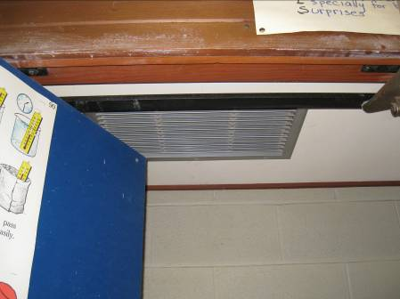

Exhaust vent in closet

Picture 6

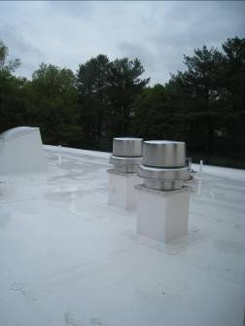

Rooftop exhaust fans

Picture 7

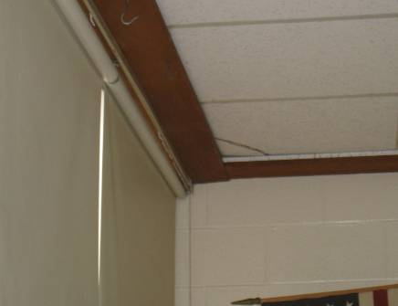

Broken ceiling tile

Picture 8

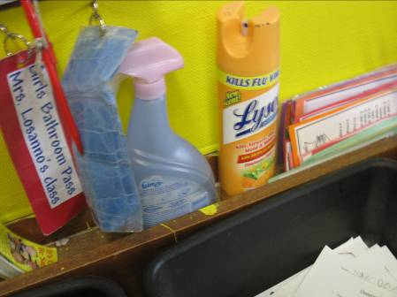

Cleaning and air deodorizing products

Picture 9

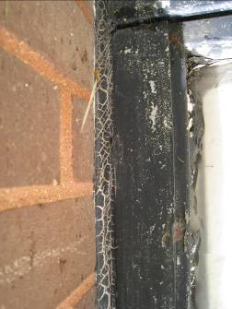

Aged window caulking

Picture 10

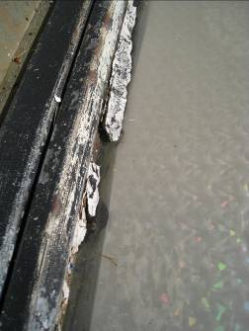

Crumbling window sealant

Picture 11

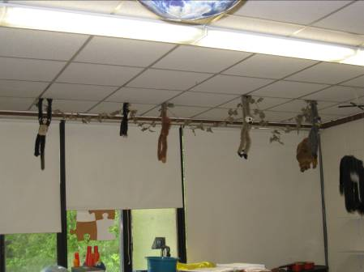

Items hanging from ceiling tile system
Location | Carbon  Dioxide  (ppm) | Carbon Monoxide  (ppm) | Temp  (°F) | Relative  Humidity  (%) | TVOCs  (ppm) | PM2.5  (μg/m³) | Occupants  in Room | Windows  Openable | Ventilation |  |  | Remarks
 |  |  |  |  |  |  |  |  | Intake | Exhaust |  | Remarks
Background |  | 398 | 67 | 63 | ND | 6
Unoccupied Areas
201 | 656 | ND | 72 | 55 | ND | 6 | 0 | Y | Y |  | Y | DO, Items hanging from CTs, plants, CF
202 | 541 | ND | 72 | 53 | ND | 5 | 0 | Y | Y |  | Y
203 | 468 | ND | 72 | 54 | ND | 5 | 0 | Y | Y |  | Y | Cleaners, AD, fridge
204 | 567 | ND | 72 | 54 | ND | 5 | 0 | Y | Y |  | Y | DO, terrarium
205 | 465 | ND | 72 | 54 | ND | 8 | 0 | Y | Y  Off |  | Y | DO, breaches/broken CT
206 | 434 | ND | 71 | 55 | ND | 4 | 0 | Y | Y |  | Y | DO, CF
207 | 444 | ND | 71 | 55 | ND | 5 | 0 | Y | Y |  | Y | DO, MT
208 | 410 | ND | 71 | 54 | ND | 5 | 0 | Y | Y |  | Y | CPs
Occupied Areas
Gym | 654 | ND | 74 | 51 | ND | 4 | 0 | Y | Y  Off |  | Y
Nathanson’s fffice | 861 | ND | 75 | 53 | ND | 8 | 0 | N | N |  | N | PF, DO
Nurse’s office | 801 | ND | 75 | 51 | ND | 8 | 1 | N | Y |  | N | DO
Main office | 660 | ND | 75 | 51 | ND | 5 | 1 | N | Y |  | N | PF
Teacher’s work room | 700 | ND | 75 | 51 | ND | 6 | 0 | N | Y |  | N | DO, PC, water dispenser on carpet
Cafeteria | 594 | ND | 76 | 48 | ND | 4 | 150 | N | Y |  | Y
101 | 631 | ND | 74 | 51 | ND | 6 | 16 | Y | Y |  | Y | DO, DEM
102 | 781 | ND | 74 | 53 | ND | 5 | 18 | Y | Y  Items |  | Y | Items hanging from CT, AT, DEM
103 | 854 | ND | 73 | 54 | ND | 8 | 20 | Y | Y  Plants |  | Y | Hand sanitizer
104 | 810 | ND | 74 | 54 | ND | 5 | 19 | Y | Y  Items |  | Y | AD, plants
105 | 604 | ND | 75 | 50 | ND | 5 | 0 | Y | Y |  | Y
106 | 542 | ND | 74 | 51 | ND | 5 | 0 | Y | Y |  | Y | DEM, CPs
107 | 573 | ND | 73 | 52 | ND | 5 | 0 | Y | Y |  | Y | DEM, CPs
108 | 612 | ND | 74 | 54 | ND | 8 | 0 | Y | Y |  | Y | CPs, DEM
112 | 801 | ND | 75 | 56 | ND | 5 | 21 | Y  ¾ open | Y  Plants, items |  | Y  Weak | DEM, CPs
113 | 869 | ND | 74 | 42 | ND | 7 | 22 | Y | Y |  | Y  Weak | CPs
114 | 945 | ND | 75 | 54 | ND | 7 | 22 | Y | Y |  | Y  Blocked | DEM, AD, CPs, items, plants, strong DEM odor from children using products
115 | 715 | ND | 75 | 51 | ND | 6 | 16 | Y | y  Plants |  | Y
116 | 720 | ND | 75 | 51 | ND | 8 | 23 | Y  ¼ open | Y |  | Y | Breach in CT

An Information Booklet Addressing PCB-Containing Materials in the Indoor Environment of Schools
and Other Public Buildings



Prepared by

Bureau of Environmental Health
Massachusetts Department of Public Health
December 2009
INTRODUCTION
The purpose of this information booklet is to provide assistance to school and public building officials and the general public in assessing potential health concerns associated with polychlorinated biphenyl (PCB) compounds in building materials used in Massachusetts and elsewhere. Recently, the U.S. Environmental Protection Agency (EPA) provided broad guidance relative to the presence of PCBs in building materials, notably PCBs in caulking materials. The most common building materials that may contain PCBs in facilities constructed or significantly renovated during the 1950s through the 1970s are fluorescent light ballasts, caulking, and mastic used in tile/carpet as well as other adhesives and paints.
This information booklet, developed by the Massachusetts Department of Public Health’s Bureau of Environmental Health (MDPH/BEH), is designed to supplement guidance offered by EPA relative to potential health impacts and environmental testing. It also addresses managing building materials, such as light ballasts and caulking, containing PCBs that are likely to be present in many schools and public buildings across the Commonwealth. This is because the Northeastern part of the country, and notably Massachusetts, has a higher proportion of schools and public buildings built during the 1950s through 1970s than many other parts of the U.S. according to a 2002 U.S. General Accounting Office report. The Massachusetts School Building Authority noted in a 2006 report that 53 percent of over 1,800 Massachusetts school buildings surveyed were built during the 1950s through 1970s. This information booklet contains important questions and answers relative to PCBs in the indoor environment and is based on the available scientific literature and MDPH/BEH’s experience evaluating the indoor environment of schools and public buildings for a range of variables, including for PCBs as well as environmental data reviewed from a variety of sources.
1. What are PCBs?
Polychlorinated biphenyl (PCB) compounds are stable organic chemicals used in products from the 1930s through the late 1970s. Their popularity and wide-spread use were related to several factors, including desirable features such as non-flammability and electrical insulating properties. Although the original use of PCBs was exclusive to closed system electrical applications for transformers and capacitors (e.g., fluorescent light ballasts), their use in other applications, such as using PCB oils to control road dust or caulking in buildings, began in the 1950s.
2. When were PCBs banned from production?
Pursuant to the Toxic Substance Control Act (TSCA) of 1976 (effective in 1979), manufacturing, processing, and distribution of PCBs was banned. While the ban prevented production of PCB-containing products, it did not prohibit the use of products already manufactured that contained PCBs, such as building materials or electrical transformers.
3. Are PCBs still found in building materials today?
Yes. Products made with PCBs prior to the ban may still be present today in older buildings. In buildings constructed during the 1950s through 1970s, PCBs may be present in caulking, floor mastic, and in fluorescent light ballasts. Available data reviewed by MDPH suggests that caulking manufactured in the 1950s through 1970s will likely contain some levels of PCBs. Without testing it is unclear whether caulking in a given building may exceed EPA’s definition of PCB bulk product waste of 50 parts per million (ppm) or greater. If it does, removal and disposal of the caulk is required in accordance with EPA’s TSCA regulations (40 CFR § 761).
4. Are health concerns associated with PCB exposure opportunities?
Although the epidemiological evidence is sometimes conflicting, most health agencies have concluded that PCBs may reasonably be anticipated to be a carcinogen, i.e., to cause cancer.
PCBs can have a number of non-cancer effects, including those on the immune, reproductive, neurological and endocrine systems. Exposure to high levels of PCB can have effects on the liver, which may result in damage to the liver. Acne and rashes are symptoms typical in those that are exposed to high PCB levels for a short period of time (e.g., in industry / occupational settings).
5. If PCBs are present in caulking material, does that mean exposure and health impacts are likely?
No. MDPH/BEH’s review of available data suggests that if caulking is intact, no appreciable exposures to PCBs are likely and hence health effects would not be expected. MDPH has conducted indoor tests and reviewed available data generated through the efforts of many others in forming this opinion.
6. How can I tell if caulking or light ballasts in my building may contain PCBs?
If the building was built sometime during the 1950s through 1970s, then it is likely that the caulking in the building and/or light ballasts may contain some level of PCBs. Light ballasts manufactured after 1980 have the words “No PCBs” printed on them. If the light ballast does not have this wording or was manufactured before 1980, it should be assumed that it contains PCBs.
7. What are light ballasts?
A light ballast is a piece of equipment that controls the starting and operating voltages of fluorescent lights. A small capacitor within older ballasts contains about one ounce of PCB oil. If light bulbs are not changed soon after they go out, the ballast will continue to heat up and eventually result in the release of low levels of PCBs into the indoor air.
8. Does the presence of properly functioning fluorescent light ballasts in a building present an environmental exposure concern?
No appreciable exposure to PCBs is expected if fluorescent light ballasts that contain PCBs are intact and not leaking or damaged (i.e., no visible staining of the light lenses), and do not have burned-out bulbs in them.

9. Should I be concerned about health effects associated with exposure to PCBs as a result of PCB-containing light ballasts?
While MDPH has found higher PCB levels in indoor air where light bulbs have burned-out, the levels are still relatively low and don’t present imminent health threats. A risk assessment conducted recently at one school did not suggest unusual cancer risks when considering a worst case exposure period of 35 years for teachers in that school. Having said this, MDPH believes that facility operators and building occupants should take prompt action to replace bulbs and/or ballasts as indicated to reduce/eliminate any opportunities for exposure to PCBs associated with PCB-containing light ballasts.
10. When should PCB-containing light ballasts be replaced?
If ballasts appear to be in disrepair, they should be replaced immediately and disposed of in accordance with environmental regulatory guidelines and requirements. However, if light bulbs burn out, the best remedy is to change them as soon as possible. If light bulbs are not changed soon after they go out, the ballast will continue to heat up and eventually result in the release of low levels of PCBs into the indoor air. Thus, burned-out bulbs should be replaced promptly to reduce overheating and stress on the ballast. As mentioned, ballasts that are leaking or in any state of disrepair should be replaced as soon as possible.
It should be noted that although older light ballasts may still be in use today, the manufacturers’ intended lifespan of these ballasts was 12 years. Thus, to the extent feasible or in connection with repair/renovation projects, the older light ballasts should be replaced consistent with the intended lifespan specified by the manufacturers.
11. Does MDPH recommend testing of caulking in buildings built during the 1950s -1980?
Caulking that is intact should not be disturbed. If caulking is deteriorating or damaged, conducting air and surface wipe testing in close proximity to the deteriorating caulking will help to determine if indoor air levels of PCBs are a concern as well as determining the need for more aggressive cleaning. Results should be compared with similar testing done in an area without deteriorating caulking. In this way, a determination can be made regarding the relative contribution of caulking materials to PCBs in the general indoor environment.
12. What if we determine that caulking in our building is intact and not deteriorating?
Based on a review of available data collected by MDPH and others, the MDPH does not believe that intact caulking presents appreciable exposure opportunities and hence should not be disturbed for testing. As with any building, regular operations and maintenance should include a routine evaluation of the integrity of caulking material. If its condition deteriorates then the steps noted above should be followed. Consistent with EPA advice, if buildings may have materials that contain PCBs, facility operators should ensure thorough cleaning is routinely conducted.
13. Should building facilities managers include information about PCB-containing building materials in their Operations and Maintenance (O&M) plans?
Yes. All buildings should have an O&M plan that includes regular inspection and maintenance of PCB building materials, as well as thorough cleaning of surfaces not routinely used. Other measures to prevent potential exposure to PCBs include increasing ventilation, use of HEPA filter vacuums, and wet wiping. These O&M plans should be available to interested parties.
14. Are there other sources of PCBs in the environment?
Yes. The most common exposure source of PCBs is through consumption of foods, particularly contaminated fish. Because PCBs are persistent in the environment, most residents of the U.S. have some level of PCBs in their bodies.
15. Where can I obtain more information?
For guidance on replacing and disposing of PCB building materials, visit the US EPA website: http://www.epa.gov/pcbsincaulk/. For information on health concerns related to PCBs in building materials, please contact MDPH/BEH at 617-624-5757.

The service life is the median time during which a particular system or component of …[an HVAC]… system remains in its original service application and then is replaced. Replacement may occur for any reason, including, but not limited to, failure, general obsolescence, reduced reliability, excessive maintenance cost, and changed system requirements due to such influences as building characteristics or energy prices (ASHRAE, 1991).

