INDOOR AIR QUALITY ASSESSMENT

Henry B. Burkland Intermediate School
41 Mayflower Avenue
Middleborough, Massachusetts

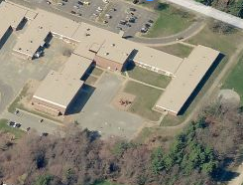

Prepared by:
Massachusetts Department of Public Health
Bureau of Environmental Health
Indoor Air Quality Program
February 2016

BACKGROUND
Building: | Henry B. Burkland Intermediate School (BIM)
Address: | 41 Mayflower Avenue  Middleborough, Massachusetts
Assessment Requested by: | Middleborough Public Schools (MPS)
Reason for Request: | Revisit to examine remediation of water damage
Date of Assessment: | January 19, 2016
Massachusetts Department of Public Health/Bureau of Environmental Health (MDPH/BEH) Staff Conducting Assessment: | Mike Feeney, Director  Indoor Air Quality (IAQ) Program
Date of Building Construction: | 1998
Building Description: | A one-story, brick-faced building with basement. The flat portions of the roof consist of PVC membrane and the sloped portions are metal.
Building Population: | Approximately 800 students in grades 3-5 with a staff of about 100
Windows: | Openable

METHODS
Please refer to the IAQ Manual and appendices for methods, sampling procedures, and interpretation of results (MDPH, 2015a).

RESULTS and DISCUSSION

Microbial/Moisture Concerns
As noted in our previous report (MDPH, 2015b), the building has a flat roof that overhangs the exterior wall of the building (Figure 1). This vertical section of the roof overhang inside the ceiling plenum had fiberglass insulation batts installed against a gypsum wallboard (GW) material, which appears to have been subjected to chronic water damage (Picture 1) to the materials as well as fiberglass insulation (Picture 2).
MPS contracted to have the following activities done to remediate the water damage:
- The fiberglass batts were removed.
- The interior roof surface was treated with an antimicrobial agent.
- Each location was then sealed using spray foam insulation (Picture 3).
BEH staff examined the rooms (15, 17, 19, 21-A, 21-B and 21-C) where this initial water damage was noted and which were remediated. A number of other rooms were also remediated in other BIM wings.

CONCLUSIONS/RECOMMENDATIONS
Based on the observations at the time of the visit, the remediation efforts have removed/eliminated mold-colonized materials that were noted in the BIM ceiling plenum during the January 12, 2015 visit by BEH staff.

REFERENCES
Massachusetts Department of Public Health (MDPH). 2015a. Indoor Air Quality Manual: Chapters I-III. Available at: http://www.mass.gov/eohhs/gov/departments/dph/programs/environmental-health/exposure-topics/iaq/iaq-manual/.
Massachusetts Department of Public Health (MDPH). 2015b. Indoor Air Quality Assessment Henry B. Burkland Intermediate School, 41 Mayflower Avenue, Middleborough, Massachusetts. Massachusetts Department of Public Health, Bureau of Environmental Health, Boston, MA. http://www.mass.gov/eohhs/gov/departments/dph/programs/environmental-health/exposure-topics/iaq/iaq-rpts/cities-and-towns-m.html#middleborough
Picture 1
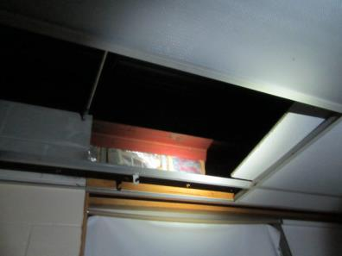
Affected gypsum wallboard (behind insulation) above ceiling tile system in classroom found during January 12, 2015 assessment
Picture 2
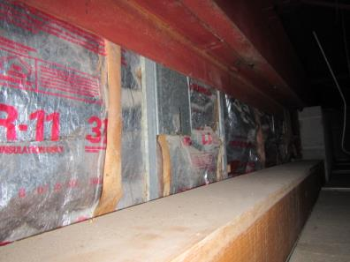
Affected gypsum wallboard (behind insulation) above ceiling tile system in classroom found during January 12, 2015 assessment
Picture 3
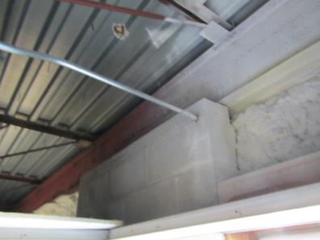
Soffit sealed with spray foam insulation

