INDOOR AIR QUALITY ASSESSMENT
WATER DAMAGE INVESTIGATION

Henry B. Burkland Intermediate School
41 Mayflower Avenue
Middleborough, Massachusetts

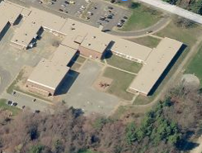

Prepared by:
Massachusetts Department of Public Health
Bureau of Environmental Health
Indoor Air Quality Program
January 2015

Background/Introduction
At the request of Mr. James Harding, Facilities Director for the Middleborough Public Schools (MPS), the Massachusetts Department of Public Health (MDPH), Bureau of Environmental Health (BEH) provided assistance and consultation regarding indoor air quality (IAQ) concerns at the Henry B. Burkland Intermediate School (BIS) located at 41 Mayflower Avenue, Middleborough, Massachusetts. On January 12, 2015, the school was visited by Mike Feeney, Director and Cory Holmes, Environmental Analyst/Regional Inspector in BEH’s IAQ Program. Concerns about mold growth related to water-damaged building materials prompted the request.

Methods
MDPH staff performed a visual inspection of building materials for water damage and/or microbial growth.

Discussion
As reported by MPS officials, concerns were raised about possible water damage issues in the building. The mechanical ventilation system in each classroom consists of a unit ventilator (univent) that provides heating and fresh air supply and a ceiling-mounted exhaust vent ducted to motors on the roof. Each classroom has a ceiling tile system that is suspended from the underside of the building’s roof decking; this forms a ceiling plenum. The building has a flat roof that overhangs the exterior wall of the building (Figure 1). This vertical section of the roof overhang inside the ceiling plenum has fiberglass insulation batts installed against a gypsum wallboard (GW) material, which appears to have been subjected to chronic water damage (Picture 1). Moist air penetration through the exterior wall/roof junction or seams in the roof overhang material is the likely cause. The installation of porous GW directly against the cold surface of the exterior masonry can cause this material to generate condensation, moistening the GW under certain temperature and relative humidity conditions. Once wet, the GW cannot dry due to the fiberglass insulation installed over the wet interior side of the GW (Pictures 1 and 2).
It is noteworthy that the insulation surfaces that face into the ceiling plenum do not appear to be water-damaged. Also of note is the structure of the heating ventilating and air-conditioning (HVAC) system in the building. The space between the roof deck and suspended ceiling plenum is not part of the HVAC system and therefore should not be subject to air movement that would result in aerosolization of microbes or spores from water damaged materials. The combination of the covering of the water-damaged materials and neutral air pressure within the ceiling plenum would limit the opportunity for microbes and associated particles to enter into classrooms below the suspended ceiling.
Based on these observations, a number to steps can be employed to address the condition of the insulation material temporarily (e.g., through the end of the school year).
- The insulation in the ceiling plenum serves as a barrier to prevent the aerosolization of microbes and/or associated materials. By ensuring that the insulation is continuous, it would serve as a barrier to prevent microbial release into the ceiling plenum.
- The ceiling tile system serves as a secondary barrier. Ensuring that all ceiling tiles are in-place would serve as a secondary barrier for materials in the plenum from entering occupied space.
- Operating the univents pressurizes the classrooms, which will force air into the plenum through the suspended ceiling. Please note, that any breaches in floors/walls and pathways for utilities within the univent cabinet (Pictures 3 and 4), should be sealed to prevent draw of air from wall cavities/crawlspaces into the univent.
Each of these methods should be used to provide a temporary solution until the water-damaged materials can be remediated in a comprehensive manner, which will like require dismantling of exterior walls and roof componenets.

Conclusions
Although mold growth on building materials is a concern, the remediation/removal of such materials is critical. If not done correctly with the building unoccupied, this proper remediation/removal of such material can allow for mold spores to be released into the indoor environment. Therefore such remediation must be done under controlled conditions (i.e., containment and depressurization). Removal of materials at the BIS will most likely require extensive destructive removal of exterior wall panels, masonry as well as roof components, which can release construction-related dust and particulate matter into the indoor environment. As mentioned, it is highly recommended that this type of remediation activity be conducted when the building is unoccupied for a sufficient period of time (e.g., at the end of the current school year). Appendix A (attached) is the MDPH guidance document “Preventing Mold Growth in Massachusetts Schools During Hot, Humid Weather”.

Recommendations
In view of the findings at the time of the visit, the following recommendations are made. These recommendations were communicated at the time of the assessment and are reiterated below.
- Ensure all affected GW above ceiling tiles are completely covered/tightly packed behind a layer of insulation.
- Ensure all ceiling tile systems are fully intact.
- Pressurize classrooms by taking the following steps:
  - Operate classroom univents on “high”;
  - Make adjustments/repairs to thermostat/control systems to maintain comfort;
  - Keep classroom doors shut to maintain positive pressure; and
  - Open classroom windows to provide comfort as needed.
- Ensure all breaches in floors, walls and univent cabinets are properly sealed (Pictures 3 and 4).
- Upgrade univent filters [e.g., minimum efficiency reporting value (MERV) 8].
- Continue with plans over school vacation to conduct remediation efforts of affected building materials. Remediation should be done in a manner consistent with recommendations found in “Mold Remediation in Schools and Commercial Buildings” published by the US Environmental Protection Agency (US EPA, 2001) (http://www.epa.gov/mold/mold_remediation.html).
Consult with an architectural firm and/or building envelope specialist for proper building material/insulation installation to prevent reoccurrence.
Figure 1
Schematic of the Ceiling Plenum Components
(Not to scale)

Roof Decking
Roof
Overhang
Insulation Ceiling
Plenum

Water-damaged GW

Suspended Ceiling of Classroom

Outdoors Indoors

Picture 1
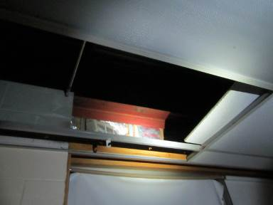
Affected gypsum wallboard (behind insulation) above ceiling tile system in classroom
Picture 2
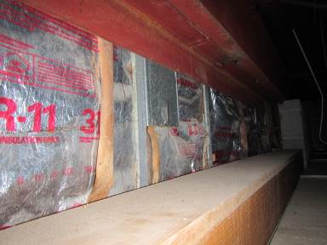
Affected gypsum wallboard (behind insulation) above ceiling tile system in classroom
Picture 3
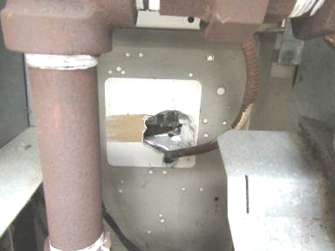
Breach in wall inside univent cabinet
Picture 4
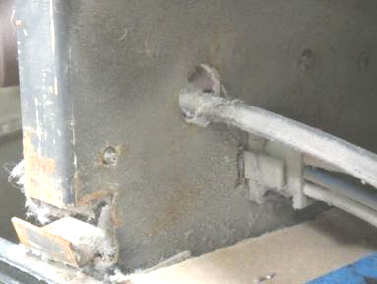
Hole in univent cabinet, post-filter

