INDOOR AIR QUALITY ASSESSMENT

Burlington Public Library
22 Sears Street
Burlington, Massachusetts



Prepared by:
Massachusetts Department of Public Health
Bureau of Environmental Health
Indoor Air Quality Program
February 2014

Background/Introduction
In response to a request from the Town of Burlington’s Human Resources Department, the Massachusetts Department of Public Health (MDPH), Bureau of Environmental Health (BEH), provided assistance and consultation regarding indoor air quality (IAQ) concerns at the Burlington Public Library (BPL) located at 22 Sears Street, Burlington, Massachusetts. The request was prompted by concerns related to water damage and general IAQ in the building. On, August 8, 2013, the BPL was visited by Ruth Alfasso, Environmental Engineer/Inspector in BEH’s IAQ Program to conduct an assessment. On October 29, 2013, Michael Feeney, Director, BEH/IAQ Program and Ms. Alfasso returned to the BPL to examine the building envelope regarding water leaks and associated building effects.
The BPL is a two-story brick building that was constructed in 1995. The roof is mostly flat with a section of peaked slate. The building contains book stacks and shelving areas, periodical shelving areas, offices, meeting/study rooms, a rare/historic book room, a staff lounge, locker area, and storage rooms. The BPL is open seven days a week during most of the year. Windows were originally openable throughout the building, but have been rendered inoperable due to concerns about access and climate/moisture control.

Methods
Air tests for carbon monoxide, carbon dioxide, temperature and relative humidity were conducted with the TSI, Q-Trak, IAQ Monitor, Model 7565. Air tests for airborne particle matter with a diameter less than 2.5 micrometers were taken with the TSI, DUSTTRAK™ Aerosol Monitor Model 8520. BEH/IAQ staff also performed a visual inspection of building materials for water damage and/or microbial growth.

Results
The BPL has an employee population of approximately 25 on any given day and can be visited by up to 600 daily. The tests were taken during normal operations. Test results from the August 8, 2013 visit appear in Table 1; no additional measurements were taken during the October 29, 2013 visit.

Discussion

Ventilation
It can be seen from Table 1 that carbon dioxide levels were above 800 parts per million (ppm) in 6 of 28 areas, indicating an adequate supply of fresh air in the large majority of the areas tested at the time of assessment. It is also important to note, however, that many areas were sparsely populated or unoccupied at the time measurements were taken, which may result in reduced carbon dioxide levels. Carbon dioxide levels would be expected to be higher with full occupancy.
Mechanical ventilation is provided by two rooftop air handling units (AHUs) (Picture 1). Fresh air is drawn into the AHUs, filtered and heated/cooled and then ducted to numerous variable air volume (VAV) units located in the ceilings for additional tempering. Conditioned air is delivered into rooms through ceiling-mounted air diffusers (Picture 2). Curtain-style air diffusers are also located along perimeter walls of the building (Picture 3). Return air is reportedly drawn into the ceiling plenum through perforated metal ceiling tiles.
Restroom exhaust ventilation is provided by ceiling-mounted vents connected directly to exhaust vents on the roof. Exhaust flow in restrooms was found to be weak and bathroom odors were noted in several of the restrooms examined.
To maximize air exchange, the MDPH recommends that both supply and exhaust ventilation operate continuously during periods of occupancy. In order to have proper ventilation with a mechanical supply and exhaust system, the systems must be balanced to provide an adequate amount of fresh air to the interior of a room while removing stale air from the room. It is recommended that HVAC systems be re-balanced every five years to ensure adequate air systems function (SMACNA, 1994). The date of the last balancing of these systems was not available at the time of assessment.
Minimum design ventilation rates are mandated by the Massachusetts State Building Code (MSBC). Until 2011, the minimum ventilation rate in Massachusetts was higher for both occupied office spaces and general classrooms, with similar requirements for other occupied spaces (BOCA, 1993). The current version of the MSBC, promulgated in 2011 by the State Board of Building Regulations and Standards (SBBRS), adopted the 2009 International Mechanical Code (IMC) to set minimum ventilation rates. Please note that the MSBC is a minimum standard that is not health-based. At lower rates of cubic feet per minute (cfm) per occupant of fresh air, carbon dioxide levels would be expected to rise significantly. A ventilation rate of 20 cfm per occupant of fresh air provides optimal air exchange resulting in carbon dioxide levels at or below 800 ppm in the indoor environment in each area measured. MDPH recommends that carbon dioxide levels be maintained at 800 ppm or below. This is because most environmental and occupational health scientists involved with research on IAQ and health effects have documented significant increases in indoor air quality complaints and/or health effects when carbon dioxide levels rise above the MDPH guidelines of 800 ppm for schools, office buildings and other occupied spaces (Sundell et al., 2011). The ventilation must be on at all times that the room is occupied. Providing adequate fresh air ventilation with open windows and maintaining the temperature in the comfort range during the cold weather season is impractical. Mechanical ventilation is usually required to provide adequate fresh air ventilation.
Carbon dioxide is not a problem in and of itself. It is used as an indicator of the adequacy of the fresh air ventilation. As carbon dioxide levels rise, it indicates that the ventilating system is malfunctioning or the design occupancy of the room is being exceeded. When this happens, a buildup of common indoor air pollutants can occur, leading to discomfort or health complaints. The Occupational Safety and Health Administration (OSHA) standard for carbon dioxide is 5,000 parts per million parts of air (ppm). Workers may be exposed to this level for 40 hours/week, based on a time-weighted average (OSHA, 1997).
The MDPH uses a guideline of 800 ppm for publicly occupied buildings. A guideline of 600 ppm or less is preferred in schools due to the fact that the majority of occupants are young and considered to be a more sensitive population in the evaluation of environmental health status. Inadequate ventilation and/or elevated temperatures are major causes of complaints such as respiratory, eye, nose and throat irritation, lethargy and headaches. For more information concerning carbon dioxide, please see Appendix A.
Temperature readings ranged from 69ºF to 73ºF during the assessment, which were within or very close to the MDPH recommended comfort guidelines (Table 1). The MDPH recommends that indoor air temperatures be maintained in a range of 70ºF to 78ºF in order to provide for the comfort of building occupants. In many cases concerning indoor air quality, fluctuations of temperature in occupied spaces are typically experienced, even in a building with an adequate fresh air supply.
The relative humidity measurements during the assessment ranged from 60 to 74 percent (Table 1), which were mostly above the MDPH recommended comfort range. The MDPH recommends a comfort range of 40 to 60 percent for indoor air relative humidity. Note that the outdoor relative humidity was measured at 75 percent with intermittent light showers. While relative humidity in the BPL was lower than outside, the humidity levels measured inside suggests that sources of humidity may exist in the building and that air conditioning and exhaust ventilation may not be functioning adequately to remove humidity from the building. Moisture removal is important since higher humidity reduces the ability of the body to cool itself by perspiration; “heat index” is a measurement that takes into account the impact of a combination of heat and humidity on how hot it feels. At a given indoor temperature, the addition of humid air reduces occupant comfort and may generate heat complaints. If moisture levels are decreased, the comfort of the individuals increases.
In addition, relative humidity in excess of 70 percent for extended periods of time can provide an environment for mold and fungal growth in building materials (ASHRAE, 1989). For storage and handling of paper, parchment and leather (e.g., books), relative humidity below 55 percent is recommended (Wilson, 1995).
BPL staff have also been monitoring humidity in various areas of the building and recorded numerous times where humidity measurements have been elevated above optimal ranges. Note that other issues relating to moisture and water infiltration were found in the BPL during the assessment; see the Microbial/Moisture Concerns section of this report.
Relative humidity levels in the building would be expected to drop during the winter months due to heating. The sensation of dryness and irritation is common in a low relative humidity environment. Low relative humidity is a very common problem during the heating season in the northeast part of the United States.

Microbial/Moisture Concerns
Several sources of moisture issues were reported/found during both the August 8, 2013 and the October 29, 2013 visits. The exterior walls exhibited a significant coating of white material along the edge of the roof (Picture 4). This material is efflorescence./ Please note, efflorescence is not mold; it is a sign of water exposure in brick and mortar. As moisture penetrates and works its way through mortar, brick or plaster, water-soluble compounds dissolve, creating a solution. As the solution moves to the surface of the material, the water evaporates, leaving behind white, powdery mineral deposits. The roof in this area is flat with a raised parapet. The parapet itself was cracked (Picture 5) and had efflorescence above the roof membrane (Picture 6). Signs of chronic moisture issues (staining) were also visible along the front of the building below the slate roof/metal flashing (Picture 7).
These stains indicate damage is occurring to the parapet, roof and façade of the building and suggest that even if no leaks from the roof have been detected inside the building, this condition may be contributing to increased humidity inside. Water was also observed pooling on the joint between the flat rubber membrane and peaked slate roofs (Picture 8).
BPL staff reported that the building is equipped with an internal drainage system, which surrounds the outside of the upper floor between the façade and internal walls. Water from the roof flows to drainage conduits through holes on the edge of the parapet (Picture 6) as well as to standard roof drains. It was also reported that approximately a year ago, there was a blockage of the internal conduits, which led to a significant flow of water into the building from locations above and adjacent to the windows in many rooms (Pictures 9 and 10). This situation resulted in extensive water damage to wallboard, carpeting and items that were located in these areas. A flooding restoration contractor was reportedly hired to dry/clean items and carpeting but no wallboard materials were removed and carpeting that was dried was put back in place. Internal drainage pipes were reportedly cleaned and repaired and a regular schedule of maintenance for the system has been implemented. The internal drainage design does not appear to be appropriate or well-designed for this building and will need frequent monitoring and maintenance to prevent another flooding incident. It is also possible that moisture has remained in wall cavities long enough to establish microbial growth. For that room, an examination of wall interiors/cavities in areas with extensive water damage should be conducted.
BPL staff also report that some of the VAV boxes have been subject to significant leaks, including condensate and, potentially, heating/cooling fluid. Several supply vents and some of the metal ceiling tiles show evidence of rust from these incidents (Picture 11). HVAC systems should be maintained regularly to prevent leaks from occurring. If condensation is occurring, the system may need additional/replacement insulation or reconfiguration to include a condensate drip pan piped to adequate drainage.
Other potential sources of leaks and humidity were observed in/around the building:
- Windows in some areas are not watertight.
- Water fountains were observed in carpeted areas (Picture 12), which can be a source of leaks/spills.
- Plants and shrubs were noted to be growing in close proximity to the outside of the building (Picture 13), which can hold moisture against the building’s exterior. The growth of roots against exterior walls can bring moisture in contact with the foundation. Plant roots can eventually penetrate the wall, leading to cracks and/or fissures in the foundation. Over time, these conditions can undermine the integrity of the building envelope and provide a means of water entry into the building via capillary action through exterior walls, foundation concrete, and masonry (Lstiburek & Brennan, 2001). The freezing and thawing action of water during the winter months can create cracks and fissures in the foundation that can result in additional penetration points for both water and pests.
- Basement areas are subject to chronic water intrusion and condensation. The stairwell to the basement was observed to be damp, which is reportedly a typical condition (Picture 14). There were also signs of chronic dampness in the boiler room, including floor stains and corrosion on equipment.
- Basement hallway walls showed signs of historic water damage, which reportedly stems from high groundwater infiltration. Since the interior basement stairs directly communicate with the rest of the library, moisture issues in this area are likely contributing to overall humidity issues in the building.
- Stairs from the basement to the outside are covered in moss and show other signs of chronic dampness (Picture 15). If the doors to the outside do not remain watertight, source will also add moisture into the building.
All of these conditions can introduce water and humidity into the indoor environment, leading to water damage. It is particularly important to prevent excess moisture because of the presence of materials that are especially sensitive to water damage in a library.
A stand-alone dehumidifying unit was observed in the staff office on the first floor. This unit was reportedly brought in recently following severe humidity issues associated with hot, humid outside weather. Dehumidifiers can be a useful addition to help control moisture, however they need to be emptied, cleaned and maintained frequently to ensure that stagnant water collected inside or malfunction of the units do not result in other problems.
Areas under sinks were examined and some were found to contain porous materials such as paper products (Picture 16). The area underneath sinks is a moist environment and items stored there may be subject to chronic dampness due to leaks and condensation, which may lead to microbial growth. In addition, accumulated items under sinks may make it harder to detect leaks.
Plants were observed in some areas (Picture 17). Plants can be a source of pollen and mold, which can serve as respiratory irritants for some sensitive individuals. Plants should be properly maintained and equipped with drip pans to prevent water damage to porous building materials and be located away from ventilation sources to prevent the aerosolization of dirt, pollen or mold.

Other IAQ Evaluations
Indoor air quality can be negatively influenced by the presence of respiratory irritants, such as products of combustion. The process of combustion produces a number of pollutants. Common combustion emissions include carbon monoxide, carbon dioxide, water vapor, and smoke (fine airborne particle material). Of these materials, exposure to carbon monoxide and particulate matter with a diameter of 2.5 micrometers (μm) or less (PM2.5) can produce immediate, acute health effects upon exposure. To determine whether combustion products were present in the indoor environment, BEH/IAQ staff obtained measurements for carbon monoxide and PM2.5.

Carbon Monoxide
Carbon monoxide is a by-product of incomplete combustion of organic matter (e.g., gasoline, wood and tobacco). Exposure to carbon monoxide can produce immediate and acute health effects. Several air quality standards have been established to address carbon monoxide and prevent symptoms from exposure to these substances. The MDPH established a corrective action level concerning carbon monoxide in ice skating rinks that use fossil-fueled ice resurfacing equipment. If an operator of an indoor ice rink measures a carbon monoxide level over 30 ppm, taken 20 minutes after resurfacing within a rink, that operator must take actions to reduce carbon monoxide levels (MDPH, 1997).
The American Society of Heating Refrigeration and Air-Conditioning Engineers (ASHRAE) has adopted the National Ambient Air Quality Standards (NAAQS) as one set of criteria for assessing indoor air quality and monitoring of fresh air introduced by HVAC systems (ASHRAE, 1989). The NAAQS are standards established by the US EPA to protect the public health from six criteria pollutants, including carbon monoxide and particulate matter (US EPA, 2006). As recommended by ASHRAE, pollutant levels of fresh air introduced to a building should not exceed the NAAQS levels (ASHRAE, 1989). The NAAQS were adopted by reference in the Building Officials & Code Administrators (BOCA) National Mechanical Code of 1993 (BOCA, 1993), which is now an HVAC standard included in the Massachusetts State Building Code (SBBRS, 2011). According to the NAAQS, carbon monoxide levels in outdoor air should not exceed 9 ppm in an eight-hour average (US EPA, 2006).
Carbon monoxide should not be present in a typical, indoor environment. If it is present, indoor carbon monoxide levels should be less than or equal to outdoor levels. On the day of assessment, outdoor carbon monoxide concentrations were non-detect (ND) (Table 1). No measureable levels of carbon monoxide were detected in the building during the assessment (Table 1).

Particulate Matter
The US EPA has established NAAQS limits for exposure to particulate matter. Particulate matter includes airborne solids that can be irritating to the eyes, nose and throat. The NAAQS originally established exposure limits to PM with a diameter of 10 μm or less (PM10). In 1997, US EPA established a more protective standard for fine airborne particulate matter with a diameter of 2.5 μm or less (PM2.5). This more stringent PM2.5 standard requires outdoor air particle levels be maintained below 35 μg/m³ over a 24-hour average (US EPA, 2006). Although both the ASHRAE standard and BOCA Code adopted the PM10 standard for evaluating air quality, MDPH uses the more protective PM2.5 standard for evaluating airborne PM concentrations in the indoor environment.
Outdoor PM2.5 concentration was measured at 11 μg/m³ (Table 1). PM2.5 levels measured indoors ranged from 5 to 10 μg/m³ (Table 1), which were below the NAAQS PM2.5 level of 35 μg/m³. Frequently, indoor air levels of particulates (including PM2.5) can be at higher levels than those measured outdoors. A number of mechanical devices and/or activities that occur indoors can generate particulate during normal operations. Sources of indoor airborne particulates may include but are not limited to particles generated during the operation of fan belts in the HVAC system, use of stoves and/or microwave ovens in kitchen areas; use of photocopiers, fax machines and computer printing devices; operation of an ordinary vacuum cleaner and heavy foot traffic indoors.

Volatile Organic Compounds
Indoor air concentrations can be greatly impacted by the use of products containing volatile organic compounds (VOCs). VOCs are carbon-containing substances that have the ability to evaporate at room temperature. Frequently, exposure to low levels of total VOCs (TVOCs) may produce eye, nose, throat and/or respiratory irritation in some sensitive individuals. For example, chemicals evaporating from a paint can stored at room temperature would most likely contain VOCs. In an effort to identify materials that can potentially increase indoor VOC concentrations, BEH/IAQ staff examined rooms for products containing these respiratory irritants.
Cleaning/sanitizing products and pesticides were observed in some rooms (Table 1). These products contain chemicals that can be irritating to the eyes, nose and throat of sensitive individuals. Cleaning products should be properly labeled and stored in an area inaccessible to children. In addition, Material Safety Data Sheets (MSDS) should be available at a central location for each product in the event of an emergency. Consideration should be given to providing staff with standardized cleaning products and supplies to prevent any potential for adverse chemical interactions between residues left from cleaners used by the facilities staff and those left by cleaners brought in by others. If necessary, pest control measures should be conducted by a licensed professional in accordance with a facility-wide integrated pest management (IPM) program.
There are several areas in the building containing photocopiers, and a lamination machine. Photocopiers and lamination machines can be sources of pollutants such as VOCs, ozone, heat and odors, particularly if the equipment is older and in frequent use. Both VOCs and ozone are respiratory irritants (Schmidt Etkin, 1992). Photocopiers should be kept in well ventilated rooms, and should be located near openable windows or exhaust vents.

Other Conditions
Finnaly, other conditions that can affect indoor air quality were observed during the assessment. Of note is the existence of an unidentified, ducted vent in the basement hallway (Picture 18). BEH/IAQ staff traced this ductwork to a fixture that appears to be the combustion air intake for the building’s heating system (Picture 19), which has an opening in a subterranean pit. It is possible that this vent is meant to serve as the pressure equalization vent for the building’s elevator. An inspection door was opened in this ductwork and the interior was found coated with dirt and other debris (Picture 20). In addition, the vent vanes were corroded, indicating exposure to moisture. These conditions likely indicate the draw of unconditioned/ unfiltered outdoor air from the below grade air intake. In this configuration, hot, moist air can enter the building through this vent to create odors and condensation in the basement area during hot, humid weather.
AHUs are typically equipped with air filters that should be cleaned or changed per the manufacturer’s instructions. One of the rooftop units was opened and filters were examined. The filters are of a type with a lower dust spot efficiency (Picture 21). The dust spot efficiency is the ability of a filter to remove particulates of a certain diameter from air passing through the filter. Filters that have been determined by ASHRAE to meet its standard for a dust spot efficiency of a minimum of 40 percent would be sufficient to reduce many airborne particulates (Thornburg, D., 2000; MEHRC, 1997; ASHRAE, 1992). Pleated filters with a Minimum Efficiency Reporting Value dust-spot efficiency of 9 or higher are recommended. Note that increasing filtration can reduce airflow (called pressure drop), which can subsequently reduce the efficiency of the unit due to increased resistance. Prior to any increase of filtration, each AHU should be evaluated by a ventilation engineer to ascertain whether it can maintain function with more efficient filters.
A number of supply and exhaust vents and personal fans had accumulated dust/debris. Vents and fans should be cleaned periodically in order to prevent them from serving as a source of aerosolized particulates.
In some areas, large numbers of items were found stored on desks, tables and counters (Pictures 22 and 23). Large numbers of items provide a source for dusts to accumulate. These items make it difficult for custodial staff to clean. Items should be relocated and/or cleaned periodically to avoid excessive dust build up.
Upholstered furniture and plush toys were observed in several areas (Picture 23; Table 1). These items are covered with fabrics that may be exposed to human skin. This type of contact can leave oils, perspiration, hair and skin cells. Dust mites feed upon human skin cells and excrete waste products that contain allergens. In addition, if relative humidity levels increase above 60 percent, dust mites tend to proliferate (US EPA, 1992). In order to remove dust mites and other pollutants, frequent vacuuming of upholstered furniture and plush toys is recommended (Berry, 1994). It is also recommended that upholstered furniture (if present in public buildings), be professionally cleaned on an annual basis. Where an excessively dusty environment exists due to outdoor conditions or indoor activities (e.g., renovations), cleaning frequency should be increased (every six months) (IICRC, 2000).
The BPL is carpeted; the Institute of Inspection, Cleaning and Restoration Certification (IICRC), recommends that carpeting be cleaned annually (or semi-annually in soiled high traffic areas) (IICRC, 2005). While new carpeting has been installed in many areas, some of the carpeting in other areas is old and worn (Picture 24) and can provide a source of particulates from carpet fibers and aerosolizable organic materials.

Conclusions/Recommendations
There is significant evidence that water infiltration, water damage and elevated humidity are significant problems in this building, particularly because it is a library and the storage and handling of paper and other highly susceptible materials is necessary. BEH/IAQ staff noted significant cracking and other deterioration in the parapet and exterior walls during the October 28, 2013 visit, to such a degree that is suggested that a building engineer examine the exterior wall panels and parapet for structural integrity and to make remedial recommendations to Burlington officials as soon as feasible. Correcting some of the issues may take significant amounts of planning and capital resources. In view of these findings, two sets of recommendations are made: short-term measures that may be implemented as soon as practicable and long-term measures that will require planning and resources to address overall IAQ concerns:

Short-Term Recommendations
- Operate mechanical ventilation systems continuously while the building is occupied.
- Assess function of exhaust vents in restrooms to ensure that fans are operating continuously, drawing air, and that a source of make-up air, such as a door vent or undercut, is available to assist with removing odors and contaminants from restrooms.
- Continue to use stand-alone dehumidifying equipment and consider additional units for areas where discomfort due to high humidity is reported. Ensure that all units are emptied, cleaned and maintained as per the manufacture’s instructions. Continue to monitor humidity to determine the best placement and effectiveness of these units as well as monitoring the effectiveness of other moisture-related repairs.
- Continue to monitor and maintain the internal drainage system and roof drains to prevent additional leaks/floods.
- Consider opening wall cavities impacted by recent water intrusion events to determine if hidden water damage and mold growth or continued dampness exists. Remove and replace building materials found to be mold-colonized or significantly deteriorated. Small test holes may be used and then patched or covered by a blank switch/outlet plate if materials do not need to be remediated.
- If mold-colonized building materials are found, remove them in manner consistent with Mold Remediation in Schools and Commercial Buildings published by the US Environmental Protection Agency (US EPA) (US EPA, 2001). Copies of this document can be downloaded from the US EPA website at: http://www.epa.gov/mold/mold_remediation.html.
- Work with an HVAC engineering firm to examine all VAV boxes and associated piping and ductwork to find/repair water damage, leaks and sources of condensation. Ensure insulation is intact and continuous over surfaces where needed.
- Ensure AHU filters are changed as per the manufacturers’ instructions or more frequently if needed. Consider upgrading to pleated MERV 9 (or higher) dust-spot efficiency filters. Prior to any increase of filtration, HVAC system components should be evaluated by a ventilation engineer as to whether they can maintain function with more efficient filters.
- Repair windows so that they are watertight.
- Continue to keep stored items away from areas known to accumulate moisture or leaks until building repairs can be completed.
- Ensure indoor plants are equipped with drip pans. Examine drip pans periodically for mold growth and disinfect with an appropriate antimicrobial, as needed. Move plants away from the air stream of mechanical ventilation equipment.
- Consider using waterproof mats under water fountains or removing carpeting in these areas and replacing with non-porous flooring.
- Keep areas under sinks free of porous or excessive items.
- Identify the purpose of the vent in Picture 18. Clean the interior of this duct of dirt and debris. Have a building engineer determine whether this vent and ductwork are necessary for the operation of the elevator. If not necessary, consideration should be given to permanently sealing this vent since it is a source of unconditioned outdoor air that would be a moisture/odor source.
- Remove plants from direct contact with the exterior of the building. Consider trimming shrubbery to five feet away from the building foundation.
- Ensure exterior doors remain watertight. Look for light penetration/drafts around doors, replace/install weather stripping as needed.
- For buildings in New England, periods of low relative humidity during the winter are often unavoidable. Therefore, scrupulous cleaning practices should be adopted to minimize common indoor air contaminants whose irritant effects can be enhanced when the relative humidity is low. To control for dusts, a high efficiency particulate arrestance (HEPA) filter equipped vacuum cleaner in conjunction with wet wiping of all surfaces is recommended. Avoid the use of feather dusters. Drinking water during the day can help ease some symptoms associated with a dry environment (throat and sinus irritations).
- Consider supplying staff with cleaners that are the same as or compatible with cleaners used by janitorial staff to prevent interactions. Ensure that all cleaner containers are properly labeled and kept in areas inaccessible to children. Maintain MSDS’ in a central location.
- Clean fresh air diffusers, exhaust vents and personal fans on a regular basis.
- Relocate or consider reducing the amount of materials stored in offices to allow for more thorough cleaning.
- Clean plush toys and upholstered furniture regularly with a HEPA-equipped vacuum to remove dust and dust mites.
- Clean carpeting annually or semi-annually in soiled high traffic areas as per the recommendations of the Institute of Inspection, Cleaning and Restoration Certification (IICRC). Copies of the IICRC fact sheet can be downloaded at: http://1.cleancareseminars.net/?page_id=185 (IICRC, 2005).
- Continue with plans to replace worn carpeting and consider the use of carpet squares in these areas.
- Ensure photocopiers and laminations machines are located in well-ventilated areas.
- Discontinue staff use of pesticides in the building.
- Consider contacting a licensed pest control management firm to develop and implement a facility-wide IPM program.
- Refer to resource manuals and other related indoor air quality documents for further building-wide evaluations and advice on maintaining public buildings. Copies of these materials are located on the MDPH’s website: http://mass.gov/dph/iaq.

Long-Term Recommendations
- Have a professional building envelope specialist/building engineer examine the roof and upper walls of the BPL for sources of water infiltration that are leading to efflorescence and intrusion into the building. This should include an investigation of the rooftop and internal drainage systems to assess the likelihood of continued issues with leaks/flooding and alternative methods for providing drainage for the building.
- Seek professional opinion regarding issues of chronic dampness in the basement, correction of which may require additional drainage work outside the building foundation to direct groundwater away. If chronic dampness in the basement cannot be corrected, consider methods to isolate basement areas from occupied areas (e.g., doors) to prevent moisture/odor intrusion.
- Consult with an HVAC engineering firm to conduct an overall assessment and correction of issues with HVAC equipment, including AHU drainage and VAV box condensation/leaks.
- Have the HVAC system balanced and consider adopting a balancing schedule of every 5 years for all mechanical systems, as recommended by ventilation industry standards.

References
ASHRAE. 1989. Ventilation for Acceptable Indoor Air Quality. American Society of Heating, Refrigeration and Air Conditioning Engineers. ANSI/ASHRAE 62-1989.
ASHRAE. 1992. Gravimetric and Dust-Spot Procedures for Testing Air-Cleaning Devices Used in General Ventilation for Removing Particulate Matter. American Society of Heating, Refrigeration and Air Conditioning Engineers. ANSI/ASHRAE 52.1-1992.
Berry, M.A. 1994. Protecting the Built Environment: Cleaning for Health. Michael A. Berry, Chapel Hill, NC.
BOCA. 1993. The BOCA National Mechanical Code/1993. 8th ed. Building Officials & Code Administrators International, Inc., Country Club Hills, IL.
IICRC. 2000. IICRC S001. Reference Guideline for Professional On-Location Cleaning of Textile Floor Covering Materials. Institute of Inspection, Cleaning and Restoration Certification. Institute of Inspection Cleaning and Restoration, Vancouver, WA.
IICRC. 2005. Carpet Cleaning FAQ 4 Institute of Inspection, Cleaning and Restoration Certification. Institute of Inspection Cleaning and Restoration, Vancouver, WA.
Lstiburek, J. & Brennan, T. 2001. Read This Before You Design, Build or Renovate. Building Science Corporation, Westford, MA. U.S. Department of Housing and Urban Development, Region I, Boston, MA.
MDPH. 1997. Requirements to Maintain Air Quality in Indoor Skating Rinks (State Sanitary Code, Chapter XI). 105 CMR 675.000. Massachusetts Department of Public Health, Boston, MA.
MEHRC. 1997. Indoor Air Quality for HVAC Operators & Contractors Workbook. MidAtlantic Environmental Hygiene Resource Center, Philadelphia, PA.
OSHA. 1997. Limits for Air Contaminants. Occupational Safety and Health Administration. Code of Federal Regulations. 29 C.F.R 1910.1000 Table Z-1-A.
SBBRS. 2011. Mechanical Ventilation. State Board of Building Regulations and Standards. Code of Massachusetts Regulations, 8th edition. 780 CMR 1209.0.
Schmidt Etkin, D. 1992. Office Furnishings/Equipment & IAQ Health Impacts, Prevention & Mitigation. Cutter Information Corporation, Indoor Air Quality Update, Arlington, MA.
SMACNA. 1994. HVAC Systems Commissioning Manual. 1st ed. Sheet Metal and Air Conditioning Contractors’ National Association, Inc., Chantilly, VA.
Sundell. 2011. Sundell, J., H. Levin, W. W. Nazaroff, W. S. Cain, W. J. Fisk, D. T. Grimsrud, F. Gyntelberg, Y. Li, A. K. Persily, A. C. Pickering, J. M. Samet, J. D. Spengler, S. T. Taylor, and C. J. Weschler. Ventilation rates and health: multidisciplinary review of the scientific literature. Indoor Air, Volume 21: pp 191–204.
Thornburg, D. 2000. Filter Selection: a Standard Solution. Engineering Systems 17:6 pp. 74-80.
US EPA. 1992. Indoor Biological Pollutants. US Environmental Protection Agency, Environmental Criteria and Assessment Office, Office of Health and Environmental Assessment, research Triangle Park, NC. EPA 600/8-91/202. January 1992.
US EPA. 2001. “Mold Remediation in Schools and Commercial Buildings”. Office of Air and Radiation, Indoor Environments Division, Washington, DC. EPA 402-K-01-001. March 2001. Available at: http://www.epa.gov/iaq/molds/mold_remediation.html.
US EPA. 2006. National Ambient Air Quality Standards (NAAQS). US Environmental Protection Agency, Office of Air Quality Planning and Standards, Washington, DC. http://www.epa.gov/air/criteria.html.
Wilson, W. K. 1995. Environmental Guidelines for the Storage of Paper Records. NISO TR01-1995. National Information Standards Organization, NISO Press, Bethesda MD.
Picture 1
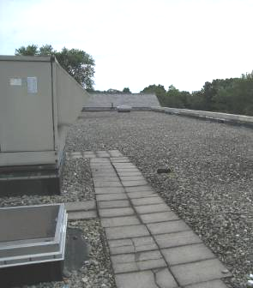

Air handling unit (AHU)

Picture 2

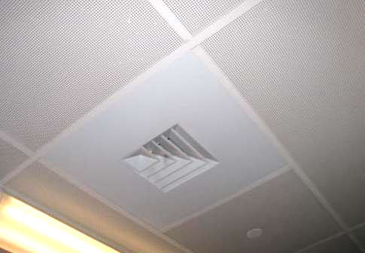

Ceiling-mounted fresh air diffuser

Picture 3

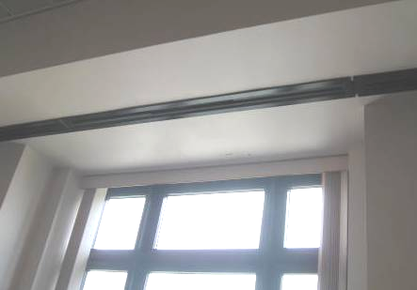

Curtain-style fresh-air diffuser in front of window

Picture 4

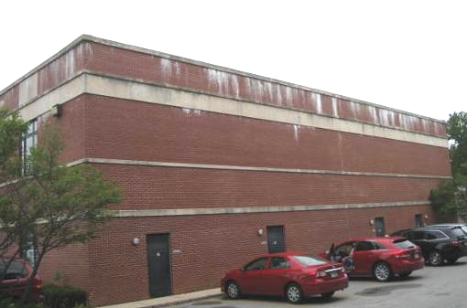

Side of building showing efflorescence (white deposits near the top edge of the building)

Picture 5

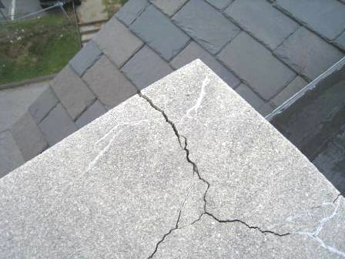

Cracks in top of parapet

Picture 6

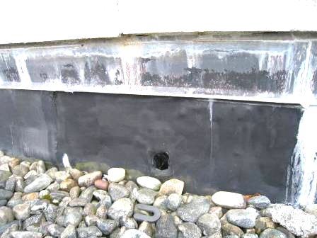

Efflorescence on roof parapet, note drain hole

Picture 7

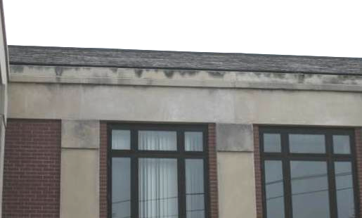

Signs of water infiltration (staining) on the front edge of the building where the roof is slate

Picture 8

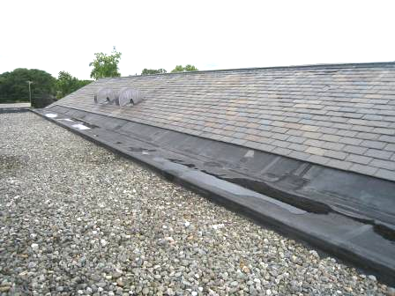

Water pooling on joint between flat rubber and peaked slate roof areas

Picture 9

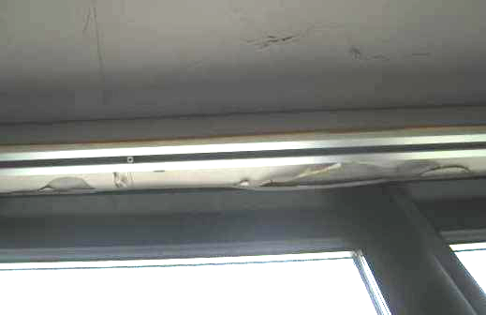

Peeling paint showing water damage above second-floor window

Picture 10

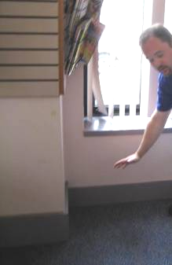

Demonstration of location on first floor where severe water infiltration occurred

Picture 11

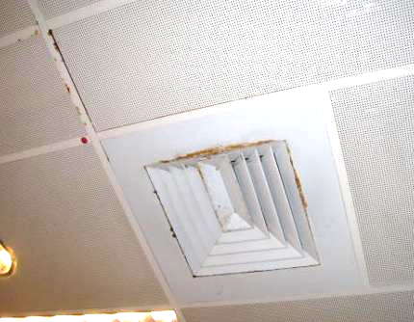

Rust (dark staining) on supply vent and metal ceiling tiles

Picture 12

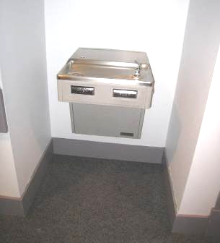

Water fountain in carpeted area

Picture 13

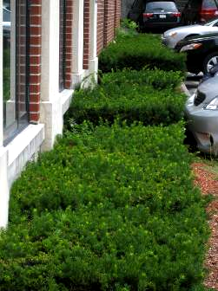

Shrubs in contact with building foundation/exterior wall

Picture 14

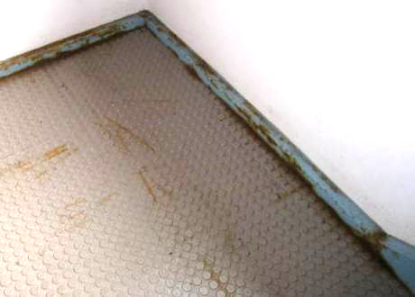

Rust stains and damp flooring in bottom of basement stairwell

Picture 15

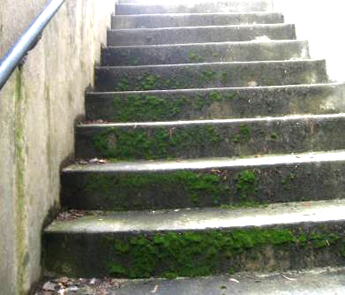

Stairs from basement to outside, note moss and other evidence of chronic dampness

Picture 16

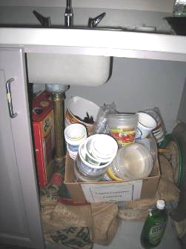

Items, including cardboard and paper, under sink

Picture 17

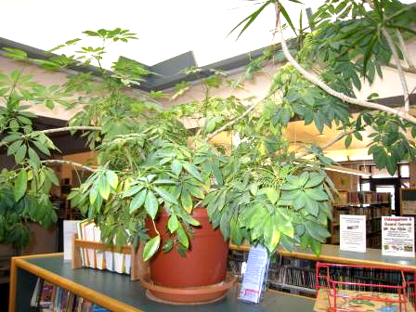

Plants in children’s area

Picture 18

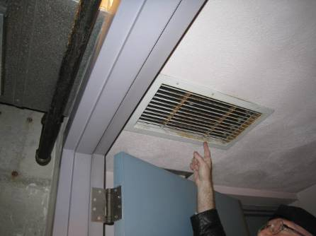

Unidentified vent in basement, note rust on vent vanes

Picture 19

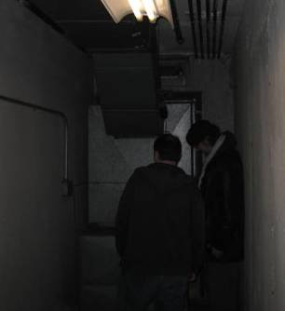

Fixture that appears to be the combustion air intake for the building’s heating system

Picture 20

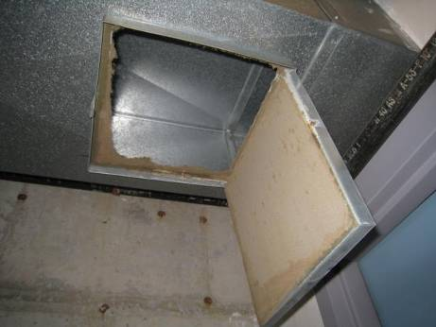

Dirt and debris accumulation inside the duct shown in Picture 18
Picture 21

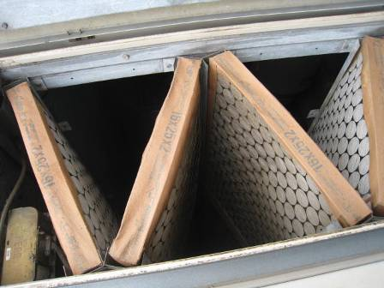

Filters in AHU

Picture 22

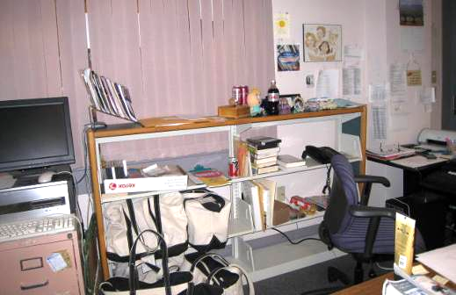

Various items in office

Picture 23

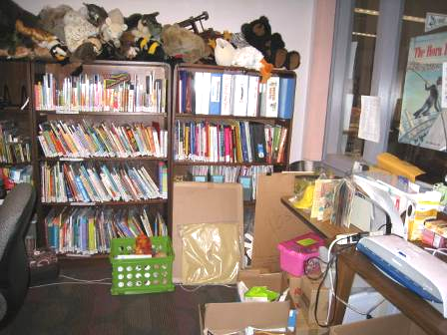

Items, including plush toys

Picture 24

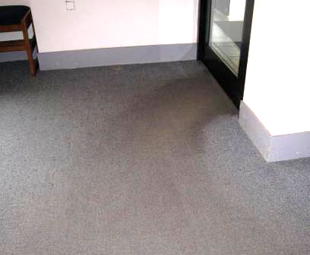

Worn carpeting in front entrance area
Location | Carbon  Dioxide  (ppm) | Carbon Monoxide  (ppm) | Temp  (°F) | Relative  Humidity  (%) | PM2.5  (µg/m³) | Occupants  in Room | Windows  Openable | Ventilation |  | Remarks
 |  |  |  |  |  |  |  | Supply | Exhaust | Remarks
Background | 310 | ND | 75 | 76 | 11 |  |  |  |  | Overcast, light drizzle
Second Floor
Director’s Office | 812 | ND | 73 | 66 | 5 | 3 | N | Y | Y
Assistant Director’s Office | 770 | ND | 73 | 63 | 5 | 0 | N | Y | Y | Items
Administration Reception | 811 | ND | 73 | 63 | 5 | 1 | N | Y | Y | PC, items
Reference Area | 799 | ND | 73 | 64 | 5 | 1 | N | Y | Y
Reference Office | 911 | ND | 72 | 68 | 7 | 0 | N | Y | Y | PF, CP
Computer area in Reference | 765 | ND | 72 | 64 | 6 | 4 | N | Y | Y | Wall hangings
Tech Services |  | ND | 72 | 63 | 6 | 4 | N | Y | Y | Window/window area leaks, items covered in plastic every night to prevent damage, PF, plants, sink/items under sink, printers, rusty CTs
Business Reference | 869 | ND | 72 | 65 | 6 | 1 | N | Y | Y | Reports of poor air circulation in this area, supply vent is flagged
Periodical Storage room | 817 | ND | 72 | 64 | 5 | 0 | N | Y | Y | Slight paper odor
Non-fiction (Aisle 641.8) | 815 | ND | 72 | 62 | 6 | 0 | N | Y | Y
Study Room/Book Sale | 790 | ND | 71 | 61 | 5 | 0 | N | Y | Y | Books stored here have been sorted downstairs
Study Room/Library Supplies | 789 | ND | 70 | 60 | 5 | 0 | N | Y | Y | Items
2nd floor Men’s restroom |  |  |  |  |  |  |  | Y | Y | Floor drains, supply dusty/dirty
2nd floor Women’s Restroom |  |  |  |  |  |  |  | Y | Y | Dusty supply vent, weak exhaust
Study Room/Public use typewriter | 780 | ND | 70 | 72 | 5 | 0 | N | Y | Y | History of water damage in this room
Study Room 4 | 461 | ND | 70 | 73 | 5 | 0 | N | Y | Y | This room reportedly has fewer issues
Miles Historic Document Room | 406 | ND | 69 | 73 | 5 | 0 | N | Y | Y | Room has own humidity control but system not fully understood. Has historic WD
Meeting Room 4 | 442 | ND | 70 | 72 | 5 | 0 | N | Y | Y | New paint in study rooms
Study Room 6 | 462 | ND | 70 | 72 | 6 | 0 | N | Y | Y
Study Room 5 | 551 | ND | 71 | 74 | 6 | 1 | N | Y | Y
Staff Lounge |  | ND | 71 | 72 | 6 | 1 | N | Y | Y | Food, items, microwave, stove (electric), sink, pesticide cans under sink
Library staff locker room | 420 | ND | 71 | 71 | 5 | 0 | N | Y | Y | Couches, items
Men’s Staff restroom |  |  |  |  |  |  | N | Y | Y | AT
Women’s staff restroom |  |  |  |  |  |  | N | Y | Y | Exhaust vent weak
Current Periodicals | 410 | ND | 72 | 68 | 6 | 3 | N | Y |  | Plush chairs
First Floor
Children’s Area, front | 438 | ND | 73 | 68 | 8 | 2 | N | Y | Y | Condensation between door panes
Children’s Area lounge | 445 | ND | 73 | 64 | 7 | 0 | N | Y | Y | Plush chairs
Downstairs meeting | 650 | ND | 73 | 69 | 6 | 24 | N | Y | Y | Sinks in back of room, items underneath
Children’s Area play/audio room |  | ND | 73 | 65 | 6 | 8 | N | Y | Y | Plush items (puppets), plants, skylight
Girls restroom |  |  |  |  |  |  | N | Y | Y | Odors, very weak exhaust
Adult Fiction (“M” aisle) | 416 | ND | 73 | 61 | 6 | 0 | N | Y | Y
Staff Office (rear) | 500 | ND | 72 | 62 | 6 | 2 | N | Y | Y | PC, used books are brought in and sorted here, dehumidifier
Staff Office (front) | 573 | ND | 71 | 63 | 6 | 0 | N | Y | Y | Laminator, stuffed toys, items
Circulation Desk | 410 | ND | 72 | 67 | 6 | 0 | N | Y | Y | Rubber floor, new front door, PF
YA Fiction area | 511 | ND | 72 | 67 | 10 | 0 | N | Y | Y | Area reportedly severely previously water-impacted (1 year ago), signs of historic WD, couches, carpeting to be replaced
New Book/AV area | 425 | ND | 72 | 67 | 7 | 1 | N | Y | Y | Plush chairs, faint musty odor, carpeting worn, windows allow water inside
Basement
Basement hallway |  |  |  |  |  |  |  |  |  | Signs of chronic water infiltration
Boiler room |  | ND |  |  |  |  |  |  |  | Slight gas odor, condensation drains may not slope/drain enough

