INDOOR AIR QUALITY ASSESSMENT

Burlington Town Hall
29 Center Street
Burlington, Massachusetts



Prepared by:
Massachusetts Department of Public Health
Bureau of Environmental Health
Indoor Air Quality Program
May 2011

Background/Introduction
Due to potential concerns regarding indoor air quality (IAQ) issues, the Massachusetts Department of Public Health (MDPH), Bureau of Environmental Health (BEH) conducted an IAQ assessment at the Burlington Town Hall (BTH), located at 29 Center Street, Burlington, Massachusetts. The assessment was done in cooperation with Ms. Joanne Faust, Human Resources Director for the Town of Burlington and Sharon Mastenbrook, Director of Public Health, Burlington Board of Health. On February 15, 2011, Cory Holmes, Environmental Analyst/Regional Inspector and Ruth Alfasso, Environmental Engineer/Inspector for BEH’s Indoor Air Quality (IAQ) Program made a visit to the BTH to conduct the IAQ assessment.
The BTH is a two-story building with a basement originally built in 1969. The building underwent complete renovations in 1997. It has a red-brick exterior and a mansard roof; reportedly, the roof was fully replaced in 2009.

Methods
Air tests for carbon monoxide, carbon dioxide, temperature and relative humidity were conducted with the TSI, Q-Trak, IAQ Monitor, Model 7565. Air tests for airborne particle matter with a diameter less than 2.5 micrometers were taken with the TSI, DUSTTRAK™ Aerosol Monitor Model 8520. BEH staff also performed visual inspection of building materials for water damage and/or microbial growth.

Results
Approximately 30 people work in the BTH; it also houses the town’s computer server equipment and the town’s repository of paper archived materials. The building provides services to the public and hosts public meetings. Tests were taken during normal operations and results appear in Table 1.

Discussion

Ventilation
It can be seen from Table 1 that carbon dioxide levels were below 800 parts per million (ppm) in all but one area surveyed, indicating adequate air exchange at the time of the assessment (Table 1). The heating, ventilation and air conditioning (HVAC) system consists of air-handling units (AHU) located in the attic (Picture 1) and first floor. Conditioned air is distributed to ceiling-mounted air diffusers (Picture 2) and ducted back to the AHU via return vents (Picture 3). Some of the air diffusers were found to be equipped with directional baffles (Picture 4).
The HVAC system is controlled by a combination of digital thermostats (Picture 5) and rotary thermostats (Picture 6). Each thermostat examined had a fan switch with two settings, on and auto; some also had an off position. When the fan is set to on, the system provides a continuous source of air circulation and filtration. The automatic setting on the thermostat activates the HVAC system at a preset temperature. Once the preset temperature is reached, the HVAC system is deactivated. Therefore, no mechanical ventilation is provided until the thermostat re-activates the system. The MDPH recommends that thermostats be set to the fan “on” setting during occupied hours to provide continuous air circulation.
In one location (the left side of the Tax Office) one of the return/exhaust vents had been blocked off with a sheet of plastic installed beneath the grillwork (Picture 7). When return vents are blocked or not operational, the HVAC system cannot operate as it was designed to. In addition, stale air is not properly exhausted from the space and may increase feelings of occupant discomfort.
To maximize air exchange, the MDPH recommends that both supply and exhaust ventilation operate continuously during periods of occupancy. In order to have proper ventilation with a mechanical supply and exhaust system, the systems must be balanced to provide an adequate amount of fresh air to the interior of a room while removing stale air from the room. It is recommended that existing ventilation systems be re-balanced every five years to ensure adequate air systems function (SMACNA, 1994). The date of the last balancing of the HVAC system was not available at the time of the assessment.
The Massachusetts Building Code requires that each room have a minimum ventilation rate of 20 cubic feet per minute (cfm) per occupant of fresh outside air or openable windows (SBBRS, 1997; BOCA, 1993). The ventilation must be on at all times that the room is occupied. Providing adequate fresh air ventilation with open windows and maintaining the temperature in the comfort range during the cold weather season is impractical. Mechanical ventilation is usually required to provide adequate fresh air ventilation.
Carbon dioxide is not a problem in and of itself. It is used as an indicator of the adequacy of the fresh air ventilation. As carbon dioxide levels rise, it indicates that the ventilating system is malfunctioning or the design occupancy of the room is being exceeded. When this happens, a buildup of common indoor air pollutants can occur, leading to discomfort or health complaints. The Occupational Safety and Health Administration (OSHA) standard for carbon dioxide is 5,000 parts per million parts of air (ppm). Workers may be exposed to this level for 40 hours/week, based on a time-weighted average (OSHA, 1997).
The MDPH uses a guideline of 800 ppm for publicly occupied buildings. A guideline of 600 ppm or less is preferred in schools due to the fact that the majority of occupants are young and considered to be a more sensitive population in the evaluation of environmental health status. Inadequate ventilation and/or elevated temperatures are major causes of complaints such as respiratory, eye, nose and throat irritation, lethargy and headaches. For more information concerning carbon dioxide, please see Appendix A.
Temperatures in occupied areas ranged from 68º F to 79º F, which were within or close to the MDPH recommended comfort guidelines, except for the 2nd floor council chambers, which is a large area used for public meetings had a measurement of 64º F. The HVAC system in this area had been deactivated at the time of the assessment because the room was not being utilized. The MDPH recommends that indoor air temperatures be maintained in a range of 70º F to 78º F in order to provide for the comfort of building occupants. In many cases concerning indoor air quality, fluctuations of temperature in occupied spaces are typically experienced, even in a building with an adequate fresh air supply.
The relative humidity measured in occupied areas ranged from 8 to 14 percent, which was below the MDPH recommended comfort range in all areas surveyed. The MDPH recommends a comfort range of 40 to 60 percent for indoor air relative humidity. The sensation of dryness and irritation is common in a low relative humidity environment. Low relative humidity is a very common problem during the heating season in the northeast part of the United States.
It was noted that the building had humidifier units located on the walls of several offices and common areas (Picture 8). It was reported that these units had been installed during the major remodeling in 1997, but had all been deactivated with the water service to each unit also shut off. The reasons given for installing these units were reportedly to improve the functioning of copying machines which had been known to experience paper jams during periods of low relative humidity, as well as to improve occupant comfort. The humidifying machines had reportedly been deactivated because of the expenses associated with maintenance and repair of the units; in addition, newer copying machines are more tolerant of dry conditions. MDPH/BEH does not recommend the use of humidifying devices in office spaces, since local increases in humidity can lead to condensation and related problems.

Microbial/Moisture Concerns
In order for building materials to support mold growth, a source of water exposure is necessary. Water-damaged ceiling tiles were seen in a few areas, several reportedly due to ice dam conditions that had occurred prior to the recent roof replacement. Water-damaged ceiling tiles indicate leaks from either the roof or plumbing system and can provide a source for mold growth. These tiles should be replaced after a water leak is discovered and repaired. One damaged tile was found in the archive room (Picture 9), which was reportedly due to a pipe break in the ceiling. The employee in this area reported that a full cleanup had been performed following the pipe break, and that no water had contacted the stored paper materials or other items inside the archives.
BEH staff also examined the outside perimeter of the building to identify breaches in the building envelope and/or other conditions that could provide a source of water penetration. It was noted that several of the downspouts from the gutters were disconnected at the bottom, with one crushed (Picture 10). Another downspout enters the ground so it was not possible to tell whether it discharged into an appropriate storm drain. If downspouts are not configured to drain correctly, water from the roof may be directed to the walls or foundation or may collect on the roof. These conditions can undermine the integrity of the building envelope and provide a means of water entry by capillary action into the building through exterior walls, foundation concrete and masonry (Lstiburek & Brennan, 2001).
MDPH/BEH staff received reports that carpets had become water-damaged due to spills from water dispensers in the building. Carpeting adjacent to these units is vulnerable to water damage and should be covered by a rubber/plastic mat if water dispensers cannot be relocated to tile-floored areas.
The US Environmental Protection Agency (US EPA) and the American Conference of Governmental Industrial Hygienists (ACGIH) recommend that porous materials (e.g., ceiling tiles, carpeting) be dried with fans and heating within 24 to 48 hours of becoming wet (US EPA, 2001; ACGIH, 1989). If not dried within this time frame, mold growth may occur. Once mold has colonized porous materials, they are difficult to clean and should be removed/discarded.
At least one plant was observed sitting on a paper towel rather than a drip pan. A continually damp towel provides a medium for mold growth and may be attractive to pests. Plants should be kept on washable drip pans, should not be overwatered, and the drip pans should be cleaned regularly.

Other IAQ Evaluations
Indoor air quality can be negatively influenced by the presence of respiratory irritants, such as products of combustion. The process of combustion produces a number of pollutants. Common combustion emissions include carbon monoxide, carbon dioxide, water vapor and smoke (fine airborne particle material). Of these materials, exposure to carbon monoxide can produce immediate, acute health effects upon exposure. To determine whether combustion products were present in the building environment, BEH staff obtained measurements for carbon monoxide.

Carbon Monoxide
Carbon monoxide is a by-product of incomplete combustion of organic matter (e.g., gasoline, wood and tobacco). Exposure to carbon monoxide can produce immediate and acute health effects. Several air quality standards have been established to address carbon monoxide and prevent symptoms from exposure to these substances. The MDPH established a corrective action level concerning carbon monoxide in ice skating rinks that use fossil-fueled ice resurfacing equipment. If an operator of an indoor ice rink measures a carbon monoxide level over 30 ppm, taken 20 minutes after resurfacing within a rink, that operator must take actions to reduce carbon monoxide levels (MDPH, 1997).
The American Society of Heating, Refrigerating and Air-Conditioning Engineers (ASHRAE) has adopted the National Ambient Air Quality Standards (NAAQS) as one set of criteria for assessing indoor air quality and monitoring of fresh air introduced by HVAC systems (ASHRAE, 1989). The NAAQS are standards established by the US EPA to protect the public health from six criteria pollutants, including carbon monoxide and particulate matter (US EPA, 2006). As recommended by ASHRAE, pollutant levels of fresh air introduced to a building should not exceed the NAAQS levels (ASHRAE, 1989). The NAAQS were adopted by reference in the Building Officials & Code Administrators (BOCA) National Mechanical Code of 1993 (BOCA, 1993), which is now an HVAC standard included in the Massachusetts State Building Code (SBBRS, 1997). According to the NAAQS, carbon monoxide levels in outdoor air should not exceed 9 ppm in an eight-hour average (US EPA, 2006).
Carbon monoxide should not be present in a typical, indoor environment. If it is present, indoor carbon monoxide levels should be less than or equal to outdoor levels. On the day of the assessment, outdoor carbon monoxide concentrations were non-detect (ND) (Table 1). No measureable levels of carbon monoxide were detected inside the building during the assessment (Table 1).

Particulate Matter
The US EPA has established NAAQS limits for exposure to particulate matter. Particulate matter is airborne solids that can be irritating to the eyes, nose and throat. The NAAQS originally established exposure limits to particulate matter with a diameter of 10 μm or less (PM10). According to the NAAQS, PM10 levels should not exceed 150 micrograms per cubic meter (μg/m³) in a 24-hour average (US EPA, 2006). These standards were adopted by both ASHRAE and BOCA. Since the issuance of the ASHRAE standard and BOCA Code, US EPA established a more protective standard for fine airborne particles. This more stringent PM2.5 standard requires outdoor air particle levels be maintained below 35 μg/m³ over a 24-hour average (US EPA, 2006). Although both the ASHRAE standard and BOCA Code adopted the PM10 standard for evaluating air quality, MDPH uses the more protective PM2.5 standard for evaluating airborne particulate matter concentrations in the indoor environment.
Outdoor PM2.5 was measured at 13 μg/m³ (Table 1). Indoor PM2.5 levels ranged from 2 to 5 μg/m³ (Table 1). Both indoor and outdoor PM 2.5 levels were below the NAAQS PM2.5 level of 35 μg/m³. Frequently, indoor air levels of particulates (including PM2.5) can be at higher levels than those measured outdoors. A number of mechanical devices and/or activities that occur indoors can generate particulate during normal operations. Sources of indoor airborne particulates may include but are not limited to particles generated during the operation of fan belts in the HVAC system, use of stoves and/or microwave ovens in kitchen areas; use of photocopiers, fax machines and computer printing devices; operation of an ordinary vacuum cleaner and heavy foot traffic indoors.
A variety of copying and printing devices were noted in occupied areas of the building, as well as several areas where food is stored and heated or prepared, including coffee pots, microwaves and toaster ovens, all of which may produce particulates (Picture 11). Areas such as these with a high potential to cause particulate emissions or odors should be located close to exhaust ventilation and away from sensitive individuals when possible.

Other Conditions
Several other conditions that can potentially affect indoor air quality were identified during the assessment. Extra and/or discarded filters for the various portions of the heating system were found to be stored in the attic (Picture 12). Improper storage of filters could cause them to become damaged, reducing the filtration efficiency; they may also become contaminated with mold/moisture, dust or other contaminants which could be spread to other portions of the building when/if they are used.
Although a preventative maintenance plan is in place, which reportedly changes filters up to four times a year, the type of filters installed in AHUs provide minimal filtration of respirable dusts (Pictures 13 and 14). In order to decrease aerosolized particulates, disposable filters with an increased dust spot efficiency can be installed. The dust spot efficiency is the ability of a filter to remove particulates of a certain diameter from air passing through the filter. Filters that have been determined by ASHRAE to meet its standard for a dust spot efficiency of a minimum of 40 percent would be sufficient to reduce many airborne particulates (Thornburg, D., 2000; MEHRC, 1997; ASHRAE, 1992). Pleated filters with a Minimum Efficiency Reporting Value dust-spot efficiency of 9 or higher are recommended. Note that increasing filtration can reduce airflow (called pressure drop), which can subsequently reduce the efficiency of the unit due to increased resistance. Prior to any increase of filtration, each AHU component should be evaluated by a ventilation engineer to ascertain whether it can maintain function with more efficient filters.
In a number of areas, items were observed on the floor, windowsills, tabletops, counters, bookcases and desks. The large number of items stored provides a source for dusts to accumulate. These items (e.g., papers, folders, boxes) make it difficult for custodial staff to clean. Items should be relocated and/or be cleaned periodically to avoid excessive dust build up. In addition, these materials can accumulate on flat surfaces (e.g., desktops, windowsills and carpets) in occupied areas and subsequently be re-aerosolized causing further irritation.
Several supply, exhaust and return vents were observed to have accumulated dust/debris (Pictures 3 and 4). If exhaust vents are not functioning, backdrafting can occur, which can re-aerosolize accumulated dust particles. Supply vents can aerosolize accumulated dust once activated.
Many areas of the building contain wall to wall carpeting. It was unclear if a regular carpet cleaning program was in place. The Institute of Inspection, Cleaning and Restoration Certification (IICRC), recommends that carpeting be cleaned annually (or semi-annually in soiled high traffic areas) (IICRC, 2005).
Finally, restrooms are equipped with automatic air freshener dispersers (Picture 15), although it could not be determined if these were operational. Air fresheners contain chemicals that can be irritating to the eyes, nose and throat of sensitive individuals. In addition, air fresheners do not remove materials causing odors, but rather mask odors which may be present in the area.

Conclusions/Recommendations
In view of the findings at the time of the visit, the following recommendations are made to improve indoor air quality:
- Operate the HVAC system continuously in the fan “on” mode during periods of occupancy to maximize air circulation and filtration.
- Remove the plastic covering the return vent on the left side of the Tax Office. Use louvers and correct any unbalanced conditions in the HVAC system to reduce any feelings of draftiness from this vent.
- For buildings in New England, periods of low relative humidity during the winter are often unavoidable. Therefore, scrupulous cleaning practices should be adopted to minimize common indoor air contaminants whose irritant effects can be enhanced when the relative humidity is low. To control for dusts, a high efficiency particulate arrestance (HEPA) filter equipped vacuum cleaner in conjunction with wet wiping of all surfaces is recommended. Avoid the use of feather dusters. Drinking water during the day can help ease some symptoms associated with a dry environment (throat and sinus irritations).
- Ensure that all water service to the disused humidifier units is cut and capped to prevent leaks.
- Repair or replace broken or missing downspouts and ensure gutters are in proper working condition.
- Remove/replace water-damaged ceiling tiles. Examine the area above and around these areas for mold growth. Disinfect areas of water leaks with an appropriate antimicrobial.
- Prevent water damage by using drip pans for plants and cleaning them regularly.
- Consider outfitting water dispensers with a rubber/plastic mat to prevent water damage to carpeting.
- Continue to change filters for air handling equipment as per the manufacturers’ instructions or more frequently if needed. Consider upgrading to pleated MERV 9 (or higher) dust-spot efficiency. Prior to any increase of filtration, HVAC system components should be evaluated by a ventilation engineer as to whether it can maintain function with more efficient filters.
- Store spare filters in a dry, low contaminant environment or keep them in the original boxes until needed; discard used filters promptly so they are not accidentally reused.
- Relocate or consider reducing the amount of stored materials to allow for more thorough cleaning. Clean items regularly with a wet cloth or sponge to prevent excessive dust build-up.
- Consider consolidating areas where food is stored and heated, and locate them near an exhaust vent to draw particulates and odors away from occupants.
- Clean supply, exhaust and return vents periodically of accumulated dust.
- Discontinue the use of strongly-scented air fresheners in the building if this has not already been done.
- Clean carpeting annually or semi-annually in soiled high traffic areas as per the recommendations of the Institute of Inspection, Cleaning and Restoration Certification (IICRC). Copies of the IICRC fact sheet can be downloaded at: http://www.cleancareseminars.com/carpet_cleaning_faq4.htm (IICRC, 2005)
- For more information on mold consult as “Mold Remediation in Schools and Commercial Buildings” published by the US Environmental Protection Agency (US EPA, 2001). Copies of this document can be downloaded from the US EPA website at: http://www.epa.gov/iaq/molds/mold_remediation.html
- Refer to resource manuals and other related indoor air quality documents for further building-wide evaluations and advice on maintaining public buildings. Copies of these materials are located on the MDPH’s website: http://mass.gov/dph/indoor_air

References
ACGIH. 1989. Guidelines for the Assessment of Bioaerosols in the Indoor Environment. American Conference of Governmental Industrial Hygienists, Cincinnati, OH.
ASHRAE. 1989. Ventilation for Acceptable Indoor Air Quality. American Society of Heating, Refrigeration and Air Conditioning Engineers. ANSI/ASHRAE 62-1989
ASHRAE. 1992. Gravimetric and Dust-Spot Procedures for Testing Air-Cleaning Devices Used in General Ventilation for Removing Particulate Matter. American Society of Heating, Refrigeration and Air Conditioning Engineers. ANSI/ASHRAE 52.1-1992.
BOCA. 1993. The BOCA National Mechanical Code-1993. 8th ed. Building Officials & Code Administrators International, Inc., Country Club Hills, IL.
IICRC. 2005. Carpet Cleaning FAQ 4 Institute of Inspection, Cleaning and Restoration Certification. Institute of Inspection Cleaning and Restoration, Vancouver, WA.
Lstiburek, J. & Brennan, T. 2001. Read This Before You Design, Build or Renovate. Building Science Corporation, Westford, MA. U.S. Department of Housing and Urban Development, Region I, Boston, MA
MDPH. 1997. Requirements to Maintain Air Quality in Indoor Skating Rinks (State Sanitary Code, Chapter XI). 105 CMR 675.000. Massachusetts Department of Public Health, Boston, MA.
MEHRC. 1997. Indoor Air Quality for HVAC Operators & Contractors Workbook. MidAtlantic Environmental Hygiene Resource Center, Philadelphia, PA.
OSHA. 1997. Limits for Air Contaminants. Occupational Safety and Health Administration. Code of Federal Regulations. 29 C.F.R 1910.1000 Table Z-1-A.
SBBRS. 1997. Mechanical Ventilation. State Board of Building Regulations and Standards. Code of Massachusetts Regulations. 780 CMR 1209.0
SMACNA. 1994. HVAC Systems Commissioning Manual. 1st ed. Sheet Metal and Air Conditioning Contractors’ National Association, Inc., Chantilly, VA.
Thornburg, D. 2000. Filter Selection: a Standard Solution. Engineering Systems 17:6 pp. 74-80.
US EPA. 2001. “Mold Remediation in Schools and Commercial Buildings”. Office of Air and Radiation, Indoor Environments Division, Washington, DC. EPA 402-K-01-001. March 2001. Available at: http://www.epa.gov/iaq/molds/mold_remediation.html
US EPA. 2006. National Ambient Air Quality Standards (NAAQS). US Environmental Protection Agency, Office of Air Quality Planning and Standards, Washington, DC. http://www.epa.gov/air/criteria.html
Picture 1

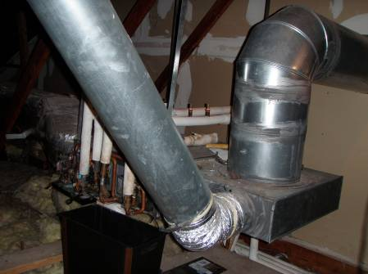

Attic Air Handling Units

Picture 2

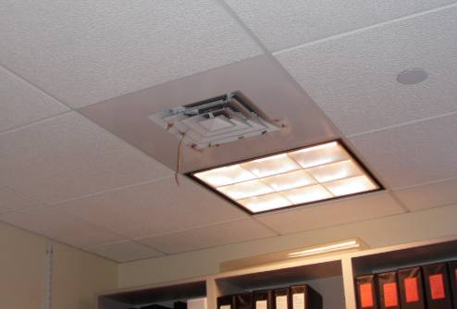

Ceiling Mounted Air Diffuser

Picture 3

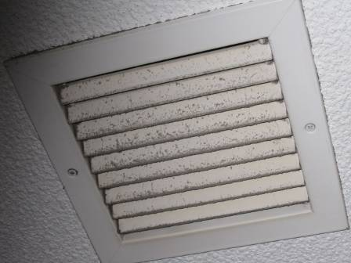

Return Vent, Note the Presence of Dust/Debris

Picture 4

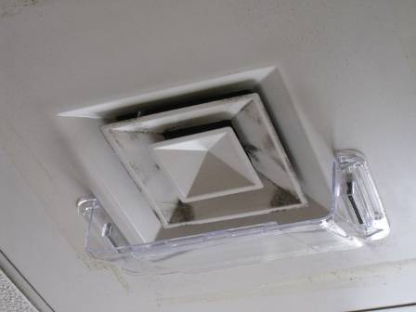

Clear Plastic Baffle for Supply Vent, Note the Presence of Dust/Debris

Picture 5

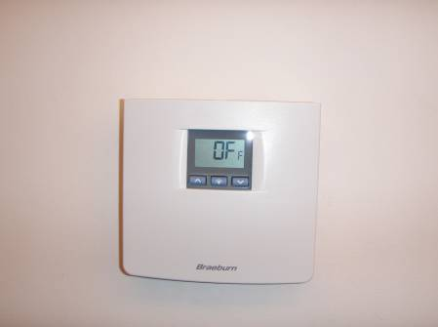

Digital Thermostat in the Council Chambers, Turned Off When Space is Unoccupied

Picture 6

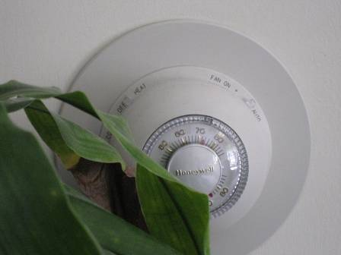

Typical Rotary Thermostat

Picture 7

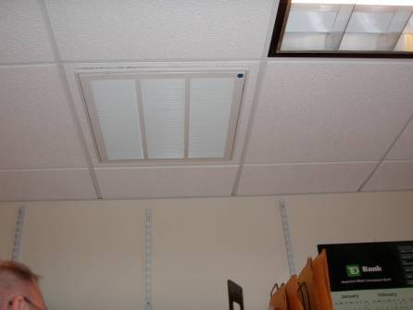

Return Vent Blocked With Plastic (plastic not visible beneath vent)

Picture 8

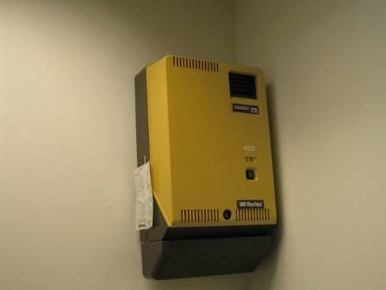

One of Several Humidifier Units throughout the Building, Now Deactivated

Picture 9

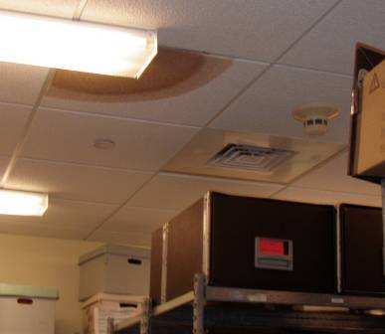

Darkly Stained Ceiling Tile in the Archive Room

Picture 10

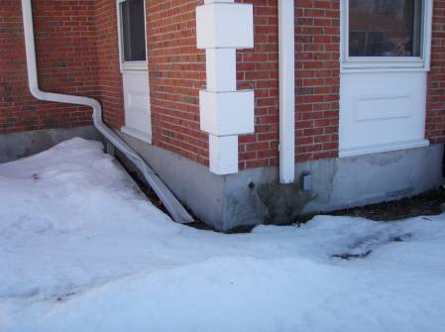

Crushed and Disconnected Downspouts

Picture 11

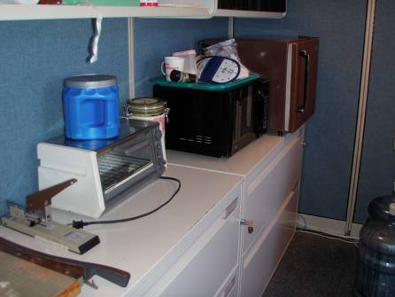

Example Food Preparation Area with Toaster Oven, Refrigerator and Microwave

Picture 12

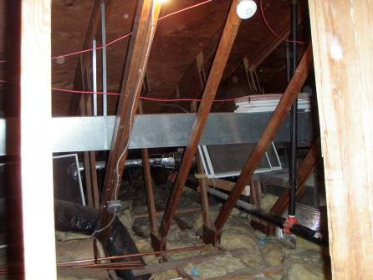

Attic Area Showing Stored or Discarded Air Filters (Arrow)

Picture 13

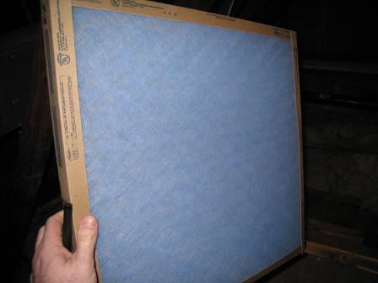

Fibrous Mesh Air Filter Indicating Poor Dust Spot Efficiency

Picture 14

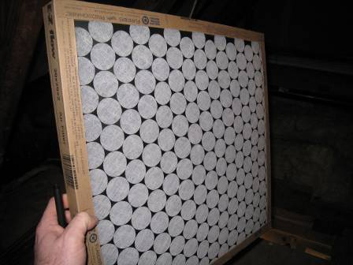

Fibrous Mesh Air Filter Indicating Poor Dust Spot Efficiency

Picture 15

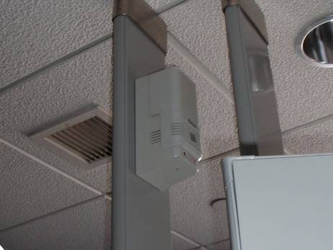

Automatic Air Freshener Dispenser in Women’s Restroom (may not be active)

Location | Carbon  Dioxide  (ppm) | Carbon Monoxide  (ppm) | Temp  (°F) | Relative  Humidity  (%) | PM2.5  (µg/m3) | Occupants  in Room | Windows  Openable | Ventilation |  | Remarks
 |  |  |  |  |  |  |  | Supply | Exhaust | Remarks
Background (Outside) | 360 | ND | <32 | 13 | 13 |  |  |  |  | Two cars were entering/leaving parking lot during background reading. Temperature reading is from weather underground at wunderground.com
1st floor: Town Clerk’s Office | 605 | ND | 75 | 9 | 5 | 2 | Y | Y | Y
2nd side, Town Clerk’s Office | 596 | ND | 74 | 9 | 4 | 0 | N | Y | N
Assessor’s Office, Main | 668 | ND | 75 | 10 | 4 | 2 | Y | Y | Y
Assistant Assessor’s Office | 685 | ND | 76 | 11 | 4 | 0 | Y | Y | Y | Strong sunlight/solar gain in office
Assistant Data Collector’s Office | 672 | ND | 75 | 9 | 4 | 0 | Y | Y | Y | 3 computers in a small space
Tax Office, Left | 638 | ND | 75 | 10 | 4 | 2 | Y | Y | Y | Thermostat for this room was set to “off”
Tax Office, Right | 682 | ND | 74 | 10 | 4 | 4 | Y | Y | Y | One of the exhaust vents is sealed with plastic
Tax Office, Center | 701 | ND | 74 | 10 | 5 | 1 | Y | Y | Y
Treasurer’s Office | 587 | ND | 79 | 9 | 3 | 0 | Y | Y | Y
2nd floor:  Council Chambers | 525 | ND | 64 | 13 | 3 | 0 | Y | Y | Y | Large room with multiple supply vents, and three zones of thermostat control
HR Office | 639 | ND | 68 | 12 | 3 | 0 | Y | Y | Y | Tape/paper found in supply vent
Main Accountancy Office | 875 | ND | 72 | 14 | 3 | 3 | Y | Y | Y | Several plants, including one on a towel, several printers, computers and office equipment
Accountancy Office, Side | 785 | ND | 75 | 10 | 4 | 0 | Y | Y | Y
Copy/Lounge | 797 | ND | 76 | 10 | 3 | 0 | N | Y | N | Ceiling contains pull-down stairs to the attic. Also contains a coffee pot station and a copier
Selectman’s Office | 692 | ND | 75 | 8 | 3 | 2 | Y | Y | Y | Previous reports of water damage in this room, corrected at the time of occurrence
Assistant Town Manager’s Office | 713 | ND | 74 | 9 | 4 | 1 | Y | Y | Y
Town Manager’s Office | 585 | ND | 72 | 8 | 3 | 0 | Y | Y | Y
Small Meeting Chamber | 617 | ND | 74 | 8 | 3 | 4 | Y | Y | Y
2nd Floor women’s Bathroom | 571 | ND | 72 | 8 | 3 | 0 | Y | Y | Y | Contains an automatic air freshener, not known if operational/on
Basement: Computer Server Room |  |  |  |  |  | 0 | N | Y | Y | Has additional wall and floor-mounted AC units. Undergoing some construction. Not typically staffed.
Mechanical Room |  |  |  |  |  | 0 | N |  |  | Natural-gas fired hot water system
Custodial Room |  |  |  |  |  | 0 | N | Y | Y | Sink, mop sink, cleaning chemical storage and two desks
Archives |  |  |  |  |  | 1 | N | Y | Y | Has separate air system for maintenance of archival documents
Storage |  |  |  |  |  | 1 | N | Y | Y
Management Info Systems Room |  |  |  |  |  | 2 | N | Y | Y | Use of personal heater
Mail Room |  |  |  |  |  | 0 | N | Y | Y
Basement Women’s Bathroom |  |  |  |  |  | 0 | N | Y | Y | Contains an automatic air freshener, not known if operational/on

