INDOOR AIR QUALITY ASSESSMENT

Burncoat High School
179 Burncoat Street
Worcester, MA

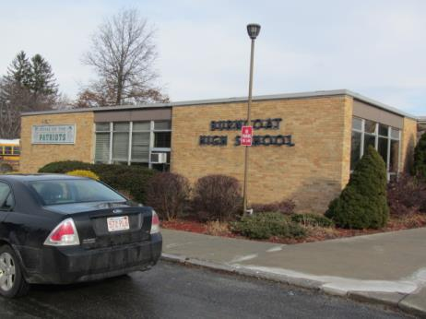

Prepared by:
Massachusetts Department of Public Health
Bureau of Environmental Health
Indoor Air Quality Program
March 2017

Background/Introduction
Building: | Burncoat High School (BHS)
Address: | 179 Burncoat Street, Worcester, MA
Assessment Requested by: | Brian Allen, Chief Financial and Operations Officer, Worcester Public Schools (WPS)
Reason for Request: | Concerns regarding polychlorinated biphenyls (PCBs) and general indoor air quality (IAQ)
Date of Assessment: | January 12, 2017
Massachusetts Department of Public Health/Bureau of Environmental Health (MDPH/BEH) Staff Conducting Assessment: | Mike Feeney, Director, IAQ Program,  Cory Holmes and Jason Dustin Environmental Analysts/Inspectors IAQ Program
Date of Building Construction: | 1964
Building Description: | Two-level brick building consisting of classrooms, auditorium, gymnasium, art rooms, kitchen, cafeteria, library and office space.
Building Population: | The school has approximately 1,064 students and 75 staff
Windows: | Openable

The Indoor Air Quality (IAQ) Program was asked by the WPS to provide technical assistance regarding the potential impact of window caulking at BHS. The IAQ Program assessed the building to ascertain window caulking was being managed in a manner consistent with recommendations made by the US EPA, “Practical Actions for Reducing Exposure to PCBs in Schools and Other Buildings Guidance for school administrators and other building owners and managers” (Appendix A). In this document, the US EPA makes the following recommendations regarding window caulking:
- Clean inside schools and other buildings frequently to reduce dust and residue.
- Encapsulate the caulking.
- Ensure that ventilation systems are operating. (US EPA, 2015).
BEH/IAQ staff conducted two activities at BHS: a general assessment of IAQ to determine if the ventilation system was operating adequately, as well as an examination of window caulking throughout the building. The assessment of window caulking was to ascertain if it was intact and whether any caulking debris was present on window frames or sills inside classrooms.

Methods
Please refer to the IAQ Manual and appendices for methods, sampling procedures, and interpretation of results (MDPH, 2015).

Results and Discussion
Window Frame Caulking Conditions
Window frames in the BHS were encapsulated with a sealant prior to the MDPH/IAQ visit. The sealant was intact in most locations (Table 1). Windows that had incomplete sealant cover were noted (Table 1). No interior sides of window frames were noted having damaged/crumbling caulking and sills were found to be free of accumulated dust.

General Ventilation
The following is a summary of indoor air testing results (Table 2).
- Carbon dioxide measurements were above the MDPH recommended level of 800 parts per million (ppm) in the majority of areas surveyed the day of assessment, indicating a lack of fresh air exchange. Likely causes are discussed under the “Ventilation” section of the report.
- Temperature was within the MDPH recommended range of 70°F to 78°F in most of the areas visited. Cold complaints were expressed in the music areas, particularly the practice rooms.
- Relative humidity was within or very close to the MDPH recommended range of 40% to 60%.
- Carbon monoxide levels were non-detectable in all areas tested.
- Particulate matter (PM2.5) concentrations measured were below the National Ambient Air Quality (NAAQS) level of 35 μg/m³ in all areas surveyed.

Ventilation
Fresh air in most classrooms is supplied by air handling units (AHUs) located in a mechanical room in the lower level. The AHUs draw air from outdoors through an intake vent on the exterior wall of the building (Picture 1). In most classrooms, return air is drawn through floor vents (Picture 2). Fresh and return air streams are mixed together in a large mixing room in the lower level (Picture 3). Supply air is then filtered, heated, and provided to classrooms via floor-mounted air diffusers (Picture 4).
BEH/IAQ staff noted that the louvers for the fresh air intake vent in the mixing room were mostly closed (Picture 1). BHS facilities staff reported that this restricted setting was due to the extreme cold weather that was experienced the week prior to the assessment. Closing the fresh air louvers is the likely cause of the elevated carbon dioxide levels measured in classrooms with moderate occupancy (Table 2). Adequate fresh air supply and properly functioning exhaust are both extremely important in diluting and removing normally occurring indoor air pollutants.
Floor-mounted supply and return vents were found to have accumulated debris in many areas (Picture 5). This design is prone to collect debris and may act to aerosolize particulate matter if not regularly vacuumed, preferably using a high efficiency particulate arrestance (HEPA) filter equipped vacuum cleaner.
The location of the return vents on the floors makes it easy for the vents to be blocked by stored materials. In a number of classrooms, these vents were blocked with trash barrels (Picture 6). In order to function properly, both supply and return vents must remain free of obstructions.
BHS facilities personnel reported that the filters in the mixing room are changed twice per year. BEH/IAQ staff noted that the filters appeared partially occluded at the time of assessment (Picture 7). Filter changing frequency should be increased as needed following regular inspections.
Other areas such as restrooms and locker rooms have local exhaust vents which draw air from these areas and eject it directly outside. BEH/IAQ staff noted that the exhaust was not functioning in several areas (Table 2). The automotive area appears to have both ceiling-mounted general exhaust units and floor-mounted local exhaust ports (Pictures 8 and 9). It was not clear at the time of assessment whether these units function properly and it was reported by BHS facilities staff that faculty typically refrain from idling vehicles indoors. Nevertheless, properly functioning exhaust systems should be utilized whenever vehicles enter the garage or when any solvents or other products containing VOCs are used in this area. Products of combustion and VOCs can have irritant effects.
In order to have proper ventilation with a mechanical supply and exhaust system, these systems must be balanced to provide an adequate amount of fresh air while removing stale air from a room. The date of the last balancing of these systems was not available at the time of the assessment. It is recommended that existing ventilation systems be re-balanced every five years to ensure adequate air systems function (SMACNA, 1994).

Microbial/Moisture Concerns
Water-damaged ceiling tiles were observed in several areas throughout the BHS (Table 2; Pictures 10 and 11). At the time of assessment, BHS Facilities staff indicated that water-damaged ceiling tiles are replaced routinely throughout the school. It was not clear how many of these water-damaged ceiling tiles are actively leaking or if they are due to historic leaks that have since been repaired.
Water-damaged plaster ceilings were noted in some areas including the auditorium and locker rooms. It is important to note that plaster is unlikely to support mold growth even when exposed to periodic water leaks. BEH/IAQ staff did note accumulations of powdery, white material on ceilings in locker rooms (Pictures 12 and 13). The white material is called efflorescence; efflorescence is a characteristic sign of water damage to building materials such as brick, mortar, or plaster, but it is not mold growth. As moisture penetrates and works its way through mortar around brick, water-soluble compounds dissolve, creating a solution. As the solution moves to the surface of the brick or mortar, water evaporates, leaving behind white, powdery mineral deposits. This condition indicates that water from the exterior has penetrated into the building. Plaster and brick do not typically support mold growth because these materials are not carbon-based; however paint, items, or debris near the walls that are moistened may become mold-colonized. When present, efflorescence can be readily cleaned. BHS Facilities staff indicated that the leaks in the auditorium are ongoing and are currently being addressed by roofers. Locker room water damage was extensive and it was reported by BHS Facilities staff that the women’s locker room has been closed until planned renovations to the area are made.
BEH/IAQ staff noted a classroom with an active water leak around a column in room F2 (Picture 14). This leak was coming from the ceiling around the column and may be the result of a roof or flashing failure in that area. This leak should be repaired to prevent water damage to porous building materials.
Measures should be taken to ensure water-damaged materials are cleaned, replaced, and/or repaired in a manner consistent with the U.S. Environmental Protection Agency’s guidelines (US EPA, 2008). The US EPA and the American Conference of Governmental Industrial Hygienists (ACGIH) recommend that porous materials (e.g., ceiling tiles, gypsum wallboard) be dried with fans and heating within 24 to 48 hours of becoming wet (US EPA, 2008; ACGIH, 1989). If not dried within this time frame they should be removed/discarded.
Several classrooms contained plants (Table 2). Plants can be a source of pollen and mold, which can be respiratory irritants to some individuals. Plants should be properly maintained and equipped with drip pans to prevent water damage to porous materials. Plants should also be located away from air diffusers to prevent the aerosolization of dirt, pollen, and mold (Picture 15).
Sinks were observed in a number of classrooms. Some of the sinks examined lacked caulking in the space between the backsplash and countertop (Table 2; Room D6), which may allow water damage to building materials or stored items beneath. These seams should be examined periodically to ensure the caulking is intact.

Other Concerns
Other conditions that can affect IAQ were observed during the assessment. Exposure to low levels of total volatile organic compounds (TVOCs) may produce eye, nose, throat, and/or respiratory irritation in some sensitive individuals. To determine if VOCs were present, BEH/IAQ staff examined rooms for products containing VOCs. BEH/IAQ staff noted hand sanitizers, cleaners, air deodorizers, and dry erase materials in use within the building (Picture 16; Table 2). All of these products have the potential to be irritants to the eyes, nose, throat, and respiratory system of sensitive individuals.
A strong sewer-like odor was noted upon entering the H-wing corridor. BEH/IAQ staff noted a strong smell from the janitor closet across from H17. It was discovered that a wet mop may have contributed to this odor. BHS Facilities staff removed the mop from the building. The area should also be inspected for any possible dry drain traps as discussed further below.
Abandoned plumbing fixtures were noted in several areas including the clothing “Boutique”, locker rooms, room C1B and science labs (Table 2; Pictures 17 to 19). These fixtures should be removed and properly capped if it is decided that they will not be used in the future. Otherwise water should be added regularly to the fixtures/drains to avoid dry drain traps which allow sewer gas to accumulate in occupied spaces. BHS staff reported that drains in locker rooms have a water/vinegar solution added regularly however some shower stalls have accumulated storage which may make this task difficult.
Window-mounted air-conditioning units were observed in some areas. This type of equipment has a filter, which should be cleaned prior to use. Any debris that accumulates in the coils of the unit should also be cleaned according to manufacturer’s recommendations (Picture 20).
Missing ceiling tiles were observed in some rooms and hallways (Picture 21). Missing and ajar ceiling tiles can allow dust and debris from the ceiling plenum system to migrate into occupant spaces. All ceiling tile systems should be intact and flush.
Tennis balls had been sliced open and placed on chair footings to reduce noise (Picture 22). Tennis balls are made of a number of materials that are a source of respiratory irritants. Constant wearing of tennis balls can produce fibers and lead to off-gassing of VOCs. Tennis balls are made with a natural rubber latex bladder, which becomes abraded when used as a chair leg pad. Use of tennis balls in this manner may introduce latex dust into the school environment. Some individuals are highly allergic to latex (e.g., spina bifida patients) (SBAA, 2001). It is recommended that the use of materials containing latex be limited in buildings to reduce the likelihood of symptoms in sensitive individuals (NIOSH, 1997; NIOSH, 1998).
In classrooms throughout the school, items were observed on windowsills, tabletops, counters, bookcases and desks. The large number of items stored in classrooms provides a source for dusts to accumulate. These items, (e.g. papers, folders, boxes) make it difficult for custodial staff to clean. Dust can be irritating to eyes, nose, and respiratory tract. Items should be relocated and/or be cleaned periodically to avoid excessive dust build up.
Dust and debris from the water-damaged plaster ceiling was noted in the auditorium on the floor and chairs. Facilities staff reported that the ceilings have been scraped and painted recently. This area should be properly cleaned to avoid irritant effects from this particulate matter. Some occupants expressed concerns regarding a lack of general housekeeping and cleanliness of other areas as well (Picture 23). Wet-wiping of surfaces, HEPA vacuuming and wet-mopping of floors will all help to reduce particulate matter/irritants in occupied areas but as mentioned above, occupants must cooperate by removing accumulated items on surfaces and floors in order to allow for effective cleaning.
Many classrooms have dry erase boards and/or chalk boards. Some classrooms were noted to have accumulations of chalk dust (Picture 24) or dry erase residue in the trays. Both of these may have irritant effects when aerosolized.
Missing light covers were seen in a few areas (Table 2; E4, Book Storage). Fixtures should be equipped with access covers installed with bulbs fully secured in their sockets. Breakage of glass can cause injuries and may release mercury and/or other hazardous compounds.

Conclusions/Recommendations
The assessment of the window caulking found no damaged/crumbling materials on the interior of the building. In the majority of areas, window caulking was encapsulated with a sealant compound. The MDPH/IAQ Program recommends that WPS staff inspect the condition of the sealant on a quarterly basis and make repairs as needed. It appears that the operational status of the ventilation system could be improved to both dilute and remove environmental pollutants for the interior of the building. In view of the findings at the time of the assessment, the following is recommended:
- Inspect the condition of window sealant on a quarterly basis and make repairs as needed.
- Consult a ventilation engineer to ensure proper settings for the fresh air intake louvers in the AHU mixing room. Adequate fresh air supply is vital to diluting normally occurring indoor air quality pollutants.
- Continue to ensure all water leaks (e.g., auditorium roof and column in room F2) are fixed promptly and remove any water-damaged porous materials (e.g., ceiling tiles) that were not dried properly within 24-48 hours.
- Ensure that any water-damaged plaster ceilings/walls are repaired and clean any associated debris (e.g., auditorium) to avoid irritant effects.
- Determine whether abandoned plumbing fixtures are to be used or not. Fixtures that are to be used should have water poured into drains on a regular basis to avoid dry drain traps. Fixtures no longer needed should be removed and properly capped.
- Ensure that all ventilation components throughout the building (classrooms, gym, cafeteria, etc.) are properly functioning and operating continuously during occupied hours.
- Evaluate music/practice rooms for proper heating/insulation.
- Remove all items (e.g., barrels) blocking supply and exhaust vents to ensure adequate airflow.
- Monitor AHU filters in the mixing room regularly and replace more frequently as needed. Ensure that the filters have a minimum efficiency of MERV 8 as reported by BHS staff.
- Use a HEPA vacuum to regularly clean floor-mounted supply and return vents which are prone to debris accumulation.
- Automotive exhaust systems should be utilized whenever vehicles enter the garage or when any solvents or other products containing VOCs are used in this area. Continue to refrain from idling vehicles in the building.
- Regularly clean window-mounted air conditioning filters and units according to manufacturer’s recommendations. Ensure cooling fins are clean and free of debris.
- Replace missing ceiling tiles to prevent the egress of dirt, dust, and particulate matter into occupied areas.
- Replace water-damaged pipe insulation in F-wing hallway (Picture 21).
- Ensure that procedures are in place for occupants to report leaks, wet tiles, and other maintenance conditions so that they can be logged and repaired promptly.
- Move plants away from any air streams in classrooms. Avoid over-watering or placing them on porous materials (e.g., cloth, paper) and examine drip pans periodically for mold growth.
- Examine seams between the sink countertops and backsplashes periodically to ensure sealant is intact (e.g., room D6). Seal areas around sinks to prevent water damage to cabinet interiors and adjacent wallboard.
- Eliminate the use of scented items, including air deodorizing sprays and plug-ins to prevent respiratory irritation.
- Reduce the use of or eliminate products containing VOC’s in classrooms (harsh cleaners, hand sanitizers, etc.).
- Clean chalk trays, dry erase board trays, and areas around pencil sharpeners to prevent accumulation of materials.
- Replace tennis balls on chair footings with latex-free glides.
- Consider adopting a balancing schedule of every 5 years for all mechanical ventilation systems, as recommended by ventilation industrial standards (SMACNA, 1994).
- Relocate or consider reducing the amount of materials stored in classrooms to allow for more thorough cleaning. Clean items regularly with a wet cloth or sponge to prevent excessive dust build-up. Encourage occupants to report any areas that need improvement in general housekeeping as it will improve overall IAQ.
- Ensure mops are properly stored/dried to prevent odors.
- For buildings in New England, periods of low relative humidity during the winter are unavoidable. Therefore, scrupulous cleaning practices should be adopted to minimize common indoor air contaminants whose irritant effects can be enhanced when the relative humidity is low. To control for dusts, a high efficiency particulate arrestance (HEPA) filter equipped vacuum cleaner in conjunction with wet wiping of all surfaces is recommended. Avoid the use of feather dusters. Drinking water during the day can help ease some symptoms associated with a dry environment (throat and sinus irritations).
- Replace all covers for fluorescent light fixtures building-wide.
- Consider adopting the US EPA (2000) document, “Tools for Schools”, as an instrument for maintaining a good IAQ environment in the building. This document is available at: http://www.epa.gov/iaq/schools/index.html.
- Refer to resource manual and other related IAQ documents located on the MDPH’s website for further building-wide evaluations and advice on maintaining public buildings. These documents are available at: http://mass.gov/dph/iaq.

References
American Conference of Governmental Industrial Hygienists (ACGIH). 1989. Guidelines for the Assessment of Bioaerosols in the Indoor Environment. American Conference of Governmental Industrial Hygienists, Cincinnati, OH.
MDPH. 2015. Massachusetts Department of Public Health. Indoor Air Quality Manual: Chapters I-III. Available at: http://www.mass.gov/eohhs/gov/departments/dph/programs/environmental-health/exposure-topics/iaq/iaq-manual/.
National Institute for Occupational Safety and Health (NIOSH). 1997. NIOSH Alert Preventing Allergic Reactions to Natural Rubber latex in the Workplace. National Institute for Occupational Safety and Health, Atlanta, GA.
National Institute for Occupational Safety and Health (NIOSH). 1998. Latex Allergy A Prevention. National Institute for Occupational Safety and Health, Atlanta, GA.
SBAA. 2001. Latex In the Home And Community Updated Spring 2001. Spina Bifida Association of America, Washington, DC.
SMACNA. 1994. HVAC Systems Commissioning Manual. 1st ed. Sheet Metal and Air Conditioning Contractors’ National Association, Inc., Chantilly, VA.
US EPA. 2000. Tools for Schools. Office of Air and Radiation, Office of Radiation and Indoor Air, Indoor Environments Division (6609J). EPA 402-K-95-001, Second Edition. https://www.epa.gov/iaq-schools.
US EPA. 2008. “Mold Remediation in Schools and Commercial Buildings”. Office of Air and Radiation, Indoor Environments Division, Washington, DC. EPA 402-K-01-001. September 2008. Available at: http://www.epa.gov/mold/mold-remediation-schools-and-commercial-buildings-guide.
US EPA. 2015. Practical Actions for Reducing Exposure to PCBs in Schools and Other Buildings Guidance for school administrators and other building owners and managers July 28, 2015. Available at: https://www.epa.gov/sites/production/files/2016-03/documents/practical_actions_for_reducing_exposure_to_pcbs_in_schools_and_other_buildings.pdf
Picture 1
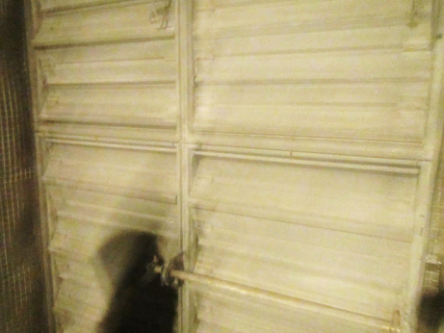
Fresh air supply intake vent (note louvers nearly closed)
Picture 2
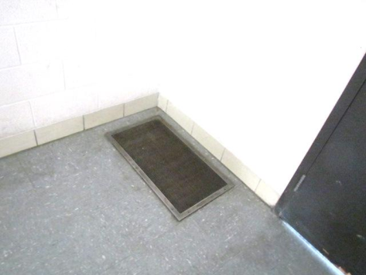
Interior room return vent
Picture 3
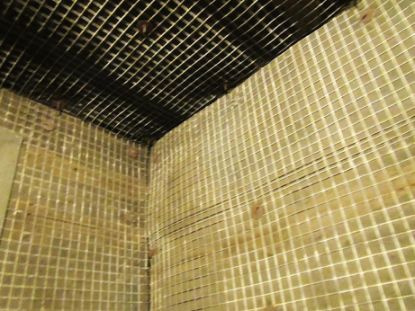
Large AHU mixing room located in lower level
Picture 4
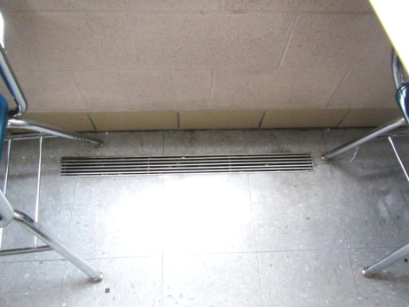
Floor-mounted supply vent in classroom
Picture 5
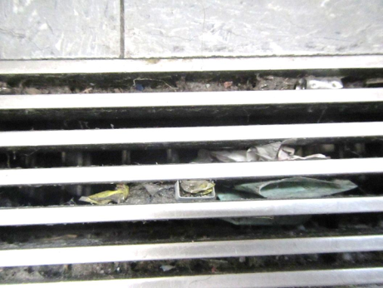
Floor-mounted supply vent showing accumulated debris
Picture 6
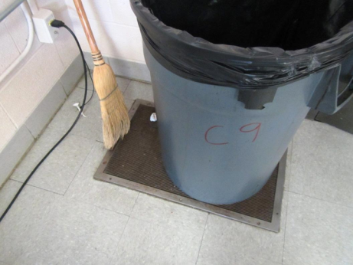
Barrel and broom stored on return vent
Picture 7
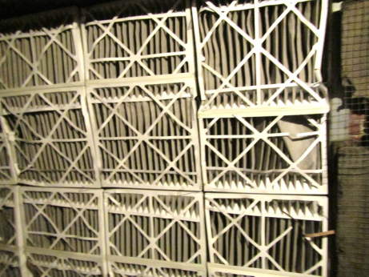
Bank of air filters in the AHU mixing room
Picture 8
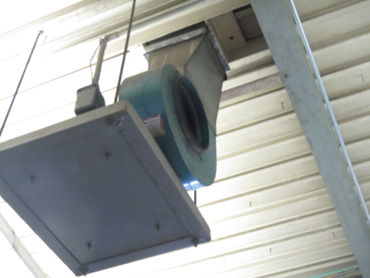
Ceiling-mounted general exhaust fan in Automotive area
Picture 9
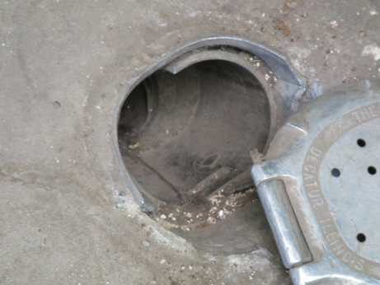
Floor-mounted local exhaust port near vehicle lift
Picture 10
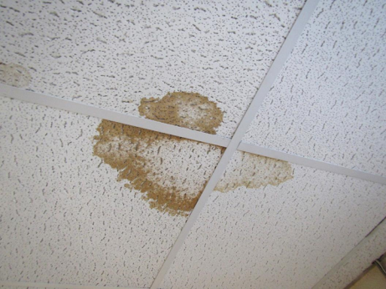
Water-damaged ceiling tiles
Picture 11
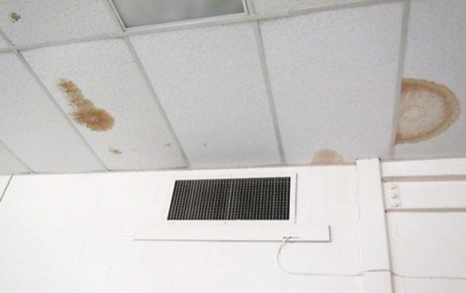
Water-damaged ceiling tiles
Picture 12
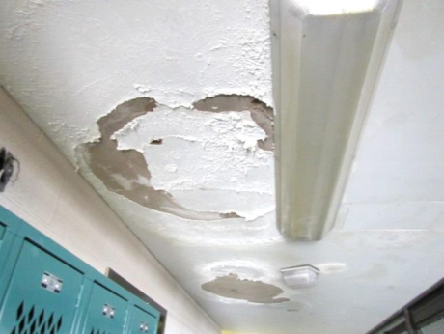
Water-damaged plaster ceilings in Men’s Locker room
Picture 13
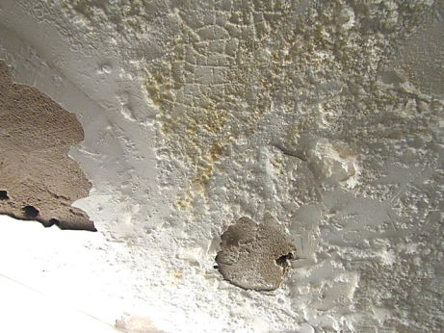
Water-damaged plaster ceiling in Women’s Locker room (note efflorescence)
Picture 14
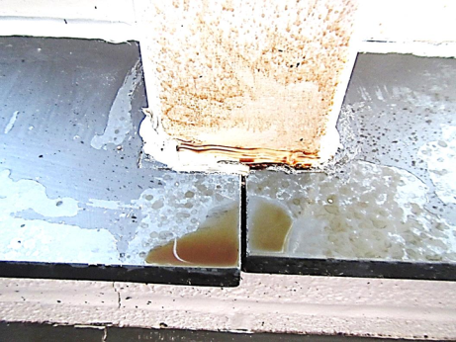
Actively leaking area around column in room F2
Picture 15
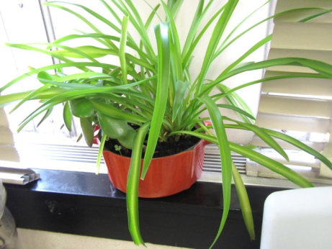
Plant located in air stream of supply diffuser
Picture 16
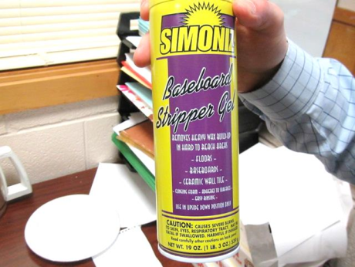
Cleaner/floor stripper containing strong irritants
Picture 17
Abandoned urinal in Clothes Boutique
Picture 18
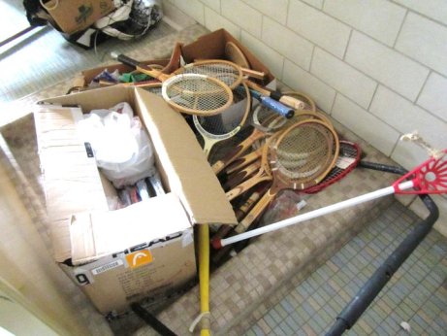
Abandoned shower stall in Women’s Lockers (note stored items over drain)
Picture 19
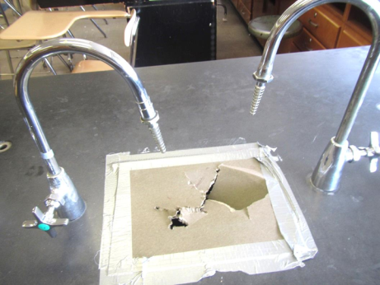
Abandoned sinks in science room
Picture 20
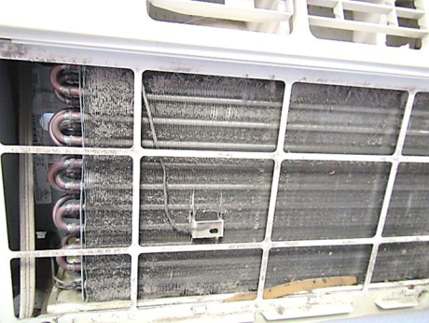
Window AC unit showing debris accumulated in coils
Picture 21
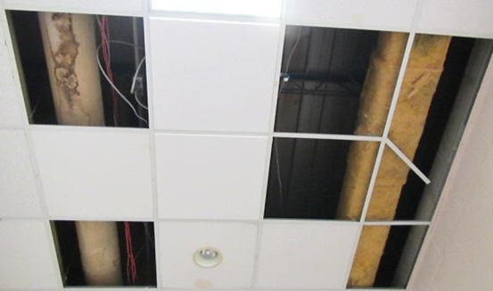
Missing ceiling tiles in F-wing hallway, note water-damaged pipe insulation and exposed fiberglass
Picture 22
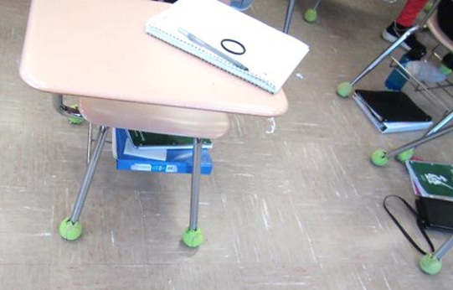
Tennis balls used as chair glides
Picture 23
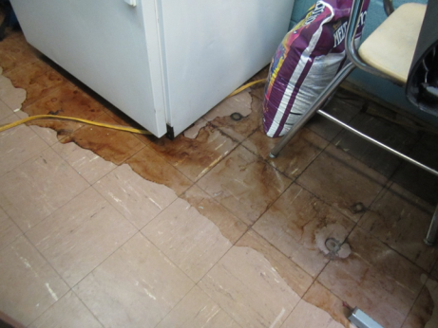
Large spill of possible coffee residue remaining on floor
Picture 24
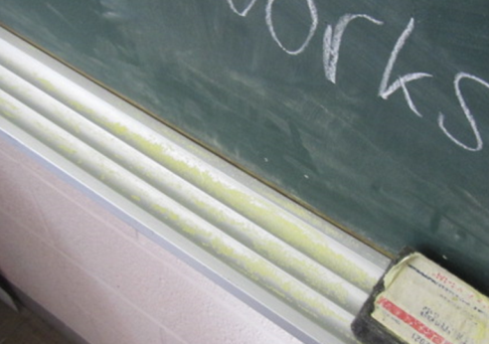
Accumulation of chalk dust in the tray
Location/Room | Encapsulant Incomplete | Damaged Caulking | Dust on Windowsill
Principal | N | N | N
Main office | N | N | N
Reception | N | N | N
Security | N | N | N
A6 | N | N | N
A8 | Y | N | N
A12 | Y | N | N
A14 | N | N | N
Hallway A 18 | N | N | N
A16 | N | N | N
A18 | Y | N | N
B6 | N | N | N
B8 | N | N | N
B1 | N | N | N
B3 | N | N | N
B5A | N | N | N
B5 | N | N | N
B8 | N | N | N
D1 | Y | N | N
D4 | N | N | N
D3 | Y | N | N
D6 | Y | N | N
D5 | Y | N | N
D6A | N | N | N
D8 | Y | N | N
D10 | N | N | N
D cafeteria | N | N | N
D cafeteria hallway | N | N | N
B cafeteria | N | N | N
B14 | N | N | N
Chemistry Storage | N | N | N
B10 | N | N | N
B15 | N | N | N
B17 | N | N | N
B19 | N | N | N
Lounge | N | N | N
C1A | N | N | N
C3 | N | N | N
C5 | N | N | N
C9 | N | N | N
Storage | N | N | N
C19 | N | N | N
C21 | Y | N | N
C14 | N | N | N
C12 | N | N | N
Location/Room | Encapsulant Incomplete | Damaged Caulking | Dust on Windowsill
C6 | Y | N | N
C4 | N | N | N
C2 | N | N | N
E1 | N | N | N
E3 | N | N | N
E5 | N | N | N
E5A | N | N | N
E8 | N | N | N
E6 | N | N | N
E4 | N | N | N
E2 | N | N | N
D14 | N | N | N
D16 | Y | N | N
D18 | N | N | N
D20 | N | N | N
E22 | N | N | N
E24 | N | N | N
F2 | N | N | N
F4 | N | N | N
F6 | N | N | N
Auto | N | N | N
A5 | N | N | N
A7 | N | N | N
A9 | Y | N | N

Location | Carbon  Dioxide  (ppm) | Carbon Monoxide  (ppm) | Temp  (°F) | Relative  Humidity  (%) | PM2.5  (µg/m³) | Occupants  in Room | Windows  Openable | Ventilation |  | Remarks
 |  |  |  |  |  |  |  | Supply | Exhaust
Background | 342 | ND | 56 | 56 | 24 | - | - | - | - | Overcast, intermittent sprinkles
Principal’s Office | 801 | ND | 67 | 54 | 9 | 4 | Y | Y | - | Carpet, plants, water cooler on carpet
Main Office | 1001 | ND | 74 | 46 | 3 | 6 | Y | Y | Y | 3 WD CT, CP, wall to wall carpet
Connor Office | 968 | ND | 71 | 53 | 10 | 1 | N | Y | N
Weeks Office | 1005 | ND | 75 | 44 | 7 | 0 | N | Y | N | 1 WD CT, CP
A5 | 934 | ND | 68 | 58 | 7 | 2 | Y | Y | Y | Ceiling fan, 1 WD CT
A7- Green | 824 | ND | 76 | 40 | 7 | 1 | Y | Y | - | CPs, plants, AC
A7- Main | 819 | ND | 76 | 40 | 9 | 7 | N | Y | - | WD CT, plants, HS, air cleaner
A7-rear office | 594 | ND | 75 | 39 | 11 | 0 | Y open | Y | N | CPs, plants, gap in CT near supply vent
A8 | 761 | ND | 75 | 44 | 7 | 0 | Y open | Y | Y | DEM
A9 | 832 | ND | 75 | 41 | 6 | 0 | N | Y | Y | MT, WD CTs x 2
Food Pantry | 895 | ND | 75 | 42 | 4 | 3 | N | N | N | Spill near fridge (coffee?)
A12 | 825 | ND | 72 | 44 | 3 | 1 | Y | Y | N | Plants, DEM, dirty supply vents, dirty floor
A14 | 1040 | ND | 73 | 47 | 6 | 4 | Y | Y | Y | PF, personal heater
Clothes boutique | 1100 | ND | 73 | 43 | 7 | 7 | Y | N | Y | AI, Clothes stacks, abandoned plumbing fixtures (capped?)
A16 | 836 | ND | 72 | 49 | 7 | 3 | Y | Y | Y | PF, broken CT
A18 | 1240 | ND | 72 | 51 | 6 | 11 | Y | Y | Y | Ajar CT
B1 | 1021 | ND | 73 | 47 | 3 | 22 | Y | Y | Y | DEM, CPs
B2 | 822 | ND | 75 | 43 | 3 | 10 | Y | Y | N | DEM, AI
B3 | 1045 | ND | 75 | 44 | 2 | 20 | Y | Y | Y | DEM, AI, scented HS, PF, DO
B4 | 885 | ND | 74 | 44 | 3 | 15 | Y | Y | N | Holes in ceiling, PF
B5 | 614 | ND | 70 | 50 | 8 | 2 | Y open | Y | Y | Heat complaints
B5 A (inner) | 826 | ND | 74 | 43 | 2 | 1 | Y | Y | N | WD CT, HS
B5 A (outer) | 797 | ND | 72 | 50 | 7 | 0 | N | N | Y
B8 | 1043 | ND | 75 | 49 | 6 | 24 | Y | Y | Y | Tennis balls on chair legs
B9 | 777 | ND | 74 | 46 | 8 | 20 | Y open | Y | Y | Chalk dust, PF, DO-exhaust vent close proximity
B10 | 851 | ND | 74 | 43 | 3 | 4 | Y | Y | Y | WD CT, DEM, AI
B11 | 819 | ND | 75 | 46 | 10 | 1 | Y | Y | Y | ~12 occupants gone ~30 mins
B14 | 999 | ND | 74 | 44 | 9 | 24 | Y | Y | Y | Science sinks
B15 | 937 | ND | 73 | 49 | 5 | 2 | Y | Y | N | 4 WD CT, plants
B19 Assist Principal | 855 | ND | 73 | 48 | 8 | 3 | Y | Y | Y | Ceiling fan, AC-dust filter/cooling fins
B Cafeteria | 1526 | ND | 74 | 51 | 8 | 68 | Y | Y | Y | Return partially blocked
Furnace/mixing room | - | ND | - | - | - | - | - | - | - | Bank of pleated filters, fresh air louvres nearly shut completely
Cortez Office | 939 | ND | 74 | 46 | 5 | 1 | N | N | N | CF
Teacher Resource Center | 872 | ND | 74 | 47 | 5 | 1 | Y | Y | N | Restroom exhaust-off, photocopier
Teachers Dining | 888 | ND | 74 | 48 | 5 | 2 | Y | Y | Y | 2 WD CT along exterior wall
Teachers’ Lounge | 808 | ND | 74 | 46 | 5 | 1 | Y | Y | Y
C1A | 959 | ND | 78 | 40 | 9 | 16 | Y | Y | Y | Art supplies, halfwall, AI, DEM
C1B | 1017 | ND | 78 | 41 | 7 | 10 | Y | Y | Y | Exhaust off, cleaning complaints, dry drain traps (occasional odors)
C2 | 1206 | ND | 76 | 47 | 7 | 12 | Y | Y | Y | WD CT corner
C4 | 1054 | ND | 75 | 47 | 8 | 1 | Y open | Y | Y | 23 occupants just left, 1 WD CT
C6 | 1218 | ND | 75 | 48 | 7 | 7 | Y | Y | Y | 2 WD CT corner
C8 | 1427 | ND | 76 | 49 | 8 | 22 | Y | Y | Y | PF-dusty
C9 | 810 | ND | 77 | 40 | 3 | 4 | Y | Y | Y | AI, Trash barrel on return vent, split AC
C7 | 816 | ND | 75 | 41 | 4 | 0 | Y | Y | N | HS, AC, AI
C12 | 1126 | ND | 73 | 47 | 3 | 11 | Y | Y | Y | HS, DEM
C14 | 1101 | ND | 73 | 46 | 3 | 9 | Y | Y | Y | Trash barrel on floor return vent
C19 | 1291 | ND | 75 | 46 | 2 | 12 | Y | Y | Y | DEM, AI, heat complaints
C21 | 1132 | ND | 74 | 45 | 4 | 17 | Y | Y | Y | DEM
D1 | 1017 | ND | 74 | 47 | 10 | 24 | Y | Y | Y | Ajar CT
D4 | 641 | ND | 73 | 46 | 8 | 7 | Y open | Y | Y | PF
D5 | 1205 | ND | 73 | 46 | 4 | 18 | Y | Y | Y | HS, DEM
D6 | 992 | ND | 73 | 48 | 10 | 8 | Y | Y | Y | WD backsplash/sink, plants
D6 A | 715 | ND | 72 | 48 | 8 | 6 | Y open | Y | Y | PF
D8 | 971 | ND | 74 | 46 | 3 | 17 | Y | Y | Y | DEM, AI
D10 | 776 | ND | 73 | 44 | 4 | 6 | Y | - | Y | HS, plants
D10-office 3 | 665 | ND | 72 | 44 | 4 | 0 | Y open | Y | N | AI, window AC
D14 | 1171 | ND | 71 | 53 | 6 | 16 | Y | Y | Y | 5 WD CT
D16 | 870 | ND | 71 | 52 | 6 | 14 | Y open | Y | Y | 3 WD CT
D18 | 1692 | ND | 73 | 52 | 4 | 25 | Y | Y | Y | DEM, stuffy, return blocked
D20 | 930 | ND | 72 | 46 | 2 | 9 | Y | Y | Y | WD CT
D24 | 1002 | ND | 73 | 45 | 1 | 10 | Y | Y | Y | HS, AI
E1 | 1065 | ND | 73 | 44 | 7 | 7 | Y | Y | Y | HS, AI
E3 | 979 | ND | 71 | 46 | 5 | 14 | Y | Y | Y | HS, vented kiln, CPs, fragrances
E4 | 1018 | ND | 72 | 51 | 10 | 12 | Y | Y | Y | Missing light cover, ajar CT, PF,WD CTs
E5 | 944 | ND | 71 | 48 | 4 | 7 | Y | Y | Y | DEM, HS
E5A | 875 | ND | 71 | 47 | 3 | 3 | Y | Y | Y | Plants, PF, DEM
E6 | 946 | ND | 72 | 50 | 8 | 0 | Y open | Y | Y | 6 WD CT, PF, MT
E8 | 1051 | ND | 72 | 52 | 9 | 15 | Y | Y | Y | ACs, plants, WD CT exterior wall
Library | 1155 | ND | 75 | 44 | 7 | 23 | Y | Y | Y | DEM, CPs, split ACs, trash barrel on return vent, mastic coming up around new tiles
Library office | 893 | ND | 74 | 42 | 2 | 0 | Y | Y | Passive | AI, HS, sink, personal heater
E Hallway | 1100 | - | - | - | - | 0 | - | - | -
Book Storage | - | - | - | - | - | - | - | - | - | No covers on fluorescent lights, missing bulbs, general cleaning complaints
F2 | 1251 | ND | 72 | 50 | 5 | 22 | Y open | Y | Y | PFs, roof drain leak along windows
F4 | 1010 | ND | 74 | 47 | 5 | 19 | Y | Y | Y | 4 WD CT
F6 | 814 | ND | 75 | 46 | 5 | 13 | Y open | Y | Y | Dusty vents, PF
F8-10 Automotive | 787 | ND | 73 | 43 | 5 | 15 | Y | Y | Y | Ceiling-mounted general exhaust, floor mounted local exhaust ports, solvents, etc.
F Wing Hallway/Basement |  |  |  |  |  |  |  |  |  | MTs, exposed fiberglass insulation, WD pipe wrap
ROTC Office | 1157 | ND | 71 | 47 | 8 | 0 | Y | Y | Y | MTs, WD CTs
JROTC | 1291 | ND | 70 | 50 | 11 | 11 | Y | Y | Y | Exhaust-off
Boys Locker Room | 522 | ND | 70 | 47 | 8 | 0 | Y | Y | Y | Peeling paint/efflorescence plaster ceiling, ventilation-off
Gym | 628 | ND | 72 | 46 | 6 | 18 | Y | Y | Y
Girls Locker Room | 581 | ND | 69 | 49 | 4 | 2 | Some | Y | Y off? | Badly WD plaster ceilings, efflorescence, musty odor, abandoned shower drains w/storage in stalls
H3 | 678 | ND | 68 | 52 | 6 | 0 | N | Y | N | Dusty vents
H7 | 653 | ND | 67 | 50 | 6 | 0 | Y | Y | N | Cold complaints
H9 | 674 | ND | 71 | 49 | 8 | 2 | N | Y | Y | Missing light covers
H11 | 703 | ND | 70 | 49 | 9 | 1 | N | Y | Y | Blocked floor vents
H14 | 623 | ND | 70 | 50 | 7 | 0 | Y | Y |  | DEM, PF
H16 | 635 | ND | 70 | 51 | 6 | 15 | Y | Y | Y | Chalk dust
H17 | 670 | ND | 65 | 55 | 7 | 12 | Y | Y | Y | Strong sewer-like odor, mop head in nearby janitor closet found to be one source, possible dry drain trap
Band Room | 680 | ND | 70 | 49 | 7 | 1 | Y | Y | Y | Dust control issues
Auditorium–rear | 690 | ND | 70 | 46 | 9 | 12 | Y | Y | Y | Active leaks in plaster ceiling, roof work has been ongoing, WD plaster ceiling, plaster debris on seats and floor
Auditorium-front | 584 | ND | 69 | 46 | 10 | 12 | Y | Y | Y | WD plaster ceiling
Lower level-Auditorium/stage | 687 | ND | 69 | 48 | 8 | 18 | Y | Y | Y | Univent & AHU supply

