Commonwealth of Massachusetts
Executive Office of Health and Human Services
Creating a Business Account on MyMassGov to Access Virtual Gateway Applications Guide
Table of Contents
Creating a Business MyMassGov Account 2
Set up Multifactor Authentication (MFA) 7
Log In to Virtual Gateway Application(s) 10
Access to More Than One Organization 12
Access to More Than One Virtual Gateway User ID 13
How to Switch Accounts (Log In under different VG User ID) 14
Resetting your password 15
Virtual Gateway Customer Service 16

Last Updated: May 17, 2026

This reference guide will assist a first-time provider user who needs to create a MyMassGov account and set up multifactor authentication (MFA) to access their Virtual Gateway applications.

Creating a Business MyMassGov Account
- Click the following link to access the Virtual Gateway: https://virtualgateway.mass.gov/
- Click Log In.
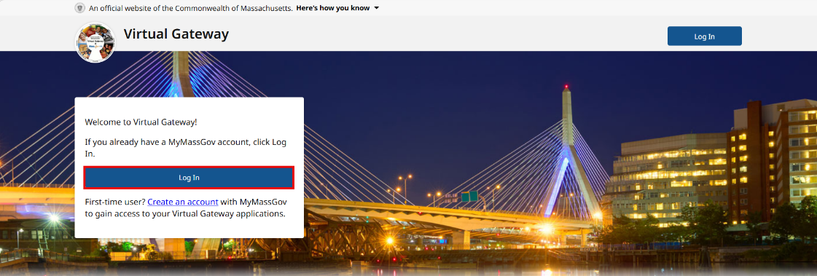
- Click Business Log In for my job or my business.
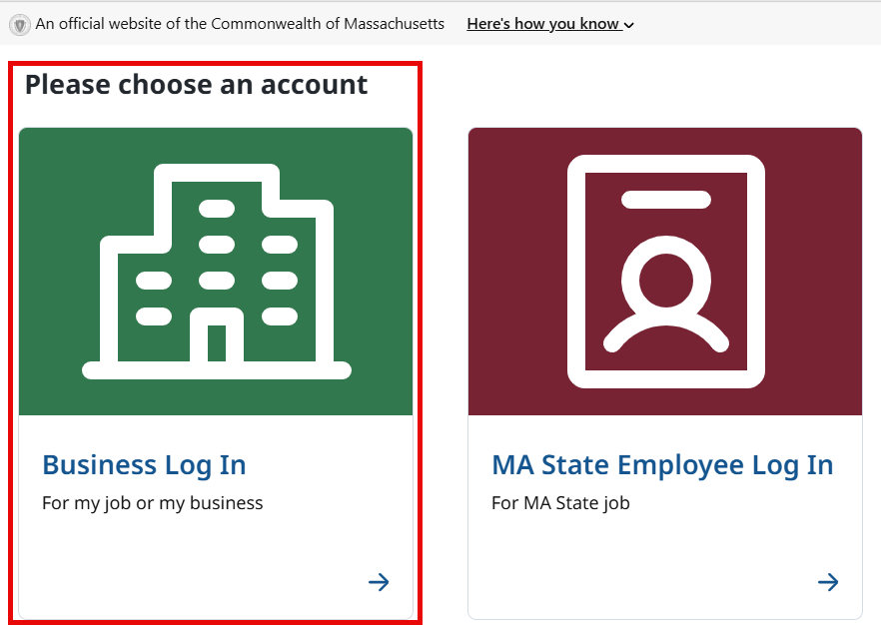
- Click Proceed on the Security Warning page.
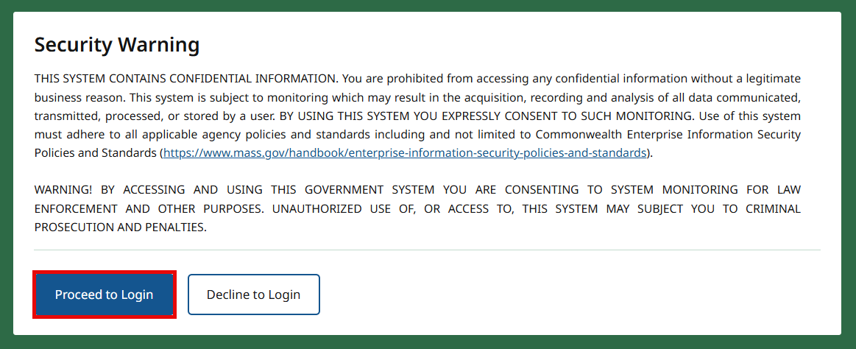
- First time using MyMassGov? Click the CREATE AN ACCOUNT button.
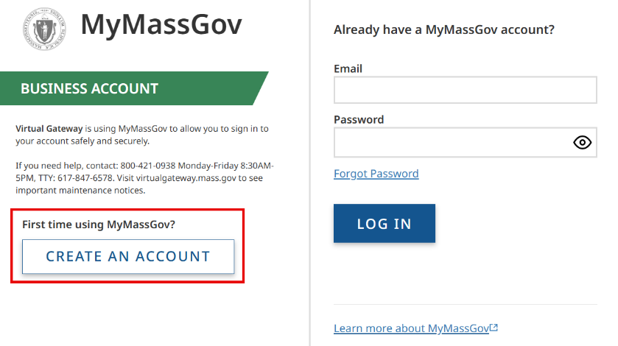
Consent to share MyMassGov profile information
- Click Continue button. Note: After giving consent, user will not see this page again when logging into account.
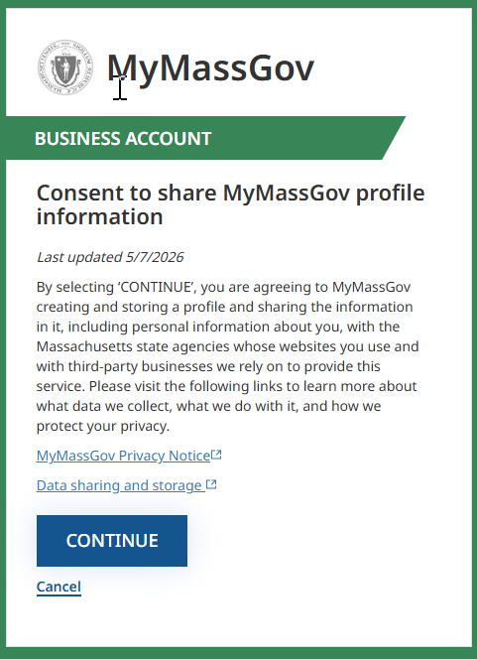
Create your account - Step 1 of 3: Verify your email
- Enter Email
- Click the SEND VERIFICATION CODE button.
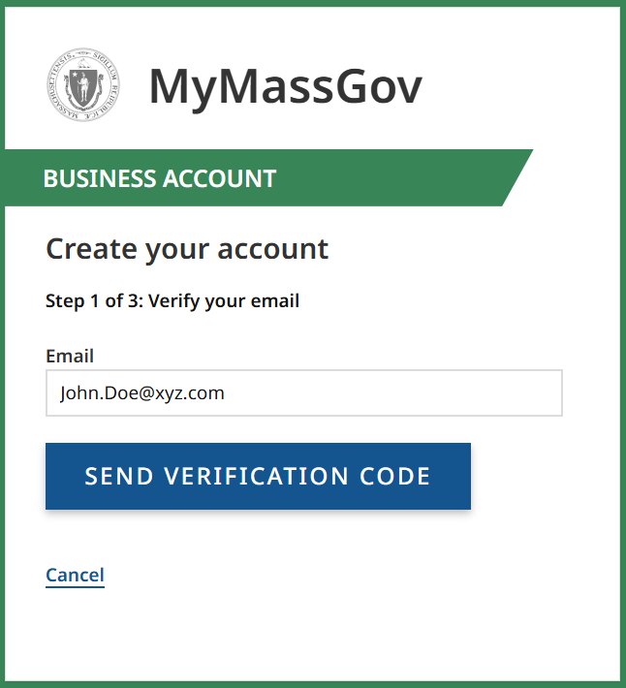
- You will receive an email with a one-time verification code (email from MyMassGov - login@noreply.mass.gov with Subject: Verify your email address)
- Copy or type the Verification Code into the Verification code field
- Click VERIFY EMAIL.
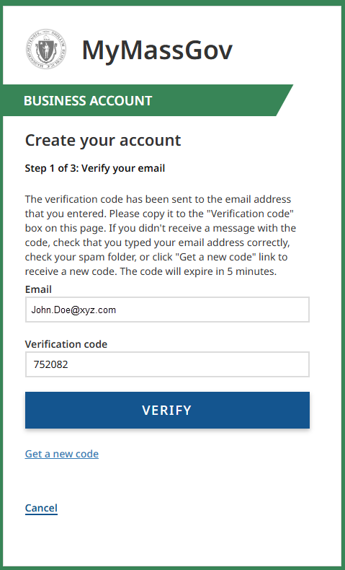
Create your account - Step 2 of 3: Add account details
- Enter First Name.
- Enter Last Name.
- Click CONTINUE.
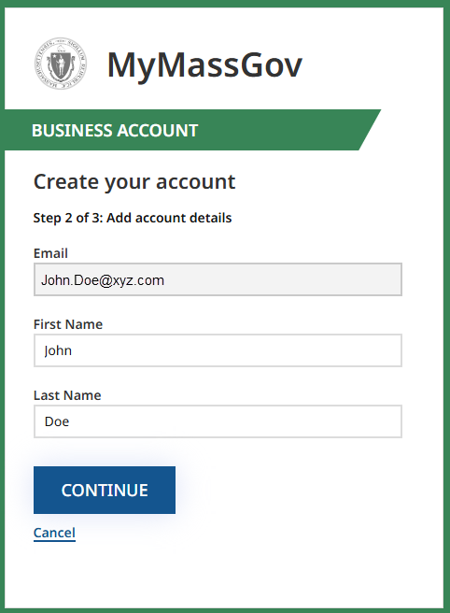
Create your account - Step 3 of 3: Set up your password
- Enter New Password.
- Confirm New Password.
- Click Create Account.
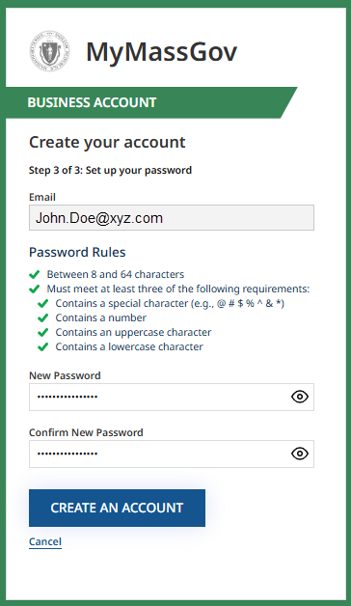
Your MyMassGov Business account has been created. The next step is to set up your multifactor authentication (MFA).
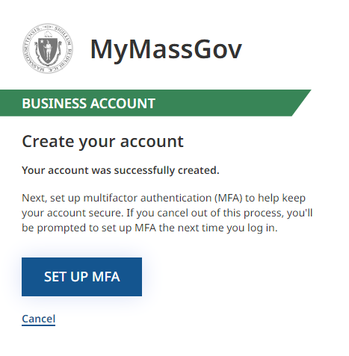

Set up Multifactor Authentication (MFA)
On the ‘Choose your Authentication Method’ screen, check the MFA option(s) you would like to use. You must choose at least one and can choose one, two, or all three. We recommend setting up at least two MFA option with Telephone number (voice and text) being one method when possible. Telephone number is required if you need to call for an MFA Reset. You will set up each option separately.
- Authentication App*- Select this choice if you would like to verify using an authentication app
- Phone (Voice and Text Message)- Select this choice if you would like to verify using one phone number
- Secondary Phone (Voice and Text Message)- Select this choice if you would like to verify using two phone numbers
- Select authentication method(s)
- Click CONTINUE
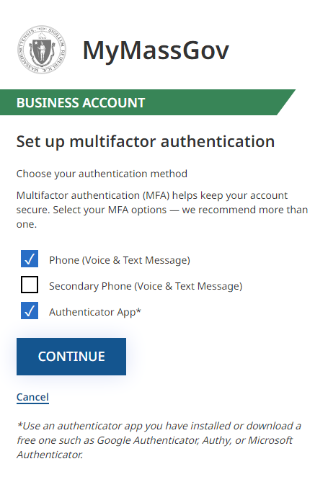

OPTION 1: To setup an Authentication App:
Authentication App*
- At the ‘Choose your authentication method’ screen select 'Authentication app*’
- Click ‘Continue’
- Link an authentication app- Use an authentication app you have installed or download a free one such as Google Authentication, Authy, or Microsoft Authenticator
- Open your authentication app
- Scan the QR code that appears under ‘Scan this QR code with your app’
- If you have trouble scanning the code, click ‘Having trouble’ and enter the code flush left in the ‘Enter your code’ field
- Enter the code that appears in your authenticator app in the ‘Enter your code’ text field
- Click ‘Continue’
OPTION 2: To setup a phone number:
Phone (Voice and Text Message)
- At the ‘Choose your authentication method’ screen select ‘Phone (Voice and Text Messages)’
- At the ‘Link your phone number’ screen select the correct country code
- Enter the phone number you’d like to use to receive a one-time code
- Click either ‘Text me’ or ‘Call me’
- Enter the code sent to your phone
- Click ‘Verify code’
- If you don’t receive a code or the code you received doesn’t work or expires, select ‘Get a new code’ and a new code will be sent to your phone
OPTION 3: To setup a second phone number:
Phone (Voice and Text Message)
- Secondary Phone (Voice and Text Message)
- At the ‘Choose your authentication method’ window select both ‘Phone (Voice and Text Message)’ and ‘Secondary Phone (Voice and Text Message)’
- After successfully setting up your first phone number as an authentication method, you will see a screen to link a secondary number
- Select the correct country code
- Enter a different second phone number you’d like to use to receive a one-time code
- Click ‘Continue’
- Click either ‘Text me’ or ‘Call me’
- Enter the code sent to your phone
- Click ‘Verify code’
- If the code you received does not work or expires, click ‘Get a new code’ and enter it
- Enter Code.
- Click VERIFY CODE.
The next time you log in, you might be asked to verify your account using one of these methods. You’ll be able to choose which one you’d like to use.
If you set up verification by authentication app:
- In the ‘Verify your account’ screen, click ‘Authentication app’
- Enter the six-digit code you receive from your authentication app
- Click ‘Continue’
- You will be logged into your account
If you set up verification by phone number:
- At the ‘Verify your account’ screen, click ‘Phone (Voice and Text Messages)
- At the next screen, you’ll see the phone number you entered to be used for verification*
- If you set up two phone numbers, you’ll see both options here and can choose one
- Click ‘Text Me’ or “Call Me’
- Enter the six-digit code that was sent to the phone number shown. The code will expire in five minutes from the time it is sent.
- Click ‘Verify code’
- If the code you received does not work or expires, click ‘Get a new code’ and enter it
*NOTE: If the phone number you see on the screen to be used for verification is not correct, start over and make sure you’re logging into the correct account.
The success page will appear letting you know your Virtual Gateway account has been created, and you can now log in.
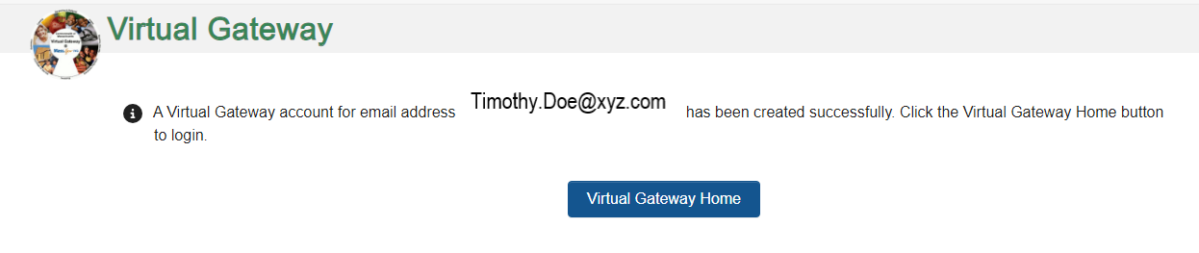

Log In to Virtual Gateway Application(s)
- Click the Log In button.
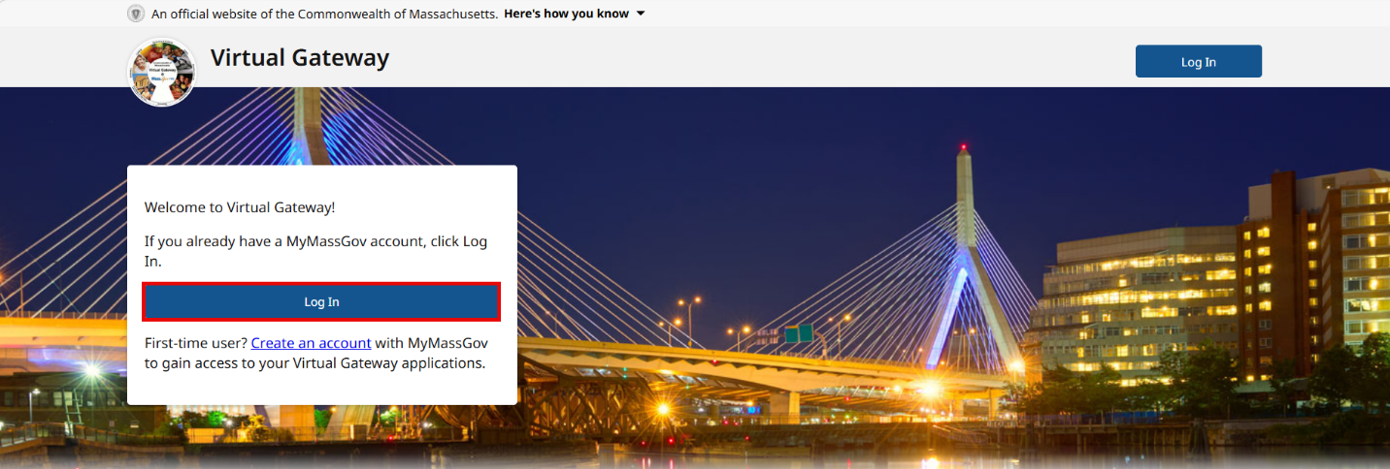
- Click Business Log In.
- Read Security Warning.
- Click the Proceed button.
- Enter Email.
- Enter Password.
- Click LOG IN button.

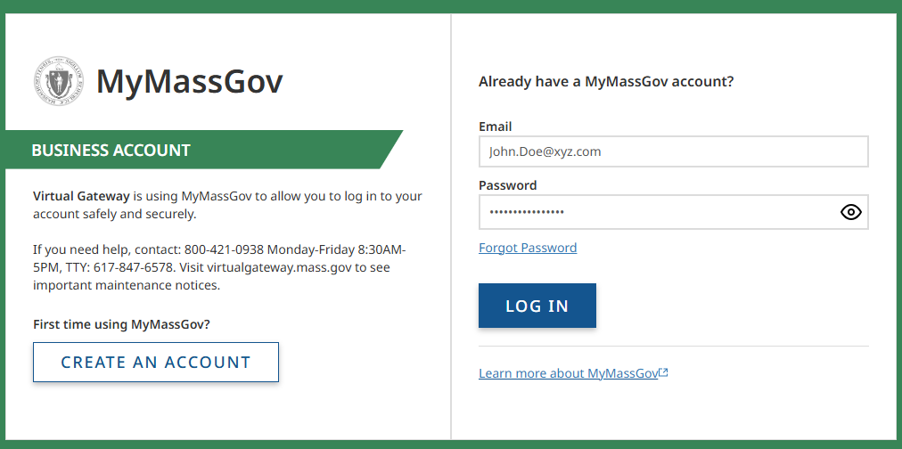
Click verification method as listed on your screen (Authenticator app, Text Me, Call Me)
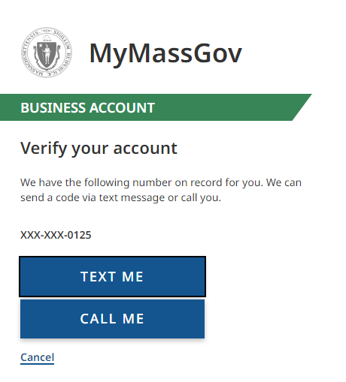
- Enter verification code (authenticator app, phone, text message).
- Click Verify.
The first-time logging into the Virtual Gateway you will be taken to the Accept/Update Agreement page. All Virtual Gateway users must accept the terms and conditions to proceed to the Applications page.
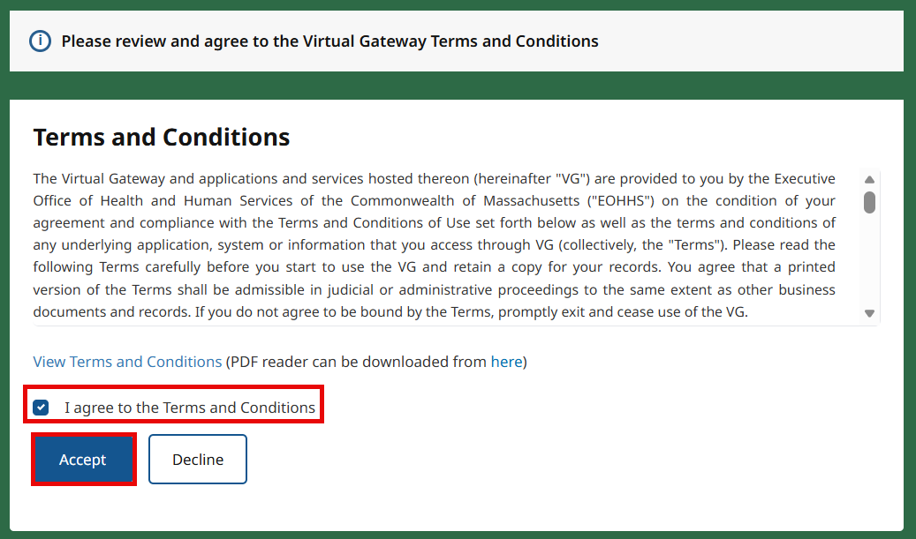
- Review Terms and Conditions.
- Check the checkbox next to ‘I agree to terms and conditions.
- Click the Accept button.

Access to More Than One Organization
If you have access to more than 1 organization, you will be taken to the Select Organization page.
Note: Skip this section if you only have access to 1 organization
- Select Organization from drop down menu.
- Click Proceed.
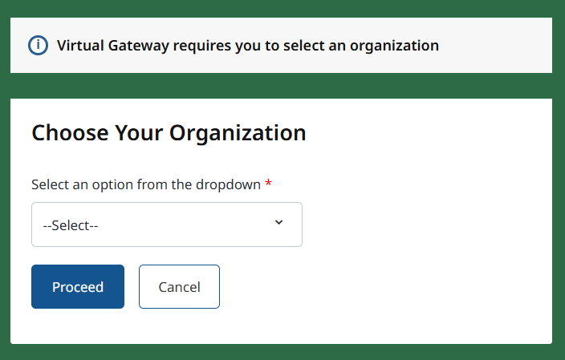
The Virtual Gateway Dashboard page appears.
Congratulations! You have successfully created a MyMassGov business account, set up multifactor authentication and logged into Virtual Gateway to access the applications you have access to.

Access to More Than One Virtual Gateway User ID
Users who have more than one User ID will be redirected to the Choose Your Username page. This page will display the accounts associated with your email address. The user selects a Virtual Gateway ID from the list.
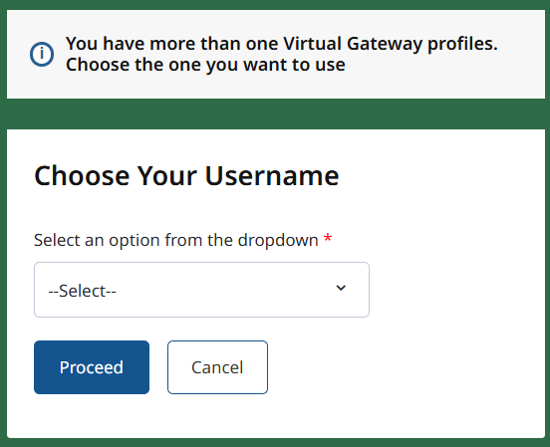
- User selects the VG User ID that they want to link to/access. Note: User will need to link each time they need to access a different VG User ID.
- Click the Proceed button.
The user receives the message stating the User ID selected. As directed on the screen, the change will take effect on the next log in.
- Click the Continue button.
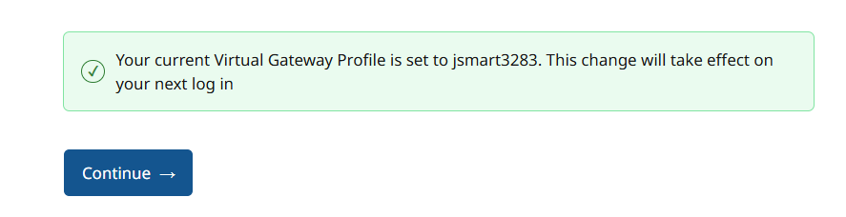
- Follow Steps above to log into your other account(s). If within the same session, you will not need to enter a verification code. If a verification code is needed, it will generate through the authenticator app, voice or text.
The Virtual Gateway Dashboard appears. You will see in the upper right of the screen your First/Last Name and the User ID currently logged in under. If you need to switch to a different account, the Switch Profile option is on the Dashboard.
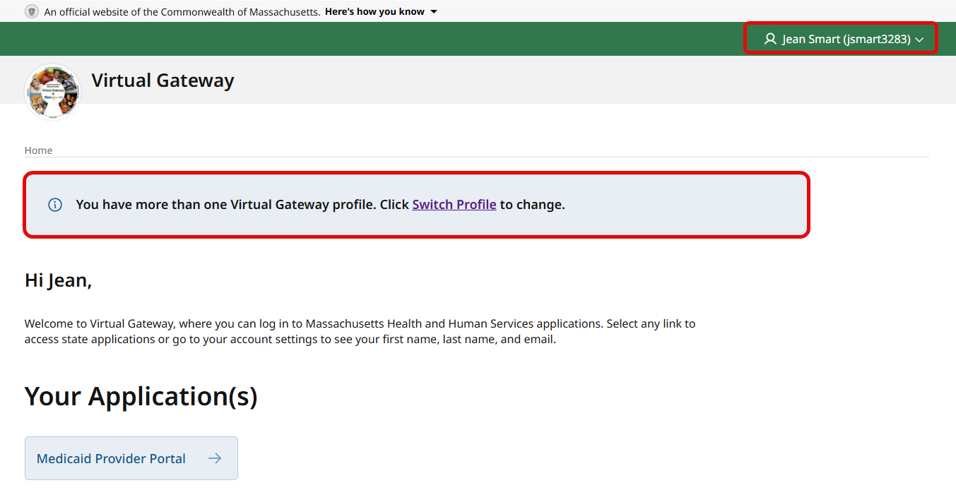

How to Switch Accounts (Log In under different VG User ID)
- Click Switch Profile.
The menu will display the Change your profile page.
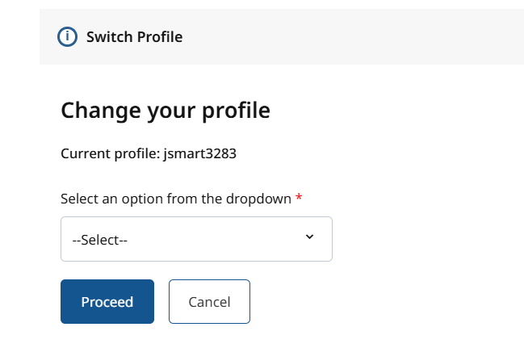
- Click drop-down menu for User ID. The User ID(s) not currently linked will appear in the drop-down menu. Notice that ID currently logged in is not listed and that is because that ID is currently associated/linked – as noted in message on screen.
- Click to select a different User ID from list.
- Click the Proceed button.

The user is now associated to the selected Virtual Gateway Profile selected.
Users will need to log in again after linking.
- Click the Continue button.
- Follow Steps above. If within the same session, you will not need to enter a verification code. If a verification code is needed, it will generate through the authenticator app.
- Click on application to access.

Resetting your password
Forgot your MyMassGov Password?
If you have forgotten your password or want to reset it, complete the following steps:
- Click the following link to access the Virtual Gateway website: https://virtualgateway.mass.gov/
- Click the Log In button.
- Click the Business Log In button.
- Click ‘Proceed’ to accept the Security Warning.
- On the MyMassGov page under the Already have an account? area (right side of page) where you would normally enter your email and password, click on the ‘Forgot password’ link.
- Enter your email address.
- Select ‘Send verification code’.
- Check your email for a message containing a verification code. If you don’t see it in your inbox, be sure to check your spam folder.
- Enter the code you received.
- Select ‘Verify code’.
NOTE: Once a code is sent, it is good for 5 minutes. If you do not enter it within that timeframe, you will need to click on the ‘Send new code’ link to receive another code for verification.
- Enter a new password.
NOTE: Your password must meet the password requirements listed on the page. Once a checkmark is next to each requirement, your password has met the requirements.
- Re-enter your password to confirm it.
- Click ‘Continue’.
You will be brought the Virtual Gateway Dashboard.
Remember to use the new password you just created the next time you log in.

Virtual Gateway Customer Service
If assistance is needed, contact Virtual Gateway Customer Service.
Virtual Gateway Customer Service: (800) 421-0938 - TTY (617) 847-6578
Monday - Friday 8:30 am - 5:00 pm

