

DCAMM
CAD Standards

Revision 3: January 2021

INTRODUCTION

The Division of Capital Asset Management & Maintenance (DCAMM) has developed the DCAMM CAD Standards with to create consistency and data compatibility among a variety of designers, consultants and contractors, project applications and post construction activities. It is the goal of DCAMM to maintain a set of CAD Standards that are timely, current, and reflect state-of-the-art technology, data management, and current managerial techniques throughout the project life cycle.
The intent of these CAD Standards is to provide a means for consistent graphics management on all projects under the responsibility of DCAMM. This document has been approved as the official reference for determining the graphical display, symbology, and electronic file management conventions to be used on all DCAMM projects. These CAD Standards are designed to help DCAMM’s designers communicate requirements to clients, contractors, consultants, and others involved in project document preparation, project coordination, and construction as well as to help DCAMM to maintain facilities once construction is complete.
The DCAMM CAD Standards are not a specification or requirement of what software products are to be utilized on DCAMM projects, but rather a specification of how graphic and tabular data are to be created and delivered to DCAMM. The Standards reflect DCAMM data management needs and alignment with the United States National CAD Standard – V6.
The DCAMM CAD Standards are a requirement for all DCAMM projects.
All requests for any deviation in the use and requirements of the DCAMM CAD Standards are to be submitted in writing to the DCAMM Project Manager.
DCAMM CAD Standards are complementary to the “DCAMM BIM Guidelines for Design and Construction,” the DCAMM Standard Specifications,” the DCAMM “Designers Procedures Manual,” the DCAMM “Cost Estimating Manual” and other DCAMM contracts, documents, requirements and procedures promulgated by DCAMM.
To ensure data consistency and compatibility across various data providers on various projects, a CAD “SEED file” has been developed. This file is provided to DCAMM designers and consultants for use on all DCAMM projects in order to create a standard drawing package. For a detailed description of the SEED file please refer to Section 4.1.
The SEED file contains the following:
1. Cover Sheet (PDF and DWG)
2. Title block (PDF and DWG)
3. Pen Settings (CTB)

All requests for any deviation in the use and requirements of the DCAMM CAD Standards are to be requested in writing to the DCAMM Project Manager.
Please note that these standards will be periodically revised and updated to stay current with changing technology, DCAMM policies, and construction practices.
It is recognized that the disciplines associated with DCAMM activities change, and this manual and associated SEED file will be revised to reflect such changes.
For projects using Building Information Modeling (BIM) to develop computer-based virtual building models, a section has been added to the DCAMM CAD Standards to outlines the drawing output process from the BIM authoring software to meet the DCAMM CAD Standard requirements. While the DCAMM CAD Standards address different areas of construction documentation, the DCAMM “BIM Guidelines for Design and Construction” address the modeling aspects of the workflow.
DCAMM understands that CAD and BIM workflows are very different, and therefore, there are limitations to maintaining consistency with CAD Standards requirements when implementing BIM on a project. That said, the DCAMM CAD Standards remain the primary standard for 2-dimensional deliverables on all DCAMM projects, while the BIM Guidelines for Design and Construction address specialized needs for the implementation of BIM and 3-dimensionsional deliverables on DCAMM projects.
Furthermore, a BIM Implementation section has been developed to outline the integration of the DCAMM CAD Standards for BIM use. This section provides guidelines for incorporating the DCAMM CAD Standards requirements into a BIM workflow for most projects.
The DCAMM CAD Standards reflect the expertise of a group of DCAMM employees from several offices who reviewed and commented. To assist in the update of this DCAMM CAD Standards document, DCAMM retained the services of Skanska USA Building, Inc. of Boston, Massachusetts.

TABLE OF CONTENTS
INTRODUCTION
TABLE OF CONTENTS
PURPOSE
ABOUT THIS DOCUMENT
1.1 ACCESSING THE CAD STANDARDS
1.2 USING THE STANDARDS FILES
2.1 PROJECT DIRECTORY STRUCTURE AND FILE NAMING
CONVENTION
2.2 PROJECT INFORMATION DELIVERY
2.3 DIRECTORY STRUCTURE
2.4 FILE NAMING CONVENTION
2.5 SUBMISSIONS
2.6 ELECTRONIC DELIVERABLES
2.6.1 DESIGNERS RECORD TURNOVER: ELECTRONIC REQUIREMENTS
2.6.2 DELIVERABLE REQUIREMENTS
2.6.3 QUALITY CONTROL
2.6.4 CAD STANDARDS ELECTRONIC SUBMITTAL
CHECKLIST
3.1 CAD PRACTICES AND PROCEDURES
3.2 LAYERING SCHEME DEFINITION
3.3 ENTITY AND LAYER LINETYPES
3.4 ENTITY AND LAYER COLORS
3.5 COORDINATE SYSTEMS
3.6 SYMBOLOGY
3.6.1 DIGITAL INSERTION OF SCALEABLE SYMBOLS
3.6.2 DIGITAL INSERTION OF NON-SCALEABLE SYMBOLS
3.6.3 CREATING SYMBOLS
3.6.4 OBJECT ENABLERS
3.7 PLOTTED LINEWEIGHTS
3.8 TEXT STYLES AND HEIGHTS
3.9 DIMENSION STYLES
3.10 EXTERNAL REFERENCE FILES
3.11 POLYLINES
3.12 DATA EXTRACTION (Area and Information Extraction)
4.1 SEED FILE
4.2 ACCESSING LAYERS BY GROUP FILTERS
4.3 TITLE BLOCKS
4.4 LOADING THE DCAMM TITLE BLOCK INTO SEED FILE
4.5 DCAMM STANDARD COVER SHEET
5.1 CAD PRACTICES AND PROCEDURES
5.2 CAD CONFIGURATION (Plotting by Layout)
5.3 TEMPLATE DRAWING SETUP
5.4 PAGE SETUPS
5.5 PLOT SETUP
6.1 BIM INTEGRATION
6.2 ACCESSING LAYERS BY GROUP FILTERS
6.3 TITLE BLOCKS
6.4 LOADING THE DCAMM TITLE BLOCK INTO SEED FILE
6.5 DCAMM STANDARD COVER SHEET
7.1 DISTRIBUTION FILES
8.1 UPDATE AND REVISION PROCEDURES
9.1 CONTACT AND SUPPORT INFORMATION
10.1 CONCLUSION

11.1 BIBLIOGRAPHY

APPENDIX

I - LAYER SCHEME................................................................................. (1-53)

II - PEN SETTINGS (CTB) ........................................................................ (1)

III - PLOTTING TO PDF ............................................................................ (1-2)

IV - CREATING PAGE SETUPS & PLOTTER CONFIGURATIONS.... (1-16)

V - REQUEST TO CHANGE STANDARDS............................................. (1)

VI - CAD DRAWING REQUIREMENTS.................................................... (1-9)

V1.1 SCHEMATIC DESIGN PHASE………………… ………………... (VI-1) V1.2 DESIGN DEVELOPMENT PHASE ………………………...…….. (VI-3) V1.3 CONSTRUCTION DOCUMENT PHASE ……………………….... (VI-6)

PURPOSE

The DCAMM CAD Standards Manual establishes requirements and procedures for the preparation and submission of CAD-based drawings throughout the project life cycle. Adherence to this standard ensures that both DCAMM internal staff and consultants involved will receive and produce graphic and tabular data in a consistent format. This consistency will improve the compatibility of these drawings internally and the efficient exchange of data between DCAMM consultants, and client agencies.

The DCAMM CAD Standards largely reflects the National CAD Standards, Version 6. In the case of differences between the two documents, the DCAMM CAD Standards is to be considered definitive for DCAMM projects.

All CAD deliverables must be in the latest software platforms and provided in DWG format. All deliverables outlined herein are required by contract for all DCAMM work.

This manual is intended to be used in conjunction with The Designers Procedures Manual effective June 2005.

ABOUT THIS DOCUMENT

The chapters within this manual describe how DCAMM uses CAD and how to configure CAD to support the DCAMM’s CAD Standard, which it has adopted. Additionally, Section 4 of this manual provides guidelines for BIM and CAD integration, highlighting best practices for importing and exporting files between 2D CAD programs and 3D modeling platforms.

While DCAMM is not requiring the use of Autodesk AutoCAD, sample workflow images from Autodesk AutoCAD have been included as examples throughout this document.

The appendices, which follow, support the chapters in several ways. In addition, appendices have been provided to support CAD related subject matter.

1.1 ACCESSING THE CAD STANDARDS

The DCAMM CAD Standards consists of a series of support files, which are available at the DCAMM website located at http://www.mass.gov/anf/property-mgmt-and-construction/design-and- construction-of-public-bldgs/guides-manuals-and-standards/division-of-capital-asset-management- cad-standards.html.

The “DCAMM_Standards” folder contains the DCAMM “Seed file,” DCAMM Title block, DCAMM Cover Sheet and a pdf version of the DCAMM CAD Standard Manual.

For internal access to the DCAMM CAD Standards and associated files, DCAMM users can use the DCAMM Intranet link.

1.2 USING THE STANDARDS FILES

The Standards directory contains two primary types of files: files that do not require ongoing user interaction to utilize and files that do require ongoing user interaction to utilize. The first type refers to files used as CAD support files, which only need to be copied once to the proper support folders. The second type refers to files such as Borders and Title Sheets along with their associated revision blocks. These files do require some user interaction to utilize in a drawing.

2.1 PROJECT DIRECTORY STRUCTURE AND FILE NAMING CONVENTION
This chapter provides a structure for the development of CAD projects. Adherence to this structure will ensure that DCAMM receives maximum benefit from its CAD implementation.

The two primary goals of this structure are as follows:
- Promote effective and efficient coordination between functional groups
- Develop CAD projects in a way that will facilitate the use of the electronic information beyond the initial contract.

2.2 PROJECT INFORMATION DELIVERY
All project related electronic deliverables and related data shall be submitted via electronic media (i.e., thumb drive, external hard drive, ftp, etc.). All deliverables, upon submission, will become the property of the Commonwealth of Massachusetts.

2.3 DIRECTORY STRUCTURE

Within the Projects folder, individual project folders will be created using the Project Number. Each project folder shall contain a series of sub-folders as listed below.

DWG Folder
The DWG folder is used to store all design (model) drawing files.

Rules of the Drawing Folder:

- Additional folders may not be created in the DWG folder.

DWG_SHEETS Folder
The DWG_SHEETS folder is used to store all Plot Sheet drawings. These drawings consist of a series of external references. All drawings in a set shall have a corresponding plot sheet drawing in this folder. Each of the drawings may contain multiple layouts within a single file. The stipulations of this are:

- Only consecutive drawings may be stored on multiple paper-space tabs in a single drawing.
- The tabs must be named for the sheet and the tabs must be in sequence in the drawing file.

Please refer to Section 2.4 FILE NAMING CONVENTION for information on naming DWG sheet drawings.

Rules of the DWG_SHEETS Folder:

- Additional folders may not be created in the Sheets folder.
- Only DWG sheet drawings shall be stored in the DWG_Sheets folder.

PDF Folder
At each milestone PDF files are created and placed in this folder. (e.g. Sketch, Preliminary, Revision Number)

- Sub-folders may be created in the PDF folder representing each milestone

SCRATCH Folder
The Scratch folder shall contain temporary design data. This folder is to be used to store temporary drawings and other design information.

Rules of the Scratch Folder:

- Sub-folders may be created in the Scratch folder.
- The Scratch folder will not be archived with the project.

FROMOTHERPROJECTS Folder
The Fromotherprojects folder will contain drawings and data that have been taken from other projects that relate to the current project.

Rules of the Fromotherprojects folder

- Subfolders may be created in the Fromotherprojects folder.
- The Fromotherprojects folder will be archived with the project number.

IMAGES Folder
The IMAGES folder is provided to store digital photographs or other images relevant to the project. Photos or images to be referenced by drawing files should be referenced from this folder.

Rules of the Images folder:

- Subfolders may be created in the Images folder.
- The Images folder will be archived with the project.

MANAGEMENTDOCS Folder

The Management docs folder stores non-drawing related project data. This folder should store spreadsheets, word documents, e-mails and other types of non-drawing information that relate to the project.

Rules of the Management docs folder:

- Subfolders may be created in the Managementdocs folder.
i.e. Word-Files, Sent-Out (Text and PDF), and Email

RECEIVED Folder
The Received folder is to contain design information received from outside sources such as consultants. The folder is intended to provide a storage container for dated information. Even though the received information may be design files that will be stored in the discipline root as model files, the received folder can contain a dated archive of these files to identify when the data was received and exactly what the submittal contained on that date.

Rules of the Received folder:

- Subfolders may be created in the Received folder.
- Subfolders shall have the date as a prefix as follows: YY/MM/DD

RELEASED Folder
The Released folder is to contain design information released to outside sources such as consultants. The folder is intended to provide a storage container for dated information. Even though the released information may be design files that will be stored in the discipline root as model files, the released folder can contain a dated archive of these files to identify when the data was released and exactly what the submittal contained on that date.

Rules of the Released folder:

- Subfolders may be created in the Released folder.
- Subfolders shall have the date as a prefix as follows: YY/MM/DD

ALTERNATE SCHEMES Folder
The Alternate Schemes folder is an area intended to store various schemes of a design component. It provides the designer an area in which to make trial changes to a design. If a scheme is created and chosen as the final, the scheme drawings shall be moved to the MODEL folder.

Rules of the Alternate Schemes folder:

- Subfolders may be created in the Schemes folder

2.4 FILE NAMING CONVENTION

Model Files: (DWG Folder)

Model files are working drawing files containing actual design geometry. These drawings will be named by providing the discipline code followed by the Project Number, a plan type and a user defined description of the drawing’s contents. Please refer to the tables below for the plan type codes. Once defined, a model file’s name shall not change through the life cycle of the project. This restriction is required due to the nature of externally referencing Model files.

The filename will take the form of:

PN D-FP-User Description.dwg

 | Project Number
*D = | The Discipline Code
**FP = | Model File Plan Type
User Description = | User defined description of the files contents

- * Allowable discipline codes are: A, C, E, F, G, I, L, M, P & S
- ** Please refer to the Charts below for the abbreviations used for each of the Model File Plan Types

MODEL FILE PLAN TYPES
TS | Border Sheet | FN | Furniture Plan
KP | Key Plan
 |  | PP | Piping Plan
CP | Reflected Ceiling Plan | FP | Fire Protection Plan
DT | Detail | HP | HVAC Plan
EL | Elevation
FP | Floor Plan | FA | Fire Alarm Plan
 |  | EP | Electrical Power Plan
LG | Legend | LP | Lighting Plan
QP | Equipment Plan
SH | Schedule | TP | Telephone/Data Plan
XD | Existing/Demolition Plan

DWG file name example: 0001-A06-FP01-First Floor Plan.dwg

Model File Plan Type vs. Drawing Type:
A model file plan type is used in the model file naming convention to distinguish what type of drawing it is. The alpha character used in the drawing numbering convention denotes a drawing type.

DWG Sheet Files:
DWG Sheets are drawing files that consist of an externally referenced border sheet, an inserted drawing-info block and a single or multiple externally referenced model files. All DWG sheet drawings will be created in the DWG folder. The file names for DWG sheets will be the Project Number and discipline code and with the sheet number range appended to the end. The DWG sheet filename shall not have a user description appended to it (alternate if discipline code is used).

The filename will take the form of:

PN-SHT (single sheet) (0001-A06-FP01.dwg)
PN-SHT_SHT.dwg (sheets 1 through 4 in a single drawing file) (0001- A06-FP001-FP004.dwg)

PN = | Project Number
D = | Discipline Code (Refer to chart on Previous Page)
0001_004 = | Starting Sheet Number to Ending Sheet Number (assumes multiple sheets stored in Layout Tabs in a single drawing file).

2.5 SUBMISSIONS

All submissions shall conform to the DCAMM CAD Standards. The CAD portions of the Certified Study, including but not limited to Surveys, Geotechnical Plans, and Existing Conditions Drawings, as well as Schematic, Design Development, and sixty (60%) per cent complete design submissions shall be submitted to the DCAMM Project Manager. At his or her discretion, the DCAMM Project Manager shall load these preliminary submissions to eBuilder.

Electronic versions of Bid Documents and Bid Documents Addenda shall conform to the DCAMM CAD Standards. Bid Documents and associated Addenda shall be stored in eBuilder.

Upon the completion of construction, Record Drawings shall be prepared by the designer(s) and submitted to the DCAMM Project Manager. The CAD version of this submittal shall conform to the DCAMM CAD Standards and shall be stored in eBuilder.

2.6 ELECTRONIC DELIVERABLES

Electronic files and documentation are due with the final submission (and any required interim submission) for each project.

This includes studies, data, or graphics, which may or may not include drawings. Final submissions that do not include all files and documentation are incomplete DCAMM strongly emphasizes the importance of final record drawings. These drawings will be used in the management of DCAMM buildings by DCAMM and by client Facilities Management departments. State buildings typically have significant changes in their configuration over their life span. Accurate record drawings are of vital importance in these building management and alteration processes.

2.6.1 DESIGNER RECORDS TURNOVER: ELECTRONIC REQUIREMENTS

- Record Drawings shall be submitted as follows:

CAD files (.dwg format) of dated/Stamped Record Drawings submitted via electronic media.

PDF files of dated/Stamped Record Drawings via electronic media.

All as-builts should be submitted by the Contractor and incorporated into Record Drawing deliverables.

All pages of Record Drawing submittal should be labeled, “Record.”

- GIS Deliverables shall be submitted as follows:

In addition to data to be delivered to DCAMM in .dwg format, the following items, described as GIS deliverables, are to be delivered as specified below:

- Parcel boundaries
- Building footprints
- Roads (if new) within the survey
- Contours and elevation data (if a project requirement)

- All GIS deliverable data should be delivered in the Massachusetts State Plane Coordinate System, Mainland Zone, with units of feet or meters utilizing the horizontal datum of NAD83 and the vertical datum of NAVD88.

2. All final digital data will be delivered in GIS shapefile or geodatabase format via electronic media suitable for use with ArcGIS. All deliverables will become the property of the Commonwealth of Massachusetts.

2.6.2 DELIVERABLE REQUIREMENTS

All electronic files, documentation, and associated data shall be submitted to DCAMM via electronic media. All deliverable shall be in a format that can be read and processed by DCAMM supported hardware and software. All files should be named, at minimum, with the following details: date, DCAMM project name/number, CAMIS project number and CAMIS building name/number.

Upon submission, all deliverables will become the property of the Commonwealth of Massachusetts.

2.6.3 QUALITY CONTROL

The Designer is responsible for the quality control of their submissions. DCAMM will visually and electronically check these submissions to verify compliance. High quality of drawings is essential, Drawings must be edited before submittal in the matter that lines in corners shall connect; blocks on unnecessary locations shall be deleted or purged.
DCAMM will reject and require correction of any required deliverables or formats that do not meet requirements.

2.6.4 CAD STANDARDS ELECTRONIC SUBMITTALS CHECK LIST

- For final deliverables, verify that all entities outside the drawing limits are deleted.

- Remove all extraneous graphics outside border area. PURGE all blocks, layers, attributes, etc. not referenced in the drawing. Avoid nested blocks

- Name files as specified in Section 2.4 of this Manual.

- Verify that all xrefs (.dwgs and images) are attached without drive or directory specifications. Do not include paths in xref.

- Xrefs shall be bound when submitted.

- Check that all unused layout tabs are deleted.

- Drawing submissions shall have revision stamps in the title block (ex: As builts, record drawing, etc.)

- Objects shall be assigned the appropriate layer based on DCAMM’s standards as outlined in Appendix I.

- Object color, line type and line weight shall be set to BYLAYER NOTE: (Colors should align with NCS V6)

- Text in tables and schedules shall be editable.

- Rooms, spaces and boundaries shall be drawn using polylines to allow easy extraction of information. Please refer to Section 3.11 for data extraction.

NOTE:

* Survey drawings submitted by the consultant to Programming Department shall be on the correct layers and symbology and contour lines as well as space assignments shall be drawn as polylines. All drawings are to be submitted in DWG format and PDF format.

* All drawings submitted to the Office of Leasing and State Planning shall include USF Stamp in Title block (see DCAMM Standards.dwg) and shall be in both DWG and PDF format.

All Drawings submitted to Facilities Management Department shall be in both DWG and PDF format.

3.1 CAD PRACTICES AND PROCEDURES

CAD drawing files must be consistently formatted to provide an effective method of data dissemination and retrieval. To that end, this DCAMM CAD Standards will guide the user in the requirements of layer naming, graphic symbology, lettering styles, drawing units and other features.

3.2 LAYERING SCHEME DEFINITION

All layers contained in drawings have been defined using the National CAD Standards. All disciplines use a layer standard that is similar. The major components of a standard layer name are defined as follows:

DISCIPLINE.STATUS-MAJOR-MINOR-DESC

LEVEL 1 DISCIPLINE DESIGNATORS
G | General
H | Hazardous Materials
V | Surveying/Mapping
B | Geotechnical
C | Civil
L | Landscape
S | Structural
A | Architectural
I | Interiors
Q | Equipment
F | Fire Protection
P | Plumbing
D | Process
M | Mechanical
E | Electrical
W | Distributed Energy
T | Telecommunications
R | Resource
X | Other Disciplines
Z | Contractor/Shop Drawings
O | Operations

STATUS = Indication of the information’s current status

LEVEL 1 DISCIPLINE DESIGNATORS
A | Abandoned
D | Existing to demolish
E | Existing to remain
F | Future work
M | Items to be moved
N | New work
T | Temporary work
X | Not in contract
1-9 | Phase Numbers

MAJOR = Major grouping of features that have common characteristics
A typical layer name showing the required field only. The mandatory Major Group field is highlighted:
A | - | W | A | L | L

MINOR = Sub grouping of Major Category
A typical layer name showing one optional Minor Group field:
A | - | W | A | L | L | - | F | U | L | L

A typical layer name showing two optional Minor Group fields:
A | - | W | A | L | L | - | F | U | L | L | - | T | E | X | T

DESC= Extended description of layers for clarity

For example:

M-N-HVAC- -IDEN
M (Mechanical) = Discipline, N (New work) = Status, HVAC = Major Group,
= no minor, IDEN (Annotation) = Extended Description

NOTE: the layer information shall reflect survey information collected in the course of site plan development, stake outs, etc. for DCAMM projects

All drawing files shall be produced using DCAMM layer names and layer name formats.

Note: Not every layer will be used in every project.
See Appendix I. When submitting drawings, no objects will be on layer 0 (zero) unless otherwise specified. Layers in the Appendix have been assigned Departmental Activity color coded and shall be read as follows

L = Leasing Data Color Coded S = Study and Planning Data Color Coded
SU = Survey Data Color Coded C = Design/Construction Data Color Coded

3.2 ENTITY AND LAYER LINETYPES

Standard DCAMM linetypes have been created for use with all design documents. These linetypes have been assigned to their respective layers in the “DCAMM Seed file.dwg” drawing, which has been supplied within these standards. Additional linetypes have been created for special circumstances when the lettering within a linetype needs to be rotated or when the pattern of the linetype needs to be scaled down. As a general rule, all entities should have their linetype assigned “bylayer” and not “byentity”. One exception occurs with certain standard symbols that contain entities that have their linetype assigned “byblock”. Another exception occurs when there is a need to assign one of the “short” or “rotated” variations of a linetype to a particular entity.

To verify the correct linetype scaling settings for a DWG_SHEETS drawing, which utilizes one or more Layouts, first type “PSLTSCALE” at the command prompt and make sure that the value is set to “1”. This sets all linetypes to be scaled to the paper space viewport scale factor. In addition, the “LTSCALE” should be set to “1”. Verify this setting in the same way by typing “LTSCALE” at the command prompt and making sure that the value is set to “1”.

Working drawings, which reside in the DWG folder should have the LTSCALE set to the appropriate drawing scale.

3.3 ENTITY AND LAYER COLORS

All entities will be drawn on the specified layers and must have color assigned “by layer” not “by entity”. Layer color assignments are included in the layer definitions provided.

3.4 COORDINATE SYSTEMS

In an effort to organize, consolidate, and standardize the information generated and consumed by all divisions within the agency, Coordinate Systems must be used in all projects. The objective of this requirement is to make the data files easier for users to identify and integrate in planning and design. Survey data for site plans shall be tied to the Massachusetts State Plane Coordinate System and should so indicate. The Designer and/or Responsible Engineer must be capable of delivering survey data in whatever formats are specified by DCAMM: .dwg, shape files, etc.

3.5 SYMBOLOGY

A symbol is defined as a prearranged group of geometry that can be inserted, at scale, into a drawing. The CAD term for a symbol by this definition is “block”. There are two types of symbols provided in this standard: Scaleable and Non-Scaleable symbols.

3.5.1 DIGITAL INSERTION OF SCALEABLE SYMBOLS

Scaleable: Scaleable symbols are created with the intent that they will appear the same size when plotted at different scales.

- For ease of use, the insertion scale factor of each scalable symbol will depend on the output plot scale; Example: If the scale of the viewport is 1:30 (decimal units), then each symbol inserted in the drawing will be scaled up 30x. In the case of a drawing created at 1/8”=1’-0” (architectural units), the symbol will be inserted with a scale of 96x. For architectural units, the drawing scale will be multiplied by 12 based on the fact that architectural units correspond to inches.

- Symbols are created on Layer “0”, and will automatically take on the characteristics of the layer they are inserted on. All symbols shall be inserted on the layer identified in this standard.

3.5.2 DIGITAL INSERTION ON NON-SCALEABLE SYMBOLS

Non-Scaleable: Non-Scaleable symbols are created with the intent that they will appear true size at all plotting scales.

- These symbols will be inserted with a scale of 1.

- Symbols will be created on Layer “0”, and will take on the characteristics of the layer they are inserted on. All symbols shall be inserted on the layer identified in this standard.

3.5.3 CREATING SYMBOLS

- Symbols must be documented, and be supplied to the CAD manager or CAD Committee in digital format as a single CAD drawing file along with an accompanying plot of the symbol and the “Request to Change Standards Form” which is contained in Appendix V.

- Symbols must be created on Layer “0”. Other layers may be present in the drawing for supplemental information such as text with the symbol.

- Colors should always be set to “bylayer” and linetypes should be set to “bylayer” whenever possible.

- Text within the symbol should be sized appropriately so that it is legible upon plotting.

- The symbol should be drawn so that the insertion point is located appropriately. After using the “wblock” command, the resultant drawing file should be edited to have the “base” of the drawing set to 0,0,0. This can be implemented and checked by using the CAD “base” command. The 0,0,0 coordinate in the drawing file should be the location of the insertion point for the block.

- Symbol drawings should be purged of all unused blocks, linetypes, text styles, delete any extraneous layer filters and run an audit to find and fix any errors.

3.5.4 OBJECT ENABLERS

Enablers are collaboration utilities that allow users of other Autodesk products to view and manipulate objects created in AutoCAD MEP toolset. Enablers use ObjectDBX technology to allow object data created in AutoCAD MEP toolset to be accessed outside its native environment. This provides data accessibility for design teams that create and receive AutoCAD MEP toolset files. All object enablers should be included in file submission by designer or consultant.

3.6 PLOTTED LINEWEIGHTS

The colors used in the layer definition provided in this document correspond to plotted pen weights. All plotted submittals shall be provided using these pen weight assignments.

Most CAD products make use of a CTB file to assign pen weights to object colors. Many variables within the CTB file remain common throughout the pen assignments. Constant variables within the CTB file will be defined as follows:

VARIABLE | VALUE
COLOR | USE OBJECT COLOR
DITHER | AUTOMATIC
VIRTUAL PEN NUMBER | AUTOMATIC
LINETYPE | USE OBJECT LINETYPE
ADAPTIVE | NO
LINE END STYLE | USE OBJECT END STYLE
LINE JOIN STYLE | USE OBJECT JOIN STYLE
FILL STYLE | USE OBJECT FILL STYLE

3.7 TEXT STYLES AND HEIGHTS
To promote consistency in preparing CAD drawings, as well as to prevent the use of “third- party” CAD font files, only fonts distributed with the Autodesk products or standard Windows fonts shall be used. Where consultant logos contain non-standard fonts, these non- standard logo fonts should be duplicated as “graphics” for DCAMM deliverables. DCAMM requests that all non-standard logo fonts be similarly converted to “graphics” for its deliverables. All additional fonts must be approved by DCAMM.

Text styles have been created and provided with the “Seed file.” To use standard text styles, simply open CAD Design Center (hit control key and 2 or type adcenter) and navigate to the folder which contains the file “DCAMM Seed file.dwg”, as shown in Figure 3.7.1.
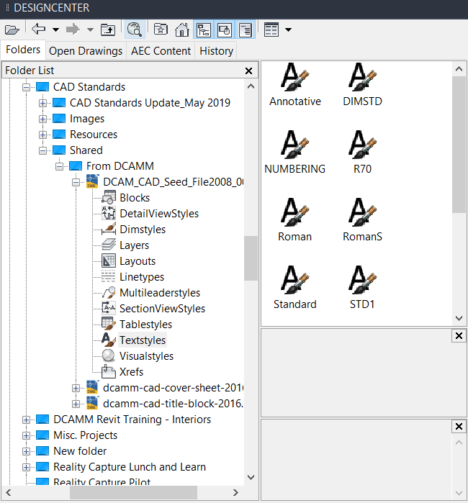

Figure 3.7.1

Drag and drop the desired text styles into your current drawing. The text styles have been named in conjunction with text height and plotting scale. For example, if you are going to lot at a scale of 1/8”=1’-0” and want to create text which will plot at an actual size of 1/10th of an inch, the appropriate text style would be “1-8in –1ft_1-10th”.

The width factor should be set to 1.0 and Oblique Angle should be set to zero for all text styles. Standard text heights are defined as follows:

USE | PLOTTED HEIGHT
Major Titles | 3/16”
Sub Titles | 1/8”
Notes, Dimensions, etc. | 3/32”

Note: All consultants’ logos have to be created, or edited to match, DCAMM standard fonts.

3.8 DIMENSION STYLES

As with the text styles, dimension styles have been provided with this document in an attempt to promote consistency throughout the creation of contract drawings.

The dimension styles are contained in the “DCAMM template.dwt” file and can be dragged and dropped into a current drawing by using CAD’s DesignCenter in the same manner as the text styles (shown in Figure 1.1). Similar to the text styles, the dimension styles have been named in conjunction with the final plotting scale. For example, if you are working at a scale of 1”=16’ select the style “1-16in – 1ft”.

All Dimstyles have been created to use the text style “DIM_Romans”. This font has been defined with the Romans.shx font. The height shall be defined as zero. The height of the dimension text will be a multiple of the DimScale system variable and the final plotted height. The Width Factor shall remain one and the Oblique Angle shall remain zero. In addition, all colors should be set to bylayer. All precision settings are open to drawing specific changes.

3.9 EXTERNAL REFERENCE FILES

All external reference files will be attached to drawings as “Overlays”. By adhering to this process, all users will be able to use drawings within their own disciplines as well as drawings from other disciplines without concern for cyclical references and other potential problems. All external reference files shall be referenced by use of “Relative Path”, as shown in Figure 3.9.1 below

Type xref and attach DWG, as shown in Figure 3.9.1.

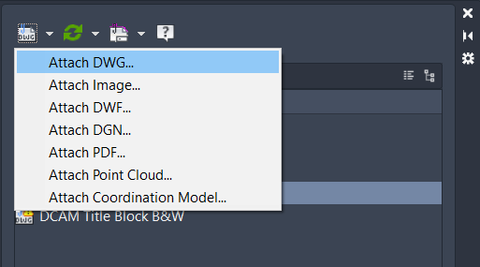

Figure 3.9.1

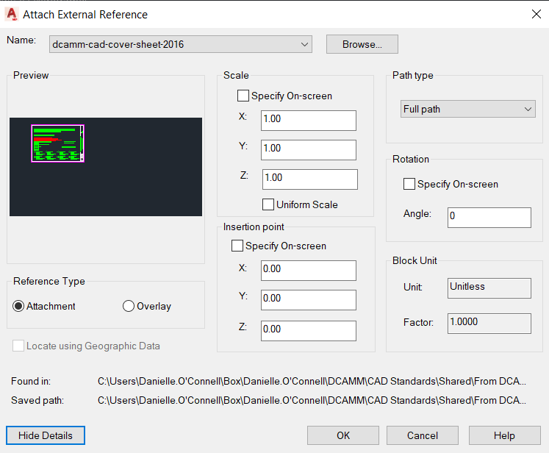

Figure 3.9.2

NOTE:
All submitted drawings from consultants should be bound as inserts.
To bind an xref select the xref drawing or drawings from the xref manager and click on bind, as shown below on Figure 3.9.3

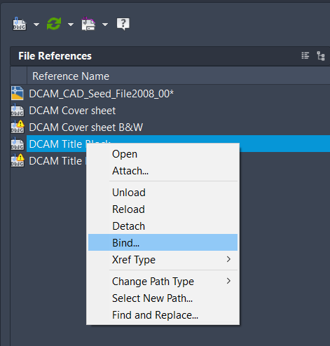

Figure 3.9.3

Then select Insert from the window dialog box, as shown in Figure 3.9.4

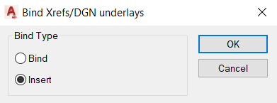
Figure 3.9.4

Binding an xref converts DWG references (xrefs) to standard local block definitions. If you bind an xref into the current drawing, the xref and all its dependent named objects become a part of the current drawing. Use XBIND to add individual xref-dependent named objects, such as blocks, text styles, dimension styles, layers, and linetypes, to the local definition table. The two methods of binding xrefs to the current drawing are Bind and Insert. Bind alters the definition table names of an xref when it is inserted. Insert does not alter the definition table names of an xref when it is inserted. To bind a nested xref, you must also select the parent xref.

Bind
Binds the selected DWG reference to the current drawing. Xref-dependent named objects are changed from blockname|definitionname to blockname$n$definitionname syntax. In this manner, unique named objects are created for all xref-dependent definition tables bound to the current drawing.

For example, if you have an xref named FLOOR1 containing a layer named WALL, after binding the xref, the xref-dependent layer FLOOR1|WALL becomes a locally defined layer named FLOOR1$0$WALL. The number in $n$ is automatically incremented if a local named object with the same name already exists. In this example, if FLOOR1$0$WALL already existed in the drawing, the xref-dependent layer FLOOR1|WALL would be renamed FLOOR1$1$WALL.

Insert
Binds the DWG reference to the current drawing in a way similar to detaching and inserting the reference drawing. Rather than being renamed using blockname$n$definitionname syntax, xref-dependent named objects are stripped of the xref name. As with inserting drawings, no name-incrementing occurs if a local named object shares the same name as a bound xref-dependent named object. The bound xref-dependent named object assumes the properties of the locally defined named object.

For example, if you have an xref named FLOOR1 containing a layer named WALL, after binding with the Insert option, the xref-dependent layer FLOOR1|WALL becomes the locally defined layer WALL.

3.10 POLYLINES

As required per all departments at DCAMM, when creating linework to define objects such as rooms, spaces, contour lines, etc, polylines should be used as well as regular lines. Polylines should be used to represent all programmatic elements, including but not limited to closed spaces, e.g. rooms, circulation areas, building envelope, etc., and be on a separate layer(s) depending upon the facility being designed. These features should also be represented as non polylined line work on their own layer(s).

A polyline is a connected sequence of line segments created as a single object. You can create straight line segments, arc segments, or a combination of the two.

Multisegmented lines provide editing capabilities unavailable for single lines. For example, you can adjust their width and curvature. After you've created a polyline, you can edit it with PEDIT or use EXPLODE to convert it to individual line and arc segments.

To create a polyline type PLINE in the command line or click on the Draw Menu, as shown in Figure 3.10.1

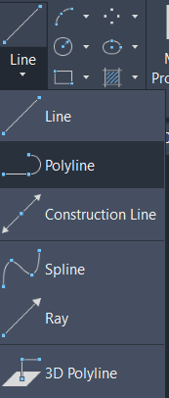
Figure 3.10.1

To convert an existing group or set of lines to Polylines, type PEDIT in the command line and choose select polyline as shown in Figure 3.10.2

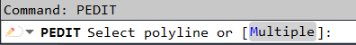

Figure 3.10.2

Then choose Join as shown in Figure 3.10.3, and then select all lines to be joined into a polyline and hit enter and then enter again to complete the command.

Figure 3.10.3

To draw a filled circle (to represent the section or end view of a piece of concrete reinforcing bar, for example), use the DONUT command by typing DONUT or DO, and specify an inside diameter of 0. See Figure 3.10.4 below. The DONUT command is also available from the Draw menu, as shown in Figure 3.10.5.

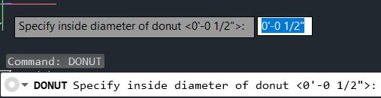
Figure 3.10.4

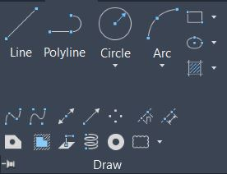
Figure 3.10.5

The DONUT command draws an LwPolyline or Polyline object composed of two semi-circular arcs that form a circle. The difference between the inside diameter and outside diameter specified when drawing a donut determines the thickness of the arc segments.

You can snap to the center of a donut (i.e., polyline arc segments) using the center object snap mode.

3.11 DATA EXTRACTION (Area and Information Extraction)
To extract information such as square footage of a room directly into a table or to an Excel spreadsheet, boundaries defined by polylines should be created as shown in Figure 3.11.1 Firms using Architectural Desktop or CAD Architecture “Spaces” should export these “Spaces” as CAD polylines, on an appropriate layer, and then follow the existing DCAMM standard for extracting area information from polylines, as mentioned in this section.
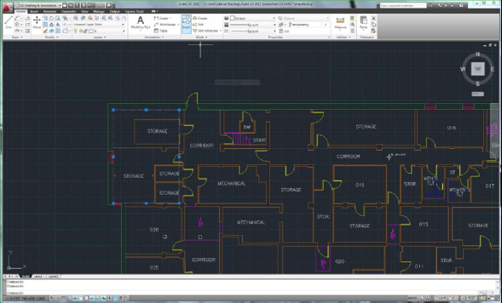

Figure 3.11.1

To begin extracting data, go to your Insert tab and locate the Linking and Extraction tools. Click on the Extract Data option as shown below in Figure 3.11.2 or type the command EATTEXT.

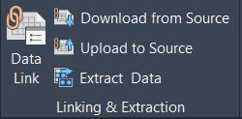

Figure 3.11.2

From the Data Extraction window dialog box, select create a new data extraction and then hit next as shown in Figure 3.11.3

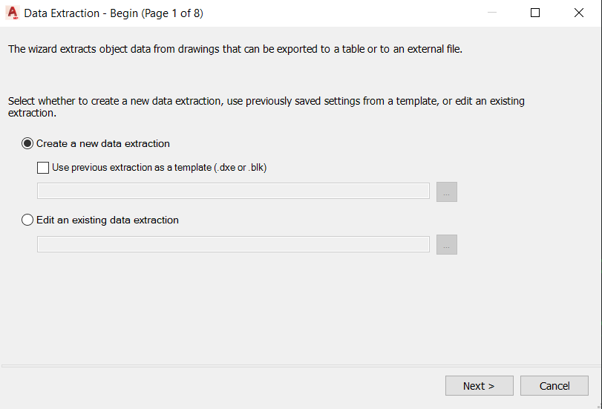
Figure 3.11.3

When prompted to save the data extraction, choose a location where to save the data extraction settings, which can then be used for a future similar extraction.

Then choose the folder or drawing option on the right to get the source drawings from where the data is going to be extracted, as shown in Figure 3.11.4
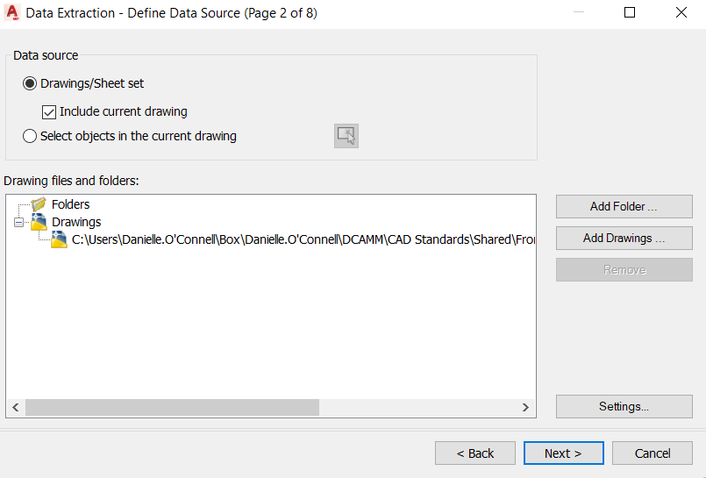
Figure 3.11.4

Next, on the left side check for the object or object category to be scanned through (ex: 2d Polyline), and then hit next as shown in Figure 3.11.5.
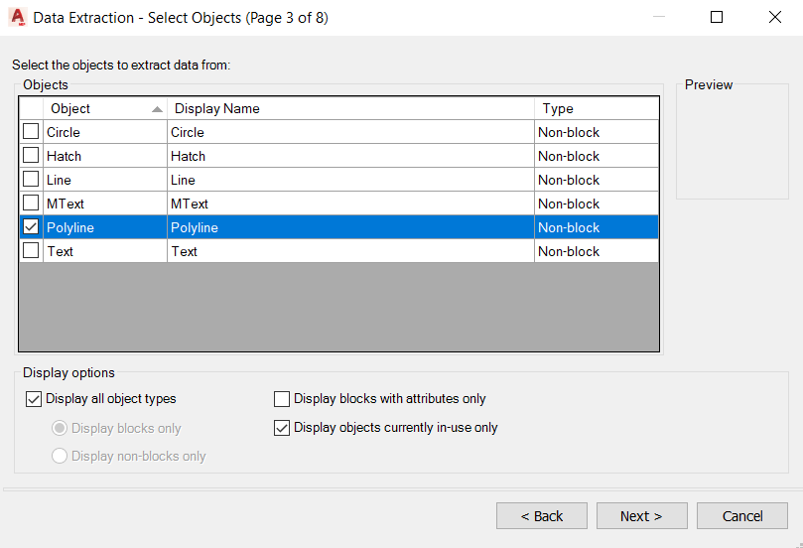

Figure 3.11.5
Next, from of the properties shown for the category previously selected (2d Polyline), select the properties that are going to be extracted, (ex: Area, Comments, etc.), as shown below in Figure 3.11.6.

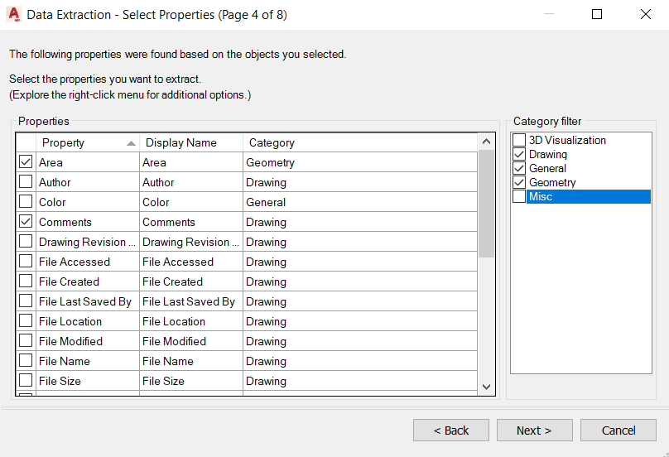
Figure 3.11.6

Next, in the preview window for the extracted table, reorder the columns by clicking and holding the header. By right clicking on the header you can rename, sort, hide or add a column. Hit next, as shown in Figure 3.11.7.
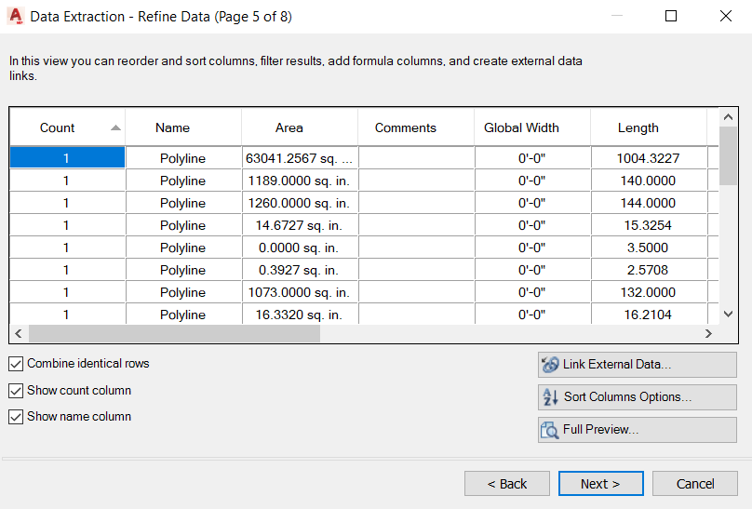

Figure 3.11.7

Next, check the box for insert data extraction table into drawing, and if an Excel spreadsheet is needed, check Output data to external file and check on the browse location to save that Excel file, as shown below in Figure 3.11.8, then click next.
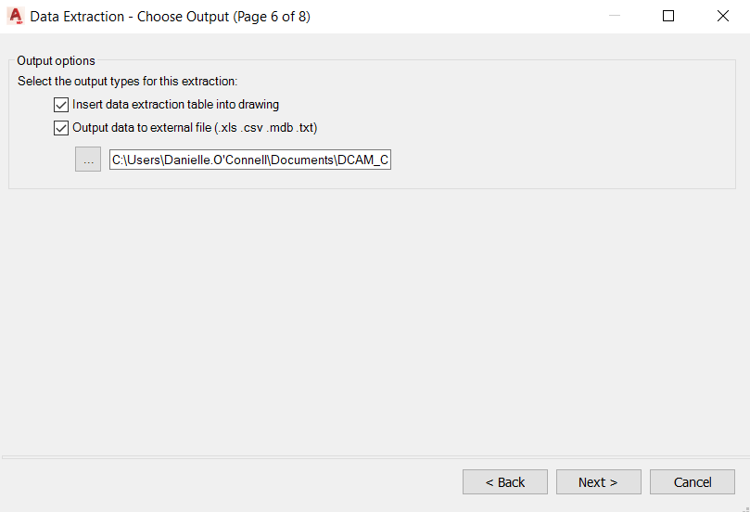
Figure 3.11.8
Next, choose a table style if already defined or simply use the default standard and use this dialogue box to change the settings of how the table will be displayed, as shown in Figure 3.11.9. Hit next.

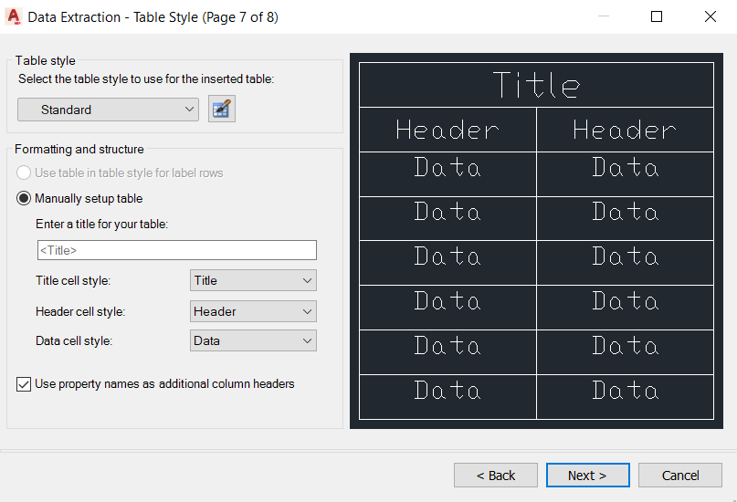
Figure 3.11.9

Finally, hit Finish, to complete, as shown in Figure 3.11.10. Then click to insert the newly extracted table into your drawing.
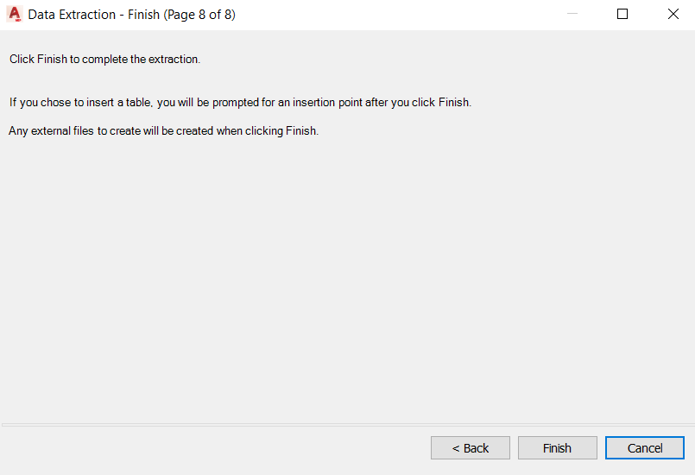
Figure 3.11.10

4.1 SEED FILE

To ensure data consistency and compatibility among the various data providers, DCAMM developed a CAD “Seed file”. This file, a digital version of DCAMM’s CAD standards, will be provided to DCAMM consultants for use on DCAMM projects. The file will automatically set up the consultants’ CAD environment according to the standard, thus ensuring all consultants’ deliverables are consistent and compatible, irrespective of the source and or discipline.

To use the “Seed file” on future projects just open the provided “DCAMM Seed file.dwg,” as shown in Figure 4.0.1.

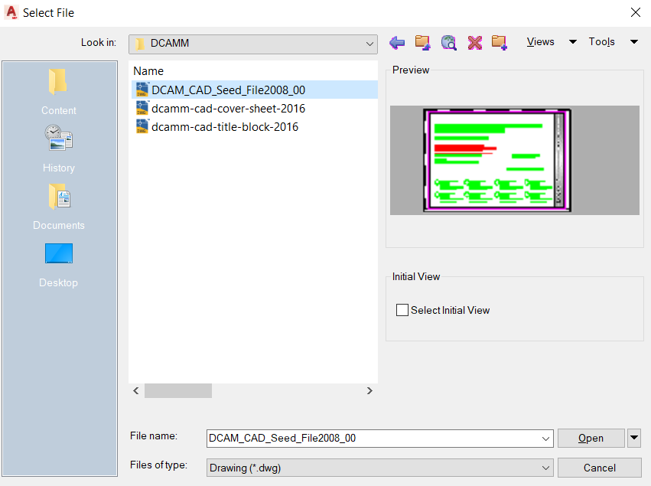
Figure 4.0.1

Pick the appropriate layer group filter and start the drafting process.

The “Seed file” includes all layers to be used based on group filter (Design and Construction, Survey, Planning, Leasing) and their respective layer requirements. Please refer to Section 4.2 for use of layer group filters.

In addition to the “Seed file,” DCAMM will also provide the “DCAMM Title block.” For more information and instructions about how to use it, refer to Section 4.2.

4.2 ACCESING LAYERS BY GROUP FILTERS
To display layers based on a DCAMM Department or Discipline, follow the steps outlined below:

      - Type LAYER on the command line or in the layer tool bar just click on the icon LAYER PROPERTIES MANAGER.

      - Once in the layer properties manager window, select any group filter from the list on the left (DCAMM department or discipline) and then hit OK. See Figure 4.1.1 below.

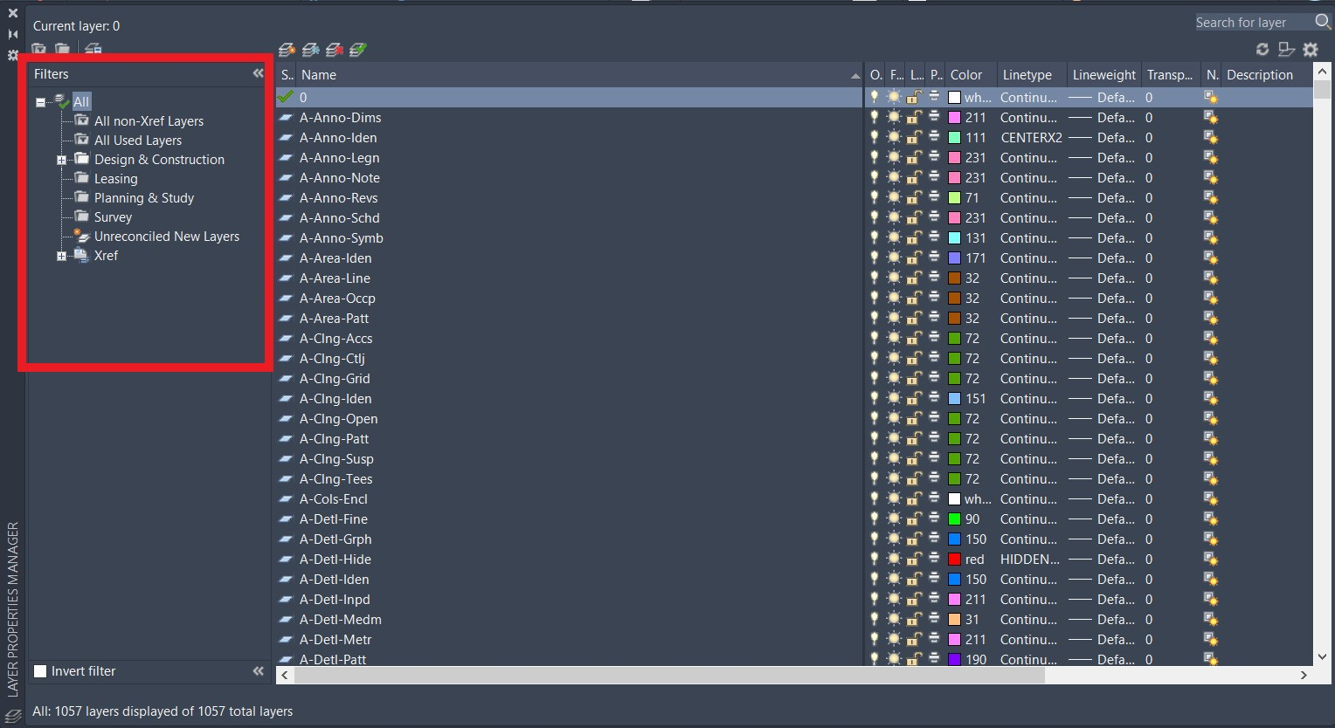
Figure 4.1.1

      - Now you can select layers as usual, when needed, and only the layers included in the group filters by DCAMM department and/or disciplines will display as shown in Figure 4.1.2.

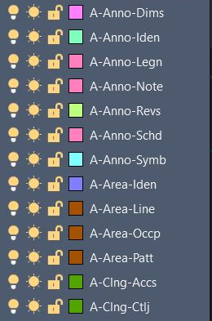
Figure 4.1.2

4.3 TITLE BLOCKS
All drawings shall be ¼” scale unless approved by DCAMM.
Drawings shall be submitted on a standard DCAMM 30” x 42” sheet with a standard DCAMM title block, as shown in Figure 4.2.1.

NOTE: Any other sheet size must be reviewed and approved by DCAMM Project Manager.
Second Sheet will be the list of drawings and legends, with additional pages if necessary.
The date on which the drawings were submitted to DCAMM shall be inserted in the title box of all schematic design drawings.

A small-scale, legible key plan adjacent to the title box on all drawings showing section, detail or partial plan locations, when the floor plan to which the sections, detail or partial plans apply, shall be included on another sheet. The key plan shall indicate the drawing number of the sheet where the section was taken.

Drawing submissions shall have revision stamps in the title block (ex:As builts, Record Drawing, etc.)

General Dimensions and Notes shall be indicated. Please refer to Section 4.3 for a detailed explanation of the DCAMM Title block.
Figure 4.2.1
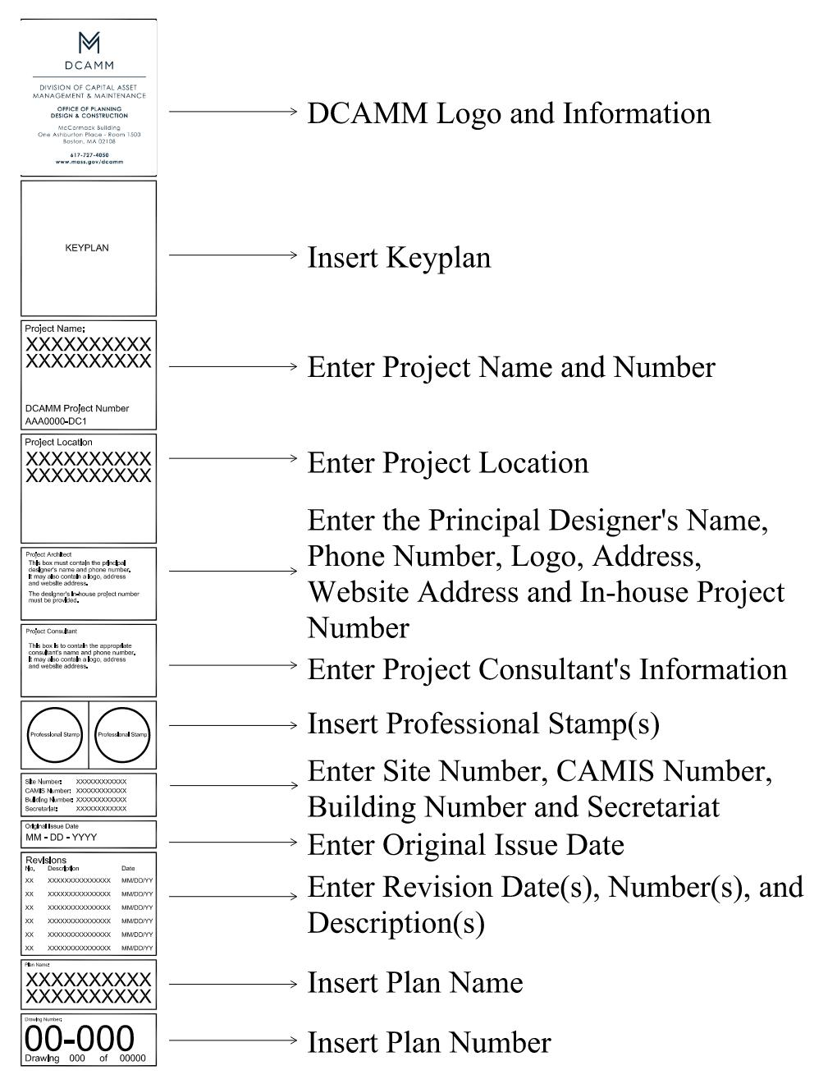

4.4 LOADING THE DCAMM TITLEB LOCK INTO SEED FILE

To load DCAMM’s title block, do the following:

      - Open your DCAMM “Seed file” and click on the Layout tab (e.g. 30 x 42) where the title block is as shown below in Figure 4.3.1.

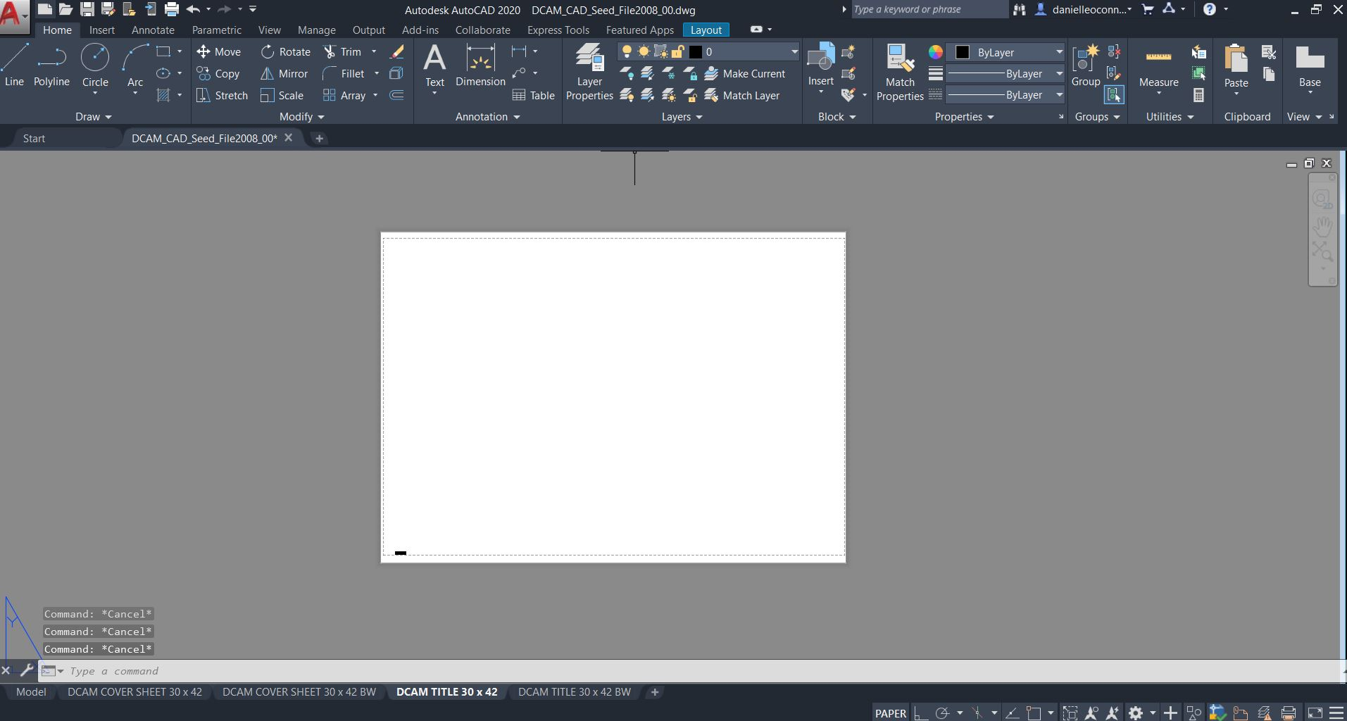
Figure 4.3.1

      - Type XREF in the command line or go to the Insert tab and click on Attach, as show in Figure 4.3.2.

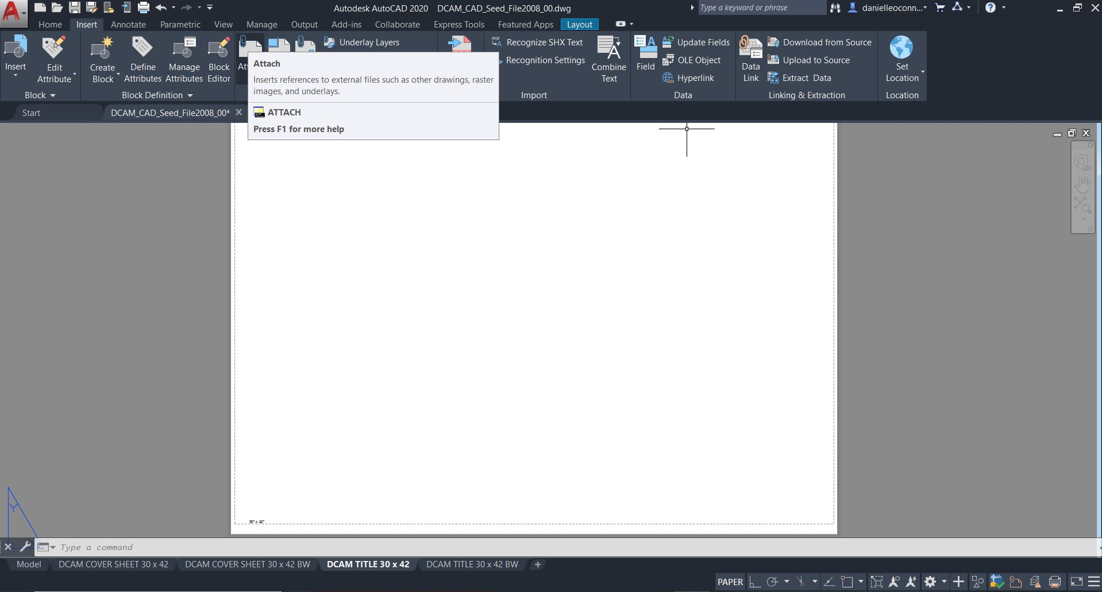
Figure 4.3.2

      - In the XRef Manager, click on the Title block Xref drawing (e.g. DCAMM Title Block), as shown in Figure 4.3.3.

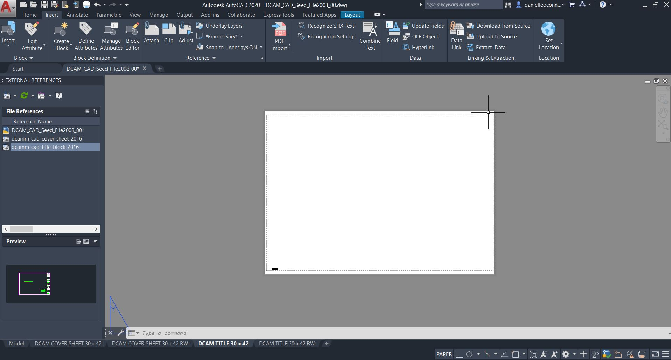
Figure 4.3.3

      - In the Details portion of the window, click on the right side of the path line to bring up the box, as show in Figure 4.4.4.

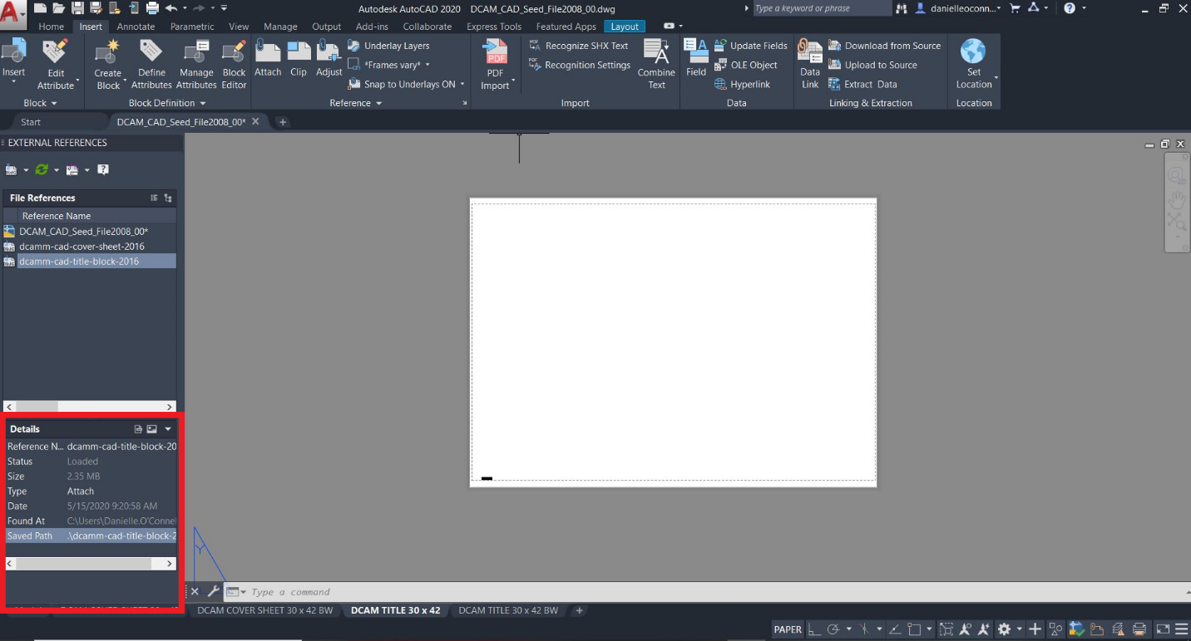
Figure 4.4.4

      - In the Select new path window, browse to the corresponding new location of the title block as show in Figure 4.4.5.
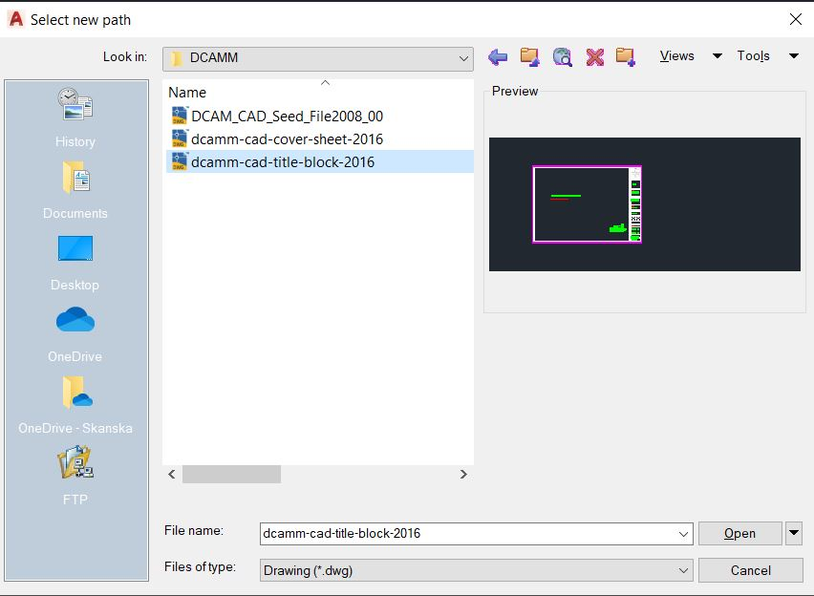

Figure 4.4.5
      - To reload all Xrefs, click on the reload button in the Xref window as shown below in Figure 4.4.6.

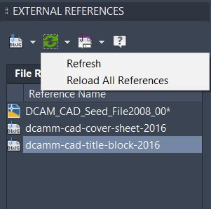
Figure 4.4.6

4.5 DCAMM STANDARD COVER SHEET

A standard cover sheet has been provided, as shown in Figure 4.5.1 to be used along with the “Seed file” and the DCAMM title block. To use the cover sheet, follow the steps described in Section 4.4 to reload an external reference file, or use the provided DCAMM title block file to manipulate accordingly.

Figure 4.5.1

5.1 CAD PRACTICES AND PROCEDURES

In order to plot successfully using this standard, some configuration of the CAD environment will be necessary. This configuration will only need to be completed once and will streamline plotting moving forward.

5.2 CAD CONFIGURATION (Plotting by Layout)
CAD options must be modified to insure proper placement of the border in the paper space layout environment.

To make the required modifications, choose the Tools pull-down menu and select Options at the bottom. From the Options dialog, select the Display tab. In the Display tab, make the necessary configuration changes to the Layout Elements portion as shown in Figure 5.2.1.

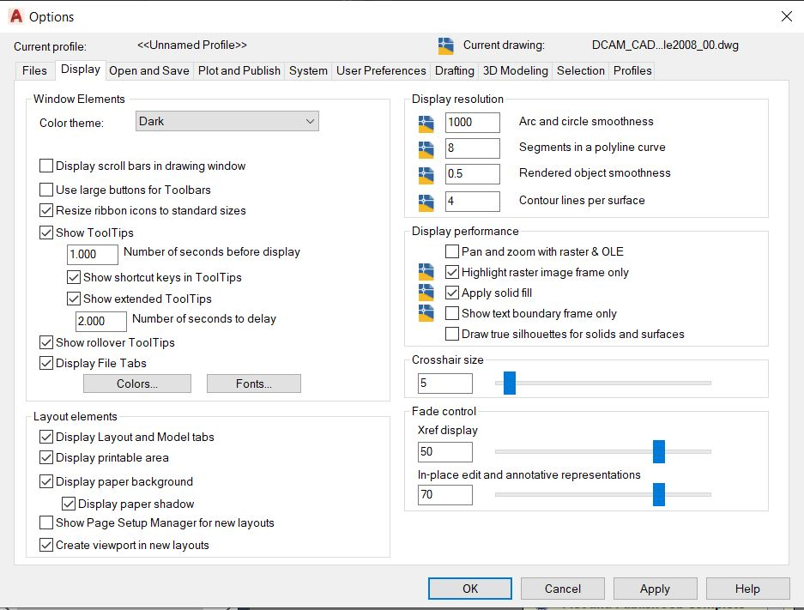
Figure 5.2.1

The setting changes made in the Options dialog affects the workstation and will not need to be changed in future sessions.

5.3 TEMPLATE DRAWING SETUP
For proper plotting and consistency, the CAD Standard makes use of a template drawing file. Supplied with this standard is a template named “DCAMM Seed file.dwg” in which the unit type is set to Architectural. To install either of this template drawings, copy them to the “Template” directory in your CAD environment install directory.

Both templates are essentially blank drawings saved with the extension “dwt” which have been started from scratch, been assigned a unit type and which makes use of a CTB file. If you currently have a drawing template ensure that your template has “Use Color Dependant Plot Styles” by clicking on the Plot Style Table Settings button shown in Figure 5.3.1, under the Options Dialog Box. You can access the Options Dialog box by clicking “Format”, then “Options”, then toggled in the Plot and Publish tab of the Options dialog box as shown in Figure 5.3.2
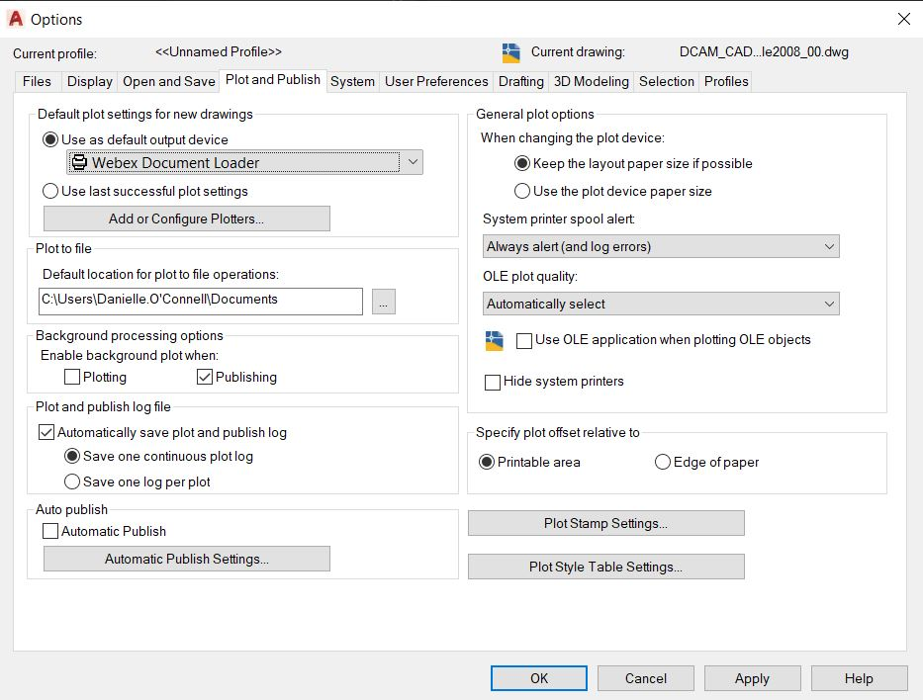
Figure 5.3.1

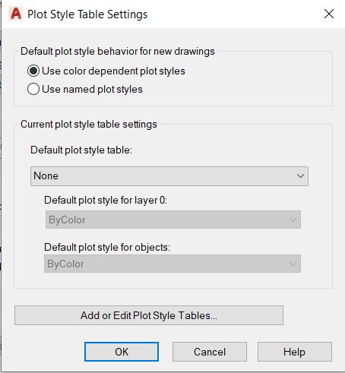

Figure 5.3.2

5.4 PAGE SETUPS
Page Setups enable the user to save specific settings within the CAD plotting environment. The Page Setups created for the in-house designers make use of PC3 files as well as configuration changes. PC3 files are typically copied to the “Plotters” folder under the root CAD installation directory. For specific instructions on how to recreate this for your plotting environment, refer to Appendix IV.

5.5 PLOT SETUP

All drawings shall be plotted from a paper space layout tab. The tab will be named the same as the sheet number being plotted. Full size and half size sheets may be plotted from a single layout by utilizing page setups. Multiple layouts are not to be used for full size and half size sheets. Multiple layouts may be used for the plotting of multiple sequential sheets.

To prepare the layout space for plotting, select a layout tab located at the bottom of your drawing environment as shown in Figure 5.5.1

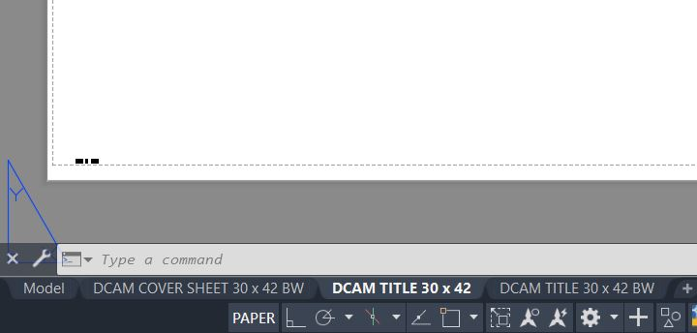
Figure 5.5.1
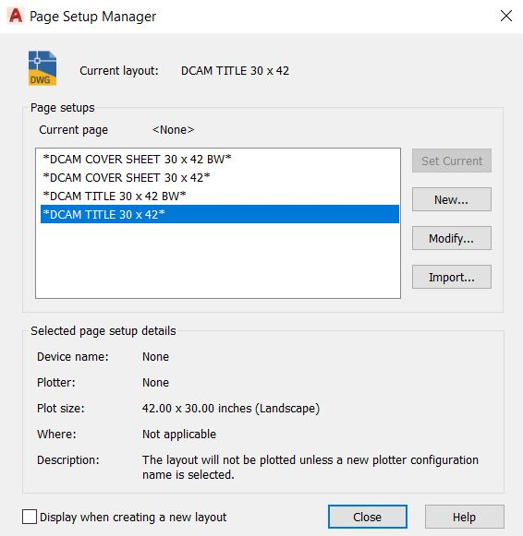
If the Page Setup dialog is not displayed automatically by selecting the layout tab, right click on the layout tab and choose Page Setup from the menu. A Page Setup dialogue box will open like Figure 5.5.2.

Figure 5.5.2
Next, navigate to the Page Setups drawing and select the Open button as shown in Figure 5.5.3. “Location where you have drawing with defined layouts”
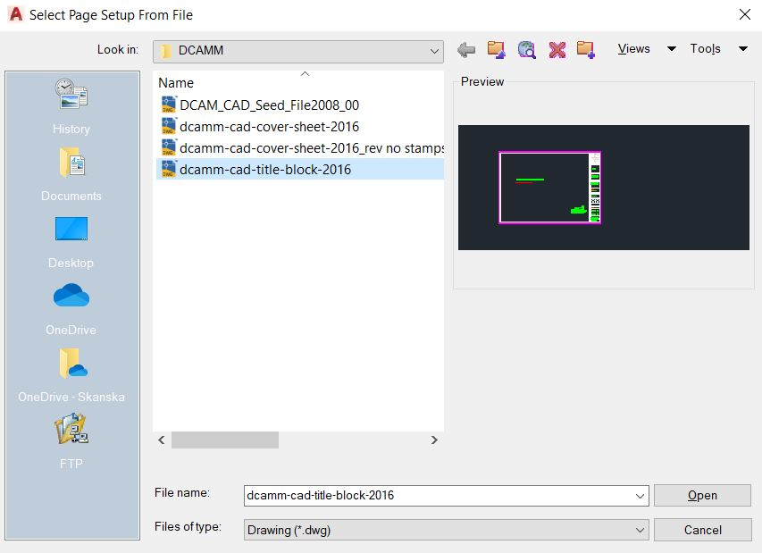
Figure 5.5.3

You will now select a Pag Setup. The Page Setup name will denote the device name as well as the plot size. Once a selection has been made, select OK to return to the Page Setup Manager as shown in Figure 5.5.4.
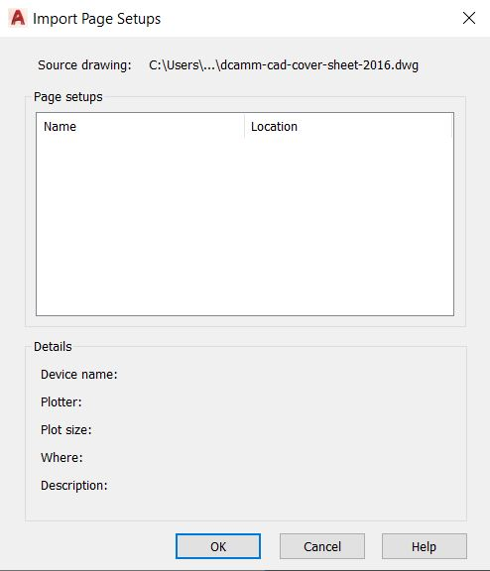
Figure 5.5.4
Now that the display has returned to the Page Setup Dialog box, select the appropriate Page Setup and click Set Current. See Figure 5.5.5.
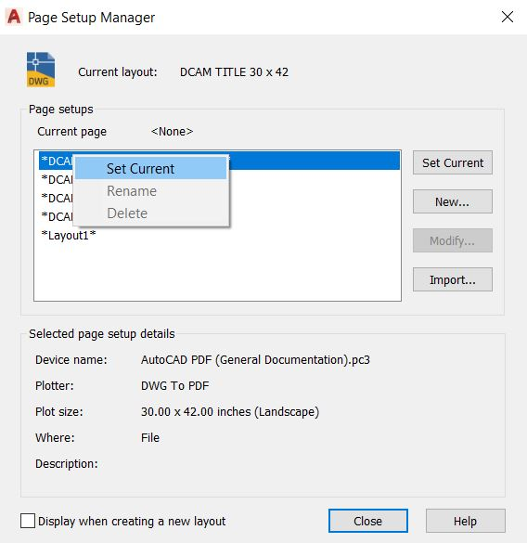 Figure 5.5.5

6.1 BIM INTEGRATION

The National CAD Standards (NCS) and National BIM Standards (NBIMS) have outlined guidelines for typical processes for the computer-based exchanges of information generated during the design, build, and operate project lifecycle. Since both 2-dimensional drawings, as well as computer-based virtual models, are a typical product of building information modeling techniques, it is important to outline the process for obtaining CAD files as output from the BIM process.

Additionally, for BIM projects, please refer to Section 9 of the DCAMM BIM Guidelines for Design and Construction which outlines drawing Requirements for paper printing and publishing. Additional requirements from the building’s operating entity may apply and should be reviewed in conjunction with these standards.

6.1.1 CAD Integration with BIM for Symbology
- Use industry standards for plan view representations
- Create symbols using annotation families in modeling platform if scalable
- If graphics appear too small, import DWG into the annotation family
- Turn off 3D models for plan views, but leave for all other views

6.1.2 Sheets
- Provide same title block family for both CAD and 3D modeling tools for all disciplines
- Use parameters for data fields in the title, including sheet number, name, status, designer fields, etc.
- Export to CAD to make sheets match from both platforms
  - Make sure CTB uses printing line weight
- Match parameters from 3D modeling fields as CAD to work with the Sheet Set manager/Project Navigator

6.1.3 Schedules
- When using export tools, workflow is from 3D modeling tool out, then back in
- Original file must be sourced from 3D modeling tool
- Use view templates to define schedule appearance to match CAD
- Add vertical formatting and formulas for schedules through shared project parameters

6.1.4 Exporting to CAD
- Follow the NCS for layers
- Match lineweights to Revit template
- Use true type fonts
- When using dimensions/multi-leaders, avoid using assigned colors and linetypes

6.1.5 Importing from CAD
Keep in mind, color is not essential for 3D model drafting and plan views in terms of pen widths, so it is important to assign lineweights to layers, in addition to colors when using CTBs for plotting. Layers will convert to line styles in 3D modeling software and therefore the lineweight settings are crucial.

For more information, refer to the National CAD Standards, V6.

7.1 DISTRIBUTION FILES

Associated with this document are several support files, which contain the settings and standards, described in this document. Internally, all workstations have been configured to access these files.

8.1 UPDATE AND REVISION PROCEDURES

The dynamic nature of CAD and BIM technology and the engineering process dictates that this document will change over time.

Changes may be made based on errors and omissions, as well as to enhance or update the standards based on changes in the CAD or BIM environment. All requested changes to this document must be accompanied by a request to change standards form provided in Appendix IV. The request to change the standard form must be provided to the DCAMM Project Manager. All requests to change standard forms will be reviewed by committee on a periodic basis. If the change is approved, it will be incorporated into the next version of this document and all support files will be modified.

Updates to this document and the related support files will be made as required.

9.1 CONTACT AND SUPPORT INFORMATION

Questions regarding the standards provided within this document should be directed to DCAMM Project Manager.

10.1 CONCLUSION

This document is a comprehensive standard for the creation of CAD drawings created or submitted to DCAMM. All drawings submitted must adhere to the conventions documented herein.

