1



# The California Parkinson’s Disease Registry



Mark Damesyn, DrPH, MPH, Director

California Parkinson’s Disease Registry

**Massachusetts Parkinson’s Disease Registry Advisory Committee**

**February 16, 2022**

## Presentation Overview



California Department of Public Health



* Legislative History
* Purpose and Procedures
* Reporting Highlights
* Next Steps and Future Aims

2



## Legislative History

**Senate Bill 97 (2017)**

**Assembly Bills 715 (2019) and 2128 (2020)**

**Assembly Bill 133 (2021)**

Extend Registry to 1/1/2022

Established Registry through 1/1/2020

Remove Sunset Date; Establish Neurodegenerative Diseases Registry

**Purpose**

* Enable research to better prevent and treat

Parkinson’s Disease

* + Epidemiologic research to know which geographic and population groups are most impacted
  + Clinical research to develop treatments
  + Health services research to design and target services for

Parkinson’s patients



California Department of Public Health



4

**Procedures:**

**How is the registry data used?**



1

Analyzed epidemiologically to identify more affected groups: Geographic, socio-economic, demographics.



2

Shared with researchers who are investigating PD risk, treatment and health care patterns.



3

Researchers accessing the registry will be required to adhere to strict data security procedures and guidelines.



4

No data will be released until the researcher has gained approval from CCPHS and IRBs.

**Procedures:**

What kind of data is being collected?

Demographic information about PWP:

Name, DOB, address

Their health care providers:

MD, specialty

Basic clinical information:

Date of diagnosis, ICD-10 code



[https://www.cdph.ca.gov/Programs/CCDPHP/DCDIC/CDSRB/CDPH%20Document%](https://www.cdph.ca.gov/Programs/CCDPHP/DCDIC/CDSRB/CDPH%20Document%20Library/CPDR/CPDR%20Guide%20to%20Reporting_FINAL_January2020.pdf)

[20Library/CPDR/CPDR%20Guide%20to%20Reporting_FINAL_January2020.pdf](https://www.cdph.ca.gov/Programs/CCDPHP/DCDIC/CDSRB/CDPH%20Document%20Library/CPDR/CPDR%20Guide%20to%20Reporting_FINAL_January2020.pdf)

**Procedures:**

What about HIPAA* and patient confidentiality?

* Informed consent is not necessary.
* Maintaining strict confidentiality is a high priority of the

registry.

* All data will be managed with encryption protection

and stored in a secure database.

* No information shared with DMV.

*Health Insurance Portability and Accountability Act of 1996, Public Law 104-191

Procedures: How data is sent to CPDR

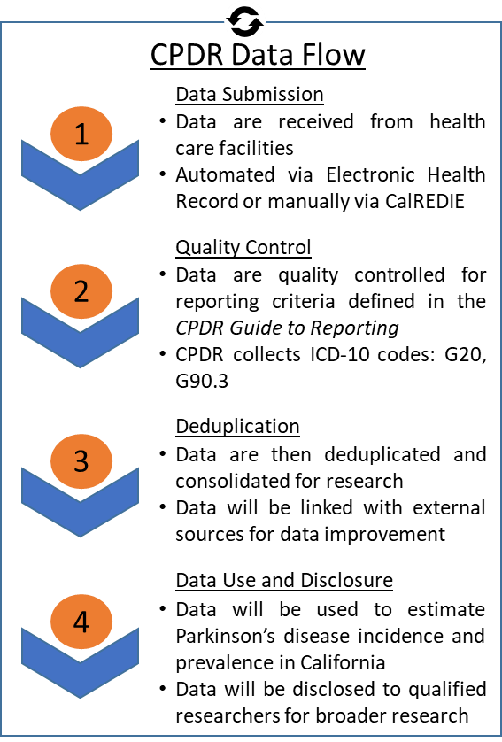

Frequently Asked Questions

1. “Do I have to send my data to CPDR?”

Answer: No. All reporting requirements are directed to providers so there is nothing patients must do.

Procedures: How data is sent to CPDR



Frequently Asked Questions

1. “Do I have to send my data to CPDR?”

Answer: No. All reporting requirements are directed to providers so there is nothing patients must do.

1. “If I have multiple doctors, which one reports, or are

they all required to report?”

Answer: All providers diagnosing or treating a patient must report to the state, regardless of reporting by another providers.

Procedures: How data is sent to CPDR



#### Frequently Asked Questions

##### “Do I have to send my data to CPDR?”

Answer: No. All reporting requirements are directed to providers so there is nothing patients must do.

##### “If I have multiple doctors, which one reports, or are

they all required to report?”

Answer: All providers diagnosing or treating a patient must report to the state, regardless of reporting by another providers.

##### “Will the California Department of Motor Vehicles (DMV) have access to or be provided CPDR data?”

Answer: No. CPDR data is never sent to the DMV.

Procedures: How data is sent to CPDR



#### Frequently Asked Questions

##### “Do I have to send my data to CPDR?”

Answer: No. All reporting requirements are directed to providers so there is nothing patients must do.

##### “If I have multiple doctors, which one reports, or are

they all required to report?”

Answer: All providers diagnosing or treating a patient must report to the state, regardless of reporting by another providers.

##### “Will the California Department of Motor Vehicles (DMV) have access to or be provided CPDR data?”

Answer: No. CPDR data is never sent to the DMV.

##### “How are the data used?”

Answer: The data are used to examine the incidence, prevalence, and distribution of Parkinson’s disease throughout California. The data will also be disclosed to qualified researchers to conduct other studies of Parkinson’s disease.

Reporting Highlights

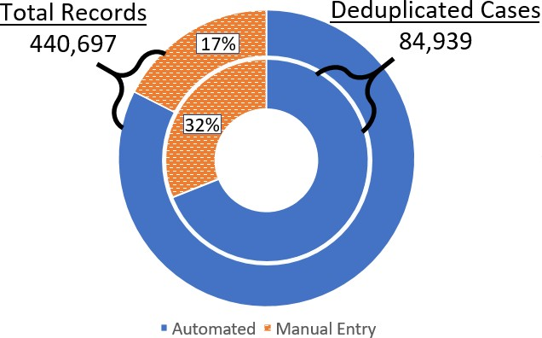

* Data has been successfully collected through the first three years of mandated reporting.
* CPDR continues to process data, increase data capture, and develop estimates of statewide Parkinson’s disease incidence and prevalence.

*Data as of May 31, 2021*

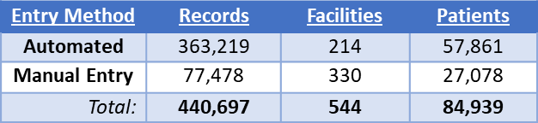

Reporting Highlights

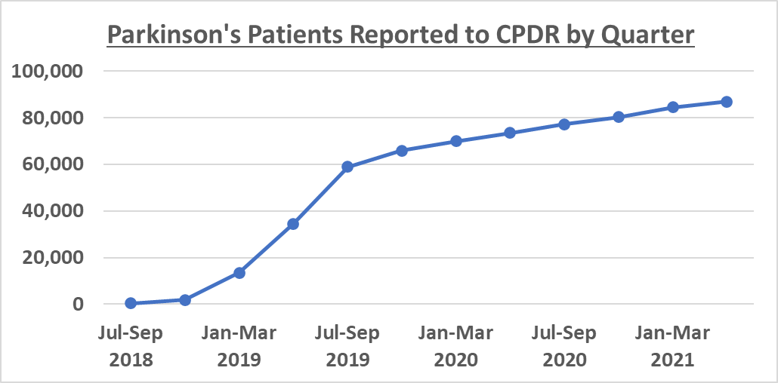

**First Reporting Deadline**

Total Patients Reported: 84,939

Data as of May 31, 2021

**Reporting Highlights Demographics**

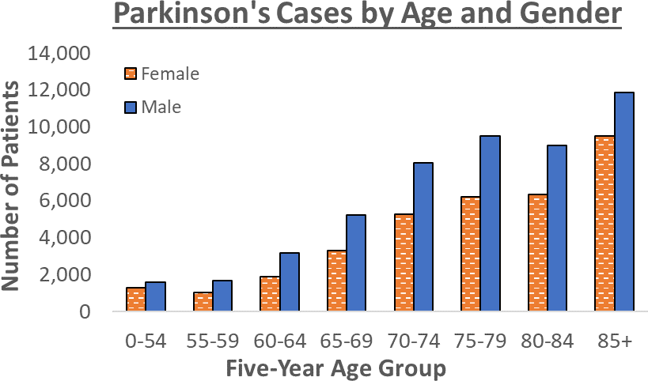

* The number of patients **over 85 years old** is about **7x more** than the number of patients **under 55 years.**
* CPDR estimates a **male-to-female ratio of approximately 1.5-to-1** or almost a 50% greater likelihood of Parkinson’s disease occurring in men.

Demographics of Parkinson’s Disease in California

Top 5 Counties with Most Patients

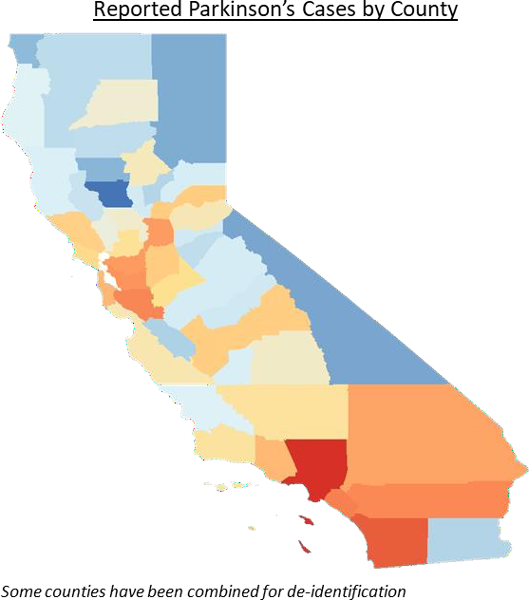

**4**

**1**

**3 2 5**

* 1. Los Angeles – 18,462
  2. San Diego – 9,842
  3. Orange – 5,564
  4. Santa Clara – 5,164
  5. Riverside – 4,957
* Data are current as of May 31, 2021 but are still incomplete as not all facilities to reporting to CPDR.
* CPDR data will be compared to environmental, hospitalization, and other sources of data to

improve surveillance.

Challenges

### Retaining funding

* + Program required supplemental funding from Michael J. Fox Foundation

during 6-month period when funding authority had sunset

### Case Validation

* + Lack of signs, symptoms, and treatment data results in possible misclassification
* Engagement of Researcher Community

Next Steps and Future Aims



* CPDR will continue to onboard health facilities and improve data validation to increase the completeness and quality of registry data.
* CPDR has published a data disclosure protocol which allows qualified researchers with a

valid scientific interest to apply for CPDR data.

* Neurodegenerative Diseases Registry (starting 1/1/2023; mandatory data collection starting 7/1/2023) will utilize approach similar to the Parkinson’s Disease Registry, resulting in further interest in and support of the CPDR.

