Background/Introduction

INDOOR AIR QUALITY ASSESSMENT

Cambridge City Information Technology and
Historical Commission Offices
831 Massachusetts Avenue, 2nd floor
Cambridge, MA 02139

Prepared by:
Massachusetts Department of Public Health
Bureau of Environmental Health
Indoor Air Quality Program
August 2015

In response to a request from Kari Sasportas, Environmental Health Specialist for the City of Cambridge, the Massachusetts Department of Public Health (MDPH), Bureau of Environmental Health (BEH) conducted an indoor air quality (IAQ) assessment at the Cambridge City Information Technology and Historical Commission Offices (CIT/HC) located on the second floor of 831 Massachusetts Avenue in Cambridge, Massachusetts. On July 8, 2015, a visit to conduct an IAQ assessment was made by Ruth Alfasso, Environmental Engineer/Inspector in BEH’s IAQ Program. Ms. Alfasso was accompanied by Mary Hart, Chief Information Officer, Cambridge Information Technology Department; Paul Lyle, Superintendent of Public Buildings for the City of Cambridge; and Ms. Sasportas during the visit.
The CIT/HC offices occupy the second floor of the Michael J. Lombardi Municipal Building located next to Cambridge City Hall. The first floor is occupied by other City offices. The space has been occupied by Cambridge City offices for more than 15 years. The space contains offices, open workstations, reception/waiting room, conference rooms, storage areas and a small kitchen. Ceilings consist of suspended ceiling tiles. Floors consist of wall-to-wall carpeting in the majority of areas. Windows are openable.

Methods
Air tests for carbon monoxide, carbon dioxide, temperature and relative humidity were conducted with the TSI, Q-Trak, IAQ Monitor, Model 7565. Air tests for airborne particle matter with a diameter less than 2.5 micrometers were taken with the TSI, DUSTTRAK™ Aerosol Monitor Model 8520. Screening for total volatile organic compounds (TVOCs) was conducted using a RAE Systems, MiniRAE 2000 Model, Photoionization Detector. BEH/IAQ staff also performed a visual inspection of building materials for water damage and/or microbial growth.

Results
The employee population of the CIT/HC offices is approximately 40; members of the public may visit daily. The tests were taken during normal operations and appear in Table 1.

Discussion

Ventilation
It can be seen from Table 1 that carbon dioxide levels were below 800 parts per million (ppm) in all 30 areas tested, indicating adequate air exchange on the day of the assessment. Fresh air for the space is provided by an air handling unit (AHU) located in a penthouse above the second floor. Outside air is drawn into the AHUs through a vent outside the penthouse (Picture 1) and ducted to ceiling-mounted supply diffusers. Return air is drawn back into ceiling vents via a plenum system and returned to the AHUs. Thermostats are computer-controlled centrally.
Ventilation in restrooms is provided by exhausts vented directly to fans on the roof. Restroom vents were found to be on at the time of the visit.
To maximize air exchange, the MDPH recommends that both supply and exhaust ventilation operate continuously during periods of occupancy. In order to have proper ventilation with a mechanical supply and exhaust system, the systems must be balanced to provide an adequate amount of fresh air to the interior of a room while removing stale air from the room. It is recommended that HVAC systems be re-balanced every five years to ensure adequate air systems function (SMACNA, 1994). The date of last balancing of this system was not known at the time of the visit.
Minimum design ventilation rates are mandated by the Massachusetts State Building Code (MSBC). Until 2011, the minimum ventilation rate in Massachusetts was higher for both occupied office spaces and general classrooms, with similar requirements for other occupied spaces (BOCA, 1993). The current version of the MSBC, promulgated in 2011 by the State Board of Building Regulations and Standards (SBBRS), adopted the 2009 International Mechanical Code (IMC) to set minimum ventilation rates. Please note that the MSBC is a minimum standard that is not health-based. At lower rates of cubic feet per minute (cfm) per occupant of fresh air, carbon dioxide levels would be expected to rise significantly. A ventilation rate of 20 cfm per occupant of fresh air provides optimal air exchange resulting in carbon dioxide levels at or below 800 ppm in the indoor environment in each area measured. MDPH recommends that carbon dioxide levels be maintained at 800 ppm or below. This is because most environmental and occupational health scientists involved with research on IAQ and health effects have documented significant increases in indoor air quality complaints and/or health effects when carbon dioxide levels rise above the MDPH guidelines of 800 ppm for schools, office buildings and other occupied spaces (Sundell et al., 2011). The ventilation must be on at all times that the room is occupied. Providing adequate fresh air ventilation with open windows and maintaining the temperature in the comfort range during the cold weather season is impractical. Mechanical ventilation is usually required to provide adequate fresh air ventilation.
Carbon dioxide is not a problem in and of itself. It is used as an indicator of the adequacy of the fresh air ventilation. As carbon dioxide levels rise, it indicates that the ventilating system is malfunctioning or the design occupancy of the room is being exceeded. When this happens, a buildup of common indoor air pollutants can occur, leading to discomfort or health complaints. The Occupational Safety and Health Administration (OSHA) standard for carbon dioxide is 5,000 parts per million parts of air (ppm). Workers may be exposed to this level for 40 hours/week, based on a time-weighted average (OSHA, 1997).
The MDPH uses a guideline of 800 ppm for publicly occupied buildings. A guideline of 600 ppm or less is preferred in schools due to the fact that the majority of occupants are young and considered to be a more sensitive population in the evaluation of environmental health status. Inadequate ventilation and/or elevated temperatures are major causes of complaints such as respiratory, eye, nose and throat irritation, lethargy and headaches. For more information concerning carbon dioxide, please see Appendix A.
Temperature readings during the assessment ranged from 71ºF to 73ºF (Table 1), which are all within the MDPH recommended comfort guidelines. The MDPH recommends that indoor air temperatures be maintained in a range of 70ºF to 78ºF in order to provide for the comfort of building occupants. In many cases concerning indoor air quality, fluctuations of temperature in occupied spaces are typically experienced, even in a building with an adequate fresh air supply. A few offices were noted to have direct sunlight, increasing the feelings of heat. Use of adjustable blinds and shades should help to prevent heat complaints due to solar gain.
The relative humidity measured during the assessment ranged from 59 to 64 percent, which is within or close to the upper end of the MDPH recommended comfort range. The MDPH recommends a comfort range of 40 to 60 percent for indoor air relative humidity. Note that outdoor relative humidity during the assessment was measured at 85 percent. Relative humidity levels in the building would be expected to drop during the winter months due to heating. The sensation of dryness and irritation is common in a low relative humidity environment. Low relative humidity is a very common problem during the heating season in the northeast part of the United States.

Microbial/Moisture Concerns
A few water-damaged ceiling tiles were observed in offices and the kitchen area (Picture 2). It was reported that when periodic roof leaks occur, they are repaired and tiles are replaced. It was reported by Mr. Lyle that the City of Cambridge is planning capital maintenance, including roof work, on all City buildings including the CIT/HC.
Water staining was also observed on the side of the building near the roof. This condition may indicate that water is likely penetrating the exterior walls from the roof and may eventually penetrate the building. When capital maintenance/repairs are performed to the roof, repair of flashing and repointing of brickwork may be needed to reduce water penetration.
The US EPA and the American Conference of Governmental Industrial Hygienists (ACGIH) recommend that porous materials be dried with fans and heating within 24 to 48 hours of becoming wet (US EPA, 2001; ACGIH, 1989). If porous materials are not dried within this time frame, mold growth may occur. Once mold has colonized porous materials, they are difficult to clean and should be removed and discarded.
A corroded/damaged exhaust vent grate was observed outside one of the restrooms (Picture 3). This damage is likely due to water vapor from the restrooms condensing on the grate over a long period of time. The damaged grate should be replaced. In addition, the restroom door should remain closed so that the exhaust vents in the restrooms can remove accumulated water vapor. It may be useful to move this grate a few tiles over to prevent it from drawing air from the restroom directly into the plenum.
Plants were observed in several areas (Table 1). Plants can be a source of pollen and mold, which can be respiratory irritants to some individuals. Plants should be properly maintained, over-watering of plants should be avoided and drip pans should be inspected periodically for mold growth and cleaned or replaced as necessary. It was reported that a fruit fly problem had occurred in the building previously that had been traced to overwatered, poorly maintained plants and that removal of some plants and better maintenance of others had fixed the problem.
Humidifiers were observed in a few offices. These appliances should be operated, maintained and kept clean per manufacturer’s instructions to prevent microbial growth in the water vessel.

Other IAQ Evaluations
Indoor air quality can be negatively influenced by the presence of respiratory irritants, such as products of combustion. The process of combustion produces a number of pollutants. Common combustion emissions include carbon monoxide, carbon dioxide, water vapor, and smoke (fine airborne particle material). Of these materials, exposure to carbon monoxide and particulate matter with a diameter of 2.5 micrometers (μm) or less (PM2.5) can produce immediate, acute health effects upon exposure. To determine whether combustion products were present in the indoor environment, BEH/IAQ staff obtained measurements for carbon monoxide and PM2.5.

Carbon Monoxide
Carbon monoxide is a by-product of incomplete combustion of organic matter (e.g., gasoline, wood and tobacco). Exposure to carbon monoxide can produce immediate and acute health effects. Several air quality standards have been established to address carbon monoxide and prevent symptoms from exposure to these substances. The MDPH established a corrective action level concerning carbon monoxide in ice skating rinks that use fossil-fueled ice resurfacing equipment. If an operator of an indoor ice rink measures a carbon monoxide level over 30 ppm, taken 20 minutes after resurfacing within a rink, that operator must take actions to reduce carbon monoxide levels (MDPH, 1997).
The American Society of Heating Refrigeration and Air-Conditioning Engineers (ASHRAE) has adopted the National Ambient Air Quality Standards (NAAQS) as one set of criteria for assessing indoor air quality and monitoring of fresh air introduced by HVAC systems (ASHRAE, 1989). The NAAQS are standards established by the US EPA to protect the public health from six criteria pollutants, including carbon monoxide and particulate matter (US EPA, 2006). As recommended by ASHRAE, pollutant levels of fresh air introduced to a building should not exceed the NAAQS levels (ASHRAE, 1989). The NAAQS were adopted by reference in the Building Officials & Code Administrators (BOCA) National Mechanical Code of 1993 (BOCA, 1993), which is now an HVAC standard included in the Massachusetts State Building Code (SBBRS, 2011). According to the NAAQS, carbon monoxide levels in outdoor air should not exceed 9 ppm in an eight-hour average (US EPA, 2006).
Carbon monoxide should not be present in a typical, indoor environment. If it is present, indoor carbon monoxide levels should be less than or equal to outdoor levels. During the assessment, outdoor carbon monoxide concentrations were measured at non-detect (ND). Indoor levels were all ND (Table 1).

Particulate Matter
The US EPA has established NAAQS limits for exposure to particulate matter. Particulate matter includes airborne solids that can be irritating to the eyes, nose and throat. The NAAQS originally established exposure limits to PM with a diameter of 10 μm or less (PM10). In 1997, US EPA established a more protective standard for fine airborne particulate matter with a diameter of 2.5 μm or less (PM2.5). This more stringent PM2.5 standard requires outdoor air particle levels be maintained below 35 μg/m³ over a 24-hour average (US EPA, 2006). Although both the ASHRAE standard and BOCA Code adopted the PM10 standard for evaluating air quality, MDPH uses the more protective PM2.5 standard for evaluating airborne PM concentrations in the indoor environment.
Outdoor PM2.5 concentrations were measured at 90-110 μg/m³ (Table 1). Note that particulate matter levels outdoors on the day of the assessment were elevated statewide due to the hot, humid weather conditions; according to AirNow (http://www.airnow.gov), a website run by the U.S. EPA, PM2.5 levels statewide were in the “moderate” category, as defined by PM2.5 levels of between 50 and 100 μg/m³. Elevated outdoor levels can contribute to indoor particulate matter load as air moves into the building. PM2.5 levels indoors ranged from 42 to 74 μg/m³, which were all above the NAAQS PM2.5 level of 35 μg/m³ but lower than those measured outside.
Filters on the AHU were examined during the assessment (Picture 4). They appear to be properly fitted pleated filters but the dust spot efficiency could not be determined. The dust spot efficiency is the ability of a filter to remove particulate matter of a certain diameter from air passing through the filter. Filters that have been determined by ASHRAE to meet its standard for a dust spot efficiency of a minimum of 40 percent (i.e. a MERV of 9) would be sufficient to reduce many airborne particulates (Thornburg, 2000; MEHRC, 1997; ASHRAE, 1992). Pleated filters with a Minimum Efficiency Reporting Value (MERV) dust-spot efficiency of 9 or higher are recommended. Note that increasing filtration may require evaluation and adjustments to the AHU systems to deal with the increased resistance to flow of higher MERV value filter. It is reported that the HVAC filters are changed quarterly. If high outdoor particulate matter levels continue, filters may need to be changed more often.
In addition, a number of activities that occur indoors and/or mechanical devices can generate particulate matter during normal operations. Sources of indoor airborne particulate matter may include but are not limited to particles generated during the operation of fan belts in the HVAC system; use of stoves and/or microwave ovens in kitchen areas; use of photocopiers, fax machines and computer printing devices; and operation of an ordinary vacuum cleaner and heavy foot traffic indoors.

Volatile Organic Compounds
Indoor air concentrations can be greatly impacted by the use of products containing volatile organic compounds (VOCs). VOCs are carbon-containing substances that have the ability to evaporate at room temperature. For example chemicals evaporating from a paint can stored at room temperature would most likely contain VOCs. Frequently, exposure to low levels of total VOCs (TVOCs) may produce eye, nose, throat and/or respiratory irritation in some sensitive individuals. In order to determine if VOCs were present, testing for TVOCs was conducted. Outdoor TVOC concentrations were ND on the day of the assessment (Table 1). No measureable levels of TVOCs were detected in the building during the assessment (Table 1).
Ongoing minor renovations in this space have included painting, which is reportedly sometimes performed while the space is occupied. It is recommended that any renovations be conducted while space is unoccupied to prevent exposure of occupants to odors, vapor and dusts. If off-hours renovations cannot be conducted, the spaces under renovation should be separated from occupied spaces using plastic sheeting and closed doors when at all possible. No paint odors were noted during the assessment.
Other sources of VOCs were observed. Several areas had dry erase boards and related materials (Table 1). Materials such as dry erase markers and dry erase board cleaners may contain VOCs, such as methyl isobutyl ketone, n-butyl acetate and butyl-cellusolve (Sanford, 1999), which can be irritating to the eyes, nose and throat.
Hand sanitizer was also observed (Table 1); these products may contain ethyl alcohol and/or isopropyl alcohol, which are highly volatile and may be irritating to the eyes and nose. Sanitizing products may also contain fragrances to which some people may be sensitive.
Cleaning and air freshening products were observed (Picture 5). Cleaning products, air fresheners and other air deodorizers contain chemicals that can be irritating to the eyes, nose and throat of sensitive individuals. Many air fresheners contain 1,4-dichlorobenzene, a VOC which can reduce lung function (NIH, 2006). Furthermore, deodorizing agents do not remove materials causing odors, but rather mask odors that may be present in the area. Cleaning products should be properly labeled and stored in an appropriate area. In addition, a Material Safety Data Sheet (MSDS) should be available at a central location for each product in the event of an emergency.

Other Conditions
Minor renovation activities were conducted over the last few months in the building. Occupants expressed concerns regarding dusts and debris from wall sanding, ncutting and other activities. As described above, it is preferable to perform renovations during unoccupied hours, and to separate as much as possible renovation work areas from occupied space. Increased cleaning to remove dust and debris before it can be reaerosolized and distributed to occupied areas is also important. One room was vacant due to construction (Picture 6; note dust and debris on floors and surfaces). Plastic barriers over doorways should be used in such situations to contain dusts until work is completed and cleaning has been performed.
An exhaust vent on the roof was opened and examined (Picture 7), which was not currently running and contained some debris. Since the bathroom exhaust vents were operating at the time of the assessment, the purpose of this vent was not clear. The vent was reportedly in the process of being repaired and should be cleaned of debris.
Personal fans, air purifiers and heaters were observed in many offices (Picture 8). Some of these appliances were dusty. Dust on these items can be reaerosolized and cause irritation or odors. In addition, air purifiers may have filters or other components that need to be cleaned and maintained so that they do not become a source of air pollution.
In some areas, accumulations of items were seen on floors, windowsills, tabletops, counters, bookcases and desks, which provide a source for dusts to accumulate (Picture 9). These items (e.g., papers, folders, boxes) make it difficult for custodial staff to clean. Items should be relocated and/or be cleaned periodically to avoid excessive dust build up.
Since the HVAC system in the building uses the plenum for return air, it is especially important that the ceiling tile system remain intact to prevent dust and debris from being entrained in the return system or being blown back into occupied areas. Several holes were noted in the ceiling tile system, especially in the room that was formerly a training room. These tiles should be replaced with intact ones. In addition, items were observed hanging from the ceiling tile system in one office, which can disrupt the tile system and may also become a source of accumulated dusts.
Windows on the floor are openable and are reportedly sometimes opened by occupants. Opening windows will increase fresh air, but can introduce excess heat and moisture into the building on days when outdoor conditions are hot and humid. This can compromise the effectiveness of the HVAC system and create conditions where condensation on cool surfaces may occur. Also, when outdoor particulate matter levels are high, this can introduce pollutants into the indoor environment because the air coming in windows does not get filtered. Windows additionally do not have screens which may allow flying pest into the building. Consider educating staff on appropriate times to open windows and when to keep them closed for better indoor air quality and comfort, and ensure that all windows are closed tightly at the end of each workday.
Most areas of the office space had wall-to-wall carpeting. Carpeting in hallways was reported to be only a few years old, while carpeting in offices was reportedly at least 15 years old and was stained and worn in places. The average lifespan of carpeting is approximately 11 years; therefore, consideration should be given to planning for new flooring (Bishop, 2002). Disintegrating textiles can be a source of airborne particulate matter, which can be irritating to the eyes, nose and throat. Carpeting in offices is reportedly planned to be replaced. The Institute of Inspection, Cleaning and Restoration Certification (IICRC) recommends that carpeting be cleaned annually (or semi-annually in soiled high traffic areas) (IICRC, 2012). Regular cleaning with a high efficiency particulate arrestance (HEPA) filtered vacuum in combination with an annual cleaning will help to reduce accumulation and potential aerosolization of materials from the carpeting.

Conclusions/Recommendations
In view of the findings at the time of the visit, the following recommendations are made:
- Perform any renovation work during unoccupied hours whenever possible. When renovations during occupied hours are necessary, isolate renovation areas from occupied areas to the greatest extent possible and keep the work areas as clean as possible to avoid dusts and fumes penetrating occupied spaces. Ensure paints, mastics or other potential VOC-containing products are used in well-ventilated areas. Consider blocking plenum return vents in areas undergoing renovations. Refer to Appendix B “Methods Used to Reduce/Prevent Exposure to Construction/Renovation Generated Pollutants in Occupied Buildings” for more information.
- Operate all ventilation systems throughout the building continuously during periods of occupancy to maximize air exchange. This would include leaving thermostat fan settings in the “on” mode (not auto) for continuous airflow.
- Consider adopting a balancing schedule of every 5 years for all mechanical ventilation systems, as recommended by ventilation industrial standards (SMACNA, 1994).
- For buildings in New England, periods of low relative humidity during the winter are often unavoidable. Therefore, scrupulous cleaning practices should be adopted to minimize common indoor air contaminants whose irritant effects can be enhanced when the relative humidity is low. To control for dusts, a high efficiency particulate arrestance (HEPA) filter equipped vacuum cleaner in conjunction with wet wiping of all surfaces is recommended. Avoid the use of feather dusters. Drinking water during the day can help ease some symptoms associated with a dry environment (throat and sinus irritations).
- Continue to repair roof and replace water-damaged tiles as needed. Ensure that any water-damaged materials are removed/repaired in accordance with USEPA and ACGIH recommendations. Address flashing and brickwork repairs when capital roof maintenance is performed.
- Replace damaged return vent grate shown in Picture 3. Keep restrooms doors closed when not in use to prevent water vapor from penetrating into the hallway. Consider relocating this vent.
- Indoor plants should be properly maintained and equipped with drip pans to prevent water damage to porous building materials and be located away from ventilation sources to prevent the aerosolization of dirt, pollen or mold. Monitor for insect infestations and remove plants if needed.
- Use and maintain humidifiers in accordance with manufacturer’s instructions.
- Determine the MERV value of the filters used in the HVAC system and consider upgrading to higher dust-spot efficiency filters if they are lower than MERV 9. Prior to any increase of filtration, HVAC system components should be evaluated by a ventilation engineer as to whether they can maintain function with more efficient filters.
- If high particulate matter levels outdoors continue, consider changing the filters more often.
- Reduce the use of hand sanitizing products especially those containing fragrances.
- Maintain heaters, air purifiers and personal fans in accordance with manufacturers’ instructions and keep them clean of dust and debris.
- Remove or relocate papers and other items to allow custodial staff to clean.
- Ensure the ceiling tile system/plenum is intact; replace or repair ceiling tiles with holes. Avoid hanging items from the ceiling tile system.
- Take care to only open windows when outdoor humidity and pollution levels are low. Ensure all windows are closed tightly at the end of the workday. Consider installing screens if flying insects are a problem.
- Vacuum carpet with a high efficiency particulate arrestance (HEPA) filtered vacuum in combination with cleaning carpeting annually or semi-annually in soiled high traffic areas as per the recommendations of the Institute of Inspection, Cleaning and Restoration Certification (IICRC, 2012).
- Refer to resource manuals and other related indoor air quality documents for further building-wide evaluations and advice on maintaining public buildings. Copies of these materials are located on the MDPH’s website: http://mass.gov/dph/iaq.

References
ACGIH. 1989. Guidelines for the Assessment of Bioaerosols in the Indoor Environment. American Conference of Governmental Industrial Hygienists, Cincinnati, OH.
ASHRAE. 1989. Ventilation for Acceptable Indoor Air Quality. American Society of Heating, Refrigeration and Air Conditioning Engineers. ANSI/ASHRAE 62-1989.
ASHRAE. 1992. Gravimetric and Dust-Spot Procedures for Testing Air-Cleaning Devices Used in General Ventilation for Removing Particulate Matter. American Society of Heating, Refrigeration and Air Conditioning Engineers. ANSI/ASHRAE 52.1-1992.
Bishop. 2002. Bishop, J. & Institute of Inspection, Cleaning and Restoration Certification. A Life Cycle Cost Analysis for Floor Coverings in School Facilities.
BOCA. 1993. The BOCA National Mechanical Code/1993. 8th ed. Building Officials & Code Administrators International, Inc., Country Club Hills, IL.
IICRC. 2012. Carpet Cleaning FAQ 4 Institute of Inspection, Cleaning and Restoration Certification. Institute of Inspection Cleaning and Restoration, Vancouver, WA.
MDPH. 1997. Requirements to Maintain Air Quality in Indoor Skating Rinks (State Sanitary Code, Chapter XI). 105 CMR 675.000. Massachusetts Department of Public Health, Boston, MA.
MEHRC. 1997. Indoor Air Quality for HVAC Operators & Contractors Workbook. MidAtlantic Environmental Hygiene Resource Center, Philadelphia, PA.
NIH. 2006. Chemical in Many Air Fresheners May Reduce Lung Function. NIH News. National Institute of Health. July 27, 2006. http://www.nih.gov/news/pr/jul2006/niehs-27.htm
OSHA. 1997. Limits for Air Contaminants. Occupational Safety and Health Administration. Code of Federal Regulations. 29 C.F.R 1910.1000 Table Z-1-A.
Sanford. 1999. Material Safety Data Sheet (MSDS No: 198-17). Expo® Dry Erase Markers Bullet, Chisel, and Ultra Fine Tip. Sanford Corporation. Bellwood, IL.
SBBRS. 2011. Mechanical Ventilation. State Board of Building Regulations and Standards. Code of Massachusetts Regulations, 8th edition. 780 CMR 1209.0.
SMACNA. 1994. HVAC Systems Commissioning Manual. 1st ed. Sheet Metal and Air Conditioning Contractors’ National Association, Inc., Chantilly, VA.
Sundell. 2011. Sundell, J., H. Levin, W. W. Nazaroff, W. S. Cain, W. J. Fisk, D. T. Grimsrud, F. Gyntelberg, Y. Li, A. K. Persily, A. C. Pickering, J. M. Samet, J. D. Spengler, S. T. Taylor, and C. J. Weschler. Ventilation rates and health: multidisciplinary review of the scientific literature. Indoor Air, Volume 21: pp 191–204.
Thornburg, D. 2000. Filter Selection: a Standard Solution. Engineering Systems 17:6 pp. 74-80.
US EPA. 2001. Mold Remediation in Schools and Commercial Buildings. US Environmental Protection Agency, Office of Air and Radiation, Indoor Environments Division, Washington, D.C. EPA 402-K-01-001. http://www.epa.gov/mold/mold_remediation.html
US EPA. 2006. National Ambient Air Quality Standards (NAAQS). US Environmental Protection Agency, Office of Air Quality Planning and Standards, Washington, DC. http://www.epa.gov/air/criteria.html.
Picture

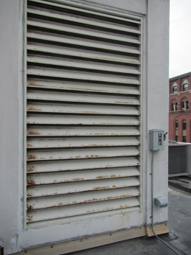

AHU intake vent on the penthouse

Picture 2

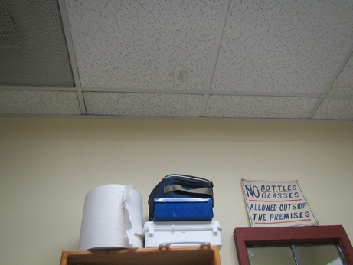

Water-damaged ceiling tile in kitchen
Picture 3

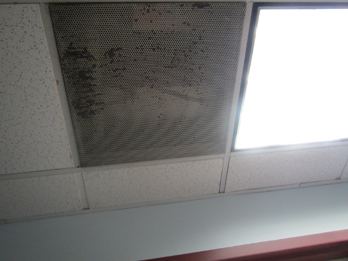

Water-damaged/corroded exhaust vent grate

Picture 4

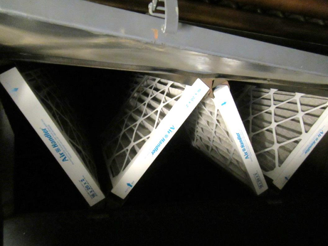

Pleated filters in the AHU
Picture 5

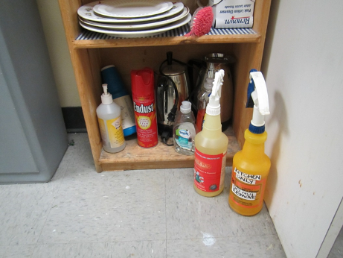

Cleaning products in the kitchen

Picture 6

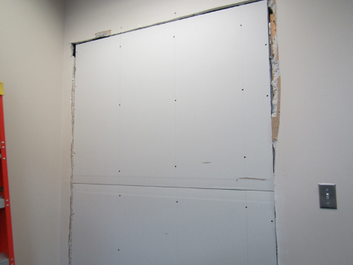

Inside room being renovated
Picture 7

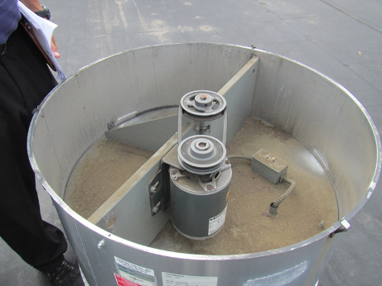

Non-functioning exhaust vent, note debris inside

Picture 8

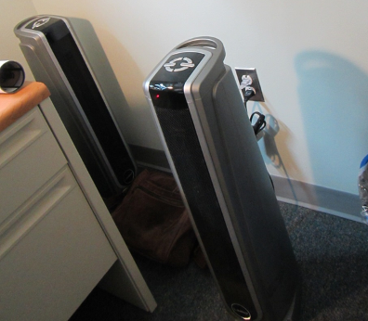

Air purifiers

Picture 9

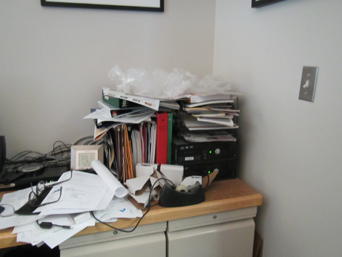

Papers and accumulated items in an office

Location | Carbon  Dioxide  (ppm) | Carbon Monoxide  (ppm) | Temp  (°F) | Relative  Humidity  (%) | PM2.5  (µg/m³) | TVOCs  (ppm) | Occupants  in Room | Windows  Openable | Ventilation |  |  | Remarks
 |  |  |  |  |  |  |  |  | Intake | Exhaust
Background | 485 | ND | 80 | 85 | 90-110 | ND |  |  |  |  |  | Hot, humid, hazy, measurements taken on roof next to air intakes
3-person office | 597 | ND | 71 | 64 | 52 | ND | 3 | Y | Y |  | Y | DEM, AI
Amero | 643 | ND | 72 | 62 | 45 | ND | 1 | Y | Y |  | N | DO, plant
Belford | 642 | ND | 71 | 62 | 48 | ND | 0 | Y | Y |  | N | Plant, 2 fans/AP, DO
Coe | 590 | ND | 71 | 62 | 42 | ND | 1 | Y | Y |  | Y | AI
Computer lab/storage | 612 | ND | 72 | 61 | 47 | ND | 0 | N | Y |  | Y | Items, PF
Conference room | 570 | ND | 71 | 63 | 48 | ND | 0 (some just left) | Y | Y |  | Y | DEM
Cube area/former training room | 635 | ND | 72 | 62 | 49 | ND | 5 | N | Y |  | Y | Holes in CT
Dalembert | 570 | ND | 71 | 62 | 47 | ND | 1 | Y | Y |  | Y | Plants
Dugas | 671 | ND | 71 | 63 | 43 | ND | 0 | Y | Y |  | Y | Plant, HS, DEM
Grello | 658 | ND | 72 | 59 | 47 | ND | 2 | Y | Y |  | Y | AP just on, DEM
Hamilton | 660 | ND | 71 | 62 | 45 | ND | 0 | Y | Y |  | Y | Items hanging from ceiling, PF/AP – dusty
Hart | 702 | ND | 73 | 60 | 65 | ND | 1 | Y | Y |  | Y | DO, AP and humidifier (off)
Herdfield | 660 | ND | 72 | 61 | 49 | ND | 2 | Y | Y |  | N | DEM, PF
Kitchen | 619 | ND | 72 | 62 | 50 | ND | 0 | Y | Y |  | Y | Microwave, fridge, toaster, sink drips, NC, water-damaged ceiling tile
Left Rest Room |  |  |  |  |  |  |  | N | Y |  | Y on | CP/scented spray
Levin | 639 | ND | 71 | 62 | 48 | ND | 1 | Y | Y |  | Y | PF, DEM
Nollet | 633 | ND | 71 | 63 | 45 | ND | 1 | Y | Y |  | Y | PF, heater
Print/copy area | 610 | ND | 72 | 61 | 45 | ND | 0 | N | Y |  | Y | PC and printer, stand fan
Rena | 618 | ND | 72 | 59 | 48 | ND | 0 | Y | Y |  | Y | DEM
Roderick | 629 | ND | 71 | 63 | 63 | ND | 2 | Y | Y |  | Y
Turner | 628 | ND | 71 | 62 | 72 | ND | 1 | Y | Y |  | Y | DEM, papers on floor
Vacant/construction | 621 | ND | 72 | 59 | 54 | ND | 0 | Y | Y |  | Y | Plant, dust/debris
Venuto | 647 | ND | 71 | 64 | 51 | ND | 1 | Y | Y |  | Y | DO
Historical Commission
Charlie | 599 | ND | 72 | 60 | 43 | ND | 0 | Y | Y |  | Y | Papers/items, humidifier
Conference room | 640 | ND | 72 | 61 | 74 | ND | 3 | Y | Y |  | Y | Plants, paper, solar gain
Files/storage | 618 | ND | 73 | 59 | 44 | ND | 0 | Y | Y |  | Y | DEM
Main open area | 713 | ND | 72 | 61 | 60 | ND | 0 | N | Y |  | Y
Office near IT | 621 | ND | 72 | 61 | 48 | ND | 0 | Y | Y |  | Y | Plants and items, paper on floor/desk
Pauli | 669 | ND | 72 | 62 | 59 | ND | 0 | Y | Y |  | Y | Plants, PF
Sarah Burks | 600 | ND | 73 | 59 | 47 | ND | 1 | Y | Y |  | Y
Susan | 588 | ND | 72 | 60 | 48 | ND | 0 | Y | Y |  | Y | AI

