# BACKGROUND

**INDOOR AIR QUALITY ASSESSMENT**

**Cambridge Health Department**

**119 Windsor St**

**Cambridge, MA**



Prepared by:

Massachusetts Department of Public Health

Bureau of Environmental Health

Indoor Air Quality Program

October 2018

|  |  |
| --- | --- |
| **Building:** | Cambridge Health Department (CHD) |
| **Address:** | 119 Windsor St, Cambridge, MA 02139 |
| **Reason for Request:** | General indoor air quality (IAQ) and indoor humidity concerns |
| **Date of Assessment:** | September 15, 2018 |
| **Massachusetts Department of Public Health/Bureau of Environmental Health (MDPH/BEH) Staff Conducting Assessment:** | Sharon Lee, Environmental Analyst, IAQ Program |
| **Date of Building Construction:** | 1920 |
| **Building/Site Description:** | The CHD is housed in the basement level of the Cambridge Health Alliance complex, which is a multi-story brick building. The building was acquired by the City in 1996. |
| **Windows:** | Openable |
| **Occupancy:** | The ground floor houses approximately 35 staff members. |

# Methods

Please refer to the IAQ Manual for methods, sampling procedures, and interpretation of results (MDPH, 2015).

# Results

The following is a summary of indoor air testing results (Table 1).

* **Carbon dioxide levels** were below the MDPH guideline of 800 parts per million (ppm) in all areas.
* **Temperature** was within the MDPH recommended range of 70°F to 78°F in all occupied areas tested.
* **Relative humidity** was above the MDPH recommended range of 40 to 60% in all occupied areas tested.
* **Carbon monoxide levels** were non-detect (ND) throughout the occupied areas surveyed.
* **Fine particulate matter (PM2.5)** concentrations measured were below the National Ambient Air Quality Standard (NAAQS) level of 35 μg/m3 in all areas assessed.

# Discussion

## Ventilation

It can be seen from Table 1 that carbon dioxide levels were below 800 ppm in all areas surveyed, indicating adequate ventilation. Rooftop heating, ventilation, and air-conditioning (HVAC) units reportedly supply 100% fresh, filtered air to the entire building (Picture 1). Air from the rooftop (HVAC) units is delivered to three separate basement closets, each of which contains an air-handling unit (AHU). Each AHU filters then heats/cools air, which is then distributed via ductwork connected to ceiling-mounted fresh air diffusers (Picture 2).

Exhaust ventilation is provided by grates installed in the suspended ceiling. The return/exhaust air is drawn into the space above the suspended ceiling (called the ceiling plenum), which returns to the closet AHU (Picture 2). It is important to note that some areas do not appear to have ceiling grates. It is also possible that these locations may use air pressurization and undercut hallway doors to transfer exhaust air into the hallway, where exhaust vents can remove normally occurring pollutants. In addition to plenum returns, some areas of the CHD also had what appeared to be ducted ceiling-mounted return vents (Picture 3). These vents are likely connected to rooftop exhaust fans, which draw air out of the building. Some of these rooftop fans were not operating at the time of assessment.

To maximize air exchange, the MDPH recommends that both supply and exhaust ventilation operate continuously during periods of occupancy. In order to have proper ventilation with a mechanical supply and exhaust system, the systems must be balanced to provide an adequate amount of fresh air to the interior of a room while removing stale air from the room. It is recommended that HVAC systems be re-balanced every five years to ensure adequate air systems function (SMACNA, 1994). The date of the last balancing of these systems was not available.

Of note is the age of the basement AHUs, which were likely installed during the 1980s, which would make the HVAC system roughly 35 years old. Efficient function of equipment of this age is difficult to maintain, since compatible replacement parts are often unavailable. According to the American Society of Heating, Refrigeration and Air-Conditioning Engineering (ASHRAE), the service life[1] for the various components of the HVAC system is between 20 to 30 years, assuming routine maintenance of the equipment (ASHRAE, 1991). Despite attempts to maintain the equipment, the optimal operational lifespan of this equipment has been exceeded.

## Microbial/Moisture Concerns

*Relative Humidity*

The Boston area experienced an unprecedented period of extended hot, humid weather. According to the Washington Post, “[d]ata…show[s]…cities in the Northeast have witnessed such humidity levels for record-challenging duration...[i]ncluding Albany, Boston, Burlington Portland and Providence” during the summer of 2018 (WP, 2018). “Boston and nearby locations… [saw]…historic numbers of those warm nights with low temperatures at or above 70 degrees…Providence and Blue Hill Observatory have already broken their annual records” (WP, 2018). If a building does not have either adequate exhaust ventilation and/or air chilling capacity to remove/reduce relative humidity from outside air, then hot, moist air can be introduced into a building and linger to increase occupant discomfort as well as possibly moisten materials that may lead to mold growth.

Building occupants expressed concerns regarding high humidity in the building, particularly during the summer months. The MDPH recommends a comfort range of 40 to 60 percent for indoor air relative humidity. Elevated relative humidity levels were observed within the CHD during the visit, with outdoor relative humidity measured at 55 percent and indoor relative humidity ranging from 61 to 73 percent. These relative humidity measurements exceeded comfort guidelines and show that indoor relative humidity levels exceeded the outdoor measurement in all locations.

High relative humidity indoors can indicate that the HVAC system is insufficient remove water vapor from multiple sources, which may include drawn outside fresh air, moisture infiltration through breaches in exterior walls, infiltrated rain/groundwater, respiration from occupants, potential plumbing or steam leaks, water vapor from cooking, and moisture in the air supply.

Moisture removal is important since higher humidity at a given temperature reduces the ability of the body to cool itself by sweating. “Heat index” and “apparent temperature” are measurements that take into account the impact of a combination of heat and humidity on how individuals perceive heat. At a given indoor temperature, the addition of humid air increases occupant discomfort and may generate heat complaints. If moisture levels are decreased, the comfort of the individuals can increase. Importantly, as described in detail in the Microbial/Moisture Concerns section, relative humidity in excess of 70 percent for extended periods of time can provide an environment for mold and fungal growth (ASHRAE, 1989).

### Humidity and condensation

As mentioned, not all areas have ducted exhaust ventilation to remove air from the space. This can contribute to moisture build up in the building. Moisture that is introduced by the closet AHUs is recirculated within the space, resulting in increased relative humidity and reduced occupant comfort. Over time, chronic moisture from condensation can lead to water damage to building materials.

Moisture from humid air will condense and accumulate on the surface of building materials that have temperatures **at or below the dew point.** The dew point is the temperature that air must reach for saturation to occur. For example, during humid weather when the temperature is 85°F and relative humidity is 90%, the dew point is approximately 82°F. Surfaces with a temperature at or below 82°F are prone to condensation formation.

In order for mold growth to occur, materials must be exposed to chronic moisture. Below-grade spaces are more likely to experience elevated relative humidity levels. Relative humidity in excess of 70 percent for extended periods of time, even in the absence of other sources of water, can provide an environment for mold and fungal growth (ASHRAE, 1989). Porous material should be dried with fans and heating within **24 to 48 hours of becoming wet** (US EPA, 2008, ACGIH, 1989). If porous materials are not dried within this time frame, mold growth may occur.

Evidence of condensation-related issues includes dark material consistent with mold growth observed on supply vents and ceiling tiles (Pictures 4 and 5). The type of damage observed suggests that water is condensing on metal air diffusers surfaces and ceiling tiles in proximity to the diffusers. Moisture can condense when the air conditioning system chills the supply diffusers that are in contact with humid air. Dust and debris that adhere to ceiling tiles or build up on air vents become a source of material on which mold can grow.

A musty odor was noted in office 0336 at the time of the assessment. The wall on the exterior side of this office also appeared to be bowing and cracking (Picture 6). BEH/IAQ staff took wall temperature measurements and conducted moisture testing on walls of this office. The wall temperature in this office was 64°F, which is equal to the dew point measured here (Table 1). As discussed, condensation will accumulate on materials at or below the dew point. Gypsum wallboard can wick moisture over time, which can result in odors. Prolonged exposure to moisture can compromise the integrity of the wallboard and result in mold growth.

Water-damaged ceiling tiles were observed in a number of areas (Picture 7; Table 1). Leaks should be repaired and pipes should be fitted with insulation to prevent condensation from occurring. Water-damaged ceiling tiles should be replaced once the leaks have been fixed. During the replacement, the area above the ceiling tile system should be checked for any additional water damage or odors and cleaned or repaired as needed.

While BEH/IAQ staff were assessing the condition of the equipment, it was reported that drip pans have overflowed in the past, resulting in damage to gypsum wallboard. This damaged wallboard was removed and replaced. While clogs in drip pan drain lines can occur from dust and mineral deposition, drainage from older equipment can also become clogged by rust. Rust is a sign of chronic moisture (Picture 8). Drain pans and pipes should be cleaned periodically to prevent buildup that can result in overflow and water damage.

Dehumidifiers are typically used to reduce humidity in below-grade during hot, humid weather or as needed. A few dehumidifiers were observed in the hallway areas and a few offices; however, not all units were operating. Dehumidifiers must be maintained in accordance with manufacturer’s instructions including drainage and cleaning.

### Other sources of water damage

CHD staff reported past issues with water intrusion through the exterior wall of the building. Following a flooding event, water-damaged gypsum wallboard was removed and replaced. Consideration should be given to removing carpet and replacing with floor tiles at least two feet from exterior walls.

Indoor plants were observed in a few areas (Table 1). Plants can be a source of pollen and mold, which can be respiratory irritants to some individuals. Plants should be properly maintained and equipped with drip pans and should be located away from air diffusers to prevent the aerosolization of dirt, pollen, and mold.

A breach/gap was observed between the sink backsplash and countertop (Table 1). This space can allow water into the porous material underneath. Over time, this can lead to water damage and mold growth.

## Other IAQ Evaluations

Indoor air can be greatly impacted by the use of products containing volatile organic compounds (VOCs), which can cause eye, nose, throat, and/or respiratory irritation. BEH staff examined areas for products containing these respiratory irritants and noted some offices contained dry erase materials and cleaning products (Table 1).

In several areas, items were observed on windowsills, tabletops, counters, bookcases and desks as well as in storage rooms. The large number of items in offices and storage areas provides a source for dusts to accumulate. These items (e.g., papers, folders, boxes) make it difficult for custodial staff to clean. Items should be relocated and/or be cleaned periodically to avoid excessive dust build up. Dust can accumulate on flat surfaces (e.g., desktops, shelving and carpets) in occupied areas and subsequently be re-aerosolized causing further irritation. Dust can also serve as a source for mold growth.

Note that papers and other items were found stored on the floor (Picture 10). Because of humidity and the potential for condensation on the floor, no porous items such as papers, boxes, or clothing should be stored on the floor. Any items should be placed in cabinets or on shelving.

# Recommendations

In view of the findings at the time of the visit, the following recommendations are made:

**Short-term Recommendations**

1. Work with an HVAC engineer/contractor to service and maximize the capacity of existing AHUs to dehumidify and adequately drain condensation.
2. Consider adopting a balancing schedule of every 5 years for all mechanical ventilation systems, as recommended by ventilation industrial standards (SMACNA, 1994).
3. Examine and clean condenser drip pans and lines to prevent overflow and water damage to nearby walls.
4. Use dehumidifiers regularly to remove moisture from the space. Consider purchasing additional units for use during periods of sustained high humidity. Ensure all units are maintained in accordance with manufacturer’s instructions including drainage and cleaning.
5. Consider keeping office doors open to improve air exchange and dehumidification.
6. Clean air diffusers regularly to prevent mold growth.
7. Remove and replace any ceiling tiles that show signs of water staining or mold growth.
8. Use a moisture meter to determine whether interior walls along the exterior of the building have elevated moisture content. Remove and replace these gypsum walls with cement boards to prevent damage from moisture during flood or high humidity/condensation events.
9. Ensure water-damaged or mold-colonized materials are remediated consistently with the recommendations in the US Environmental Protection Agency’s Mold Remediation in Schools and Commercial Buildings (US EPA, 2008).
10. Consider removing carpet from at least two feet from the wall and replacing with vinyl floor tiles.
11. Ensure indoor plants are properly maintained and not overwatered, and ensure each has a waterproof drip pan to prevent damage to porous materials.
12. Repair sink backsplashes with appropriate caulking material, or replace with a single-piece unit.
13. Reduce use of products and equipment that contain VOCs.
14. Remove paper and other porous items products from the floor to prevent moistening through condensation.
15. Ensure flat surfaces are cleaned periodically to prevent buildup of dust, which can serve as a source for mold growth.
16. Refer to resource manual and other related indoor air quality documents located on the MDPH’s website for further advice on maintaining public buildings. These documents are available at: <http://mass.gov/dph/iaq>.

**Long-Term Recommendations**

# Consider having an HVAC engineer examine the design and current functioning of the existing HVAC system.

# Examine the feasibility of replacing existing HVAC system components as recommended by the HVAC engineer.

# References

ACGIH. 1989. Guidelines for the Assessment of Bioaerosols in the Indoor Environment. American Conference of Governmental Industrial Hygienists, Cincinnati, OH.

ASHRAE. 1989. Ventilation for Acceptable Indoor Air Quality. American Society of Heating, Refrigeration and Air Conditioning Engineers. ANSI/ASHRAE 62-1989.

ASHRAE. 1991. ASHRAE Applications Handbook, Chapter 33 “Owning and Operating Costs”. American Society of Heating, Refrigeration and Air Conditioning Engineers, Atlanta, GA.

MDPH. 2015. Massachusetts Department of Public Health, Indoor Air Quality Manual: Chapters I-III. Available at: <http://www.mass.gov/eohhs/gov/departments/dph/programs/environmental-health/exposure-topics/iaq/iaq-manual/>.

SMACNA. 1994. HVAC Systems Commissioning Manual. 1st ed. Sheet Metal and Air Conditioning Contractors’ National Association, Inc., Chantilly, VA.

US EPA. 2008. Mold Remediation in Schools and Commercial Buildings. US Environmental Protection Agency, Office of Air and Radiation, Indoor Environments Division, Washington, D.C. EPA 402-K-01-001. <http://www.epa.gov/mold/mold-remediation-schools-and-commercial-buildings-guide>.

WP. 2018. ‘It’s been relentless’: Smothering summer humidity in the Northeast has crushed records. Washington Post, Washington, DC. <https://www.washingtonpost.com/news/capital-weather-gang/wp/2018/08/30/its-been-relentless-smothering-summer-humidity-in-the-northeast-has-crushed-records/>

**Picture 1**

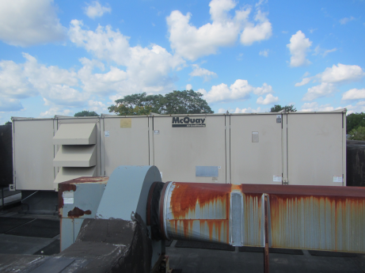

**Rooftop HVAC unit**

**Picture 2**

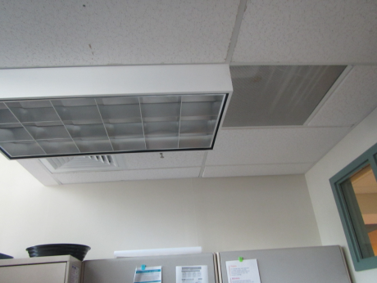

Supply Diffuser

Plenum Return

**Ceiling-mounted supply and return vents**

**Picture 3**

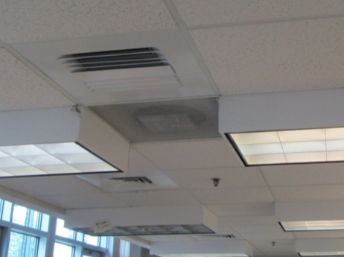

Ducted return

**Return vent likely ducted to rooftop exhaust vent**

**Picture 4**

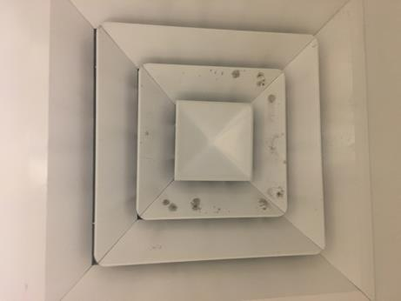

**Mold growth on ceiling air diffuser vent (source: CHD, 2018)**

**Picture 5**

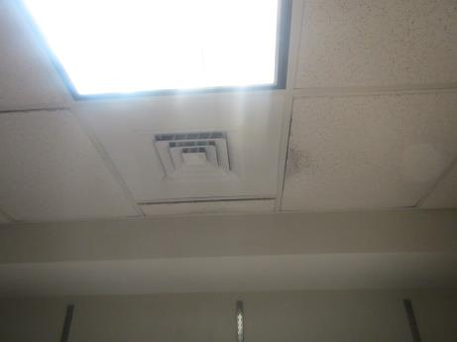

**Mold growth on ceiling tile**

**Picture 6**

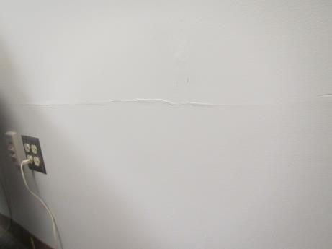

**Bowing/cracking wall in office 0336**

**Picture 7**

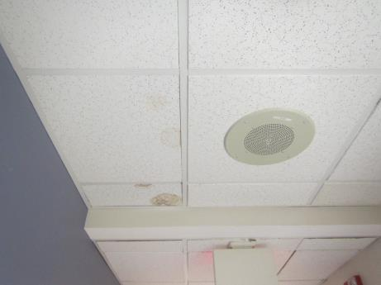

**Water-damaged ceiling tiles**

**Picture 8**

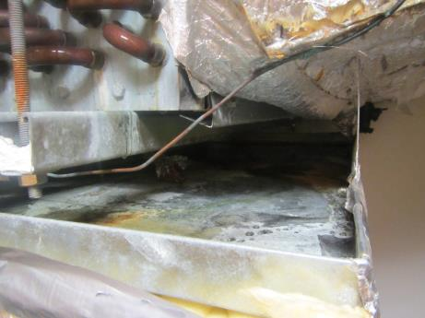

**Mineral deposit and rust stains in condensate drip pain**

**Picture 9**

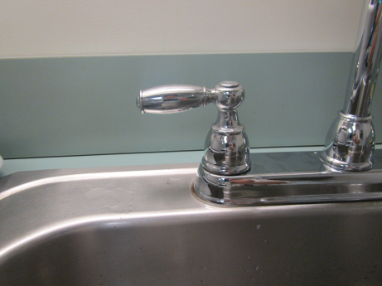

**Breach between sink backsplash and countertop**

**Picture 10**

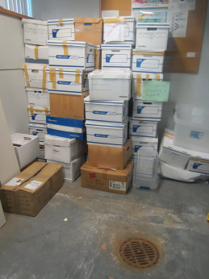

**Paper boxes and items stored on floor**

| Location | **Carbon**  **Dioxide**  **(ppm)** | **Carbon Monoxide**  **(ppm)** | **Temp**  **(°F)** | **Relative**  **Humidity**  **(%)** | **Dew Point**  **(°F)** | **PM2.5**  **(µg/m3)** | **Occupants**  **in Room** | **Windows**  **Openable** | **Ventilation** | | **Remarks** |
| --- | --- | --- | --- | --- | --- | --- | --- | --- | --- | --- | --- |
| **Supply** | **Exhaust** |
| Outdoor/  background | 537 | 1 | 88 | 65 |  | 15 |  |  |  |  |  |
| 0250 | 574 | ND | 75 | 63 | 64 | 4 | 1 | N | Y | Y | PF, DO |
| 0251 | 448 | ND | 73 | 66 | 64 | 4 | 0 | N | Y | N | Paper on floor, WD-CTs |
| 0314 | 470 | ND | 74 | 69 | 66 | 8 | 0 | N | Y | Y |  |
| 0311 | 474 | ND | 74 | 68 | 65 | 4 | 0 | N | Y | Y | Breach between sink backsplash and countertop, microwave |
| 0313 | 487 | ND | 74 | 69 | 66 | 4 | 1 | N | Y | N | DO |
| 0315 | 611 | ND | 73 | 73 | 66 | 4 | 1 | N | Y  dusty | N | DO, CPs |
| 0317 | 504 | ND | 72 | 71 | 64 | 4 | 0 | N | Y | N | DO |
| 0320 | 504 | ND | 74 | 71 | 66 | 5 | 0 | Y | Y  dusty | Y | WD-CTs |
| 0308 | 509 | ND | 75 | 72 | 67 | 3 | 0 | Y | Y  off | N |  |
| 0307 | 473 | ND | 74 | 70 | 66 | 3 | 0 | N | N |  | Plants, AT, DO |
| 0306 | 504 | ND | 74 | 66 | 65 | 3 | 1 | N | Y | N | Dehumidifier (off), DO |
| 0305 | 512 | ND | 73 | 73 | 66 | 3 | 0 | N | Y  dusty |  | Stored items |
| 0304 | 464 | ND | 73 | 70 | 65 | 3 | 0 | N | N | N | PF, DEM, DO |
| 0303 | 470 | ND | 72 | 69 | 64 | 3 | 1 | N | Y |  | DO, DEM |
| 0302 | 494 | ND | 74 | 61 | 63 | 3 | 0 | N | Y |  | Dehumidifier, WD-CTs |
| 0301 | 495 | ND | 74 | 70 | 66 | 0 | N | Y | N |  | Papers stored on floor, mold growth/staining on CT |
| 0336 | 505 | ND | 72 | 70 | 64 | 3 | 0 | Y  one open | N | N Replaced by CT |  |
| 0337 | 494 | ND | 71 | 73 | 64 | 5 | 0 | Y | Y | N | Dusty, mold growth/staining on CT |
| 0340 | 624 | ND | 72 | 71 | 64 | 4 | 4 | Y | Y | Appears sealed | Plants |
| 0331-1 | 585 | ND | 73 | 71 | 65 | 3 | 0 | N | Y | N | Copier |
| 0330 | 515 | ND | 73 | 71 | 65 | 3 | 0 | N | Y  mold/  dust |  | Mold growth/stain on CT |
| 0332 | 477 | ND | 72 | 71 | 64 | 3 | 0 | N | Y  mold/  dust | N | CPs, Mold growth/stain on CT |
| 0333 | 532 | ND | 72 | 73 | 65 | 4 | 0 | N | Y  dusty |  |  |
| Reception | 536 | ND | 73 | 73 | 66 | 8 | 4 | N | Y | N | Plants |

1. The service life is the median time during which a particular system or component of …[an HVAC]… system remains in its original service application and then is replaced. Replacement may occur for any reason, including, but not limited to, failure, general obsolescence, reduced reliability, excessive maintenance cost, and changed system requirements due to such influences as building characteristics or energy prices (ASHRAE, 1991).