EXHIBIT 1

F.1.a.i Patient Panel:

Describe your existing Patient Panel, including incidence or prevalence of disease or behavioral risk factors, acuity mix, noted health disparities, geographic breakdown expressed in zip codes or other appropriate measure, demographics including age, gender and sexual identity, race, ethnicity, socioeconomic status and other priority populations relevant to the Applicant's existing patient panel and payer mix.

The Applicant’s patient panel comprises the USA East Province, which includes 664 men. The average age of the patient panel is 69 and the median age is 72.

Age | Number of  Priests
33-39 | 17
40-49 | 33
50-59 | 66
60-64 | 58
65-69 | 74
70-74 | 104
75-79 | 96
80-84 | 88
85-89 | 74
90-94 | 46
95-99 | 8

The Applicant operates at or near capacity most of the time and at certain times there is a waitlist. Campion operates the only licensed, skilled nursing facility servicing the USA East Province. From June 2017 to May 2019, the Applicant served 243 unique men with an average of age of 81.5 years old for a total of 58,974 resident days as follows:

Resident Days By Year | Resident Days Level II | Resident Days Level IV | Total
6/1/17 - 5/31/18 | 11,212 | 8,559 | 19,771
6/1/18 - 5/31/19 | 10,751 | 9,354 | 20,105
6/1/19 - 5/31/20 | 11,069 | 8,029 | 19,098

The average length of stay is at Campion is 271 days for long-term skilled nursing and 297 days for residential care. The average length of stay for short-term skilled nursing is 46 days and the average length of stay for short term residential care is 23 days. As the Priests age and need more assistance, they can transition from the rest home to skilled nursing. For example, there is currently a few men who they anticipate will need to make this transition in the near future but there are currently no skilled beds are available.

The Applicant determined that as the Priests age that there is more need for skilled nursing beds to provide them the necessary care as described herein. The Priest are generally high functioning but receive fragmented care prior to arriving at Campion. The top four diagnosis are

cardiac, diabetes, dementia and hypertension. On the skilled unit, 50-60% of the Priest receive assistance with one activity of daily living and 40-50% receive assistance with two more activities of daily living.

Factor 5: Relative Merit

F5.a.i Describe the process of analysis and the conclusion that the Proposed Project, on balance, is superior to alternative and substitute methods for meeting the existing Patient Panel needs as those have been identified by the Applicant pursuant to 105 CMR 100.210(A)(1). When conducting this evaluation and articulating the relative merit determination, Applicant shall take into account, at a minimum, the quality, efficiency, and capital and operating costs of the Proposed Project relative to potential alternatives or substitutes, including alternative evidence-based strategies and public health interventions.

Proposal: The Proposed Project is a request to upgrade the classification of 12 Level IV beds on the third Floor to 12 Level II beds, and substantial capital expenditure to complete renovations to convert the third floor to a 12-bed level II skilled nursing unit and a 6-bed level IV residential care unit. There is no change in the GSF of the facility or the Applicant’s licensed bed capacity.

Quality: The Proposed Project would enable the Applicant to upgrade the level of care so that it can continue to care for the aging Patient Panel with increasing acuity. The Proposed Project would also add efficient mechanical upgrades to the facility.

Efficiency: The Proposed Project would allow the Applicant to be more efficient and operate in a more cost effective manner.

Capital Expense: The cost of the Proposed Project, which will be funded entirely by the Jesuits.

Operating Costs: Operating costs will increase as additional clinical staff will need to be hired to manage the new skilled nursing unit.

Option 1:

Alternative Proposal: Maintain the status quo by continuing to operate with the existing complement of Level II and Level IV beds.

Alternative Quality: This is not a feasible solution as demand for skilled nursing services exists with the Patient Population and the alternative would be to place a Priest in an outside facility until a bed becomes available at Campion. This would lead to more transitions of care.

Alternative Efficiency: This alternative would be inefficient.

Alternative Capital Expense: This alternative would allow the Applicant to forgo certain construction costs; however, it would have an overall negative impact on access, quality of care, patient satisfaction and cost effective and efficient operations.

Alternative Operating Costs: There would be no operating costs associated with sustain the current complement of long-term care beds and forgoing the renovation. However, this alternative would not afford the Applicant with any operational efficiencies since it continues to operate at near capacity which has limited or delayed access to the Patient Panel.

Option 2:

Alternative Proposal: Complete the Proposed Project but license the 12-Level II bed skilled nursing facility unit at a Dementia Special Care Unit.

Alternative Quality: This alternative proposal would allow the Applicant to create a dedicated skilled unit for dementia care.

Alternative Efficiency: Based on the Jesuits research, the need for general long-term and short-term skilled care for the Patient Panel outweighs the need for a dedicated skilled unit for dementia care.

Alternative Capital Expense: This alternative would be more expensive for the Applicant as it would need to meet the specific physical plant requirements for a dementia special care unit and the applicant could not use the beds for patients who do not require dementia care.

Alternative Operating Costs: The operating costs would be similar to the Proposed Project. This alterative would require additional clinical staff w be hired to manage and provide care in the dementia special care unit.

F5.a.ii Describe the process of analysis and the conclusion that the Proposed Project, on balance, is superior to alternative and substitute methods for meeting the existing Patient Panel needs as those have been identified by the Applicant pursuant to 105 CMR 100.210(A)(1). When conducting this evaluation and articulating the relative merit determination, Applicant shall take into account, at a minimum, the quality, efficiency, and capital and operating costs of the Proposed Project relative to potential alternatives or substitutes, including alternative evidence-based strategies and public health interventions.

The Applicant and the Jesuits considered the above options to meet its Patient Panel’s need. Renovating the existing facility to upgrade the classification of the Level IV beds to Level II beds was found to be the most acceptable option based on the access to services and cost effectiveness compared to the other options.

2819\0015\661038.1

EXHIBIT 4

F4.a.i Capital Costs Chart
Existing Reno
Number of Beds: 18 18
Gross SF Per bed: 613 601
(1) (2) (3) (4) (5) (6) (7) (8) (9) (10) (11) (12) (13)

Present Square Footage
Square Footage Involved in Project Resulting Square Footage New Construction Renovation Area
Total Cost
New Const. Renov.

Functional Areas Net Gross Net Gross Net Gross Net Gross New Construction Renovation Cost/SF Cost/SF

Third Floor - North Wing
 | 510 |  | 557 |  | 0 |  | 0 |  | 141 |  | 165 |  | 141 |  | 165
 | 0 |  | 0 |  | 0 |  | 0 |  | 98 |  | 115 |  | 98 |  | 115
 | 301 |  | 329 |  | 0 |  | 0 |  | 0 |  | 0 |  | 0 |  | 0
 | 5,438 |  | 5,936 |  | 0 |  | 0 |  | 1,718 |  | 2,015 |  | 1,718 |  | 2,015
 | 590 |  | 644 |  | 0 |  | 0 |  | 391 |  | 459 |  | 391 |  | 459
 | 381 |  | 416 |  | 0 |  | 0 |  | 32 |  | 38 |  | 32 |  | 38
 | 7,220 |  | 7,881 |  | 0 |  | 0 |  | 2,380 |  | 2,791 |  | 2,380 |  | 2,791
 | 2,450 |  | 2,675 |  | 0 |  | 0 |  | 954 |  | 1,119 |  | 954 |  | 1,119
 | 443 |  | 485 |  | 0 |  | 0 |  | 232 |  | 253 |  | 232 |  | 253
 | 10,113 |  | 11,040 |  | 0 |  | 0 |  | 3,566 |  | 4,182 |  | 3,566 |  | 4,182
 |  |  | 827 |  |  |  | 0 |  |  |  | 295 |  |  |  | 295
 | 0 |  | 0 |  | 0 |  | 0 |  | 608 |  | 713 |  | 608 |  | 713
 | 0 |  | 0 |  | 0 |  | 0 |  | 391 |  | 459 |  | 391 |  | 459
 | 0 |  | 0 |  | 0 |  | 0 |  | 0 |  | 0 |  | 0 |  | 0
 | 0 |  | 0 |  | 0 |  | 0 |  | 2,801 |  | 3,058 |  | 2,801 |  | 3,058
 | 0 |  | 0 |  | 0 |  | 0 |  | 520 |  | 610 |  | 520 |  | 610
 | 0 |  | 0 |  | 0 |  | 0 |  | 168 |  | 197 |  | 168 |  | 197
 | 0 |  | 0 |  | 0 |  | 0 |  | 4,488 |  | 5,036 |  | 4,488 |  | 5,036
 | 0 |  | 0 |  | 0 |  | 0 |  | 1,414 |  | 1,658 |  | 1,414 |  | 1,658
 | 0 |  | 0 |  | 0 |  | 0 |  | 217 |  | 237 |  | 217 |  | 237
 | 0 |  | 0 |  | 0 |  | 0 |  | 6,119 |  | 6,639 |  | 6,119 |  | 6,639
 |  |  | 0 |  |  |  | 0 |  |  |  | 751 |  |  |  | 751
 | 10,113 |  | 11,040 |  | 0 |  | 0 |  | 9,685 |  | 10,821 |  | 9,685 |  | 10,821

Rest Home
Day Room Dining Activities
Residents Rooms
Nursing & Support, etc. Support / Storage, Mech, etc. Subtotal - Departmental SF Circulation
Elevator / Stairs
Total - Departmental SF
Exterior wall Skilled Nursing Day Room
Dining
Activities Residents Rooms
Nursing & Support, etc. Support / Storage, Mech, etc. Subtotal - Departmental SF Circulation
Elevator / Stairs
Total - Departmental SF
Exterior wall
Total Third Floor - North Wing Total including the exterior wall

11,867

0 11,867

11,867

Fourth Floor - North Wing
Rest Home Day Room Dining Activities
Residents Rooms Nursing & Support, etc.
Support / Storage, Mech, etc. Subtotal - Departmental SF Circulation
Elevator / Stairs
Total - Departmental SF
Exterior wall
Total Fourth Floor - North Wing Total including the exterior wall

11,867
510 |  | 557 |  | 0 |  | 0 |  | 0 |  | 0 |  | 510 |  | 557
0 |  | 0 |  | 0 |  | 0 |  | 0 |  | 0 |  | 0 |  | 0
511 |  | 558 |  | 0 |  | 0 |  | 0 |  | 0 |  | 511 |  | 558
5,228 |  | 5,707 |  | 0 |  | 0 |  | 0 |  | 0 |  | 5,228 |  | 5,707
590 |  | 644 |  | 0 |  | 0 |  | 58 |  | 68 |  | 581 |  | 634
381 |  | 416 |  | 0 |  | 0 |  | 49 |  | 57 |  | 390 |  | 426
7,220 |  | 7,881 |  | 0 |  | 0 |  | 107 |  | 125 |  | 7,220 |  | 7,881
2,450 |  | 2,675 |  | 0 |  | 0 |  | 0 |  | 0 |  | 2,450 |  | 2,675
443 |  | 485 |  | 0 |  | 0 |  | 0 |  | 0 |  | 443 |  | 485
10,113 |  | 11,040 |  | 0 |  | 0 |  | 107 |  | 125 |  | 10,113 |  | 11,040
 |  | 827 |  |  |  | 0 |  |  |  | 0 |  |  |  | 827
10,113 |  | 11,040 |  | 0 |  | 0 |  | 107 |  | 125 |  | 10,113 |  | 11,040

318 |  | 347 |  | 0 |  | 0 |  | 318 |  | 347 |  | 318 |  | 347
327 |  | 357 |  | 0 |  | 0 |  | 0 |  | 0 |  | 327 |  | 357
175 |  | 191 |  | 0 |  | 0 |  | 0 |  | 0 |  | 175 |  | 191
4,743 |  | 5,178 |  | 0 |  | 0 |  | 1,662 |  | 1,814 |  | 4,743 |  | 5,178
865 |  | 944 |  | 0 |  | 0 |  | 650 |  | 710 |  | 865 |  | 944
137 |  | 150 |  | 0 |  | 0 |  | 137 |  | 150 |  | 137 |  | 150
6,565 |  | 7,167 |  | 0 |  | 0 |  | 2,767 |  | 3,021 |  | 6,565 |  | 7,167
2,466 |  | 2,692 |  | 0 |  | 0 |  | 285 |  | 311 |  | 2,466 |  | 2,692
413 |  | 452 |  | 0 |  | 0 |  | 0 |  | 0 |  | 413 |  | 452
9,444 |  | 10,427 |  | 0 |  | 0 |  | 3,052 |  | 4,065 |  | 9,444 |  | 10,427
 |  | 1,018 |  |  |  | 0 |  |  |  | 0 |  |  |  | 1,018
9,444 |  | 10,427 |  | 0 |  | 0 |  | 3,052 |  | 4,065 |  | 9,444 |  | 10,427

0 125

11,867

Second Floor - North Wing
Skilled Nursing Day Room Dining
Activities Residents Rooms
Nursing & Support, etc. Support / Storage, Mech, etc. Subtotal - Departmental SF Circulation
Elevator / Stairs
Total - Departmental SF
Exterior wall
Total Second Floor - North Wing Total including the exterior wall

11,445

0 4,065

11,445

3429\0003\654736.1

EXHIBIT 2

Fentanyl disguised as prescription meds
13
Rhode Island issues warning about counterfeit lookalike pills

By Sean philip Cotter

Rhode Island authorities are warning of fake pills that may look like pre- scription drugs — but are actually full of the danger- ous and potent fentanyl.
“Some counterfeit, or fake, pills are made to look like prescription opioids & benzodiazepines (“ben- zos”),” the Rhode Island Department of Health tweeted Wednesday. “They are unsafe and can contain unknown amounts of ille- gally made fentanyl. One pill can cause a fatal over- dose.”
Benzodiazepines are more commonly known by the drug’s brand names, which include Valium and Xanax.
Fentanyl is an extremely
strong synthetic opioid that’s frequently bought and sold illegally.
Over the past few years, it’s become an increasingly common street drug, a more potent cousin to her- oin.
Fentanyl and heroin, which it’s often cut into, have led to increasing numbers of overdose deaths over the past decade. Massachusetts, as is the case with many parts of the country, continues to battle the source of opi- oid abuse.
The Rhode Island authorities further note that signs of an opioid overdose include “Breath- ing slowly; can’t be woken up; turning blue with a pale look; blue fingernails and lips.”
The Massachusetts Department of Health this year switched from quar- terly reports of opioid
overdose deaths to semi- annual public analyses, so there’s no new data since June. The state last year
reported 2,015 opioid-re- lated overdose deaths, continuing a trend of edg- ing down lightly since the
2016 peak of 2,102 — but still far more than the 500- 700 such deaths reported a year in the 2000s.

$5,500

BOY SCOUTS OF AMERICA
Campion Health & Wellness, Inc.
Campion Health & Wellness, Inc. (“Applicant”), a licensed skilled nursing facility (“Facility”) dedicated to serving Jesuits priests, located at
319 Concord Rd., Weston, MA 02493 intends to file a Notice of Determination of Need (“Application”) with the Massachusetts Department of Public Health to perform substantial renovations to the third floor and related renovations to the Facility’s key building systems, and will seek
approval to upgrade the classification of 12 Level IV rest home beds to Level II skilled nursing beds (the “Proposed Project”). The Proposed Project does not result in any expansion of gross square feet of the Facility or change to the Applicant’s licensed bed capacity. At the completion of the Proposed Project, if its request to upgrade the classification of beds is approved and other requirements are met, the third floor, which now consists of 18 Level IV rest home beds, would consist of a 12 bed Level II bed skilled nursing unit and a 6 bed Level IV rest home unit. The Applicant does not anticipate any price or service impacts on the Applicant’s existing Patient Panel as a result of the Proposed Project. The total value of the Proposed Project based
on the maximum capital expenditure is $3,738,853. Any ten Taxpayers of Massachusetts may register in connection with the intended Application by no later than December 1, 2020 or 30 days from the Filing Date, whichever is later, by contacting the Department of Public Health Determination of Need Program, 250 Washington Street, 4th Floor, Boston, MA 02108 or by email at dph.don@massmail.state.ma.us.
Public Announcement Concerning a Proposed Health Care Project
www.bostonherald.com
FILES FOR BANKRUPTCY

If you were a victim of sexual abuse. you may be eligible for compensation.

BE PROUD TO TAKE POSITIVE ACTION
tHursday, octoBer 29, 2020

Contact the Law Offices of Mitchell Garabedian
for a claim evaluation today.

Call 888 995-2214

www.Garabedianlaw.com
Boston Herald
DEADLINE TO FILE IS NOVEMBER 16TH 2020

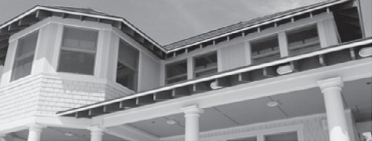LEGAL NOTICES LEGAL NOTICES LEGAL NOTICES LEGAL NOTICES LEGAL NOTICES LEGAL NOTICES
31

NOTICE OF PUBLIC HEARING
The Boston Redevelopment Authority d/b/a the Boston Planning and Development Agency (&quot;BPDA&quot;), pursuant to Sections 80A-2, 80B-5, 80B-7 and 80D-5 of the Boston Zoning Code (“Code”), hereby gives notice that it will hold a virtual Public Hearing on Thurs- day, November 12, 2020 at 5:30 p.m., televised on Boston City TV (Xfinity Channel 24, RCN Channel 13, and Verizon Fios Channel 1962) and live streamed on boston.gov, to consider the proposed Simmons University 2020 Institutional Master Plan (“Proposed IMP”) and to consider the IMP Projects (“Proposed Project”) as a Development Impact Project. The Proposed IMP covers the development of the University’s campus over the next ten years, with the goal of consoli- dating all on- campus housing and student activities onto the Univer- sity’s Academic Campus. The Proposed Project consists of significant renovations to the existing Lefavour Hall and Main College Building, as well as the construction of the Living and Learning Center, a pro- posed tower containing athletics, dining, and approximately 1,100 student housing beds. You may participate in this Public Hearing by registering at https://bit.ly/35ECG2D. The Proposed IMP may be viewed at https://bit.ly/3juXe2I. The Proposed Project, explained in the University’s Draft Project Impact Report (“DPIR”), may be viewed at https://bit.ly/34o4sBi.
Teresa Polhemus, Executive Director/Secretary
Boston Redevelopment Authority
Oct 29
NOTICE OF PUBLIC HEARING
The Boston Redevelopment Authority d/b/a the Boston Planning & Development Agency (“BPDA”), pursuant to Sections 80A-2 and 80D- 5 of the Boston Zoning Code (“Code”), hereby gives notice that it will hold a virtual Public Hearing on Thursday, November 12, 2020 at 6:00 p.m., televised on Boston City TV (Xfinity Channel 24, RCN Channel 13, and Verizon Fios Channel 1962) and live streamed on boston.gov , to consider the (i) Second Amended &amp; Restated Master Plan for Planned Development Area No. 94 (the “Revised Master Plan”), (ii) Second Amended & Restated Phase 1 Development Plan for Planned Development Area No. 94 (the “Revised Phase 1 Development Plan”), and (iii) Phase 4 Development Plan for Planned Development Area No. 94 (the “Phase 4 Development Plan”). The Proponent proposes to construct two new mixed-use buildings, including residential, health/ fitness club and retail uses. Phase 1A will be located on an approxi- mately 78,000 square foot lot (including the new roadway) at the corner of Bartlett Street and Washington Street. Phase 1A will reach a maximum building height of up to 70 feet and will include up to 110,000 square feet of Gross Floor Area, consisting of approximately 12,000 square feet of commercial space and retail space, and up to 63 Dwelling Units. Phase 1B will consist of a second new building and will reach a maximum building height of up to 70 feet and will be lo- cated on an approximately 67,000 square foot lot adjacent to Phase 1A on Washington Street, and is anticipated to include a new publicly accessible plaza and a total of up to 110,000 square feet of Gross Floor Area, consisting of approximately 13,300 square feet of com- mercial and retail space and up to 63 Dwelling Units. Phase 4 consists of a new six-story, up to 52-unit residential building to be situated on the approximately 31,000 square-foot “Lot D” within Planned De- velopment Area No. 94, which is currently cleared and vacant. The Proposed Project is programmed and designed as a senior housing component. Members of the public may participate in this Public Hearing by registering at https://bit.ly/35ECG2D or by emailing your testimony to BRABoard@boston.gov . Emailed testimony will be read aloud during the hearing. The Proposed Notice of Project Change, Second Amended and Restated Plan and Amended Development Plan may be viewed at the following link:
http://www.bostonplans.org/projects/development-projects/
bartlett-place
Teresa Polhemus, Executive Director/Secretary Boston Redevelopment Authority
Oct 29

LEGAL NOTICES LEGAL NOTICES LEGAL NOTICES

LEGAL NOTICES LEGAL NOTICES

NOTICE OF PUBLIC HEARING
The Boston Redevelopment Authority d/b/a the Boston Planning and Development Agency “BPDA”), pursuant to Sections 80A-2 and 80D- 5 of the Boston Zoning Code (“Code”), hereby gives notice that it will hold a virtual Public Hearing on Thursday, November 12, 2020 at 5:40 p.m., televised on Boston City TV (Xfinity Channel 24, RCN Channel 13, and Verizon Fios Channel 1962) and live streamed on boston.gov, to consider the proposed Sixth Amendment to the Boston University Charles River Campus 2013-2023 Institutional Master Plan (“Pro- posed IMP Amendment”). With the Proposed IMP Amendment, Bos- ton University intends to lease and occupy approximately 16,000 square feet of the existing building at 540 Commonwealth Avenue on a long-term basis for academic and administrative use. The lease of this space will include minor interior reconfigurations only. You may participate in this Public Hearing by registering at https:// bit.ly/35ECG2D. The Proposed IMP Amendment may be viewed at https://bit.ly/37AiWzK.
Teresa Polhemus, Executive Director/Secretary
Boston Redevelopment Authority
Oct 29
www.bostonherald.com
Boston Herald

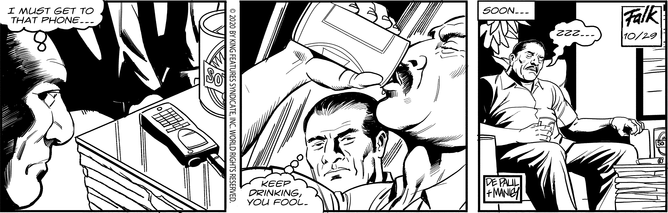

JUMBLE SOLUTION
For convenient home delivery of the Boston Herald, call (800) 882-1211.
Public Announcement Concerning a Proposed Health Care Project Campion Health & Wellness, Inc.
Campion Health & Wellness, Inc. (“Ap- plicant”), a licensed skilled nursing facil- ity (“Facility”) dedicated to serving Jesuits priests, located at 319 Concord Rd., Weston, MA 02493 intends to file a Notice of De- termination of Need (“Application”) with the Massachusetts Department of Public Health to perform substantial renovations to the third floor and related renovations to the Facility’s key building systems, and will seek approval to upgrade the classifica- tion of 12 Level IV rest home beds to Level II skilled nursing beds (the “Proposed Proj- ect”). The Proposed Project does not result in any expansion of gross square feet of the Facility or change to the Applicant’s licensed bed capacity. At the completion of the Pro- posed Project, if its request to upgrade the classification of beds is approved and other requirements are met, the third floor, which now consists of 18 Level IV rest home beds, would consist of a 12 bed Level II bed skilled nursing unit and a 6 bed Level IV rest home unit. The Applicant does not anticipate any price or service impacts on the Applicant’s existing Patient Panel as a result of the Pro- posed Project. The total value of the Pro- posed Project based on the maximum capital expenditure is $3,738,853. Any ten Taxpay- ers of Massachusetts may register in con- nection with the intended Application by no later than December 1, 2020 or 30 days from the Filing Date, whichever is later, by con- tacting the Department of Public Health De- termination of Need Program, 250 Washing- ton Street, 4th Floor, Boston, MA 02108 or by email at dph.don@massmail.state.ma.us.
Oct 29
THE PHANTOM
KIosK runny MeeKly cactus during the california Gold rush, this
land owner had a — one-tracK
”MIne”

The University of Massachusetts Building Authority, Barbara J. Kro- ncke Executive Director, request Bids from Trade Contractors inter- ested in providing HVAC for the Quad Development Project located in the main University of Massachusetts Boston campus on 100 Morrissey Boulevard (Project #UMBA 17-B1). The Awarding Author- ity invites DCAMM Qualified Trade Contractors pursuant to M. G. L. Chapter 149A to submit bids. The Construction Manager is Gilbane Construction Co.
Plans and Specifications will be available free of charge via electronic download starting October 28, 2020 10:00 AM at www. biddocson- line.com. All bidders must register at www.biddocsonline.com in or- der to submit bids and receive notification of any addenda.
Trade Contractors may obtain hard copies of the Construction Docu- ment from Nashoba Blue, Inc., 433 Main Street, Hudson, MA 01749 (978-568-1167) via UPS Ground Delivery only. A refundable deposit of
$300.00 per set (up to two sets), in the form of a certified or cashier’s check to the order of “BidDocs Online Inc.”, is required. Deposits may be paid electronically. Additional sets may be purchased for $300.00. Bidders requesting Bid Documents to be mailed to them shall include a separate check for $70.00 per set for UPS Ground delivery payable to BidDocs Online Inc. No personal or corporate checks nor cash can be accepted as deposits for the Construction Documents.
Bids shall be submitted electronically on the “Bid Forms” at www. biddocsonline.com, on or before November 12, 2020, 2:00 PM. A DCAMM Update Statement, a Certificate of Eligibility, and a bid de- posit in the amount of 5% of the total bid price must accompany each bid. The estimated cost of construction is $53,385,000. The project is funded by the UMass Building Authority.
Oct 29

LEGAL NOTICES

Auctionsaleofunredeemed pledges of Empire Loan Co. on the premises 1130 Washington St., Boston, MA, on Nov 4 2020 @ 10:00ambyHarveyCohen, Auctioneer.MA.Lic.#353

CROSSWORD SOLUTION

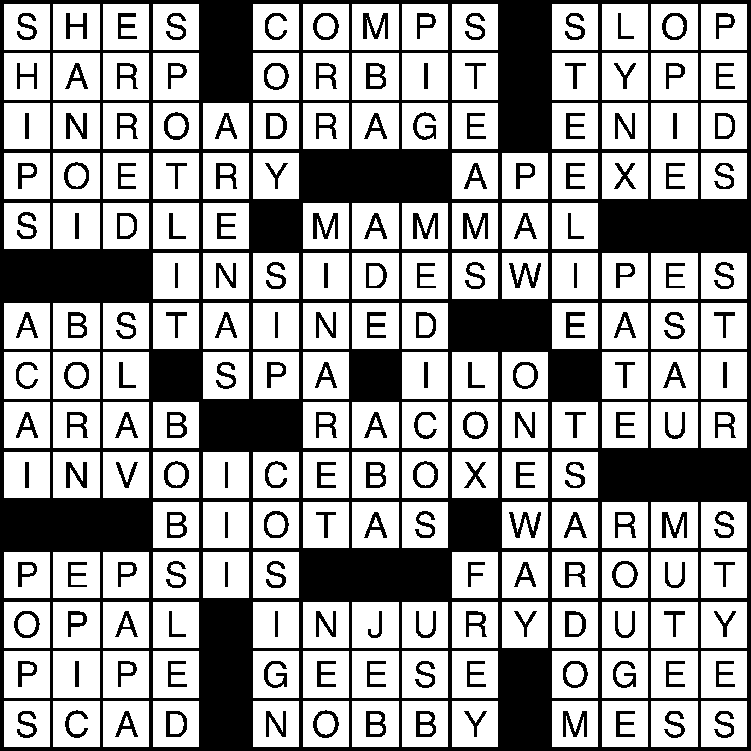

LEGAL NOTICES

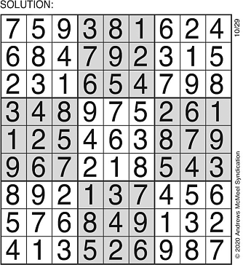Auction sale of unredeemed pledgesofEmpireLoanCo. of Lynn on the premises 1130 Washington St., Bos- ton, MA, on Nov 7 2020 @10:00 am by Harvey Cohen, Auctioneer. MA. Lic.
SUDOKU SOLUTION

LEGAL NOTICES

Auction sale of unredeemed pledgesofEmpireLoanCo. of Stoughton onthepremi- ses1130WashingtonSt.,Bo- ston, MA, on Nov72020 @10:00ambyHarveyCoh- en,Auctioneer.MA.Lic.#353
tHursday, octoBer 29, 2020

CAMPION HEALTH & WELLNESS, INC.
COMMONWEALTH OF MASSACHUSETTS 021261
VENDOR: CHECK NUMBER:
DATE:

11/12/2020

I
DATE | REF. NO. | DESCRIPTION |  | GROSS AMOUNT | DISCOUNT | NET AMOUNT
11/11/2020 | 11/11/20 | PROJ 2020-003, Filing Fee for DoN |  | $7,477.71 | 0.00 $7 | 477.71
 |  |  | TOTALS

$7,477.71 $0.00 $7,477.71
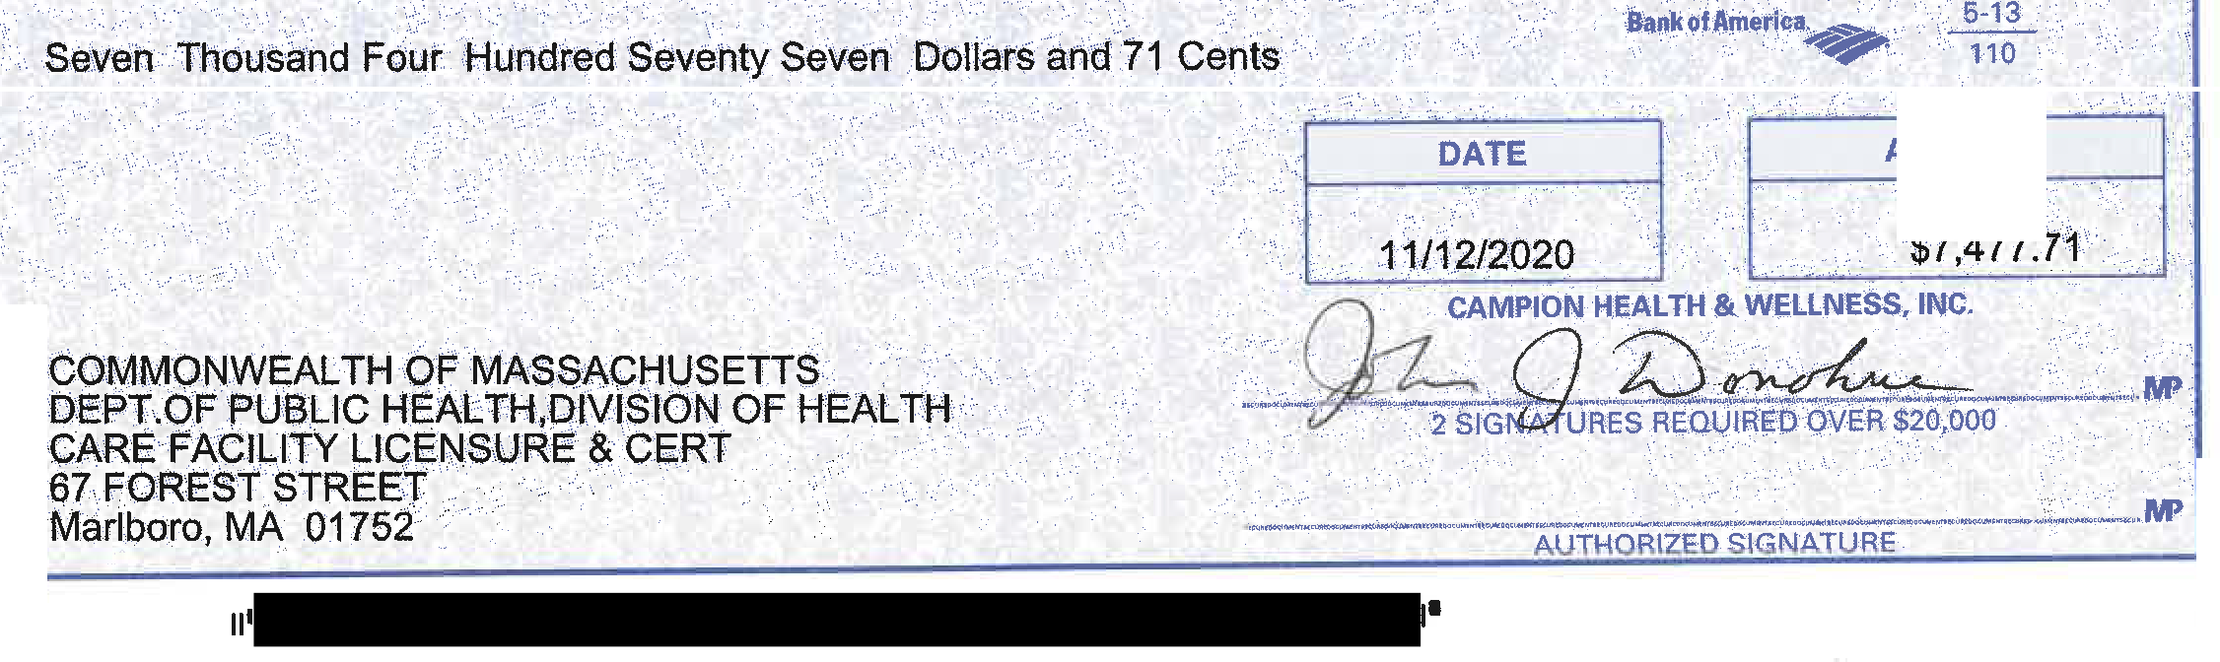
C4tvlPION ff&AbTH w, a l .NE·SS}INC.
- . .
> .3l CQNCOR.f iRPJ\P. ·• · ....
,\ W STON\ MA 0249;:t i3 98
AMOUNT
TO THE
ORDER
····OF;

