Application Number:

Massachusetts Department of Public Health Determination of Need
Change in Service

Original Application Date:
NONE-20111605-LS
11/16/2020

Version: DRAFT 6-14-17
DRAFT

Applicant Information

Applicant Name:
Campion Health & Wellness, Inc.
Emily B. Kretchmer, Esq.
Legal Counsel

Contact Person:
6174827211
ekretchmer@kb-law.com
Title:

Phone:
Ext: E-mail:

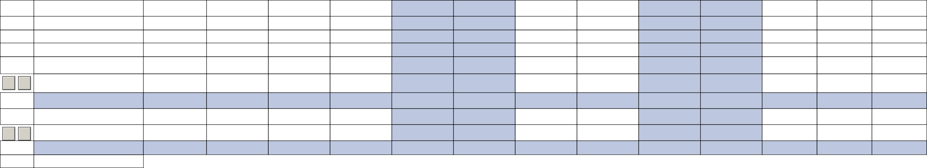
Facility: Complete the tables below for each facility listed in the Application Form
1 Facility Name: Campion Health & Wellness CMS Number: 225656 Facility type: Long Term Care Facility
Change in Service
2.2 Complete the chart below with existing and planned service changes. Add additional services with in each grouping if applicable.
Add/Del Rows |  | Licensed Beds  Existing | Operating Beds  Existing | Change in Number of Beds ( +/-)  Licensed Operating | Number of Beds After Project Completion (calculated)  Licensed Operating | Patient Days  (Current/ Actual) | Patient Days  Projected | Occupancy rate for Operating Beds  Current Beds Projected | Average Length of Stay (Days) | Number of Discharges  Actual | Number of Discharges  Projected
 | Acute
Medical/Surgical 0% 0%
Obstetrics (Maternity) 0% 0%
Pediatrics 0% 0%
Neonatal Intensive Care 0% 0%
ICU/CCU/SICU 0% 0%
+ - 0% 0%
Total Acute 0% 0%
Acute Rehabilitation 0% 0%
+ - 0% 0%
Total Rehabilitation 0% 0%
Acute Psychiatric

Add/Del Rows
Licensed Beds

Existing
Operating Beds

Existing
Change in Number of Beds ( +/-)

Licensed Operating
Number of Beds After Project Completion (calculated)

Licensed Operating
Patient Days

(Current/ Actual)
Patient Days

Projected
Occupancy rate for Operating Beds

Current Beds Projected
Average Length of Stay (Days)
Number of Discharges

Actual
Number of Discharges

Projected

Adult 0% 0%
Adolescent 0% 0%
Pediatric 0% 0%
Geriatric 0% 0%
+ - 0% 0%
Total Acute Psychiatric 0% 0%
Chronic Disease 0% 0%
+ - 0% 0%
Total Chronic Disease 0% 0%

Substance Abuse
detoxification 0% 0%
short-term intensive 0% 0%
+ - 0% 0%
Total Substance Abuse 0% 0%

Skilled Nursing Facility
Level II 34 12 46 11,069 15,526 0% 0% 161 103 119
Level III 0% 0%
Level IV 36 -12 24 8,029 8,029 0% 0% 176 111 105
+ - 0% 0%
Total Skilled Nursing 70 0 70 19,098 23,555 0% 0% 337 214 224
2.3 Complete the chart below If there are changes other than those listed in table above.

Add/Del
Rows List other services if Changing e.g. OR, MRI, etc
+ -

Existing Number of Units

Change in Number +/-

Proposed Existing Volume Number of Units

Proposed Volume

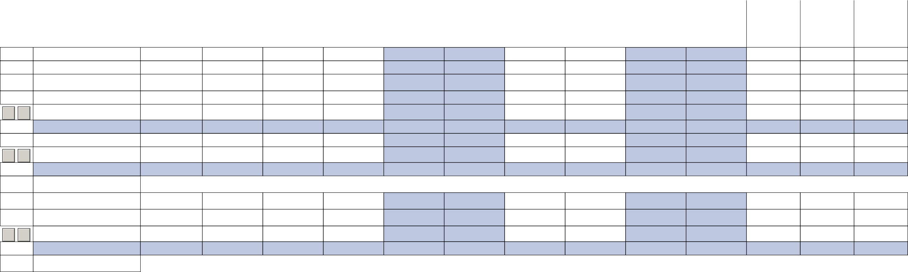
Add additional Facility
Delete this Facility

When document is complete click on "document is ready to file". This will lock in the responses and date and time stamp the form. To make changes to the document un-check the "document is ready to file" box.
Edit document then lock file and submit Keep a copy for your records. Click on the "Save" button at the bottom of the page.
To submit the application electronically, click on the"E-mail submission to Determination of Need" button.
Document Ready for Filing

This document is ready to file:
E-mail submission to Determination of Need
Date/time Stamp: 11/16/2020 11:43 am

