INCIDENT HIGHLIGHTS
DATE:
January 4, 2022
TIME:
12:30 p.m.
VICTIM:
27-year-old flower production technician
INDUSTRY/NAICS CODE:
Other Food Crops Grown Under Cover/111419
EMPLOYER:
Cannabis cultivation and processing, indoors
SAFETY & TRAINING:
Lacked a comprehensive safety and health program and had limited training
SCENE:
Cannabis processing facility
LOCATION:
Massachusetts
EVENT TYPE:
Asthma exacerbation

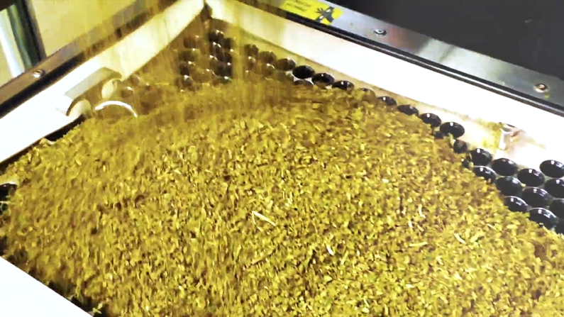

REPORT#: 22MA002 REPORT DATE: November 16, 2023

Cannabis Flower Technician Experiences Fatal Asthma Exacerbation —Massachusetts
SUMMARY
On January 4, 2022, a 27-year-old flower production technician at an indoor cannabis cultivation and processing facility experienced an asthma exacerbation. She was working with processed cannabis, became short of breath and ultimately stopped breathing and lost consciousness. READ THE FULL REPORT> (p.3)
CONTRIBUTING FACTORS
Key contributing factors identified in this investigation include:
- Failure to recognize ground cannabis as a potential occupational respiratory hazard
- Failure to adequately control the spread of airborne cannabis dust
- Lack of a comprehensive safety and health program and overall safety training
LEARN MORE> (p.10)
RECOMMENDATIONS
Massachusetts FACE investigators concluded that, to help prevent similar occurrences, employers should:
- Assess and control hazardous materials in the workplace, including asthmagens.
- Ensure that all workers are properly trained about hazardous materials in the workplace.
- Develop and implement a comprehensive safety and health program that addresses hazard recognition, avoidance of unsafe conditions, and proper use of equipment. LEARN MORE> (p.10)
Massachusetts FACE Program

Fatality Assessment and Control Evaluation (FACE) Program

The Massachusetts Department of Public Health, in cooperation with the National Institute for Occupational Safety and Health (NIOSH), conducts investigations on the causes of work-related fatalities. The goal of this program, known as Massachusetts Fatality Assessment and Control Evaluation (Massachusetts FACE) is to prevent future fatal workplace injuries. Massachusetts FACE aims to achieve this goal by identifying and studying the risk factors that contribute to workplace fatalities, by recommending intervention strategies, and by disseminating prevention information to employers and employees.

NIOSH funded state-based FACE Programs currently include: California, Kentucky, Louisiana, Massachusetts, Michigan, New York, Oregon, and Washington.
Email | Website
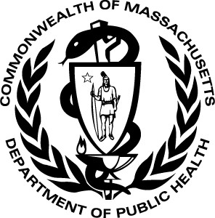
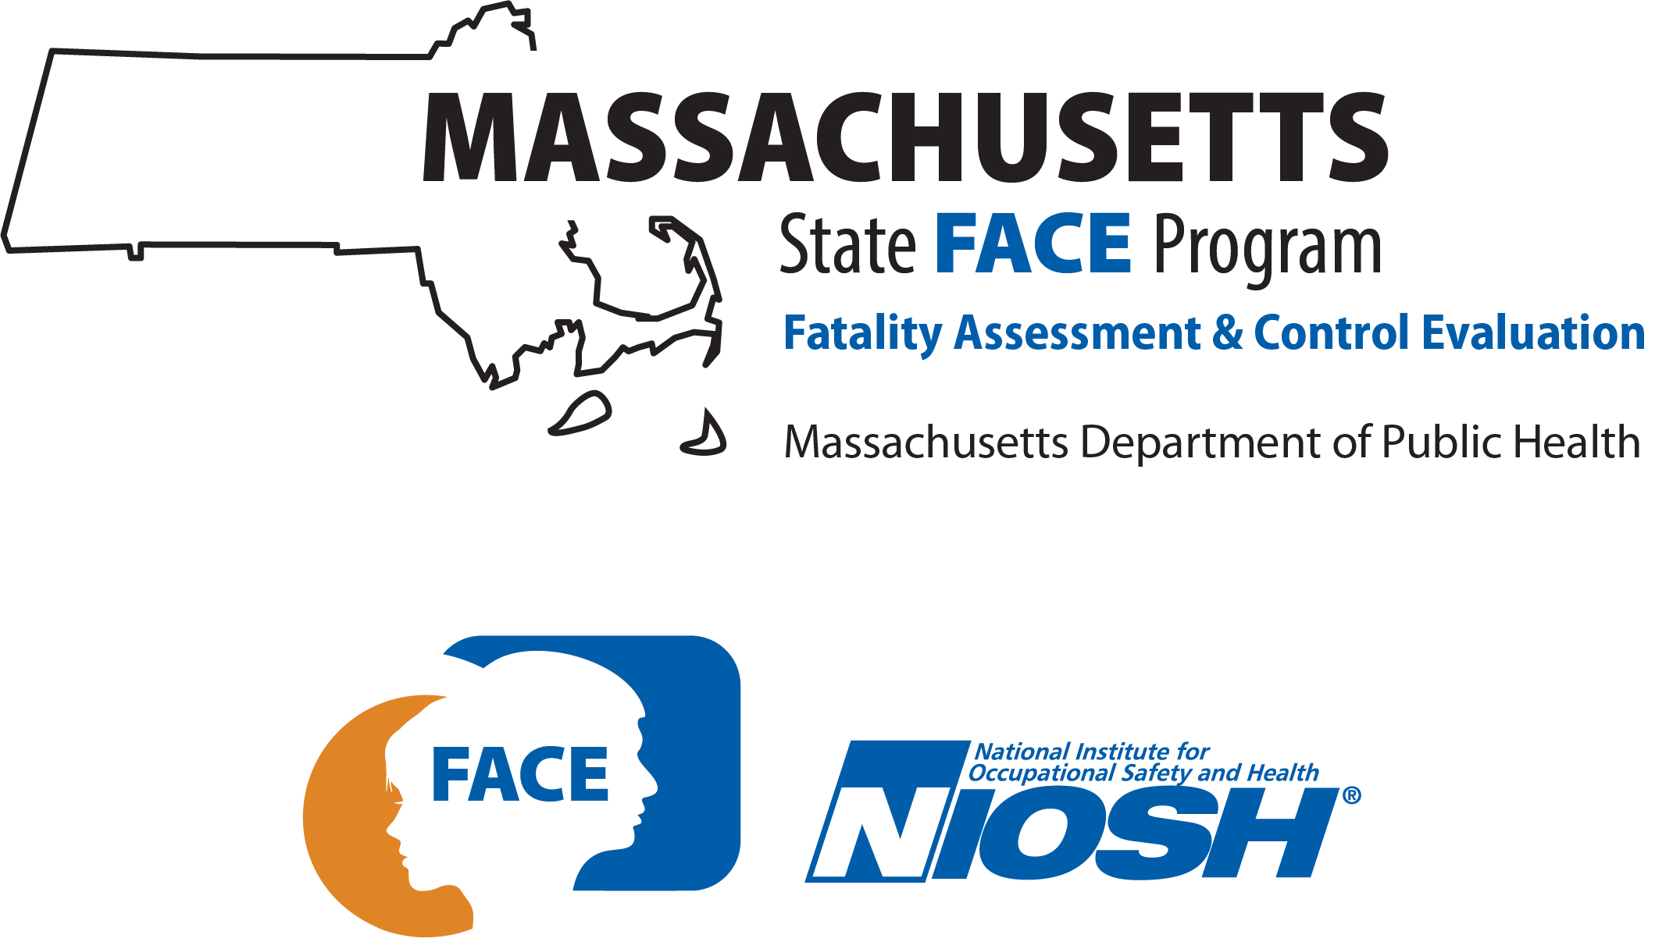

INTRODUCTION

On January 4, 2022, a 27-year-old White non-Hispanic female flower production technician at an indoor cannabis cultivation and processing facility experienced an asthma exacerbation. She was working with dried, ground cannabis and became short of breath and ultimately stopped breathing and lost consciousness. Staff at the site called 911 and began cardiopulmonary resuscitation (CPR). She was transported to a regional trauma center where she remained on life support until she died on January 7. The Massachusetts FACE Program learned of the incident from the Occupational Safety and Health Administration (OSHA) on January 13, 2022, and initiated steps to collect relevant documentation to investigate the event. Several records were reviewed in the course of the investigation, including data from the electronic death registration system (death certificate); medical records from the January event and one prior asthma exacerbation at the workplace requiring transport by ambulance to the local hospital; additional prior medical records describing her health history; public obituary and news coverage; and records from OSHA, including publicly available records listing citations and abatement steps recommended in the hazard alert letter. Massachusetts FACE staff spoke with the next of kin of the worker to gather a more detailed health history. Massachusetts FACE staff also spoke with representatives from the company and toured the facility with senior site safety staff to view the equipment and workspace and discuss the event and safety and health policies.

EMPLOYER
The employer is a cannabis producer and retailer with production and retail sites in multiple U.S. states. The company had operated commercial growing and production facilities in other states for approximately four years before commencing operations at the site in Massachusetts in 2021. The property where the incident occurred was purchased in 2019 and was renovated over several years. In Massachusetts, the company operated three retail sites and an indoor growing and processing facility where the victim worked. As of the publication of this report, the company had decided to cease operations in the state and had closed the retail sites and taken steps to transfer the growing facility to another company.

At the time of the incident, the employer had workers’ compensation insurance. As required by Massachusetts law, all employers operating in Massachusetts are required to carry workers’ compensation insurance for their employees and for themselves if they are an employee of the company. The requirement applies no matter the number of hours worked or the number of employees. Employees of this site did not have union representation.

At the time of the incident, the company employed approximately 300 workers at the site. These included workers that supported the growing, harvesting, processing, packaging, and distribution operations. Approximately half of the workforce supported the cultivation of the cannabis plants. Workers were involved in the harvesting and pre-processing of the cannabis flowers in the growing area of the facility. Production workers were responsible for preparing the flowers and buds for sale as raw flowers or processing the cannabis to use in making pre-rolled cannabis joints, called pre-rolls. Fifteen workers, including the victim, were in this processing role or worked in the processing room. Other production workers processed the cannabis to make extracts for oils and edible products. Other workers specialized in inventory, counting, packaging, and distribution of cannabis products to the three retail stores in the state and to other retailers within the state through the wholesale market. The company had a safety manager local to the site and a regional safety manager. Other workers supported maintenance and security at the site.

The operation had two day-shifts, 5:00 a.m. through 1:30 p.m., a second shift starting after the first shift and ending at 10:00 p.m., and security personnel that worked overnight. The site operated Monday through Friday, and some workers continued cultivation activities over the weekend.

WRITTEN SAFETY PROGRAMS and TRAINING
At the time of the incident, the employer had a written hazard communication program. Workers were provided one hour of safety training in the form of a presentation during orientation when they were hired. This included roughly 20 health and safety topics, including hazard communication. The training did not include content about safety considerations for handling the cannabis plant or products and did not include information about the risk of allergic reaction to the cannabis plant or dust. Certain employees were provided with additional training such as CPR and the use of automated external defibrillators (AEDs) available at the site. The employer maintained copies of safety data sheets (SDSs) as part of the hazard communication program. The SDSs were available electronically and in hard copy in a binder where chemicals were stored.

WORKER INFORMATION
The victim was a 27-year-old White non-Hispanic female who started working for the company in May 2021, the same month the company started production. Her first job at the site was titled cycle counter. This role was a floater in inventory and involved counting products. These tasks were part of a systematic way to confirm inventory counts and maintain product security. This task was conducted in different parts of the facility and based in storage rooms or vaults located in various areas of the building. In August 2021, she changed roles to become a cycle counter specifically for the production division. In October 2021, she was moved to a different production role and became a flower technician. She worked the day shift from 5:00 a.m. through 1:30 p.m. She was responsible for filling jars with unprocessed flowers and buds and filling pre-rolls with ground cannabis. This work involved processing and handling whole and ground cannabis flower buds. She was one of four workers in the grinding room. When she became aware of her breathing problems, she moved to a workstation just outside of the grinding room where she continued to assemble cannabis pre-rolls.

EQUIPMENT
Various pieces of equipment were used in processing the cannabis product. After the cannabis was harvested and hung to dry, a machine was used to trim the flowers and buds from the stem of the plant. Trimming was also performed by hand. Whole flowers or buds were placed into jars for sale as unprocessed product. A machine was used to fill and weigh and seal the jars. When this machine was not working optimally, the workers shifted to filling the jars by hand.
In the grinding room flowers were also processed by grinding or milling to make the material smaller. This work included a grinding machine (Figures below) that was next to workstations where pre-rolls were filled. The machine was manufactured by a Canadian company that specialized in production equipment for the cannabis industry. The grinding machine specific to this incident was 28 inches long, 28 inches wide, and 52 inches in height. The machine had a guarded hopper on the top where unprocessed flowers were placed.
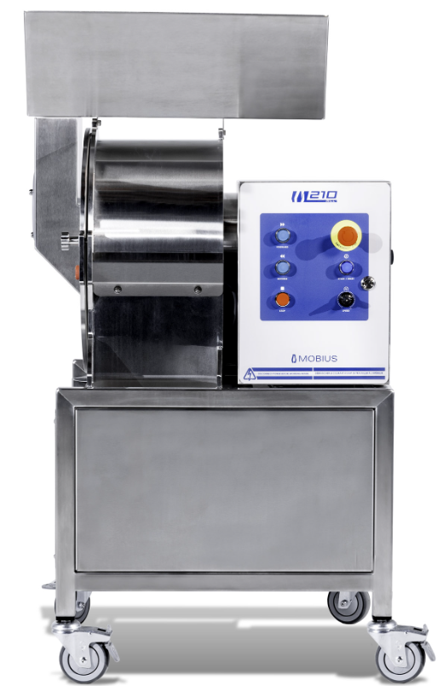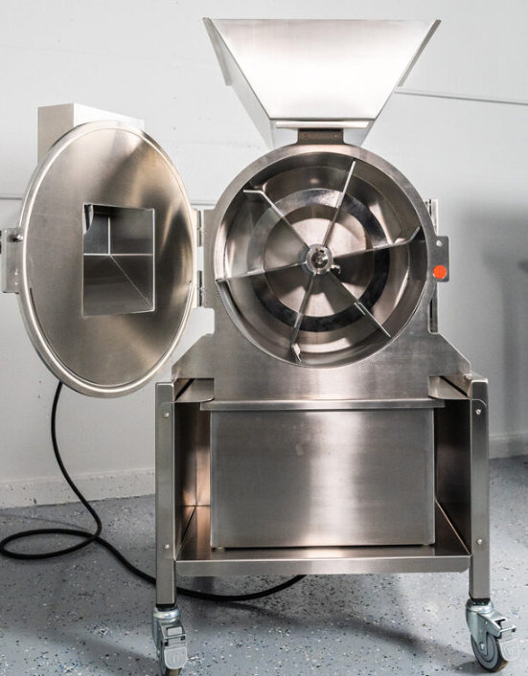
Figure 1 – Grinding machine Figure 2 – Grinding machine with impeller door open
Images from manufacturer site https://mobiustrimmer.com/cannabis-automation/m210-cannabis-mill/

The flowers would fall into a drum where a rotating impeller would scrape them against a milling screen on the bottom of the drum (Figures 2 and 3). A selection of milling screens came with the machine and standard available screens had holes that ranged in size from ¾ inch down to 1/16 inch to create coarse or fine processed product. As the product passed through the screen, it would fall into a collection bin below the drum (visible in Figure 2; removed in Figure 4).
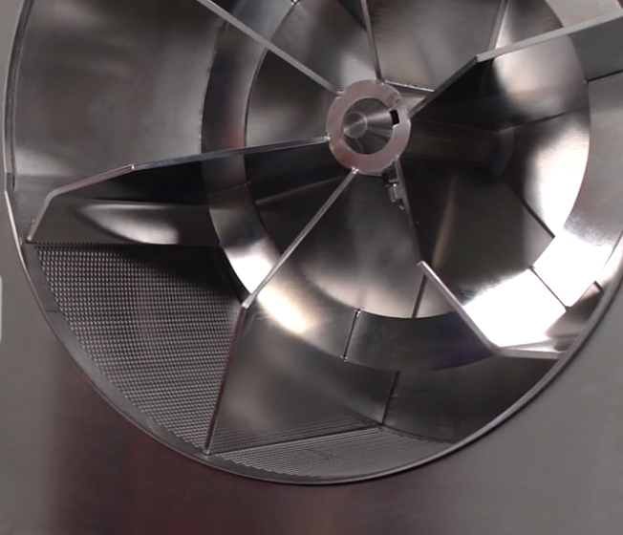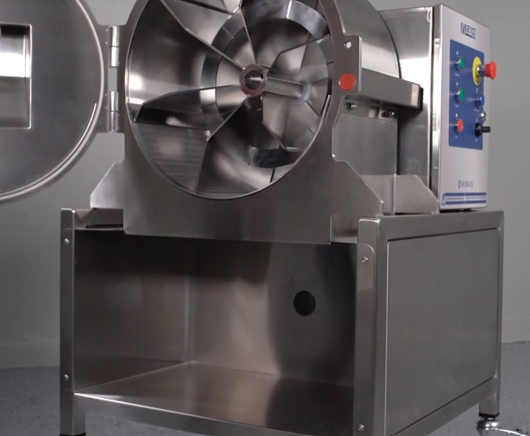
Figure 3 – Impeller and milling screen Figure 4 – Impeller and collection area, bin removed
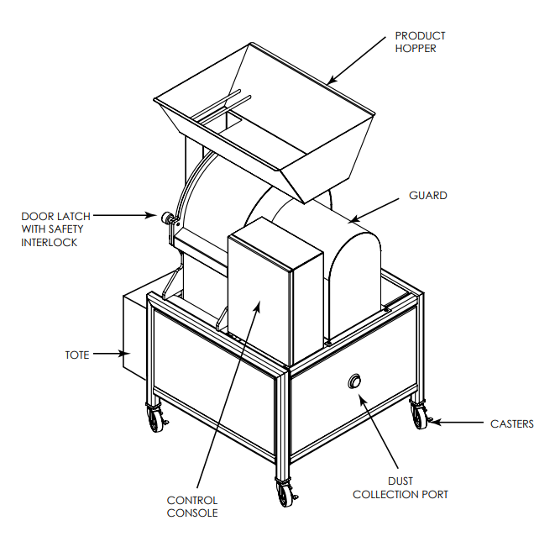
Figure 5 – Machine schematic
The machine had a local exhaust dust collection system that was installed by the cannabis company. It consisted of a dedicated vacuum cleaner attached by a hose to a port on the machine. This port is on the rear of the machine and is visible in Figures 4 and 5. When the grinding machine was in use, the vacuum machine was to be turned on to reduce airborne cannabis dust. The grinder was run for intervals of approximately 15 minutes and was run an average of three times each day. Workers remained in the room to complete other tasks while the grinder was running.
The operator’s manual included instructions regarding the use of the machine and precautions concerning the dust created by the machine. The manual did not specify or suggest what kind of vacuum or dust collection system should be attached to the machine and did not specify for how long the collection system should be run to collect dust after milling.
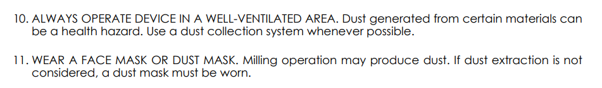
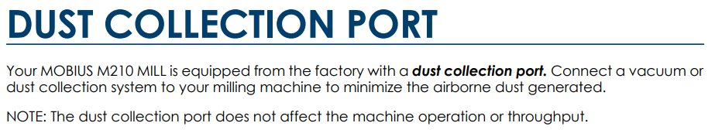
Figure 6 – Images from operator’s manual
Ground cannabis was primarily prepared in the grinding machine and further processed in a small table-top blender to produce the desired consistency.
Another machine called a shaker or rocket box (Figure 7) was used to make cannabis pre-rolls and was set up near the grinder. The machine was used to shake the ground product down into paper rolls that were loaded into a rack (Figure 8). The ground cannabis was poured into the open top of this machine. The machine vibrated as the user moved the ground cannabis around a tray to evenly distribute and fill the rolls. The rolls were then packed down and weighed and twisted to finish them. Workers also assembled pre-rolls by hand and weighed the rolls. This work was conducted at counter-height tables both inside the grinding room and just outside.

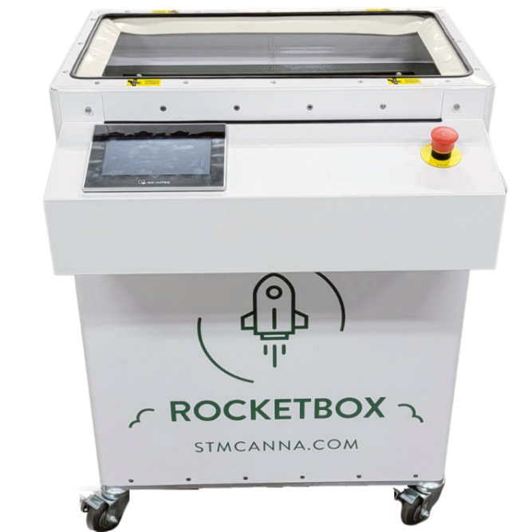
Figure 7 – Shaker box machine Figure 8 – Shaker box, top view of roll cylinders
Protective clothing available at the facility included nitrile gloves, long-sleeve tops, hairnets, beard covers, and shoe covers. These were provided to those workers handling product and described as a measure to prevent contamination of the finished product. Goggles, protective glasses, and hearing protection were available for use as well as surgical-style masks for COVID-19 infection control. Respirators, including elastomeric half facepiece and full facepiece respirators with exchangeable cartridge filters, were used by certain workers depending on their roles and those workers were included in a respiratory protection program. Fabric face coverings, surgical masks, and N95 filtering facepiece respirators were used as dust masks by other workers, including the victim. However, masks were not always available from the employer and workers were not fit-tested as part of a formal respiratory protection program. Masks were not consistently used by workers in the grinding room. The victim at times did use N95 filtering facepiece respirators and reportedly obtained them from outside of work because they were not available from the employer.

INCIDENT SCENE
The building, more than 150 years old, was located in a historic industrial area on a major interstate river. It was originally a mill and more recently occupied by a furniture reconditioner/reseller until the cannabis company purchased the property in 2019. The building underwent renovation to convert the space to accommodate cannabis growing and processing. The final space was more than 150,000 square feet, with the majority used for cultivation. The grinder, blender, and shaker box were located together in a room where the workers assembled pre-rolls. The room measured approximately 25 feet by nine feet. Workers assembling pre-rolls were stationed at a table in the grinding room and at a table outside of the grinding room where the jar filling and other packaging tasks were completed.

WEATHER
On the day of the incident, the weather had a low of 14 degrees Fahrenheit and a high of 34 degrees Fahrenheit, as recorded at a regional weather station. [Weather Underground]. The weather is not believed to have been a factor in this incident.

INVESTIGATION
Review of the worker’s job tasks, exposures, and health history led to the finding that her exposure to the cannabis plant and ground cannabis at work contributed to her developing an allergy and ultimately asthma. The MA FACE program and partner investigators believe this is the first occupational asthma fatality in this U.S. workforce. Information from multiple sources taken together suggests that the victim did not have asthma prior to starting at the cannabis facility in May 2021. In a 2022 interview with FACE staff, the victim’s next of kin noted that the victim never had asthma. This is consistent with information from a medical record from a November 2021 emergency department visit (described in more detail below) in which the victim denied a prior history of asthma. She did have a history of chronic cough and was evaluated for suspected cough-variant asthma by a pulmonologist in 2016. Based on the evaluation, which included pulmonary function testing and pre- and post-bronchodilator spirometry but not methacholine challenge, the pulmonologist excluded asthma and offered alternative likely causes for her cough, including cigarette and marijuana smoking, gastroesophageal reflux disease (GERD), and occasional rhinitis. Finally, according to her primary care physician, she had not seen the victim since late 2015 and had not prescribed her any allergy or asthma medication in the interim.
The victim began working at the facility in May 2021. In late July 2021, she was seen at an urgent care center for symptoms consistent with COVID-19 or another respiratory infection. She tested negative for COVID-19 and was instructed to treat the symptoms with over-the-counter medications. She had a follow-up appointment a week later. She again tested negative for COVID-19. Cough was listed as a secondary diagnosis and bilateral diffuse wheezes were noted on physical exam. Her chest X-ray (radiograph) was normal Approximately 3 months after starting at the facility, the victim reportedly experienced cough, shortness of breath, and a runny nose that worsened throughout the workday. These symptoms became worse after she changed roles within the company in October 2021, moving from counting finished product to being a flower technician in the grinding room, which required handling and processing cannabis. She reportedly recognized and reported to her supervisor an increase in symptoms when working within the grinding room. Her symptoms increased when the grinder was in operation, and she would move to an assembly workspace just outside the room to reduce her exposure. Other attempts to reduce her exposure to cannabis dust that were implemented by the company included closing the door to the grinding room and installing plastic sheeting around the dust collection vacuum. She also began to use an N95 filtering facepiece respirator that she obtained from outside of work.
In early November 2021, approximately five weeks after having started the flower technician role, she experienced an episode of acute shortness of breath at work. Emergency medical services (EMS) were called and responded to the scene. EMS noted she was experiencing shortness of breath, coughing, and rhonchi (the sound of fluid in her airways, when breathing in and out). In the ambulance on the way to the local hospital, she was treated with oxygen and an albuterol bronchodilator delivered through a nebulizer. She had an oxygen saturation of 98% recorded in the ambulance. At the hospital she felt better – she had an oxygen saturation of 97% recorded and her shortness of breath had resolved. She reported no fever, chills, headache, sore throat, or abdominal symptoms. She had faint bilateral wheezing noted on physical exam, tested negative for COVID-19, and had an unremarkable chest x-ray. She denied a history of asthma, discussed a possible allergy to something at work, and reported having a chronic cough and runny nose. It was suspected she might be developing asthma and had underlying allergies. She was prescribed a five-day regimen of oral steroids and a rescue inhaler, along with over-the-counter allergy medication.
On the day of the January 2022 incident, the victim was working in the production area loading ground product into paper rolls to create pre-rolled cannabis joints. She was using an N95 filtering facepiece respirator and wearing a long-sleeved jacket and protective nitrile gloves. She became increasingly short of breath and reportedly used her inhaler repeatedly throughout the day without an improvement in symptoms. She was also coughing and sneezing. Her condition worsened until she experienced respiratory arrest and cardiac arrest at the site. Co-workers performed CPR with the aid of a bag valve mask. An AED was available at the site and brought to the scene and deployed. Chest compressions and use of the bag valve mask were continued. EMS arrived and continued CPR and also activated the AED. The AED assessed her heart rhythm and did not initiate a shock to reset the rhythm. She was intubated at the site and after five epinephrine injections her heart was restarted prior to her arrival at the regional trauma center. Scanning indicated she had sustained a brain injury from lack of oxygen. She remained in the intensive care unit for three days and did not recover.

CAUSE OF DEATH
The medical examiner listed the cause of death as brain death, due to cardiac arrest (12 hours prior), due to respiratory arrest (spanning four days), due to presumed severe asthma attack.

CONTRIBUTING FACTORS
Occupational injuries and fatalities are often the result of one or more contributing factors or key events in a larger sequence of events that ultimately result in the injury or fatality. Massachusetts FACE investigators identified the following unrecognized hazards as key contributing factors in this incident:
- Failure to recognize ground cannabis as a potential occupational respiratory hazard
- Failure to adequately control the spread of airborne cannabis dust
- Lack of a comprehensive safety and health program and overall safety training

RECOMMENDATIONS/DISCUSSION

Recommendation #1: Employers should assess and control hazardous materials in the workplace, including asthmagens.
Discussion: In response to the fatality, air monitoring was conducted by OSHA to understand what may have contributed to the worker’s worsening respiratory symptoms and her development of asthma. The samples were collected over an entire shift and the sampling devices were turned off for meal breaks and for other breaks. Air monitoring conducted by OSHA after the event found low levels of endotoxins and respirable dust. It should be noted that the dust collection vacuum connected to the grinder had been replaced in the weeks after the fatality, before OSHA conducted sampling. Air sampling devices were worn by staff to measure their individual exposures throughout their work tasks and shifts. The total personal respirable dust from the grinder operator was 0.012 micrograms per cubic meter (m³) over an eight-hour sample. For other workers in the grinding room, who were not the primary grinder operator but worked in the vicinity, respirable dust was not detected with their eight-hour personal air samples. Personal air sampling was also conducted by OSHA to assess endotoxins. The operator’s level was 27 endotoxin units (EU) per m³ and levels of 1.8 EU/m³ and 1.9 EU/m³ were measured on two other workers in the room. FACE investigators reviewed evidence documenting the scene at the time of the event which showed cannabis dust covering the exterior of the original dust collection vacuum and surfaces around the equipment. The replacement unit reportedly reduced the amount of airborne dust to the level that no dust was visible. Required testing of samples of final product, conducted to comply with quality standards established for retail cannabis sellers, was performed on a periodic basis, and did not reveal any other possible chemical contaminants. Assessment of work practices and chemicals used at the site did not reveal any other substances identified as contributing to her respiratory symptoms.
OSHA spoke with additional flower production workers and identified several with respiratory symptoms or skin reactions they associated with working at the facility. One former employee had symptoms consistent with work-related asthma. Additional findings and details from those interviews are being published separately.
Cannabis sativa is an ancient crop with allergenic properties recognized by pioneering occupational physicians; Bernardino Ramazzini noted in the early 1700s that hemp workers experienced chronic cough that progressed to asthma [Davidson]. Cannabis dust and cannabis smoke are both asthmagens and sensitizing agents based on research reviewed by the Association of Occupational and Environmental Clinics (AOEC) as listed in the AOEC Exposure Code Lookup tool. There is more scientific literature in recent years that concludes cannabis users and production workers can develop allergies and become sensitized to cannabis and develop asthma and related conditions [Sack, Jackson, Reeb-Whitaker].
It is essential that employers assess and control all hazardous materials in the workplace, including respiratory hazards. A job hazard analysis (JHA) is a method for systematically analyzing a job task for potential hazards. A hazard is any situation that could result in injury or illness if left uncontrolled. This analysis considers the interconnected relationship between the worker, the task, the tools, and the work environment. The purpose of a JHA is to identify potential hazards prior to the start of a task to reduce or eliminate the hazard(s).
Asthmagens such as cannabis have the potential to sensitize individuals and that process can lead to a more profound allergic response over time. The worker’s symptoms had progressed over time. She continued to work in a role that involved handling the ground cannabis. Further control of the hazard or removing the victim from this work environment could have prevented this fatality. In addition, recognition of symptoms in the victim and in other workers at the site should lead to a more thorough hazard assessment and implementation of additional controls.
Controlling the source of any airborne cannabis dust should be the main objective, as limiting worker exposure to the cannabis dust can prevent sensitization and reduce symptoms among workers who are already sensitized. This is consistent with the prioritization of control methods under the hierarchy of controls. This established tool helps demonstrate that eliminating the hazard at the source is the most effective control and that elimination efforts be implemented first.
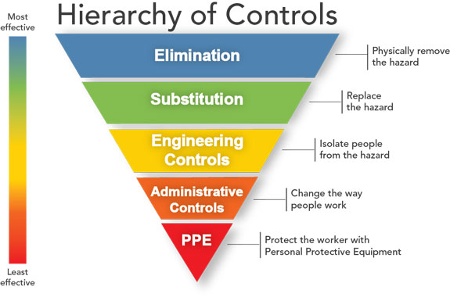
Figure 9 – Hierarchy of Controls
After the dust has been further controlled with equipment modifications and ventilation, additional work process changes that bridge engineering controls and administrative controls can be implemented. These can include changes in procedure in how the ground cannabis is contained, transported, and manipulated in the course of production. Other administrative controls can include providing additional distance between the workers and the source, such as moving the assembly tables away from the grinding equipment. Administrative controls can also include schedule or work task changes to limit any individual worker’s exposure. The steps the victim and the employer took, to have her work outside of the grinding room and to close the grinding room door, are examples of administrative controls. All of these methods are essential tools in controlling any individual worker’s exposure. While these controls are being implemented and assessed, it may be necessary to also implement a comprehensive respiratory protection program for the workers in this space. It is important to continue to strive to eliminate and control the source of the hazard.
Given the main objective is collecting and containing the cannabis dust, it is equally important that the procedures used to maintain the ventilation and dust collection equipment do not reintroduce the cannabis dust into the work environment or expose workers. Any ductwork, apparatus, and filters need to be emptied, cleaned, and maintained or replaced and the hazardous material must be disposed of appropriately.

Recommendation #2: Employers should ensure that all workers are properly trained about hazardous materials in the workplace.
Discussion: The employer provided health and safety training for new hires. The training did not acknowledge the allergenic properties of cannabis or the potential for on-the-job exposure to cause respiratory problems. Employers must train workers about all hazardous materials in the workplace.
One of the most cited OSHA standards is 29 CFR 1910.1200 Hazard Communication. This standard describes the Globally Harmonized System of Classification and Labeling of Chemicals (GHS), safe handling, use, and storage of chemicals in the workplace, and training. As described on the OSHA Hazard Communication topic page:
All employers with hazardous chemicals in their workplaces must have labels and safety data sheets for their exposed workers, and train them to handle the chemicals appropriately.
All employers with hazardous chemicals in their workplaces must ensure the chemicals are labeled and provide SDSs for the products. SDSs are a standardized way to share important safety information with the workers that encounter the products. SDSs should be used to train the workers on how to handle the chemicals appropriately.
While conducting research in the course of the investigation, MA FACE was able to locate just one existing SDS for a cannabis plant product, available from another manufacturer, online. The information found on the web was last updated in 2014, at a time when such documentation in the United States was still called a Material Safety Data Sheet (MSDS). The MSDS was for cannabis sativa and described as a dried hemp product. This is an indicator of the status of the cannabis industry at the time, when hemp was legal, and how companies were trying to apply federal requirements. That SDS was not for ground cannabis product that was manufactured for wholesale distribution for recreational or medicinal use.
While the grinding of cannabis was one of many steps in processing the plant for use and sale in finished products, such as pre-rolls, the grinding created a concentration of the potent component of the plant at volumes such that it should have been treated as hazardous. It is necessary to train workers about these materials, even in the absence of relevant SDSs, so they may understand the hazard and the reasoning for any protective equipment modifications, procedures, or personal protective equipment used. It is also essential that the workers be trained to recognize the signs and symptoms of exposure and overexposure that may indicate a developing allergy.

Recommendation #3: Employers should develop and implement a comprehensive safety and health program that addresses hazard recognition, avoidance of unsafe conditions, and proper use of equipment.
Discussion: Ensuring workers are properly trained about the hazardous materials in their workplace is one component of a comprehensive safety and health program. While this investigation focused on exposure and reaction to cannabis and cannabis dust, numerous hazards have been identified in the industry. See Additional Resources below. Having a comprehensive safety and health program is essential to maintaining a safe workplace. A safety and health program should include the systematic identification, evaluation, and prevention or control of both general workplace hazards and the hazards of specific jobs and tasks. The core elements of an effective safety and health program are management leadership, worker participation, hazard identification and assessment, hazard prevention and control, education and training, and program evaluation and improvement. The program should outline safe work practices workers are expected to adhere to, specific safety protection for all tasks workers perform, how workers can identify and avoid hazards, and who workers should contact when safety and health issues or questions arise. The program should also include an explanation of the workers’ rights to protection in the workplace.
When developing a safety and health program, employers should start by performing a general hazard analysis of tasks routinely performed by employees. Those findings should be incorporated into the comprehensive program. Employers should also use their employees’ expertise throughout the program development process, and eventually during the updating process, by seeking employee input. Once the program is developed, employers should ensure that they have fully and effectively implemented their safety and health program by routinely performing assessments of tasks and immediately addressing any observed unsafe conditions. The program should also be updated when safety concerns arise and when new equipment, tasks, and chemicals are introduced into the workplace.
Routine training should be provided to all employees on the program’s topics and procedures, and the training should also include hazard recognition and the avoidance of unsafe conditions. All training provided to employees should be documented. Training ensures that workers know how to safely perform required job tasks. Trainings should be performed by a competent person, which is defined by OSHA as “one who is capable of identifying existing and predictable hazards in the surroundings or working conditions which are unsanitary, hazardous, or dangerous to employees, and who has authorization to take prompt corrective measures to eliminate them.” Any training needs to be provided in the employee’s preferred language. This means the training must be provided in the language(s) and at the literacy level(s) of the employees.
The Massachusetts Department of Labor Standards (DLS) offers free consultation services to help small employers improve their safety and health programs, identify hazards, and train employees. DLS can be contacted at 508-616-0461. More information about DLS can be found on their website at www.mass.gov/dos/consult.
The Massachusetts Department of Industrial Accidents (DIA) has grants available for providing workplace health and safety training to employers and employees. Any company covered by the Massachusetts Workers’ Compensation Insurance Law is eligible to apply for these grants.

Recommendation #4: Employers should implement a medical surveillance program to monitor the health of their workers.
Discussion: In this setting, workers were exposed to the cannabis plant through all the stages of cultivation and processing. In addition to the victim, other workers at the site experienced symptoms and allergic responses. This exposure includes dermal or skin contact with plant material on parts of the body that are exposed as well as inhalation of ground cannabis dust and other airborne components that were present in the building and concentrated in certain work areas. Those combined workplace exposures may be compounded by additional exposure to cannabis outside of work through recreational or medicinal use. With ongoing workplace exposure, it is necessary to watch for signs and symptoms of allergy and asthma in all workers. Training of the workforce in recognizing signs and symptoms is an important component, as is oversight by supervisors and managers. Workers should be evaluated periodically by a healthcare provider with expertise in occupational allergy and asthma. This evaluation can be part of a formal medical screening and surveillance program that monitors the health of the workforce and ensures proper medical follow-up is completed. The program can help identify workers early who may be developing lung disease and help identify work tasks that contribute to exposure and warrant additional controls. It is necessary that the medical surveillance be ongoing as it may take time for allergies to develop and symptoms to become apparent. A medical surveillance program may include a regular worker questionnaire to monitor for allergies, asthma, and respiratory symptoms. New or worsening respiratory symptoms should prompt additional evaluation and controls.

Recommendation #5: Equipment manufacturers should adopt and implement the concept of Prevention through Design (PtD) to identify potential hazards associated with equipment and then eliminate these hazards through design changes.

Discussion: The concept of Prevention through Design (PtD), as it would relate to equipment manufacturers, is addressing safety and health needs during the design process to prevent or minimize hazards that could result in injuries, illnesses, and fatalities to equipment operators and others. Applying PtD during the design phase would initiate the process of thinking about how the machine functions in relation to the individuals who would operate, maintain, come in contact with, or interact with the machine. The goal is to identify potential hazards during these interactions. Once hazards are identified, the machine design can be altered to eliminate or control these hazards.

In this case, the manufacturer designed the grinding machine with a dust collection port so the end user could attach a vacuum or connect to a broader ventilation system. This kind of local exhaust dust collection, at the source where the dust is created, can be effective. This is an example of PtD. While the instruction manual for the machine indicated that the unit should be used in a well-ventilated area, connected to active ventilation, or the user should wear respiratory protection, more information could have been provided about the kind of collection system that should be used. The company initially had attached a shop vacuum that was able to pull dust through the port but that was unable to contain the dust. The manufacturer should recommend or package for sale with the machine a specific dust collection vacuum or style that has been tested and evaluated through use and maintenance cycles. An additional design enhancement could be to use an interlock that ensures the dust collection vacuum is both present and operating then the grinder is activated. Other equipment and processes in the grinding area, including the blender and the pre-roll machine, should be assessed and considered for design enhancements that would better control and contain the cannabis dust.

Recommendation #6: Industry licensing agencies in Massachusetts should consider how they can further support the health and safety of cannabis industry workers.

Discussion: The Cannabis Control Commission is the entity in Massachusetts that is responsible for licensing and periodically inspecting cannabis production facilities in the state. The Commission’s core work includes ensuring production of a safe consumer product. Worker health and safety are also central to the work of the Commission, as reflected in state regulations requiring adult use and medical use licensees (companies) to have and follow written operating procedures including “policies and procedures to promote workplace safety consistent with the standards set forth under the Occupational Safety and Health Act” (OSHA). The Commission can serve as a valuable bridge to connect the facilities, management, and workers with safety and health resources available from state and federal agencies. The Commission is in a position to share expert industry knowledge and experience with agencies, such as OSHA and DPH, so they can better understand the processes involved in cannabis cultivation and processing. This can include recognizing when processing equipment is not adequately controlling cannabis dust and promoting the sharing of best practices in controlling hazards present in the industry.

ADDITIONAL RESOURCES

NIOSH, Work-related Asthma.

NIOSH, Health Hazard Evaluation Program Evaluation of a Medicinal Cannabis Manufacturing Facility with an Indoor and Outdoor Grow Operation; Evaluation of Potential Hazards during Harvesting and Processing Cannabis at an Outdoor Organic Farm; Evaluation of Potential Hazards During Harvesting and Trimming Cannabis at an Indoor Cultivation Facility.

OSHA, Job Hazard Analysis and sample form.

OSHA, Hazard Identification and Assessment.

OSHA, Hazard Communication: Small Entity Compliance Guide for Employers That Use Hazardous Chemicals. OSHA Publication 3695.

OSHA, Medical Screening and Surveillance.

CalOSHA, Cannabis Industry Health and Safety.

Colorado Department of Public Health & Environment, Guide to Worker Safety and Health in the Marijuana Industry.

DISCLAIMER
Mention of any company or product does not constitute endorsement by Massachusetts FACE or the National Institute for Occupational Safety and Health (NIOSH). In addition, citations to websites external to Massachusetts FACE and NIOSH do not constitute Massachusetts FACE or NIOSH endorsement of the sponsoring organizations or their programs or products. Furthermore, Massachusetts FACE and NIOSH are not responsible for the content of these websites. All web addresses referenced in this document were accessible as of the publication date.

REFERENCES
Weather Underground. Weather History. Massachusetts: TWC Product and Technology LLC.

OSHA Code of Federal Regulations. 29 CFR 1910.134. Respiratory Protection.

OSHA Code of Federal Regulations. 29 CFR 1910.1200. Hazard Communication.

OSHA. Recommended Practices for Safety and Health Programs, Hazard Prevention and Control.

OSHA hazard control worksheet in Identifying Hazard Control Options: The Hierarchy of Controls.

Reeb-Whitaker C, LaSee CR, Bonauto DK. Surveillance of work-related asthma including the emergence of a cannabis-associated case series in Washington State. J Asthma. 2021 Aug 16:1-11. doi: 10.1080/02770903.2021.1955379. Epub ahead of print. PMID: 34288786. https://pubmed.ncbi.nlm.nih.gov/34288786/.

Davidson M, Reed S, Oosthuizen J, O'Donnell G, Gaur P, Cross M, Dennis G. Occupational health and safety in cannabis production: an Australian perspective. Int J Occup Environ Health. 2018 Jul-Oct;24(3-4):75-85. doi: 10.1080/10773525.2018.1517234. Epub 2018 Oct 3. PMID: 30281413; PMCID: PMC6237171. https://www.ncbi.nlm.nih.gov/pmc/articles/PMC6237171/.

Sack C, Simpson C, Pacheco K. The emerging spectrum of respiratory diseases in the U.S. cannabis industry. Semin Respir Crit Care Med. 2023 Apr 4. doi: 10.1055/s-0043-1766116. Epub ahead of print. PMID: 37015286. https://pubmed.ncbi.nlm.nih.gov/37015286/.

Jackson, B., Cleto, E. & Jeimy, S. An emerging allergen: Cannabis sativa allergy in a climate of recent legalization. Allergy Asthma Clin Immunol 16, 53 (2020). https://doi.org/10.1186/s13223-020-00447-9.

Association of Occupational and Environmental Clinics (AOEC). AOEC Exposure Code Lookup tool http://www.aoecdata.org/ExpCodeLookup.aspx.

National Institute for Occupational Safety and Health, Workplace Safety & Health Topics, Prevention Through Design. www.cdc.gov/niosh/topics/ptd.

Code of Massachusetts Regulations. 935 CMR 500.00 Adult use of marijuana 105(1)(r) and 501.00 Medical use of marijuana 105(1)(r).

