Commonwealth of Massachusetts
Executive Office of Health and Human Services

Virtual Gateway


CBHI CANS Activity Report Reference Guide
(Certified Assessor and Organization Roles)
November 2016


CBHI Member Progress Report Reference Guide
Contents
Summary of Reference Guide 3
Logon to Virtual Gateway 3
Generating the CANS Activity Report 3
Sample of a CANS Activity Report 6
Questions or Need Assistance? 7

Summary of Reference Guide
The CANS Activity Report will help users monitor Assessors’ activity over a period of time within the organization. This reference guide will walk a user through how to access, run and view the CANS Activity Report.

Logon to Virtual Gateway
To log on to the Virtual Gateway (VG), go to https://sso.hhs.state.ma.us/. Select the Children’s Behavioral Health Initiative (CBHI) business service to enter CANS in the VG.
Note: Refer to the Login Assistance page at www.mass.gov/eohhs/provider/training-and-edu/vg/login-help-for-providers-and-state-agency-staff.html for more information on managing your Virtual Gateway (VG) account.

Generating the CANS Activity Report
A user with a designated organizational role or certified assessor role may generate and view the CANS Activity Report.
From the Main Assessment Menu:
- Select the [Reports] tab.
- Select [CANS Activity Report] from the pick list.
- Select the [OK] button.
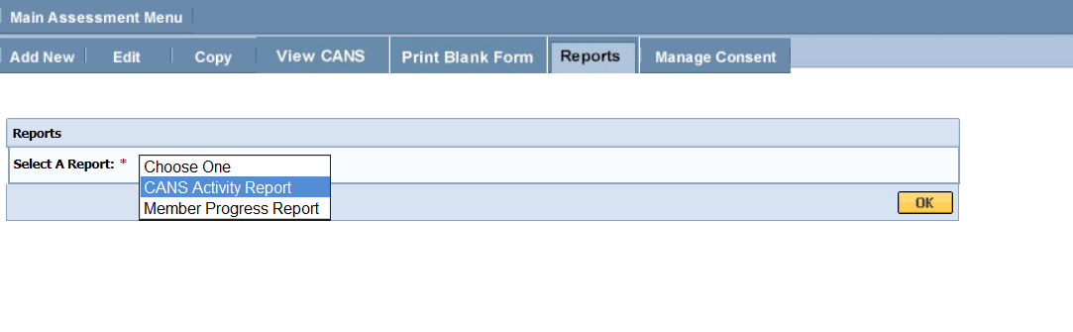
- Enter the [MassHealth ID] of the Member.
- Select the [OK] button.

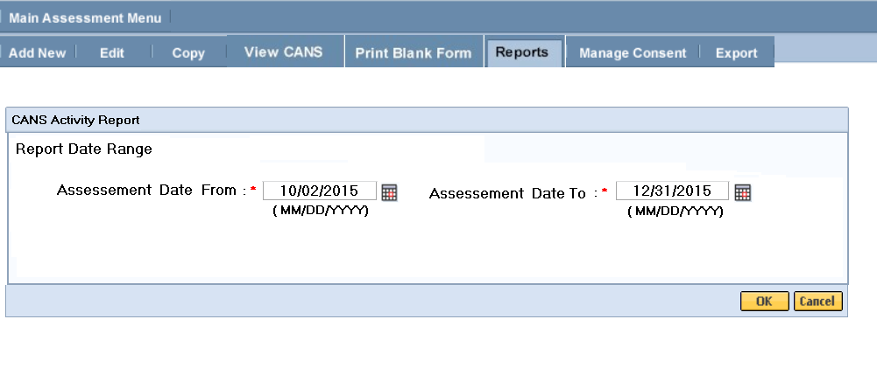
- Select the Certified Assessor name(s) to be included in the report.
Note: The system shall display instructional text and will restrict designated user to select more than 15 Certified Assessor names. System error message will contain count of selection.
- Select the [OK] button.
The next screen will prompt a user to select the statuses of CANS to be included in the report.
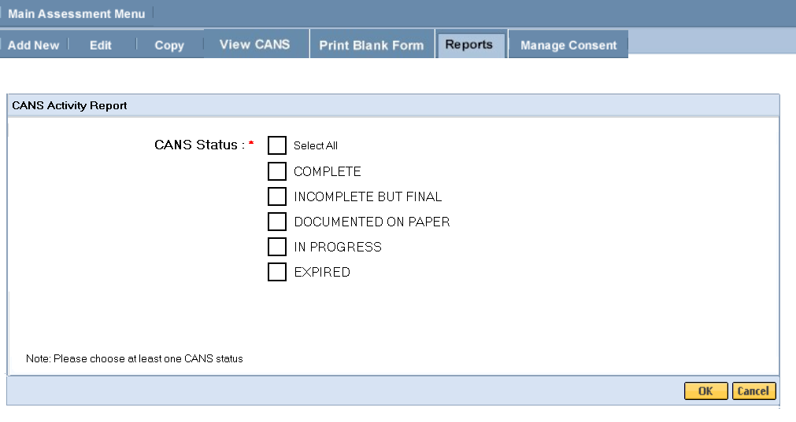
- Select the [Level of Care] to include in the report.

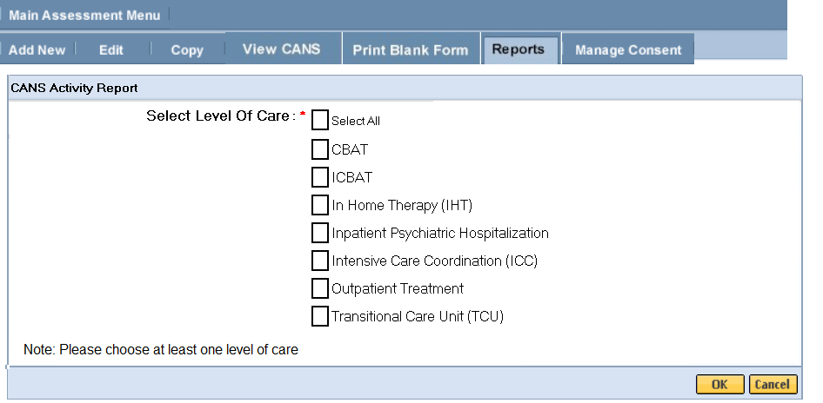

- Select the MCEs to be included in the report.

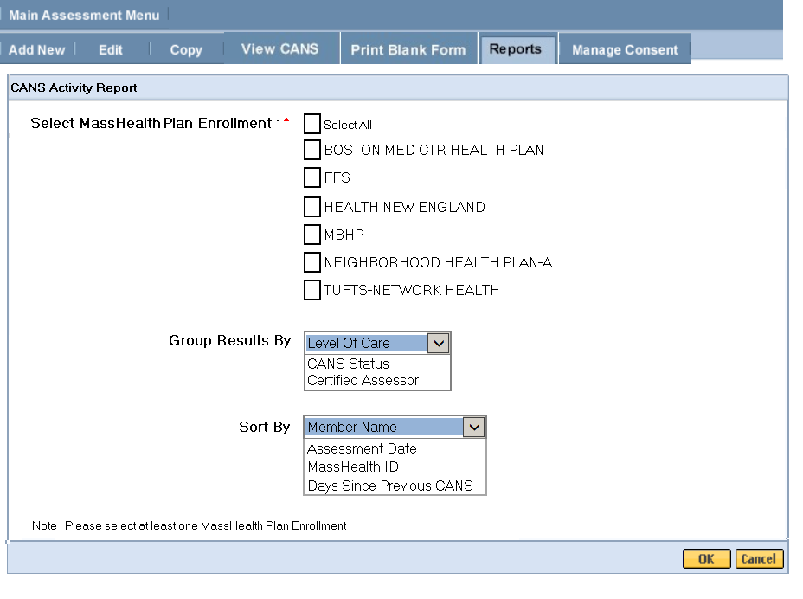
- The report can be viewed in PDF or Excel format.

Sample of a CANS Activity Report
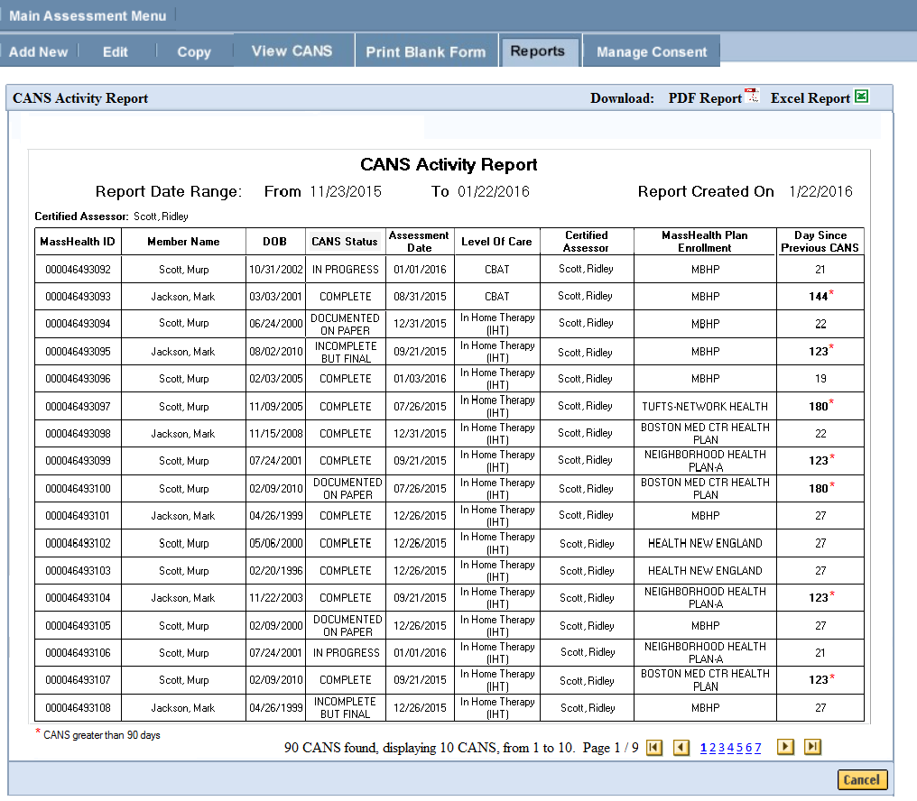
Notes:
- You may review, print or save the record in Adobe Acrobat Reader or Microsoft Excel.
- If you do not have Adobe Acrobat Reader currently installed you can download it for free at http://get.adobe.com/reader/.
- When completed, close the browser window and return to the CBHI application.
Important PHI Reminder:
You now have a file containing Protected Health Information on your computer. Remember to follow your organization's procedures regarding privacy and data security.

Questions or Need Assistance?
Call Virtual Gateway Customer Service
1-800-421-0938
(617-847-6578 - TTY for those with complete or partial loss of hearing)
8:30 am to 5:00 pm Monday through Friday
Bookmark the Children's Behavioral Health Initiative Website:
www.mass.gov/masshealth/cans

