**INDOOR AIR QUALITY ASSESSMENT**

**Canton High School**

**900 Washington Street**

**Canton, MA**

Canton High School
900 Washington Street
Canton, MA


Prepared by:

Massachusetts Department of Public Health

Bureau of Environmental Health

Indoor Air Quality Program

October 2019

# Background

|  |  |
| --- | --- |
| Building: | Canton High School |
| Address: | 900 Washington Street, Canton, MA |
| Assessment Requested by: | Canton Public School Department and Canton Teacher’s Union |
| Reason for Request: | Concerns about indoor air quality (IAQ) and chronic illness |
| Date of Assessment: | May 29, 2019 |
| Massachusetts Department of Public Health/Bureau of Environmental Health (MDPH/BEH) Staff Coordinating/Conducting Assessment: | Cory Holmes and Jason Dustin, Environmental Analysts/Inspectors, IAQ Program; and Brenda Netreba and Catherine Ngo, Environmental Analysts, Community Health Assessment Section of the Environmental Epidemiology Program |
| Building Description: | A campus of several multi-level concrete and brick buildings (B & C) with flat roofs. |
| Year Built: | B Building was originally constructed in 1956 and C Building was built in 1962, with both buildings renovated in 2006. |
| Building Population: | The school houses a student population of approximately 982 and a staff of approximately 100. |
| Windows: | Openable |

# Methods

Please refer to the IAQ Manual for methods, sampling procedures, and interpretation of results (MDPH, 2015).

# IAQ Testing Results

The following summarizes indoor sampling results at the time of assessment (Table 1).

* ***Carbon dioxide*** levels were above the MDPH guideline of 800 parts per million (ppm) in 23 of 138 areas tested, which is explained further in the *Ventilation* section of this report. MDPH recommends that carbon dioxide levels be maintained at 800 ppm or below. This is because most environmental and occupational health scientists involved with research on IAQ and health effects have documented significant increases in IAQ complaints and/or health effects when carbon dioxide levels rise above the MDPH guideline of 800 ppm for schools, office buildings and other occupied spaces (Sundell et al., 2011).
* ***Temperature*** was within or close to the recommended range of 70°F to 78°F in areas tested the day of assessment. However, several staff expressed issues with temperature/comfort control. It is important to note that thermal comfort conditions vary greatly among individuals and it is challenging to set a temperature that can satisfy everyone, particulary in a public/school building. As a general rule, optimum temperatures would achieve 80% occupant acceptability (ASHRAE 2004).
* ***Relative humidity*** was within the recommended range of 40 to 60% in areas tested. Low relative humidity, which is typical in New England during the heating season, can lead to common symptoms such as: dry skin, lips, and scalp; dry/scratchy throats and noses (nose bleeds); exacerbation of asthma, eczema, or allergies; dry/irritated eyes; and irritation of respiratory tract.
* ***Carbon monoxide*** levels were non-detectable (ND) in all areas tested.
* ***Fine particulate matter (PM2.5)*** concentrations measured were below the National Ambient Air Quality Standard (NAAQS) level of 35 μg/m3 in all areas tested.
* ***Total Volatile Organic Compounds (TVOCs)*** levels were ND in all areas tested except for one. Classroom 152 had a level of 5 ppm due to the application of polyurethane over painted art projects (rain barrels). This type of activity should be done outdoors or in an area with local exhaust ventilation.

## Ventilation

A heating, ventilating, and air conditioning (HVAC) system has several functions. First it provides heating and, if equipped, cooling. Second, it is a source of fresh air. Finally, an HVAC system will dilute and remove normally occurring indoor environmental pollutants by not only introducing fresh air, but by filtering the airstream and ejecting stale air to the outdoors via exhaust ventilation.

Fresh air in most classrooms is supplied by unit ventilator (univent) systems (Picture 1). A univent draws air from outdoors through a fresh air intake located on the exterior wall of the building (Picture 2) and returns air through an air intake located at the base of the unit ([Figure 1](https://www.mass.gov/doc/unit-ventilator-univent-0/download)). Fresh and return air are mixed, filtered, heated and provided to classrooms through an air diffuser located in the top of the unit. In several areas univents were deactivated or operating intermittently.

Exhaust ventilation for classrooms is provided by wall or ceiling vents (Pictures 3 and 4). In some areas, vents were not operating and/or were obstructed by classroom items/furniture. The location of some exhaust vents (i.e., near hallway doors) can limit exhaust efficiency (Picture 5). If doors are left open, the vents will tend to draw air from the hallway *into* the classroom instead of stale air and airborne pollutants *out* of the classroom as designed.

Mechanical ventilation in interior rooms and common areas (e.g., gym) is provided by rooftop or ceiling-mounted air-handling units (AHUs). Fresh air is distributed via ceiling-mounted air diffusers and ducted back to AHUs via ceiling or wall-mounted return vents (Pictures 6 and 7). Some science rooms are also equipped with specialty lab exhaust hoods to conduct experiments (Picture 8). A program should be in place to ensure that these lab hoods are in proper working order/recalibrated as per the manufacturer’s instructions.

To maximize air exchange, the MDPH recommends that both supply and exhaust ventilation operate continuously during periods of school occupancy. In order to have proper ventilation with a mechanical supply and exhaust system, the systems must be balanced to provide an adequate amount of fresh air to the interior of a room while removing stale air from the room. It is recommended that HVAC systems be re-balanced every five years to ensure adequate air systems function (SMACNA, 1994).

## Microbial/Moisture Concerns

Water-damaged ceiling tiles were observed in hallways, some classrooms and other areas (Pictures 6 and 9; Table 1), which may be historic evidence of leaks. Tiles should be replaced once leaks are found and repaired.

Many areas contained air conditioners (ACs); some were portable floor-based units and some were window or wall-mounted. These units have condensation drains, which may become clogged and leak if they are not maintained.

The univent in classroom 430 has a history of water leaks. At the time of assessment, no current leaks were reported; in addition, the univent was opened and found dry/clean. Room 423 also has a history of leaks from the univent; however this room contains wall to wall carpet (Picture 10). Although the carpet was dry at the time of assessment, it might be prudent to remove the carpet either entirely or the area around the univent to prevent further water damage/possible mold growth.

Water-damaged drywall was observed in the weight room (Picture 11). The window system in this area should be closely examined to determine if repairs are needed to prevent further water intrusion that could lead to mold growth. Water-damaged drywall was also observed in classroom 172 (Art) near a skylight (Picture 12). It is likely that this skylight or flashing is in need of repair to prevent further leaks.

The athletic offices appeared to be below grade. These offices had carpeting installed directly over the concrete slab/tile. It was reported that during warmer months, the air conditioning is inactive in this area. Carpeting is typically not recommended in lower levels in contact with the ground as it is porous and may be exposed to chronic condensation during humid weather. In addition, occupants should refrain from storing other porous items (e.g., boxes, paper) directly on the ground to avoid microbial colonization (Picture 13).

Indoor plants were observed in several areas (Table 1). Plants, soil, and drip pans can serve as sources of mold/bacterial growth. Plants should be properly maintained, over-watering of plants should be avoided, and drip pans should be inspected periodically for mold growth. In addition, plants should not be placed on top of or in the airstream of HVAC equipment such as univents.

## Volatile Organic Compounds (VOCs)

Exposure to low levels of total VOCs (TVOCs) may produce eye, nose, throat, and/or respiratory irritation in some sensitive individuals. To determine if VOCs were present, BEH/IAQ staff measured TVOCs in the areas assessed; no measureable levels were detected with the exception of classroom 152, which was using paints/polyurethane at the time of assessment. Adequate ventilation is required to remove irritants from cleaning products and other sources of TVOCs. BEH/IAQ staff also examined rooms for products containing VOCs. BEH/IAQ staff noted hand sanitizers, cleaners, air deodorizers and dry erase materials in use within the building (Table 1). All of these products have the potential to be irritants to the eyes, nose, throat, and respiratory system of sensitive individuals. Photocopiers and laminators were located in the teacher work rooms. Photocopiers can emit ozone and TVOCs, especially when they are older or heavily used, laminators give off waste heat and plastic odors.

## Other IAQ Evaluations

Other conditions that can affect IAQ were observed during the assessment. The MDPH recommends pleated filters for HVAC equipment with a Minimum Efficiency Reporting Value (MERV) of 8, which are adequate in filtering out pollen and mold spores (ASHRAE, 2012). Filters should also be changed two to four times a year, or per the manufacturer’s recommendations. BEH/IAQ staff examined univent filters, which appear to be mid-grade/pleated (Picture 14) that are reportedly MERV 8 and changed twice a year (i.e., winter/summer vacations).

The kiln room was reported to have housekeeping issues in the past. Accumulated dust from ceramic making can have irritant effects if aerosolized. The room was fairly clean at the time of this assessment (Picture 15).

Some areas were noted to have missing, ajar, or bowed ceiling tiles (Pictures 16 and 17, Table 1). These tiles should be re-seated or replaced to avoid them serving as pathways for odors and particulates to enter occupied spaces.

Many classrooms had personal fans. Some of these had dusty blades. Some supply and exhaust vents were also observed to be dusty. This dust can be reaerosolized when the equipment is activated. In many areas, items including books, papers, toys and decorative items were observed on floors, windowsills, tabletops, counters, bookcases, and desks, which can make it more difficult for custodial staff to clean.

Several areas contained carpeting. The usable life of carpeting in schools is approximately 10-11 years (IICRC, 2002). Aging carpet can produce fibers that can be irritating to the respiratory system. In addition, tears or lifting carpet can create tripping hazards. Carpeting should be cleaned annually or semi-annually in soiled high traffic areas as per the recommendations of the Institute of Inspection, Cleaning and Restoration Certification (IICRC, 2012). Some classrooms had area rugs, which should also be cleaned regularly and discarded when too worn out or soiled to be cleaned.

### Radon

Note that the Environmental Protection Agency (EPA) conducted a National School Radon Survey in which it discovered nearly one in five schools had “…at least one frequently occupied ground contact room with short-term radon levels above 4 [picocuries per liter] pCi/L” (US EPA, 1993). EPA’s action level for radon is 4 pCi/L. The BEH/IAQ Program therefore recommends that every school be tested for radon, and that this testing be conducted during the heating season while school is in session in a manner consistent with USEPA radon testing guidelines. Radon measurement specialists and other information can be found at [www.nrsb.org](http://www.nrsb.org) and <http://aarst-nrpp.com/wp>, with additional information at: <http://www.mass.gov/eohhs/gov/departments/dph/programs/environmental-health/exposure-topics/iaq/radon>.

## Health Concerns

At the request of administrators of the Canton Public Schools in response to concerns raised by the Canton Teachers Association, BEH staff from CHA conducted in-person interviews with interested employees of Canton High School on May 29, 2019 and also offered to conduct interviews over the phone for those unable to attend on that day. IAQ staff conducted an indoor air quality assessment of the building the same day.

The interviews included the administration of a questionnaire by BEH/CHA staff to obtain information on the type and frequency of symptoms experienced by employees. The questionnaire was closely modeled on surveys used previously by BEH as well as those used by the National Institute of Occupational Safety and Health (NIOSH) and the U.S. Environmental Protection Agency (US EPA). The questionnaire elicited information on specific symptoms that have been reported in the scientific/medical literature as commonly experienced by occupants of buildings with indoor air quality problems as well as information on perceived air quality and personal health factors. These types of questionnaires are used to systematically collect building-related health concerns and environmental complaints. The information collected, in conjunction with the assessment of the indoor environment, can be used to evaluate possible associations between indoor air quality and health and to recommend appropriate follow-up, if warranted.

### Employee Interview Results

Canton High School has an employee population of approximately 100 individuals. Eleven individuals (11%) participated in the BEH interview. All responses were reviewed to identify the types of diseases and symptoms that were reported, their frequency of occurrence, and whether any unusual patterns emerged suggestive of a possible association with indoor environmental conditions at the school.

Under both state and federal regulations, personally-identifying information shared by employees is confidential; therefore, the following discussion does not include specific information on the interview results but rather is limited to the concerns that were raised and topics that were discussed.

### Health Effects

The average age of the 11 employees who participated in the interviews was approximately 40 years old and the average length of employment at the school was 11 years. Smoking status was obtained in the interviews due to the role of smoking in respiratory health.

The most commonly reported symptoms (with at least 6 of the 11 employees reporting that they experienced the symptoms at least once in the four weeks prior to the interview) were: dry, itching, burning, watering, or irritated eyes; stuffy or runny nose or sinus congestion not related to an infection; headaches; coughing; sneezing; pain or stiffness in the neck, shoulders, or back; and unusual tiredness, fatigue, or drowsiness (see Appendix A). Respondents were asked if there was a particular time of day or week when their symptoms became worse or occurred more frequently. Overall, there did not appear to be a consistent pattern among respondents with most employees reporting no observable pattern over the course of a day or week. Three respondents reported that certain symptoms became worse or occurred more frequently during the afternoon. Three individuals also noticed that certain symptoms became worse or more frequent during the end of the week.

Employees were also asked if they had been diagnosed by a doctor with any of the following conditions: asthma, eczema, hay fever, or migraine headaches. Six of the 11 individuals reported having been diagnosed with at least one of these conditions.

The employees who participated in the interviews were asked if they had any other health-related concerns about Canton High School that had not yet been discussed. Concerns were raised by the majority of individuals about the incidence of various types of cancer among current and former employees.

### Building Concerns

BEH/CHA staff also asked employees several questions about their perceptions of environmental conditions in their work surroundings. The most common conditions as reported by at least six of the 11 employees were that the air was too dry and the temperature was too hot.

All employees who participated in the interviews were asked if they had any other building-related concerns at Canton High School that had not yet been discussed. A variety of concerns were raised, including the following:

* Flooding and roof leaks, particularly in the C building
* Historical and ongoing issues with mold on surfaces inside the building
* Uncertainty about the quality of the drinking water, and results of lead testing
* Infrequent sweeping and dusting of classrooms
* Presence of mice droppings
* Concern about the nearby former Plymouth Rubber facility.

### Symptomology and Building Location

The locations where individuals reported working in the building and their health concerns were evaluated with respect to the results from the environmental testing conducted by BEH/IAQ staff. All employees reported that there were specific locations within the building where they spend the majority of their time. Eight individuals reported working primarily in one location throughout the course of a given day.

## Health Discussion

The respiratory/irritant and other symptoms reported among participants in this health investigation are generally those most commonly experienced in buildings with indoor air quality problems. These included itchy, runny, or watery eyes; stuffy or runny nose or sinus congestion not related to an infection; headaches; and unusual tiredness, fatigue or drowsiness. Such symptoms are commonly associated with ventilation problems in buildings, although other factors (e.g., odors, microbiological contamination) may also contribute (Passarelli, 2009; Norbäck, 2009; Burge, 2004; Stolwijk, 1991).

Approximately 16% of the areas tested during BEH’s inspection on May 29th had carbon dioxide levels above the recommended limit of 800 ppm (23 of the 138 areas that were tested). Among the rooms where those interviewed reported spending the most amount of time, nine had carbon dioxide levels above the guideline. Indoor air quality complaints and health effects occur more frequently in buildings with carbon dioxide levels above this value. High levels of carbon dioxide indicate potential ventilation problems and have been associated with headaches, tiredness, and impaired decision-making performance (Norbäck and Nordström, 2008; Satish et al., 2012). This may have been a contributing factor for participants who reported headaches and/or unusual tiredness, fatigue, or drowsiness.

Results from the assessment also indicate a number of opportunities for exposure to allergens, i.e., potential mold growth from water damage and dust. Given that exposure to excessive dust and mold can exacerbate pre-existing conditions (e.g., asthma, allergies), it is possible that some individuals may react to mold and excessive dust differently than the general population. Allergic responses include hay fever-type symptoms such as runny nose and red eyes. It is important to note that the onset of allergic reaction to triggers such as mold/moisture can be either immediate or delayed.

### Cancer Concerns

Concerns about cancer were raised by several staff during the in-person and phone interviews. According to the American Cancer Society, one out of three women and one out of two men develop cancer in their lifetime, and cancer will affect three out of every four families (ACS 2016). For this reason, cancers often appear to occur in “clusters,” and it is understandable that someone may perceive that there are an unusually high number of cancer diagnoses in their neighborhood, workplace or town. Upon close examination, many of these “clusters” are not unusual increases, as first thought, but are related to such factors as local population density or a concentration of individuals who possess related behaviors or risk factors for cancer. Some, however, are unusual; that is, they represent a true excess of cancer in a workplace, a community, or among a subgroup of people. A suspected cluster is more likely to be a true cancer cluster if it involves a high number of diagnoses of one type of cancer in a relatively short time period rather than several different types diagnosed over a long period of time (i.e., 20 years), a rare type of cancer rather than common types, and/or a large number of diagnoses among individuals in age groups not usually affected by that cancer. These types of clusters may warrant further public health investigation.

The Massachusetts Cancer Registry (MCR), a division in the MDPH Office of Data Management and Outcomes Assessment, is a population-based surveillance system that has been monitoring cancer incidence in the Commonwealth since 1982. Individuals diagnosed with cancer in Massachusetts are reported to the MCR based on their residence at diagnosis and not their workplace. For that reason, calculating an expected rate of cancer is difficult at best for a place of employment, such as a school. The most practical first step in evaluating cancer in the workplace is to determine the types of cancer reported at the time of the interviews and whether they appear to represent an unusual pattern.

Many cancers occur because of changes to cells that happen by random chance. These are called sporadic or spontaneous mutations and are not due to any particular exposure to a cancer-causing agent (i.e., carcinogen). Other times, exposure may be an initiating or contributing factor to the development of cancer in an individual. The latency period is the time interval between an initiating event (such as a random mutation or exposure to a carcinogen) and the appearance of symptoms of the disease or its diagnosis. Cancer, in general, has a long latency period but it may vary depending on the type, magnitude, and timing of the exposure. Cancers that are solid tumors are believed to have a long latency period, estimated to be no shorter than 10 years and possibly as long as 50 years or more (Hall 2006; NRC 2005; UNSCEAR 2000; Bang 1996; Frumkin 1995). Due to the long latency period for most types of cancer, it is difficult to identify exactly what may have contributed to an individual’s cancer development. It is likely that multiple risk factors influence the development of most cancers. In addition, an individual’s risk of developing cancer may change over time and may depend upon a complex interaction between their genetic makeup and exposure to a cancer-causing agent.

Based on information that was shared by participants during the individual interviews, many different cancer types were reported to have occurred over a long period of time among current and former employees of Canton High School. To protect patient privacy, no specific details will be provided about any of the particular cancer diagnoses. Different types of cancer are different diseases with different causes, risk factors, characteristics, and age patterns. A risk factor is anything that increases a person’s chance of developing cancer and can include hereditary conditions, medical conditions or treatments, infections, lifestyle factors, or environmental exposures. Risk factor summaries for several cancer types are available on the Massachusetts Environmental Public Health Tracking website at <https://matracking.ehs.state.ma.us/Health-Data/Cancer/Risk_Factor_Summaries.html>. Appendix B provides an information sheet on cancer in Massachusetts. It may also be found online at <https://www.mass.gov/info-details/cancer-in-massachusetts>. For more information about the incidence of cancer within Massachusetts communities, visit the Massachusetts Environmental Public Health Tracking website at [www.mass.gov/dph/matracking](http://www.mass.gov/dph/matracking) and the MCR’s city/town reports at [www.mass.gov/dph/mcr](http://www.mass.gov/dph/mcr).

### Other Building Concerns

The quality of the drinking water at Canton High School was raised as a concern. The drinking water for the school is supplied by the town of Canton, which receives about 80% of their water from local wells and 20% from the Massachusetts Water Resources Authority (MWRA) regional water system. A review of the 2018 Water Quality Report revealed no violations of state and federal drinking water standards in the municipal water supply (Canton DPW, 2019).

It should be noted, however, that lead can get into water through plumbing and some service lines. In October 2016, testing results showed that lead and copper levels at Canton High School were below EPA’s action levels for these metals with the exception of lead at two locations. Action was taken to replace the plumbing and/or the fixture at both locations where exceedances had occurred (MassDEP, 2019a). Since these samples were collected in October 2016, the US Environmental Protection Agency (EPA) updated their guidance for schools. The new guidance states that there is no known safe level of lead for children (USEPA, 2018). In light of EPA’s change, MassDEP now recommends that schools “continue to evaluate and remediate taps/fixtures with lead levels below 15 ppb until the lowest possible concentration of lead is achieved (MassDEP, 2019b).” It is recommended that school administrators refer to MassDEP’s website on Follow-Up Steps for Schools and Early Education and Child Care Facilities (EECF) with Lead Detections over 1 ppb or Copper Results over the Action Level at <https://www.mass.gov/guides/follow-up-steps-for-schools-and-eecf-with-lead-detections-over-1-ppb-or-copper-results-over> or contact MassDEP’s Drinking Water Program at 617-292-5770. Appendix C contains an information sheet on lead in drinking water for schools and childcare facilities, which is also available at <https://www.mass.gov/service-details/lead-in-drinking-water-faq-for-school-and-childcare-facilities>.

Concerns were also raised by a few participants about the nearby site of the former Plymouth Rubber Company, located at 104 Revere Street. This 33-acre property was used by the Revere Copper Works for a copper rolling mill from 1801 to 1902 and then by the former Plymouth Rubber Company for rubber and vinyl manufacturing until 2006. The site remained vacant until 2015 when redevelopment was initiated to transform the former mill complex into mixed residential, commercial, and green space (GeoInsight, 2017). Remediation activities conducted under the Massachusetts Contingency Plan (MCP), the statewide hazardous waste site cleanup program, have included soil excavation, groundwater treatment, and removal of underground storage tanks. Exposure to nearby residents is not expected as contaminants did not migrate beyond the site boundaries. Development of one area of the site will require a barrier (such as a permanent building structure or parking lot) to restrict children’s access to soil contaminated with lead and zinc (GeoInsight, 2019). For more information about this site, visit the Massachusetts Department of Environmental Protection (MassDEP) website for waste sites and reportable releases at <https://eeaonline.eea.state.ma.us/portal#!/wastesite/4-3011520> or contact the MassDEP’s Southeast Regional Office at 508-946-2700.

# Conclusions/Recommendations

## Health Conclusions

Due to the small number of participants, limited information about health and building-related concerns was collected. The symptoms primarily reported among the 11 participants in this health investigation (itchy, runny, or watery eyes; stuffy or runny nose or sinus congestion not related to an infection; headaches; and unusual tiredness, fatigue or drowsiness) are generally those most commonly experienced in buildings with indoor air quality problems and are commonly associated with ventilation problems in buildings. It is possible that levels of carbon dioxide above the recommended limit may have been a contributing factor for those participants who reported headaches and/or unusual tiredness, fatigue, or drowsiness.

Although the incidence of cancer among employees of Canton High School was a concerned expressed by several staff interviewed on May 29, 2019, it is important to consider the following:

* Different types of cancer are individual diseases with separate causes and risk factors.
* Cancers in general have long latency or development periods that can range from 10 to 50 years in adults, particularly for solid tumors.
* The development of most cancers is likely influenced by multiple risk factors.

## Indoor Air Quality Conclusions

The following recommendations are made to assist in improving IAQ:

1. Operate univents and AHUs continuously during occupied periods (fan “on” *not* “auto”). Ensure fresh air intake louvers are functioning properly to adjust outside air intake. Make repairs as needed.
2. Ensure exhaust vents/motors are operable in classrooms/common areas.
3. Consider hiring an HVAC engineer to ensure the adequacy of the fresh air supply given the building design and population. Make adjustments accordingly.
4. Remove all items and furniture from the vicinity (~3-5 feet) of univents and exhaust units.
5. Use openable windows to supplement fresh air during temperate weather. Ensure all windows are tightly closed at the end of the day.
6. Create a system for staff to report/log temperature/comfort discrepancies. Make repairs/adjustments to thermostats/HVAC system as needed.
7. Consider adopting a balancing schedule of every 5 years for all mechanical ventilation systems, as recommended by ventilation industrial standards (SMACNA, 1994).
8. Ensure leaks are repaired and replace any water-damaged ceiling tiles.
9. Examine windows in weight room for necessary repairs to prevent water intrusion and further damage to building materials. Once corrected, make repairs to water-damaged drywall near windows.
10. Repair leaks to skylight in room 172. Replace water-damaged drywall.
11. Consider removing carpeting in lower level areas (e.g., athletics) to avoid the porous carpeting from being exposed to condensation during humid weather.
12. Refrain from storing porous items directly on the floor of concrete slabs or lower levels.
13. Indoor plants should be properly maintained and equipped with drip pans to prevent water damage to porous building materials and be located away from ventilation sources to prevent the aerosolization of dirt, pollen, or mold. Do not rest plants on porous materials (e.g., cloth, paper).
14. Ensure regular cleaning of dust/debris in the kiln room. Refrain from sweeping these materials to avoid aerosolization. A HEPA vacuum should be used to collect the dust along with wet wiping of surfaces.
15. Ensure that air conditioners drain properly by inspecting hoses for proper length and clogs/leaks periodically. Clean/maintain in accordance with manufacture’s recommendations.
16. For buildings in New England, periods of low relative humidity during the winter are often unavoidable. Therefore, scrupulous cleaning practices should be adopted to minimize common indoor air contaminants whose irritant effects can be enhanced when the relative humidity is low. To control for dusts, a high efficiency particulate arrestance (HEPA) filter equipped vacuum cleaner in conjunction with wet wiping of all surfaces is recommended. Avoid the use of feather dusters. Drinking water during the day can help ease some symptoms associated with a dry environment (throat and sinus irritations).
17. Ensure exhaust ventilation is operating in restrooms and in areas with photocopiers and laminators.
18. Institute a calibration program for all chemical lab hoods to ensure proper function.
19. Continue to use MERV 8 (or higher) filters in univents and AHUs. Change filters 2-4 times a year, or as manufacture recommends.
20. Regularly clean/vacuum univent cabinets (e.g., during filter changes), supply/return vents, and personal fans to avoid aerosolizing accumulated particulate matter.
21. Relocate or consider reducing the amount of materials stored in classrooms to allow for more thorough cleaning. Clean items regularly with a wet cloth or sponge to prevent excessive dust build-up.
22. Clean window and portable AC filters prior to and periodically/as needed during the cooling season.
23. Reduce the use of air deodorizers, cleaning products, sanitizers, and other products containing VOCs. Consider adopting green cleaning procedures. Ensure cleaning products are properly labeled, and keep material safety sheets on file.
24. Clean carpeting and area rugs annually or semi-annually in soiled high traffic areas as per the recommendations of the Institute of Inspection, Cleaning and Restoration Certification (IICRC, 2012).
25. Consider replacing old worn carpeting past its useful life (> 10-11 years) and in areas where leaks occur (e.g., room 423). Prior to disturbing flooring, ensure all state and federal regulations are followed concerning any regulated materials (e.g., asbestos) that may be encountered.
26. Re-seat ajar ceiling tiles and replace bowed or missing ceiling tiles.
27. Consider adopting the US EPA (2000) document, “Tools for Schools”, as an instrument for maintaining a good IAQ environment in the building available at: <http://www.epa.gov/iaq/schools/index.html>.
28. If not conducted previously, radon testing should be conducted at the school by a certified radon measurement specialist during the heating season. Radon measurement specialists and other information can be found at: [www.nrsb.org](http://www.nrsb.org/), and <http://aarst-nrpp.com/wp/>. Testing criteria should include the following:
    1. Test all ground contact rooms;
    2. Test during normal/occupied hours;
    3. Test during the heating season;
    4. Test during typical winter temperatures.
29. Refer to resource manual and other related IAQ documents located on the MDPH’s website for further building-wide evaluations and advice on maintaining public buildings. These documents are available at: <http://mass.gov/dph/iaq>.

# References

### IAQ Assessment Section

ASHRAE. 2004. American Society of Heating, Refrigeration and Air Conditioning Engineers (ASHRAE) BSR/ASHRAE Addendum D to ANSI/ASHRAE Standard 55-2004.

ASHRAE. 2012. American Society of Heating, Refrigeration and Air Conditioning Engineers (ASHRAE) Standard 52.2-2012 -- Method of Testing General Ventilation Air-Cleaning Devices for Removal Efficiency by Particle Size (ANSI Approved).

IICRC. 2002. Institute of Inspection, Cleaning and Restoration Certification. A Life-Cycle Cost Analysis for Floor Coverings in School Facilities.

IICRC. 2012. Institute of Inspection, Cleaning and Restoration Certification. Carpet Cleaning: FAQ.

MDPH. 2015. Massachusetts Department of Public Health. Indoor Air Quality Manual: Chapters I-III. Available at: <http://www.mass.gov/eohhs/gov/departments/dph/programs/environmental-health/exposure-topics/iaq/iaq-manual/>.

SMACNA. 1994. HVAC Systems Commissioning Manual. 1st ed. Sheet Metal and Air Conditioning Contractors’ National Association, Inc., Chantilly, VA.

Sundell. 2011. Sundell, J., H. Levin, W. W. Nazaroff, W. S. Cain, W. J. Fisk, D. T. Grimsrud, F. Gyntelberg, Y. Li, A. K. Persily, A. C. Pickering, J. M. Samet, J. D. Spengler, S. T. Taylor, and C. J. Weschler. Ventilation rates and health: multidisciplinary review of the scientific literature. *Indoor Air*, Volume 21: pp 191–204.

US EPA. 1993. Radon Measurement in Schools, Revised Edition. Office of Air and Radiation, Office of Radiation and Indoor Air, Indoor Environments Division (6609J). EPA 402-R-92-014. <https://www.epa.gov/sites/production/files/2014-08/documents/radon_measurement_in_schools.pdf>.

US EPA. 2000. Tools for Schools. Office of Air and Radiation, Office of Radiation and Indoor Air, Indoor Environments Division (6609J). EPA 402-K-95-001, Second Edition. <http://www.epa.gov/iaq/schools/index.html>.

### CHA Section

American Cancer Society (ACS). 2016. Cancer Facts & Figures. Available at [www.cancer.org](http://www.cancer.org)

Bang KM. 1996. Epidemiology of occupational cancer. J Occup Med; 11(3):467-85.

Burge, PS. 2004. Sick building syndrome. Occupational and Environmental Medicine 61:185-190.

Canton Department of Public Works (DPW). 2019. 2018 Drinking Water Quality Report.

Available at <https://www.town.canton.ma.us/261/Water-Sewer-Division>.

Frumkin H. 1995. Carcinogens. In: Levy BS and Wegman DH, editors. Occupational Health-­ Recognizing and Preventing Work-Related Disease. 3rd ed. Boston: Little, Brown and Company. p. 293.

GeoInsight, Inc. (GeoInsight). 2019. Post-Permanent Solution Release Abatement Measure Completion Report, Former Plymouth Rubber Company, 104 Revere Street, Canton, Massachusetts, RTN 4-3011520. Available at <https://eeaonline.eea.state.ma.us/EEA/fileviewer/Default.aspx?formdataid=0&documentid=499670>.

GeoInsight. 2017. Phase IV Final Inspection and Completion Report and Temporary and Partial-Permanent Solution Statement, Former Plymouth Rubber Company, 104 Revere Street, Canton, Massachusetts, RTN 4-3011520. Available at <https://eeaonline.eea.state.ma.us/EEA/fileviewer/Default.aspx?formdataid=0&documentid=411328>.

Hall EJ. 2006. Radiobiology for the radiologist. 6th ed. Philadelphia: Lippincott Williams & Wilkins; p. 138

Massachusetts Department of Environmental Protection (MassDEP). 2019a. Lead and Copper in School Drinking Water Sampling Results. Available at <https://eeaonline.eea.state.ma.us/portal#!/search/leadandcopper/results?SchoolName=Canton%20High>.

MassDEP. 2019b. Revised 3Ts Letter. Available at <https://www.mass.gov/files/documents/2019/05/21/revised-3ts-letter_0.pdf>.

National Research Council (NRC). 2005. Health risks from exposure to low levels of ionizing radiation. BEIR VII Phase 2. Washington, DC: National Academies Press.

Norbäck, D. 2009. An update on sick building syndrome. Current Opinion in Allergy and

Immunology 9:55-59.

Norbäck and Nordström. 2008. Sick building syndrome in relation to air exchange rate,

CO2, room temperature and relative air humidity in university computer classrooms: an

experimental study. International Archives of Occupational and Environmental Health

82:21–30.

Passarelli, GR. 2009. Sick building syndrome: an overview to raise awareness. Journal of

Building Appraisal 5(1):55-66.

Satish, U. et al. 2012. Is CO2 an Indoor Pollutant? Direct Effects of Low-to-Moderate

CO2 Concentrations on Human Decision-Making Performance. Environmental Health

Perspectives 120(12): 1671–1677.

Stolwijk, J. 1991. Sick-building syndrome. Environmental Health Perspectives 95:99-100.

U.S. Environmental Protection Agency (USEPA). 2018. 3Ts for Reducing Lead in Drinking Water in Schools and Child Care Facilities. Available at <https://www.epa.gov/sites/production/files/2018-09/documents/final_revised_3ts_manual_508.pdf>.

United Nations Scientific Committee on the Effects of Atomic Radiation (UNSCEAR). 2000. Sources and Effects of Ionizing Radiation. Volume I. New York: United Nations Scientific Committee on the Effects of Atomic Radiation.

**Picture 1**

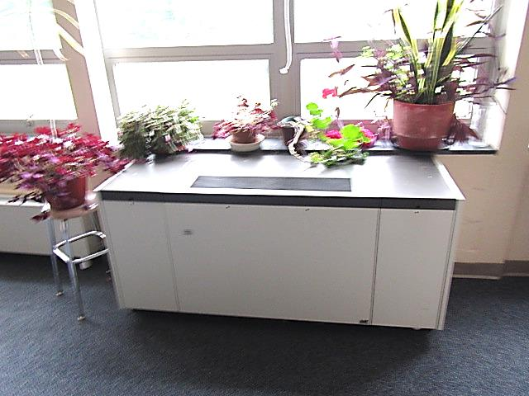

**Typical classroom univent, note plants**

**Picture 2**

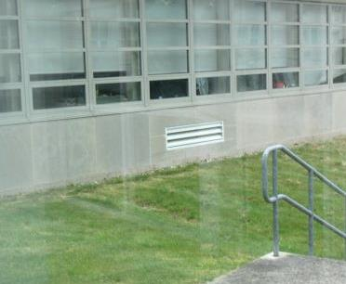

**Univent fresh air intake**

**Picture 3**

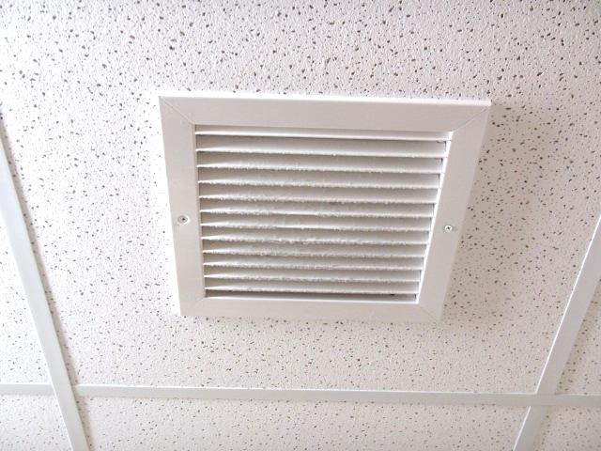

**Ceiling exhaust vent**

**Picture 4**

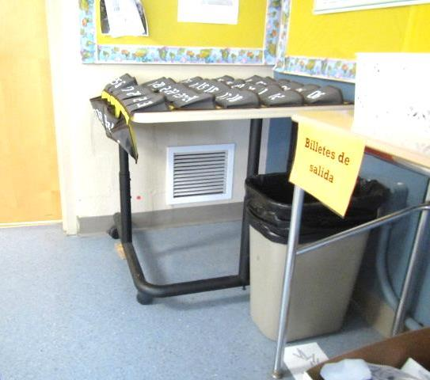

**Wall-mounted exhaust vent**

**Picture 5**

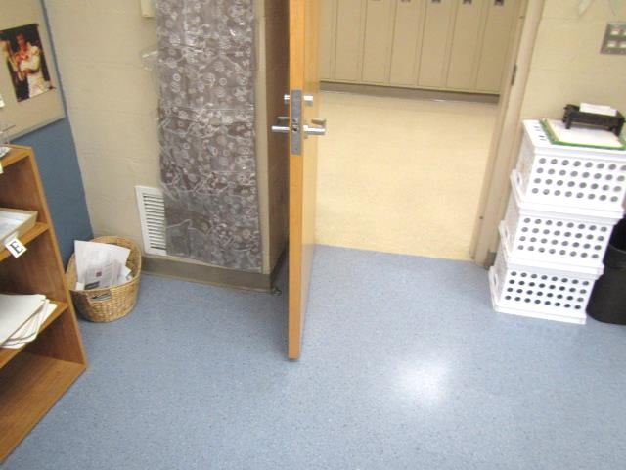

**Partially obstructed exhaust vent (arrow), also note proximity to open classroom door**

**Picture 6**

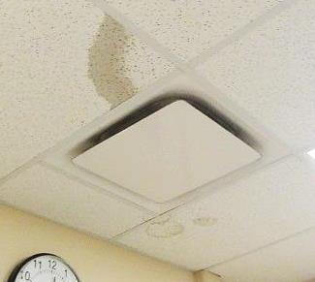

**Supply diffuser, note water-damaged ceiling tiles**

**Picture 7**

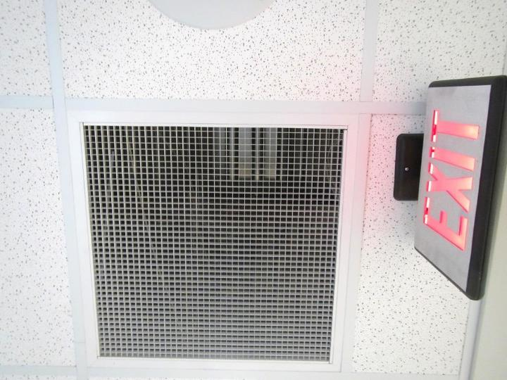

**Ceiling-mounted return grill**

**Picture 8**

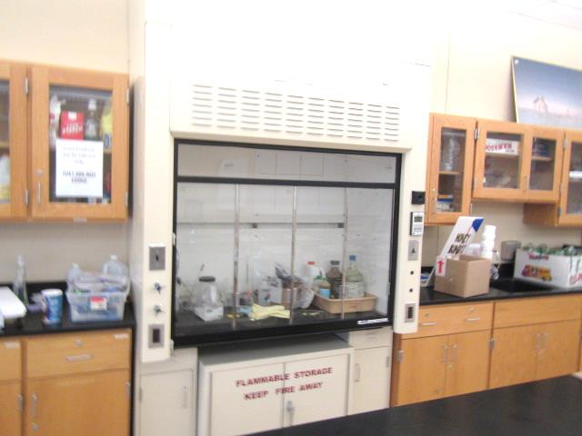

**Lab hood in science room**

**Picture 9**

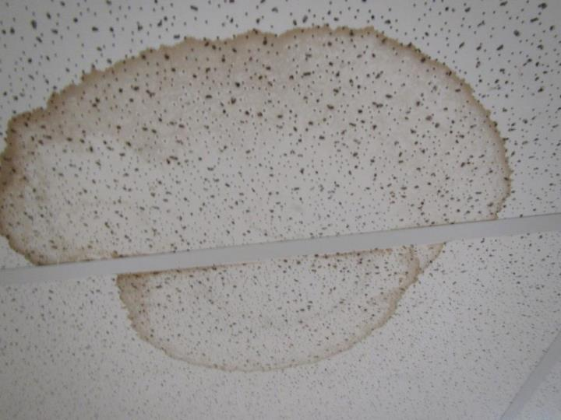

**Water-damaged ceiling tiles**

**Picture 10**

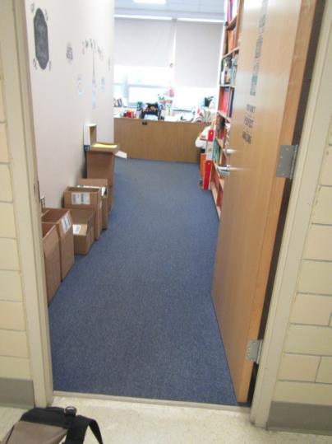

**Carpeting in room 423, near univent that has leaked in the past**

**Picture 11**

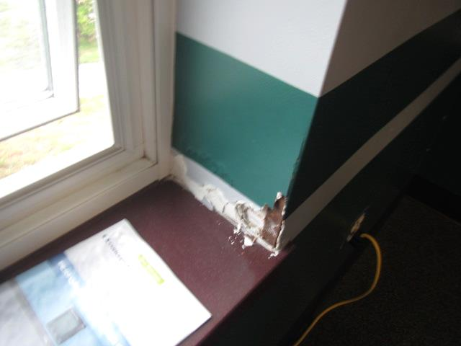

**Water-damaged gypsum wallboard near windows in weight room**

**Picture 12**

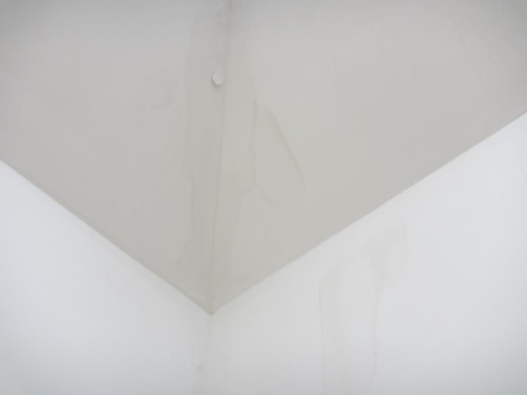

**Water-damaged drywall near skylight in room 172**

**Picture 13**



**Porous items (paper) stored directly on floor**

**Picture 14**

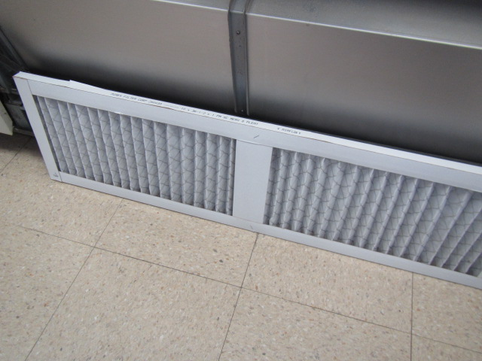

**Univent pleated MERV 8 filter**

**Picture 15**

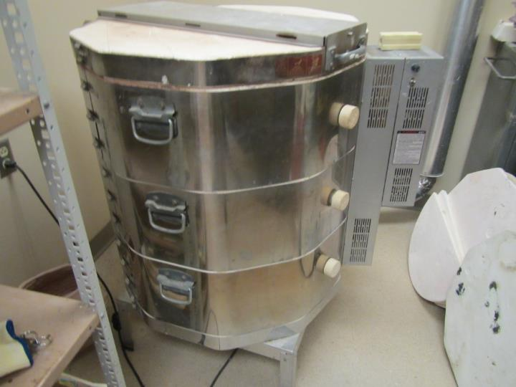

**Kiln room**

**Picture 16**

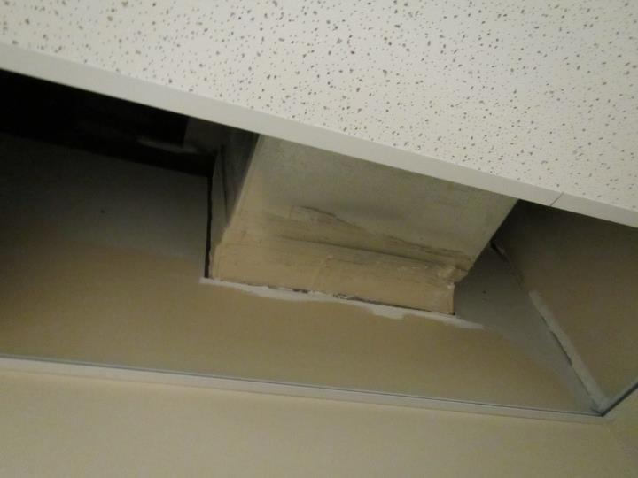

**Missing ceiling tile**

**Picture 17**

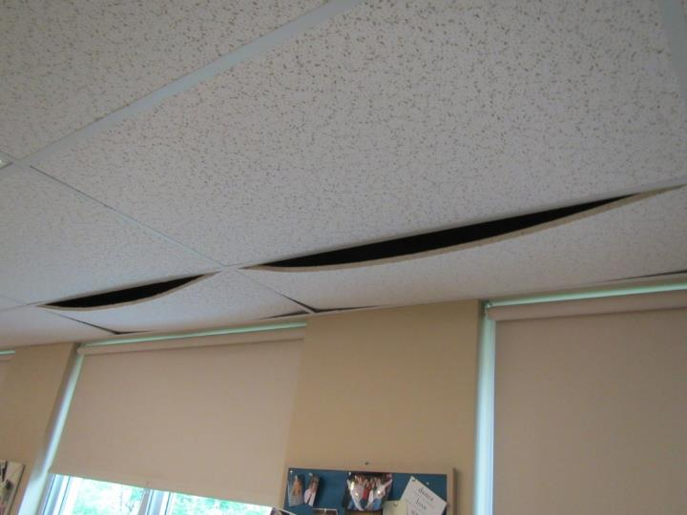

**Bowed ceiling tiles**

| Location | **Carbon**  **Dioxide**  **(ppm)** | **Carbon Monoxide**  **(ppm)** | **Temp**  **(°F)** | **Relative**  **Humidity**  **(%)** | **PM2.5**  **(µg/m**3**)** | **TVOCs**  **(ppm)** | **Occupants**  **in Room** | **Windows**  **Openable** | **Ventilation** | | | **Remarks** |
| --- | --- | --- | --- | --- | --- | --- | --- | --- | --- | --- | --- | --- |
| **Intake** | **Exhaust** | |
| Background | 399 | ND | 54 | 66 | 17 | ND | - | - | - | | - | Overcast, cool |
| **B Building** |  |  |  |  |  |  |  |  |  | |  |  |
| Library Conf Room | 811 | ND | 71 | 50 | 2 | ND | 4 | N | Y | | Y | Carpet, 3 WD CTs |
| 300 | 603 | ND | 70 | 48 | 2 | ND | 5 | N | Y | | Y | Carpet |
| Library 301 | 586 | ND | 71 | 47 | 2 | ND | 0 | N | Y | | Y | 4 WD CTs |
| Library Office | 599 | ND | 71 | 47 | 2 | ND | 0 | N | Y | | Y | Carpet, 3 WD CTs |
| Library Work Room | 605 | ND | 71 | 47 | 2 | ND | 0 | N | Y | | Y |  |
| 302/303 Weight Room | 445 | ND | 70 | 47 | 2 | ND | 1 | Y  open | Y | | Y | WD GW window |
| 210 TV studio | 683 | ND | 71 | 44 | 1 | ND | 0 | N | Y | | Y |  |
| 211 | 645 | ND | 71 | 44 | 2 | ND | 1 | N | Y | | Y | Carpet |
| 212 | 617 | ND | 71 | 43 | 1 | ND | 0 | N | Y | | Y | WD CT |
| 213 | 686 | ND | 71 | 44 | 2 | ND | 1 | N | Y | | Y | DEM, HS |
| Editing | 645 | ND | 71 | 43 | 2 | ND | 5 | N | Y | | N |  |
| 214 | 740 | ND | 70 | 43 | 1 | ND | 14 | N | Y | | Y | AI, DEM |
| 215 | 1017 | ND | 73 | 50 | 3 | ND | 6 | Y | Y off | | Y | HS, UV off/intermittent (stuffy) |
| 216 | 676 | ND | 69 | 44 | 1 | ND | 0 | N | Y | | Y | DEM, carpet, dusty vent, computers, exhaust odor? |
| 217 | 768 | ND | 72 | 48 | 6 | ND | 3 | Y | Y | | Y | UV on, plants, DEM, area rug |
| 218 | 778 | ND | 70 | 48 | 1 | ND | 0 | N | Y | | N | Carpet, AI |
| 219 | 608 | ND | 72 | 47 | 1 | ND | 0 | N | Y | | Y | 5 WD CTs, PF |
| 240 | 764 | ND | 72 | 47 | 2 | ND | 2 | Y open | Y off | | Y | 8 WD CTs, DO |
| 241 | 852 | ND | 72 | 47 | 1 | ND | 11 | Y | Y | | Y | AC, PFs, DO, 6 WD CTs |
| 242 | 1062 | ND | 73 | 48 | 1 | ND | 19 | Y | Y | | Y | DO |
| 243 | 1027 | ND | 74 | 47 | 2 | ND | 24 | Y  open | Y  off | | Y  off | DO |
| 244 | 911 | ND | 75 | 45 | 2 | ND | ~20 | Y  open | Y | | Y  off | DO, class just left |
| 245 Computer Lab | 697 | ND | 74 | 43 | 1 | ND | 0 | Y | Y | | Y | Carpet |
| 246 | 1016 | ND | 73 | 47 | 2 | ND | 19 | Y  open | Y | | Y | PFs |
| 247 | 798 | ND | 73 | 46 | 1 | ND | 16 | N | Y | | Y | DO, 2 WD CTs, carpet |
| 247 Conf Room | 727 | ND | 73 | 47 | 2 | ND | 0 | N | Y | | Y | Area rug, 3 WD CTs |
| 248 | 438 | ND | 72 | 43 | 1 | ND | 0 | Y | Y | | Y  off |  |
| 249 | 743 | ND | 74 | 46 | 1 | ND | 1 | N | Y | | Y | 6 WD CTs, carpet |
| 250 | 477 | ND | 70 | 45 | 2 | ND | 1 | Y  open | Y | | Y | 5 WD CTs, lab hood, PF |
| 251 | 1258 | ND | 72 | 50 | 4 | ND | 27 | Y | Y | | Y | UV off/Intermittent |
| 252 | 420 | ND | 67 | 47 | 2 | ND | 8 | Y | Y | | Y | 7 WD CTs, PF |
| 253 | 492 | ND | 71 | 43 | 1 | ND | 0 | Y | Y off | | Y off | HS |
| 254 | 662 | ND | 70 | 49 | 2 | ND | 25 | Y | Y | | Y | DO, PF, 3 WD CTs |
| 255 | 688 | ND | 71 | 46 | 3 | ND | 8 | Y | Y | | Y | HS |
| Chemical storage 39 | - | - | - | - | - | - | - | - | Y | | Y | No local exhaust, WD CTs |
| 256 | 743 | ND | 71 | 50 | 2 | ND | 21 | Y | Y | | Y | 3 WD CTs |
| 257 | 582 | ND | 72 | 44 | 3 | ND | 1 | N | Y | | Y | Carpet |
| 258 | 407 | ND | 70 | 47 | 2 | ND | 0 | Y | Y | | Y | 5 WD CTs |
| 259 | 780 | ND | 72 | 48 | 2 | ND | 22 | Y | Y | | Y | DO, PF, 15 WD CTs |
| 261 | 526 | ND | 72 | 44 | 4 | ND | Y | Y | Y | | Y | HS, DEM, CP |
| 262 | - | - | - | - | - | - | - | - | - | | - | In meeting |
| 263 | 531 | ND | 71 | 45 | 3 | ND | 0 | Y | Y | | Y | CPs, DEM |
| 102 | 404 | ND | 70 | 45 | 1 | ND | 1 | Y | Y | | Y |  |
| 103 | 434 | ND | 69 | 48 | 1 | ND | 0 | N | Y | | Y |  |
| 104 | 492 | ND | 69 | 55 | 1 | ND | 0 | Y | Y | | Y | DO |
| 110 | 751 | ND | 71 | 45 | 2 | ND | 5 | N | Y | | Y | Carpet |
| 111 | 688 | ND | 71 | 44 | 3 | ND | 0 | N | Y | | Y | Carpet |
| 112 Guidance - main | 632 | ND | 70 | 49 | 1 | ND | 9 | N | Y | | Y | Carpet |
| -office 1 | 601 | ND | 70 | 47 | 1 | ND | 0 | Y | Y | | Y | HS, AF, carpet |
| -office 2 | 639 | ND | 70 | 47 | 1 | ND | 0 | Y | Y | | Y | Carpet |
| -office 3 | 623 | ND | 70 | 48 | 2 | ND | 0 | Y | Y | | Y | Personal heater, air freshener, carpet |
| -office 4 | 604 | ND | 70 | 47 | 1 | ND | 0 | Y | Y | | Y | Carpet, personal heater, HS |
| -office 5 | 560 | ND | 70 | 47 | 1 | ND | 0 | Y | Y | | Y | Plants, carpet, HS |
| -workroom | 590 | ND | 70 | 47 | 2 | ND | 0 | N | Y | | Y | Paper on floor |
| -conference | 619 | ND | 71 | 47 | 2 | ND | 1 | N | Y | | Y | Carpet, DEM, WD CT |
| 113 | 876 | ND | 72 | 48 | 2 | ND | 4 | N | Y | | Y | Tile flooring, upholstered furniture |
| 114 Nurse | 582 | ND | 69 | 49 | 3 | ND | 1 | N | Y | | Y |  |
| 115 | - | - | - | - | - | - | - | - | - | | - | Meeting in progress |
| 116 | 480 | ND | 68 | 50 | 3 | ND | 0 | N | Y | | Y | AI, carpet, WD CTs, upholstered furniture in back office |
| 117 | 773 | ND | 72 | 46 | 1 | ND | 6 | N | Y | | Y | DEM |
| 118 | 393 | ND | 69 | 49 | 2 | ND | 0 | Y | Y | | Y | DEM, bowed CTS x 4, missing ceiling tile |
| 119 | 658 | ND | 72 | 45 | 2 | ND | 1 | N | Y | | Y | DEM, HS |
| 120 | 556 | ND | 71 | 47 | 2 | ND | 1 | N | Y | | Y | HS, carpet |
| 121 | 468 | ND | 69 | 45 | 1 | ND | 0 | N | Y | | Y |  |
| 122 | 558 | ND | 70 | 45 | 2 | ND | 0 | Y | Y | | Y | AHU, tile flooring, DEM, WD CT in hall outside room |
| 123 | 914 | ND | 70 | 49 | 1 | ND | 16 | Y | Y | | Y | DEM |
| 129 | 537 | ND | 70 | 45 | 4 | ND | 0 | N | Y | | Y | UV, Missing ceiling tile, DEM, tile flooring |
| 131 | 685 | ND | 71 | 48 | 3 | ND | 0 | N | Y | | Y | WD CT |
| 132 | 703 | ND | 71 | 47 | 3 | ND | 1 | Y | Y | | Y | HS, Carpet, boxes on floor |
| 133 | 649 | ND | 71 | 46 | 2 | ND | 1 | Y | Y | | Y | DEM, AI, carpet below grade, boxes on floor |
| 139 | 713 | ND | 71 | 49 | 3 | ND | 11 | Y | Y | | Y |  |
| 140 | 578 | ND | 71 | 47 | 5 | ND | 0 | N | Y | | Y | Carpet, AI on floor, HS |
| 141 | 1134 | ND | 71 | 50 | 9 | ND | 3 | Y | Y | | Y off | DEM |
| 142 | 1153 | ND | 71 | 50 | 8 | ND | 18 | Y | Y | | Y | DEM, HS |
| 143 | 860 | ND | 71 | 48 | 10 | ND | 25 | Y | Y | | Y | DEM, HS, WD CT |
| 144 | 1000 | ND | 71 | 51 | 9 | ND | 22 | Y | Y | | Y | Plant, rubber odor from bucket of Tennis balls |
| 145 | 634 | ND | 71 | 46 | 12 | ND | 0 | N | Y | | Y | Carpet, Computers, DEM, on AHU |
| 146 | 581 | ND | 69 | 47 | 9 | ND | 1 | Y | Y | | Y | DEM, UV, PF, HS |
| 147 | 689 | ND | 72 | 46 | 9 | ND | 0 | N | Y | | Y | AHU, DEM, tile floor |
| 148 | 500 | ND | 70 | 47 | 8 | ND | 1 | Y | Y | | Y off | UV, CP |
| 149 | 701 | ND | 72 | 47 | 8 | ND | 1 | N | N | | N | WD CT x 6, CPs |
| 150 | 639 | ND | 71 | 46 | 7 | ND | 14 | Y | Y | | Y | AHU, DEM |
| 151 | 1008 | ND | 71 | 50 | 7 | ND | 19 | Y | Y | | Y | AI, items on UV |
| 152 | 574 | ND | 70 | 45 | 8 | 5.0* | 19 | Y | Y | | Y | AI, DEM, art project-painting/polyurethane* rain barrels |
| 153 | 555 | ND | 71 | 47 | 8 | ND | 1 | Y | Y | | Y | DEM |
| 154 robotics | 432 | ND | 70 | 45 | 9 | ND | 2 | Y | Y | | Y | DEM, CPs |
| 155 | 544 | ND | 72 | 47 | 6 | ND | 0 | Y | Y | | Y | DEM, non-carpeted, UV |
| 156 | 472 | ND | 69 | 46 | 9 | ND | 9 | Y | Y | | Y | DEM, ceiling UV, WD CT |
| 157 CAD | 502 | ND | 71 | 46 | 9 | ND | 0 | N | Y | | Y | Carpet, DEM, CT ajar |
| 158 | 582 | ND | 69 | 49 | 7 | ND | 10 | Y | Y | | Y | CP, DEM, UV, past issues with neighbors burning wood/smoke odor entrainment |
| Metal shop 159 | 412 | ND | 68 | 48 | 16 | ND | 0 | Y | Y | | Y | Slight burning/welding odor, local exhaust hood |
| Wood shop 160 | 435 | ND | 70 | 44 | 6 | ND | 0 | Y | Y | | Y | Local exhaust |
| Auditorium | 492 | ND | 69 | 55 | 1 | ND | 0 | N | Y | | Y |  |
| Practice Room 1 | 460 | ND | 69 | 51 | 1 | ND | 0 | Y | Y | | Y |  |
| Practice Room 2 | 463 | ND | 69 | 51 | 1 | ND | 0 | Y | Y | | Y |  |
| Practice Room 3 | 461 | ND | 69 | 50 | 2 | ND | 0 | Y | Y | | Y |  |
| Main office | 564 | ND | 69 | 53 | 1 | ND | 4 | N | Y | | Y | On AHU, carpet, ceiling plenum return |
| -office 1 | 530 | ND | 70 | 50 | 1 | ND | 0 | N | Y | | Y |  |
| -Principal | 493 | ND | 70 | 48 | 1 | ND | 0 | N | Y | | Y | DEM, AI |
| -Asst. Principal | 487 | ND | 70 | 48 | 1 | ND | 0 | N | Y | | Y | AI, DEM |
| -Mail | 492 | ND | 71 | 48 | 2 | ND | N | N | Y | | Y | Photocopier, fridge on carpet |
| -Shea office | 509 | ND | 71 | 47 | 2 | ND | 0 | N | Y | | Y | CP |
| -conference | 513 | ND | 71 | 47 | 2 | ND | 1 | N | Y | | Y | DEM, AI |
| 171 | 690 | ND | 71 | 48 | 3 | ND | 13 | N | Y | | Y | DEM |
| 172 | 510 | ND | 72 | 46 | 5 | ND | 0 | Y | Y | | Y | WD CTs x 4, WD GW near skylight |
| -Dark Room | 765 | ND | 70 | 48 | 6 | ND | 0 | N | Y | | Y | Local exhaust over work area |
| 173 | 732 | ND | 72 | 48 | 3 | ND | 15 | N | Y | | Y | Computer lab, heat complaints, DEM, HS |
| 174 | 546 | ND | 71 | 46 | 5 | ND | 0 | N | Y | | Y | DEM, AI, art supplies |
| Kiln room | 535 | ND | 71 | 46 | 7 | ND | 1 | N | Y | | Y | Dust complaints/housekeeping issues in past |
| Break room/storage 15 | 532 | ND | 71 | 47 | 3 | ND | 3 | Y | Y | | Y | Tile floor |
| Gym | 689 | ND | 70 | 49 | 2 | ND | 0 | N | Y | | Y | Slight polyurethane odor |
| Media center | 747 | ND | 70 | 48 | 2 | ND | 3 | N | Y | | Y | Hardwood, WD CTs |
| Teacher dining | 496 | ND | 71 | 45 | 2 | ND | 2 | N | Y | | Y |  |
| Café | 927 | ND | 71 | 49 | 5 | ND | 75+ | N | Y | | Y |  |
| **C Building** |  |  |  |  |  |  |  |  |  | |  |  |
| 400 | 859 | ND | 72 | 48 | 2 | ND | 0 | Y | Y | | N | Refrigerator on carpet |
| 401 | 661 | ND | 73 | 45 | 3 | ND | 1 | Y | Y | | Y | 21 occupants gone~25 mins, PF, 1 WD CT near teacher’s desk |
| 402 | 842 | ND | 72 | 47 | 3 | ND | 19 | Y | Y | | Y | DO, PF |
| Hallway (outside 403) |  |  |  |  |  |  |  |  |  | |  | WD CTs |
| 403 | 570 | ND | 73 | 45 | 2 | ND | 0 | Y | Y | | Y  off | PF |
| 404 | 644 | ND | 71 | 46 | 3 | ND | 9 | Y | Y | | Y  off | PF, missing tile |
| 405 | 1407 | ND | 74 | 54 | 3 | ND | 18 | Y | Y | | Y  off | PFs |
| 406 | 616 | ND | 72 | 44 | 3 | ND | 1 | Y | Y | | Y | DO, PFs |
| 407 | 969 | ND | 73 | 48 | 2 | ND | 19 | Y | Y | | Y | DO |
| 408 Computer Lab | 643 | ND | 73 | 45 | 3 | ND | 0 | Y | Y  off | | Y  off | Damaged/wrinkled carpet, exhaust near hallway door |
| 409 | 466 | ND | 72 | 42 | 2 | ND | 0 | Y | Y | | Y | PF |
| 410 | 639 | ND | 72 | 47 | 2 | ND | 0 | Y | Y | | Y | Exhaust partially blocked/near door |
| 411 | 983 | ND | 72 | 52 | 3 | ND | 0 | Y | Y | | Y | Exhaust blocked, PF, plants on UV |
| 412 | 738 | ND | 72 | 47 | 2 | ND | 4 | Y | Y | | Y | Exhaust blocked, PF, plants |
| 420 | 445 | ND | 73 | 45 | 3 | ND | 0 | Y | Y  off | | N | Carpet, plants on UV |
| 421 | 430 | ND | 72 | 44 | 3 | ND | 1 | Y | Y | | Y | photocopier |
| 422 | 723 | ND | 72 | 47 | 3 | ND | 18 | Y | Y  2 UVs | | Y | Carpet, PF |
| 423 | 575 | ND | 72 | 48 | 2 | ND | 1 | Y | Y | | N | History of UV leaks/wet carpet |
| 424 | 774 | ND | 71 | 47 | 2 | ND | 0 | Y | Y | | Y | DO |
| 425 | 1014 | ND | 73 | 50 | 2 | ND | 20 | Y | Y | | Y | DO |
| 426 | 689 | ND | 72 | 47 | 3 | ND | 23 | Y | Y | | Y | DO, occupants just returned from specialist |
| 430 | 719 | ND | 68 | 59 | 5 | ND | 1 | Y | Y | | Y | 20 occupants gone ~10 mins |
| 431 | 973 | ND | 70 | 56 | 4 | ND | 27 | Y | Y | | Y  off/weak | PF |
| 432 | 678 | ND | 71 | 49 | 3 | ND | 13 | Y | Y | | Y  blocked | Ajar ceiling tile |
| 434 | 401 | ND | 70 | 47 | 1 | ND | 1 | Y | Y | | Y  off | Window reported open for 2 hours prior to testing, sporadic occupancy over the course of morning |
| 435 | 430 | ND | 70 | 48 | 2 | ND | 1 | Y | Y | | Y  off | PFs |
| 436 | 443 | ND | 70 | 48 | 2 | ND | 1 | Y | Y | | Y | Plants, aquarium |
| Men’s Restroom |  |  |  |  |  |  |  | N | N | | Y  off | Exhaust vent missing grate |
| Storage 42 | 442 | ND | 70 | 52 | 1 | ND | 0 | N | N | | N | Various items both porous (cardboard, cloth, paper) and non-porous |

**Appendix A**

*Employee Survey Response Results*

|  |  |  |  |  |  |  |  |
| --- | --- | --- | --- | --- | --- | --- | --- |
|  | **Skin Irritation, Dryness, Redness or Rashes** | | |  | **Pain or Stiffness in the Neck, Shoulders or Back** | | |
|  |  |
|  | **Response** | **Number** | **Percent** |  | **Response** | **Number** | **Percent** |
|  | Yes | 4 | 36% |  | Yes | 6 | 55% |
|  | No | 7 | 64% |  | No | 5 | 45% |
|  | Total | 11 | 100% |  | Total | 11 | 100% |
|  |  |  |  |  |  |  |  |
|  | **Dry, Itching, Burning, Watering or Irritated Eyes** | | |  | **Difficulty Remembering Things or Concentrating** | | |
|  |  |
|  | **Response** | **Number** | **Percent** |  | **Response** | **Number** | **Percent** |
|  | Yes | 6 | 55% |  | Yes | 2 | 18% |
|  | No | 5 | 45% |  | No | 9 | 82% |
|  | Total | 11 | 100% |  | Total | 11 | 100% |
|  |  |  |  |  |  |  |  |
|  | **Stuffy or Runny Nose and Sinus Congestion Not Related to an Infection** | | |  | **Ear Problems such as Pain, Ringing, or Difficulty Hearing Not Related to an Infection** | | |
|  |  |
|  | **Response** | **Number** | **Percent** |  | **Response** | **Number** | **Percent** |
|  | Yes | 7 | 64% |  | Yes | 4 | 36% |
|  | No | 4 | 36% |  | No | 7 | 64% |
|  | Total | 11 | 100% |  | Total | 11 | 100% |
|  |  |  |  |  |  |  |  |
|  | **Shortness of Breath** | | |  | **Wheezing in your Chest** | | |
|  |  |
|  | **Response** | **Number** | **Percent** |  | **Response** | **Number** | **Percent** |
|  | Yes | 0 | 0% |  | Yes | 3 | 27% |
|  | No | 11 | 100% |  | No | 8 | 73% |
|  | Total | 11 | 100% |  | Total | 11 | 100% |
|  |  |  |  |  |  |  |  |
|  | **Sore, Hoarse or Dry Throat** | | |  | **Tightness across the Chest** | | |
|  |  |
|  | **Response** | **Number** | **Percent** |  | **Response** | **Number** | **Percent** |
|  | Yes | 5 | 45% |  | Yes | 0 | 0% |
|  | No | 6 | 55% |  | No | 11 | 100% |
|  | Total | 11 | 100% |  | Total | 11 | 100% |
|  |  |  |  |  |  |  |  |
|  | **Tingling in the Hands and Feet** | | |  | **Coughing** | | |
|  |  |
|  | **Response** | **Number** | **Percent** |  | **Response** | **Number** | **Percent** |
|  | Yes | 1 | 9% |  | Yes | 6 | 55% |
|  | No | 10 | 91% |  | No | 5 | 45% |
|  | Total | 11 | 100% |  | Total | 11 | 100% |
|  |  |  |  |  |  |  |  |
|  | **Headaches** | | |  | **Sneezing** | | |
|  |  |
|  | **Response** | **Number** | **Percent** |  | **Response** | **Number** | **Percent** |
|  | Yes | 7 | 64% |  | Yes | 7 | 64% |
|  | No | 4 | 36% |  | No | 4 | 36% |
|  | Total | 11 | 100% |  | Total | 11 | 100% |
|  |  |  |  |  |  |  |  |
|  | **Dizziness, Lightheadedness, or Loss of Balance** | | |  | **Unusual Tiredness, Fatigue or Drowsiness** | | |
|  |  |
|  | **Response** | **Number** | **Percent** |  | **Response** | **Number** | **Percent** |
|  | Yes | 2 | 18% |  | Yes | 7 | 64% |
|  | No | 9 | 82% |  | No | 4 | 36% |
|  | Total | 11 | 100% |  | Total | 11 | 100% |
|  |  |  |  |  |  |  |  |
|  | **Nausea or Upset Stomach** | | |  |  |  |  |
|  | **Response** | **Number** | **Percent** |  |  |  |  |
|  | Yes | 3 | 27% |  |  |  |  |
|  | No | 8 | 73% |  |  |  |  |
|  | Total | 11 | 100% |  |  |  |  |

**Appendix B**

Massachusetts Department of Public Health | Bureau of Environmental Health

Information Sheet



**What is cancer?**

**Cancer is a group of over 100 different diseases.**

Cancer occurs when abnormal cells grow out of control and crowd out normal cells. It can start anywhere in the body. Cancer types are named for the original location in the body and the type of cell or tissue. Cancer can spread (“metastasize”) to other parts of the body. But, breast cancer that has spread to the bones is still called breast cancer, not bone cancer.

**Different cancer types have different causes.**

Different types of cancer are individual diseases with different causes, risk factors, and characteristics. The reason a breast cell turns into breast cancer is not the same reason a white blood cell turns into leukemia.

**Cancer is common.**

About 1 out of every 2 men and 1 out of every 3 women will develop cancer during their lifetime. Each year, over 1.5 million people are diagnosed with cancer in the United States. About 3 out of every 4 families have at least one member who had cancer. Anyone can develop cancer, but certain factors increase your risk for getting cancer.

**What are risk factors?**

**A risk factor is something that increases your chance of getting cancer.**

Some risk factors can be avoided while others can’t. Risk factors can include:

* Hereditary conditions (such as genes passed down from parents)
* Lifestyle factors (such as smoking cigarettes or eating an unhealthy diet)
* Medical conditions and treatments (such as previous radiation treatment)
* Infections (such as human papilloma virus)
* Environmental exposures (such as certain air pollutants)

**Environmental risk factors depend on how, how much, and how long you are exposed.**

Certain chemicals, called carcinogens, can cause cancer. Carcinogens may be in the air, water, or soil— either indoors or outdoors. You are “exposed” to a carcinogen when you come into contact with it. Certain types of exposure may put you at risk for cancer, while others may not. For example, inhaling a carcinogen may increase your risk, but touching the same chemical may not. In addition, some chemicals may increase your risk only if you are exposed to high amounts over a long time.

**Your risk of getting cancer goes up as you get older.**

Almost 9 out of 10 cancer diagnoses happen in people ages 50 and older. Some types of cancer (such as leukemia) are more common in childhood. Other types are more common in adulthood. Breast cancer is the most common type in adult women, and prostate cancer is the most common type in adult men.

**Having a risk factor does not mean you will get cancer.**

Some individuals who have risk factors may not get cancer, and some individuals who get cancer may not have any known risk factors. However, controlling risk factors can help lower the chance of getting cancer.

**Why are exact causes of cancer hard to identify?**

**Cancer takes a long time to develop.**

The cause of cancer is usually related to events that happened many years ago. Most cancers are thought to take anywhere from 10 to over 50 years to appear. The length of time can depend on age, genetic factors, and intensity of an exposure.

**Multiple factors can act in combination to cause cancer.**

A risk factor influences the development of cancer but usually does not directly cause cancer. Instead, continued exposure to many different factors can greatly increase your risk. For example, an individual’s risk may depend on a complex interaction between their genetic makeup and exposure to a cancer-causing substance. In addition, random changes in cells can play a role in the development of cancer. These cancers may occur for no apparent reason.

**Risk factors change over time and are difficult to pinpoint.**

An individual’s risk of getting cancer depends on many factors that change over time. These include age and lifestyle factors (e.g. smoking, diet, exercise, and drinking alcohol). Also, chemical exposures today are very different than exposures in the past.

**What is a cancer cluster?**

**Cancer may seem to happen more often in certain places.**

A cancer cluster is an unusually high amount of cancer diagnoses happening in a community. A cancer cluster may have:

* An unusual number of people diagnosed with one cancer type over a short time
* Several people diagnosed with a rare type of cancer
* Many diagnoses in a group of people not usually affected by that type of cancer (e.g. many children getting a cancer type usually only seen in adults)

Statistical tests help determine whether the cancer increases are truly unusual or fall within expectations.

**Cancer clusters are often due to random patterns.**

Only rarely have excess cancers in a community been linked to a harmful environmental exposure. Instead, cancer increases may be due to random chance, high cancer screening rates in the community, an aging population, or lifestyle risk factors (e.g. many people who smoke). In fact, over half of all cancers are related to lifestyle factors.

**Several cases of cancer in a community are rarely a true cancer cluster.**

Sometimes, a person will begin to notice several cases of cancer in their community, usually after a family member or friend is diagnosed. People may suspect that a cancer-causing substance in the environment is the cause. But, this is rarely the case because:

* A mix of unrelated cancer types is unlikely to share a single cause.
* Cancer is common and often affects several people in a neighborhood.
* Most cancers could only have occurred from exposures many years ago, and people move in and out of different communities over time.
* Some cancers are strongly tied to genetics and can affect several blood relatives.

**How is cancer monitored in Massachusetts?**

**The Massachusetts Cancer Registry collects data on all new cancer diagnoses.**

By law, hospitals and facilities are required to report data on cancer diagnoses to the Massachusetts Cancer Registry (MCR). These cancer data for towns across Massachusetts are useful for monitoring the impact of environmental hazards. For each person with cancer, the MCR has confidential information about cancer type, cancer stage at diagnosis, residence, and individual risk factors (such as age, smoking history, and some work information).

**How are cancer clusters investigated?**

**The Massachusetts Department of Public Health investigates cancer clusters.**

The Community Health Assessment (CHA) section of the Environmental Epidemiology Program helps respond to concerns from residents. When needed, CHA conducts preliminary investigations using MCR data to see if a cancer cluster could be real.

**The Bureau of Environmental Health (BEH) investigative process has 3 phrases.**

* Phase 1: Use cancer data and risk factor information to determine if the occurrence of cancer in the community is a real concern.
* Phase 2: If needed, perform a more detailed analysis, focusing on one cancer type within a smaller geographical area.
* Phase 3: If needed, conduct a more in-depth epidemiologic study to confirm any concerns found during Phase 2.

**Where can I find more information?**

1. Bureau of Environmental Health:[www.mass.gov/dph/environmental_health](http://www.mass.gov/dph/environmental_health)

* [www.mass.gov/eohhs/gov/departments/dph/programs/environmental-health/investigations/](http://www.mass.gov/eohhs/gov/departments/dph/programs/environmental-health/investigations/)

1. MA Environmental Public Health Tracking: [www.mass.gov/dph/matracking](http://www.mass.gov/dph/matracking)
2. Massachusetts Cancer Registry: [www.mass.gov/dph/mcr](http://www.mass.gov/dph/mcr)
3. American Cancer Society: [www.cancer.org](http://www.cancer.org)

* [www.cancer.org/cancer/cancer-causes/general-info/cancer-clusters.html](https://www.cancer.org/cancer/cancer-causes/general-info/cancer-clusters.html)

**Appendix C**

This fact sheet provides information on lead and health, how lead may get into the drinking water at your school or childcare facility, and how children, teachers, and staff can avoid exposure.

Lead can be found in all parts of the environment. Although lead is found in nature, most exposure comes from human activities or use. Lead-based paint and lead-contaminated dust are the primary sources of exposure for children. Infants, young children, and developing fetuses are most sensitive to the effects of lead because their body systems are not fully developed. Precautions should be taken to minimize lead exposure.

**HOW DOES LEAD GET INTO DRINKING WATER?**

In Massachusetts, most drinking water sources from reservoirs and groundwater are lead free. When lead is present in water, it is typically due to the water flowing through lead pipes or plumbing in buildings with lead parts or solder. Service lines, which are the pipes that connect homes, schools, or other buildings to the water main, could have lead in them. Inside the school or facility, there may also be lead pipes, pipes connected with lead solder, or brass faucets or fittings containing lead. Lead levels are highest when the water has been sitting in lead pipes for several hours. Using hot water can draw lead out of pipes, solder, or taps/fixtures, releasing it into the water.

**HOW DOES LEAD GET INTO SOMEONE’S BODY?**

Lead is present in typically low levels in a variety of different sources, such as food, drinking water, soil, dust, and air. Individuals are exposed to lead from eating food, drinking water, accidentally swallowing soil and dust, and from breathing air that contains

lead. Other less common sources of lead include some handmade pottery and imported cookware, home remedies, toys, candy, jewelry, and canned food. Lead-based paint and lead-contaminated dust are the primary sources of exposure for children, but drinking water can be an important contributing source to overall exposure.

Since everyone is exposed to small amounts of lead in their daily life, it is not uncommon for a low level of lead to be present in someone’s body.

**IS IT SAFE TO BATHE IN WATER WITH ELEVATED LEVELS OF LEAD?**

Yes. Lead is not easily absorbed through the skin. It is not a problem to wash hands, bathe, or shower in water containing lead.

**WHAT IF LEAD LEVELS IN THE DRINKING WATER AT SCHOOL OR CHILDCARE FACILITIES ARE HIGH?**

The Massachusetts Department of Environmental Protection provides the following recommendations to schools and childcare facilities. The recommendations apply to taps/fixtures used for drinking, food preparation, and medical use:

* If the lead levels are 15 parts per billion (ppb) or higher, your school or childcare facility should prevent access to taps/fixtures above 15 ppb and provide an alternate source of water.
* If lead is detected below 15 ppb, the school or childcare facility should continue to evaluate and remediate taps/fixtures until the lowest possible concentration of lead is achieved.
* Taps/fixtures with higher concentrations serving infants, young children, and pregnant women should be remediated first.

Note: At taps/fixtures that should not be used for drinking, food preparation, or medical use, signs should be posted advising against their use.

MassDEP can provide technical assistance to schools and childcare facilities on testing and follow-up measures. There are a number of ways lead levels can be reduced in school drinking water, such as replacing pipes and taps/fixtures, installing filters, or initiating a flushing program. Schools and childcare facilities should have a plan to address lead in drinking water and keep parents, teachers, staff, and MassDEP informed of testing, results, and follow-up actions.

Children’s exposure to lead in drinking water at school is only a small part of their overall potential exposure. Children typically only drink water in schools and childcare facilities for a portion of the day. While it is unlikely that lead in drinking water at schools or childcare facilities would cause staff or children to have significantly elevated blood lead levels, it can contribute to overall exposure. Risk will vary, however, depending on the individual, the circumstances, and the amount of water consumed. For example, infants who drink formula prepared with lead-contaminated water may be at a higher risk because of the large volume of water they consume relative to their body size.

**CAN WATER WITH ELEVATED LEAD LEVELS BE USED FOR WASHING OUT CUTS?**

Yes. A brief exposure to elevated levels of lead in water while rinsing a cut does not pose any hazard to health.

**HOW DOES LEAD MAKE YOU SICK?**

Lead detected above 15 ppb does not necessarily mean a child will have elevated levels of lead in their blood. The amount of lead in a child’s body depends on several factors, such as their age, nutritional status, and the various sources of lead in their environment.

Lead can affect every organ system in the body, including the nervous system, kidneys, and cardiovascular system. The developing brains of infants, young children, and developing fetuses are at greatest risk. An exposure to lead that would have little effect on an adult can have a big effect on an infant, young child, and developing fetus. Most children who have lead poisoning or high levels of lead exposure do not look or act sick. The only way to confirm lead poisoning is through a blood lead test. It is important to reduce lead exposure as much as possible, particularly for infants, young children, and pregnant women.

**WHAT IF I’M PREGNANT OR PLANNING TO BECOME PREGNANT?**

Lead can pass from a mother to her developing fetus. Dust from old lead-based paint (such as during renovation) can be an important source of exposure for pregnant women. While drinking water is not usually the most significant source of lead exposure leading to elevated blood lead levels, it can be an important contributing source to overall exposure. Pregnant women should be aware of potential exposure to lead from the home and workplace, from the use of traditional home remedies, imported cosmetics, or lead-glazed pottery from cooking or storing food. Additionally, a craving to eat or mouth nonfood substances, such as soil or jewelry, can expose a person to lead. Talk to your doctor or other health care provider to discuss your lead exposure risks and whether you should be tested.

**SHOULD I OR MY CHILD HAVE BLOOD TESTING DONE?**

Testing all children following the detection of lead in a school’s or a childcare facility’s drinking water is not recommended. It is unlikely that lead in drinking water at schools or childcare facilities would cause staff or children to have elevated blood lead levels. The most important thing to do is to identify and remove suspected sources of lead exposure.

Blood tests are commonly used to screen children for lead poisoning. In Massachusetts, young children must have their blood lead levels tested at age 9-12 months, and again at ages 2 and 3, and also sometimes at age 4, depending on where they live. This scheduled approach to blood lead testing helps identify lead poisoned children and eliminate sources of lead exposure. While we do not recommend testing all children at schools or childcare facilities where elevated levels of lead in drinking water have been identified, if your child has never been screened or you have specific health concerns about your child, you should discuss this with your child’s doctor or other health care provider.

**HOW CAN I REDUCE LEAD EXPOSURE AT SCHOOL AND CHILDCARE FACILITIES?**

If you are a student, teacher, or staff member, you can help reduce your exposure if lead levels are elevated in tap water.

Easy things to do are:

* Obey signs identifying water taps/fixtures that are for handwashing only or shouldn’t be used at all.
* Let the water run for 1 minute before you drink from a tap/fixture.
* Use cold water for drinking and cooking. If you want hot water, run cold water from the tap/fixture and warm it in the microwave or on the stove.
* When mixing powdered baby formula with tap water, always use cold water. Simply warm formula to serve. Use bottled or filtered water when mixing baby formula if you know lead levels in tap water are elevated. Filters should be certified to NSF International/ANSI standards for the removal of lead below 1ppb ([www.nsf.org/services/by-industry/water-wastewater/](http://www.nsf.org/services/by-industry/water-wastewater/) or 1-877-867-3435). See MassDEP’s tips on point-of-use filters at <https://www.mass.gov/doc/tips-on-operation-maintenance-for-point-of-use-devices>.

**WHERE CAN I GET MORE INFORMATION?**

**For health information contact:**

Massachusetts Department of Public Health

Bureau of Environmental Health

Phone: 617-624-5757 | Fax: 617-624-5777 | TTY: 617-624-5286

<https://www.mass.gov/orgs/bureau-of-environmental-health>

Massachusetts Department of Public Health

Childhood Lead Poisoning Prevention Program

1-800-532-9571 [https://www.mass.gov/orgs/childhood-lead-poisoning-prevention-program](https://www.mass.gov/orgs/childhood-lead-poisoning-prevention-program%20)

**For additional drinking water information contact:**

Massachusetts Department of Environmental Protection

Drinking Water Program

617-292-5770

Program.Director-DWP@state.ma.us

<https://www.mass.gov/lead-in-drinking-water>

(See also “Assistance Program for Lead in School Drinking Water”)

**Note for Public Water Suppliers:** This FAQ does not fulfill the notification or education requirements of the Lead and Copper Rule 310 CMR 22.06B. Public Water Systems should contact MassDEP for specific Lead and Copper Rule requirements of public water systems to notify consumers of elevated lead results.

Massachusetts Department of Public Health seal

* **Massachusetts Department of Public Health**

**Bureau of Environmental Health**

250 Washington Street, 7th Floor

Boston, MA 02108

Phone: 617-624-5757 | Fax: 617-624-5777 | TTY: 617-624-5286

<https://www.mass.gov/orgs/bureau-of-environmental-health>

**May 2019**