INDOOR AIR QUALITY ASSESSMENT

Cape Cod Community College
Wilkens Library
2240 Iyannough Road
West Barnstable, Massachusetts 02668

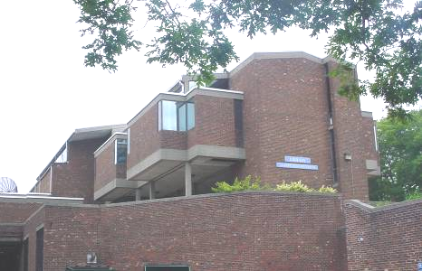

Prepared by:
Massachusetts Department of Public Health
Bureau of Environmental Health
Indoor Air Quality Program
September 2008

Background/Introduction
At the request of John Lebica, Director of Facilities Management, Cape Cod Community College (CCCC), the Massachusetts Department of Public Health (MDPH), Bureau of Environmental Health (BEH) provided assistance and consultation regarding indoor air quality concerns at the Wilkens Library (WL) on the CCCC campus in Barnstable, Massachusetts. The request was prompted by employee concerns of mold and water penetration issues. On June 26, 2008, a visit to conduct an indoor air quality assessment at the WL was made by Cory Holmes, Inspector for BEH’s Indoor Air Quality (IAQ) Program. Mr. Holmes was accompanied by Paul Knell, Staff Associate and Mr. Lebica for portions of the assessment.
The WL is a three-story, red brick building constructed in 1970. Its construction design resulted in many exterior roofs, walls and surfaces that are adjacent to each other. The building has undergone some interior renovations over the years; however, the majority of building components (e.g., carpeting, mechanical ventilation) are original. The building houses offices, student lounge areas, computer stations, circulation desks and stack areas for books. Windows are openable throughout the building.

Methods
BEH staff performed a visual inspection of building materials for water damage and/or microbial growth. Moisture content of porous building materials (e.g., carpeting, insulation) was measured with a Delmhorst, BD-2000 Model, Moisture Detector with a Delmhorst Standard Probe. Air tests for carbon dioxide, temperature and relative humidity were taken with the TSI, Q-TRAK™ IAQ Monitor, Model 8551.

Results
The WL houses approximately 20 staff members and is visited by hundreds of staff/students daily. Tests were taken during normal operations and results appear in Table 1.

Discussion

Ventilation
It can be seen from Table 1 that carbon dioxide levels were below 800 parts per million parts of air (ppm) in all areas surveyed, indicating adequate air exchange. Mechanical ventilation is provided by a heating, ventilation and air-conditioning (HVAC) system that consists of an air handling unit (AHU) located in a mechanical room on the ground floor. The AHU draws fresh outside air through an intake on the exterior of the building (Picture 1). Air is pulled through a bank of pleated filters (Picture 2) and supplied to occupied areas by wall and/or floor-mounted air diffusers (Pictures 3 and 4). Return ventilation is ducted back to the AHU through ceiling-mounted exhaust grills (Picture 5).
The AHU in the ground floor mechanical room had a large gasket connecting the air mixing room to the filter bank. BEH staff found this gasket badly damaged at the time of the assessment (Pictures 6 through 8). Without the gasket intact, the AHU draws in unfiltered air/odors/pollutants from the mechanical room; this can also make temperature/comfort control difficult. It is also important to note that the HVAC components are original equipment, dating 30 to 40 years old. Efficient function of such aged equipment is difficult to maintain, since compatible replacement parts are often unavailable.
To maximize air exchange, the MDPH recommends that both supply and exhaust ventilation operate continuously during periods of occupancy. In order to have proper ventilation with a univent and exhaust system, the systems must be balanced to provide an adequate amount of fresh air to the interior of a room while removing stale air from the room. It is recommended that HVAC systems be re-balanced every five years (SMACNA, 1994). The date of the last balancing of these systems was not available at the time of the assessment.
The Massachusetts Building Code requires that a room must a minimum ventilation rate of 20 cubic feet per minute (cfm) per occupant of fresh outside air or openable windows (BOCA, 1993; SBBRS, 1997). The ventilation must be on at all times that the room is occupied. Providing adequate fresh air ventilation with open windows and maintaining the temperature in the comfort range during the cold weather season is impractical. Mechanical ventilation is usually required to provide adequate fresh air ventilation.
Carbon dioxide is not a problem in and of itself. It is used as an indicator of the adequacy of the fresh air ventilation. As carbon dioxide levels rise, it indicates that the ventilating system is malfunctioning or the design occupancy of the room is being exceeded. When this happens a buildup of common indoor air pollutants can occur, leading to discomfort or health complaints. The Occupational Safety and Health Administration (OSHA) standard for carbon dioxide is 5,000 parts per million parts of air (ppm). Workers may be exposed to this level for 40 hours/week based on a time-weighted average (OSHA, 1997).
The MDPH uses a guideline of 800 ppm for publicly occupied buildings. A guideline of 600 ppm or less is preferred in schools due to the fact that the majority of occupants are young and considered to be a more sensitive population in the evaluation of environmental health status. Inadequate ventilation and/or elevated temperatures are major causes of complaints such as respiratory, eye, nose and throat irritation, lethargy and headaches. For more information on carbon dioxide see Appendix A.
Temperature measurements on the day of the assessment ranged from 71º F to 76º F, which were within the MDPH comfort guidelines. The MDPH recommends that indoor air temperatures be maintained in a range of 70º F to 78º F in order to provide for the comfort of building occupants. In many cases concerning indoor air quality, fluctuations of temperature in occupied spaces are typically experienced, even in a building with an adequate fresh air supply. Although, the temperature range was within the MDPH comfort guidelines the day of the assessment, occupants reported chronic temperature control issues.
The relative humidity measured in the building on the day of the assessment ranged from 69 to 78 percent, which was above the MDPH recommended comfort range in all areas. The MDPH recommends a comfort range of 40 to 60 percent for indoor air relative humidity. While temperature is mainly a comfort issue, relative humidity in excess of 70 percent for extended periods of time can provide an environment for mold and fungal growth (ASHRAE, 1989). BEH staff inspected the HVAC system located in the ground floor mechanical room and found that the outside air intake was opened/stuck in the 100 percent outside air position. Therefore, indoor relative humidity levels reflected those of outside (75%). During periods of high relative humidity (late spring/summer months), outdoor air intake should be limited to keep moisture out/maintain comfort. Relative humidity levels in the building would be expected to drop during the winter months due to heating. The sensation of dryness and irritation is common in a low relative humidity environment. Low relative humidity is a very common problem during the heating season in the northeast part of the United States.

Microbial/Moisture Concerns
In order for building materials to support mold growth, a source of moisture is necessary. Identification and elimination of water moistening building materials is necessary to control mold growth. Materials with increased moisture content over normal concentrations may indicate the possible presence of mold growth. Identification of the location of materials with increased moisture levels can also provide clues concerning the source of water supporting mold growth. In the case of the WL, two main sources of moisture were identified: elevated relative humidity drawn in through the HVAC system; and water penetration via the building envelope, (e.g., leaks from the roof/exterior walls).
As previously mentioned, the construction design of the WL involves many exterior roofs, walls and surfaces that are adjacent to each other. These surfaces/building materials require specific drainage and water tight specifications (e.g., flashing, gutters/roof drains, weep holes, roofing materials). The amount of different surfaces built into the design of the WL make it an extremely difficult building to maintain watertight integrity (Pictures 9 through 11). Efflorescence on interior brick (Pictures 12 and 13) and other water damaged materials in the building illustrate the water penetration throughout the building. Efflorescence is a characteristic sign of water penetration through building materials, but it is not mold growth. As moisture penetrates and works its way through mortar/exterior brick, water-soluble compounds dissolve, creating a solution. As this solution moves to the surface of the brick, the water evaporates, leaving behind white, powdery mineral deposits. This condition indicates that moisture is migrating through exterior brick walls.
As previously mentioned, water content of building materials was measured with a Delmhorst, BD-2000 Model, Moisture Detector with a Delmhorst Standard Probe. The Delmhorst probe is equipped with three lights that are visual aids indicating moisture level. Readings that activate the green light indicate a sufficiently dry level, those that activate the yellow light indicate borderline conditions and those that activate the red light indicate elevated moisture content. The probe is inserted into the surface of porous materials for measurement. Elevated moisture readings were measured and visible water damage and/or mold growth was detected/observed beneath carpeting along exterior walls on the 1st and 2nd floors (Table 1/Pictures 4, 14-16) and on fiberglass insulation around roof drains (Table 1/Pictures 17 and 18).
The US Environmental Protection Agency (US EPA) and the American Conference of Governmental Industrial Hygienists (ACGIH) recommends that porous materials be dried with fans and heating within 24 to 48 hours of becoming wet (US EPA, 2001; ACGIH, 1989). If porous materials are not dried within this time frame, mold growth may occur. Water-damaged porous materials cannot be adequately cleaned to remove mold growth. The application of a mildewcide to moldy porous materials is not recommended.
As previously discussed, relative humidity in excess of 70 percent for extended periods of time can provide an environment for mold and fungal growth (ASHRAE, 1989). In the experience of BEH staff, excessively humid weather can provide enough airborne water vapor to create adequate conditions for mold growth in buildings. Visible mold growth was also observed growing on the spines of cloth/textile-covered books (Pictures 19 and 20), most likely due to prolonged exposure to elevated humidity. Books with plastic or acetate covers adjacent to cloth-bound books were not mold colonized. Small areas of surface mold can be cleaned using a high-efficiency particulate air (HEPA) vacuum, after the material has thoroughly dried (Patkus-Lindbloom, 2003; US EPA, 2001).
In the case of mold-contaminated materials that cannot be thoroughly cleaned, a decision should be made concerning the storage and/or disposal of these materials. As an initial step, options concerning the preservation of materials should be considered. Porous materials that are judged not worthy of preservation, restoration or transfer to another media (e.g. microfiche or computer scanning) should be discarded. For materials to be preserved, restored or otherwise handled, an evaluation should be conducted by a professional book/records conservator. This process can be rather expensive and may be considered for conservation of irreplaceable documents that are colonized with mold. Due to the cost of records conservation, disposal or replacement of moldy materials may be the most economically feasible option.

Conclusions/Recommendations
The indoor air quality problems at the Wilkens Library raise a number of issues. The general building conditions, complex architectural design and the age/condition of ventilation equipment and carpeting, if considered individually, present conditions that can degrade indoor air quality. When combined, these conditions can serve to further negatively affect indoor air quality. Some of these conditions can be remedied by actions of building occupants. Other remediation efforts will require alteration to the building structure and equipment. For these reasons, three distinct remediation activities are recommended: A) removal/cleaning of water-damaged/mold contaminated materials, B) general indoor air quality recommendations, and C) long-term recommendations.

Recommendations for Removal/Cleaning of Water-damaged/Mold Colonized Materials
Removal of carpeting and roof drain insulation along exterior walls will remove actively growing mold that may be present on water damaged materials. However, without a thorough evaluation (and repair if needed) of the exterior of the building and HVAC system to prevent moisture/water infiltration, materials will continue to be damaged and subsequent mold growth can be expected. Removal of water damaged/mold colonized materials should be done in a manner consistent with Mold Remediation in Schools and Commercial Buildings published by the US Environmental Protection Agency (US EPA) (US EPA, 2001). Copies of this document can be downloaded from the US EPA website at: http://www.epa.gov/iaq/molds/mold_remediation.html.
- Remove carpeting approximately 2 to 3 feet from exterior walls. Disinfect floor beneath carpet with an appropriate antimicrobial agent, clean and dry. Consider replacing carpet with tile or other non-porous floor material.
- Remove/replace water damaged/mold colonized roof drain insulation.
- Inspect roof drains for leaks/proper drainage and make repairs if needed.
- Contact an HVAC engineer to evaluate the ventilation control system particulary the modulation of fresh air intake louvers. Consider having fresh air control dampers calibrated to limit outside air intake on hot, humid days during air-conditioning season.
- Keep windows and exterior doors closed during hot, humid weather to maintain indoor temperatures and avoid condensation problems.
- To help prevent/reduce musty odors from carpeting, use portable dehumidifiers to supplement air-conditioning during periods of excessive relative humidity (e.g., over 70% for extended periods of time).
- Ensure dehumidifiers are cleaned/maintained as per the manufacturer’s instructions to prevent mold/bacterial growth.
- Clean surface mold from spines of books in place with a vacuum cleaner equipped with a high efficiency particle arrestance (HEPA) filter. As an additional measure, vacuum books that do not have visible mold colonies, but are located in areas impacted by mold.
- Discard porous materials that are deemed unworthy of preservation, restoration or transfer to another media (e.g. microfiche or computer scanning). Where stored materials are to be preserved, restored or otherwise handled, an evaluation should be conducted by a professional book/records conservator. The preservation/restoration process can be rather expensive and may be considered for conservation of irreplaceable documents that are colonized with mold. Due to cost of book conservation, disposal or replacement of moldy materials may be the most economically feasible option.
- Clean efflorescence from the surface of interior walls using a HEPA filtered vacuum cleaner. Note, until exterior brick in these areas is re-pointed or sealed, efflorescence may reoccur.

General Air Quality Recommendations
- Operate all ventilation systems throughout the building continuously during periods of occupancy.
- Consider balancing mechanical ventilation systems every 5 years, as recommended by ventilation industrial standards (SMACNA, 1994).
- For buildings in New England, periods of low relative humidity during the winter are often unavoidable. Therefore, scrupulous cleaning practices should be adopted to minimize common indoor air contaminants whose irritant effects can be enhanced when the relative humidity is low. To control for dusts, a high efficiency particulate arrestance (HEPA) filter equipped vacuum cleaner in conjunction with wet wiping of all surfaces is recommended. Drinking water during the day can help ease some symptoms associated with a dry environment (throat and sinus irritations).
- Clean carpeting that has not been impacted by mold annually (or semi-annually in soiled high traffic areas) as per recommendations of the Institute of Inspection, Cleaning and Restoration Certification (IICRC). Copies of the IICRC fact sheet can be downloaded at: http://www.cleancareseminars.com/carpet_cleaning_faq4.htm (IICRC, 2005)
- Clean air diffusers, exhaust/return vents and ceilings/walls around these vents periodically of accumulated dust.
- Refer to resource manual and other related indoor air quality documents located on the MDPH’s website for further building-wide evaluations and advice on maintaining public buildings. These documents are available at: http://mass.gov/dph/indoor_air.

Long-Term Recommendations
- Consider contacting HVAC engineering firm fully evaluate the ventilation systems. Particulary the efficiency of AC components during the cooling season. Based on the age, physical deterioration and availability of parts for ventilation components, such an evaluation is necessary to determine the operability and feasibility of repairing/replacing the equipment.
- Consult with an architect and or general contractor regarding the integrity of the building envelope, primarily concerning water penetration through walls/joints/seams/roofs and exterior walls.
- Have a professional drainage/gutter installation contractor evaluate the design/condition of the current system for improvement/replacement to direct water away from the building and prevent further water damage.
- Consider replacing original/damaged/worn carpeting throughout the library to prevent the aerosolization of carpet fibers.

References
ACGIH. 1989. Guidelines for the Assessment of Bioaerosols in the Indoor Environment. American Conference of Governmental Industrial Hygienists, Cincinnati, OH.
ASHRAE. 1989. Ventilation for Acceptable Indoor Air Quality. American Society of Heating, Refrigeration and Air Conditioning Engineers. ANSI/ASHRAE 62-1989
BOCA. 1993. The BOCA National Mechanical Code/1993. 8th ed. Building Officials and Code Administrators International, Inc., Country Club Hill, IL
IICRC. 2005. Carpet Cleaning FAQ 4 Institute of Inspection, Cleaning and Restoration Certification. Institute of Inspection Cleaning and Restoration, Vancouver, WA.

OSHA. 1997. Limits for Air Contaminants. Occupational Safety and Health Administration. Code of Federal Regulations. 29 C.F.R 1910.1000 Table Z-1-A.
Patkus-Lindbloom, Beth. 2003. Emergency Salvage of Moldy Books and Paper. Technical Leaflet, Emergency Management. Section 3, Leaflet 9. Beth Patkus-Lindbloom, Preservation Consultant, Walpole, MA.
SBBRS. 1997. Mechanical Ventilation. State Board of Building Regulations and Standards. Code of Massachusetts Regulations. 780 CMR 1209.0.
SMACNA. 1994. HVAC Systems Commissioning Manual. 1st ed. Sheet Metal and Air Conditioning
US EPA. 2001. “Mold Remediation in Schools and Commercial Buildings”. Office of Air and Radiation, Indoor Environments Division, Washington, DC. EPA 402-K-01-001. March 2001. Available at: http://www.epa.gov/iaq/molds/mold_remediation.html
Picture 1

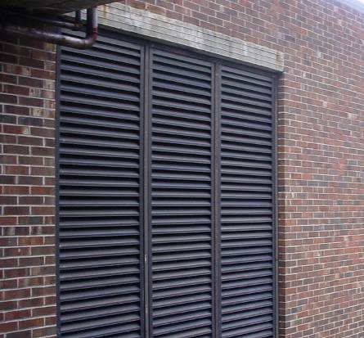

Fresh Air Intake for Library HVAC System

Picture 2

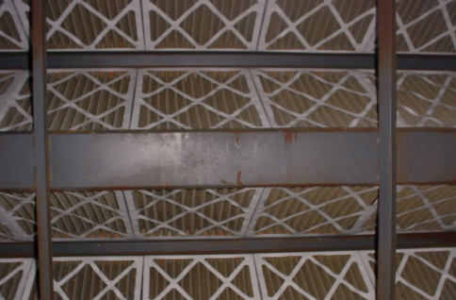

Pleated Filter Bank for Library HVAC System

Picture 3

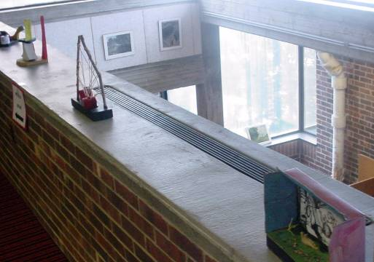

Wall-Mounted Supply Vent

Picture 4

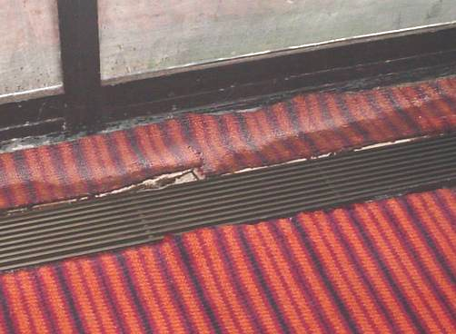

Floor-Mounted Supply Vent, Note Water Damaged/Loosened Carpeting (Top)

Picture 5

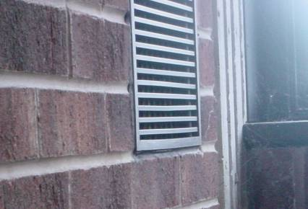

Wall-Mounted Return Vent

Picture 6

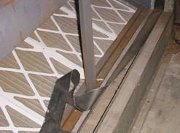

Missing/Damaged Rubber Gasket (Foreground)
Picture 7

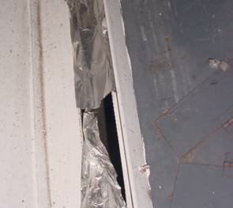

Missing/Damaged Sealant (Foil) along Side of AHU (Vertical)

Picture 8

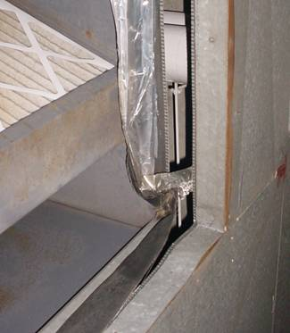

Missing/Damaged Rubber Gasket (Foreground)/Foil Tape (Vertical) Note Open Space between Duct and Mixing Room Allowing for Uncontrolled Air to Enter System

Picture 9

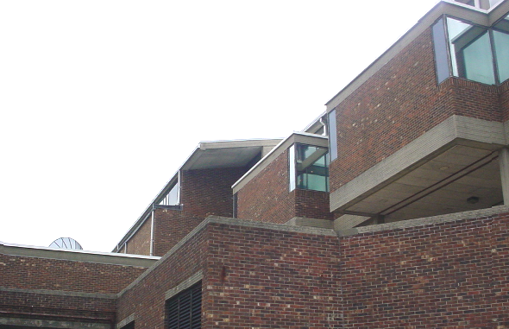

Multiple Wall and Roof Surfaces at the CCCC Library Building

Picture 10

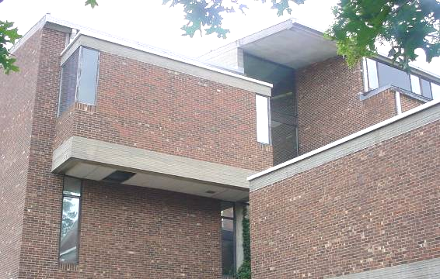

Multiple Wall and Roof Surfaces at the CCCC Library Building
Picture 11

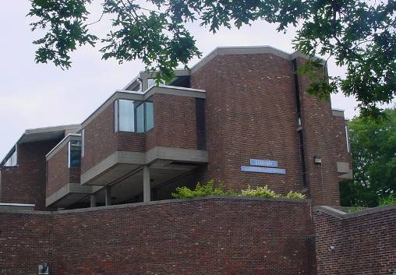

Multiple Wall and Roof Surfaces at the CCCC Library Building

Picture 12

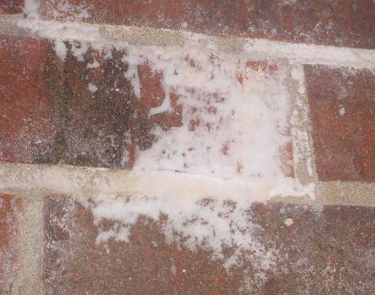

Efflorescence (i.e., Mineral Deposits) on Interior Brick
Picture 13

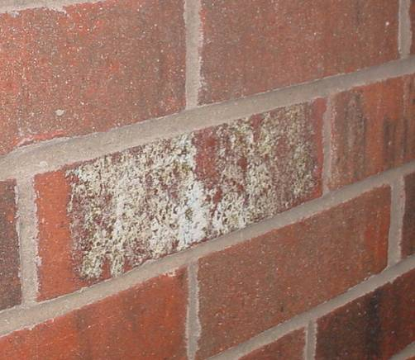

Efflorescence (i.e., Mineral Deposits) on Interior Brick

Picture 14

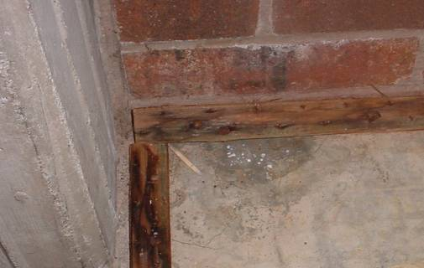

Water Damaged/Mold Colonized Wooden Tack Strips beneath Carpeting along Exterior Walls 2nd Floor
Picture 15

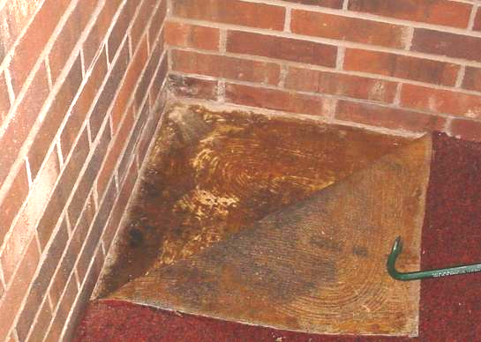

Water Damaged/Mold Colonized Carpeting along Exterior Walls 2nd Floor

Picture 16

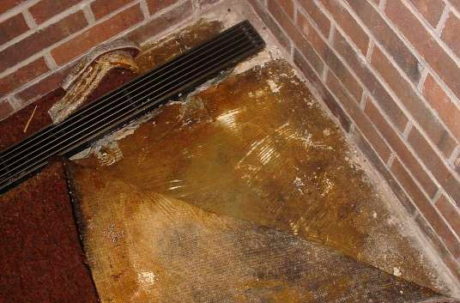

Water Damaged/Mold Colonized Carpeting along Exterior Walls
Picture 17

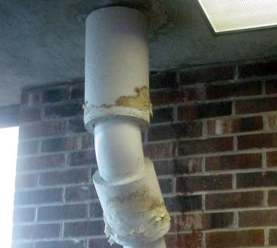

Water Damaged/Mold Colonized Insulation around Roof Drains

Picture 18

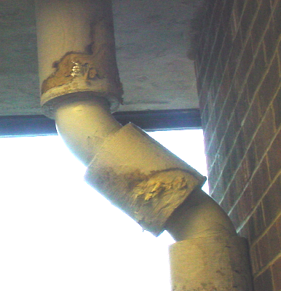

Water Damaged/Mold Colonized Insulation around Roof Drains
Picture 19

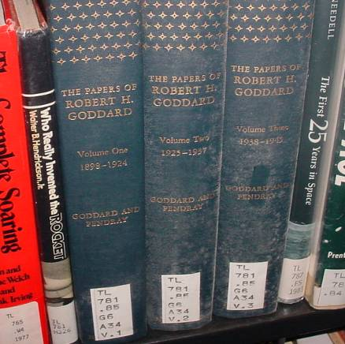

Mold Colonized Spines of Textile-Covered Books

Picture 20

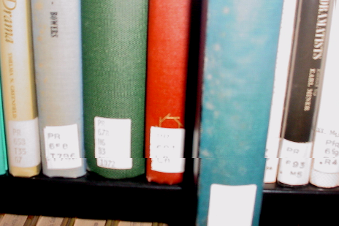

Mold Colonized Spines of Textile-Covered Books
Location/ Room |  | Occupants  in Room |  | Temp  (°F) |  | Relative  Humidity  (%) |  | Carbon  Dioxide  (ppm) |  | Windows  Openable |  | Ventilation |  |  |  | Remarks
 |  |  |  |  |  |  |  |  |  |  |  | Supply |  | Exhaust |  | Remarks
background |  |  | 80 |  | 75 |  | 385
3rd Floor
Office Space | 3 |  | 75 |  | 73 |  | 446 |  | Y |  | Y |  | Y
PA 6558 | 0 |  | 74 |  | 70 |  | 397 |  | Y |  | Y |  | Y |  | Carpet-dry (low moisture), no visible mold/moisture beneath carpet
PN 671 | 0 |  | 71 |  | 71 |  | 382 |  | Y |  | Y |  | Y |  | Carpet-dry (low moisture), efflorescence, no visible mold/moisture beneath carpet
PR Stack |  |  |  |  |  |  |  |  |  |  |  |  |  |  | Visible mold-light coating on textile book spines
Z4-7964 | 0 |  | 74 |  | 71 |  | 379 |  | Y |  | Y |  | Y
TL | 0 |  | 74 |  | 72 |  | 374 |  | Y |  | Y |  | Y |  | Visible mold-light coating on textile book spines (text books-Goddard)
2nd Floor
ITC Office | 1 |  | 75 |  | 75 |  | 414 |  | Y |  | Y |  | Y |  | Previous leaks, possible leak-roof drain, efflorescence concrete, no visible mold/moisture beneath carpet
AC 1 | 0 |  | 73 |  | 78 |  | 376 |  | N |  | N |  | N |  | Dark stain beneath carpet-possible mold growth along exterior wall, previous/current WD area, currently dry
D 750 | 0 |  | 73 |  | 78 |  | 542 |  | N |  | Y |  | Y |  | Carpet dry-WD, efflorescence-brick
E 485-336 | 0 |  | 73 |  | 77 |  | 423 |  | N |  | Y |  | Y |  | Visible mold-light coating on textile book spines
HV-JC | 0 |  | 74 |  | 73 |  | 453 |  | Y |  | Y |  | Y |  | Moistened carpet near column
Emergency Exit Area | 0 |  | 76 |  | 72 |  | 390 |  | Y |  | Y |  | Y |  | WD/moist/mold on roof drain insulation
Computer Room | 0 |  | 76 |  | 71 |  | 381 |  | Y |  | Y |  | Y |  | Wet insulation around drains, efflorescence brick
JN-JZ | 1 |  | 75 |  | 69 |  | 386 |  | Y |  | Y |  | Y
Library Conference Room | 0 |  | 74 |  | 70 |  | 396 |  | Y |  | Y |  | Y |  | Efflorescence, WD insulation around roof drains
1st Floor
Periodicals | 0 |  | 72 |  | 73 |  | 380 |  | Y |  | Y |  | Y |  | WD carpet-moistened, dark staining-possible mold growth below carpet along exterior wall
Customer Service Reference | 2 |  | 72 |  | 75 |  | 368 |  | Y |  | Y |  | Y
Library Office | 1 |  | 73 |  | 75 |  | 395 |  | Y |  | Y |  | Y
Computer Bank | 6 |  | 73 |  | 75 |  | 422 |  | N |  | Y |  | Y
Circulation Desk | 3 |  | 73 |  | 76 |  | 382 |  | N |  | Y |  | Y
Break Room | 1 |  | 73 |  | 74 |  | 388 |  | N |  | Y |  | Y
Ground Floor
Cape Cod Collection | 0 |  | 73 |  | 72 |  | 369 |  | Y |  | Y |  | Y |  | Dehumidifier
Lobby | 0 |  | 73 |  | 73 |  | 440 |  | N |  | Y |  | Y |  | Tile near exterior door

