Capital Process Manual

Introduction

The Division of Local Services (DLS) offers this capital process manual to cities and towns as a foundation for systematic capital planning and budgeting.

A capital improvement program (CIP) provides a blueprint for a community's capital expenditures and is one of the most important responsibilities of local government officials. It coordinates planning, financial capacity, and physical development. A CIP is composed of two parts—a capital program and a capital budget. The capital program is the community planning and fiscal management tool that spans five to ten years. The capital program identifies capital items, which are typically defined as tangible assets or projects that cost more than a certain threshold and that have a minimal useful life, provides a planning schedule, and offers financing options. The capital budget is the upcoming year's spending plan for capital items that is presented to the legislative body for approval.

Capital planning should be governed by clear policy. This document provides a broad framework for developing a policy encompassing the definition of a capital project, financing and funding sources, and the criteria used to evaluate submitted projects. Also included is a sample calendar outlining procedural organization, a standard capital project request form with submission instructions, and finishes with links to additional tools that communities may find useful in their capital planning process. For more information and trainings on capital planning and related topics, go to the Municipal Finance Training and Resource Center on the DLS website.

Framework
Definition of a Capital Project

A capital project is a major, nonrecurring expenditure that meets one or more of the following criteria:

- The capital improvement is a tangible asset or project estimated to cost over $25,000 and to have or to extend five or more years of useful life.
- The community would legally be allowed to borrow for the expense under M.G.L. c. 44, § 7 and M.G.L. c. 44, § 8.
- The expenditure is for real property acquisitions, construction, and long-life capital equipment.
- The project is for improvements to physical infrastructure (e.g., streets, sidewalks, and stormwater drains) and renovations of existing capital items that extend their useful lifespans.
- The purchase or long-term capital lease is for vehicles or heavy equipment that have an expected useful life of 5 or more years.
- The expenditure is to pay for the planning, engineering, or design services required for a construction or renewal project that itself qualifies as a capital expenditure.
- The purchase is for bulk purchases of similar items, like software, furniture, or radios with an expected useful life of three or more years that, when aggregated, have total costs exceeding $25,000.

Capital Asset Inventory

The community should maintain a complete detailed inventory of all city or town and school properties, assets, and fleet. This should include, at minimum, all buildings, fleet, and equipment, but it is desirable to include utilities, roads, and sewers as well. For each asset, the inventory should detail (as applicable): the dates built, acquired or last improved, original cost, current condition, expected useful life, depreciated value, extent of use, and any scheduled replacement or expansion dates.

Financing Capital Projects

The portion of the annual budget allocated to capital investment should be consistent with policy targets. Funding should be derived from a combination of property taxes, free cash, and stabilization funds, municipal debt, and by taking advantage of state and federal grant programs.

Capital project financing should follow these guidelines:

- Clearly recognize any short- or long-term impact on the operating budget in the initial project request description.
- Use available funds (e.g., free cash, capital stabilization funds, retained earnings, and community preservation funds) for capital projects as much as practical.
- Evaluate special revenue sources (e.g., grants, revolving funds) as funding options whenever practical.
- Consider capital or debt exclusions to accomplish major capital projects, such as new construction or major renovations to existing facilities.
- Identify each project’s annual operating costs and debt service costs before any long-term, bonded capital project is recommended.
- Restrict long-term debt funding to projects with lifespans greater than 10 years and costs exceeding $100,000.

Funding Sources

The following revenue sources are available for capital financing.

- Tax Levy – Cash from standard general fund revenues including property taxes, state aid, and local receipts.
- General/Capital/Other Stabilization – Appropriation from either the general stabilization or a special purpose stabilization fund.
- Free Cash – Appropriation from certified free cash.
- Non-Excluded Debt –Issuance of general obligation bonds, with debt service included in the operating budget within the levy limit.
- Excluded Debt– Issuance of general obligation bonds with annual debt service added to the tax levy limit until the debt is satisfied.
- Capital Exclusion – A one year addition to the tax levy for a specific capital acquisition.
- Enterprise Receipts –Receipts, either user charges or the appropriation of certified retained earnings.
- Revolving Fund – Revolving fund receipts authorized for capital expenditure through bylaw or ordinance.
- Grants –Partial or full funding for eligible projects. Note that grant funds may require a community match or additional funding.
- Community Preservation Act – Available to communities that adopted the CPA, projects may qualify for allowable usage of the restricted funds.

Solicit, Compile, and Evaluate Project Requests

Using standard forms, each department submits capital requests which should include clear details of each project’s justification, cost, net effect on the operating budget, and implementation schedule.

Once the project proposals are compiled, they are each evaluated based on criteria related to policy objectives, including preserving or enhancing municipal assets, increasing government efficiency and effectiveness, or enhancing the community with new programs and services.
Evaluation Criteria

Submitted projects will be categorized based on the evaluation criteria below. All evaluation criteria should be understood within the context of the municipality’s strategic capital planning framework and by how they relate to furthering its overarching capital needs.

- Public Safety and Health: What is the project’s impact on existing public health and safety conditions? Does it address an existing concern, or is there is an increased risk for unforeseen consequences?
- Legal Requirements: Is the project necessary to bring the city or town into compliance with a legal requirement or regulation mandated by the state or federal government?
- Infrastructure: How does the request address the community’s needs within the context of existing infrastructure problems, and how well does it integrate with that infrastructure?
- Efficiency: Will the project make services more cost-effective by decreasing the amount of time and labor or the overall costs?
- Impact on Service and/or Personnel: Is the request necessary to support a new or expanded service the city or town is offering? An example might be the purchase of equipment needed to support and maintain a new park or recreational area. Or, if a department has recently increased staff, is the request necessary for equipment for the new staff to perform their work?

Capital Budget Calendar

Using the requirement for legislative approval (town meeting or city council) as the end date, the capital budget calendar should specify deadlines for completing each step of the CIP process, allowing sufficient time to complete department head and public reviews, and present the recommendations to the applicable board, committee, or council for adoption.

August/  September | Finance completes annual update of capital asset inventory (buildings and equipment). Include dates built, acquired or last improved, original costs, current conditions, expected and remaining useful lifespans, depreciated values, extent of use, and any scheduled replacement or expansion dates.
 | Departments identify capital needs for upcoming year, update prior year requests.
 | Policymakers review and set annual budgeting guidelines.
 | Administration updates capital budget calendar for the coming year.
October | Stakeholders (City/Town/School/Regional/Finance Committee) hold joint budget meeting.
 | Administration and Finance Team present revenue and expenditure projections, available funds estimates, and overview of prospective capital needs.
November/ December | Administration distributes capital budget packages to all departments, boards, and committee, including worksheets, instructions, guidelines, and current multiyear plan.
 | Departments complete the capital request forms with supporting documentation including descriptions, pictures, cost estimates, etc.
January - March | Departments submit current year capital requests and 5-year projection of needs to Capital Coordinator “Coordinator” (e.g., Administration, Capital Committee, Finance Director).
 | Coordinator meets with each department on capital requests and gather additional information.
 | Review requests that may be eligible for Community Preservation Act (CPA) funding and meet with CPA Committee if applicable.
 | Coordinator and Finance Team identify potential funding sources for recommended projects.
April/May | Coordinator compiles requests into comprehensive capital package with recommendations and presents the proposed capital budget and 5-year improvement plan to Administration (Mayor/Manager/Administrator).
 | Administration finalizes capital outlay, narratives for current year, and 5-year plan
 | Present multiyear capital plan and current year capital outlay to Policymakers (Select Board/Finance Committee/City Council).
June | Legislative body accepts and funds current year plan and 5-year plan.

Capital Project Request Form

The Capital Project Request form should be completed with sufficient detail to encompass the project or asset in its entirety. It is always beneficial to attach all relevant supplemental information to aid in the evaluation of the request. This fillable form is available here and on the DLS website.

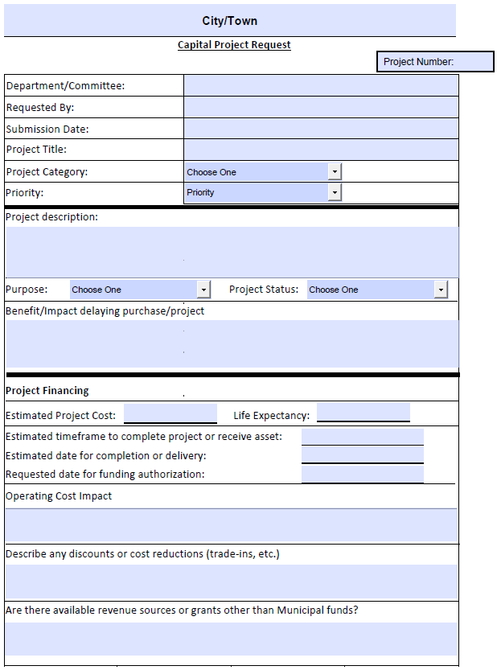

Completing the Capital Request Form – Hover over the field (in blue) for instructions

Project Number: For ease of tracking, the Coordinator will assign unique project numbers to all projects. Multiyear projects will retain the same project number over the years.

Department/Committee: Department originating the request and responsible for the project.

Requested By: Name and contact information of the person requesting the project.

Submission Date: Record the date this project was first submitted and, if applicable, the date of the most recent substantive edit (i.e., other than correcting a typo).

Project Title: Give the project a sufficiently descriptive title.

Project Category: Choose the category in the dropdown box that applies to this request:

- Building/Construction – new construction or a capital improvement to existing infrastructure
- Equipment/Furnishings – purchase of heavy equipment/vehicles, IT infrastructure, furnishings
- Land Acquisition/Open Space – purchase of land, property, or open space
- Parks/Grounds – capital improvement to parks, recreational fields, or other grounds
- Study/Design - feasibility studies, engineering, or architectural design work required for a project
- Other - another category not listed above. The project description below should adequately explain why this category was chosen.

Priority – Select the appropriate priority level based on the definitions below:

- Urgent - Addresses an imminent risk to the safety of the public or municipal personnel, and/or prevents the imminent destruction or collapse of public infrastructure and loss of assets.
- High - Necessary to ensure consistent, level service for the upcoming fiscal year. This priority type includes systems that are likely to fail, e.g., replacement of old or worn-out equipment, dramatically rehabilitate aging facilities, or facilitate a department’s ability to meet increased service demands.
- Moderate – Either replaces assets that have outlived their useful life, enhances a benefit to the community over and above the existing service level, results in cost savings or other efficiencies, or directly supports the community’s economic base by increasing property values.
- Low – Provides additions or improvements to services or programs having social, cultural, historic, economic, or aesthetic value, but does not require immediate approval and implementation.

Project Description: Provide a basic description of the proposed project or equipment purchase, including:
- Location (if a building)
- Type of building
- Intended use(s)
- Whether land acquisition will be necessary (if a building)
- Discussion of primary cost drivers
- Stakeholders involved
- Narrative description of qualification for specific funding source (e.g., grants, CPA)

Purpose: - To further categorize the project request based on the need, community impact, and priority.

Project Status:
- New –First-time submission.
- Recurring –A routine project that must be completed annually or periodically, such as upgrading a pumping station’s infrastructure or rehabilitating athletic fields. Update the submission text and financing information with any relevant changes for the upcoming year.
- Resubmission – A project was submitted in a previous year but not approved. For this submission, make any necessary updates to the description and cost estimates.
- Revision/Upgrade to Previous Project – The scope of this project has changed or requires additional resources. Projects such as this can span a number of phases over multiple fiscal years before it is completed.

Benefits of Project and Impact if not Completed: Provide justification for the project in this box. Highlight the specific benefits that will directly result from completing the project. These details may depend on the chosen priority level and purpose. For instance, if the priority level is “Moderate” and purpose is “Service Enhancement,” describe any and all new benefits the project offers, including any cost savings or efficiencies. Additionally, state how the project will benefit community and administrative stakeholders and explain any negative impacts or potential consequences of not approving the project. This information is particularly important for projects classified as “Urgent/Compliance with Law” and “Ensure Public Safety”.

Project Financing

Estimated Project Cost –Enter the estimated cost of the project or asset. Attach any quotes or other documentation to support the cost.

Life Expectancy – Provide the number of years the asset is expected to last.

Estimated timeframe to complete project or receive asset – In months or years, estimate the duration of the project or the timeframe for delivery of equipment or asset. For example, if a new ambulance requires a build out and delivery time of 1 year, enter 1 year.

Estimated date for completion or delivery – Enter the date of expected completion or delivery. If the ambulance is ordered in July, date of delivery would be the following July.

Requested date for funding authorization – Enter when project approval or authorization is needed to meet the estimated project completion or delivery date.

Operating Cost Impact: Explain the project’s temporary and/or long-term impact on the operating budget. For example, capital construction projects can result in increased operating costs. Costs may increase during the project’s duration (e.g., increased use of one building while another is demolished and reconstructed) or be longer lasting, such as new a building resulting in increased utility costs or the hiring of additional maintenance personnel.

Describe any discounts or cost reductions – Describe and provide documentation for available discounts or cost reductions, such as trade in value.

Available revenue sources or grants – Provide any potential grants, donations, or other available funds to supplement the regular financing of capital projects and assets. Attach documentation of possible grant opportunities, along with the community’s funding requirements for acceptance.

Additional Capital Planning and Budgeting Tools

Click here to download the following tools which have been compiled into a single workbook and here for a sample capital planning policy. The complete catalog of capital planning information can be accessed on the DLS website.

Town Budget/Capital Calendar – Sample combined annual and capital calendar

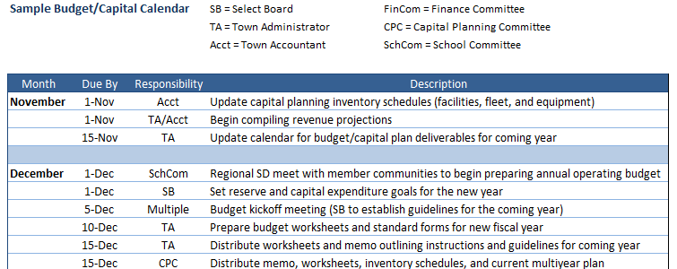

Capital Improvement Plan Summary – Sample Capital Improvement Plan showing the capital budget (current year) and capital program (following five years) with funding sources, and a brief narrative for current year proposed capital purchases.
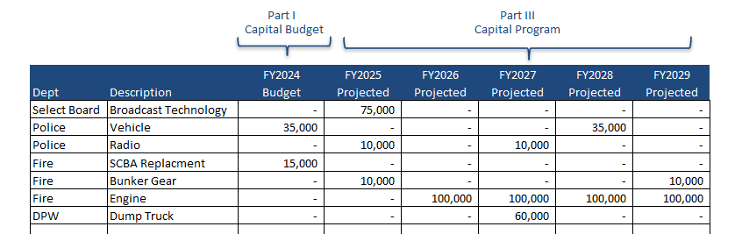

Asset Inventory/Facilities Inventory - To support a systematic acquisition and replacement schedule, communities should maintain and annually update detailed asset and fleet inventories which should include, at a minimum, dates built or manufactured, acquired or last improved, original costs, current conditions, expected and remaining useful lifespans, depreciated values, extent of use, and any scheduled replacement or expansion dates.

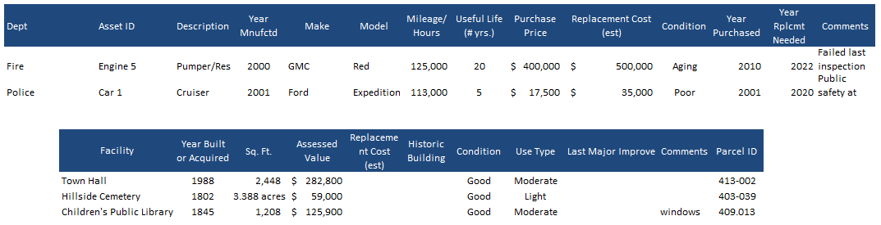

Financial Targets Worksheet – Communities should establish budgetary targets (with upper and lower limits) to frame the discussion regarding annual capital expenditures. Completing the financial targets worksheet will assist local officials in defining financial policies and establishing benchmarks for the annual capital planning and budget process.

