Adapted from and photos used with permission of the New York State Department of Health

**Suggested sources for the items listed above:**

* **Hardware store/home & garden center:** gloves, flashlight, batteries, tape and tongs
* **Medical supply company:** forceps
* **Forestry supply company/outdoor store:** fine mesh insect net

**Items for a Bat Capture Kit**

* **Gloves** – heavy, preferably pliable, thick leather.
* **Kitchen tongs or forceps** – 9” to 12” in length.
* **Coffee can or other similar container** –preferably with a tight-fitting lid.
* **Sheet of cardboard**
* **Tape**
* **Net** – with fine mesh and long handle.
* **Flashlight** – to locate the bat without scaring the animal and causing it to fly around.
* Guidelines for **How To Handle Bats at Summer Camp** or **What To Do If You Find a Bat In Your Home** – to determine when a bat should be captured.

**When to Capture a Bat**

* If contact between a person and a bat may have occurred, even if no wounds can be seen.
* If a bat is found close to an unattended child, a person who was sleeping, a person with sensory or mental impairment, or a pet.

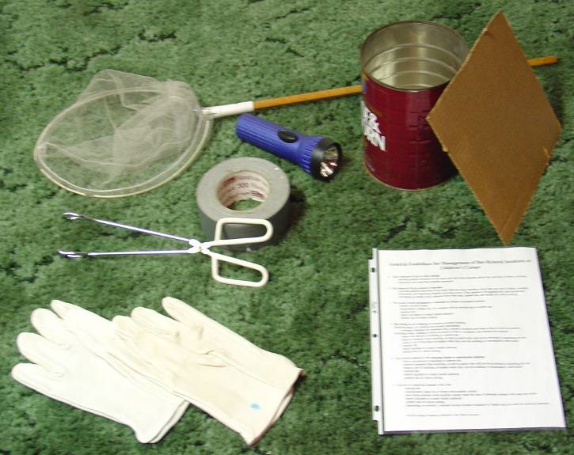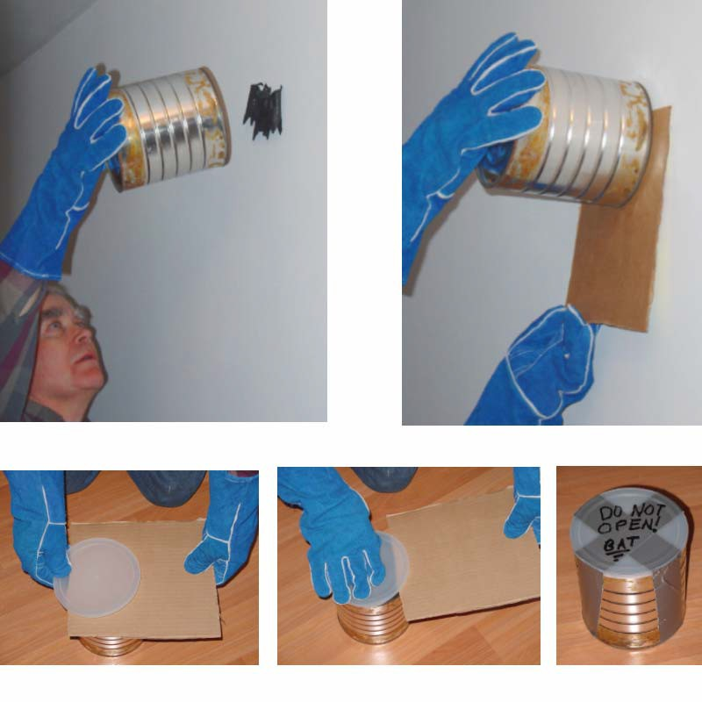

**4**

**3b**

**3a**

**For questions about bats and rabies please contact your local board of health or call the Massachusetts Department of Public Health, Division of Epidemiology and Immunization at 617-983-6800.**

**1**

**2**

**How to capture a bat**

**Use a container** – Close the doors and windows to the room, then wait until the bat lands. Approach slowly, placing the container over the bat (**1**). Slide the cardboard between the wall and the container, lifting away from the wall as a unit (**2**). Slowly slide the cardboard off the container while simultaneously slipping on the appropriately sized lid (**3a and b**). Tape a lid to the container so the bat cannot escape and label the container so it is not accidentally opened (**4**). Contact your local board of health.

**Use a net** – Bats are very sensitive to movement around them. To capture a bat with a net you have to come from behind. Transfer the bat to a container with forceps or thick leather gloves.

Massachusetts Department of Public Health, updated 2018

**Capturing a Bat: What You Need and How to Do It**