Indoor Air Quality Assessment

Carbuncle House
495 Main Street
Oxford, Massachusetts

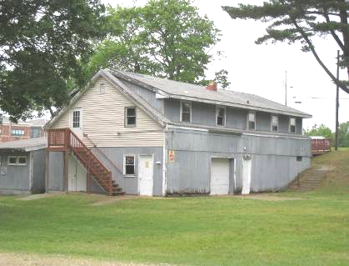

Prepared by:
Massachusetts Department of Public Health
Bureau of Environmental Health
Indoor Air Quality Program
August 2012

Background/Introduction
At the request of Terry Fike of the Oxford Board of Health, the Massachusetts Department of Public Health (MDPH), Bureau of Environmental Health (BEH) conducted an indoor air quality (IAQ) assessment at the Carbuncle House (CH), 495 Main Street, Oxford, Massachusetts. The request was prompted by musty odors and mold concerns in the building. On June 5, 2012, a visit to conduct an IAQ assessment was made by Michael Feeney, Director and Kathleen Gilmore, Environmental Analyst/Regional Inspector for BEH’s IAQ Program.
The CH is multi-level, wood clad building originally constructed as a private residence. The building was purchased by the Town of Oxford and serves as a public beach house on Carbuncle Pond. CH is also used for a children’s camp program during summer months when the Carbuncle Pond beach is open. CH is closed for the remainder of the year.
Two rooms finished in pinewood on the upper level are used for camp programs (Picture 1). All other upper and lower level rooms are either not used or not open to the public. A structure was added to the original building, which contains restrooms and changing areas for beach patrons. Windows are openable throughout the building. The furnace/forced hot air system ductwork are abandoned and not in use.

Methods
BEH staff performed visual inspection of interior building materials to identify the source of odors, water damage and/or microbial growth, as well as the exterior of the building.

Discussion

Microbial/Moisture Concerns
A musty odor was detected upon entering the upper level rooms. The odor was traced to heating registers, return vents and holes (Pictures 2 through 4) located in the floor and walls of the upper level. The heating registers are connected to forced hot air system/furnace located in the basement that is not currently in use. Open ducts (Picture 5) and duct vents (Picture 6) in the lower level can serve as a means for mold associated odors/particulates to enter the vents and migrate to the upper level of the building.
The lower level contains water-damaged gypsum wallboard with visible mold (Picture 7) likely due to roof leaks from the peak of the changing area/restroom structure (Picture 8), which is missing shingles. Water damage also exists in the ceiling of the upper level former kitchen (Picture 9).
It should be noted that the upper level also has rooms with wall-to-wall carpeting. While these rooms are not in use, the fact that the building lacks air conditioning can result in wall-to-wall carpeting being subject to moisture, and when wet, can become a source of mold growth. Materials can become colonized with mold if exposed to water and remaining moist. If sufficiently moistened, porous materials such as books, paper, insulation and carpeting can support mold growth (US EPA, 2001). The US EPA and the American Conference of Governmental Industrial Hygienists (ACGIH) recommend that porous materials be dried with fans and heating within 24 to 48 hours of becoming wet (US EPA, 2001; ACGIH, 1989). If porous materials are not dried within this time frame, mold growth may occur. Once mold has colonized porous materials, they are difficult to clean and should be removed and discarded.
The changing area/restrooms did not appear to have a mechanical means to exhaust air. Without exhaust ventilation, water vapor, moisture and odors can linger in these locations.

Other IAQ Conditions
BEH staff identified other conditions that can potentially affect indoor air quality. In the rooms occupied by the summer camp programs, items and materials (e.g., papers, folders, boxes and art supplies) were observed (Pictures 10 and 11). The large number of stored items provides a source for dusts to accumulate, making it difficult for custodial staff to clean. Items should be discarded, relocated and/or cleaned periodically to avoid excessive dust build up. In addition, these materials can accumulate on flat surfaces (e.g., tables, shelving and carpets) in occupied areas and subsequently be re-aerosolized causing further irritation.
In several unoccupied rooms of the building rodent droppings were observed on floors and carpets (Picture 12). Rodent infestation can result in IAQ related symptoms due to materials found in their wastes. Mouse urine contains a protein that is a known sensitizer (US EPA, 1992). A three-step approach is necessary to eliminate rodent infestation:
- cleaning of waste products from the interior of the building;
- reduction/elimination of pathways/food sources that are attracting rodents; and
- removal of the rodents.
To eliminate exposure to allergens, rodents must be removed from the building. Please note that removal, even after cleaning, may not provide immediate relief since allergens can persist in the building’s interior for several months after rodents are eliminated (Burge, 1995).

Conclusions/Recommendations
It appears that the odor source at CH is from the abandoned heating registers and open ductwork. Some of these conditions can be remedied if the building is to be used in its current manner. If usage changes, a significant number of repairs to the structure would be warranted. For these reasons, a two-phase approach is recommended. The first consists of short-term measures to improve air quality and the second consists of long-term measures that will require planning and resources to adequately address the overall IAQ concerns.

Short-Term Recommendations
- Permanently seal heating register openings in rooms used by the public in the upper level floors.
- Remove water-damaged gypsum wallboard from the lower level and ceiling in the upper level in a manner consistent with the US Environmental Protection Agency’s guidance “Mold Remediation in Schools and Commercial Buildings”, published by the US Environmental Protection Agency (US EPA, 2001). This document can be downloaded from the US EPA website: http://www.epa.gov/iaq/molds/mold_remediation.html.
- Consider sealing the entrances to the areas of the upper level floors that are not in use. Consult with the fire department regarding appropriate fire egress for these areas.
- Repair roof leaks.
- Remove wall-to-wall carpeting.
- Consideration should be given to supplying mechanical exhaust ventilation for the changing areas/restrooms. This can be achieved by using floor or pedestal fans to exhaust air via the entrances.
- Examine rooms and the exterior walls/doors of the building for means of rodent egress and seal appropriately. If doors do not seal at the bottom, install a weather strip as a barrier to rodents.
- Relocate or consider reducing the amount of materials stored in occupied rooms to allow for more thorough cleaning. Clean items regularly with a wet cloth or sponge to prevent excessive dust build-up.
- Refer to resource manuals and other related indoor air quality documents for further building-wide evaluations and advice on maintaining public buildings. Copies of these materials are located on the MDPH’s website: http://mass.gov/dph/iaq

Long-Term Recommendations
- Repair or replace the roof.
- Install rain gutters and downspouts.
- Replace rotted wall exterior.
- Replace the heating system.

References
ACGIH. 1989. Guidelines for the Assessment of Bioaerosols in the Indoor Environment. American Conference of Governmental Industrial Hygienists, Cincinnati, OH.
Burge, H.A. 1995. Bioaerosols. Lewis Publishing Company, Boca Raton, FL.
US EPA. 1992. Indoor Biological Pollutants. US Environmental Protection Agency, Environmental Criteria and Assessment Office, Office of Health and Environmental Assessment, research Triangle Park, NC. EPA 600/8-91/202. January 1992.
US EPA. 2001. “Mold Remediation in Schools and Commercial Buildings”. Office of Air and Radiation, Indoor Environments Division, Washington, DC. EPA 402-K-01-001. March 2001. Available at: http://www.epa.gov/iaq/molds/mold_remediation.html
Picture 1

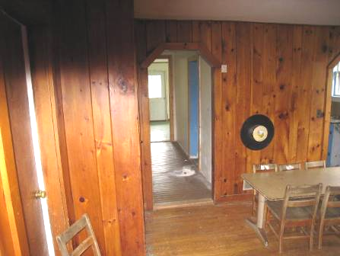

Finished Pinewood Room on Upper Level

Picture 2

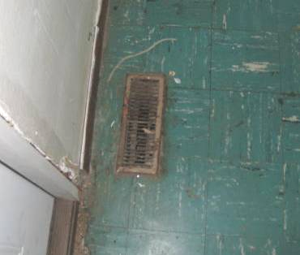

Heating Register in Upper Level Floor

Picture 3

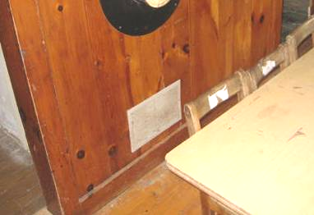

Return Vent in Upper Level (Arrow)

Picture 4

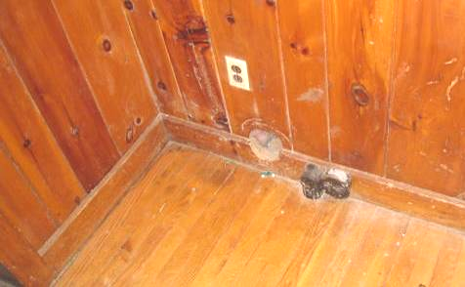

Hole in Wall in Upper Level (Arrow)

Picture 5

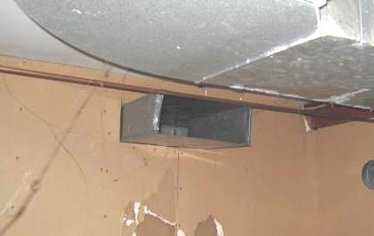

Open Duct in Lower Level

Picture 6

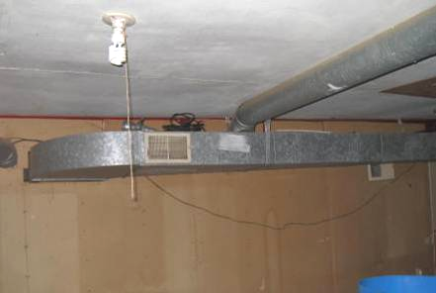

Duct Vent Opening in Lower Level (Arrow)

Picture 7

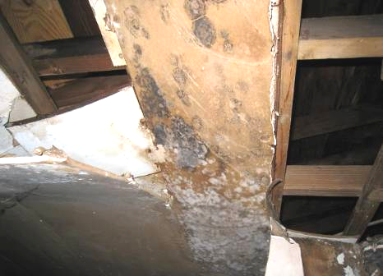

Mold-Colonized Gypsum Wallboard

Picture 8

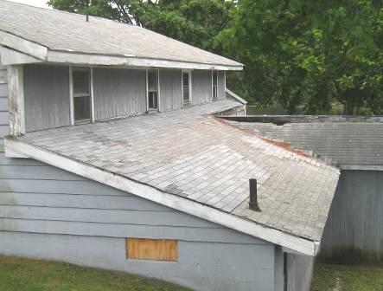

Roof Peak of Changing Area/Rest Rooms Missing Shingles (Arrow)

Picture 9

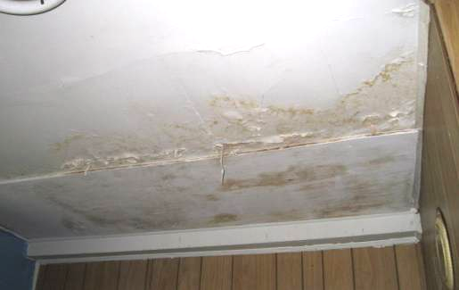

Water-damaged Ceiling in Kitchen

Picture 10

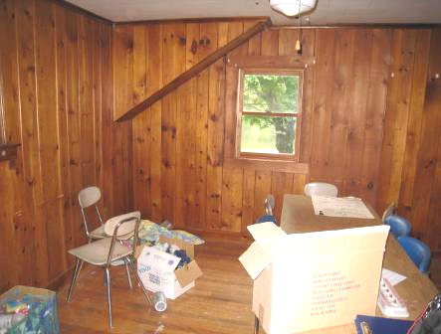

Items Stored on Floor and Tables of Room Used by Summer Camp Programs

Picture 11

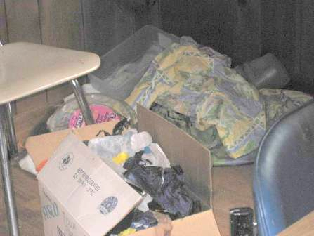

Items Observed in Boxes and on Floor

Picture 12

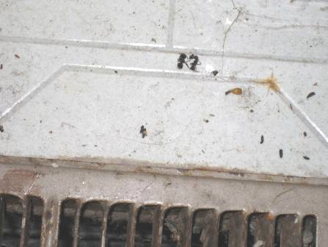

Rodent Droppings on Floor

