Overview

ACTIVITIES: WHAT THE CARE COORDINATOR DOES

Initial Meeting with Youth and Family

Initial Care Plan Meeting

Safety Planning Meeting

Implementation Care Plan Team Meeting

WRAPAROUND PRINCIPLES
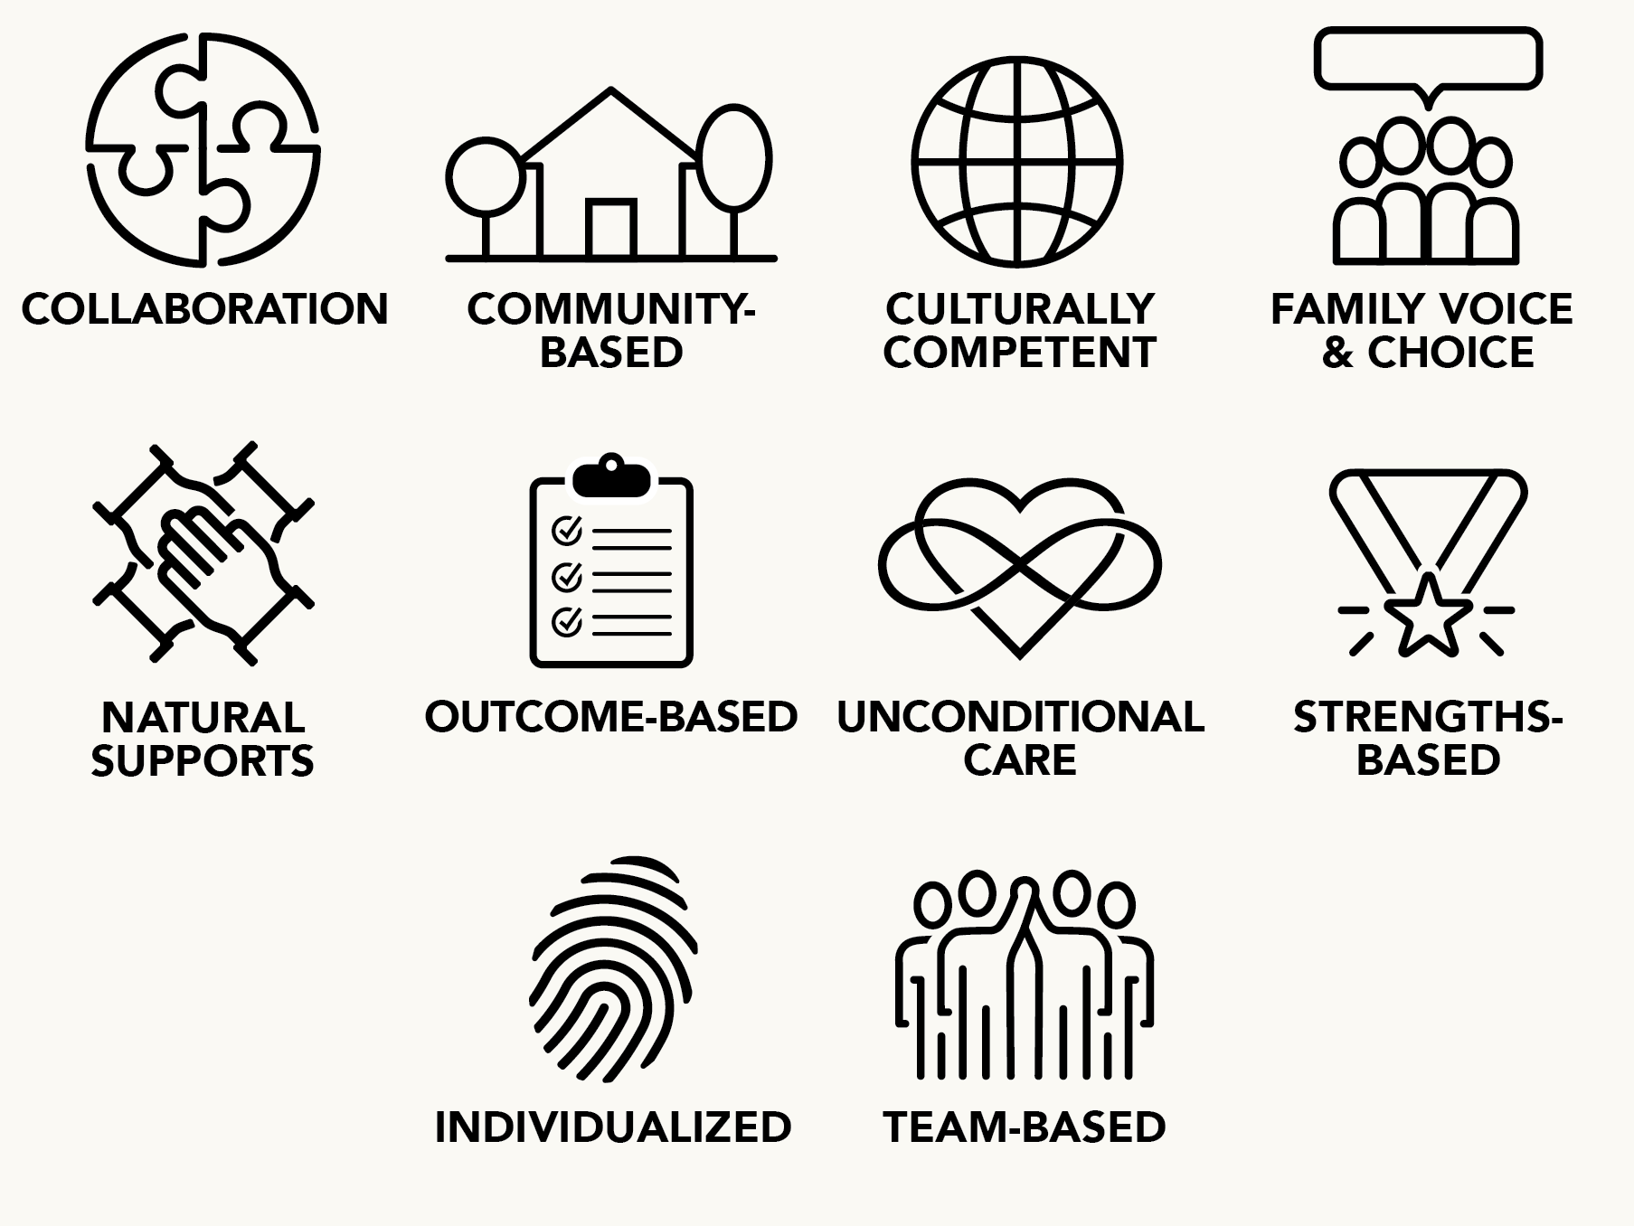

Initial Meeting with Youth and Family

SKILL SET

How the Care Coordinator does it
Introduce yourself to the family and youth; engage them in dialogue, actively listening to the family’s concerns.
Describe wraparound in a way that addresses family concerns and is tailored to their needs and learning styles; prepare them for purposeful transition.
Describe your role, including its limitations.
Answer family and youth questions about wraparound, staff roles, and the family’s role.
Help the family consider whether trying wraparound may be a good option to meet their needs.
Explain confidentiality and information-sharing with the family and youth; obtain needed releases.
Explain your responsibility to ensure safety and your role as a mandatory reporter. explain your agency’s policy on how reports are made; describe how reporting may benefit the family.
Ask the youth and family if they have any immediate or potential safety concerns or urgent needs.
If indicated, create an initial safety plan and brainstorm ways of stabilizing the identified concerns, include family strengths, culture, and natural supports.
If indicated and with assistance from the family, coordinate and communicate safety plans with other agency staff and potential team members as needed.

Initial Care Plan Meeting (1 of 2)

SKILL SET

How the Care Coordinator does it
Arrange for team meeting times and location that are sensitive to
the needs of the youth/family and of other team members.
Distribute documents at or prior to the team meeting including agenda, SNCD, and visual aids for the family vision, priority needs, and identified strengths and culture related to each prioritized need.
Introduce each team member, sharing the strengths they bring to
the team.
Review, discuss, and add strengths for the youth and family at the team meeting.
Develop consensus on ground rules that support input, safety, and team cohesion.
Develop consensus on confidentiality at the team level; ensure that all team members understand the process and commit to maintaining confidentiality.
Develop agreement on a decision-making process that maximizes youth and family voice and choice, and that prevents blame.
Review the family vision with the team and facilitate a process to refine it as needed; develop consensus to support the vision.
Develop a team mission describing how the team will support the family in achieving their vision; and obtain commitment from all team members to the mission.
Assist the youth, family, and team to review, amend, reach consensus, and prioritize the list of youth and family needs.
Help the youth, family, and team identify potential concerns for which a safety plan should be developed.
Develop goals that address the prioritized needs and team mission.
Review strengths and culture of the youth, family, and team related to each prioritized need.
Lead a brainstorming process to identify multiple natural and formal service and support options to address each need. give team members a chance to advocate for their preferred options.
Review the selected options to ensure they include multiple choices that are strengths-based and culturally appropriate. Support the family to select the best options, using the agreed-upon decision-making process.

Initial Care Plan Meeting (2 of 2)

SKILL SET

How the Care Coordinator does it
Develop short-term objectives and clearly stated measurement strategies for each identified need.
Develop an action plan for each selected option specifying who will do what, when, where, how often, and how team members will actively participate in plan implementation.
Develop short-term objectives and clearly stated measurement strategies for each identified need.
Develop an action plan for each selected option specifying who will do what, when, where, how often, and how team members will actively participate in plan implementation.
Evaluate the meeting by asking team members to share their observations about the quality of the process and the plan developed, and obtain team suggestions to improve the next meeting.
Develop team consensus on frequency and schedule for future meetings.
Produce, review with family (and custodial providers, if applicable), and distribute written wraparound and safety plans.

Safety Planning Meeting

SKILL SET

How the Care Coordinator does it
Together with the youth, family, and team members, prioritize potential safety concerns based on severity, likelihood of occurrence, and impact on the youth and family.
Ask the team to create a brief, clear statement of the safety concerns.
Collect data and information on the frequency, intensity, duration, and context of the behavior.
Identify what happens before the safety concern(s) occur that clearly defines the setting events for the behavior; also identify conditions when the behavior does not occur.
Identify external and internal signs the potential safety concern is beginning.
Describe what happens when safety concerns occur, including who is involved and other activities going on in the environment that make the situation better or worse.
Identify what happens after the events to define the functions of the behavior; develop an educated guess about benefits or functions the individual gets from the behavior.
Discuss what has been tried in the past, how well it was implemented, and how well it worked.
Develop reasonable short-term objectives and measurement strategies for the safety plan in order to assess the plan’s success.
Identify strengths and culture related to the identified safety concerns.
Based on the functional assessment, brainstorm options and develop a safety plan that defines action steps to prevent the safety concern or situation from happening by modifying what occurs before the
situation.
Based on the functional assessment, brainstorm options and develop an early intervention strategy that addresses signs that indicate the behavior is beginning and that shows ways to de-escalate.
Develop plans for teaching alternative behaviors to address the function of the behavior within the family culture.
Brainstorm options and develop a detailed and sequential set of
action steps to be followed by the team if the predicted safety concerns occur.

Implementation Care Plan
Team Meeting

SKILL SET

How the Care Coordinator does it
With increasing youth and family involvement, explore why any action steps were not completed and strategize about what to do next.
With increasing youth and family involvement, review if the services and supports defined in the plan are meeting the identified needs and supporting progress toward the family vision.
With increasing youth and family involvement, foster a team culture that honors team members for their contributions and that frequently celebrates successes.
Continue ongoing reflective discussions with team about purposeful transition.
Continue to increase youth and family management of the team process and their overall wraparound plan.
With increasing youth and family control over the process, identify new areas of need as they emerge or as objectives are met, and plan to address them.
Brainstorm needed options and continue to develop revised plans, including updating the safety plan.
Create and maintain team safety and confidentiality.
Continually assess team satisfaction, safety, and cohesion with the current wraparound plan and planning process and bring concerns to the team.
Monitor the team’s progress in carrying out the team mission and progress towards achieving the youth and family vision.

