**INDOOR AIR QUALITY ASSESSMENT**

**Carnegie Library**

**201 Avenue A, Turners Falls**

**Montague, MA**

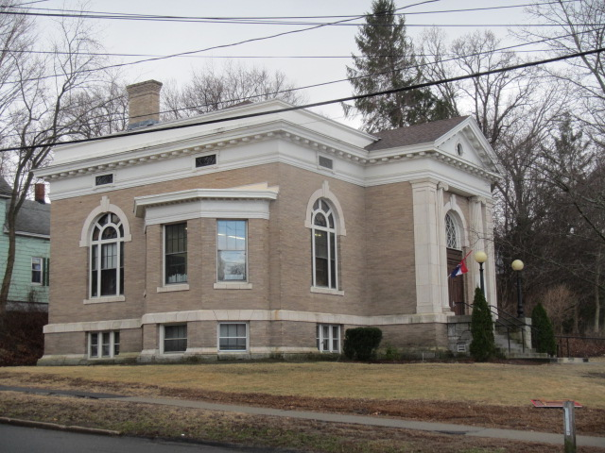

Prepared by:

Massachusetts Department of Public Health

Bureau of Environmental Health

Indoor Air Quality Program

June 2016

**BACKGROUND**

|  |  |
| --- | --- |
| **Building:** | Carnegie Library (CL) |
| **Address:** | 201 Avenue A, Turners Falls  Montague, MA |
| **Assessment Requested by:** | Gina McNeely, Health Agent, Montague Board of Health |
| **Reason for Request:** | Reports of respiratory problems in building |
| **Date of Assessment:** | March 18, 2016 |
| **Massachusetts Department of Public Health/Bureau of Environmental Health (MDPH/BEH) Staff Conducting Assessment:** | Mike Feeney, Director, Indoor Air Quality (IAQ) Program |
| **Date of Building Construction:** | 1905 |
| **Building/Site Description:** | Constructed as a brick library |
| **Windows:** | Openable |
| **Building Occupancy:** | 8 staff plus members of the public |

# METHODS

Please refer to the IAQ Manual for methods, sampling procedures, and interpretation of results (MDPH, 2015).

# RESULTS and DISCUSSION

The following is a summary of indoor air testing results (Table 1).

* ***Carbon dioxide*** levels were above the MDPH recommended level of 800 parts per million (ppm) in approximately half of the areas surveyed, indicating inadequate air exchange in the building.
* ***Temperature*** was below the MDPH recommended range of 70°F to 78°F in nearly all occupied areas surveyed.
* ***Relative humidity*** was below but close to the lower level of the MDPH recommended range of 40 to 60% in all areas tested.
* ***Carbon monoxide*** levels were non-detectable in all areas tested.
* ***Particulate matter (PM2.5)*** concentrations measured were below the National Ambient Air Quality (NAAQS) level of 35 μg/m3 in all areas tested.

## Ventilation

A heating, ventilating and air conditioning (HVAC) system has several functions. First it provides heating and, if equipped, cooling. Second, it is a source of fresh air. Finally, an HVAC system will dilute and remove normally occurring indoor environmental pollutants by not only introducing fresh air, but by filtering the airstream and ejecting stale air to the outdoors via exhaust ventilation. Even if an HVAC system is operating as designed, point sources of respiratory irritants may exist and cause symptoms in sensitive individuals. The following analysis examines and identifies components of the HVAC system and likely sources of respiratory irritant/allergen exposure due to water damage, aerosolized dust and/or chemicals found in the indoor environment.

The first floor and basement of the CL are connected to an air handling unit (AHU) located in the basement furnace room. This air handling unit only recirculates and heats/cools air as there is no fresh air supplied to it. Conditioned air from the AHU is supplied to the first floor through ducts to floor-mounted vents (Picture 1); air is returned to the AHU through other floor-mounted vents. There is no general exhaust system for the building either. In this configuration, normally occurring environmental pollutants can build up indoors which can increase irritation to the eye, nose and respiratory system.

The second floor of the CL is not connected to this AHU. Windows are openable, and window-mounted air conditioners are used to provide cooling during hot weather. The building contains a louvered passive air vent on the second floor, which can vent heat to the attic in warm weather.

The floor-mounted fresh air supply vents on the first floor were found to contain dust and debris (Picture 2), which prevents the free flow of air from the vent. In addition, the settled debris can become aerosolized when the vent is operating.

The basement area is currently used as office space. This space was originally used for storage and was converted into a meeting and film-showing room in 1977 (TOM, 1977). The basement space was designed for intermittent use, not as office space to be used continuously during a work day. The basement office had heaters installed in the paneled walls (Picture 3). These units have no filters and are installed directly into the walls without insulation or means of fireproofing. The front of each unit has a label that states “Source of possible ignition. High temperature. Keep combustible material away from front of heater.” (Picture 4). In addition, use of this heating unit would readily aerosolize dust and other debris which can be irritating to the eyes, nose and respiratory system.

## Furnace Exhaust Emissions

No measurable levels of carbon monoxide were detected inside the building (Table 1); however there are concerns regarding combustion products in occupied spaces. The AHU is a furnace as well as a duct ventilating system. The flue connecting the furnace to the chimney had a visible hole (Picture 5). The AHU fan and a barometric pressure vent are located below the hole in the flue. When operating, it is possible that the AHU fan is drawing air from the furnace room through seams in the AHU. This condition can depressurize the room, reducing air available for the furnace, as well as potentially distributing products of combustion escaping from the flue through the supply vents to occupied spaces.

## Microbial/Moisture Concerns

As mentioned previously, the CL basement area was converted into a meeting and film room in 1977. A suspended ceiling, wood paneling with insulation on exterior walls, and wall-to wall carpeting was installed. Carpeting is not recommended in below-grade areas due to the likelihood of it becoming moist from leaks and condensation.

Moisture sampling was conducted in the wood paneling, which was found to contain moisture (0.6-0.9 percent) when compared to an interior wood wall (ND) at the time of the assessment. If properly insulated and installed, the wall paneling should have a moisture content equivalent to interior samples. The wall space behind the paneling could not be examined. It is important to note that the greater Montague area had 0.4 inches of rain four days prior to the assessment, which suggests that the moisture in paneling and materials could be from several days prior. The US Environmental Protection Agency (US EPA) and the American Conference of Governmental Industrial Hygienists (ACGIH) recommends that porous materials be dried with fans and heating within 24 to 48 hours of becoming wet (US EPA, 2008; ACGIH, 1989). If porous materials are not dried within this time frame, mold growth may occur.

Other areas in the front of the building had paint on the basement walls which was significantly peeled or bubbled (Picture 6) with broken paint containing a powder called efflorescence. Efflorescence is a characteristic sign of water damage to building materials such as brick or plaster, but it is not mold growth. As moisture penetrates and works its way through mortar around brick, water-soluble compounds dissolve, creating a solution. As the solution moves to the surface of the brick or mortar, water evaporates, leaving behind white, powdery mineral deposits. This condition indicates that water from the exterior has penetrated into the building.

The basement also has significant amounts of gypsum wallboard (GW) that is water-damaged and in some instances, mold-colonized (Picture 7). CL staff reported that the south corner of the basement is subject to standing water from moisture penetration through the foundation wall. Several conditions outdoors likely contribute to the presence of standing water:

* A cement apron installed at the base of the exterior walls has cracked and shifted away from the wall (Picture 8). In this condition, rainwater and melting snow can penetrate around and though the cement apron, which can then penetrate through the foundation behind the paneling.
* The cement apron at the rear of the building appears to be sloped towards the rear wall. Since the driveway does not have a curb (Picture 9), rainwater from the driveway can flow onto the ground and apron adjacent to the foundation.
* A roof over the rear door has a downspout that empties directly onto the ground at the foundation (Picture 10).
* A large cement access ramp was installed in the CL southwest wall (Picture 11). The configuration for the ramp would allow rainwater to accumulate against the foundation (Pictures 12 and 13).

Another factor which may increase moisture in the building is the combustion air vent for the furnace. In the furnace room is a round, open duct which provides air for the furnace to properly combust fuel. Significant airflow was noted from the vent with the AHU deactivated. The outdoor opening for the combustion air duct appears to be a fixed louvered vent in the cement access ramp (Picture 14) and no internal dampers or louvers are present. Weather conditions in the greater Montague area on the day of the assessment had a steady westerly wind over 10 MPH (WU, 2016). In its current configuration, outdoor air readily enters into the furnace room when a southwest or westerly wind impinges the CL. This can become a significant moisture source during hot, humid weather, which can then lead to moistening of various materials in the basement that can be susceptible to mold colonization and will also make temperature control in hot weather difficult. Combustion air vents are typically configured with bends in the ductwork to prevent air pressurization from weather.

## Other Conditions

It is likely that the wall-to-wall carpet in the CL is nearly 40 years old. The average service life of carpeting is approximately eleven years (Bishop, 2002). It was unclear if the building has a regular carpet cleaning program. The Institute of Inspection, Cleaning and Restoration Certification (IICRC), recommends that carpeting be cleaned annually (or semi-annually in soiled high traffic areas) (IICRC, 2012).

# CONCLUSIONS/RECOMMENDATIONS

A number of building conditions, described in the report, may contribute to respiratory symptoms. These conditions/issues combined with a lack of a mechanical ventilation system with fresh air supply and exhaust ventilation can play a role in causing and/or exacerbating respiratory symptoms described by building occupants.

Correcting some of the issues may take significant amounts of planning and capital resources. In view of these findings, two sets of recommendations are made: **short-term measures** that may be implemented as soon as practicable and **long-term measures** that will require planning and resources to address overall IAQ concerns:

**Short-Term Recommendations**

1. Seal the holes and seams in the furnace flue with an appropriate fire rated sealant.
2. Install carbon monoxide detectors in each occupied level of the building.
3. Discontinue the use of the wall heaters shown in Picture 4.
4. Remove all water-damaged GW, paneling and insulation from the basement in a manner consistent with guideline set forth in the US EPA document, Mold Remediation in Schools and Commercial Buildings. It is not recommended to reinstall GW, paneling, insulation or any porous materials along exterior walls in below grade spaces. If necessary use cement board.
5. Remove carpeting from the basement room. Carpeting in below grade spaces is not recommended due to the likely generation of condensation during hot, humid weather on a basement floor/foundation that is not insulated.
6. Examine the paneling on interior walls in the basement and remove as needed.
7. Occupied areas should have either a mechanical ventilation system with fresh air supply or opening windows. Consideration should be given to relocating workers to areas with vents or windows.
8. Redirect the downspout in Picture 10 to empty at least 5 feet away from the foundation.
9. Seal all cracks and crevices in the cement apron at the base of the building.
10. Consider installing a downward-curved open duct over the combustion air vent in the access ramp to prevent direct wind impingement and pressurization of the furnace room.
11. For buildings in New England, periods of low relative humidity during the winter are often unavoidable. Therefore, scrupulous cleaning practices should be adopted to minimize common indoor air contaminants whose irritant effects can be enhanced when the relative humidity is low. Drinking water during the day can help ease some symptoms associated with a dry environment (throat and sinus irritations).
12. Use a vacuum cleaner equipped with a high efficiency particulate arrestance (HEPA) filter in conjunction with wet wiping to remove dust from all surfaces. Avoid the use of feather dusters.
13. Clean/vacuum the vents regularly to remove dust and debris.
14. Clean remaining carpeting in accordance with IICRC recommendations (IICRC, 2012).
15. Refer to resource manual and other related indoor air quality documents located on the MDPH’s website for further building-wide evaluations and advice on maintaining public buildings. These documents are available at <http://mass.gov/dph/iaq>.

**Long Term Recommendations**

1. Examine the feasibility of installing a fresh air supply and exhaust system to the existing HVAC system.
2. Consider repaving the driveway to slope away from the building or install a solid curb on the edge of the driveway closest to the foundation.
3. Examine the feasibility of improving drainage around the access ramp to have water drain away from the building.
4. Replace carpeting in the building on the upper floors; consider using carpet squares to allow for easier maintenance.

# REFERENCES

ACGIH. 1989. Guidelines for the Assessment of Bioaerosols in the Indoor Environment. American Conference of Governmental Industrial Hygienists, Cincinnati, OH.

Bishop, J. 2002. Institute of Inspection, Cleaning and Restoration Certification.: A Life Cycle Cost Analysis for Floor Coverings in School Facilities.

IICRC. 2012. Institute of Inspection, Cleaning and Restoration Certification. Carpet Cleaning: FAQ. Retrieved from http://www.iicrc.org/consumers/care/carpet-cleaning/#faq.

MDPH. 2015. Massachusetts Department of Public Health. “Indoor Air Quality Manual: Chapters I-III”. Available from <http://www.mass.gov/eohhs/gov/departments/dph/programs/environmental-health/exposure-topics/iaq/iaq-manual/>

TOM. 1977. Town of Montague—Building Permit No. 884 March 7, 1977.

US EPA. 2008. Mold Remediation in Schools and Commercial Buildings. US Environmental Protection Agency, Office of Air and Radiation, Indoor Environments Division, Washington, D.C. EPA 402-K-01-001. <http://www.epa.gov/mold/mold-remediation-schools-and-commercial-buildings-guide>.

WU. 2016. Weather Underground, Weather history for KORE-March 18, 2016. <https://www.wunderground.com/history/airport/KORE/2016/3/18/DailyHistory.html?MR=1>

**Picture 1**

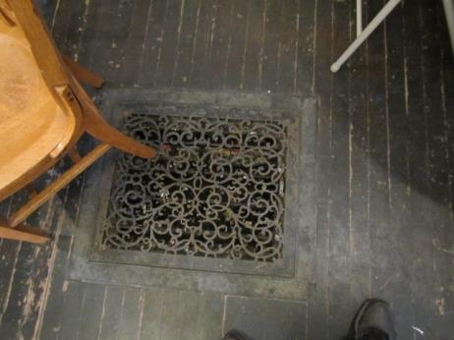

**Floor-mounted air supply**

**Picture 2**

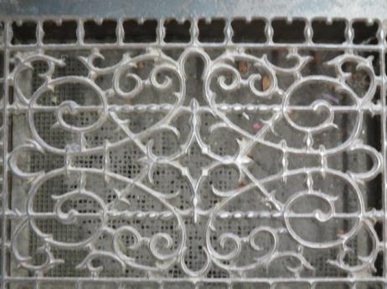

**Vent occluded with dust**

**Picture 3**

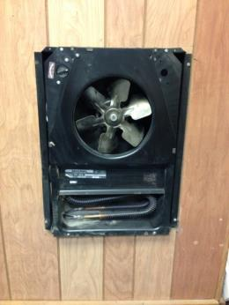

**Wall heater in basement**

**Picture 4**

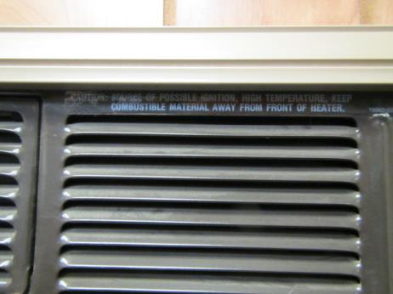

**Label on heater**

**Picture 5**

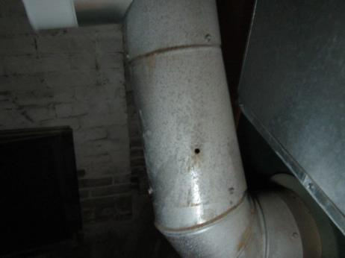

**Hole in the furnace flue**

**Picture 6**

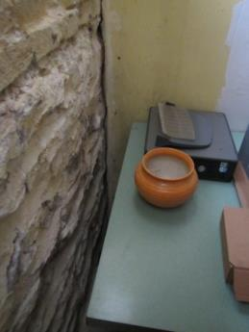

**Peeling paint and efflorescence in basement**

**Picture 7**

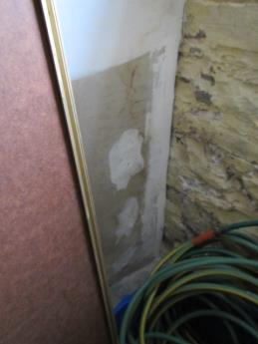

**Mold-colonized GW in basement**

**Picture 8**

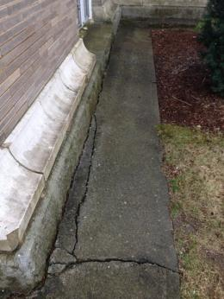

**Cracks and open seams in apron at base of the exterior wall**

**Picture 9**

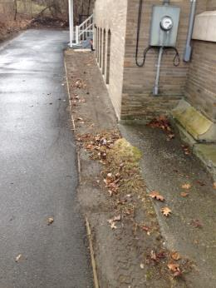

**Driveway with no curb**

**Picture 10**

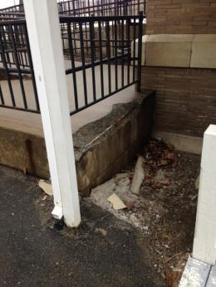

**Downspout that empties water towards building**

**Picture 11**

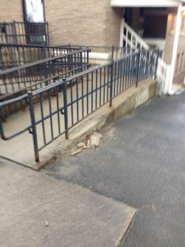

**Access Ramp**

**Picture 12**

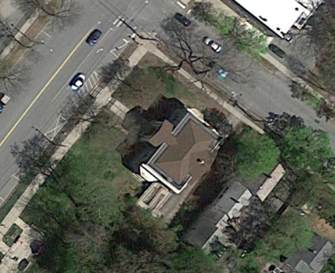

**Access ramp exposed soil (arrow)**

**Picture 13**

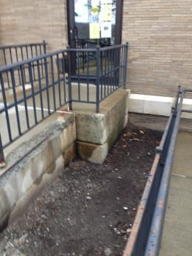

**Close-up of area shown in Picture 12**

**Picture 14**

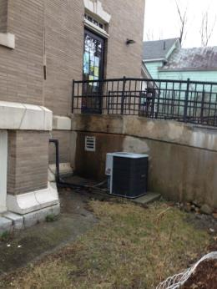

**Combustion air vent (arrow)**

| **Location** | **Carbon**  **Dioxide**  **(ppm)** | **Carbon Monoxide**  **(ppm)** | **Temp**  **(°F)** | **Relative**  **Humidity**  **(%)** | **PM2.5**  **(µg/m3)** | **Occupants**  **in Room** | **Windows**  **Openable** | **Ventilation** | | **Remarks** |
| --- | --- | --- | --- | --- | --- | --- | --- | --- | --- | --- |
| **Supply** | **Exhaust** |
| Background (outdoors) | 433 | ND | 47 | 48 |  |  |  |  |  |  |
| Basement office | 638 | ND | 68 | 37 | 6 | 2 | N | Y | N |  |
| Basement rear area | 348 | ND | 69 | 36 | 1 | 0 | N | Y | N |  |
| Book storage | 589 | ND | 66 | 37 | 1 | 0 | N | Y | N |  |
| Furnace room | 589 | ND | 64 | 37 | 2 | 0 | N | Y | N |  |
| Children’s | 829 | ND | 65 | 39 | 1 | 1 | Y | Y | N |  |
| Computers | 950 | ND | 69 | 36 | 1 | 1 | Y | Y | N |  |
| Reference | 820 | ND | 69 | 35 | 1 | 0 | Y | Y | Y |  |
| Main stack | 784 | ND | 69 | 34 | 6 | 1 | Y | Y | N |  |
| Card catalog | 858 | ND | 69 | 34 | 1 | 0 | N | N | N |  |
| Main desk | 852 | ND | 70 | 34 | 2 | 2 | Y | Y | Y |  |
| Museum | 605 | ND | 66 | 34 | 0 | 0 | Y | Y | N |  |