INDOOR AIR QUALITY ASSESSMENT
Sgt. William H. Carney Academy
247 Elm Street
New Bedford, MA
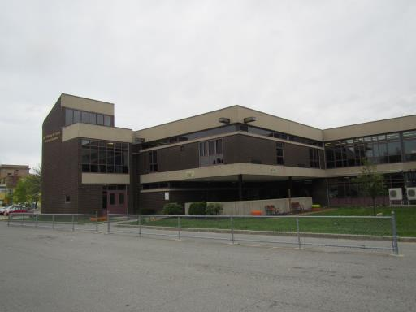
Prepared by:
Massachusetts Department of Public Health
Bureau of Environmental Health
Indoor Air Quality Program
May 2017

Background

Building: | Sgt. William Carney Memorial Academy
Address: | 247 Elm Street, New Bedford, MA
Assessment Coordinated Through: | Mary Freire Kellogg, City of New Bedford Health Department and Al Oliveira,  Director of Facilities Operations, New Bedford Public Schools
Reason for Request: | General indoor air quality (IAQ)  concerns
Date of Assessment: | May 5, 2017
Massachusetts Department of Public Health/Bureau of Environmental Health (MDPH/BEH) Staff Conducting Assessment: | Cory Holmes, Environmental Analyst and  Ruth Alfasso, Environmental Engineer, IAQ Program
Date of Building Construction: | 1977
Building Description: | Brick and concrete construction with complex shape
Building Population: | Approximately 530 students in grades K through 4 with a staff of approximately 80
Windows: | Openable

IAQ Testing Results
Please refer to the IAQ Manual for methods, sampling procedures, and interpretation of results (MDPH, 2015). The following is a summary of indoor air testing results (Table 1).
- Carbon dioxide levels were above 800 parts per million (ppm) in about half of the locations assessed, indicating that additional air exchange is warranted.
- Temperature was above the recommended range of 70°F to 78°F in many areas the day of assessment, with many complaints of excessive heat/lack of temperature control.
- Relative humidity was within or close to the recommended range of 40 to 60% in most areas the day of the assessment.
- Carbon monoxide levels were non-detectable in all indoor areas tested.
- Fine particulate matter (PM2.5) concentrations measured were below the NAAQS limit of 35 μg/m³ in all areas tested.

Ventilation
A heating, ventilating and air conditioning (HVAC) system has several functions. First it provides heating and, if equipped, cooling. Second, it is a source of fresh air. Finally, an HVAC system will dilute and remove normally occurring indoor environmental pollutants by not only introducing fresh air, but by filtering the airstream and ejecting stale air to the outdoors via exhaust ventilation. Even if an HVAC system is operating as designed, point sources of respiratory irritation may exist and cause symptoms in sensitive individuals.
Fresh air is provided by a combination of unit ventilators (univents) located in individual classrooms (Picture 1) and air handling units (AHUs), which serve central areas such as the gym, library and office areas. The unit ventilators draw fresh air through a vent on the exterior wall (Picture 2). Air is mixed with return air from the room, filtered, heated (if needed) and delivered back to the room (Figure 1). Air from the AHUs is filtered, heated or cooled as needed, and delivered to rooms via ducted supply vents (Picture 3).
Many univents were found turned off at the time of the assessment, and some that were on were found to be blowing hot air, even in rooms where the temperature was above 78°F. In addition, many univents were obstructed by items placed on top or furniture blocking the front (Picture 4). Both the top and the return vent at the bottom need to be kept clear of obstructions for the units to operate.
Exhaust vents are located on the ceilings of rooms supplied with air from the AHUs. Most classrooms had exhaust vents located along the floor (Pictures 5 and 6). Many exhaust vents were obstructed with items (Picture 6), and none were found to be drawing air. Additional exhaust vents are located in toilet rooms and other areas; many of these were also not functioning.
In order to have proper ventilation with a mechanical supply and exhaust system, these systems must be balanced to provide an adequate amount of fresh air while removing stale air from a room. It is recommended that existing ventilation systems be re-balanced every five years to ensure adequate air systems function (SMACNA, 1994). It is unknown the last time these systems were balanced.

Microbial/Moisture Concerns
Water-damaged ceiling tiles were observed in many classrooms and hallways (Pictures 7 and 8; Table 1), which indicate leaks from the building envelope or plumbing system. These tiles should be replaced after the leak is found and repaired. Some of the damage is occurring around the roof/exterior walls of the building, with some of the wall plaster and other materials also damaged (Picture 9). Repairs to the edges of the roof may be necessary to prevent water infiltration. The newly-installed windows in classrooms will likely help reduce the amount of water infiltration. Buckets were noted in the library (Picture 10) to catch water from active leaks from the greenhouse, which was undergoing window repairs/replacement at the time of assessment (Picture 11).
The building has a complex shape including four round structures that are silo-like stairwells. As shown in Pictures 12 and 13, the slanted portion of each silo roof drains directly against the building and onto the foundation. Over time, this has led to significant water damage inside each of the stairwells (Picture 14). While the building materials in the stairwells do not support microbial growth, any items or furnishings in the stairwell areas, which are used for storage and some instructional space, can become moistened. It may be possible to modify the drainage for the stairwell roofs to direct water away from the building exterior walls of the stairwells to prevent additional damage.
Plants were observed in a few areas (Picture 15; Table 1). Plants can be a source of pollen and mold, which can be respiratory irritants to some individuals. Plants should be properly maintained and equipped with drip pans and should be located away from air diffusers to prevent the aerosolization of dirt, pollen and mold.
Sinks were observed in a number of classrooms. Many of the sinks were labeled as out of order (Picture 16; Table 1) and some of them were dripping/running and could not be turned off. Leaking plumbing can be a source of moisture to classroom materials and the indoor environment, particularly when outdoor humidity is high. Some sinks examined also had porous items (paper, boxes) stored inside the sink cabinet, which is a moist environment.
A refrigerator in a staff breakroom had mold on the gaskets (Picture 17). Other refrigerators were observed in classrooms. Refrigerators should be cleaned out regularly to prevent odors and microbial growth. Gaskets should be cleaned with a mild antimicrobial solution; if they are too heavily stained to be cleaned, they should be replaced.
A variety of air conditioning units are used in classrooms, including portable air conditioners (Picture 18) and ceiling-mounted air conditioners (Picture 19). Air conditioners collect condensation that should be drained to prevent water damage and microbial growth. Condensation collection pans/vessels and drains should be inspected for leaks and clogs and cleaned periodically to prevent stagnant water and debris that can lead to odors and microbial growth.
Trees overhang the roof in some areas (Picture 12), which can lead to deterioration of the building envelope due to root infiltration and dampness against the exterior surface. Plants can also be a source of debris and pollen to air intakes and drains. Plants and trees should be trimmed away from the building and from overhanging the roof.

Construction/Renovation Issues
At the time of the visit, new windows had very recently been installed throughout the school. While these windows will improve access to fresh air, there were some concerns expressed regarding odors from sealants and other disruptions due to the project. Consult Appendix A “Methods Used to Reduce/Prevent Exposure to Construction/Renovation Generated Pollutants in Occupied Buildings” for more information on how to conduct renovation activities in an occupied building.

Other IAQ Evaluations
Exposure to low levels of total VOCs (TVOCs) may produce eye, nose, throat, and/or respiratory irritation in some sensitive individuals. To determine if VOCs were present, BEH/IAQ staff examined rooms for products containing VOCs. BEH/IAQ staff noted hand sanitizers, cleaners, air fresheners and dry erase materials in use within the building (Pictures 16 and 20; Table 1). All of these products have the potential to be irritants to the eyes, nose, throat, and respiratory system of sensitive individuals. Photocopiers and laminators were located in the teacher’s work room. Photocopiers can emit ozone and TVOCs, especially when they are older or heavily used, laminators give off waste-heat and plastic odors.
In a few classrooms, tennis balls were found sliced open and placed around chair legs to reduce noise (Picture 21). Tennis balls are made of a number of materials that are a source of respiratory irritants. Constant wearing of tennis balls can produce fibers and off-gas VOCs. Tennis balls are made with a natural rubber latex bladder, which becomes abraded when used as a chair leg pad. Use of tennis balls in this manner may introduce latex dust into the school environment. Some individuals are highly allergic to latex (e.g., spina bifida patients) (SBAA, 2001). It is recommended that the use of materials containing latex be limited to reduce the potential for symptoms in sensitive individuals (NIOSH, 1997). Latex-free glides should be used for this purpose. Note that in some classrooms, pieces of felt were tied around chair legs instead of tennis balls (Picture 22); these should be changed out when they get worn or soiled.
A univent was opened and the filter examined. It was determined to be a type that provides minimal filtration (Picture 23). Pleated filters Minimum Efficiency Reporting Value (MERV) of 8 which are adequate in filtering out pollen and mold spores (ASHRAE, 2012) would be useful. Note, however, that an increase in filtration can cause stress on equipment, which needs to be evaluated to determine if the higher-rated filters will allow adequate function. Filters are reported to be changed in both univents and the AHUs three to four times a year. Air conditioners in use in classrooms also have filters that need to be cleaned or changed regularly in accordance with manufacturer’s instructions to prevent the build-up of dust and debris.
Many classrooms had personal fans. Some of these had dusty blades (Picture 24; Table 1). Some supply and exhaust vents were also observed to be dusty (Picture 3, Table 1). This dust can be reaerosolized when the equipment is activated. In many areas, items, including books, papers, toys and decorative items were observed on floors, windowsills, tabletops, counters, bookcases, and desks (Pictures 1, 4 and 25; Table 1), which can make it more difficult for custodial staff to clean. In a few classrooms, items were hanging from the ceiling, which can collect dust (Picture 26). Disruption of the ceiling tile system, including hanging items and missing tiles (e.g., Pictures 8 and 10), can allow unconditioned air and debris from above the ceiling to enter occupied spaces.
Most classrooms had carpeting that appeared to be dated to the 1970s. In many areas, this carpeting was visibly very worn, frayed, wrinkled and stained (Pictures 27 and 28; Table 1). The service life of carpeting in schools is approximately 10-11 years (IICRC, 2002). Aging carpet can produce fibers that can be irritating to the respiratory system. In addition, tears or lifting carpet can create tripping hazards. It was reported by school officials that a carpet replacement program was in progress. Carpeting should be cleaned annually or semi-annually in soiled high traffic areas as per the recommendations of the Institute of Inspection, Cleaning and Restoration Certification (IICRC, 2012). Non-carpeted surfaces are recommended for most areas of schools.
Many classrooms had area rugs, which should also be cleaned regularly and discarded when too worn out or soiled to be cleaned. Plush and upholstered items such as couches, pillows, and toys were also found (Pictures 29 and 30) and should also be cleaned regularly to remove the build-up of oils and debris.
Missing/ajar light covers were seen in a few areas (Table 1; Picture 31). Fixtures should be equipped with access covers installed with bulbs fully secured in their sockets. Breakage of glass can cause injuries and may release mercury and/or other hazardous compounds.
Finally a chalkboard was noted installed over the univent in the classroom directly outside the greenhouse (Picture 32). This location can allow the accumulated chalk dust to become airborne by being directly in the stream of the univent fan. Chalk dust is an eye and respiratory irritant.
Note that the Environmental Protection Agency (EPA) conducted a National School Radon Survey in which it discovered nearly one in five schools had “…at least one frequently occupied ground contact room with short-term radon levels above 4 [picocuries per liter] pCi/L” (US EPA 1992). The BEH/IAQ Program therefore recommends that every school be tested for radon, and that this testing be conducted during the heating season while school is in session in a manner consistent with USEPA radon testing guidelines. Radon measurement specialists and other information can be found at www.nrsb.org and http://aarst-nrpp.com/wp, with additional information at: http://www.mass.gov/eohhs/gov/departments/dph/programs/environmental-health/exposure-topics/iaq/radon.

Conclusions/Recommendations
The following recommendations are made to assist in improving IAQ:
- Since renovation-generated pollutants can be a source of chemicals, dust, and other debris, it is highly recommended that guidance presented in “Methods Used to Reduce/Prevent Exposure to Construction/Renovation Generated Pollutants in Occupied Buildings” be used as part of any additional window replacement or other projects in the schools. This guidance is included as Appendix A.
- Operate all supply and exhaust ventilation equipment continuously during occupied periods.
- Use openable windows to supplement fresh air during temperate weather. Ensure all windows are tightly closed at the end of the day.
- Investigate/adjust thermostats and controls to allow for unheated air to be circulated in classrooms when the temperature is at or above the setpoint.
- Remove items and furniture blocking univents and exhaust vents.
- Repair all exhaust vents. Check exhaust vents for air draw periodically.
- Consider adopting a balancing schedule of every 5 years for all mechanical ventilation systems, as recommended by ventilation industrial standards (SMACNA, 1994).
- Ensure roof and plumbing leaks are repaired and replace water-damaged ceiling tiles.
- Consider repointing the exterior brick where water infiltration occurs, particularly in the area of the stairwells.
- Repair water-damaged building materials in classrooms, hallways and stairwell areas.
- Investigate whether drainage from the roofs of the stairwell areas can be improved to reduce water penetration through the walls, such as extending the scupper and installing a splash zone, or installing a gutter downspout.
- Avoid storage of any porous materials in the stairwells.
- Properly maintain plants, including drip pans, to prevent water damage to porous materials. Plants should also be located away from air diffusers to prevent the aerosolization of dirt, pollen, and mold.
- Repair sinks in classrooms, or turn off the water to prevent leaks. If sinks are unused temporarily, pour water down drains periodically to maintain the trap seal. Avoid dumping food or other materials apart from plain water into unused or seldom-used sinks to avoid odors.
- Sinks that are no longer to be used should be properly removed with the plumbing cut and capped.
- Refrain from storing porous items or large amounts of items under sinks.
- Ensure all refrigerators are kept clean to prevent microbial growth and odors. Clean gaskets and other surfaces with a mild antimicrobial solution to remove debris and mold.
- Ensure that condensation from air conditioning equipment is draining properly. Check collector pans, piping and any associated pumps for clogs and leaks and clean periodically to prevent stagnant water build-up and remove debris that may provide a medium for microbial growth.
- Trim back trees from overhanging the roof.
- Reduce use of products and equipment that create VOCs and ozone; only use in well-ventilated areas. Avoid the use of air freshening products including plug-ins and sprays.
- Ensure exhaust ventilation is operating in areas with photocopiers and laminators.
- Replace tennis balls on chair footings with latex-free glides. If felt is used as a glide, replace felt when it becomes worn or soiled.
- Consider upgrading to a pleated filter of MERV 8 in univents and AHUs, if these can be used with the current equipment. Continue to change filters 2-4 times a year.
- Regularly clean/vacuum univent cabinets, supply/return vents and fans to avoid aerosolizing accumulated particulate matter.
- For areas with very hard to reach vents, lights and ceiling tiles, consider coordinating use of a lift to address multiple issues at the same time.
- Avoid hanging items from the ceiling tile system. Ensure all tiles are flush with the ceiling tile system.
- Continue with plans to replace outdated carpeting past its useful life. Consider using non-carpet flooring in classroom areas.
- Clean carpeting and area rugs regularly and discard those that are worn out or too soiled to be cleaned.
- Clean upholstered and plush items regularly to remove oils, dust and debris.
- Consider reducing the amount of items stored in classrooms to make cleaning easier. Periodically move items to clean flat surfaces.
- Replace/repair fluorescent light covers and ensure fluorescent lights are fully secured to prevent breakage.
- Relocate chalkboard in greenhouse classroom away from the airstream of the univent.
- Encourage faculty to report classroom/building related issues via a tracking program.
- Continue to adopt the US EPA (2000) document, “Tools for Schools”, as an instrument for maintaining a good IAQ environment in the building available at: http://www.epa.gov/iaq/schools/index.html.
- The school should be tested for radon by a certified radon measurement specialist during the heating season when school is in session. Radon measurement specialists and other information can be found at: www.nrsb.org, and http://aarst-nrpp.com/wp/.
- Refer to resource manual and other related IAQ documents located on the MDPH’s website for further building-wide evaluations and advice on maintaining public buildings. These documents are available at: http://mass.gov/dph/iaq.

References
ASHRAE. 2012. American Society of Heating, Refrigeration and Air Conditioning Engineers (ASHRAE) Standard 52.2-2012 -- Method of Testing General Ventilation Air-Cleaning Devices for Removal Efficiency by Particle Size (ANSI Approved). 2012.
IICRC. 2002. Institute of Inspection, Cleaning and Restoration Certification. A Life-Cycle Cost Analysis for Floor Coverings in School Facilities.
IICRC. 2012. Institute of Inspection, Cleaning and Restoration Certification. Carpet Cleaning: FAQ. Retrieved from http://www.iicrc.org/consumers/care/carpet-cleaning.
MDPH. 2015. Massachusetts Department of Public Health. “Indoor Air Quality Manual: Chapters I-III”. Available at: http://www.mass.gov/eohhs/gov/departments/dph/programs/environmental-health/exposure-topics/iaq/iaq-manual/.
NIOSH. 1997. NIOSH Alert Preventing Allergic Reactions to Natural Rubber latex in the Workplace. National Institute for Occupational Safety and Health, Atlanta, GA.
SBAA. 2001. Latex In the Home And Community Updated Spring 2001. Spina Bifida Association of America, Washington, DC.
SMACNA. 1994. HVAC Systems Commissioning Manual. 1st ed. Sheet Metal and Air Conditioning Contractors’ National Association, Inc., Chantilly, VA.
US EPA. 1993. Radon Measurement in Schools, Revised Edition. Office of Air and Radiation, Office of Radiation and Indoor Air, Indoor Environments Division (6609J). EPA 402-R-92-014. https://www.epa.gov/sites/production/files/2014-08/documents/radon_measurement_in_schools.pdf
US EPA. 2000. Tools for Schools. Office of Air and Radiation, Office of Radiation and Indoor Air, Indoor Environments Division (6609J). EPA 402-K-95-001, Second Edition. http://www.epa.gov/iaq/schools/index.html.
Picture 1
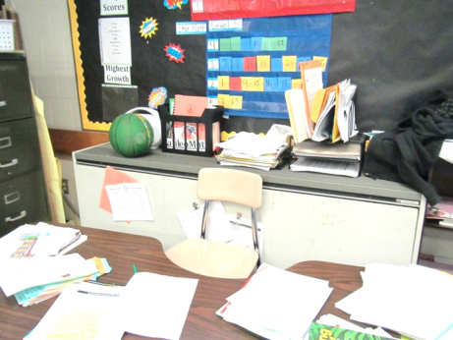
Unit ventilator (univent), note items on top and in front
Picture 2
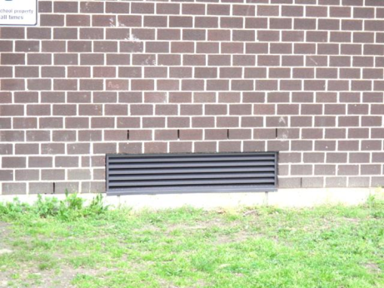
Univent air intake on outside wall
Picture 3
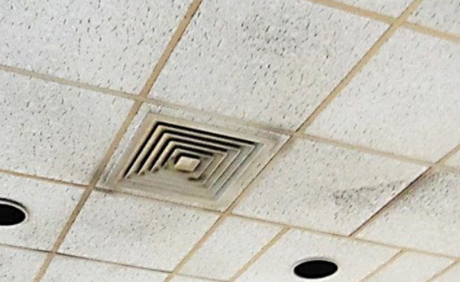
Supply vent from AHU to common area, note dust on vents and tiles
Picture 4
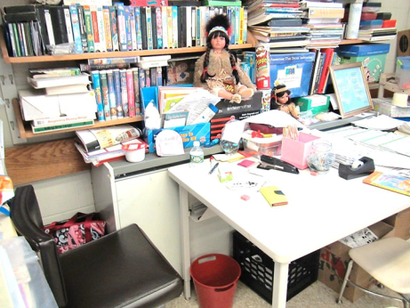
Univent obstructed with items and furniture
Picture 5
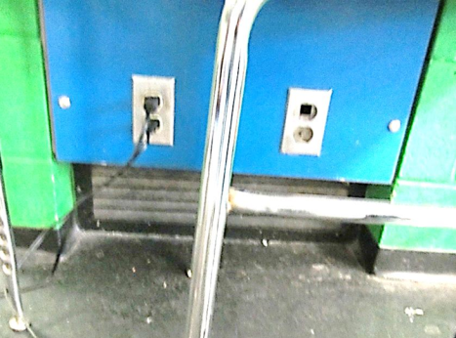
Classroom exhaust vent near floor
Picture 6
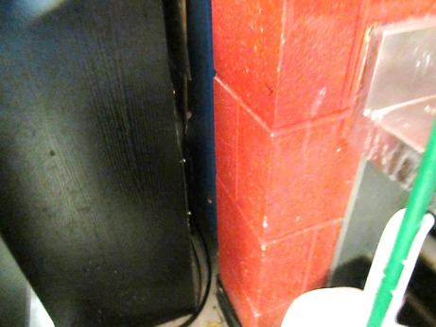
Wall-mounted exhaust vent (arrow) almost completely blocked by furniture
Picture 7
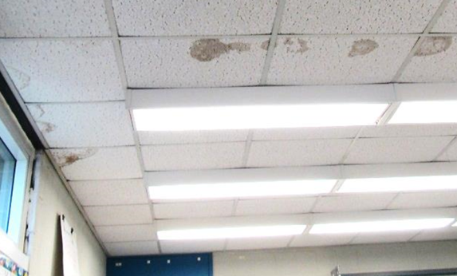
Water-damaged ceiling tiles
Picture 8
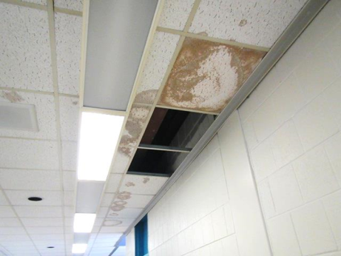
Water-damaged and missing ceiling tiles
Picture 9
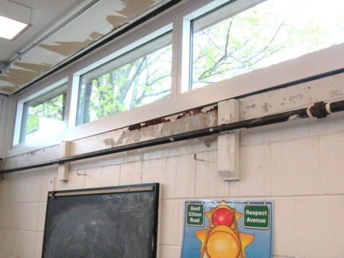
Water damage to wall and ceiling near windows
Picture 10
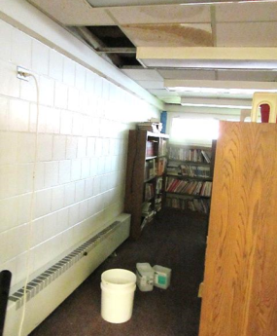
Buckets to catch active leaks from above greenhouse
Picture 11
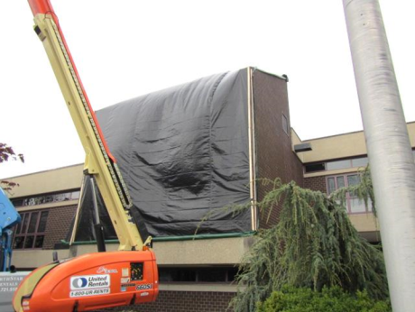
Greenhouse window repair/replacement project
Picture 12
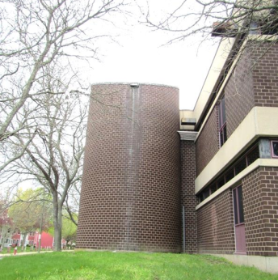
Edge of silo showing scupper drainage against the side of the building, also note overhanging trees
Picture 13
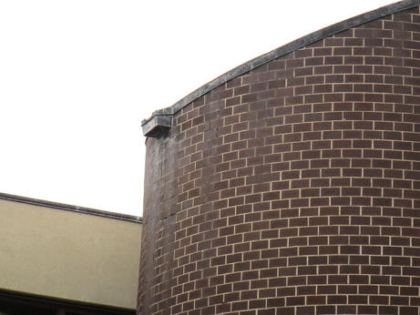
Closer view of the roof slant and drainage from the top of the silo
Picture 14
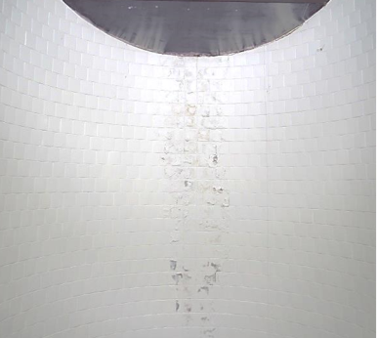
Silo interior showing water-damaged paint and efflorescence
Picture 15
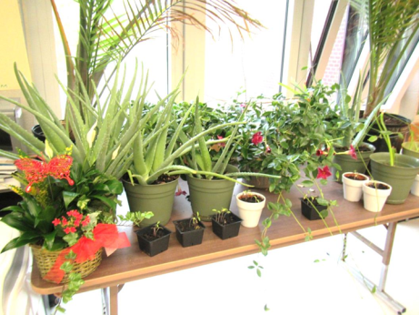
Plants in a classroom
Picture 16
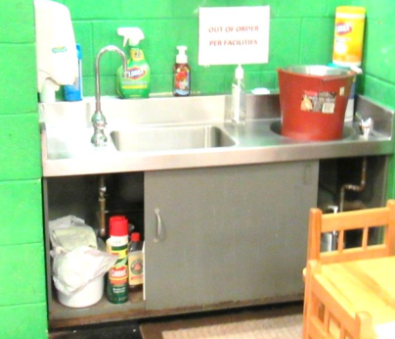
Sink out of order, note cleaning products and items stored underneath
Picture 17
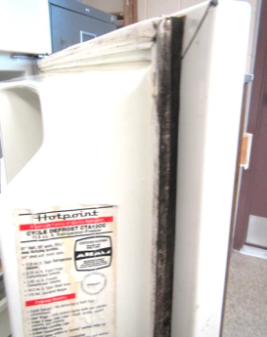
Mold-stained gasket in breakroom fridge
Picture 18
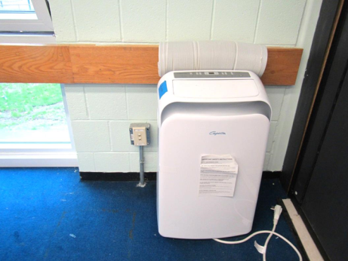
Portable air conditioner (not currently in use)
Picture 19
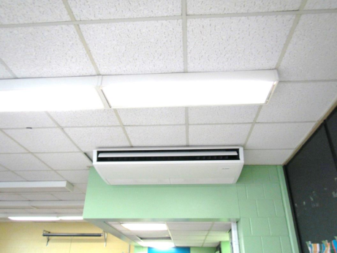
Ceiling-mounted air conditioner
Picture 20
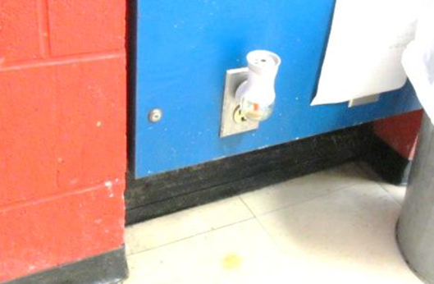
Plug-in air freshener
Picture 21
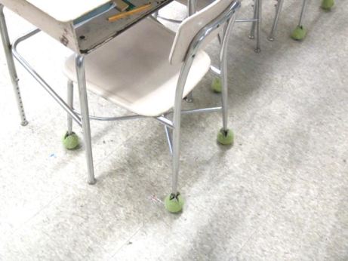
Tennis balls used as chair glides
Picture 22
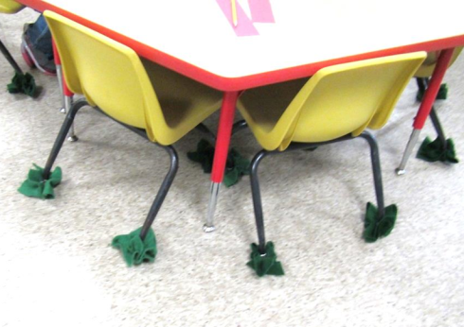
Felt used as chair glides
Picture 23
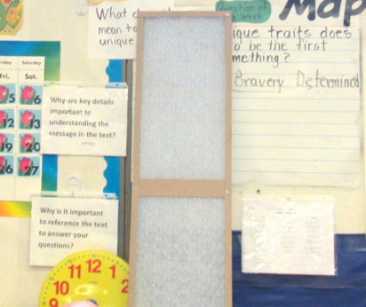
Mesh filter from univent
Picture 24
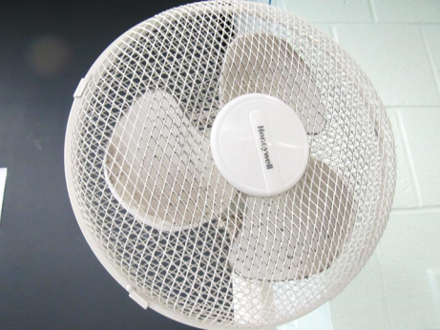
Dusty fan blades
Picture 25
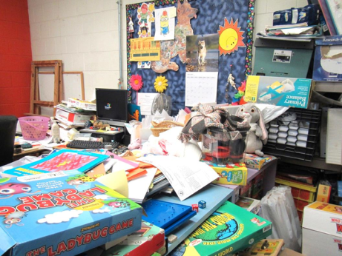
Classroom clutter
Picture 26
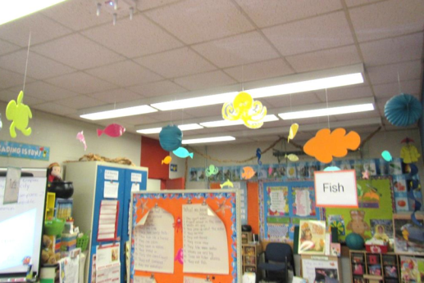
Items hanging from ceiling tile system
Picture 27
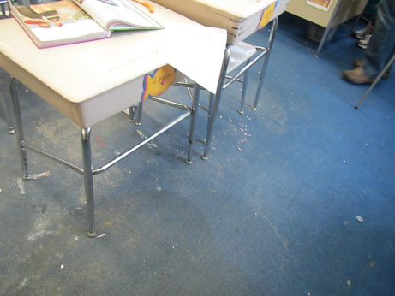
Worn carpeting with debris
Picture 28
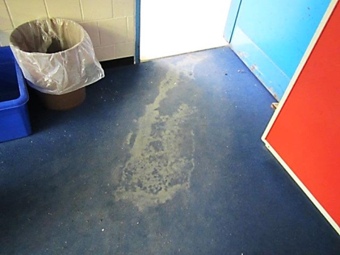
Severely worn carpeting
Picture 29
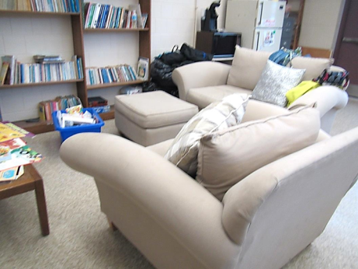
Upholstered items
Picture 30
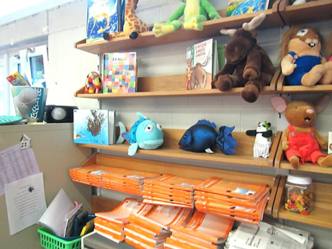
Plush toys
Picture 31
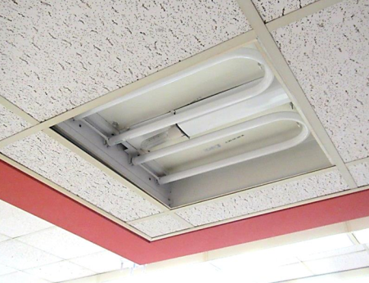
Missing fluorescent light cover
Picture 32
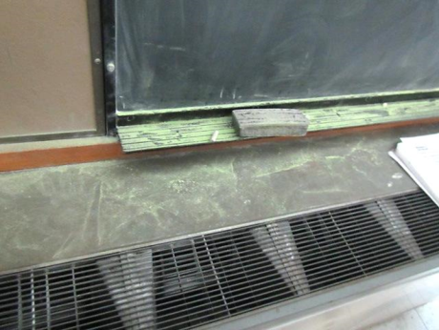
Chalkboard installed over univent
Location | Carbon  Dioxide  (ppm) | Carbon  Monoxide  (ppm) | Temp  (°F) | Relative  Humidity  (%) | PM2.5 (ug/m³) | Occupants  in Room | Windows  Openable | Ventilation |  | Remarks
Background | 428 | 1.3 | 58 | 43 | 7 |  |  |  |  | Windy and overcast
2nd Floor
A-201 | 793 | ND | 79 | 36 | 3 | 0 | Y | Y | Y | WD CTs along exterior wall
A-203 | 924 | ND | 81 | 36 | 5 | 16 | Y open | Y Off | Y Off | DO, items on UV, 4 WD CT
A-204 | 955 | ND | 79 | 38 | 4 | 29 | Y open | Y | Y | DO, 3 WD CT, PF
A-206 | 872 | ND | 81 | 37 | 4 | 24 | Y open | Y Off | Y | 2 WD CT, area rugs
Team Planning 3 | 749 | ND | 85 | 31 | 4 | 0 | N | Y | Y | Dust/debris on vents, 1 WD CT, PF
A-207 | 791 | ND | 82 | 32 | 4 | 24 | Y open | Y Off | Y | PF, items on UV, DO
A-211 | 561 | ND | 76 | 36 | 4 | 0 | Y open | Y | Y | WD concrete wall/rusted metal, 1 WD CT
Music Studio 1 | 584 | ND | 74 | 40 | 8 | 2 | Y open | Y Off | Y | Old/worn carpeting, 4 WD CT, PF-dusty
Greenhouse Classroom | 917 | ND | 79 | 39 | 4 | 14 | Y | Y  Off | Y | 8 WD CT, MT, chalkboard over UV
Art | 772 | ND | 80 | 37 | 3 | 23 | N | Y | Y | 7 WD CT, dust/debris-vents, PF (5)
A-228 | 1054 | ND | 76 | 46 | 8 | 20 | Y open | Y | Y | PF – on, sink, DEM, plants, TB, 4 WD CT
A-229 | 754 | ND | 80 | 37 | 10 | 0 | Y 3 open | Y obst. | Y obst. | Area rug, portable AC (off), fridge, PF on, DEM, sink, HS
A-232 | 787 | ND | 82 | 34 | 8 | 0 | N | Y | N | HS
A-233 | 916 | ND | 81 | 37 | 15 | 0 | Y 2 open | Y obst. | Y obst. | WD CT, very old carpet
A-235 | 961 | ND | 81 | 36 | 5 | 2 | Y  Open | Y  Off | Y  Off | Missing light cover, area rugs, 9 WD CT, CP, 26 occupants just left
A-236 | 814 | ND | 80 | 35 | 5 | 1 | Y 3 open | Y obst. | Y | NC, AC, sink (out of order), PF on
A-238 | 837 | ND | 80 | 36 | 10 | 1 | Y 2 open | Y | Y obst. | Worn carpet, WD CT, PS, DEM
A-section stairwell room | 771 | ND | 80 | 35 | 8 | 0 | N | Y | N | WD CT, WD plaster wall, AI
Gym, upper level |  |  |  |  |  | ~30 | N | Y
C-202 | 1529 | ND | 74 | 35 | 7 | 15 | Y | Y | Y | UV off, AC DEM, CP, fridge and microwave, sink, NC
C-203 | 1735 | ND | 73 | 48 | 8 | 6 | Y | Y | Y | Area rug, NC, sink marked “do not use”, sink leaking
C-204 | 1244 | ND | 74 | 38 | 6 | 0 | Y | Y UV on | Y off | Ceiling AC, NC, area rug
C-205 | 1395 | ND | 72 | 41 | 7 | 1, class just left | Y | Y UV on | Y off | Hot air from UV, reports of odors from window project – dissipated, old carpet, area rug
C-207 | 874 | ND | 72 | 43 | 7 | 12 | Y ajar | Y UV on | Y obst. | AC
C-208 | 1272 | ND | 73 | 44 | 9 | 8 | Y | Y UV Yon | Y | Subdivided, old carpet and area rug, AC
C-212 | 971 | ND | 76 | 40 | 8 | 0 | N | Y | Y off | PF, fridge
C-228 | 1487 | ND | 77 | 44 | 9 | 22 | Y open | Y off, obst | Y off
C-229 | 809 | ND | 76 | 39 | 9 | 23 | Y open | Y off | Y obst. | NC, HS, DEM, PF – dusty, portable AC
C-232 | 801 | ND | 79 | 35 | 10 | 20 | Y open | Y off, obst. | Y obst. | Sink, DEM, portable AC, old carpeting, WD wall and CT
C-233 | 1225 | ND | 80 | 37 | 7 | 12 | Y open | Y off | Y | Plants, CP, HS
C-234 | 775 | ND | 80 | 35 | 6 | 23 | Y open | Y off | Y | Portable AC
C-235 SPED | 701 | ND | 80 | 33 | 6 | 19 | Y open | Y UV off | Y off | DEM, PFs, old carpet, area rugs, books/items
2nd floor staff women’s restroom |  |  |  |  |  |  | N | N | Y off, dusty
2nd floor staff men’s restroom |  |  |  |  |  |  | N | N | Y off
Sensory room | 801 | ND | 78 | 35 | 8 | 0 | Y | Y | Y | Sink -- not working, rubber mats
1st Floor
Staff lunch | 650 | ND | 73 | 40 | 9 | 1 | Y + door | Y | Y | Food, WD CT and wall plaster, NC, upholstered items
Staff toilet |  |  |  |  |  |  | N | N | Y off
Nurse | 542 | ND | 78 | 37 | 4 | 3 | Y | Y | Y | 4 WD CT, WD walls, WD wooden cabinet
Career Awareness 2 | 482 | ND | 76 | 32 | 4 | 4 | Y | Y | Y | WD walls, dust/debris-vents, UV ceiling
C-106 | 969 | ND | 74 | 42 | 9 | 14 | Y + door | Y UV off | Y off | Area rug, felt on chair legs
C-106 Toilet room |  |  |  |  |  |  | N | N | Y off | No doors to toilet rooms
C-109 | 822 | ND | 74 | 40 | 8 | 15 | Y + door (open) | Y | Y | Area rug, DEM, CP, WD plaster, fridge, felt on chair legs
C-112 | 1050 | ND | 74 | 43 | 12 | 15 | Y + door | Y on | Y | TBs, area rug, toilet room exhaust off
C-112A | 1046 | ND | 75 | 41 | 8 | 2 | Y | N | Y
C-133 | 643 | ND | 75 | 36 | 3 | 5 | Y | Y | Y | Dust/debris-vents
Conference Room | 617 | ND | 77 | 38 | 3 | 0 | N | Y | Y | Damaged CT, MT, PF
Assistant Principal | 669 | ND | 78 | 37 | 4 | 0 | Y | Y | Y | Dust/debris-vents
Library | 723 | ND | 79 | 38 | 3 | 2 | Y | Y | Y | Active leak (below greenhouse) under repair, WD CTs, carpet squares
Main office | 706 | ND | 76 | 38 | 8 | 2 | Y | Y | Y | NC, PC
Special services (1) | 616 | ND | 77 |  | 8 | 1 | N | Y | N | NC, AF odor
Ms. Treadup | 522 | ND | 75 | 36 | 9 | 0 | Y open | Y | Y | Portable AC, DO, PF, NC, paper and items
Special services (2) | 607 | ND | 77 | 38 | 8 | 1 | N | Y | Y on | PF, NC
Special services (3) | 598 | ND | 78 | 36 | 8 | 0 | N | Y | Y on | HS, CP, PF
Library computer room | 729 | ND | 79 | 38 | 8 | 22 | Y open | Y |  | WD wall, WD CT, MT, computers, new carpet
Project Area 1 | 925 | ND | 81 | 37 | 5 | 3 | N | Y | Y | Excessively hot, dust/debris-vents
Project Area 2 | 785 | ND | 81 | 35 | 8 | 0 | N | Y | Y | PF, NC, DO
Team Planning 1 | 807 | ND | 79 | 37 | 5 | 3 | N | Y | Y | Dust/debris-vents, plug-in AF
A-101 | 931 | ND | 75 | 39 | 9 | Just left | Y open | Y on | Y | Old carpet and area rug, DEM
A-103 | 752 | ND | 77 | 39 | 5 | 23 | Y open | Y | Y | DO, 3 WD CT
A-104 | 905 | ND | 76 | 38 | 11 | 21 | Y | Y off | Y | WD CT, old carpet and area rug, DEM, pillows
A-106 | 619 | ND | 76 | 38 | 12 | 19 | Y open | Y | Y | DO, old/worn carpeting, WD walls
A-107 | 1097 | ND | 77 | 39 | 11 | 25 | Y open | Y obst. |  | Fridge and microwave, AI, WD CT and WD wall, old carpet and area rug
A-111 | 751 | ND | 78 | 34 | 10 | 19 | Y open | Y off | Y | Old carpet and area rug, DO
A-115 | 1159 | ND | 78 | 41 | 10 | 24 | Y | Y off | Y ceiling | WD wall, DO
First floor cafeteria | 1094 | ND | 77 | 48 | 12 | ~70 | Y and door | Y dusty | Y | NC
Ms. Medieros | 977 | ND | 81 | 43 | 9 | 1 | N | Y | Y | Area rug, PF on, DO
A-128 | 841 | ND | 79 | 37 | 9 | Just left | Y open | Y UV off | Y | Old carpet and area rug, plush items, items hanging from ceiling
A-129 | 748 | ND | 77 | 37 | 9 | 0 | Y open | Y UV off |  | Old carpet, WD CT and wall, sink - leaking, CP
A-133 | 724 | ND | 75 | 38 | 10 | 0 | Y open | Y UV off | Obst. | Area rug, PS
A-135 | 607 | ND | 78 | 37 | 6 | 1 | Y open | Y off | Y | 26 occupants gone~20 mins, items on UV, 1 WD CT
A-136 | 1569 | ND | 75 | 46 | 12 | 0 | Y | Y off | Y off | Portable AC, fridge and microwave, NC and area rug
A-138 | 763 | ND | 77 | 39 | 7 | 2 | Y | Y | Y | Area rug, TB, WD walls, items on/front UV, PF, DO, 25 occupants gone~20 mins
Conference 1 | 772 | ND | 80 | 40 | 6 | 0 | N | Y | Y | PF, TB
Conference 2 | 977 | ND | 83 | 38 | 16 | 1 | N | Y | Y | PF-dusty, dust/debris-vents, DO
Team Planning 2 | 898 | ND | 81 | 35 | 6 | 1 | N | Y | Y | DO, dust/debris - vents/CTs
Hallway |  |  |  |  |  |  |  |  |  | Missing light covers

