COMMONWEALTH OF MASSACHUSETTS

SUFFOLK COUNTY BOARD OF REGISTRATION IN PHARMACY

)
In the Matter of )
CAROLINE S. DAWSON )
PH-PT Registration No. 10758 )
(Reg. Expires 2/26/2012) )
_
)

Docket No. PHA-2011-0333

FINAL DECISION AND ORDER BY DEFAULT

On April 5, 2012, the Board of Registration in Pharmacy ("Board") issued and duly served on Caroline S. Dawson, ("Respondent") an Order to Show Cause ("Show Cau;e Order")1 related to a complaint filed regarding Respondent's pharmacy technician registration. On June 25, 2012, the Board issued and duly served on Respondent another OTSC at an additional address (83 Fairwood Drive, Pembroke, MA 02359). In addition to stating the allegations against Respondent, the Show Cause Order notified Respondent that an Answer to the Show Cause Order ("Answer") was to be submitted within 21 days of receipt of the Show Cause Order2. The Show Cause Order also notified Respondent of
the right to request a hearing on the allegations3, and that any hearing request (" Request
for Hearing") was to be submitted within 21 days ofreceipt of the Show Cause Order.4 Respondent was further notified that failure to submit an Answer within 21 days "shall result in the entry of default in the captioned matter" and, if defaulted, "the Board may enter a Final Decision and Order that assumes the truth of the allegations in the Show Cause Order and may revoke, suspend, or take other disciplinary action against Respondent's pharmacy registration . . .including any right to renew his license."
The Show Cause Order was delivered by first class and certified mail by the United States Postal Service to the Respondent's address ofr ecord . The first class mail was not returned. The certified mail was returned as by the United States Postal Service

1 Pursuant to 801 CMR 1.01(6)(a).
2 In accordance with 801 CMR 1.01(6)(d)(2).
3 Pursuant to M.G.L. c. 112, § 61.
4 Respondent was also notified that failure to timely submit a Request for Hearing would constitute a waiver of the right to a hearing.

As of the date of this Final Decision and Order by Default, Respondent has failed to file either an Answer or a Request for Hearing.

The Board has afforded Respondent an opportunity for a full and fair hearing on the allegations in the Show Cause Order as required by M.G.L. c. 30A, s. 10, and sufficient notice of the issues involved to afford Respondent reasonable opportunity to prepare and present evidence and argument as required by M.G.L. c. 30A, s. 11(1). The Board has also notified Respondent of the obligation under 801 CMR 1.01(6)(d) to file an Answer to the Show Cause Order within 21 days of its receipt and of the consequences of failing to file an Answer or otherwise respond.

As authorized by M.G.L. c. 30A, s. 10(2), the Board may make informal disposition of any adjudicatory proceeding by default. Upon default, the allegations of the complaint against Respondent are accepted as true. Danca Corp. v. Raytheon Co., 28 Mass. App. Ct. 942, 943 (1990).

Based on the foregoing, the Board enters a default in the above-captioned matter and, consequently, the allegations in the Order to Show Cause are deemed to be true and Respondent has waived the right to be heard. In accordance with the Board's authority and statutory mandate, the Board orders as follows:

O-n October 9, 2012, in accordance with the Board's authority and statutory mandate, the Board voted to issue this Final Decision and Order by Default and
RE VOKE any right Respondent may have to renew Pharmacy Technician registration No. 7241 (expiration 02/09/2013; suspended May 14, 2011), by the following vote, effective as of the date issued: In favor: George A. Cayer, R.Ph.; Stanley B. Walczyk,
R.Ph.; Karen M. . Ryle, R.Ph.; Donald D. Accetta, M.D.; Anita Young, R.Ph.; and Kathy
J. Fabiszewski, N.P., Ph.D. Opposed: None. Recused: James T. DeVita, R.Ph. Absent: .· Absent: Joanne M. Trifone, R.Ph.; Sophia Pasedis, R.Ph., Pharrn.D. and Steven Budish.
management or other interest or involvement in any pharmacy related business in any setting. If at any time in the future Respondent seeks registration by the Board, Respondent will be required to meet all current requirements for licensure at the time of any such application, including, but not limited to, re-application, re-examination, re training and moral character qualifications (including consideration of any convictions or unlawful activity) and any other reinstatement terms and conditions the Board may deem to be necessary and appropriate. Respondent is hereby advised that the Board does not envision any terms or conditions pursuant to which the Board would consider Respondent to be qualified for licensure as a pharmacy technician in the Commonwealth in the future.

EFFECTIVE DATE OF.ORDER

The Order of the Board shall be effective as of October 9, 2012.

Respondent is hereby notified of the right to appeal this Final Decision and Order by Default to the Supreme Judicial Court, pursuant to G.L. c. 112, § 64 and G.L.
c. 30A, §§ 14 and 15, within thirty days of receipt of notice of this Final Decision and
. Order by Default.

Board Decision No. 2693 Attachnient
1BOA:RD:OF:RE,GIS:TRAvTION
President
Effective Date: October 9, 2012

First Class and Certified Mail No. 7012 0470 0001 3526 9326

3

.·.;·: ··:··.: .
....

..·_
.\ :-:

COMMONWEALTH OF MASSACHUSEITS . .·..·
•, ; :.
SUFFOLK COUNTY BOARD OF REGISTRATION IN PHARMACY

)
In the Matter of )
CAROLINE S. DAWSON )
PH-PT Registration No. 10758 )
_(Re_g. _Exp_ire_s 2_/26_/20_12)____ )
)

Docket No. PHA-2011-0333 ·

•. . .. ..
.··:·..·.-) <·.:
..
·.:· , .

.: i



• •
ORDER TO SHOW CAUSE ..!·.. ,:
! .
I •
Caroline S. Dawson (hereinafter "you" or "Respondent"), you. are hereby ord ed.. _:···i>L:·
to appear and show cause why the Massachusetts Board of Registration in Pharmacy . , (''Board") should not suspend, revoke or otherwise talce action against your pharmacy 1
technician registration, Registration No. 10758, or your right t·o renew such registration, pursuant to Massachusetts General Laws (G. L.) Chapter 112, §§ 42A and 61 and Board regulations 247 CMR 2.00 et seq. based upon the following facts and allegations:

- On or about March 4, 2009, the Board issued you a pharmacy technician registration, Registration No. 10758.

- On or about January 10, 2012, the Board issued a Temporary Order of Summary Suspension of your Registration. You failed to timely request a hearing on the necessity of a continuance of the Temporary Order of Summar·y Suspension and a Final Order of Summary Suspension was issued on or.about January 18, 2012. . Your Registration remains suspended.

- While employed as a pharmacy technician at Stop and Shop Pharmacy#469 located at 129 Samoset Street in Plymouth, Massachusetts, you diverted numerous controlled substances on diverse dates. ·

- You admitted to diverting the controlled substances to Stop and Shop Pharmacy representatives and the Plymouth Police on or about December 9, 2011.

- Your conduct as alleged above warrants disciplinary action by the Board against your pharmacy technician registration pursuant to G. L. c. 112, §§ 42A and 61, and 247 CMR 2.00 -, for deceit, malpractice, gross misconduct in the practice of the profession, and offenses against the laws of the Commonwealth relating thereto.

- Your conduct as described above constitutes failure to conduct professional activities in conformity with federal, state and municipal laws, ordinances and/or regulations, of the Board and therefore warrant disciplinary action by the Board

pursuant to M.G.L. c. 112, §§ 27, 28, and 42A, M.G.L. c. 94C, and 247 CMR 2.00 -, and 10.03 (l)(a), (b), _(e), (h), (I), (k), (r), (u), (v), and (x).

- 7. Your conduct as described above also constitutes unprofessional conduct and cond ct which undermines public confidence ill the integrity of the pharmacy
. .
"•··. ···-·--· -

  - profession. Sugarman v. Board of Registration in Medicine, 422 Mass. 338, 342

.
... . . .

(1996); see also, Kvitka, v. Board of Registration in Medicine, 407 Mass. 140,"?ert_. :_: .::
:·:·_
denied, 498 U.S. 823 (1990); Raymond v. Board of Registration in Medicine, 38T / ·. _:':· Mass. 708, 713 (1982). : '. ·:.. : .
r·i.,;:
··..• j·:.
::; | >
...

. . ....

You have a right to an adjudicatory hearing ("hearing'') on the allegations contained .in th e Order to Show Cause before the Board acts to suspend, revoke, or ·
.- ... :

. ::

impose other discipline against your registration. G.L. c. 112, §§ 42A and 61. Your right· to a hearing may be claimed by submitting a written request for a hearing within twenty- '
one (21) days of receipt of this Order to Show Cause. You must also submit an Answer:.;,_-. ; ; . to this Order to Show Cause in accordance with 801 CMR 1.01(6)(d) within twenty-on·e· -;·..-:: ,({ .·..
(21) days of receipt of this Order to Show Cause. The Board will give you prior written .. ·:; ...
notice of the time and place of the hearing following receipt of a written request for a . :·. hearing.

Hearings shall be conducted in accordance with the State Administrative Procedure Act, G.L. c. 30A, §§ 10 and 11, and the Standc1Id_ Adjudicatory Rules of Practice and Procedµre, 801 qvfR 1.01 and 1.03, unde· r which you are granted certain· . .. 'rights including, but not limited to, the rights: to a hearing, to secure legal counsel or

.-,

another representative to represent your.interests, to call and examine witnesses, to cross- · examine witnesses who testify against you, to testify on your own behalf, to introduce· evidence, and to make arguments in support of your position.

The Board will make an audio recording of any hearing conducted in the captioned matter. In the event that you wish to appeal a final decision of the Board, it is incumbent on you to supply a reviewing court with a"proper record" of the proceeding, which inay include a written transcript. New Bedford Gas and Light Co. v. Board of
Assessors of Dartmouth, 368 Mass. 745, 749-750 (1975). Upon request, the Boar<;]. wilt make available a copy of the audio recording of the proceeding at-your own expense. ·.
Pursuant to 801 CMR 1.01.(10) (i)(l), upon motion, you "maybe allowed to provide a
public stenographer to transcribe the proceedings at [your] own expense upon terms · ordered by the Presiding Officer." Those terms may include a requirement that any cripy of the transcript produced must be sent promptly upon completion and on an ongoing basis directly to the Presiding Officer by the stenographer or transcription service. The transcript will be made available to the Prosecutor representing the Board. Please note that the administrative record of the proceedings, including but not limited to, the written transcript of the hearing is a public record and subject to the provisions of G.L. c. 4, § 7 and G. L. c. 66, § 10.

Yqur failure to submit a written request for ahe g within twenty-one (21) days of receipt of this Order to Show Cause shall constitute a waiver of the right to a hearing on the allegations herein and on any Board disciplinary action. Your failure to submit an Answer to the Order to Show Cause within twenty-one (21/days of receipt of the Order to Show Cause shall result in the entry of defau(t in the captioned matter.

2

. j,·.
: ;. ,
. i·

: !
. i' ::·
.
i: ;.-
.

Notwithstanding the earlier filing of an Answer and/or request for a hearing your failure to appear for any scheduled status conference, pre-hearing conference · or hearing dates, or failure to otherwise defend this action shall result in the entry of default.
If yo1{. :1a:re·defaulted; the Board may" enter a Fin."al Decision and Order that assume.s....:.. ,.

,.
i •
; !

, !..

the truth of the alleg tions in this Order to Show Cause, an_d may revoke, suspend, or alee ..:, other disciplinary action against your registration to practice as pharmacy technician iI?- · :
;
the Commonwealth of Massachusetts, including any riglit to renew your registration. :_: . i.: . .
. . ;, .. ::···: \.
Your Answer to the Order to Show Cause and your written request for a hearing : ·: ·
:/
'-:_:.
m t b fil e. d with Jam.es G. Lavery, Chief Board Prosecutor at the following add;ess./ . : ::·... ) ! .?
I • ,'

James G. Lavery · Chief Board Prosecutor
Department of Public Health
· Office of the General Counsel
. 239 Causeway Street, Fourth Floor Boston, MA 02114
, :

You or your representative may examine Board records relative to this case prior to· the date of the hearing during regular business hours at the office of the Chief Board Prosecutor. If you elect to undertake such an examination, then please contact Prosecuting Counsel in advance at (617) 973-0822 to schedule a time that is mutually·: convenient.
_

. i
:-:

Dated: June 5, 2012
2
' . :
Board of Registration 4i Pharmacy, Michael J. Tocco, R.PH, President

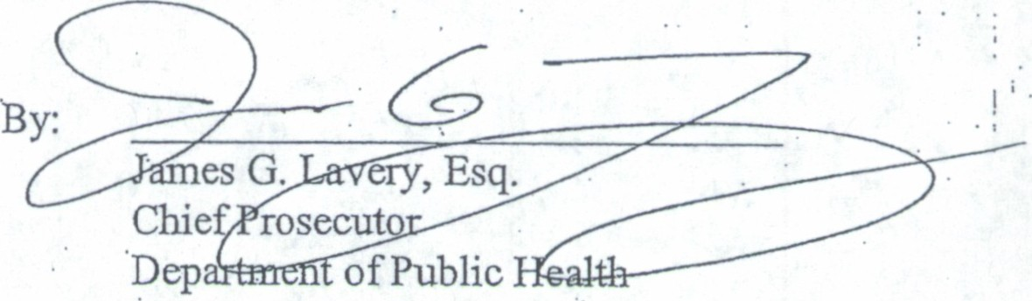

3 . .!

CERTIFICATE OF SERVICE

I, James G. Lavery, hereby certify that a copy of the foregoing Cover Letter,
- o rder to Show Cause and Certificate of Service were served upon the Respondent:


Caroline S. Dawson

by first class mail, postage prepaid, and by Certified Mail# 7011 1570 0000 8180 3411;

by first cla.ss mail, this 25th day of June 2012. ·

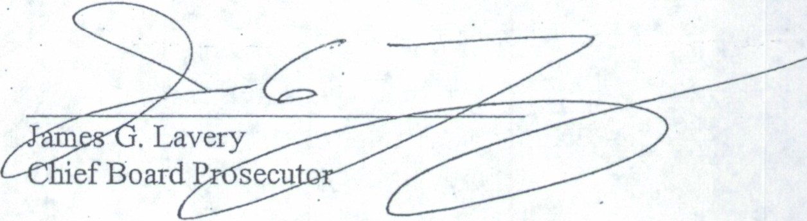

1

