Municipal Vulnerability Preparedness Program Action Grant Case Study
Municipality: Town of Athol, Massachusetts
Project Title: Greening Lord Pond Plaza Climate Resilience Action Plan
Award Year (FY): FY21
Grant Award: $117,760
Match: $40,625
Match Source: Time
One or Two Year Project: One-Year Project
Municipal Department Leading Project: Athol Planning and Economic Development
Project Website URL: https://lordpondplaza.wordpress.com/
Community Overview:
- What is the population size of your community and where is it located?
- Do you have any Environmental Justice or other Climate Vulnerable communities? (Think about both those who live and work in your town.)
- Other unique traits of your municipality like who the top employers are, geography, history, etc.
The town of Athol, originally settled in 1730s as Pequoiag, is currently home to 12,000 residents. Situated approximately 70 miles west of Boston, Athol is a former industrial “mill town” along the Route 2 corridor, bordered by Phillipston, Petersham, New Salem, Orange, and Royalston. Athol’s history as a mill town is characterized by its proximity to the Millers River which meanders through the town in an east to west direction where it ultimately flows to the Quabbin Reservoir. Factories powered by the Millers River through the mid and late-19th century established Athol’s legacy as “Tool Town” by supporting numerous high-precision tool manufacturing, notably L.S. Starrett Company, which remains the town’s largest local employer.
Project Description and Goals:
- Where was the project located?
- What climate change impacts did the project address?
- What were the specific goals and tasks of the project as stated in your application?
- Did your project meet the goals set forth in your application in terms of:
  - Employing nature-based solutions
  - Improving equitable outcomes for and fostering strong partnerships with EJ and other Climate Vulnerable Populations
  - Providing regional benefits
  - Implementing the public involvement and community engagement plan set forth in your application
  - Finishing the project on time
The Greening Lord Pond Plaza project is located at Lord Pond Plaza in downtown Athol bounded by Main Street, Exchange Street, South Street, and Freedom Street. The plaza is characterized by paved parking area that support a combination of publicly and privately-owned entities including retain shopping, dining, historical mill buildings, the Athol Senior Center, and other various business types. Lord Pond Plaza was identified as a key source of climate vulnerability in the community during previous climate resilience planning initiatives in Athol. The goal of the project is to redevelop Lord Pond Plaza in a manner that addresses two key sources of climate exposure: extreme temperatures/urban heat island effect, and inland/urban flooding due to extreme precipitation events. The effects of urban heat island effect and inland flooding present significant social, economic, and environmental vulnerability for the Town of Athol.
As described within Athol’s climate resilience planning initiatives occurring from 2019-2020, the community identified Lord Pond Plaza as an important community feature that must become climate resilient to support future community prosperity. This is particularly true for socially vulnerable/climate vulnerable groups within the community that include environmental justice populations, low-income elderly populations, and teens/transition age youth. The use of nature-based solutions/green infrastructure, notably the daylighting of a buried stream channel that flows beneath the plaza, serves as an important approach to achieve project goals. Project stakeholders collaborated to identify solutions to enhance the climate resilience of Lord Pond Plaza while simultaneously promoting co-benefits to the community through measures such as public recreation/gathering space, improving vehicular and pedestrian safety, and supporting existing and future business use.
A key project feature was to conduct robust community engagement that drew upon previous climate resilience planning in Athol. The goal of this project’s engagement approach was to inform the development of conceptual design alternatives and a preferred concept design that may be advanced to construction in future project phases. Abutter meetings, public site walk and informational meetings, presentations to the Athol Board of Selectmen and Planning Board, a mural competition, and a project website used to communicate information and conduct community surveys served as the engagement methodology for the project. As a key project partner, the North Quabbin Community Coalition expanded the visibility of this project within the North Quabbin region leading to a successful project outcome.
Results and Deliverables:
- Describe, and quantify (where possible) project results (e.g. square footage of habitat restored or created, increase in tree canopy coverage, etc.). Report out on the metrics outlined in your application.
- Provide a brief summary of project deliverables with web links, if available.
The Greening Lord Pond Plaza project resulted in the development of a preferred concept plan and Climate Resilience Action Plan that the community may use to advance its climate resilience goals in downtown Athol. Aligned with community goals for social resilience, the Greening Lord Pond Plaza Climate Resilience Action Plan was informed by community engagement occurring as part of Athol’s climate resilience planning initiatives from 2019-2021. The preferred concept alternative results in a significant reduction of impervious surface at the plaza, the restoration of Mill Brook through daylighting and improved vehicular and pedestrian safety, achieved through nature-based solutions. A summary of project materials including the concepts developed for this project and the Greening Lord Pond Plaza Climate Resilience Action Plan report are provided on the project website: https://lordpondplaza.wordpress.com/
Lessons Learned:
- What lessons were learned as a result of the project? Focus on both the technical matter of the project and process-oriented lessons learned.
- What is the best way for other communities to learn from your project/process?
Lessons learned from the project are related to the intense interest from the community for this project outcome. As with any redevelopment project, stakeholders from the community bring differing opinions of what Lord Pond Plaza should ultimately look like. Maintaining a consistent and robust engagement strategy where interested stakeholders consider themselves heard as part of the process is important. While not every design recommendation made by stakeholders is feasible, the interests of stakeholders have been applied where possible. Using engagement to inform evaluation frameworks such as the one developed for this project, helps to promote a more inclusive project outcome.
Partners and Other Support:
- Include a list of all project partners and describe their role in supporting/assisting in the project.
The North Quabbin Community Coalition was an important partner on this project. In addition to drawing upon its vast network within the North Quabbin region to advertise project related events and information, the coalition also organized and ran the mural competition.
Project Photos:
- In your electronic submission of this report, please attach (as .jpg or .png) a few high-resolution (at least 300 pixels per inch) representative photos of the project. Photos should not show persons who can be easily identified, and avoid inclusion of any copyrighted, trademarked, or branded logos in the images. MVP may use these images on its website or other promotional purposes, so please also let us know if there is someone who should receive credit for taking the photo.

Winning Mural Submission
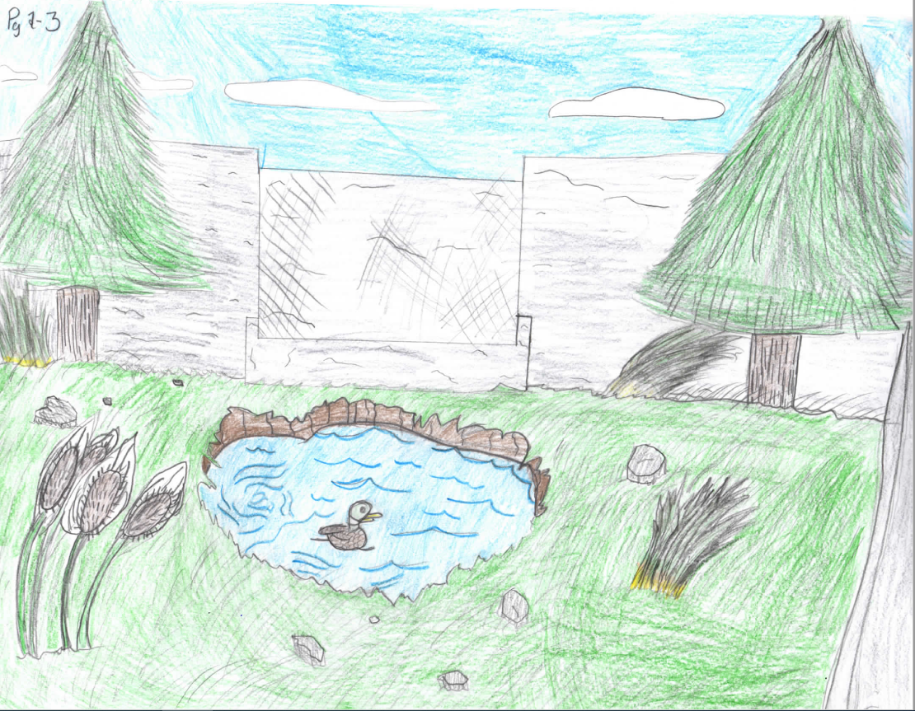

Community Site Walk
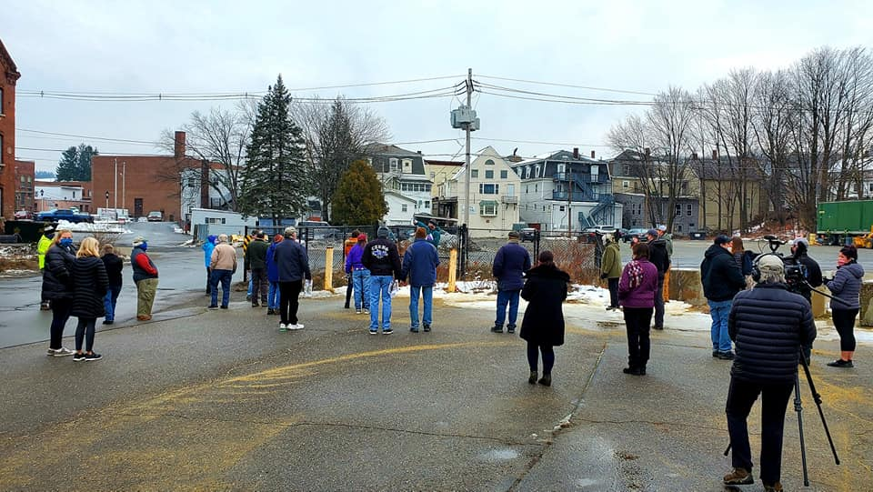

Preferred Concept Plan