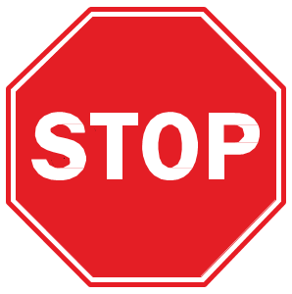

**General PPE Precautions**

**Unit With COVID Cases**

**in the Last 14 Days**

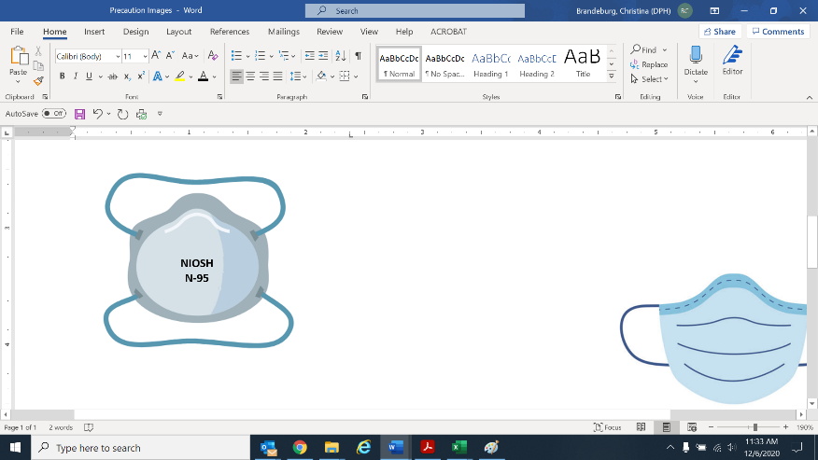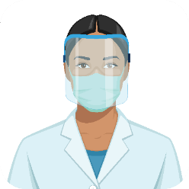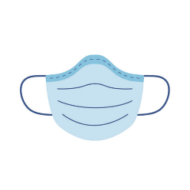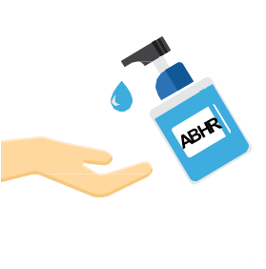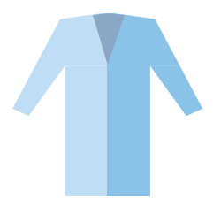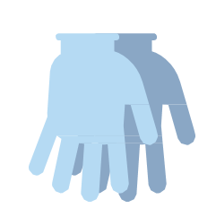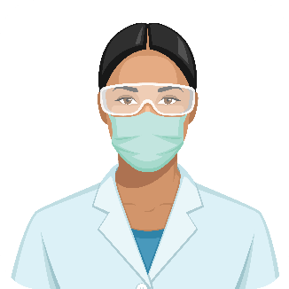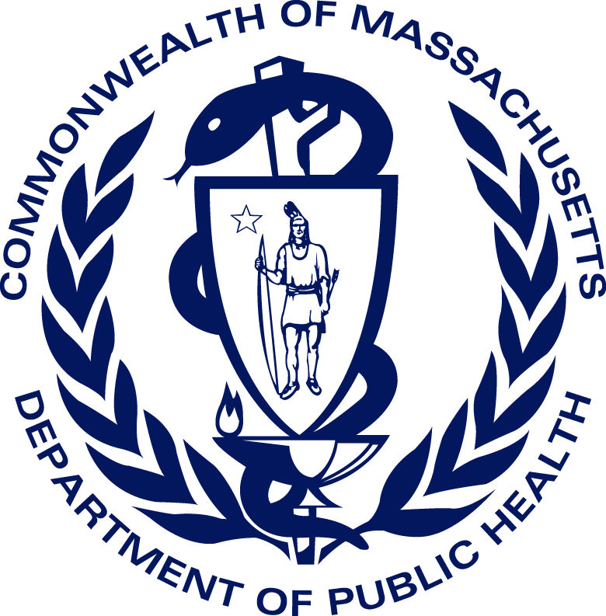

*Examples of high-contact resident care activities:

* Dressing
* Bathing/showering
* Transferring
* Providing hygiene
* Changing linens
* Changing briefs or assisting with toileting
* Device care or use: central line, urinary catheter, feeding tube, tracheostomy/ventilator
* Wound care: any skin opening requiring a dressing

Updated: 6/17/2021

N-95 for aerosol-generating procedures

**✓**

**✓**

**✓**

**High-Contact Care\***

**✓**

**Eye protection**

(goggles or face shield)

**Mask**

**Gloves -** Change between each resident

**Clean hands:** when entering & exiting

**Gown -** Change between each resident