Community Behavioral Health Promotion and Prevention Commission

Kate Ginnis, MSW, MPH, MS
Senior Director of Child, Youth, and Family Policy and Programs MassHealth
June 10, 2021
3:00-5:00 pm
WebEx

Agenda

- Welcome and Introductions
- Approval of 4/8 Meeting Minutes
- Agency Updates
- Commission Priorities and Next Steps

Summary of Behavioral Health Promotion and Upstream Prevention Commission’s

Recommendations

  - Infuse Prevention, Promotion, and Results First Science into State Government

  - Innovate to Fund Promotion and Prevention

  - Building Prevention Infrastructure

  - Investing in What Works: Evidence-based Prevention and Promotion
Programming and Systems

  - Prevention Workforce: Supporting Caregivers and Integrating Behavioral Health

  - Promoting Behavioral Health in Schools

PROMOTION
Case
Indicated
Standard
Treatment for Known Disorders
Universal
Compliance
with Long-Term Treatment
(Including

Source: Adapted from: Institute of Medicine. (1994). Reducing risks for mental disorders: Frontiers for preventive intervention research. Washington, DC: National Academy Press.

Commission is focused here

PROMOTION

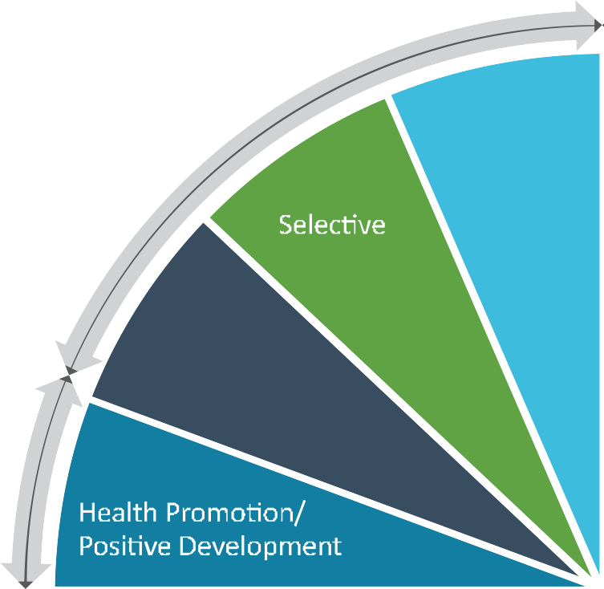Source: Adapted from: Institute of Medicine. (1994). Reducing risks for mental disorders: Frontiers for preventive intervention research. Washington, DC: National Academy Press.
PROM
Indicated
Universal

Confirmed 2021 Meeting Schedule

Date | Time | Location
August 12, 2021 | 3:00-5:00 pm | TBD
October 14, 2021 | 3:00-5:00 pm | TBD
December 9, 2021 | 3:00-5:00 pm | TBD
February 10, 2022 | 3:00-5:00 pm | TBD
March 1, 2022 – Submission of Annual Report to the Legislature

Appendix: Promote-Prevent Commission Recommendations
Expanded Summary of Behavioral Health Promotion and Upstream Prevention
Commission’s Recommendations
- Infuse Prevention, Promotion, and Results First Science into State Government
  - Employ data driven decision-making in the Legislature and State Agencies
  - Establish a permanent Promote Prevent Commission
  - Adopt standardized concepts for evidence-based decision making
- Innovate to Fund Promotion and Prevention
  - Establish public-private partnerships at the state and local-level
  - Direct revenues from the sale of cannabis to fund community-based prevention
  - Establish a Behavioral Health Promotion, Prevention, and Early Intervention Trust Fund (BeHaPPE Trust Fund)
  - Assess opiate manufactures and wholesalers to fund prevention and promotion
- Building Prevention Infrastructure
  - Strengthen and invest in community-level coalitions
  - Fund technical assistance for community prevention leaders
  - Support local youth commissions
  - Advance and encourage data collection on local behavioral health issues

- Investing in What Works: Evidence-based Prevention and Promotion
Programming and Systems
  - Invest in evidence-based programming, promote family economic stability, and reauthorize the Prevention and Wellness Trust Fund
- Prevention Workforce: Supporting Caregivers and Integrating Behavioral Health
  - Advance behavioral health promotion and prevention education and support for law enforcement, healthcare staff, caregivers, and educators
  - Expand access to early intervention behavioral health services
- Promoting Behavioral Health in Schools
  - Advance social-emotional learning for new educators
  - Incorporate mental health promotion education into school health curriculums
  - Protect elementary students’ access to opportunities for recess and free-play

