Commonwealth of Massachusetts
Executive Office of Health and Human Services

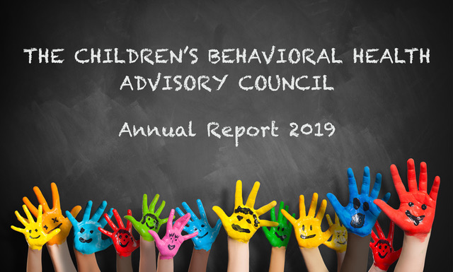

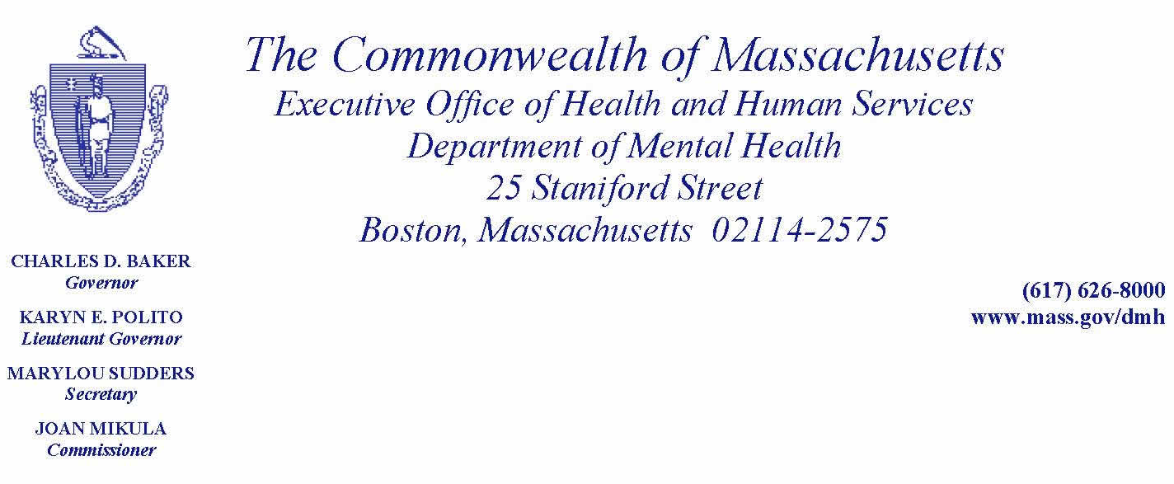

October 1, 2019

On behalf of the Children’s Behavioral Health Advisory Council (Council), established under the provisions of Chapter 321 of the Acts of 2008, I am pleased to transmit its 2019 Annual Report.

Council membership is diverse and multi-disciplinary. It is comprised of representatives of leading professional guilds, trade organizations, state agencies, family and young adult leaders and other stakeholders. A listing of the Council’s membership is attached as Appendix A. Throughout its years, the Council has worked to ensure that children’s behavioral health receives the attention that it deserves in the larger policy conversations about healthcare reform.

The Council’s work is driven by the knowledge that:

- Half of all lifetime mental illnesses begin by age 14; three quarters by age 24.
- Between 13-20% of children living in the United States are affected by mental illness in a given year.
- 50% to 75% of youth with a substance use disorder also experience a co-occurring mental illness.
- Suicide is now the second leading cause of death for youth between the ages of 10 to 24.
- 50% of students age 14 or older with a mental disorder drop out of high school, the highest drop-out rate of any “disability” group.
- The CDC estimates that the economic impact of mental health challenges among youth under age 24 is $247 billion annually.

Without intervention, child and adolescent psychiatric disorders frequently continue into adulthood and are increasingly associated with disability and increased medical costs. For example, research shows that when children with coexisting depression and conduct disorders become adults, they tend to use more health care services and have higher healthcare costs than other adults. Thus, while children are not “cost drivers,” our failure to intervene or engage in preventative measures result in bringing them to adulthood, where their medical needs and costs become significantly higher.

In 2019, the Council explored a number of critical issues such as the status of the Emergency Psychiatric Inpatient Admission policy, intervention for youth experiencing a first psychotic episode, “parity 2.0” for physical and behavioral health conditions, and the coverage of certain behavioral health benefits for children and adolescents for those with insurance regulated by the Division of Insurance. Council members have acted as key advisors on these important topics and serve as ambassadors to their constituencies on these matters.

Sincerely,
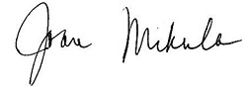
Joan Mikula
Commissioner
On behalf of the Children’s Behavioral Health Advisory Council

cc: Marylou Sudders, Secretary, Executive Office of Health and Human Services

INTRODUCTION AND PRELIMINARY STATEMENT

Section 1 of Chapter 321 of the Acts of 2008 amended Chapter 6A of the Massachusetts General Laws, by inserting Section 16Q and established the Children’s Behavioral Health Advisory Council (Council) and placed the Council, “within but not subject to control of, the executive office of health and human services.” Additionally, the language of section 16Q (a) states the Council is to, “advise the governor, the general court and the secretary of health and human services.” The scope and breadth of the Council’s advisory role is best evidenced in subparagraph (d) of Section 16Q, which authorizes the Council to make recommendations in the following areas:

- best and promising practices for behavioral health care of children and their families, including practices that promote wellness and the prevention of behavioral health problems and that support the development of evidence-based interventions with children and their parents;
- implementation of interagency children’s behavioral health initiatives with the goal of promoting a comprehensive, coordinated, high-quality, safe, effective, timely, efficient, equitable, family-centered, culturally-competent and a linguistically and clinically appropriate continuum of behavioral health services for children;
- the extent to which children with behavioral health needs are involved with the juvenile justice and child welfare systems;
- licensing standards relevant to the provision of behavioral health services for programs serving children, including those licensed by entities outside of the executive office of health and human services;
- continuity of care for children and families across payers, including private insurance; and
- racial and ethnic disparities in the provision of behavioral health care to children.

The Council believes it is vital to its mission, and ultimately to the families and children of the Commonwealth, that it was established as an independent advisor to both the Executive and Legislative branches. Our credibility as an advisory body depends upon our independence and ongoing commitment to advocate for legislation, policies, practices and procedures that best serve the families and children of the Commonwealth with emotional disorders and behavioral health needs. Our recommendations are guided by our expertise, experience, and our commitment to the families and children of the Commonwealth. We hope our work is useful to both the Executive and Legislative branches as we collectively work toward an integrated health care system that addresses the behavioral health needs of our children and adolescents.

COUNCIL’S ACTIVITIES

During the period covered by this Report (October 2018 through September 2019), the Council met five times, on the first Monday of the month. In addition, Council members attended the Children’s Behavioral Health (CBH) Knowledge Center Symposium and the CBH Innovation Awards on May 10, 2019.

This year the Council served as key advisors on a number of timely and important topics which are detailed below.

October 2018 – This meeting focused on DMH’s efforts to establish programs focused on early intervention in first episode psychosis (FEP). Dr. Margaret Guyer-Deason shared information about how DMH has utilized its Community Mental Health Services Block Grant funding from the Substance Abuse and Mental Health Services Administration (SAMHSA) to build capacity and competence of behavioral health providers to provide evidence-supported treatment of early psychosis in order to:

- Improve access to FEP services across the Commonwealth.
- Decrease the duration of untreated psychosis.
- Improve the treatment outcomes and quality of life for adolescents and young adults experiencing early psychosis and their families.

At this meeting Council members advised DMH on how to engage community members and schools on raising awareness about this issue. Council members were also asked to share SAMHSA tip-sheets and other FEP materials with their constituencies.

December 2018 – In December, the Children’s Mental Health Campaign shared details about proposed bills for the upcoming legislative session and led a discussion focused on how to further refine and improve parity for behavioral and physical health care. Council members were asked to offer their ideas for areas to focus on that could improve equitable access to behavioral health care. Recommendations included:

- Equity with respect to rates for physical and behavioral health care services;
- Doubling efforts to reduce stigma and discrimination for individuals with behavioral health challenges;
- Improving behavioral health system navigation within health insurers;
- Creating more equitable standards for physical and behavioral health documentation requirements (e.g. providers note documentation is much more onerous on the behavioral health side which creates workforce challenges and increased administrative costs); and
- Reimbursement for behavioral health preventive care similar to what occurs in primary care.

February 2019 – Dr. Kathy Sanders, Deputy Commissioner for Clinical and Professional Services and Statewide Medical Director, at DMH, presented on the implementation of the Expedited Psychiatric Inpatient Admission (EPIA) policy. February 2019 marked the one year anniversary of the implementation of the policy. Dr. Sanders shared key findings from the first year of data collection and policy implementation. Findings include:

- The “boarding” issue disproportionately impacts the child and adolescent population. Extended boarding stays for youth under the age of 13 are due in part to the lack of available beds for this age group; while youth over 13 are likely to board for long periods because of aggressive/assaultive behavior and complicated presentations that make locating a bed for them more challenging.

- Despite high rates of insurance, youth and families sometimes experience an insurance lapse, which complicates locating a bed and disposition from an emergency department. Therefore, helping people regain insurance (preferably a managed care product) would help facilitate more timely dispositions to inpatient behavioral health treatment.

Council members brainstormed ideas for a so called “EPIA 2.0”. Key themes include:

- Development of a centralized bed search and triage process to maximize efficiency and reduce duplication of effort across the system;

- Enhance data collection efforts to better understand:
  - Barriers to timely disposition at the 48-96 hour mark
  - Current behavioral health services/supports (if any) for youth who are boarding;

- Better supports for the workforce – frequent turn-over and open positions make the situation more challenging; and

- Build the capacity for enhanced crisis response/availability within existing levels of care such as outpatient and mobile crisis response.

April 2019 – Danna Mauch, President and CEO of the Massachusetts Association for Mental Health presented on findings from a report commissioned by the Miller Innovation Fund on Pediatric Behavioral Health Urgent Care. Five recommendations were offered in the report to help improve access to urgent care for youth which were:

- Enhance the current system.
- Add new program components.
- Give authority to those leading clinical teams and develop more robust staffing models.
- Develop a learning community to support practice transformation and provide technical assistance.
- Implement legal/regulatory/financing changes to support urgent behavioral health care.

Advisory Council members were asked to “vote” on which of the following recommendations should be a priority focus for work in this area. Council members overwhelmingly endorsed recommendations #1 and #5. Council members indicated that existing services such as mobile crisis intervention (MCI) hold promise for better supporting youth and their families who are in crisis but legal/regulatory/financing changes would be necessary for it to fulfill its promise.

May 2019 -- As in previous years, Council members attended the Children’s Behavioral Health Knowledge Center’s Annual Symposium and Gailanne Reeh Lecture. The event was held on May 10 at the Worcester Recovery Center and Hospital. Ann Kim, Director of Health & Well-Being at IDEO Cambridge, delivered this year’s Gailanne Reeh Lecture. From 2016-2017, Ann served as the first Chief Design Officer for U.S. Surgeon General Vivek Murthy, bringing design thinking into government and urgent public health issues of addiction, opioids, and social isolation.

This year's Symposium also featured the 2019 Children's Behavioral Health Innovation Awards. Doc Wayne Youth Services was selected as the 2019 awardee. Co-funded by the Blue Cross Blue Shield of Massachusetts Foundation, the C.F. Adams Charitable Trust, and the Massachusetts Association for Mental Health (MAMH), the CBH Innovation Award is a one-time grant awarded to a non-profit children’s behavioral health or social service organization in recognition of its effort to:

- Innovatively fill an unmet need or gap in the children’s behavioral health care delivery system, or
- Respond to a “wicked” problem facing the children’s behavioral health field through creation of an innovative program or practice.

After a competitive application process, three finalists were selected to present their innovative program at the event. The more than 150 people who attended then used a real time text- voting feature to select the winner of the $10,000 prize. Doc Wayne Youth Services won for its Chalk Talk program, which blends traditional outpatient therapy and sports. The two other finalists were Riverside Community Care, for their development of Yoga-Cognitive Behavioral Therapy, and The Brookline Center’s BRYT program, which partners with schools to get youth back on track after prolonged absences. Each received a prize of $5,000.
June 2019 – Emily Sherwood, Deputy Commissioner for Child, Youth, and Family Services at DMH and Kevin Beagan from the Division of Insurance, shared an update with Council members on the coverage of the Behavioral Health for Children and Adolescents (BHCA) benefits through fully-funded commercial health insurance products regulated by the MA Division of Insurance. Services that will be added to the benefit for plans being renewed on or after July 1, 2019 include: intensive care coordination, intensive community-based acute treatment, community-based treatment, mobile crisis intervention, in-home therapy, and in-home behavioral therapy. Two additional services, therapeutic mentoring and family support and training will be added to the benefit for those plans renewing on or after July 1, 2020; the delay necessary in order to first establish a certification system for those two practitioner types.

Council members applauded state leadership for implementing this change as they believe it holds great promise to help many families who were unable to access these same services through MassHealth. Council members are eager to share the availability of these services with their constituencies and members of the public. Consumer materials are being drafted by a sub-set of Council members led by the Children’s Mental Health Campaign.

THE YEAR AHEAD

As the Executive Office of Health and Human Services undertakes its bold agenda to redesign and create a true ambulatory treatment system, Council members are poised to support and advise on this effort. Council members were encouraged to participate in the listening sessions being held across the Commonwealth during the spring and summer months and to respond to a Request for Information due to be released in August 2019.

Council members will eagerly watch the implementation of the BHCA benefit among the fully-funded commercial health plans over the next year and will be asked to advise on the establishment of a certification system for therapeutic mentors and family partners. The year ahead holds great promise for the youth and families of Massachusetts with behavioral health challenges.

APPENDIX A

The Children’s Behavioral Health Advisory Council (the Council) was established under the provisions of Chapter 321 of the Acts of 2008. The Council is a unique public-private partnership representing child-serving agencies, parents and professionals with expertise in the issues of children’s mental health. The membership of the Commission is as follows:

Joan Mikula, Chair
Commissioner
Department of Mental Health

David Matteodo
Massachusetts Association of Behavioral Health Systems Representative

Kristen Alexander
Department of Children and Families

Marsha Medalie
Association for Behavioral Healthcare Representative

Janet George
Department of Developmental Services

Tammy Mello/Joe Leavey
Children’s League of Mass Representative
Margot Tracy
MassHealth Office of Behavioral Health

Peter Metz, M.D.
New England Council of Child and Adolescent Psychiatry Representative

Carol Nolan
Department of Early Education and Care

Barry Sarvet, M.D.
Massachusetts Psychiatric Society Representative

Kevin Beagan
Division of Insurance

Michael Yogman, M.D.
Mass Chapter of the American Academy of Pediatrics Representative

Jane Ewing
Department of Elementary and Secondary Education
Eugene D’Angelo, Ph.D.
Massachusetts Psychological Association Representative

Robert Turillo
Department of Youth Services

Rebekah L. Gewirtz
National Association of Social Workers – Massachusetts Chapter Representative

Brian Jenney/Rebecca Butler
Department of Public Health

Dalene Basden
Parent/Professional Advocacy League Representative

Maria Mossaides
The Child Advocate
Office of the Child Advocate

Lisa Lambert
Parent/Professional Advocacy League Representative

Danna Mauch
Massachusetts Association for Mental Health Representative
Mary McGeown
Massachusetts Society for the Prevention of Cruelty to Children Representative

William R. Beardslee, M.D.
Massachusetts Hospital Association Representative

Ken Duckworth, M.D.
Blue Cross Blue Shield of Massachusetts Representative

Sarah Gordon Chiaramida
Massachusetts Association of Health Plans Representative

John Straus, M.D.
Massachusetts Behavioral Health Partnership Representative

Theodore Murray, M.D.
Cambridge Health Alliance

Elizabeth Bosworth
Beacon Health Strategies

Amy Carafoli-Pires
Boston Medical Center HealthNet Plan

John Sargent, M.D.

Paul Shaw

