# Commonwealth of Massachusetts

**Executive Office of Health and Human Services**

## **THE CHILDREN’S BEHAVIORAL HEALTH**

**ADVISORY COUNCIL**



# Annual Report 2022

|  |  |  |  |
| --- | --- | --- | --- |
|  | ***The Commonwealth of Massachusetts***  ***Executive Office of Health and Human Services***  ***Department of Mental Health***  ***25 Staniford Street***  ***Boston, Massachusetts 02114-2575*** | |  |
| **CHARLES D. BAKER**  ***Governor***  **KARYN E. POLITO**  ***Lieutenant Governor***  **MARYLOU SUDDERS**  ***Secretary***  **Brooke Doyle**  ***Commissioner*** | | **(617) 626-8000**  **www.mass.gov/dmh** | |

XXXX, 2022

Charles D. Baker, Governor of the Commonwealth

Amy Kershaw, Acting Commissioner, Department of Early Education and Care

Jeffrey C. Riley, Commissioner, Department of Elementary and Secondary Education

Maria Mossaides, The Child Advocate

Sen. Michael J. Rodrigues, Chair, Senate Committee on Ways and Means

Rep. Aaron Michlewitz, Chair, House Committee on Ways and Means

Sen. Cindy F. Friedman, Senate Chair, Joint Committee on Health Care Financing

Rep. John Lawn, Jr., House Chair, Joint Committee on Health Care Financing

Sen. Julian Cyr, Senate Chair, Joint Committee on Mental Health, Substance Use and Recovery

Rep. Adrian Madaro, House Chair, Joint Committee on Mental Health, Substance Use and Recovery

Sen. Adam Gomez, Senate Chair, Joint Committee on Children, Families and Persons with Disabilities

Rep. Michael Finn, House Chair, Joint Committee on Children, Families and Persons with Disabilities

On behalf of the Children’s Behavioral Health (BH) Advisory Council (Council), established under the provisions of Chapter 321 of the Acts of 2008, I am pleased to transmit its 2022 Annual Report.

The Council is a diverse and multi-disciplinary group with representatives from professional guilds, trade organizations, state agencies, families and young adult leaders, advocates, and other key stakeholders. A complete list of the Council’s membership is included in ***Appendix A*** of this Report. The Council always considered children’s behavioral health reform in the context of the Commonwealth’s broader health policy reform initiatives. In the past year, the Baker-Polito Administration began implementing its *Roadmap for Behavioral Health Reform*, a multi-year blueprint based on extensive feedback from families, providers, and other key stakeholders. The Council looks forward to continuing to support the implementation of the *Roadmap* and ensuring that children’s behavioral health remains a central tenet.

The behavioral health needs of children and adolescents have been significantly exacerbated by the COVID-19 pandemic. As directed by the Legislature, the past year the Council’s work focused on conducting an analysis of the existing and anticipated impacts of the COVID-19 pandemic on children’s behavioral health and the associated provision of services and supports. A report of its methods, participants, findings, and recommendations is included in Appendix B.

As highlighted in the report, the Commonwealth has already put in place many strategies to address children’s behavioral health needs, some as part of the *Roadmap for Behavioral Health Reform,* and others that were elicited by the challenges brought on by the COVID pandemic. There has never been a more crucial moment to improve access to children’s behavioral health care. The recommendations made by the Council as part of the COVID Study provide a guide to the types of interventions that would improve the behavioral health of children in the Commonwealth.

Sincerely,

Brooke Doyle, M.Ed, LMHC

Commissioner

On behalf of the Children’s Behavioral Health Advisory Council

cc: Marylou Sudders, Secretary, Executive Office of Health and Human Services

**I.** **INTRODUCTION AND PRELIMINARY STATEMENT**

Section 1 of Chapter 321 of the Acts of 2008 amended Chapter 6A of the Massachusetts General Laws, by inserting Section 16Q and established the Children’s Behavioral Health Advisory Council (Council) and placed the Council, “within but not subject to control of, the executive office of health and human services.” Additionally, the language of section 16Q (a) states the Council is to, “advise the governor, the general court and the secretary of health and human services.” The scope and breadth of the Council’s advisory role is best evidenced in subparagraph (d) of Section 16Q, which authorizes the Council to make recommendations in the following areas:

1. best and promising practices for behavioral health care of children and their families, including practices that promote wellness and the prevention of behavioral health problems and that support the development of evidence-based interventions with children and their parents;
2. implementation of interagency children’s behavioral health initiatives with the goal of promoting a comprehensive, coordinated, high-quality, safe, effective, timely, efficient, equitable, family-centered, culturally competent, and a linguistically and clinically appropriate continuum of behavioral health services for children;
3. the extent to which children with behavioral health needs are involved with the juvenile justice and child welfare systems;
4. licensing standards relevant to the provision of behavioral health services for programs serving children, including those licensed by entities outside of the executive office of health and human services;
5. continuity of care for children and families across payers, including private insurance; and
6. racial and ethnic disparities in the provision of behavioral health care to children.

The Council believes it is vital to its mission, and to the families and children of the Commonwealth, that it is established as an independent advisor to both the Executive and Legislative branches. Our credibility as an advisory body depends upon our independence and ongoing commitment to advocate for legislation, policies, practices, and procedures that best meet the needs of the families and children of the Commonwealth with emotional disorders and behavioral health needs. Our recommendations are guided by our expertise, experience, and our commitment to the families and children of the Commonwealth. We hope that our work is informative to both the Executive and Legislative branches as we collectively work toward an integrated health care system that addresses the behavioral health needs of our children and adolescents.

**II. COUNCIL’S ACTIVITIES**

From October 2021 through September 2022, the Council met six times. As required by Chapter 24 of the Acts of 2021, the Fiscal Year (FY) 22 budget, the work of the Council was focused on designing and conducting an analysis of the existing and anticipated impacts of the COVID-19 pandemic on children’s behavioral health and the associated provision of services and supports; and producing a report of its findings and recommendations to the Senate and House Committees on Ways and Means. The Council collaborated with the Massachusetts Society for the Prevention of Cruelty to Children (MSPCC), who led the study, and served as key advisors on all stages of the process, which are detailed in the study’s report, included in APPENDIX B.

A summary of the content of the meetings of the Council is contained below.

**October 2021** –

Commissioner Brooke Doyle opened The Council’s first meeting by welcoming members. Kelly English, Deputy Commissioner for Children, Youth and Families introduced the work of the Council for this year, which would consist of conducting The Children’s Behavioral Health COVID study as directed by the legislature.

Nancy Scannell of the MSPCC, the organization that the legislature selected to lead the study provided the members with an overview of the Study activities, and the role of Council committee members. Council Members provided input for the study and volunteered to participate in specific study tasks.

**December 2021 –**

Nancy Allen Scannell provided an update on COVID study and a timeline for its completion.

She also provided an update to the Council on the Mental Health ABC bill status.

Audrey Smolkin, Executive Director of The Center on Child Wellbeing & Trauma at UMass Chan Medical School provided Council members with an overview of the work of the Center.

Melissa Pearrow, PhD, Professor of School Psychology and Executive Director of the Behavioral Health Integrated Resources for Children (BIRCh) Project at The University of Massachusetts presented a report on the work of and plans for the School TA Center.

**February 2022** –

Nancy Allen Scannell provided members with an update on the status and plans for the COVID Study and requested member participation in next steps. She also presented an update on the State’s budget priorities related to children’s mental health.

Kate Roper and Larisa Méndez-Peñate of the Division of Pregnancy, Infancy and Early Childhood at the Department of Mental Health presented on the Pediatric Mental Health Care Access grant that was recently funded by Health Resources and Services Administration (HRSA). The grant will fund a program within the Massachusetts Child Psychiatric Program (MCPAP), which will provide psychiatric and clinical consultation as well as train pediatric practices to better identify and serve the mental health needs of young children.

**April 2021 –**

Nancy Allen Scannell, Cat Quirion and Courtney Chelo provided an Update on COVID study, which included an overview of themes discussed in listening sessions as well as how do these themes fit with what the literature on the subject says. Then they led Council members on a discussion of themes, solicited suggestions for additional themes and engaged members on a discussion of recommendations.

**June 2022 –**

Nancy Allen Scannell and staff of MSPCC presented the COVID Study’s preliminary findings and led the Council on an exercise to generate recommendations based on the findings to include in the final report.

##### III. THE YEAR AHEAD

Working closely with the Administration and the implementation of the *Roadmap for Behavioral Health Reform*, the Council will continue to advocate for the needs of youth and their families with behavioral health challenges. Specifically, the Council will advocate and support the implementation of the recommendations made in the COVID Study. The Council looks forward to another productive and impactful year of work ahead in 2022-2023.

**APPENDIX A**

**The Children’s Behavioral Health Advisory Council (the Council) was established under the provisions of Chapter 321 of the Acts of 2008. The Council is a unique public-private partnership representing child-serving agencies, parents and professionals with expertise in the issues of children’s mental health. The membership of the Commission is as follows:**

|  |  |
| --- | --- |
| Brooke Doyle, Chair  Commissioner  Department of Mental Health | David Matteodo  Massachusetts Association of Behavioral Health Systems Representative |
| Lauren Almeida  Department of Children and Families | Marsha Medalie  Association for Behavioral Healthcare Representative |
| Janet George  Department of Developmental Services | Tammy Mello/Joe Leavey  Children’s League of Mass Representative |
| Kate Ginnis  MassHealth Office of Behavioral Health | Vacant  New England Council of Child and Adolescent Psychiatry Representative |
| Carol Nolan  Department of Early Education and Care | Barry Sarvet, M.D.  Massachusetts Psychiatric Society Representative |
| Kevin Beagan  Division of Insurance | Michael Yogman, M.D.  Mass Chapter of the American Academy of Pediatrics Representative |
| Jane Ewing  Department of Elementary and Secondary Education | Eugene D’Angelo, Ph.D.  Massachusetts Psychological Association Representative |
| Vacant  Department of Youth Services | Rebekah L. Gewirtz  National Association of Social Workers – Massachusetts Chapter Representative |
| Brian Jenney/Rebecca Butler  Department of Public Health | Dalene Basden  Parent/Professional Advocacy League Representative |
| Maria Mossaides  The Child Advocate  Office of the Child Advocate | Lisa Lambert  Parent/Professional Advocacy League Representative |
| Danna Mauch  Massachusetts Association for Mental Health Representative | Mary McGeown  Massachusetts Society for the Prevention of Cruelty to Children Representative |
| William R. Beardslee, M.D.  Massachusetts Hospital Association Representative | Ken Duckworth, M.D.  Blue Cross Blue Shield of Massachusetts Representative |
| Sarah Gordon Chiaramida  Massachusetts Association of Health Plans Representative | John Straus, M.D.  Massachusetts Behavioral Health Partnership Representative |
| Theodore Murray, M.D.  Cambridge Health Alliance | Elizabeth Bosworth  Beacon Health Strategies |
| Amy Carafoli-Pires  Boston Medical Center HealthNet Plan |  |

**APPENDIX B:**

**COVID IMPACT ON CHILDREN’S BEHAVIORAL HEALTH STUDY REPORT**

# Section I: ACKNOWLEDGEMENTS

In the beginning of FY22, the Massachusetts General Court directed the Children’s Behavioral Health Advisory Council (CBHAC) to conduct an analysis of the existing and anticipated impacts of the COVID-19 pandemic on children’s behavioral health and the associated provision of services and supports.

As directed by the Legislature, the Massachusetts Department of Mental Health (DMH) Division of Child, Youth, and Family Services contracted with the Massachusetts Society for the Prevention of Cruelty to Children (MSPCC) and the Massachusetts Children’s Mental Health Campaign (CMHC) to work with CBHAC to complete this study. CMHC is a statewide network led by MSPCC, Boston Children’s Hospital, the Parent/Professional Advocacy League (PPAL), the Massachusetts Association for Mental Health (MAMH), Health Law Advocates, and Health Care for All that advocates for policy, system, and practice solutions and shared responsibility among government and institutions to ensure that all children in Massachusetts have access to resources to prevent, diagnose, and treat behavioral health issues in a timely, effective, and compassionate way.

Between January and June of 2022, the CMHC conducted a multi-pronged study to gather information and data to understand the impacts of, including disproportionate impacts on certain communities, and to inform a set of solutions to the negative effects of the pandemic on the mental health and well-being of the Commonwealth’s children and youth. The CMHC developed a COVID Impact Study Team composed of staff from Campaign Leadership organizations, MSPCC, Boston Children’s Hospital, PPAL, and MAMH to carry out the background research and data-gathering activities. The Team recruited a “kitchen cabinet” from DMH, CBHAC, and CMHC members to serve as advisors on formulating the methodology, developing data collection tools, engaging stakeholders and affected youth and families, reviewing drafts of the study report, and developing findings and recommendations for the final Report to the Legislature.

The CMHC is grateful for invaluable collaboration with CBHAC, DMH, the Executive Office of Health and Human Services (EOHHS), and allies from the child and family advocacy community, the philanthropic community, and the behavioral health provider community. Delivery of behavioral health care in Massachusetts is a true public-private partnership. Government officials, policymakers, regulators, and payers are leaders in the effort to address the impact of the pandemic on child mental health and provided generous input for this report, including a collaborative review of preliminary findings and proposed solutions. The COVID Impact Study Team particularly notes DMH’s focus on the highest impacted communities and EOHHS’ initiative to pursue reform of the ambulatory behavioral health system in the Commonwealth, which specifically implements a new “front door” to the behavioral healthcare system to facilitate timely access and to mitigate navigation challenges in getting needed care.

The CMHC COVID Impact Study Team extends its sincere thanks to the children, adolescents, and their families who serve as inspiration for this research and advocacy. The CMHC would also like to thank fellow advocates and community stakeholders for their collaboration on this study and for their dedication to improving the behavioral health system for children and adolescents.

# Section II: EXECUTIVE SUMMARY

Many children in Massachusetts are in the midst of a behavioral health crisis, struggling with anxiety and depression at unprecedented levels. The impact of the COVID-19 pandemic and the measures taken to prevent its spread challenged children and families’ abilities to navigate life and to fully function socially, emotionally, and academically. The demand for behavioral health services grew exponentially, and the existing behavioral health care capacity was unable to adequately meet the growing need for services.

From the start of the pandemic, the Commonwealth began rapidly innovating to meet both existing and emerging behavioral health needs. While serious systemic issues in the behavioral health system persist, important and impactful work has been accomplished over the last two years, which will have lasting impact on improved access to care. The Baker-Polito administration began the process of rolling out the Behavioral Health Roadmap in July of 2020 with the aim of ensuring the right treatment when and where people need it.

At the request of the Legislature, The Children’s Behavioral Health Council (CBHAC), supported by the staff of the Massachusetts Society for the Prevention of Cruelty to Children (MSPCC) conducted this study with the purpose of providing an overview of the impact of the pandemic on children’s behavioral health and well-being. The findings are categorized into four overarching categories: Impact on Family Mental Health, Access to Mental Health Services, Quality of Services, and Virtual Services.

**Impact on Family Mental Health**

Caregivers who participated in the study confirmed what experts have cited as the negative impacts of the pandemic on children and youth – the risk of regression in child development, educational progress, and mental health due to social isolation, remote education, and increased fear and family stress. Many caregivers said that the experience of living through the pandemic was deeply traumatic, both to themselves and their children.

Caregivers and youth reported that the pandemic, along with the public health measures implemented to slow the spread of COVID-19, led them to feel exhausted, frustrated, scared, and alone. Families identified factors such as drastic changes to routines, increased responsibilities, increased time spent together in the home, lack of appropriate space in the home for all family members to participate in remote work and learning, fear of COVID-19, and the need to adhere to new public health measures as being extremely challenging.

Loneliness and lack of social connections – all of which are connected to worse mental health outcomes – were heightened during the pandemic. Many caregivers reported increased feelings of family isolation, which negatively affected their and their children’s mental health. Many caregivers mentioned the added challenge of needing to maintain balance in the presence of their children to shield them and their mental health from any harm.

Parents also reported that they themselves were more likely to have lost work and had increased concerns with childcare, increased conflicts between working and providing childcare, and increased emotional distress. Conversely, some parents stated that spending more time at home as a result of the pandemic brought their families closer together and enabled them to bond with their children or caregivers in ways they had never experienced before.

**Access to Mental Health Services**

While the vast majority of children in Massachusetts have insurance, many families reported being unable to access the mental health services their children required. The pandemic exacerbated existing challenges in accessing behavioral health services for children and families. Among the top barriers to access were the inability to connect with existing and new providers, a lack of knowledge on the part of caregivers as to where and how to access services for their children, the loss of access to school-based behavioral health services, and significant wait times for access to providers across the service delivery spectrum. These barriers to access were heightened for families of color and non-native English speakers and resulted in increased caregiver burden as well as a worsening of the children’s behavioral health boarding crisis.

**Quality of Services**

The pandemic had a devastating impact on an already insufficient behavioral health workforce, and caregivers perceived this impact as undercutting the quality of the services they received throughout the pandemic. As a result of understaffing, staff turnover, and staff burnout, caregivers perceived their providers as insensitive and lacking compassion. In many cases, this resulted in caregivers feeling frustrated and unsatisfied with the quality of services their children received. Caregivers reported feeling that these services were not effective in addressing their children’s worsening mental health conditions. Ultimately, the pandemic impacted the daily life and work of individuals across all professions, including those in the mental health field, and this impact was felt by caregivers and youth in the perceived quality of the services they received during this time. Hospitals, providers, and government agencies worked tirelessly to try to address these issues in several ways. While some of the changes and new initiatives launched helped address the workforce problem, workforce challenges remain a top concern for providers across the Commonwealth and the nation.

**Virtual Services**

The increased availability of telehealth helped mitigate barriers in access to care for families. For example, caregivers in the study listening sessions and focus groups reported that the move to virtual services removed significant barriers such as transportation costs, scheduling issues, childcare, bureaucratic challenges, and lack of time. However, the use of telehealth may not be appropriate for all children. Caregivers who participated in our study reported that some children, especially young and neurodiverse children, were not able to stay fully engaged during telehealth services and that they were not always offered the option to choose in person treatment or could not do so without lengthy waits. Caregivers also identified issues with internet and technology access as barriers to using telehealth.

In response to these findings, the CBHAC submits the following recommendations:

**Invest in Mental Health Promotion and Prevention** by deploying a marketing campaign to inform families of existing, new, and upcoming resources; creating pathways for peer-based supports for youth and families; increasing respite services for families of children with behavioral health challenges; investing in evidence-based prevention programs that could be offered in non-clinical settings, including schools; addressing gaps between public and commercial insurance coverage for early screening and prevention services.

**Enhance and Expand Access to Intervention and Treatment** by making permanent the current increases to Children's Behavioral Health Initiative (CBHI) services; providing families waiting for services with gap services and self-help resources; procuring Program of Assertive Community Treatment (PACT-Y) teams for youth; implementing enhanced direct services in Massachusetts schools through a model similar to the Texas Child Health Access Through Telemedicine (TCHATT) program; developing Community Behavioral Health Center (CBHC)-school partnerships to facilitate access from school settings to community services to address emerging needs; reinvigorating Community Based Acute Treatment (CBAT) services to serve children; making permanent current investments to stabilize funding for community behavioral health services in appropriations designated for this purpose; expanding access to trauma-informed resources in community settings; opening pathways for Massachusetts Department of Elementary and Secondary Education (DESE) licensed professionals to provide reimbursable services in after school hours; applying evidence-informed approaches to better determine when and how to use virtual vs. in-person treatment; requiring commercial insurers to direct delivery of and pay for behavioral health care provided in Emergency Departments (EDs); enhancing behavioral health boarding practices to promote safety and environments that are developmentally appropriate for children of varying ages.

**Invest in the Workforce by** continuing and enhancing incentives across all providers, such as increasing reimbursement rates; increasing salaries and offering better benefits; loan forgiveness; scholarships; paid internships; access to reflective supervision. Invest in less staff intensive interventions such as group modalities and psychoeducation for caregivers and school personnel. Incentivize the integration of family partners and other peer professionals to support care in all settings, including removing reimbursement barriers for peer services. Focus on addressing the areas of most need by increasing investment in providers (and students) with diverse backgrounds (either racial, ethnic, linguistic, cultural, or individuals in the LGBTQ+ community); and providers who serve specialized populations such as, children with diagnoses of autism spectrum disorder or intellectual and developmental disabilities (ASD/IDD), children ages 0-5, children receiving DCF services, children who exhibit aggressive behaviors, children with medical complexities, etc. Provide training on cultural humility and competency for behavioral health providers, and on Social-Emotional Learning for all school personnel (not just educators). Address immediate workforce shortages by bringing in recently retired individuals to offer consultation, supervision, training, mentorship, etc. to "green" staff. Partner with colleges to rebuild the workforce.

**Promote Collaboration Among Children’s Mental Health Service Provider Sectors** by improving collaboration and communication among existing interagency and cross-sector groups focused on children’s behavioral health; widely sharing information about behavioral health resources available across the Commonwealth across agencies, and the provider community; increasing collaboration and formal partnerships between schools and community-based organizations; framing standards for shared case collaboration and communication between community-based providers, specialty providers, and pediatricians; facilitating partnerships among emergency service providers, CBHCs, return to school bridge programs, and schools, to support school re-entry and coordination; explore tele-behavioral health supports in partnership with schools; increase partnerships between clinical providers and community-based organizations that specialize in serving Black, indigenous, and people of color (BIPOC) and immigrant communities; increase collaboration and education about Intensive Hospital Diversion (IHD) services with Emergency Services Programs (ESP) teams and hospitals; increase collaboration, coordination, and shared training across all Massachusetts home visiting programs with the goal of promoting social and emotional well-being for very young children and families.

In conclusion, the children and families of Massachusetts have suffered immense trauma and loss over the past two and a half years. The unprecedented demands to cope with living through a period of unremitting fear, isolation, loss, and uncertainty during the pandemic have, understandably, proven to be beyond that of many children’s ability to cope and resources. It has also exacerbated the needs of children who were challenged by behavioral health difficulties prior to the pandemic. Consequently, there is an unparalleled demand for children’s behavioral health services from an already taxed behavioral health system, despite significant improvements and innovations made in response to the pandemic.

Children’s behavioral health is essential to their development, their ability to function, learn, be productive, develop healthy relationships, navigate life’s challenges, and contribute to their families and communities. The quality of our children’s behavioral health will affect their future and ours. The need to address children’s behavioral health is urgent.

# Section III: BACKGROUND OF THE STUDY

The Commonwealth of Massachusetts has taken numerous steps to address concerns about the impact of the COVID-19 pandemic on the mental health and the well-being of children and youth. To fully understand the effects on children’s mental health, the Legislature directed the Massachusetts Department of Mental Health (DMH) and its Children’s Behavioral Health Advisory Council (CBHAC) to conduct an analysis. CBHAC, established under Chapter 321 of the Acts of 2008, is comprised of representatives of leading professional guilds, trade organizations, state agencies, family and young adult leaders, and other stakeholders.[1] The Council’s recent efforts have focused on barriers to accessing children’s mental health services and identifying promising initiatives designed to address workforce challenges.

As framed by the Legislature, the charge was to undertake a mixed methods study employing qualitative and secondary data analysis with a targeted effort to reflect the experience of youth under the age of 22 who are consumers of behavioral health services and their families, *prioritizing underserved or underrepresented children and their families,* during the pandemic*.* As will be detailed in the Methodology Section of this Report, the CMHC COVID Impact Study Team planned and executed an investigation designed to respond to the charge from the Legislature and the Department, incorporating the following elements:

* Conduct a literature review to summarize relevant and credible data from COVID-19 impact studies that have been conducted by other organizations and produced by reliable governmental, public policy, or peer-reviewed publications.
* Gather direct input from youth, families, and communities affected by the pandemic through listening sessions, focus groups, and key informant interviews conducted to incorporate the experience of highly-impacted communities and reflect the cultural, linguistic, racial, disability, gender identity, sexual orientation, and geographic diversity in the Commonwealth.
* Recommend solutions for addressing barriers to care within the current continuum of behavioral health care and barriers to services as a result of the pandemic, including, but not limited to, barriers to care for underserved or underrepresented populations based on culture, race, ethnicity, language, disability, gender identity, sexual orientation, geographic location, or age during the pandemic.

# SECTION IV: METHODOLOGY

Findings for this report were derived from the following sources: 1) a review of key literature; 2) listening sessions; 3) focus groups; and 4) participant surveys.

## Literature Review

The COVID Impact Study Team reviewed approximately 125 published reports, peer-reviewed articles, issue briefs, surveys, and other national and Massachusetts-specific resources focused on the impact of the pandemic on children and families. Sources included government agencies, foundations, and non-profit research agencies, academic journals, and media reports.

Members of CBHAC provided an initial list of literature. Additional literature was identified through structured online research using search terms including “impact of COVID-19 on mental health,” “impact of COVID-19 on behavioral health,” and “impact of COVID-19 on children and families.” Documents were excluded if they were not specific to behavioral health or if a more updated version of a document was available. A list of key literature used to inform this report is included in the References.

## Outreach to Families and Key Stakeholders

Twenty cities were identified by the Baker-Polito Administration as communities hardest hit by the pandemic (Massachusetts Department of Public Health [DPH], 2021a). Using information from sources such as the Centers for Disease Control and Prevention’s (CDC) Social Vulnerability Index (2018) and the National Institutes of Environmental Health Sciences’ (NIEHS) COVID-19 Pandemic Vulnerability Index (U.S. Department of Health and Human Services [HHS], 2022), the authors selected the following five cities for targeted outreach: Boston, Fall River/New Bedford area,[2] Lawrence, Springfield, and Worcester. Although most participants in listening sessions, focus groups, and surveys led by the Study Team were residents of these communities, the virtual nature of the events allowed other residents of the Commonwealth to participate ([Figure 1](https://datawrapper.dwcdn.net/kI67v/4/) and [Figure 2](https://datawrapper.dwcdn.net/RAOD0/3/)).

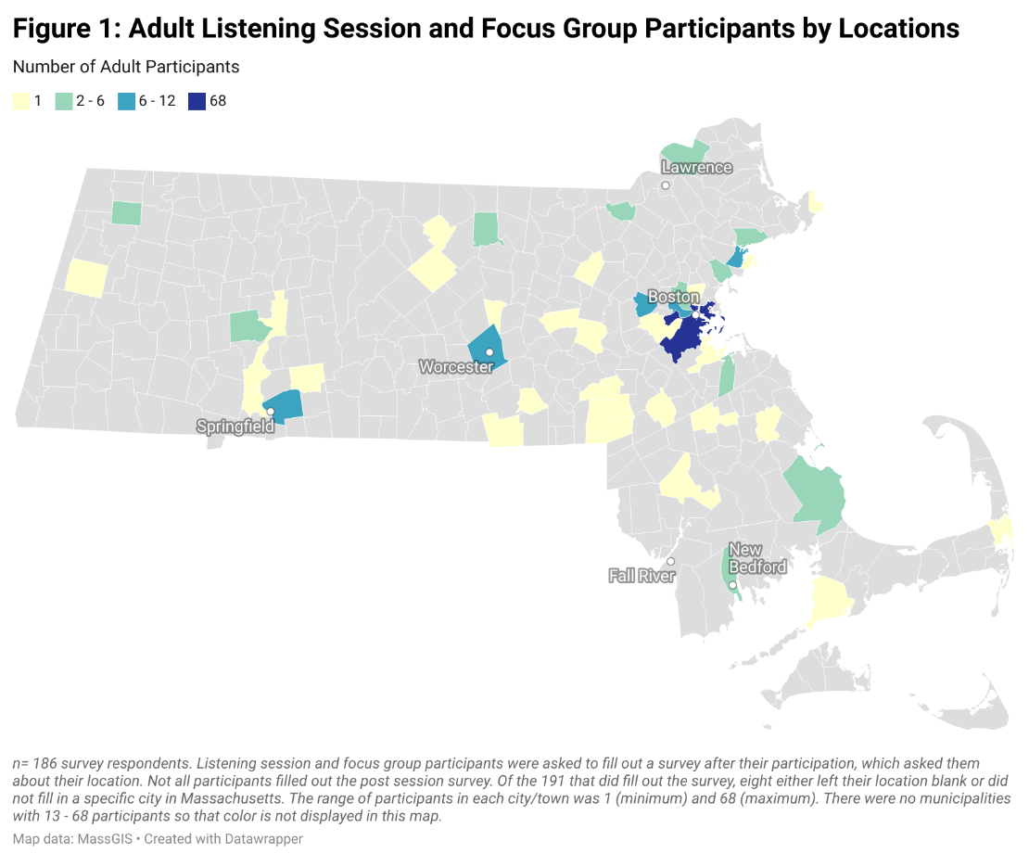

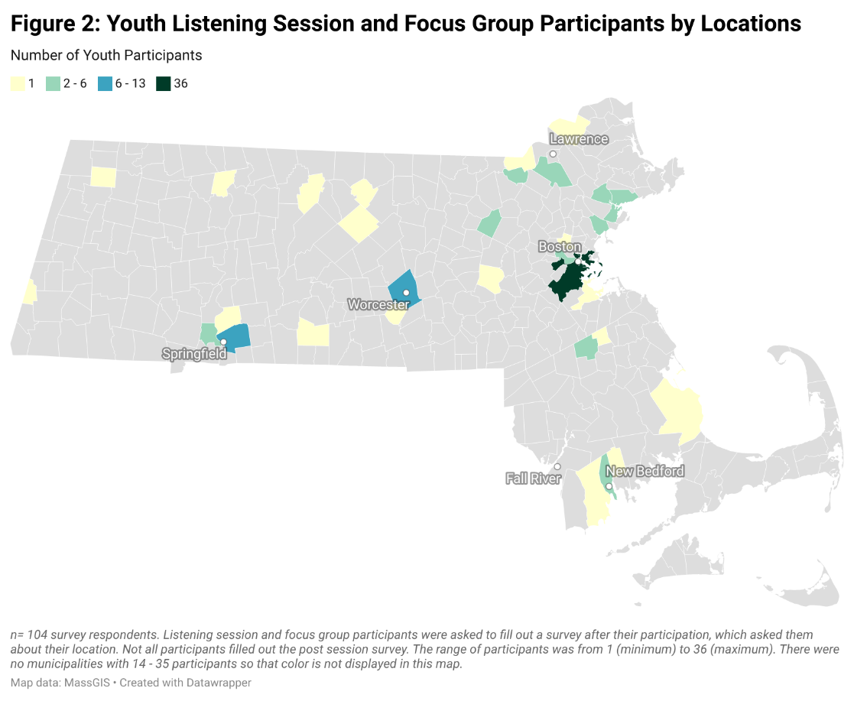

In each community, the Study Team identified community-based organizations serving significant numbers of children and families. The project team encouraged staff and families in these organizations to participate in this study. In three communities (Boston, Fall River/New Bedford, and Springfield), the project team identified one organization to assume a higher level of responsibilities in identifying participants and promoting the listening sessions, focus groups, and survey. These organizations, known as “mini-grantees,” received $2,000 as compensation for their work. Organizations contacted in Lawrence and Worcester said that, even with compensation, they did not have capacity to serve as a mini grantee. In those communities, the project team conducted additional participant outreach online and through social media.

To increase accessibility, information flyers about the listening sessions and focus groups were printed in the five most commonly spoken languages in those five communities (English, Spanish, Portuguese, Arabic, and Haitian Creole), posted on social media, and emailed to a number of community-based organizations. Spanish language interpretation was provided for all adult listening sessions and focus groups. In addition, Portuguese, Arabic, and Haitian Creole translation was provided at one adult listening session or focus group for each language, and American Sign Language (ASL) interpretation was provided at one adult listening session, one adult focus group, and one youth listening session.

Listening sessions and focus groups were provided at a variety of times including day, evening, and weekend sessions to allow families with differing schedules to attend. Participants were able to call into Zoom sessions if they did not have stable internet access.

## Listening Sessions

The COVID Impact Study Team hosted five Zoom listening sessions, each with approximately 30 to 100 participants in attendance. Four of the sessions were targeted to adults who were caregivers,[3] while one session was for youth. Sessions took place during February and March 2022. A total of 165 adults and 122 youth participated in the listening sessions. Race and ethnicity for adult listening group participants are described in Figure 3.

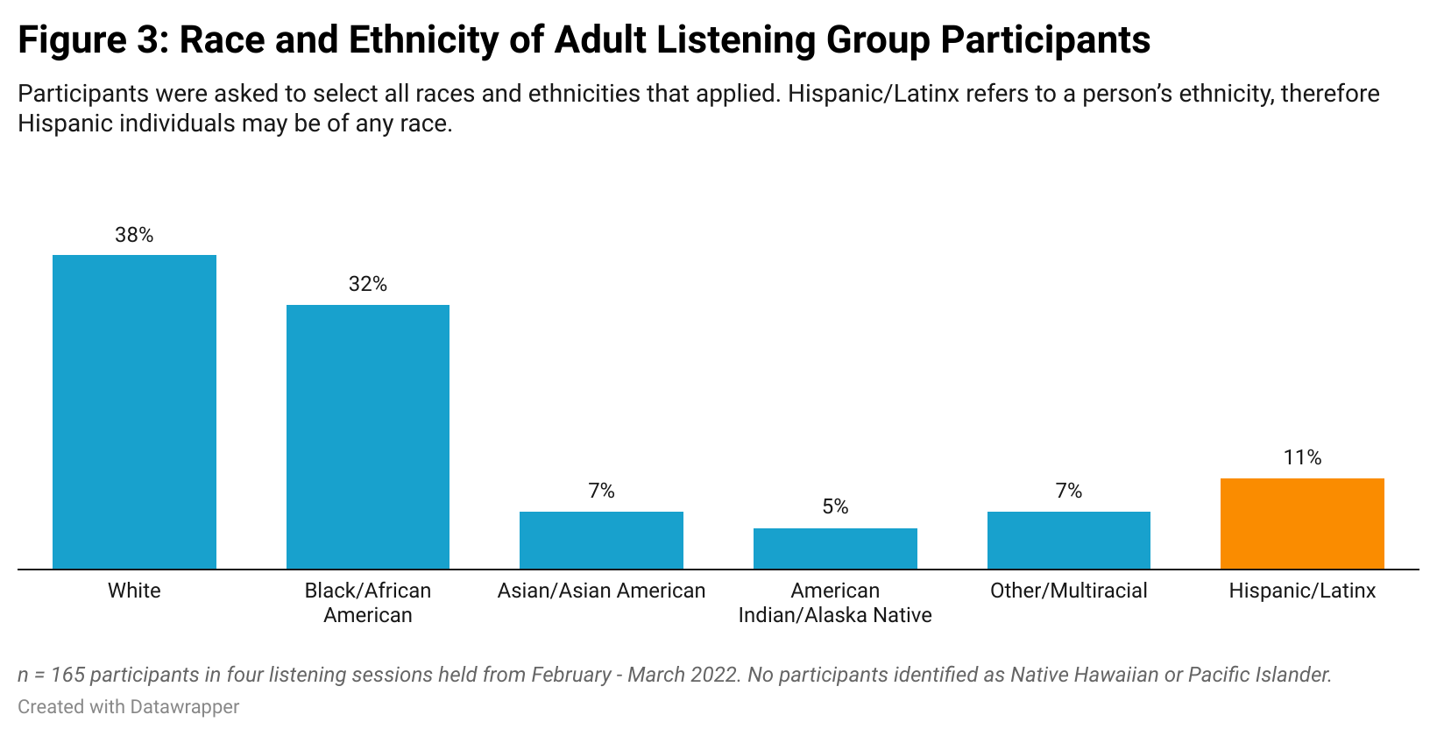

Three adult sessions were conducted in English (with additional interpretation services as described above) and one adult listening session was conducted fully in Spanish. The youth session was conducted in English with ASL interpreter services provided.

Listening sessions were 2 hours in duration for adults and 90 minutes for the youth session. Participants were given the option to participate for as long as they wanted to or could, although a majority of participants attended the entire session.

Participants in the listening sessions were asked to complete a post-participation survey regarding demographic information. Participants received a $25 Amazon gift card as compensation.

## Focus Groups

The COVID Impact Study Team hosted a total of five Zoom focus groups with three to 10 participants in each group. Four of the groups were targeted to adults while one session was for youth. Sessions took place from April to May 2022. A total of 26 adults and three youth participated in the focus groups.

Two of the adult focus groups were in English, with one specifically for Black families; one was conducted entirely in Spanish; and one was conducted in Portuguese. Additional interpretation services were provided, as described above. The youth focus group was conducted in English.

Focus groups were an hour to 90 minutes each. Participants in the listening sessions were asked to complete a post-participation survey regarding demographic information. Participants received a $100 Amazon gift card as compensation.

Both the listening sessions and focus groups were recorded for study purposes. After the listening session and focus groups were completed, the recordings were transcribed (and translated in English where necessary) and coded using Dedoose software with sufficient intercoder reliability measures. Youth and caregivers provided information confidentially and are not individually identified in the report.

## Surveys

Two surveys were created to gather feedback from families who were unable to join the listening sessions or focus groups: one to collect information from caregivers and one for youth (survey questions for both can be found in the Appendix). Surveys were translated into four languages (Spanish, Portuguese, Arabic, and Haitian Creole) with native speakers reviewing all surveys for grammar and content. The surveys were fielded from March to May 2022 with 10 questions (in addition to questions on demographic information) in each survey.

The team conducted outreach to garner participants in multiple ways, including:

* Posting survey links on CMHC’s website;
* Asking mini grantees to share the links with their networks;
* Asking identified community-based organizations in the five target cities to share the link with their members;
* Sharing survey links on multiple Facebook and Twitter pages; and
* Sharing links with member organizations of CMHC and CBHAC.

The Team received a total of 52 surveys (including seven youth surveys) from residents of Massachusetts.

# SECTION V: BACKGROUND AND CONTEXT

To ensure an understanding of the data gathered as part of this project, it is necessary to provide a short overview the state of children’s mental health in the years prior to the pandemic, and acknowledge existing trends with regard to the prevalence of mental health conditions among youth, the role of stigma as it relates to children’s mental health, the existence of significant disparities in mental health outcomes for youth from diverse populations, as well as the role social determinants of mental health play in promoting or hindering mental and behavioral well-being. In this section, the authors also discuss the preliminary impact of the pandemic on the topics named above to promote a better understanding of the study findings within a larger context.

## PRE-COVID-19 PANDEMIC

### Prevalence of Mental Health Conditions

Even before the onset of the pandemic, mental health challenges were the leading cause of disability and poor life outcomes in children and adolescents with up to one in five children ages 3 to 17 in the U.S. with a reported mental, emotional, developmental, or behavioral conditions (HHS, 2021).[4] Additionally, certain mental health conditions among children and adolescents were steadily worsening in the years leading up to the start of the pandemic in March 2020. From 2016 to 2019, a key national survey of parents found that anxiety among children ages 3 to 17 increased from 7.1 % to 9 % and depression increased from 3 % to 4 % (Table 1) (Lebrun-Harris et al., 2022).

These data reflect a larger, concerning trend toward worsening mental health among youth, especially adolescents. In the decade from 2009 to 2019, survey research conducted by the CDC found that the overall share of high school students reporting feelings of persistent sadness and hopelessness increased by about 40 % – from 26.1 % to 36.7 % (Figure 3) (CDC, 2019).[5] In addition, the percentage of high school students considering attempting, planning to attempt, or attempting suicide also increased by about 40 % from 2009 to 2019 (CDC, 2019; HHS, 2021).

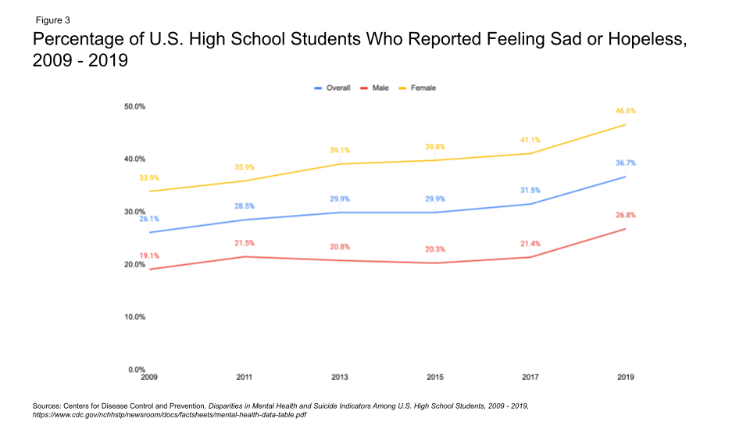

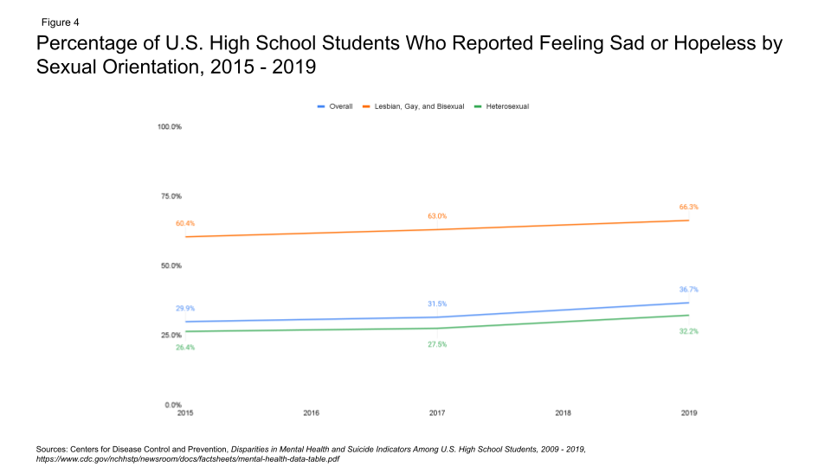

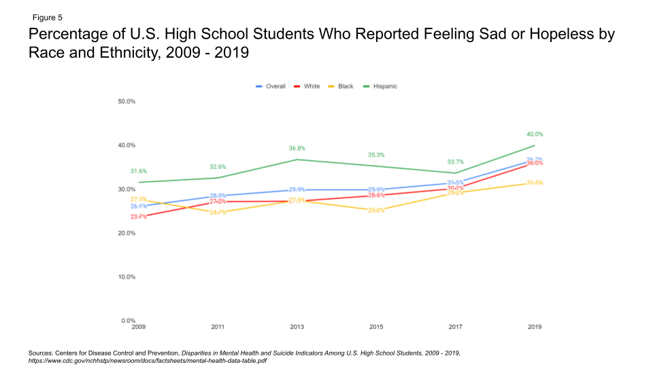

Among children in Massachusetts, some measures of mental health have worsened over time, while other measures have remained stable. Analysis of the National Survey on Drug Use and Health by Substance Abuse Mental Health Services Administration (SAMHSA) showed that in 2017, 13.6 % of youth (ages 12 to 17 years old) in Massachusetts suffered from at least one major depressive episode in the past year (similar to the national rate of 13 %) (SAMHSA, 2019). In 2019, that rate increased to 15.6 % of youth in that same age range in Massachusetts (and 15.1 % nationally) (SAMHSA, 2020a). Among youth in Massachusetts with at least one major depressive episode, 56.8 % did not receive any mental health treatment in 2019, an increase from 54.5 % in 2017 (SAMHSA, 2020a).Other measures such as youth with a severe major depressive episode and youth with substance use conditions remained stable throughout 2017 to 2019 (SAMHSA, 2020a).

Adverse childhood experiences (ACEs), which are potentially traumatic events that occur in childhood, are correlated with higher rates of mental health and substance use conditions, as well as other problems in adulthood. From 2016 to 2019, the prevalence of certain ACEs, such as parental death, witnessing interpersonal violence, experiencing or witnessing neighborhood violence, and living with someone with a substance use condition remained constant (Lebrun-Harris et al., 2022). However, the prevalence of other ACEs increased significantly, including living with someone with a mental health condition (from 7.8 % to 8.3 %) and experiencing discrimination based on race or ethnicity (from 3.7 % to 5.4 %) (Lebrun-Harris et al., 2022).

### Stigma Associated with Mental Health Conditions

Despite national and state efforts to destigmatize mental health conditions and mental health treatment, stigma continued to pose a significant barrier to accessing treatment in the years leading up to the pandemic. Mental health stigma includes shame, prejudice, or discrimination toward people with mental health conditions (Coe et al., 2021). It can take on the form of public stigma (negative attitudes that others have about mental health), self-stigma (internalized negative attitudes about mental health, and institutional stigma), and a systemic form of stigma at institution levels (American Psychiatric Association, 2020a).

Embarrassment associated with having a mental health condition is a major reason many individuals do not receive mental health treatment (CDC, 2012). For children and adolescents, delayed treatment can lead to worse outcomes. Societal stigma associated with mental health conditions can also lead to social exclusion and discrimination, which in turn can result in unequal access to resources such as access to quality health care, educational opportunities, employment opportunities, and supportive communities, among others (CDC, 2012).

Efforts to reduce stigma in the years prior to the pandemic have had mixed results. Research conducted in 1996, 2006, and 2018 suggests shifting public attitudes toward adopting a more biomedical approach to the causes of mental health conditions (Pescosolido et al., 2021). From 2006 to 2018, the desire to socially distance from those with schizophrenia and alcohol dependence was largely unchanged, although the desire to socially distance from individuals with depression decreased significantly.[6] For example, the percentage of people expressing unwillingness to work closely with someone with major depression decreased by around 18 % from 2008 to 2018, while the unwillingness to work with someone with alcoholism or schizophrenia increased by around 2 and 3 %, respectively.

### Disparities in Mental Health Outcomes

Significant disparities in mental health outcomes among families and youth from different communities have existed since well before the pandemic. Data show that people of color and LGBTQ+ individuals are more likely to have poorer health and mental health outcomes compared to their White, heterosexual, cisgender counterparts (McGuire & Miranda, 2014; Hafeez et al., 2017). Specific to mental health, LGBTQ+ individuals are more likely to have poorer mental health conditions and higher rates of substance use conditions compared to non-LGBTQ+ individuals (Hafeez et al., 2017; Dawson et al., 2021). However, people of color experience mental health conditions at similar rates compared to White individuals but are more likely to have persistent symptoms and higher burdens of disability associated with mental health conditions (McGuire & Miranda, 2014; Kapil, 2021). For example, youth identified as lesbian, gay, or bisexual were more than twice as likely as heterosexual students to report feeling sad or hopeless (Figure 4) and Hispanic high school students were slightly more likely than White or Black students to report feeling sad or hopeless (Figure 5) (CDC, 2019).

These disparities also extend to suicidality and suicide attempts among youth. In 2019, high school students who identified as lesbian, gay, or bisexual were about 2.5 times more likely to report considering, planning, or attempting suicide compared to heterosexual high school students (CDC, 2019). Trends by race and ethnicity, however, varied. For example, in 2019, White high school students were more likely than Black high school students to seriously consider suicide (19.1 % compared to 16.6 %, respectively), however, Black high school students were more likely to have attempted suicide compared to White high school students (11.8 % compared to 7.9 %, respectively) (CDC, 2019).

People of color and LGBTQ+ individuals are also less likely to access and utilize mental health care services compared to White and non-LGBTQ+ individuals (American Psychiatric Association, 2017; Health, 2022; SAMHSA, 2015). Multiple factors may contribute to this, including less accessibility of high-quality mental health care services, higher rates of poverty, cultural stigma surrounding mental health care, discrimination and racism, and lack of cultural understanding by healthcare providers (Office of Disease Prevention and Health Promotion, 2022a; American Psychiatric Association, 2017; Creamer, 2021). Research has also shown that children of color may be more likely to receive inappropriate, fragmented, or inadequate mental health services and are also less likely to complete services (Holm-Hansen, 2006).

Additionally, a review of research comparing the impact of stigma across racial groups found that people of color had higher levels of stigma toward individuals with mental health conditions and experienced more harmful consequences from mental health stigma than their White counterparts (Eylem et al., 2020). This increased stigma likely contributes to lower utilization of mental health services among people of color (Eylem et al., 2020).

### Social Determinants of Mental Health

Social determinants of mental health are conditions in which people grow, live, and work that can impact mental health risk and outcomes (Artiga & Hinton, 2018). Social determinants of mental health have a bi-directional relationship in that exposure to worse social determinants can increase risk of mental health conditions, and mental health conditions can impact social determinants such as housing, work, and education, among others. For example, youth from households with lower socioeconomic status were twice as likely to report symptoms of depression or anxiety compared to youth in higher income households (Pinals et al., 2021). Long-term unemployment and lower educational attainment have been associated with depression and anxiety as well (American Psychiatric Association, 2020b). Mental health conditions may also be associated with food insecurity, poverty, and educational outcomes in some populations (Brostow et al., 2019; Knifton & Inglis, 2020; Murphy et al., 2015).

## DURING THE COVID-19 PANDEMIC

### Prevalence of Mental Health Conditions

Many indicators of mental health significantly worsened during the pandemic. Worldwide, the prevalence of anxiety and depression among youth under the age of 18 years old doubled, with 25 % of youth experiencing symptoms of depression (up from 12.9 % in 2016) and 20 % experiencing anxiety symptoms (up from 11.6 %) (Racine et al., 2021). Neurodiverse children experienced worsening symptoms and higher levels of anxiety during the pandemic (Samji et al., 2021).

In the United States, a systematic review of peer-reviewed studies on the mental health impact of the pandemic on children and youth showed an increase in depressive and anxiety symptoms in children and adolescents during the pandemic (Samji et al., 2021). A key national survey also found that anxiety and depression among youth, which had been steadily increasing prior to the pandemic, continued this trajectory during the first year of the pandemic (Table 1, Figure 6) (Lebrun-Harris et al., 2022).At the same time, the rates of some conditions that were starting to level off prior to the pandemic increased during the first year of the pandemic. For example, behavioral diagnoses increased by 21 % from 2019 to 2020, while diagnoses of attention-deficit/hyperactivity disorder (ADHD) increased by 8.1 % during that time (Lebrun-Harris et al., 2022). Additionally, when compared to 2019, calls to the federal mental health and substance use referral line increased by 27 % in 2020 and by 55 % in 2021 (Bernstein, 2022).

In Massachusetts, rates of anxiety and depression increased in children during the pandemic. A report that used data from the National Survey of Children’s Health (NSCH) showed that the percentage of children (ages 3 to 17 years old) in Massachusetts who had anxiety or depression increased by slightly over 50 % from 2016 to 2020 (from 12.2 % to 18.4 %) (The Annie E. Casey Foundation, 2022). While this data indicates that Massachusetts had the second highest percentage of anxiety and depression among children in 2020, high percentages may be due to factors unique to Massachusetts. One such factor is high rates of insurance among children (Georgetown Center for Children and Families [CCF] 2022), which may allow families to access services more often or express their needs more often. High rates of behavioral health screenings by primary care providers for children receiving Early and Periodic Screening, Diagnosis, and Treatment (EPSDT) services (MassHealth, 2020) may also lead to more mental health conditions being identified, as well as high rates of students who receive special education services, who are also evaluated for social and emotional conditions such as anxiety and depression (Fermanich, 2020).

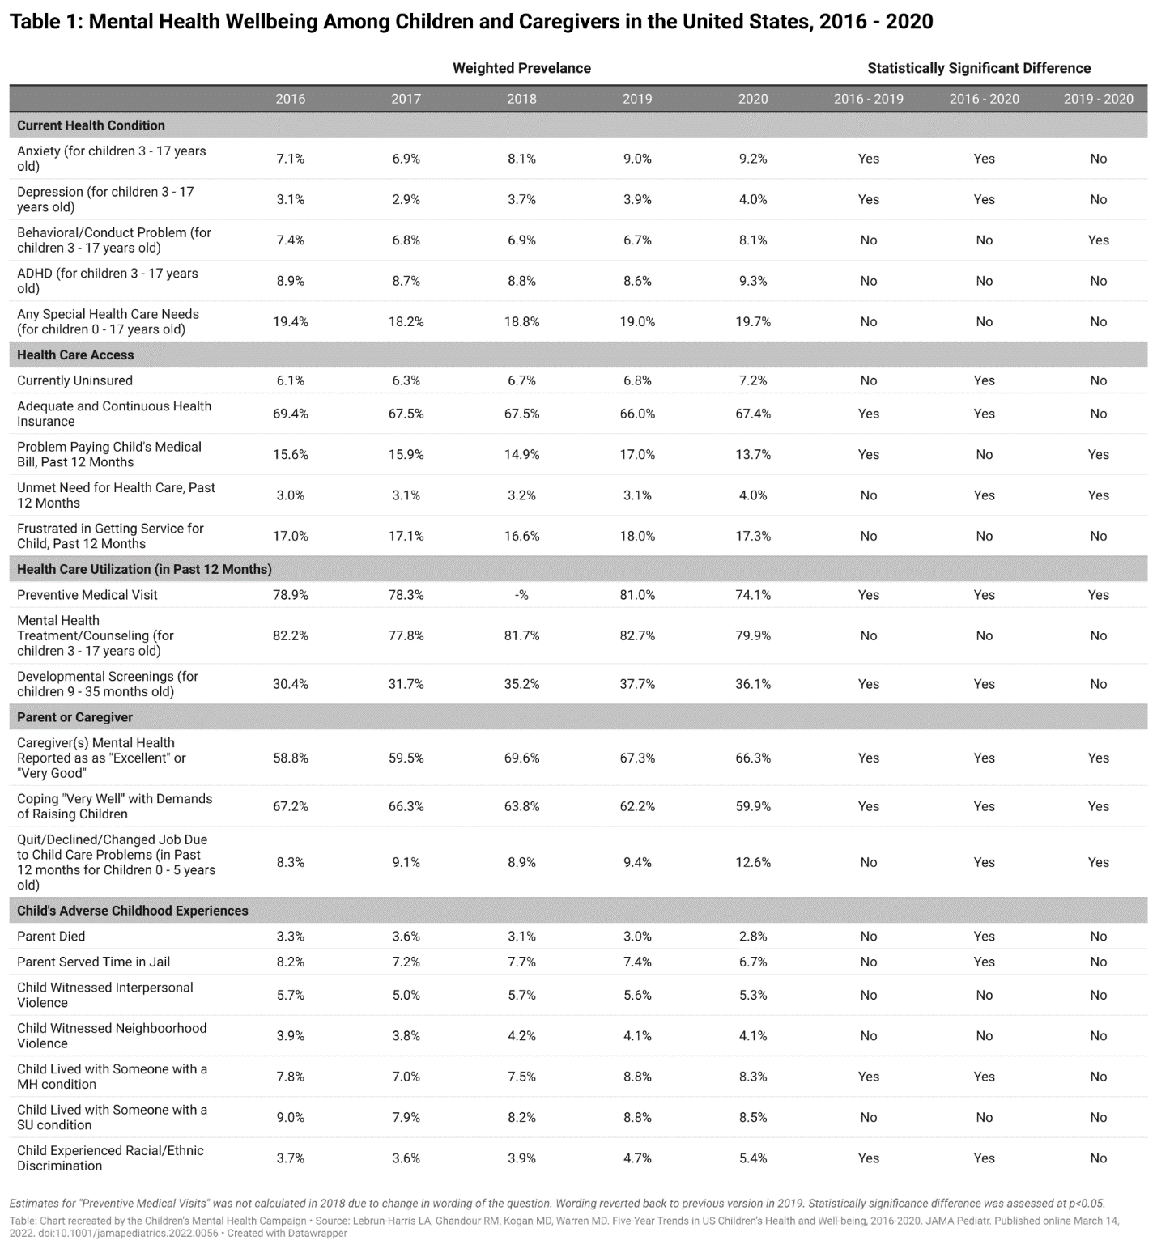

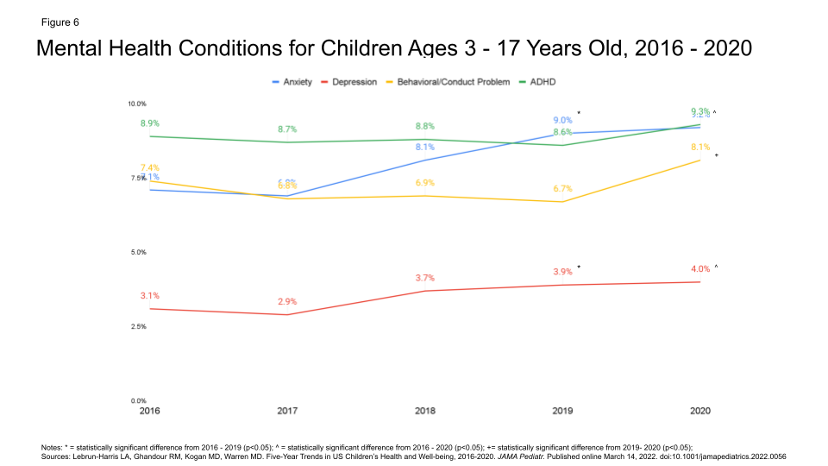

Separate studies of caregivers before and during the pandemic found that the pandemic also had a negative effect on caregivers’ mental health (Spencer et al., 2021; The JED Foundation, 2021; Lebrun-Harris et al., 2022). For example, while the percentage of caregivers reporting “excellent” or “very good” mental health increased from 2016 to 2019, that trend began to reverse in 2020, with only 66.3 % of caregivers reporting “excellent” of “very good” mental health (Lebrun-Harris et al., 2022).

In addition, the percentage of caregivers who said they were coping “very well” with the demands of raising children was already declining prior to the pandemic and continued to do so from 2019 to 2020. While the percentage of caregivers who reported having to quit, decline, or change jobs due to childcare needs was increasing prior to the pandemic, this number increased exponentially from 2019 to 2020, to 12.6 % (Lebrun-Harris et al., 2022).

### Impact of the COVID-19 Pandemic on Disparities

Some communities were disproportionately affected by the pandemic, including communities of color, non-native English speakers, and the LGBTQ+ community. As a result, the pandemic widened existing disparities in health and mental health to the detriment of these communities.

Overall, communities of color experienced disproportionately higher rates of COVID-19 cases and deaths, as well as higher rates of symptoms of anxiety and/or depression compared to White communities (Panchal et al., 2021). Analysis of the CDC’s Household Pulse Survey showed that in late 2020, Black and Hispanic adults were more likely to report symptoms of anxiety or depression compared to non-Hispanic White adults (Panchal et al., 2021). Additionally, Black parents were more likely than White parents to report that the pandemic negatively impacted their children’s education, their ability to care for their children, and their relationship with family members (Panchal et al., 2021).

Literature suggests that the pandemic also disproportionately negatively affected individuals who identify as LGBTQ+; pre-pandemic, these individuals already were more likely to report challenges with mental health and substance use (Dawson et al., 2021). A survey conducted by KFF in December 2020 and January 2021 found that nearly three-fourths of respondents who identified as lesbian, gay, bisexual, or transgender (LGBT) reported that worry and stress from the pandemic negatively impacted their mental health compared to about half of non-LGBT respondents (Dawson et al., 2021).[7] LGBT respondents were also twice as likely to report that the pandemic had a “major impact” on their mental health (Jones et al., 2022). Among children, a survey of adolescents in early 2021 found that the prevalence of poor mental health and suicide attempts was higher among students who identified as gay, lesbian, bisexual, or questioning than among their heterosexual counterparts (Dawson et al., 2021).

In Massachusetts, a survey conducted by the Massachusetts Department of Public Health (DPH) during the pandemic found that while all categories of adult respondents experienced poorer mental health compared to before the pandemic, individuals who identified as LGBTQ+, Hispanic, American Indian/Alaska Native, or multiracial reported the highest rates of poor mental health (DPH, 2022). LGBTQ+ and Hispanic respondents also reported the highest need for suicide prevention and crisis management resources.

### Impact of the COVID-19 Pandemic on Social Determinants of Mental Health

Across the U.S., the pandemic adversely impacted social determinants of mental health. At the same time, worse social determinants of mental health were associated with poorer COVID-19 outcomes. Research shows that individuals experiencing homelessness were at higher risk of COVID-19 exposure and transmission (Abrams & Szefler, 2020). In addition, school closures due to quarantining requirements exacerbated food insecurity for children who rely on school lunch programs (Abrams & Szefler, 2020). Malnutrition, which is tied to food insecurity (Food and Agriculture Organization of the United Nations, 2022), can impact both the mental health and physical health of children (Abrams & Szefler, 2020).

The disparate impact of the pandemic on minority communities extended to the impact on social determinants of health as well. For example, LGBTQ+ individuals were more likely than non-LGBTQ+ individuals to report quitting their jobs during the pandemic, taking time off related to becoming ill with COVID-19, or taking time off from work to care for a sick family member (Dawson et al., 2021). Additionally, while food insecurity increased for all households in Spring 2020 compared to 2018, Black and Hispanic households experienced food insecurity at higher rates compared to White households (Schanzenbach & Pitts, 2020).

These trends were mirrored in Massachusetts. In a survey conducted by DPH during the pandemic, groups that were more likely to report experiencing economic hardship were low-income; non-White; spoke languages other than English; had cognitive disabilities; or identified as non-binary, genderqueer, or not exclusively male or female (DPH, 2022). Hispanic respondents, female respondents, lower-income respondents, and LGBTQ+ respondents were also more likely to have a change in employment to take care of their children (DPH, 2022).

Additionally, as discussed previously, poor mental health can impact social determinants of health. In the DPH survey, individuals who reported 15 or more poor mental health days were more likely to have changes in employment in order to take care of their children, were more likely to worry about expenses, and were more likely to report worrying about basic needs like health care, technology, and childcare during the pandemic (DPH, 2021b).

# SECTION VI: COVID IMPACT STUDY FINDINGS

The pandemic tremendously impacted how we function as a society. This societal shift resulted in quick and visible repercussions, as well as repercussions that have compounded over time and inched into mainstream conversations. One such repercussion is the impact of the pandemic on children’s behavioral health and access to behavioral health care. Healthcare systems, families, and advocates quickly saw the exacerbation of an existing behavioral health crisis while national attention to the issue came a bit later. The purpose of this study is to provide a comprehensive analysis of data from various sources, including findings from published literature, listening sessions, and focus group conversations drawn directly from families, to provide an overview of the impact of the pandemic on children’s behavioral health and well-being. The findings are categorized into four overarching categories: Impact on Family Mental Health, Access to Mental Health Services, Quality of Services, and Virtual Services. For each category, authors discuss key findings from all sources and provide an in-depth analysis of the family voice, coupled with an overview of whether or how the family voice is consistent with national and state-level data and literature.

## IMPACT ON FAMILY MENTAL HEALTH

In this section, authors share the main issues families faced as a result of the pandemic and the public health response to the pandemic and discuss how those issues impacted the mental health and well-being of families across the Commonwealth. The two main findings for this section highlight the increased negative mental health outcomes both for children and the adults who care for them because of the pandemic.

#### Massachusetts youth experienced declining mental health and increased substance use during the COVID-19 pandemic.

During the first year of the pandemic, Massachusetts youth reported significantly higher rates of mental health concerns and increased substance use compared to pre-pandemic rates. In an annual survey conducted by DPH in the fall of 2020, 48 % of youth ages 14 to 24 years old reported feeling sad or hopeless almost every day for 2 weeks or more such that they stopped doing usual activities – an increase from 27 % in 2017 (DPH, 2022).[8] Among these youth, around a third reported either needing information on how to access a therapist, needing access to in-person individual or group therapy, or needing an app on their phone for their mental health (DPH, 2022). Additionally, Black non-Hispanic/non-Latino youth and youth in rural communities reported higher rates of substance use since the start of the pandemic compared to White youth and youth living urban areas (DPH, 2022).

Loneliness and lack of social connections – all of which are connected to worse mental health outcomes – were heightened during the pandemic, especially in the beginning of the pandemic in 2020 (Holt-Lunstad, 2020; Spencer et al., 2021). Youth who participated in study listening sessions and focus groups mentioned feeling isolated, lonely, and, in some cases, “lost” because of social distancing measures. Many reported that not being able to see their friends significantly impacted their well-being. Caregivers also noted how the lack of social interactions impacted their children. Additionally, youth in Massachusetts reported that they had to take on more responsibilities compared to before the pandemic. Eighteen % of youth ages 14 to 17 reported babysitting their siblings more often during the pandemic, while 6 % reported financially helping their families more during the pandemic (DPH, 2022). These additional responsibilities likely added stress and impacted their mental health.

Caregivers and youth who completed the study survey reported similar negative effects of the pandemic on their children’s mental health. Of the 45 adult respondents, 67 % reported that the pandemic made their children’s emotional and behavioral health somewhat or significantly worse. All seven of the youth respondents said the same. Of the adult respondents who reported that their children had emotional or behavioral health challenges, 30 % reported that these challenges first appeared during the pandemic, while 56 % of respondents said that their children had these challenges before the pandemic. Although the number of participants completing the study survey was small, findings are consistent with national surveys.

Not all youth had equal access to and comfort with virtual platforms, leading some to feel isolated and alone. Some youth also mentioned that the experience of isolation and remaining at home during the pandemic provided them with the time and space to get to know themselves, understand their mental health, build healthy coping mechanisms, and invest time in developing new interests and skills.

*“I learned more about myself. What I like to do and my interests and hobbies that I want to pursue down the line.”*

The pandemic has had a negative impact on the mental health of children and caregivers. Issues such as increased social isolation and disconnect from friends and loved ones took a toll on youth mental health, as evidenced by increased prevalence of mental health conditions in the past 2 years. However, some youth were able to find a “silver lining,” discovering new ways to connect with peers online or to use their newfound time and isolation to learn more about themselves and grow.

#### Many caregivers reported increased feelings of family isolation, frustration, fear, and stress during the COVID-19 pandemic, which negatively affected their mental health.

During the study listening sessions, focus groups, and through the study survey, caregivers and youth reported that the pandemic, along with the public health measures implemented to slow the spread of COVID-19, led them to feel exhausted, frustrated, scared, and alone. Families identified factors such as drastic changes to routines, increased responsibilities, increased time spent together in the home, lack of appropriate space in the home for all family members to participate in remote work and learning, fear of COVID-19, and the need to adhere to new public health measures as being extremely challenging. They reported that these factors negatively affected their mental health and their children’s mental health, development, and schooling. These perspectives reflected experiences reported by caregivers around the country (Close, 2020; Clopton, 2020).

**Routines:** In Massachusetts, from early March 2020 through the end of the school year, all childcare programs and K-12 schools suspended in-person operations,resulting in the vast majority of children completing their academic year via remote learning (Office of the Governor, 2020a; Office of the Governor, 2020b). In most cases, these measures resulted in sudden and impactful changes in routines for children and the adults in their lives (Bates et al., 2021).

Additionally, the move to remote learning disrupted routines, which took a toll on children and caregivers (Hanno et al., 2022). A study by the CDC in Fall 2020 showed that parents of children ages 5 to 12 years old receiving virtual learning were more likely than parents of children receiving in-person learning to report that their children’s mental health had worsened. These parents also reported that they themselves were more likely to have lost work and had increased concerns with childcare, increased conflicts between working and providing child care, and increased emotional distress (Verlenden et al., 2021).

At the same time schools moved to virtual formats, most extracurricular, recreational, and other programs and activities previously available to youth were closed. After-school programs, clubs, and athletics are crucial to healthy youth development, behavioral health, and well-being (Amerijckx & Humblet, 2015), and adjusting to the loss of in-person programming was a significant challenge for many families. Caregivers participating in this study said that these disruptions were a significant cause of stress, anxiety, and increased isolation for their children and for themselves.

*“It's COVID. So now there's nothing open, nothing for them to do. It's extremely isolating”*

**Increased responsibilities and time spent at home:** Many caregivers participating in the study said that being home all the time, balancing their work, supporting their children’s work, and performing all the responsibilities they had prior to the onset of the pandemic was challenging and stressful. Some reported feeling as if they had become teachers, therapists, friends, and babysitters on top of their role as caregivers. This is consistent with the literature, which demonstrates increased parental responsibilities, especially among women, as a result of the pandemic (Kerr et al., 2021).

Many caregivers said their families struggled with the increased demands of having all the children and adults in the home at the same time. Some caregivers reported their current housing situation was notadequate for everyone to participate successfully in remote learning and remote work.

*“The kids going remote, it was extremely, extremely difficult for my kids. I was working on top of that full-time, at home, and at the time, I was underhoused. And so, there's four of us in a two-bedroom apartment trying to find a quiet space for me to do work remotely, and for my kids to do remote school.”*

As a result of these stressors, many caregivers said they felt overwhelmed and exhausted, and felt they had too much to juggle. This challenge was elevated by the perceived need to “keep it together for their child.”

*“I have a son, and he cannot see me in an agitated or overwhelmed state because he is very sensitive. So if I come in looking angry and mad, he goes, ‘Well, it's time for me to be angry and mad.’"*

Research suggests that caregivers’ mental health has a significant impact on their children’s mental health and vice versa (Daundasekara et al., 2021; Wolicki et al., 2021). Many of the caregivers with whom the Study Team connected internalized this phenomenon and mentioned the added challenge of needing to maintain balance in the presence of their children to shield them and their mental health from any harm.

While many caregivers discussed the added challenges associated with the increased time spent at home because of the pandemic, a number of caregivers also discussed the positive impacts of being home more often on both themselves and their families. The COVID Impact Study survey results provide a more nuanced view of spending more time at home, suggesting that this consequence of the pandemic may have had both a positive and negative impact on children’s mental health. Many family members reported their ability to spend more time at home with loved ones as a positive impact of the pandemic, and 55.6 % said that the ability to spend more time with loved ones had a positive impact on their children’s mental health. However, a similar percentage (60 %) said that spending more time at home was a negative impact of the pandemic.

In addition to the positives mentioned in the study survey results, during study listening sessions and focus groups, some caregivers and youth discussed positive experiences about the stay-at-home order. Some reported that spending more time at home as a result of the pandemic brought their families closer together and enabled them to bond with their children or caregivers in ways they had never experienced before.

*“A positive way that COVID has affected me, truthfully, was it brought my family closer together.”*

Some families also took advantage of the added time together to start new traditions or hobbies and connect with their loved ones in more meaningful ways. A few caregivers mentioned that these silver linings of the pandemic went a long way to improving their children’s mental health and promoting well-being. Some caregivers also discussed how the pandemic provided them with the opportunity to see their children in a new light. They mentioned feeling thankful for the opportunity to witness their children’s growth and the ways in which they built resilience and persevered beyond what the caregivers thought was possible.

*“For me, my child was receiving classes on Zoom which helped me personally see how he was developing... I saw that despite his condition, I was underestimating him. And this made me feel like he had a potential much greater than what I was seeing.”*

**Fear:** At the core of the family experience with the pandemic was significant fear: fear of getting COVID-19, fear of children and loved ones getting infected, fear of hospitalization because of the sickness, fear of dying as a result of COVID-19, and the general fear and uncertainty that engulfed society for the last 2 years. Studies found increased levels of fear related to the pandemic were correlated with higher levels of depressive symptoms, post-traumatic stress, and insomnia (Samji et al., 2021). During study listening sessions and focus group discussions, caregivers discussed the stress that arose when a household member got the virus, and they did not have the ability to adequately isolate that person from the rest of the household. Caregivers discussed the extreme fear they felt about infecting loved ones with the virus:

*"I'm going to end up killing my family. I'm going to kill everyone. I'm going to die."*

Many caregivers reported living in a constant state of fear, all while having to continue parenting children, many of whom already had significant behavioral health needs. Caregivers also discussed the stress of not knowing who would care for their children if they got sick, had to be hospitalized, or worse:

*“My husband was hospitalized for four days, and my fear was that they were going to hospitalize me, too. And if so, we didn't know where to leave our kids.”*

Many caregivers said that the experience of living through the pandemic was deeply traumatic, both to themselves and their children. Many caregivers reported that their children developed anxiety over getting sick themselves. For many caregivers and children, this anxiety began at the onset of the pandemic, and is still present now. Additionally, caregivers reported not knowing how to talk to their children about the virus or how to ease their children’s anxiety about the sickness while also protecting them. This was especially challenging for families with young children and families who had children with behavioral health needs.

**Challenges adhering to COVID-19 public health safety mandates**: Public health measures implemented to contain the spread of the coronavirus, including wearing face masks, vaccination, and limited visitation of family members in hospitals, were a source of stress for some families. Some family members discussed that adjusting to wearing masks was difficult and confusing for their children, especially young children, and children with mental health needs. One young person recalled,

*“To be honest, it was difficult adjusting to the regular wearing of face masks. It was a bit stressful, too.”*

Some caregivers also mentioned the added challenge of complying to the mask mandate for children with behavioral health needs, saying they felt there was a lack of flexibility and patience on the part of educators and providers when their children were unable to abide by the mask wearing rules:

*“They basically said that he had to come with a mask, or he can't come at all, so then he didn't go.”*

Some caregivers also mentioned the COVID-19 vaccine as a source of stress in their households. They described heightened anxiety around the uncertainty of the effect the vaccine would have on them and their children, and the need for additional information before agreeing to receiving it.

In conclusion, caregivers and youth reported that being confined to home and family for social contact, education support, and emotional support had two often simultaneous effects: some reported a positive impact from spending more time with loved ones, while others reported a negative impact due to the added stress of juggling jobs and educational support, and having too little space in the family house to accommodate work, school, and socialization. In many cases, caregivers experienced a mix of both positive and negative impacts at the same time: struggling with balancing added responsibilities, while also enjoying the ability to spend more time with loved ones. In addition, caregivers repeatedly confirmed what experts early cited as the negative impacts of the pandemic on children and youth – the risk of regression in child development, educational progress, and mental health due to social isolation, remote education, and increased fear and family stress.

## ACCESS TO BEHAVIORAL HEALTH SERVICES AND RESOURCES

Access to mental health services emerged as a major theme from the listening sessions and focus group discussions with Massachusetts families conducted by the COVID Impact Study Team. Many families faced significant challenges accessing the services their children needed to thrive. In this section, the authors define access to health care services as comprising three major components: insurance coverage, availability of usual and ongoing services, and timeliness of services. A lack of or drastic change to any of these components can have negative impacts on health and mental health. While almost all children in Massachusetts have insurance, and Massachusetts worked to expand access to mental health services during the pandemic (for example, through increased flexibilities in telehealth, discussed in the “Virtual Services” section), with increases in mental health conditions and mental health needs during the pandemic, many families reported being unable to access the mental health services their children required. Families discussed specific challenges in accessing mental health services, which included difficulties identifying necessary services, challenges with relying on primary care providers to facilitate access to mental health services, changes in accessing school-based behavioral health services, decreased availability of services on behavioral health boarding, and increased challenges in accessing culturally sensitive, linguistically specific services.

#### Caregivers participating in this research generally did not identify insurance issues or problems paying for medical bills to support their children’s mental health as barriers to access.

Only a few caregivers participating in this research study identified insurance issues or problems paying for medical bills to support their children’s mental health as barriers to access. This is likely attributable to high rates of insurance coverage among children in the Commonwealth.

Massachusetts ranks first among all states for the percentage of children under age 19 with health insurance; only 1.5 % remained uninsured in 2019 (“Massachusetts State Data,” 2022). During the pandemic, there was a shift from private to public insurance as employment was disrupted and associated benefits like health insurance were also disrupted and as federal benefits for certain groups, like children, were expanded. From February 2020 to April 2022, Massachusetts’s Medicaid and Children's Health Insurance Program (CHIP) enrollment increased 23.9 % (Corallo & Moreno, 2022). Increases in Medicaid and CHIP enrollment for adults and children are likely to continue until the end of the national public health emergency due to the temporary continuous enrollment requirements (Corallo & Moreno, 2022).[9]

Increases in Medicaid and CHIP enrollment during the pandemic did not translate to increased utilization of mental health services. On the contrary, from March 2020 to August 2021, utilization of mental health services declined 23 % among Medicaid and CHIP beneficiaries 18 years and younger (Panchal et al., 2021).

#### Caregivers reported difficulties identifying pathways to accessing behavioral health services, whether with new or existing providers, which they ultimately felt impacted their children’s mental health.

The experiences of families in Massachusetts (and nationwide) with accessing usual and ongoing services was severely disrupted because of the pandemic. The families who provided feedback for this study discussed several challenges with accessing services, such as not being able to get a hold of their children’s usual mental health providers, not knowing where to go to access adequate providers to support their children’s behavioral health, and the impact of remote learning on access to appropriate school-based behavioral health resources. Many caregivers discussed the toll of having to play a more intensive role providing behavioral health support to their children in the absence of access to community or school-based services.

**Inaccessibility of children’s usual mental health providers:** Massachusetts research shows thatthe top reasons for delayed care for individuals with persistent poor mental health were canceled or delayed appointments, or that provider’s offices were closed or unresponsive to calls (DPH, 2022). A survey conducted in Fall 2020 showed that 18 % of respondents said that they had delayed medical care since July 2020 (DPH, 2022). The caregivers who participated in study listening sessions and focus groups echoed this sentiment of not being able to contact their providers, both existing and new. Caregivers recalled that when the emergency order was put in place in March of 2020, it became significantly more challenging to connect with existing providers. In many cases, providers abruptly stopped offering services without explanation or canceled appointments without rescheduling. Caregivers felt that they were left to chase providers for new appointments, sometimes making dozens of calls to access services, often to no avail. Caregivers reported feeling frustrated by what they perceived as a lack of follow-through from providers. While many caregivers reported that they understood the overwhelming nature of the crisis for many providers, they did share their perception that the quality and effectiveness of the services they received diminished as a result. This is discussed further in the quality section below.

**Not knowing where to go to access children’s mental health services:** Caregivers recognized thattheir children needed support but did not know where to go or how to find services to begin with.

*“No, it didn't even occur to me to look for [behavioral health services. I didn't know this existed, so I wasn't going to ask for something I didn't know existed.”*

This has been a longstanding challenge for many families, but it may have been exacerbated by the pandemic, as well as the resulting lack of in-person connection with providers. Caregivers reported feeling woefully unknowledgeable, through no fault of their own, of the different services available to them when their children needed behavioral health services.

**Inconsistent access to behavioral health support from pediatricians:** In the years prior to the pandemic, there was significant investment in the Commonwealth to support the integration of behavioral health and primary care through the MA Child Psychiatry Access Project (MCPAP), the development of MassHealth Accountable Care Organizations and programs to embed clinicians, and to some extent family partners, in pediatric primary care practices. Indeed, MCPAP utilization for FY21 was up 27% over pre-pandemic FY19 (12,651 vs. 9,999). The volume of MCPAP face to face assessments provided increased by 26% from FY20 to FY21 and increased 71% over FY19 fueled in large part by their practice of offering these assessments via telehealth (i.e., videoconferencing). Full year face-to-face assessments were up 32% (FY21 vs. FY20, 2,713 vs. 2,037). MCPAP’s Resource and Referral Specialists provide enrolled pediatric practices services such as identifying appropriate behavioral health treatment resources for the child/family and providing the practice and/or family the contact information to connect and engage with treatment providers. During the pandemic, like others, these specialists have had difficulties finding providers with openings for new clients.

Only a handful of caregivers who participated in the study mentioned their children’s pediatricians or primary care providers as points of access to mental health services. Caregivers who connected with pediatricians for mental health-related issues described those experiences as mostly ineffective. Caregivers recalled feeling that their children’s pediatricians were not equipped to address their children’s behavioral health needs. One caregiver specifically mentioned feelings that there were issues with the pediatrician's medication management for their child’s mental health.

*“I think my pediatrician is just not qualified to manage these kinds of medications. I mean, I'm not trying to speak for every pediatrician, just the majority of them. There is a reason there are mental health medication prescribers.”*

In a handful of cases, caregivers mentioned that their children’s primary care providers successfully connected their children with behavioral health specialists, but more often caregivers described feeling frustrated due to the pediatricians failing to provide the referral to connect their children to adequate services.

*“I spent many years trying to find help talking to the primary doctor, and they never, never sent me to do any kind of test. And still today I'm still trying to find a referral for a neurologist.”*

This discussion suggests that some of the behavioral health needs of children were beyond those that could be served in a pediatric practice, and that pediatricians’ ability to find appropriate behavioral health services in the community was hampered by the lack of availability due to long waiting lists and workforce shortages.

**Changes in access to school-based behavioral health:** Schools are uniquely positioned to facilitate access to behavioral health services for children and adolescents as they all attend school. Nationwide in 2019, 15.4 % of adolescents, or 3.7 million adolescents, ages 12 to 17 received mental health services in an educational setting (SAMHSA, 2020b). In 2020, that shifted to 12.8 % of adolescents, or 3.1 million adolescents (SAMHSA, 2021). While Massachusetts is a leader in many areas, there remains much room for improvement in the school-based behavioral health realm. Children in the Commonwealth are not accessing school-based behavioral health services in an equitable manner, and the quality and delivery of these services are not standardized. While there are a myriad of factors that contribute to this, the ratio of school-based behavioral health staff to students is an important signal of the overall availability of mental health supports in schools (Hopeful Futures Campaign, 2022). The national recommended ratios for school psychologist to students is 1:500, 1:250 for school social workers, 1:250 for school counselors, and 1:750 for school nurses (Pearrow et al., 2020). During the 2018 to 2019 school year in Massachusetts, the ratios were 1:734 for school psychologists, 1:536 for school social workers, 1:404 for school counselors, and 1:465 for school nurses (Pearrow et al., 2020). As of the February 2022 publication of *America’s School Mental Health Report Card*, the ratios in Massachusetts were 1:825 for school psychologists to students, 1:1,522 for school social workers, and 1:396 for school counselors (Hopeful Futures Campaign, 2022). Prior to the pandemic, Massachusetts did not meet the recommended ratios for school-based behavioral health staff, excluding school nurses, and since the onset of the pandemic, they are further out of ratio for school psychologists and social workers to students. This reflects a further decrease in the accessibility of school-based behavioral health services during the pandemic as Massachusetts schools were and are not adequately staffed to provide behavioral health services to all students.

However, even with an understaffed and unstandardized school-based behavioral health system, caregivers reported that their first access point to behavioral health services was often through schools. Some caregivers perceived that many schools in Massachusetts did an excellent job supporting students with special needs and their families. Yet many caregivers were dissatisfied with their schools’ communication or services during the pandemic. In the wake of schools closing and becoming virtual, some families lost the behavioral health services they were receiving in schools. They reported feeling that schools often had little to no information about community-based services that could replace the school services they lost, and that they had limited options to support their children’s behavioral health outside of school.

**Increased caregiver burden**: Because of the perceived lack of information on available services, many caregivers reported that they regularly had to research and seek out services on their own, which they found time consuming and stressful. The caregivers that were successful in finding effective support for their children recalled that the road to finding these supports was challenging and that they felt they had to “knock on every door” to locate effective help for their children. Some of the caregivers who joined the study listening sessions were intimately familiar with the Massachusetts behavioral health system, either because they were employed in a part of the system or were caregivers to children who utilized services. Even those caregivers who had extensive knowledge regarding how to navigate the system reported that the pandemic resulted in unprecedented challenges with accessing the information and services they needed for their children. Despite their best effort to locate appropriate services for their children, they were coming up empty:

*“I could go on and on about the work that we're doing to get the help, and what we're finding. [We had] to jump through every hoop there is. We've hit up the media. We've hit up everything. There's not a stone that's gone unturned for us, and there is nothing.”*

Some caregivers also reported having to act as their own service providers as they waited for services. Most commonly, caregivers reported having to be their own case managers: learning about and researching therapies or services, figuring out what their children needed, and doing the work of trying to locate services in their areas or, in many cases, in the closest available areas, often hours away. Many caregivers reported that they themselves became the only mental health support that their children were able to access during the pandemic. Caregivers reported that playing these multiple roles contributed to parental burden by taking on more than they should have to to keep their families functioning and safe.

*My daughters said, "Mommy, my therapist?" And I said, “Mommy is the therapist. Honey, what do you want to talk about?”*

Ultimately, caregivers reported that the inability to access effective services, either via channels known to them (existing providers, school-based services, etc.) or when trying to access new services, took a toll on their own mental health. Some reported feeling hopeless and frustrated as they struggled to find the necessary supports and services for their children. Many caregivers mentioned how hard it was to see their children suffer and felt that, despite trying to do everything they could to support their children, their efforts were falling short.

#### The existing problem of long wait times for both inpatient and outpatient services was exacerbated during the COVID-19 pandemic, likely contributing to the increase in ED boarding that occurred during that time.

Timeliness of services and ability to provide behavioral health care quickly were issues identified prior to the onset of the pandemic across the nation, as well as in Massachusetts (Office of Disease Prevention and Health Promotion, 2022b). In a 2002 survey conducted by PPAL in partnership with Health Care For All, 33 % of surveyed Massachusetts caregivers reported that they had to wait more than a year for their children to receive treatment as often as they needed, 13 % waited from 6 months to 1 year, 21 % waited 1 to 6 months, and 9 % reported they still had not received the services that they needed at the time of the survey (Frank et al., 2002). However, during the pandemic, increases in the number of children and adults seeking behavioral health care and severe provider shortages (see Quality of Services section below for more detail) further lengthened waits for mental health services. Indeed, a survey conducted by the American Psychological Association several months into the pandemic in 2020 revealed that 68 % of surveyed psychologists said their waitlist was longer since the pandemic started and 65. % said they did not have the capacity to take new patients (American Psychological Association, 2021). In 2022, *The Washington Post* reported that nationally, clinicians with private mental health practices saw their pre-pandemic waitlists grow in part because their existing patients were not leaving (Warner, 2022). In Massachusetts, a Fall 2021 survey of mental health provider organizations reported that waitlists continued to grow during the pandemic. Thirty-seven (37) organizations responded to the survey and collectively reported that the volume of people waiting for outpatient services in the previous 12 months had increased with around 3,015 children and youth on waitlists for initial assessments, 3,221 on waitlists for ongoing therapy and 143 for medication services at the time of the survey (Association for Behavioral Healthcare [ABH], 2022). Waitlists for initial assessments and ongoing therapy were an average of 13.6 weeks and 15.3 weeks for ongoing therapy (ABH, 2022). In March 2022, Boston Medical Center reported that they began contacting parents of children who had joined a 170-person waitlist in April 2021, 11 months prior (Bernstein, 2022).

Caregivers across this study’s listening sessions reported that their children waited many months for access to behavioral health services across all treatment modalities (inpatient, outpatient, in-home, etc.).

*“We've been on the waiting list. I finally got my son into the partial hospitalization program, after waiting over 6 months for a spot.”*

Many caregivers were told to call each week to make sure they and their children were “still on” the waitlist, adding to their burden. Some caregivers told the Study Team that when they were finallyable to access an appointment, they were told that the provider was leaving, and they would have to go back on a waitlist. In many cases, caregivers acknowledged that when they and their children were able to access services, especially non-emergency services from community-based organizations, the services were helpful. They reported that they could see the providers were doing the best they could. However, caregivers reported that, often, when they were stuck on waitlists for community-based services and their children reached a crisis point, they had to rely on emergency services. In many cases, caregivers reported feeling that the services they received on an emergency basis were not effective in addressing their children’s needs.

**Impact on behavioral health boarding:** The pandemic exacerbated an already problematic behavioral health boarding crisis in Massachusetts and across the nation. *The Boston Globe* reported that prior to the pandemic, 6 to 18 % of ED beds were occupied by behavioral health boarders. Since the onset of the pandemic in 2020 and through to 2022, behavioral health boarders have filled 21 to 28 % of ED beds (Bartlett, 2022). They have also been boarding for longer during the pandemic – an average of 78 hours compared to 26 -34 hours prior to the pandemic (Bartlett, 2022).Among youth in Massachusetts, the number awaiting inpatient hospital placements has increased drastically during the pandemic, while the number of available inpatient beds has decreased (Figure 7).

*“At one point in time, there were 17 kids that were close in age to my child and waiting for the same exact bed that she was waiting for. And there were no beds. It was brutal. And just seeing the amount of kids that were desperate for the same beds as my child's.”*

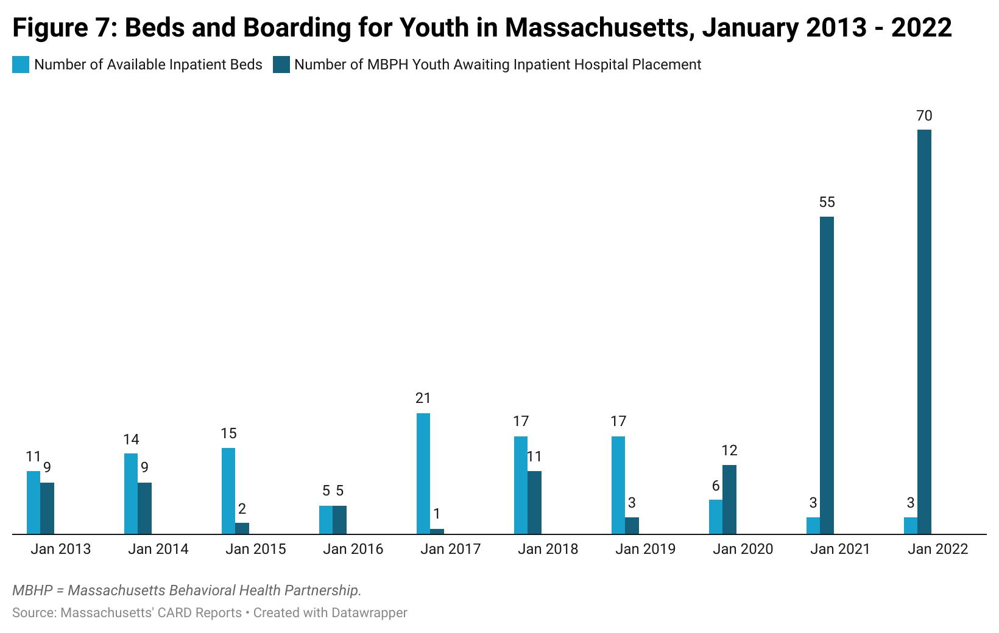

* “**Available inpatient beds” on this figure refers to beds open at the time, not the total of inpatient beds available. The total number of child and adolescent beds in Massachusetts was 323 in March 2021 and 441 in August 2022.**

|  |
| --- |
| **CALL OUT BOX: Understanding Bed Availability**  The matching of a child awaiting an inpatient hospital placement to an open inpatient bed is not a one-to-one equation, where every time a bed opens a child is automatically assigned to it. The bed(s) open on a given day may not be clinically or otherwise appropriate to meet the needs of a particular child who needs inpatient care. In some cases, this means that the child will wait for long periods of time for the right type of placement to open.  There are several factors that influence whether a specific placement is appropriate for a child. These factors include:   * **Type of placement:** Inpatient beds are developed for specific age groups and are often specialized for children with particular diagnoses, needs, and conditions including co-occurring conditions (serious medical conditions or autism spectrum disorders). * **Level of acuity in the milieu**: Staffing patterns, sleeping arrangements, and other services are designed for a mix of acuity among the patients on the unit at any given time. Safety and the ability to provide the right clinical interventions may be at risk if the number of high acuity patients exceeds the capacity to properly care for them. * **Location of inpatient hospital placement:** Children in inpatient settings need to maintain connections to their families, caregivers, and support systems. A placement too far from a child’s home may compromise the ability of caregivers and loved ones to visit and or participate in treatment. * **Caregivers’ choice:** Caregivers have the right to refuse a placement, if for any reason they believe it is not in the right for their child.   In addition, the number of licensed beds in an inpatient unit is often higher than the number of beds that are available to patients on a given day. Two of the primary factors for this are:   * **Staffing shortages/issues:** Staff vacancies can be both short term (e.g. vacation, holiday, illness, personal time) and long term (leave of absence, recruitment challenges). As a result of vacancies, a unit may be unable to be at full capacity on a given day or for long periods of time. * **Compliance with public health mandates:** For a period of time during the pandemic, public health requirements for social distancing and staffing caused temporary closure of a number of beds in the system. As these mandates are lifted these beds are coming back online. |

#### Challenges in access to mental health services (including wait times and finding appropriate providers) worsened for families of color and non-native English speakers during the COVID-19 pandemic, highlighting the existing need to increase diversity of the workforce, promote cultural humility for providers, and improve access to providers that reflect the cultural and linguistic makeup of the communities they serve.

The disparate impact of the pandemic on minority communities (including communities of color, LGBTQ+ communities, and communities of non-native English speakers) is well established (see above section on “Impact of the COVID-19 Pandemic on Disparities''). The impact of these disparities was reported widely by the individuals and families within those communities who joined the study listening sessions, focus groups, and completed the study survey. Families of color and non-native English speakers in the listening sessions and focus groups reported that cultural and linguistic barriers greatly impacted their ability to get information about and access to mental health services for their children. Some caregivers reported increased challenges with finding information about mental health services in their language.

*“It isn't accessible. I think the lack of information in various languages was what caused the biggest problems because there was information. There wasn't a place where everyone had access to it.”*

Caregivers also discussed the challenge of locating providers that reflected their children’s cultural and ethnic backgrounds. For non-native English speakers, the linguistic factors often presented a significant barrier early on in their search for services. One mother recalled not being able to make initial contact with a provider because the phone answering system they reached did not have an option in Spanish:

*“I would make a phone call about my son. I don't speak English well. I would hear: "Blah blah blah, one. Blah, blah, blah two." I don't even know what the machine is saying.”*

Many caregivers also reported that their wait times were increased because of either a need for an interpreter or having to wait for a provider who spoke their language to become available. Data suggest it is not uncommon for families of color, especially non-native English speakers, to have to wait longer for access to services (Otte, 2022). In some cases, caregivers reported feeling that they had to choose between receiving timely care for their children in English and waiting to interact with a provider in their native language, therefore subjecting their children to longer wait times.

***“****With the therapist that I have, they have never asked for a translator. With the little bit of English that I know, that's what I use to communicate.”*

The need for increased diversity and cultural responsiveness among mental health workers was present well before the onset of the pandemic, and the families the Study Team connected with who were from minority backgrounds reemphasized the need for intentional workforce development measures to ensure that, when the need arises, children and youth can connect in a timely manner with providers who share their cultural and linguistic backgrounds.

In conclusion, the pandemic exacerbated existing challenges in accessing behavioral health services for children and families. Among the top barriers to access were the inability to connect with existing and new providers, a lack of knowledge on the part of caregivers as to where and how to access services for their children, the loss of access to school-based behavioral health services, and significant wait times for access to providers all across the service delivery spectrum. These barriers to access were heightened for families of color and non-native English speakers and resulted in increased caregiver burden as well as a worsening of the children’s behavioral health boarding crisis.

## QUALITY OF SERVICES

The quality of services received and family interactions with providers, including school personnel, was a central theme in the discussions held with caregivers and youth. In this section, the authors define high-quality health care as receiving services that are safe, effective, patient-centered, timely, efficient, and equitable (Agency for Healthcare Research and Quality [AHRQ], 2018). In study listening sessions and focus groups, youth and caregivers highlighted the impact of understaffing, staff turnover, reduced provider capacity, and staff burnout in discussions about the quality of the mental health services they received throughout the pandemic. Many caregivers described negative experiences with regards to the quality of the services they received. In some instances, caregivers described providers as being unavailable, rigid in their services, overwhelmed, and judgmental. With the exception of services delivered by community-based organizations, a vast majority of caregivers and youth reported feeling that the services they received were not effective in improving their children’s mental health.

#### Many caregivers believe that staff turnover, staffing shortages, and staff burnout, which were exacerbated by COVID-19 pandemic, had a negative impact on the quality of services delivered to their children.

Several caregivers perceived understaffing, staff turnover, and reduced provider capacity as having a significant impact on the quality and effectiveness of the services they received for their children. Caregivers reported being unable to get a hold of their existing providers or having difficulty finding new providers to treat their children. Forty-two % of respondents to the study survey identified a lack of access to providers as a primary barrier in accessing mental health services for their children throughout the pandemic. Additionally, many caregivers mentioned that because of the pandemic, the behavioral health services their children were receiving (either in-home, school-based, or community-based services) were temporarily discontinued or received intermittently. This was a detriment to their children, as they required the safety and stability that comes from the care of a reliable provider to improve their behavioral health. Some caregivers reported feeling that staff turnover also significantly contributed to the discontinuation and/or intermittent nature of the services received by families.

*“My daughter got diagnosed last year during the pandemic. Up until now it's been a struggle in getting services, basically. So, I don't know what happened to all the professional people that have experience. I don't know if they're not practicing anymore, but it's just that everywhere I call, you call and it's like, ‘There's a lack of staffing. We can't do this; we can't do that’ … For me it's been very tough finding someone to help me navigate through it all.”*

Healthcare provider shortages and maldistribution, including amongst mental health providers, existed prior to the pandemic with demand often outweighing supply (ASPE, 2022; Mercer Global, 2018; AAMC, 2021). In 2017, over 123 million Americans lived in areas with mental health professional shortages (Behavioral Health + Economics Network, 2018). In 2019, there were approximately 8,300 practicing child and adolescent psychiatrists with over 15 million children and adolescents with a treatable mental health condition (AACAP, 2019). In a 2018 report, it was predicted that existing shortages would continue increasing in the following years (Behavioral Health + Economics Network, 2018). These predictions were accurate. In 2021, the number of Americans living in designated mental health provider shortage areas increased to 129.6 million, an increase of over six million from 2017 (Behavioral Health + Economics Network, 2018; KFF, 2021). Massachusetts specifically also experienced a healthcare workforce shortage prior to the pandemic (Taube & Lipson, 2021). These shortages were exacerbated by the pandemic.

Although overall staffing levels may have rebounded to pre-pandemic levels, behavioral health providers reported shortages as demand for services increased during the pandemic. In a survey conducted by the National Council for Mental Wellbeing in September 2021, 97 % of respondents said that it was difficult to recruit employees while 82 % said it was hard to retain employees (National Council for Mental Wellbeing, 2021). Seventy-eight % of respondents said that the demand for their organization’s services had increased in the past three months – a substantial increase from August 2020. In addition, hospitals in rural areas reported that the pandemic had worsened their longstanding staffing, capacity, and financing challenges (Grimm, 2021). Experts also say that while telehealth has reduced no-shows and dropout rates for patients, continued increased demand means that providers are still not able to accept all new patients (Bernstein, 2022).

Specifically in Massachusetts, the pandemic placed some initial strain on behavioral health employment. Analysis shows that in Massachusetts, the number of postings for mental health counselors decreased slightly from January 2020 to March 2020 but increased during the same time period for social workers and substance use workers (Taube & Lipson, 2021). Following that period, job postings declined in the spring of 2020 (with the biggest declines in April 2020) but began to approach pre-pandemic levels during summer 2020 (Taube & Lipson, 2021). Similar trends were observed with unemployment claims among behavioral health providers with a peak in spring 2020 and a move to pre-pandemic levels in summer 2020. However, while provider levels have rebounded to pre-pandemic levels (which were not necessarily sufficient), mental health needs and demands now exceed pre-pandemic levels, as discussed in earlier sections.

Additional analysis shows that in Massachusetts during the pandemic, recruitment and retention of mental health providers has been challenging. A survey of providers in Fall 2021 showed that for every 10 clinicians hired to work in mental health clinics, 13 clinicians left those positions (ABH, 2022).Clinics surveyed reported that, on average, there were 17 staff vacancies and a lack of suitable compensation and benefits were reported as the primary reason for providers leaving (ABH, 2022). A separate news article reported that higher wages from non-healthcare sectors (such as grocery or retail stores) has led to high turnover rates and vacancies at certain healthcare organizations (Van Buskirk, 2021).

Shortages in staffing can also contribute to longer wait times and waitlists for patients and the availability of services. An analysis of freestanding psychiatric facilities and psychiatric units in acute care hospitals in Massachusetts showed that from February 2021 to October 2021, the percentage of licensed beds that were closed due to staffing needs increased from 9 % to 14 % (MHA, 2021). Respondents reported that the biggest barriers to filling open positions were applicants refusing offers because of pay rates, along with a lack of qualified applicants (MHA, 2021). Ultimately, research shows (and families confirmed) that limited healthcare capacity because of the above stated issues was the top reason individuals in Massachusetts delayed their routine and urgent mental health care (DPH, 2022).

**Provider burnout:** Nationally, healthcare provider burnout worsened during the pandemic. While providers experienced burnout prior to the pandemic (Advisory Board, 2019), added pandemic-related stresses have contributed to increased mental health challenges, burnout, and turnover rates for providers. A survey conducted by the American Psychological Association in 2021 reported that 46 % of surveyed psychologists experienced burnout, compared to 41 % in 2020 (American Psychological Association, 2021). Additional data from a survey conducted in September 2021 show that 51 % of surveyed healthcare workers said their mental health had worsened during the pandemic (ASPE, 2022).

Research suggests that burnout and compassion fatigue can negatively impact the quality of services provided to patients. Specifically, high levels of burnout can result in providers having insufficient resources to deal with the demands of their jobs, leading to impaired job performance (Morse et al., 2012). Burnout can also lead to compassion fatigue with providers becoming less empathic, collaborative, and attentive, thus decreasing patient satisfaction (Morse et al., 2012). In many cases, caregivers reported noticing their providers were overwhelmed and burnt out, which they felt impacted the quality of services that were provided to their children:

*“…the staff are burnt out. And they're beginning to say things like, ‘Well, their behavior was bad today.’ Their behavior was telling you something was going on, the behavior was telling you they're feeling your distress, their behavior was telling you they're symptomatic.”*

Many caregivers also discussed noticing the impacts of burnout and compassion fatigue in the way providers treated their children, mentioning the need to “sensitize” and “humanize” the providers who were providing care for their child. Some caregivers also reported that, perhaps they felt judged and blamed by providers for their children’s needs because the providers were overwhelmed and burnt out. Some caregivers also mentioned that from their perspective, providers were punitive of their children because of their symptom presentation.

In conclusion, the pandemic had a devastating impact on an already insufficient behavioral health workforce, and caregivers perceived this impact as undercutting the quality of the services they received throughout the pandemic. As a result of understaffing, staff turnover, and staff burnout, caregivers perceived their providers as insensitive and lacking compassion. In many cases, this resulted in caregivers feeling frustrated and unsatisfied with the quality of services their children received. Caregivers reported feeling that these services were not effective in addressing their children’s worsening mental health conditions. Ultimately, the pandemic impacted the daily life and work of individuals across all professions, including those in the mental health field, and this impact was felt by caregivers and youth in the perceived quality of the services they received during this time. As will be discussed further in Section VII, hospitals, providers, and government agencies alike worked tirelessly to try to address these new and worsening issues in several ways. While some of the changes and new initiatives launched helped address the workforce problem, workforce challenges remain a top concern for providers across the Commonwealth and the nation. One portion of the Recommendations Section (Section VIII) is devoted to potential solutions to help alleviate these challenges.

## VIRTUAL SERVICES

In this section, the authors discuss how tele-behavioral health services were changed as a result of the pandemic and the impact this had on children and caregivers. The findings highlight that because of the state’s quick response to the need for telehealth services, more families were able to get access to the care they needed. However, some caregivers reported that telehealth services were not effective or appropriate for meeting their needs.

#### Expanded availability of tele-behavioral health services improved access for many Massachusetts youth, however tele-behavioral health was not effective for all children.

Prior to the pandemic, telehealth use for mental health services was beginning to slowly increase but was still not widely available. A study that looked at national telehealth use among privately insured beneficiaries in large, private plans found that in 2017, over 50 % of telemedicine visits were for mental health (Barnett et al., 2018). However, although this study found that from 2005 to 2017 reported telemedicine visits increased exponentially, telemedicine use was still not widely common in 2017 (Barnett et al., 2018). A separate study echoed this – national data on mental health facilities showed that the percentage of mental health facilities offering telepsychiatry services doubled from 2010 to 2017 (from 15 % to 29 %), but the majority of facilities still did not offer telemedicine services (Spivak et al., 2020).

In Massachusetts, rates of telehealth utilization among commercially insured patients in Massachusetts almost doubled from 2015 to 2017, but in 2017 it was 39 % lower than the national rate (Massachusetts Health Policy Commission, 2020). Therefore, initiatives were put in place to help increase accessibility to telehealth. In 2017, the Pediatric Physicians’ Organization at Boston Children’s Hospital (PPOC) implemented a telemedicine initiative to connect children that did not have access to local psychiatric care with psychiatrists at Boston Children’s Hospital for remote consultations and follow-up care (Massachusetts Health Policy Commission, 2022). In 2019, PPOC used this experience to develop a telehealth pilot program to help behavioral health clinicians in pediatrics practices to conduct remote evaluations and follow-up care. These experiences became crucial in the pivot to exponentially increase use of telehealth during the pandemic.

At the start of the pandemic, Governor Baker issued an executive order requiring all commercial plans to cover clinically appropriate, medically necessary behavioral services delivered via telehealth (including telephone and live video) and prohibited the implementation of administrative requirements that were more restrictive than those of MassHealth. Correspondingly MassHealth issued the first of a series of bulletins outlining coverage policies for telehealth services including behavioral health. Subsequent bulletins and legislation have made the expansion of tele-health access to behavioral health permanent and subject to parity laws.

Due to this increased flexibility, telehealth has been widely used during the pandemic and has been effective for some families. A survey conducted by PPAL in May 2020 showed that 62 % of responding caregivers and 59 % of responding youth said that services provided through telehealth were at least somewhat more effective than face-to-face visits, though many still had a strong preference for face-to-face visits (Lampert, 2020).

The increased availability of telehealth may help eliminate some barriers in access to care for families. For example, caregivers in the study listening sessions and focus groups reported that the move to virtual facilitated access to services by removing significant barriers such as transportation costs, scheduling issues, childcare, bureaucratic challenges, and lack of time. Caregivers also reported that providers were able to find creative ways to keep their children engaged:

*“His therapists have been really good. When he had to just do strictly everything Zoom, you know, they were able to email things to me so I could print them, or they figured out a way to do Zoom therapy which was really difficult with his age. But they had videos and books. They made it work. It was so different from having them come over and everything, but they definitely found a way to make it work.”*

Telehealth use can also assist in reducing stigma attached to mental health. PPOC reported that the move to virtual care has also reduced some stigma associated with seeking mental health care by “providing more distance and comfort” (Augenstein et al., 2022).

However, the use of telehealth may not be appropriate for all children. Some caregivers reported that some children, especially young and neurodiverse children, were not able to stay fully engaged during telehealth services. One parent reported:

*“Then he started with online therapies, but he was 1 year and 6 months old. He wouldn't be interested. He would get nervous. He didn't want to be stopped in front of a screen. I had to run after him.”*

Young adults also expressed concerns about telehealth. A PPAL survey conducted in May 2020 reported that 63 % of responding youth cited losing interest or needing to focus as they participated in telehealth appointments as a concern for them, and 41 % cited lack of privacy as an additional concern (Lampert, 2020).

Some caregivers also reported issues with internet access and technology. The PPAL survey showed that 20 % of responding caregivers reported missing behavioral health appointments due to challenges accessing the necessary technological apps (Lampert, 2020), and some caregivers reported in study listening sessions and focus groups reported not having stable and reliable internet access. Caregivers also mentioned issues with access to technology, bandwidth, and appropriate space, which hindered their ability to engage with virtual platforms.

In conclusion, because of the need for more access to telehealth services, the state was able to provide greater flexibility and payment parity and remove administrative barriers to use of tele-behavioral health services, which allowed more caregivers to access necessary behavioral health services. However, caregivers reported that sometimes tele-behavioral health services did not meet their needs, and they were not always offered alternative remote approaches of the option to choose in person treatment.

# SECTION VII: COMMONWEALTH OF MASSACHUSETTS POLICY, REGULATORY, AND PAYMENT REFORMS IN RESPONSE TO THE COVID-19 PANDEMIC

From the start of the pandemic, the Commonwealth, began rapidly innovating to meet both existing and emerging behavioral health needs. The input from youth and families received for this report relates to events that were occurring before the start of the pandemic to the present. While it is clear that serious systemic issues in the behavioral health system persist, important and impactful work has been accomplished over the last two years, which will have lasting impact on improved access to care.

The Baker-Polito administration began the process of rolling out the Behavioral Health Roadmap in July of 2020 with the aim of ensuring the right treatment when and where people need it. The Roadmap includes critical behavioral health system reforms that are already under way or will be implemented soon.

## Major initiatives which have been implemented or are in progress include:

## 

**Consumer Support**

*Implemented*

* MassSupport, a crisis counseling program that was available from June 2020 to November 2021, providing information and support through a toll-free telephone number, email address, and website. The program provided online screening tools for individuals to use anonymously to assess substance use, adolescent depression, generalized anxiety, alcohol use, gambling, eating disorders, bipolar symptoms, psychosis, opioid misuse, PTSD, and well-being. Those whose scores indicated they may be experiencing challenges in any area were given a list of resources where they could receive help and were encouraged to reach out to MassSupport. Services were offered in English and seven other languages. Additionally, the program trained providers in a suicide prevention and treatment, self-care, and Psychological First Aid (PFA) and Post Traumatic Stress Management (PTSM). Working with outside consultants, a group of staff worked to create peer support protocols. A training was developed and delivered to the MassSupport Peer Supporters. A manual that other programs and organizations can use to help them develop their own peer support programs was developed.
* Enhancements to [Handhold MA](https://handholdma.org/) and [Network of Care Massachusetts](https://massachusetts.networkofcare.org/mh/index.aspx). These provided information and resources to raise awareness of the mental health impacts of isolation and the pandemic, reduce the stigma of talking to friends and neighbors about mental health, and increase access to services to address the impact of the pandemic on mental health and addiction, including offering on-demand services.
* The newly launched 988 Lifeline is a direct three-digit phone line to trained National Suicide Prevention Lifeline call takers. The calls are anonymous. 988 can be used by anyone who is having suicidal thoughts. Trained call takers, who are not licensed clinicians, are available to provide free emotional support to all callers. Chat is also available through the 988 Suicide and Crisis Lifeline at[988lifeline.org](https://www.988lifeline.org/).

*In progress*

* The Behavioral Health Helpline, which will be available 24/7 to all residents of the Commonwealth to provide live support, clinical assessment, and connection to the right mental health and addiction treatment in real time. The Help Line will connect callers with community-based providers when appropriate and can deploy community-based 24/7 mobile crisis intervention when needed.
* **Investments:**
  + **$5,000,000** for a public campaign to promote awareness and use of behavioral health services.
  + **$750,000** for supports for families with serious mental health needs.

### 

### Outpatient/Ambulatory Care

*Implemented*

* Immediately (3/13/2020) expanded telehealth coverage to ensure continuity of access to services.
* Added language to the Children’s Behavioral Health Initiative’s (CBHI) services Performance Specifications requiring family-driven decisions about using telehealth for community-based services: “Services shall be provided to the youth and family in the home/community. Providers may deliver services via a Health Insurance Portability and Accountability Act (HIPAA)-compliant telehealth platform at the family’s request and if the service can be effectively delivered via telehealth.”
* **Investments:**
  + **$5,000,000** in grants for assertive community treatment, a model of community-based care for persons with serious mental illness, for people under age 22 who have been unable to be successful with less intensive levels of care. Funding could cover needs such as care coordination, family services, housing supports, and more. There is language requiring that at least one grant be made in each of the state’s health and human services regions in order to spread access to this model of care across the state.

*In Progress*

* Timely access to outpatient evaluation and treatment through new designated Community Behavioral Health Centers (CBHCs) throughout the Commonwealth.
  + Developed through the course of the pandemic and anticipated to start on 1/1/2023, CBHCs will offer same-day evaluation and referral to treatment, and mobile crisis intervention, including on evenings and weekends, in-person and via telehealth. They will also provide evidence-based mental health and addiction treatment, be responsive to the cultural and linguistic needs of their communities and serve individuals of all ages.
* Increasing access to psychologists and social workers practicing independently
  + As of 1/1/2023, independently licensed social workers and licensed psychologists practicing in the community will be able to provide services to MassHealth members.

### Crisis and Emergency Care

*Implemented*

* Enhanced capacity of the mobile crisis system by investing in and supporting the development of the Massachusetts Child Psychiatry Access Program (MCPAP) for individuals with autism spectrum disorder/intellectual disabilities (ASD/ID), focused on children and youth with ASD/ID who are in a behavioral health crisis. This service is currently serving over 100 youth and families per month.
* The Department of Mental Health (DMH) launched Emergency Department Diversion Programs. Based in community-based behavioral health agencies, these programs partner with hospitals and providers to provide alternative services to youth and adults experiencing behavioral health crises that have the capacity to be treated at home. As of late July 2022, these programs have provided services to over 340 youth and 590 adults.
* MassHealth has also developed an Intensive Hospital Diversion program built upon In Home Therapy to:
  + Respond within 24 hours when a youth is evaluated by emergency services;
  + Include psychiatry, board certified behavioral analyst (BCBA) consult, in addition to the two-person team (Masters-level clinician and a paraprofessional);
  + Require weekly team meetings with Mobile Crisis Intervention (MCI)/ED diversion staff/school personnel and managed care staff; and
  + Provide coverage for preventive behavioral health services to allow primary care and schools to get reimbursed for preventive services, therefore addressing issues before they need treatment.
* Launched the MassHealth Behavioral Health Urgent Care program.
  + Through this program, providers across the Commonwealth have increased hours and faster access for MassHealth members.
* **Investments:**
  + **○ $2,500,000 for The Executive Office of Health and Human Services to develop a confidential and secure online portal that enables health care providers, health care facilities, payors and relevant state agencies to access real-time data on children and adolescents who are boarding, awaiting residential disposition or in the care or custody of a state agency and are awaiting discharge to an appropriate foster home or a congregate or group care program;$1,500,000** to expand community-based pediatric behavioral health urgent care, particularly for children with complex needs such as involvement with the child welfare or juvenile justice systems, or children with autism spectrum disorders.

*In Progress*

* **Investments:**
  + **$5,000,000** for an online resource to help find appropriate behavioral health placements for people who are “boarding” (stuck) in emergency departments.
  + **$7,000,000** for expanded round-the-clock behavioral health services at community health centers. This is a central component of the state’s Roadmap for Behavioral Health Reform.

### Inpatient Care

*Implemented*

* Invested new funding to support expansion of inpatient bed capacity including prioritizing the development of child and adolescent psychiatric beds to address the increased demand during the pandemic.
  + Increased rates and provided an estimated $40 million in incentive funding for new beds.
  + Since March 2020 118 new inpatient child and adolescent beds have been added to the already existing 323 beds. The addition included a new inpatient program for neurodivergent youth.

**Provider Stabilization and Workforce Support**

*Implemented*

* **Investments:**
  + Invested more than $115 million in stabilization funding to support inpatient and outpatient behavioral health providers during the pandemic.
  + **American Rescue Plan Act (ARPA)** 
    - **$110,000,000** for loan repayment programs for behavioral health professionals of all types – from psychologists and primary care physicians to community health workers and recovery coaches – operated through the Behavioral Health Trust Fund and the Executive Office of Health and Human Services.
    - **$11,600,000** for a program to recruit psychiatric mental health nurse practitioners to community health centers.
    - **$500,000** for a behavioral health workforce development center at William James College.
    - In recognition of the critical role CBHI services play in responding to the mental health needs of youth, an additional 30 % temporary rate increases above on top of 1/1/2022 rate increases for CBHI services supported through ARPA funds.
    - On 7/1/22, a 10% rate increase was made permanent.

**School-Based Services**

*Implemented*

* **Investments:**
  + **$1,000,000** to create a school-based behavioral health technical assistance center.

The Department of Elementary and Secondary Education (DESE) has initiated an ongoing set of initiatives to support schools and districts in building and expanding comprehensive, multi-tiered systems of support (MTSS) for students’ mental health and well-being while students, as well as teachers, school staff, and families, are coping with the impacts of the pandemic.

Districts have been encouraged to leverage new and existing federal allocation funds to

support building and expanding MTSS. Districts have also expanded their capacity to address social and emotional learning (SEL) and mental health needs of students and families through Student Opportunity Act plans and amendments.

More than $11 million is supporting 73 districts and collaboratives through a competitive state and federally funded SEL & Mental Health grant to develop comprehensive, integrated multi-tiered systems for student, family, and educator social-emotional and/or mental health supports. This work includes building sustainable infrastructure to facilitate integrated coordination between school and community-based services and/or providers, and piloting universal mental health screenings for students in grades K-12.

DESE is also supporting professional development (PD), coaching, and other resources to bolster the school-based behavioral health infrastructure of the Commonwealth. Many of the Department’s PD offerings are part of a series that provide educators and school-

or district-wide teams with support to build sustainable, comprehensive systems for meeting

students’ needs at all levels. These include PD series and standalone sessions, MTSS Academies, and Youth Mental Health First Aid training to help teachers and other school staff to recognize, support, and refer to professional mental health services, if needed, for students who may be experiencing mental health or substance use challenges and/or may be in crisis.

DESE released an eLearning module ahead of the 2021-2022 school year with guidance and resources to help districts develop, strengthen, and implement comprehensive systems for engaging with students and their families, connecting students and families with additional supports they may need, and promoting student safety. This document also includes racial equity and cultural responsiveness considerations to support districts in promoting the well-being of all students.

DESE has also been leveraging partnerships with state and local agencies to support building comprehensive mental health systems to better coordinate supports and resources for students, families, and school districts. Working with outside partners has been critical to addressing racial inequities, expanding access to behavioral and mental health services, and promoting student health and wellness. DESE continues to engage with state agencies and local advisory groups to discuss research and identify challenges and promising practices.

# SECTION VIII: RECOMMENDATIONS

The CBHAC acknowledges the Commonwealth’s intensive focus on responding the needs of children with behavioral health needs since the onset of the pandemic. During this period, the Commonwealth implemented service responses and provided material supports to address both the pre-existing disparities in accessing behavioral health care for children and youth, but also to the urgent challenges posed to their mental health, well-being, and care access in the pandemic.

Major initiatives which have been implemented or are in progress include steps to fill gaps in public awareness and system navigation, treatment intervention and care services, and workforce stabilization.

Recommendations are organized into four categories, titled:

* *Invest in Mental Health Promotion and Prevention*
* *Enhance and Expand Access to Intervention and Treatment*
* *Invest in the Workforce*
* *Promote Collaboration Among Children’s Mental Health Service Provider Sectors*

Within each category, the authors cite two subcategories designed to distinguish between Commonwealth of Massachusetts initiatives designed to respond to or mitigate the effects of the pandemic on child, youth, and family mental health that are already committed to and/or being implemented and:

* *Current/Upcoming Initiatives*
* *New Recommendations*

Note that at the end of the Recommendations, authors briefly outline:

In reviewing the recommendations below, bear in mind the need to consider implementation strategies. The science of implementation focuses on methods or techniques that promote effective adoption, operationalization, and sustainability of interventions or practices.

|  |
| --- |
| **Invest in Mental Health Promotion and Prevention**   * ***Current/Upcoming Initiatives***   + *Intervention and Care Services*     - renew and elevate child and youth-focused public awareness and public education initiatives, including HandholdMA and JustAsk campaigns     - sustain infant and early childhood screening during well child visits in pediatric primary care settings for MassHealth and private insurance populations and follow reports to determine needs for early intervention and family support services through (including but not limited to) Team Up, LAUNCH, Healthy Steps, and MYCHILD     - expand access to and marketing of DMH Young Adult Access Centers     - expand allowable provider reimbursement by commercial insurers to include preventive interventions without need of diagnosis   + *Education and Support Services*     - fully operationalize the School-Based Behavioral Health Technical Assistance Center to support school districts statewide in rapid implementation of behavioral health promotion prevention and intervention services and supports for all students.     - sustain the work of the Center on Child Wellbeing and Trauma and their current supports to schools and the Department of Early Education and Care (EEC     - increase access to SEL and mental health education curriculum in schools * ***New Recommendations***   + *Intervention and Care Services*     - develop and deploy a marketing and social media campaign to inform families of existing, new, and upcoming availability of resources (CBHCs, Behavioral Health Helpline, HandholdMA, Network of Care MA, ESP, and key community-based organizations)   + *Education and Support Services*     - create pathways for sustaining and enhancing peer-based promotion and prevention supports for youth and families     - increase access to respite services for families of children with behavioral health challenges     - invest in evidence-based prevention programs that could be offered in non-clinical community settings, including schools     - address gaps between public and commercial insurance coverage for early screening and prevention services for children, youth, and families |
| **Enhance and Expand Access to Intervention and Treatment**   * ***Current/Upcoming Initiatives***   + *Home and Community Based*     - protect and enhance infant and early childhood mental health services including those offered through Early Intervention, home visiting and family support services through Team Up, LAUNCH, and MYCHILD     - continue to support implementation of CBHCs, Intensive Hospital Diversion (IHD), and pediatric behavioral health urgent care     - Community Behavioral Health Centers (CBHC) are required to develop partnerships with schools. To assist in this effort, five CBHCs will receive grants administered by MAMH to enable them to provide priority access to behavioral health urgent care to students     - development of P[rogram for Assertive Community Treatment for Youth (PACT-Y)](http://abh.memberclicks.net/message2/link/79d76721-b011-4a99-87ca-43b6155f96d7/1) services for children with serious emotional disturbance who have not responded well to traditional office- and/or community-based services and interventions, and may benefit from intensive, coordinated, and comprehensive services that are provided by one integrated, multi-disciplinary, community-based team   + *Digital and Virtual*     - ensure successful launch and appropriate staffing and training (including specialized training to support children) for Behavioral Health Helpline     - continue investing in improvements to school-based behavioral health     - continue expansion of access to broadband and technology for children and families to partake in virtual services (if they choose), particularly in rural areas   + *Policy and Regulation*     - clarify and standardize the process for schools to respond to incidents in a way that promotes the well-being of the child     - make permanent the current provisions requiring that reimbursement rates for virtual services be equal to in-person reimbursement rates     - formalize through regulation and policy a right for families to choose between virtual or in-person services * ***New Recommendations***   + *Services*     - preserve, annualize, and make permanent the current increases to CBHI services     - provide access to gap services for when families are waiting for services, whether for recreation or respite       * provide caregivers with easy access to peer reviewed or endorsed resources that they can use to support themselves while on waitlists for services with agencies playing a role in distribution     - implement a model similar to the Texas Child Health Access Through Telemedicine (TCHATT) program in Massachusetts schools, as a targeted consultation program between senior behavioral health clinicians and school personnel     - develop CBHC-school partnerships to facilitate access from school settings to pediatric behavioral health urgent care, routine treatment services, crisis intervention and stabilization, and other home and community-based treatment to address timely, emerging needs and prevent unnecessary use of EDs     - reinvigorate CBAT services to serve children   + *Stabilization/Supports*      - annualize and make permanent current investments of $115 million to stabilize funding for community behavioral health services in appropriations designated for this purpose     - expand access to trauma-informed resources in community settings     - open pathways for DESE licensed professionals to provide reimbursable services in after school hours.     - apply evidence-informed approaches to behavioral health triage and assessment to better determine when and how to use virtual vs. in-person treatment   + SPECIFIC TO BOARDING:     - *Current/Upcoming Initiatives:*       * expansion of IHD services through MassHealth       * increase access to ABA trained providers for youth with ASD who are boarding or in crisis       * ensure that MCPAP and MCPAP for ASD/IDD have adequate capacity to timely respond to demand from pediatric primary care, specialty, and educational settings       * invest resources in DCF congregate care settings and residential-educational programs to support enhanced therapeutic treatment in the community     - *New Recommendations*       * require commercial insurers to direct delivery of and pay for behavioral health care provided in EDs and in medical and surgical units to incentivize enhanced crisis stabilization services       * enhance behavioral health boarding practices to promote safety and environments that are developmentally appropriate for children of varying ages. |
| **Invest in the Workforce**   * ***Current/Upcoming Initiatives***   + continue to integrate reflective supervision and consultation for providers (including educators) as a professional development approach to pay attention to implicit bias, etc., and to support better outcomes with families and reduce compassion fatigue in the workforce * ***New Recommendations***   + *System Capacity and Building Improvement*     - continue and enhance incentives across all providers, including:       * reimbursement rate improvements       * increased salaries and better benefits       * loan forgiveness       * scholarships       * paid internships       * access to reflective supervision     - investigate and invest in alternative interventions that are less staff intensive       * group modalities       * psychoeducation and training for caregivers and school personnel. * *Workforce Capacity and Cultural Responsivity*   + - invest in peer professionals       * strengthen and incentivize ways to integrate family partners and other peer professionals who bring their lived expertise as they walk alongside families to support care in all settings, including removing reimbursement barriers for services provided by peer professionals     - provide workforce incentives across the board and have a focus on addressing the areas of most need, such as:       * BIPOC and bilingual providers * providers who serve specialized populations such as   + Children with diagnoses of autism spectrum disorder or intellectual and developmental disabilities (ASD/ IDD), children ages 0-5, children and youth who identify as LGBTQ+, children receiving DCF services, DCF-involved children, children who exhibit aggressive behaviors, children with medical complexities, etc.     - * community-based organizations     - increase investment in providers (and students) with diverse backgrounds (either racial, ethnic, linguistic, cultural, or individuals in the LGBTQ+ community) to increase capacity to meet the needs of different young people across the Commonwealth     - increase investment in the local community-based organization workforce     - provide the workforce with the tools they need to fulfill their roles in a developmentally appropriate, culturally humble manner       * increase training on cultural humility and competency for behavioral health providers, including how structural racism impacts healthy equity       * increase training in SEL for all school personnel (not just educators)     - address immediate workforce shortages by bringing in recently retired individuals to offer consultation, supervision, training, mentorship, etc. to "green" staff     - partner with colleges to rebuild the workforce |
| **Promote Collaboration Among Children’s Mental Health Service Provider Sectors**   * ***New Recommendations*** * Strengthen collaboration and communication among existing interagency and cross-sector groups focused on children’s behavioral health   + - share information about behavioral health resources available across the Commonwealth, across agencies, and the provider community.     - increase collaboration and formal partnerships between schools and community-based organizations that work to promote children’s well-being     - frame standards for shared case collaboration and communication between community-based providers, specialty providers, and pediatricians     - facilitate partnerships among emergency service providers, CBHCs, return to school bridge programs, and schools to support school re-entry and coordination     - explore tele-behavioral health supports in partnership with schools     - increase partnerships between clinical providers and community-based organizations that specialize in serving Black, indigenous, and people of color (BIPOC) and immigrant communities     - increase collaboration and education about IHD services with Emergency Services Programs (ESP) teams and hospitals     - increase collaboration, coordination, and shared training across all Massachusetts home visiting programs with the goal of promoting social and emotional well-being for very young children and families |

# SECTION IX: APPENDICES

1. Full list of current members of CBHAC
2. Survey questions

Appendix A

**Members of the Children’s Behavioral Health Advisory Council**

Brooke Doyle, Chair, Commissioner, Department of Mental Health

David Matteodo, Massachusetts Association of Behavioral Health Systems Representative

Lauren Almeida, Department of Children and Families

Marsha Medalie, Association for Behavioral Healthcare Representative

Janet George, Department of Developmental Services

Tammy Mello/Joe Leavey, Children’s League of Mass Representative

Kate Ginnis, MassHealth Office of Behavioral Health

Vacant, New England Council of Child and Adolescent Psychiatry Representative

Carol Nolan, Department of Early Education and Care

Barry Sarvet, M.D., Massachusetts Psychiatric Society Representative

Kevin Beagan, Division of Insurance

Michael Yogman, M.D., Mass Chapter of the American Academy of Pediatrics Representative

Jane Ewing, Department of Elementary and Secondary Education

Eugene D’Angelo, Ph.D., Massachusetts Psychological Association Representative

Vacant, Department of Youth Services

Rebekah L. Gewirtz, National Association of Social Workers – Massachusetts Chapter Representative

Brian Jenney/Rebecca Butler, Department of Public Health

Dalene Basden, Parent/Professional Advocacy League Representative

Maria Mossaides, The Child Advocate, Office of the Child Advocate

Lisa Lambert, Parent/Professional Advocacy League Representative

Danna Mauch, Massachusetts Association for Mental Health Representative

Mary McGeown, Massachusetts Society for the Prevention of Cruelty to Children Representative

William R. Beardslee, M.D., Massachusetts Hospital Association Representative

Ken Duckworth, M.D., Blue Cross Blue Shield of Massachusetts Representative

Sarah Gordon Chiaramida, Massachusetts Association of Health Plans Representative

John Straus, M.D., Massachusetts Behavioral Health Partnership Representative

Theodore Murray, M.D., Cambridge Health Alliance

Elizabeth Bosworth, Beacon Health Strategies

Amy Carafoli-Pires, Boston Medical Center HealthNet Plan

**Appendix B**

**Survey Questions**

Parent/Caregiver Survey

The COVID-19 pandemic has been difficult for children and families. The Massachusetts Children’s Behavioral Health Advisory Council is conducting a study to understand the impact of the pandemic on children and families’ access to mental health services in the Massachusetts communities most impacted by the pandemic. For this study, we are focusing specifically on gathering input from young people and families in Boston (inclusive of Chelsea and Everett), Worcester, Springfield, Lawrence, and the Fall River/New Bedford area.

Your input will help shape Massachusetts policy makers’ decisions on how best to respond to the children’s mental health crisis facing the state and the nation.

Your feedback is invaluable to us. It will only take a couple of minutes of your time to answer the questions below.

We are interested in learning about your family’s experience with access to mental health services and support in three specific settings: at home, at school, and in the community. Please answer the following questions to share your voice and experiences over the last 2+ years.

All responses to this survey are completely confidential, and will not be shared with anyone outside the project team. Your responses to this survey will help create a set of recommendations for improving children and families’ access to mental health services throughout the pandemic and beyond.

This survey is part of a larger project to elevate family voices and experiences, click here to learn more: www.childrensmentalhealthcampaign.org/childrens-behavioral-health-covid-19-study/

Email covidstudy@mspcc.org with any additional questions.

Thank you for participating in this survey.

General Demographics:

About You:

● Name:

● What town/city do you live in?

● Are you the parent or caregiver of a child who needs mental health support?

● How do you describe yourself?

○ Asian or Asian American

○ Black or African American

○ Hispanic or Latinx

○ American Indian or Alaska Native

○ Native Hawaiian or Other Pacific Islander

○ White

○ Other (please specify)

○ Prefer not to answer

● What is the primary language spoken in your home?

○ English

○ Spanish

○ Portuguese

○ Haitian Creole

○ Arabic

○ Vietnamese

○ Cantonese

○ American Sign Language

○ Other (please specify)

About your child(ren):

● How old is your child(ren)?

○ (can select more than one for more than one kid)

○ 5 and under

○ 6-10

○ 10-12

○ 13-15

○ 16-18

○ 18-22

○ 22+

● How do you describe your child?

○ Asian or Asian American

○ Black or African American

○ Hispanic or Latinx

○ American Indian or Alaska Native

○ Native Hawaiian or Other Pacific Islander

○ White

○ Other (please specify)

○ Prefer not to answer

● What is your child’s gender identity?

○ Male

○ Female

○ Non-binary/third gender

○ Prefer not to say

○ Other

—-----------------------------------------------------------------

General MH Questions:

(3 multiple choice, 4 open answer) ALL OPTIONAL TO ANSWER

1. How did the pandemic impact your child’s emotional/behavioral health?

a. Became significantly better

b. Became somewhat better

c. Remained about the same

d. Became somewhat worse

e. Became significantly worse

2. What do you think most POSITIVELY impacted your child’s mental health? (select all that apply with OTHER option)

a. Remote school

b. Fewer social interactions with peer group

c. Accessing appointments via telehealth

d. Being in control of their environment

e. Having a break from social pressures

f. Spending more time at home with loved ones

3. What do you think most NEGATIVELY impacted your child’s mental health? (select all that apply with OTHER option)

a. Remote school

b. Fewer social interactions with peer group

c. Accessing appointments via telehealth/ Loss of established medical appointments/access to medical providers

d. Spending more time at home/ changes to established routines

e. Additional anxiety from pandemic stress

f. Loss of a loved one

g. Missing friends/ important people outside of family

4. (open answer) Tell us the top 3 things that HAVE worked well for your child/ family throughout the pandemic - specifically at home, at school, and in the community:

- Where did your child primarily receive mental health services and support throughout the pandemic (for example: community-based organizations, school, etc.)

- What services were you able to access for your child (for example: outpatient therapy, in-home services, respite care, individualized support from teachers or school staff, school-based counseling groups, etc.)

5. (open answer) Tell us the top 3 things that HAVEN’T worked well for your child/ family during this time - again, specifically at home, at school, and in the community.

- What were the biggest barriers / challenges to accessing mental health services for your child throughout the pandemic? (Ex: cultural/ language differences, wait times, lack of providers)

- Were there any services you were unable to access, or did you lose access to services as a result of the pandemic?

6. (open answer) We would love to know what you and your family NEEDS right now? What resources do you need to support your child’s mental health needs?

7. (open answer) What would you RECOMMEND to improve access to mental health care for young people and families?

● (short answer) Are you willing to participate in a Focus Group discussion? If yes, please provide your email:

# SECTION X: References

Abrams, E. M., & Szefler, S. J. (2020). COVID-19 and the impact of Social Determinants of Health. *The Lancet Respiratory Medicine*, *8*(7), 659–661. https://doi.org/10.1016/s2213-2600(20)30234-4

Advisory Board. (2019, January 18). *Physician burnout in 2019, charted*. Retrieved July 31, 2022, from https://www.advisory.com/daily-briefing/2019/01/18/burnout-report

Agency for Healthcare Research and Quality. (2018, November). *Six Domains of Health Care Quality*. Retrieved July 31, 2022, from https://www.ahrq.gov/talkingquality/measures/six-domains.html

American Academy of Child and Adolescent Psychiatry. (2019, April). *Workforce Issues*. Retrieved July 31, 2022, from https://www.aacap.org/aacap/Resources_for_Primary_Care/Workforce_Issues.aspx

American Psychiatric Association. (2017). *Mental health disparities: LGBTQ*. Retrieved July 31, 2022, from https://www.psychiatry.org/File%20Library/Psychiatrists/Cultural-Competency/Mental-Health-Disparities/Mental-Health-Facts-for-LGBTQ.pdf

American Psychiatric Association. (2020a, August). *Stigma, prejudice and discrimination against people with mental illness*. Retrieved July 31, 2022, from https://www.psychiatry.org/patients-families/stigma-and-discrimination

American Psychiatric Association. (2020b, June). *APA Resource Document: Resource Document on Social Determinants of Health*. Retrieved July 31, 2022, from https://www.psychiatry.org/File%20Library/Psychiatrists/Directories/Library-and-Archive/resource_documents/Resource-Document-2020-Mental-Health-Issues-Pertaining-to-Restoring-Access-to-Firearms.pdf

American Psychological Association. (2021, October 19). *Worsening mental health crisis pressures psychologist workforce: 2021 COVID-19 Practitioner Survey*. Retrieved July 31, 2022, from https://www.apa.org/pubs/reports/practitioner/covid-19-2021

Amerijckx, G., & Humblet, P. (2015). Uses and perceived benefits of children’s recreational activities: the perspectives of parents and school professionals. *International Journal of Child Care and Education Policy*, *9*. https://doi.org/10.1186/s40723-015-0013-z

*An Act Investing in the Future of Our Health,* S2774, 192nd Congress. (2022). https://malegislature.gov/Bills/192/S2774

The Annie E. Casey Foundation. (2022, August 8). *2022 Kids Count Data Book – State Trends in Child Well-Being*. Retrieved August 10, 2022, from https://assets.aecf.org/m/resourcedoc/aecf-2022kidscountdatabook-2022.pdf

Artiga, S., & Hinton, E. (2019, July 9). *Beyond Health Care: The Role of Social Determinants in Promoting Health and Health Equity*. KFF. Retrieved July 31, 2022, from https://www.kff.org/racial-equity-and-health-policy/issue-brief/beyond-health-care-the-role-of-social-determinants-in-promoting-health-and-health-equity/

Assistant Secretary for Planning and Evaluation. (2022, May 3). *Impact of the COVID-19 Pandemic on the Hospital and Outpatient Clinician Workforce*. Retrieved July 31, 2022, from https://aspe.hhs.gov/sites/default/files/documents/9cc72124abd9ea25d58a22c7692dccb6/aspe-covid-workforce-report.pdf

Association for Behavioral Healthcare. (2022, February). *Outpatient Mental Health Access and Workforce Crisis Issue Brief*. Retrieved July 31, 2022, from https://www.abhmass.org/images/resources/ABH_OutpatientMHAccessWorkforce/Outpatient_survey_issue_brief_FINAL.pdf

Association of American Medical Colleges. (2021, June). *The Complexities of Physician Supply and Demand: Projections From 2019 to 2034*. Retrieved July 31, 2022, from https://www.aamc.org/media/54681/download

Augenstein, J., Marks, J. D., & Andrade, M. (2022, July 29). *Executive Summary: Tracking Telehealth Changes State-by-State in Response to COVID-19*. Manatt. Retrieved July 31, 2022, from https://www.manatt.com/insights/newsletters/covid-19-update/executive-summary-tracking-telehealth-changes-stat

Barnett, M. L., Ray, K. N., Souza, J., & Mehrotra, A. (2018). Trends in telemedicine use in a large commercially insured population, 2005-2017. *JAMA*, *320*(20), 2147–2149. https://doi.org/10.1001/jama.2018.12354

Bartlett, J. (2022, June 7). 'The numbers just continue to rise': Patients awaiting psychiatric treatment crowd emergency rooms. *The Boston Globe*. https://www.bostonglobe.com/2022/06/07/metro/numbers-just-continue-rise-patients-awaiting-psychiatric-treatment-crowd-emergency-rooms/

Bates, C. R., Nicholson, L. M., Rea, E. M., Hagy, H. A., & Bohnert, A. M. (2021). Life Interrupted: Family Routines Buffer Stress during the COVID-19 Pandemic. *Journal of Child and Family Studies*, *30*(11), 2641–2651. https://doi.org/10.1007/s10826-021-02063-6

Behavioral Health + Economics Network. (2018). *Addressing the Behavioral Health Workforce Shortage*. Retrieved July 31, 2022, from https://www.bhecon.org/wp-content/uploads/2016/09/BHECON-Behavioral-Health-Workforce-Fact-Sheet-2018.pdf

Bernstein, L. (2022, March 6). *This is why it's so hard to find mental health counseling right now. The Washington Post*. https://www.washingtonpost.com/health/2022/03/06/therapist-covid-burnout/

Brostow, D. P., Gunzburger, E., Abbate, L. M., Brenner, L. A., & Thomas, K. S. (2019). Mental Illness, Not Obesity Status, is Associated with Food Insecurity Among the Elderly in the Health and Retirement Study. *Journal of Nutrition in Gerontology and Geriatrics*, *38*(2), 149–172. https://doi.org/10.1080/21551197.2019.1565901

Centers for Disease Control and Prevention. (2012). *Attitudes Toward Mental Illness: Results from the Behavioral Risk Surveillance System*. Retrieved July 31, 2022, from https://www.cdc.gov/hrqol/index.htm

Centers for Disease Control and Prevention. (2018, October 9). *CDC's Social Vulnerability Index (SVI)*. Retrieved July 31, 2022, from https://svi.cdc.gov/map.html

Centers for Disease Control and Prevention. (2019). *Disparities in Mental Health and Suicide Indicators Among U.S. High School Students, 2009-2019*. Retrieved July 31, 2022, from https://www.cdc.gov/nchhstp/newsroom/docs/factsheets/mental-health-data-table.pdf

Clopton, J. (2020, July 15). *Pandemic Causing Kids to Regress, Experts Say*. WebMD. Retrieved July 31, 2022, from https://www.webmd.com/lung/news/20200715/pandemic-causing-kids-to-regress-experts-say

Close, N. (2020, May 6). *Handling Regression During COVID-19*. Yale School of Medicine. Retrieved July 31, 2022, from https://medicine.yale.edu/news-article/handling-regression-during-covid-19/

Coe, E., Cordina, J., Enomoto, K., & Seshan, N. (2021, July 23). *Overcoming stigma: Three strategies toward better mental health in the Workplace*. McKinsey & Company. Retrieved July 31, 2022, from https://www.mckinsey.com/industries/healthcare-systems-and-services/our-insights/overcoming-stigma-three-strategies-toward-better-mental-health-in-the-workplace

Corallo, B., & Moreno, S. (2022, August 3). *Analysis of Recent National Trends in Medicaid and CHIP Enrollment*. KFF. Retrieved August 3, 2022, from https://www.kff.org/coronavirus-covid-19/issue-brief/analysis-of-recent-national-trends-in-medicaid-and-chip-enrollment/

Creamer, J. (2021, December 9). *Inequalities persist despite decline in poverty for all major race and Hispanic origin groups*. U.S. Census Bureau. Retrieved July 31, 2022, from https://www.census.gov/library/stories/2020/09/poverty-rates-for-blacks-and-hispanics-reached-historic-lows-in-2019.html

Daundasekara, S. S., Beauchamp, J. E. S., & Hernandez, D. C. (2021). Parenting stress mediates the longitudinal effect of maternal depression on child anxiety/depressive symptoms. *Journal of Affective Disorders*, *295*, 33–39. https://doi.org/10.1016/j.jad.2021.08.002

Dawson, L., McGough, M., Kirzinger, A., Sparks, G., Rae, M., Young, G., & Kates, J. (2021, August 27). *The Impact of the COVID-19 pandemic on LGBT+ People's Mental Health*. KFF. Retrieved July 31, 2022, from https://www.kff.org/other/issue-brief/the-impact-of-the-covid-19-pandemic-on-lgbt-peoples-mental-health/

Eylem, O., de Wit, L., straten, A. van, Steubl, L., Melissourgaki, Z., Danışman, G. T., de Vries, R., Kerkhof, A. J. F. M., Bhui, K., & Cuijpers, P. (2020). Stigma for common mental disorders in racial minorities and majorities a systematic review and meta-analysis. *BMC Public Health*, *20*. https://doi.org/10.21203/rs.3.rs-15675/v3

Food and Agriculture Organization of the United Nations. (2022). *Hunger and food insecurity*. Retrieved July 31, 2022, from https://www.fao.org/hunger/en/

Frank, A., Greenberg, J., & Lambert, L. (2002, October). *The Experience of Massachusetts Families in Obtaining Mental Health Care for their Children*. Parent/Professional Advocacy League. Retrieved July 31, 2022, from https://ppal.net/wp-content/uploads/2020/08/Speak-out-for-Access.pdf

Grimm, C. A. (2021, March). *Hospitals Reported That the COVID-19 Pandemic Has Significantly Strained Health Care Delivery*. U.S. Department of Health and Human Services Office of Inspector General. Retrieved July 31, 2022, from https://oig.hhs.gov/oei/reports/OEI-09-21-00140.pdf

Hafeez, H., Zeshan, M., Tahir, M. A., Jahan, N., & Naveed, S. (2017). Health Care Disparities Among Lesbian, Gay, Bisexual, and Transgender Youth: A Literature Review. *Cureus*, *9*(4). https://doi.org/10.7759/cureus.1184

Hanno, E. C., Fritz, L. S., Jones, S. M., & Lesaux, N. K. (2022). School Learning Format and Children’s Behavioral Health During the COVID-19 Pandemic. *JAMA Pediatrics*, *176*(4), 410. https://doi.org/10.1001/jamapediatrics.2021.5698

Health, S. (2022, May 5). *Patient Access to Mental Healthcare Challenging for 60% of LGBTQ Kids*. PatientEngagementHIT. Retrieved July 31, 2022, from https://patientengagementhit.com/news/patient-access-to-mental-healthcare-challenging-for-60-of-lgbtq-kids

Holm-Hansen, C. (2006, October). *Racial and ethnic disparities in children’s mental health*. Amherst H. Wilder Foundation. Retrieved August 8, 2022, from https://www.wilder.org/sites/default/files/imports/TroubledYouth_10-06.pdf

Holt-Lunstad, J. (2020). The Double Pandemic Of Social Isolation And COVID-19: Cross-Sector Policy Must Address Both. *Health Affairs Blog*. https://doi.org/10.1377/forefront.20200609.53823

Hopeful Futures Campaign. (2022, February). *America's School Mental Health Report Card*. Retrieved July 31, 2022, from https://hopefulfutures.us/wp-content/uploads/2022/02/Final_Master_021522.pdf

Jones, S. E., Ethier, K. A., Hertz, M., DeGue, S., Le, V. D., Thornton, J., Lim, C., Dittus, P. J., & Geda, S. (2022). Mental Health, Suicidality, And Connectedness Among High School Students During the Covid-19 Pandemic — Adolescent Behaviors And Experiences Survey, United States, January–June 2021. *MMWR Supplements*, *71*(3), 16–21. https://doi.org/10.15585/mmwr.su7103a3

Kapil, R. (2021, August 23). *The Impact of COVID-19 on Minority Mental Health*. Mental Health Aid. Retrieved July 31, 2022, from https://www.mentalhealthfirstaid.org/2021/07/the-impact-of-covid-19-on-minority-mental-health

Kerr, M. L., Rasmussen, H. F., Fanning, K. A., & Braaten, S. M. (2021). Parenting During COVID‐19: A Study of Parents' Experiences Across Gender and Income Levels. *Family Relations*, *70*(5), 1327–1342. https://doi.org/10.1111/fare.12571

KFF. (2021, November 11). *Mental Health Care Health Professional Shortage Areas (HPSAs)*. Retrieved July 31, 2022, from https://www.kff.org/other/state-indicator/mental-health-care-health-professional-shortage-areas-hpsas/

Knifton, L., & Inglis, G. (2020). Poverty and mental health: policy, practice and research implications. *BJPsych Bulletin*, *44*(5), 193–196. https://doi.org/10.1192/bjb.2020.78

Kragen, B., Averill, A., Scheindlin, L., & Doonan, M. (2020, December 3). *Telehealth in a Post Pandemic World*. The Heller School at Brandeis University. Retrieved July 31, 2022, from https://heller.brandeis.edu/mass-health-policy-forum/

Lampert, L. (2020, June). *Telehealth for Families and Youth – What's Their Take*. Children’s Mental Health Network. Retrieved July 31, 2022, from https://www.cmhnetwork.org/wp-content/uploads/2020/07/Telehealth-and-Families.pdf

Lebrun-Harris, L. A., Ghandour, R. M., Kogan, M. D., & Warren, M. D. (2022). Five-year trends in US Children’s health and well-being, 2016-2020. *JAMA Pediatrics*, *176*(7). https://doi.org/10.1001/jamapediatrics.2022.0056

Lo, C. B., Bridge, J. A., Shi, J., Ludwig, L., & Stanley, R. M. (2020). Children’s Mental Health Emergency Department Visits: 2007–2016. *Pediatrics*, *145*(6). https://doi.org/10.1542/peds.2019-1536

Massachusetts Association for Mental Health. (2021, January 6). *An Act promoting a resilient health care system that puts patients first*. Retrieved July 31, 2022, from https://www.mamh.org/assets/files/Health-Reform_Telehealth_Bill-Summary.pdf

Massachusetts Department of Elementary and Secondary Education. (2020, February). *DESE Policy Brief: Exploring MA Special Education Data* [Issue Brief]. https://www.doe.mass.edu/research/reports/2020/01sped-data.docx

Massachusetts Department of Public Health. (2021a). *Baker-Polito Administration launches targeted outreach initiative in 20 hardest hit communities to increase equity in COVID-19 vaccine awareness and access; $1M to support vaccination in historically underserved communities*. Retrieved July 31, 2022, from https://www.mass.gov/news/baker-polito-administration-launches-targeted-outreach-initiative-in-20-hardest-hit-communities-to-increase-equity-in-covid-19-vaccine-awareness-and-access-1m-to-support-vaccination-in-historically-underserved-communities

Massachusetts Department of Public Health. (2021b). *COVID-19 Community Impact Survey: Mental Health*. Retrieved July 31, 2022, from https://www.mass.gov/doc/ccis-webinar-slides-mental-health/download

Massachusetts Department of Public Health. (2022, April 6). *COVID-19 Community Impact Survey*. Retrieved July 31, 2022, from https://www.mass.gov/resource/covid-19-community-impact-survey

Massachusetts Health & Hospital Association. (2021, December). *The Crisis Continues: The Effect of Behavioral Workforce Shortages on the Availability of Inpatient Psychiatric Services*. Retrieved August 10, 2022, from https://mhalink.informz.net/mhalink/data/images/21-12-06MRMHA-MABHS%20Psychiatric%20Staffing%20Needs%20Survey.pdf

Massachusetts Health Policy Commission. (2020, March 12). *The Pediatric Physicians’ Organization at Children’s: Utilizing Telehealth to Respond to Rising Behavioral Health Needs*. Mass.Gov. Retrieved July 31, 2022, from https://www.mass.gov/doc/the-pediatric-physicians-organization-at-childrens/download

Massachusetts Health Policy Commission. (2022, January). *The Doctor Will (Virtually) See You Now: Telehealth Visits on the Rise in Massachusetts*. Mass.Gov. Retrieved July 31, 2022, from https://www.mass.gov/doc/hpc-datapoints-issue-16-printable-version-1/download

MassHealth. (2020). *Children's Behavioral Health Initiative (CBHI) Data Reports*. Retrieved August 10, 2022, from https://www.mass.gov/info-details/childrens-behavioral-health-initiative-cbhi-data-reports

McGuire, T. G., & Miranda, J. (2014). Racial and Ethnic Disparities in Mental Health Care: Evidence and Policy Implications. *Health Affairs*, *27*(2), 393–403. https://doi.org/10.1377/hlthaff.27.2.393

Mercer Global. (2018). *Demand for Healthcare Workers Will Outpace Supply by 2025: An Analysis of the US Healthcare Labor Market*. Retrieved July 31, 2022, from https://www.mercer.com/content/dam/mercer/attachments/private/gl-career-2018-demand-for-healthcare-workers-will-outpace-supply-by-2025-analyisis-healthcare-labor-market-mercer.pdf

Morse, G., Salyers, M. P., Rollins, A. L., Monroe-DeVita, M., & Pfahler, C. (2012). Burnout in Mental Health Services: A Review of the Problem and Its Remediation. *Administration and Policy in Mental Health and Mental Health Services Research*, *39*(5), 341–352. https://doi.org/10.1007/s10488-011-0352-1

Murphy, J. M., Guzmán, J., McCarthy, A. E., Squicciarini, A. M., George, M., Canenguez, K. M., Dunn, E. C., Baer, L., Simonsohn, A., Smoller, J. W., & Jellinek, M. S. (2015). Mental health predicts better academic outcomes: A longitudinal study of elementary school students in Chile. *Child Psychiatry & Human Development*, *46*(2), 245–256. https://doi.org/10.1007/s10578-014-0464-4

National Council for Mental Wellbeing. (2021, September). *Impact of COVID-19 on Behavioral Health Workforce*. Retrieved August 10, 2022, from https://www.thenationalcouncil.org/wp-content/uploads/2022/04/NCMW-Member-Survey-Analysis-September-2021_update.pdf

Office of Disease Prevention and Health Promotion. (2022a). *Mental Health*. Mental Health | Healthy People 2020. Retrieved July 31, 2022, from https://www.healthypeople.gov/2020/leading-health-indicators/2020-lhi-topics/Mental-Health/determinants

Office of Disease Prevention and Health Promotion. (2022b). *Access to Health Services*. Access to Health Services | Healthy People 2020. Retrieved July 31, 2022, from https://www.healthypeople.gov/2020/topics-objectives/topic/Access-to-Health-Services

Office of the Governor. (2020a, March). *Order Temporarily Closing All Child Care Programs and Authorizing the Temporary Creation and Operation of Emergency Child Care Programs*. Retrieved July 31, 2022, from https://www.mass.gov/doc/march-18-2020-early-education-and-care-order/download

Office of the Governor. (2020b, March). *Order Temporarily Closing All Public and Private Elementary and Secondary Schools*. Retrieved July 31, 2022, from https://www.mass.gov/doc/march-18-2020-early-education-and-care-order/download

Otte, E. (2022, February 8). *High Demand for Mental Health Services Threatens to Overwhelm Spanish-speaking Staff*. The Connecticut Examiner. Retrieved July 31, 2022, from https://ctexaminer.com/2022/02/08/high-demand-for-mental-health-services-threatens-to-overwhelm-spanish-speaking-staff/

Panchal, N., Kamal, R., Cox, C., & Garfield, R. (2021, February 10). *The Implications of COVID-19 for Mental Health and Substance Use*. KFF. Retrieved July 31, 2022, from https://www.kff.org/coronavirus-covid-19/issue-brief/the-implications-of-covid-19-for-mental-health-and-substance-use/

Pearrow, M., Berkman, T., Walker, W., Gordon, K., Whitcomb, S., Scottron, B., Kurtz, K., Priest, A., & Hall, A. (2020). *Behavioral Health Capacity of Massachusetts Public School Districts: Technical Report*. Behavioral health Integrated Resources for Children Project. Retrieved July 31, 2022 from https://www.umb.edu/birch/research_evaluation

Pescosolido, B. A., Halpern-Manners, A., Luo, L., & Perry, B. (2021). Trends in public stigma of mental illness in the US, 1996-2018. *JAMA Network Open*, *4*(12). https//doi.org/10.1001/jamanetworkopen.2021.40202

Pinals, D. A., Fuller, D. A., & Pinals, M. J. (2021, December). *Mental Health Facts in Brief: Social Determinants of Health and Mental Health*. National Center for State Courts. Retrieved July 31, 2022, from https://www.ncsc.org/__data/assets/pdf_file/0025/70864/Social-Determinants-of-Health.pdf

Racine, N., McArthur, B. A., Cooke, J. E., Eirich, R., Zhu, J., & Madigan, S. (2021). Global Prevalence of Depressive and Anxiety Symptoms in Children and Adolescents During COVID-19. *JAMA Pediatrics*, *175*(11), 1142–1150. https://doi.org/10.1001/jamapediatrics.2021.2482

Radhakrishnan, L., Leeb, R. T., Bitsko, R. H., Carey, K., Gates, A., Holland, K. M., Hartnett, K. P., Kite-Powell, A., DeVies, J., Smith, A. R., van Santen, K. L., Crossen, S., Sheppard, M., Wotiz, S., Lane, R. I., Njai, R., Johnson, A. G., Winn, A., Kirking, H. L., … Anderson, K. N. (2022). Pediatric Emergency Department Visits Associated with Mental Health Conditions Before and During the COVID-19 Pandemic — United States, January 2019–January 2022. *MMWR*, *71*(8), 319–324. https://doi.org/10.15585/mmwr.mm7108e2

Samji, H., Wu, J., Ladak, A., Vossen, C., Stewart, E., Dove, N., Long, D., & Snell, G. (2021). Review: Mental health impacts of the COVID-19 pandemic on children and youth – a systematic review. *Child and Adolescent Mental Health*, *27*(2), 173–189. https://doi.org/10.1111/camh.12501

Schanzenbach, D., & Pitts, A. (2020, June 10). *How Much Has Food Insecurity Risen? Evidence from the Census Household Pulse Survey*. Northwestern Institute for Policy Research. Retrieved July 31, 2022, from https://www.ipr.northwestern.edu/documents/reports/ipr-rapid-research-reports-pulse-hh-data-10-june-2020.pdf

Spencer, A. E., Oblath, R., Dayal, R., Loubeau, J. K., Lejeune, J., Sikov, J., Savage, M., Posse, C., Jain, S., Zolli, N., Baul, T. D., Ladino, V., Ji, C., Kabrt, J., Mousad, L., Rabin, M., Murphy, J. M., & Garg, A. (2021). Changes in psychosocial functioning among urban, school-age children during the covid-19 pandemic. *Child and Adolescent Psychiatry and Mental Health*, *15*(1). https://doi.org/10.1186/s13034-021-00419-w

Spivak, S., Spivak, A., Cullen, B., Meuchel, J., Johnston, D., Chernow, R., Green, C., & Mojtabai, R. (2020). Telepsychiatry Use in U.S. Mental Health Facilities, 2010-2017. *Psychiatric Services*, *71*(2), 121–127. https://doi.org/10.1176/appi.ps.201900261

Substance Abuse and Mental Health Services Administration. (2015, February). *Racial/Ethnic Differences in Mental Health Service Use Among Adults*. Retrieved July 31, 2022, from https://www.samhsa.gov/data/sites/default/files/MHServicesUseAmongAdults/MHServicesUseAmongAdults.pdf

Substance Abuse and Mental Health Services Administration. (2018). *2017 National Survey on Drug Use and Health*. 2017 National Survey of Drug Use and Health Releases. Retrieved July 31, 2022, from https://www.mhanational.org/issues/2020/mental-health-america-youth-data

Substance Abuse and Mental Health Services Administration. (2020a). *2019 National Survey on Drug Use and Health*. 2019 National Survey of Drug Use and Health Releases. Retrieved July 31, 2022, from https://www.mhanational.org/issues/2022/mental-health-america-youth-data

Substance Abuse and Mental Health Services Administration. (2020b). *Key Substance Use and Mental Health Indicators in the United States: Results from the 2019 National Survey on Drug Use and Health*. Retrieved July 31, 2022, from https://www.samhsa.gov/data/sites/default/files/reports/rpt29393/2019NSDUHFFRPDFWHTML/2019NSDUHFFR1PDFW090120.pdf

Substance Abuse and Mental Health Services Administration. (2021). *Key Substance Use and Mental Health Indicators in the United States: Results from the 2020 National Survey on Drug Use and Health*. Retrieved July 31, 2022, from https://www.samhsa.gov/data/sites/default/files/reports/rpt35325/NSDUHFFRPDFWHTMLFiles2020/2020NSDUHFFR1PDFW102121.pdf

The Georgetown Center for Children & Families. (2022, May 16). *Children’s Health Coverage in Massachusetts.* Children’s Health Care Report Card. Massachusetts State Profile. Georgetown CCF Data. (2022, May 16). Retrieved July 31, 2022, from https://kidshealthcarereport.ccf.georgetown.edu/states/massachusetts

The JED Foundation. (2021, January). *Fluent Family Wellbeing Study*. Retrieved July 31, 2022, from https://www.jedfoundation.org/wp-content/uploads/2021/01/Family-Wellbeing_JED-report_12-28-20.pdf

U.S. Department of Health and Human Services. (2021, December 7). *Protecting Youth Mental Health: The U.S. Surgeon General's Advisory*. Retrieved July 31, 2022, from https://www.hhs.gov/sites/default/files/surgeon-general-youth-mental-health-advisory.pdf

U.S. Department of Health and Human Services. (2022). *NIEHS COVID-19 pandemic vulnerability Index(PVI)*. National Institute of Environmental Health Sciences. Retrieved July 31, 2022, from https://covid19pvi.niehs.nih.gov/

Taube, S., & Lipson, R. (2021, September). *COVID-19 and the Changing Massachusetts Healthcare Workforce*. Project on Workforce. Retrieved July 31, 2022, from https://www.pw.hks.harvard.edu/post/ma-healthcare-workforce

Van Buskirk, C. (2021, December 6). *Human services sector struggling amid wage competition*. WBUR News. Retrieved July 31, 2022, from https://www.wbur.org/news/2021/12/06/human-services-sector-struggling-amid-wage-competition

Verlenden, J. V., Pampati, S., Rasberry, C. N., Liddon, N., Hertz, M., Kilmer, G., Viox, M. H., Lee, S., Cramer, N. K., Barrios, L. C., & Ethier, K. A. (2021). Association of Children’s Mode of School Instruction With Child and Parent Experiences and Well-Being During the COVID-19 Pandemic — COVID Experiences Survey, United States, October 8–November 13, 2020. *MMWR*, *70*(11), 369–376. https://doi.org/10.15585/mmwr.mm7011a1

Warner, J. (2022, March 21). *The children's mental health crisis didn't start with the pandemic.* *The Washington Post*. https://www.washingtonpost.com/magazine/2022/03/21/childrens-mental-health-crisis-politicization/

Wolicki, S. B., Bitsko, R. H., Cree, R. A., Danielson, M. L., Ko, J. Y., Warner, L., & Robinson, L. R. (2021). Mental Health of Parents and Primary Caregivers by Sex and Associated Child Health Indicators. *Adversity and Resilience Science*, *2*(2), 125–139. https://doi.org/10.1007/s42844-021-00037-7

1. See Appendix A for a list of CBHAC Members.
2. Fall River and New Bedford were combined for the purpose of this study because: (a) of their geographic proximity, and (b) they met the study inclusion criteria in similar ways.
3. Caregivers will be used throughout this document to refer to parents, extended family, or anyone who provides care to a child or young adult. “Parents” may be referenced when discussing external data sources who did not include this broader definition in their work.
4. Poor life outcomes include (but are not limited to) difficulties at home, with peer relationships, and in school; greater risk of substance use; criminal behavior; incarceration; homelessness; and chronic health conditions (asthma, diabetes, etc.) For more detail, click [here](https://www.cdc.gov/mmwr/preview/mmwrhtml/su6202a1.htm).
5. The Youth Risk Behavior Survey conducted by the CDC defines persistent feelings of sadness and hopelessness as “feeling so sad or hopeless almost every day for two weeks or more in a row that a student stopped doing their usual activities.” See definition [here](https://www.cdc.gov/healthyyouth/data/yrbs/pdf/YRBSDataSummaryTrendsReport2019-508.pdf) on page 60.
6. This survey measured beliefs about underlying causes of mental health conditions, perceptions of likely violence of individuals with mental health conditions, and desires to socially distance from individuals with mental health conditions in 1996, 2006, and 2018. Specifically, they examined these beliefs toward individuals with schizophrenia, depression, and alcohol dependence. For more information see: Pescosolido et al., 2021.
7. Note: The only categories offered in the survey for individuals to self-identify were lesbian, gay, bisexual, and transgender.
8. The 2017 data presented in the DPH report are from the CDC’s Youth Risk Behavior Surveillance System Survey.
9. Note: The COVID-19 Massachusetts Declaration of Emergency ended on June 15, 2021. At the time of publication of this report, the [National Public Health Emergency Concerning the Coronavirus Disease 2019 (COVID-19) Pandemic](https://www.phe.gov/emergency/news/healthactions/phe/Pages/default.aspx) was still ongoing. The temporary continuous enrollment requirements for Medicaid/CHIP are tied to the National Emergency.