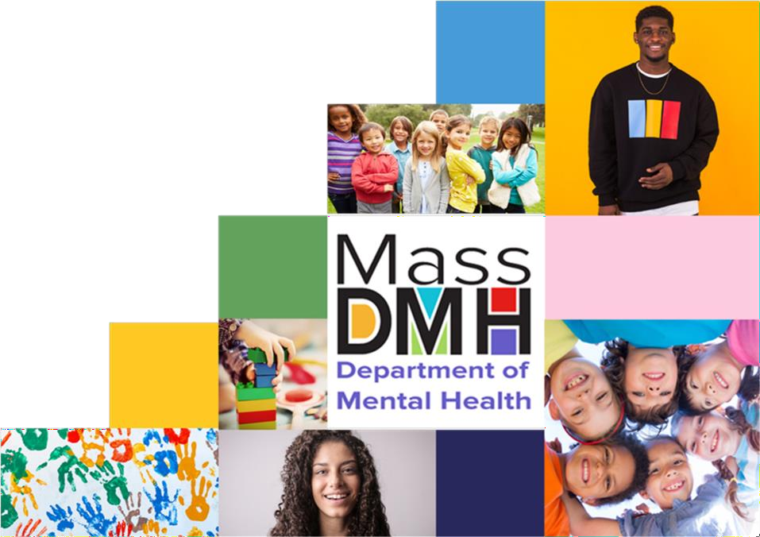

Brooke Doyle
Commissioner

THE CHILDREN’S BEHAVIORAL HEALTH ADVISORY COUNCIL

Annual Report 2023

MASSACHUSETTS DEPARTMENT OF MENTAL HEALTH

MAURA T. HEALEY
Governor
The Commonwealth of Massachusetts
Executive Office of Health and Human Services Department of Mental Health
25 Staniford Street
Boston, Massachusetts 02114-2575

(617) 626-8000

KIMBERLEY DRISCOLL
Lieutenant Governor
KATHLEEN E. WALSH
Secretary
BROOKE DOYLE
Commissioner
www.mass.gov/dmh

Maura T. Healy, Governor of the Commonwealth Kimberly Driscoll, Lieutenant Governor
Amy Kershaw, Acting Commissioner, Department of Early Education and Care Jeffrey C. Riley, Commissioner, Department of Elementary and Secondary Education Maria Mossaides, The Child Advocate
Sen. Michael Rodrigues, Chair, Senate Committee on Ways and Means Rep. Aaron Michlewitz, Chair, House Committee on Ways and Means
Sen. Cindy Friedman, Senate Chair, Joint Committee on Health Care Financing Rep. John Lawn, Jr., House Chair, Joint Committee on Health Care Financing
Sen. John Velis, Senate Chair, Joint Committee on Mental Health, Substance Use and Recovery Rep. Adrian Madaro, House Chair, Joint Committee on Mental Health, Substance Use and Recovery
Sen. Robyn Kennedy, Senate Chair, Joint Committee on Children, Families and Persons with Disabilities Rep. Jay Livingstone, House Chair, Joint Committee on Children, Families and Persons with Disabilities
On behalf of the Children’s Behavioral Health (BH) Advisory Council (Council), established under the provisions of Chapter 321 of the Acts of 2008, I am pleased to transmit its 2023 Annual Report.

The Council is a diverse and multi-disciplinary group with representatives from professional guilds, trade organizations, state agencies, families and young adult leaders, advocates, and other key stakeholders. A complete list of the Council’s membership is included in Appendix A of this Report. The Council always considered children’s behavioral health reform in the context of the Commonwealth’s broader health policy reform initiatives. The Council looks forward to continuing to support the implementation of the Roadmap for Behavioral Health Reform and ensuring that children’s behavioral health remains a central tenet.
As directed by the Legislature, two years ago the Council’s work focused on conducting an analysis of the existing and anticipated impacts of the COVID-19 pandemic on children’s behavioral health and the associated provision of services and supports. During this past year, the Council focused on analyzing and expanding on the COVID Study and providing additional recommendations to the legislature. The recommendations made by the Council in response to the COVID Study provide a guide to the types of interventions that would improve the behavioral health of children in the Commonwealth.

As the COVID-19 pandemic subsides and the world moves towards recovery, the post-pandemic effects on children's mental health continue to be a matter of concern. While some children may adapt well to the changes, others may experience lingering impacts on their emotional well-being. It's essential for policymakers, educators, healthcare providers, and communities to work together to create a supportive environment that prioritizes children's behavioral health and ensures that mental health services are accessible and available to all children who need them. By doing so, we can help children reach their full potential and build a healthier and more resilient future together.

Sincerely,
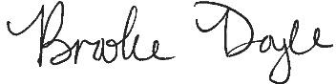

Brooke Doyle, M.Ed, LMHC Commissioner
On behalf of the Children’s Behavioral Health Advisory Council

cc: Kathleen Walsh, Secretary, Executive Office of Health and Human Services

Introduction and Preliminary Statement
Section 1 of Chapter 321 of the Acts of 2008 amended Chapter 6A of the Massachusetts General Laws, by inserting Section 16Q and established the Children’s Behavioral Health Advisory
Council (Council) and placed the Council, “within but not subject to control of, the executive office of health and human services.” Additionally, the language of section 16Q (a) states the Council is to, “advise the governor, the general court and the secretary of health and human services.” The scope and breadth of the Council’s advisory role is best evidenced in
subparagraph (d) of Section 16Q, which authorizes the Council to make recommendations in the following areas:
  - best and promising practices for behavioral health care of children and their families, including practices that promote wellness and the prevention of behavioral health problems and that support the development of evidence- based interventions with children and their parents;
  - implementation of interagency children’s behavioral health initiatives with the goal of promoting a comprehensive, coordinated, high-quality, safe, effective, timely, efficient, equitable, family-centered, culturally competent, and a linguistically and clinically appropriate continuum of behavioral health services for children;
  - the extent to which children with behavioral health needs are involved with the juvenile justice and child welfare systems;
  - licensing standards relevant to the provision of behavioral health services for programs serving children, including those licensed by entities outside of the executive office of health and human services;
  - Continuity of care for children and families across payers, including private insurance; and
  - racial and ethnic disparities in the provision of behavioral health care to children.

The Council believes it is vital to its mission, and to the families and children of the
Commonwealth, that it is established as an independent advisor to both the Executive and Legislative branches. Our credibility as an advisory body depend upon our independence and ongoing commitment to advocate for legislation, policies, practices, and procedures that best meet the needs of the families and children of the Commonwealth with emotional disorders and behavioral health needs. Our recommendations are guided by our expertise, experience, and our commitment to the families and children of the Commonwealth. We hope that our work is informative to both the Executive and Legislative branches as we collectively work toward an integrated health care systems that addresses the behavioral health needs of our children and adolescents.

Council’s Activities
From October 2022 through September 2023, the Council met six times. At the request of the Legislature, The Children’s Behavioral Health Council (CBHAC), supported by the staff of the Massachusetts Society for the Prevention of Cruelty to Children (MSPCC) conducted a study with the purpose of providing an overview of the impact of the pandemic on children’s
behavioral health and well-being. In response to the findings of this study, the Council focused their attention to the review and analysis of the following focus areas:
COVID Study & Report
RECOMMENDATIONS AND FOCUS AREAS
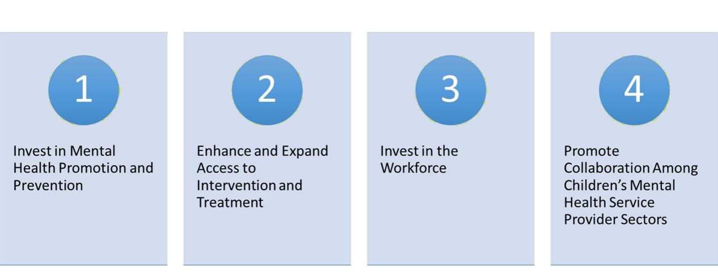
Commissioner Brooke Doyle opened the Council’ first meeting by welcoming members. Kelly English, Deputy Commissioner for Children, Youth, and Families (CYF) and Margarita O’Neill- Arana, Director of Children’s Behavioral Knowledge Center completed a preliminary review of the COVID Study findings and recommendations.
Kelly English also provided several updates throughout our Council meetings regarding the new 24/7 Behavioral Health Help Line (BHHL) which is a single, insurance-blind, multi-channel entry point for Commonwealth residents in search of mental health and substance use disorder treatment. In addition, Mi-Haita James, LCSW Director of Youth and Family Services for MassHealth Office of Behavioral Health presented on the Community Behavioral Health
Center’s (CBHC) and Youth Community Crisis Stabilization (YCCS). The CBHC’s integrate crisis and community-based treatment by combining mobile teams, crisis stabilization, and care coordination.
Courtney Chelo, MSPCC Assistant Director for Government Relations presented to the Council the final report of the COVID Study and again reviewed the four focus areas. The Council was then tasked to spend at least one hour of each of the remaining council meetings to review, analyze, and provide additional recommendations. The Council and each workgroup agreed to provide real time feedback about recommendations they would prioritize and include in this

year’s final legislative report. The Summary of the CBHAC Workgroup Recommendations can be found in Appendix B.

The Year Ahead
Since its establishment in 2008, the CBH Advisory Council continues to evolve and respond to the Children’s Behavioral Health System’s challenges and opportunities for growth. It is our priority to work closely with the new administration as we continue to support the
implementation of the Roadmap for Behavioral Health Reform. In addition, the Council aims to address the recommendations around the four focus areas of 1) Investing in Mental Health
Promotion and Prevention, 2) Enhancing and Expanding Access to Intervention and Treatment,
3) Investing in the Workforce, and 4) Promoting Collaboration Among Children’s Mental Health Service Provider Sectors. The Council convened a summer workgroup to begin planning for another productive and effective year of work ahead in 2023-2024.

APPENDIX A
The Children’s Behavioral Health Advisory Council (the Council) was established under the provisions of Chapter 321 of the Acts of 2008. The Council is a unique public-private
partnership representing child-serving agencies, parents and professionals with expertise in the issues of children’s mental health. The membership of the Commission is as follows:

Brooke Doyle, Chair Commissioner &  Kelly English, Deputy Commissioner  Department of Mental Health | David Matteodo  Massachusetts Association of Behavioral Health Systems Representative
Lauren Almeida  Department of Children and Families | Marsha Medalie  Association for Behavioral Healthcare Representative
Vacant  Department of Developmental Services[ST(1] | Rachel Gwaltney  Children’s League of Mass Representative
Mi-Haita James /Rebecca Butler MassHealth Office of Behavioral Health | Vacant  New England Council of Child and Adolescent Psychiatry Representative
Carol Nolan  Department of Early Education and Care | Barry Sarvet, M.D.  Massachusetts Psychiatric Society Representative
Kevin Beagan Division of Insurance | Marybeth Miotto, M.D., M.P.H.  Mass Chapter of the American Academy of Pediatrics Representative
Chris Pond  Department of Elementary and Secondary Education | Eugene D’Angelo, Ph.D.  Massachusetts Psychological Association Representative
Vacant | Rebekah L. Gewirtz

Department of Youth Services | National Association of Social Workers – Massachusetts Chapter Representative
Cassandra Harding  Department of Public Health | Dalene Basden  Parent/Professional Advocacy League Representative
Maria Mossaides/ Melissa Threadgill The Child Advocate  Office of the Child Advocate | Pam Sager  Parent/Professional Advocacy League Representative
Danna Mauch  Massachusetts Association for Mental Health Representative | Nancy Allen Scannell /Courtney Chelo  Massachusetts Society for the Prevention of Cruelty to Children Representative
William R. Beardslee, M.D.  Massachusetts Hospital Association Representative | Paul Jones  Blue Cross Blue Shield of Massachusetts Representative
Sarah Gordon Chiaramida  Massachusetts Association of Health Plans Representative | John Straus, M.D.  Massachusetts Behavioral Health Partnership Representative
Lydia Todd  NFI Massachusetts | Jonelle Sullivan  Carelon Behavioral Health
Amy Carafoli-Pires
Boston Medical Center HealthNet Plan

APPENDIX B
Summary of the CBHAC Workgroup Recommendations

Invest in Mental Health Promotion and Prevention

Workgroup Co-Chairs & Lead Facilitators: Margaret Hannah (William James University) and Susan Curry (Healthcare for All)

Connect and coordinate with other state agencies, commissions and initiatives focused on behavioral health promotion and prevention, including:
- The Promotion and Prevention Commission
- The new Office of Behavioral Health Promotion established under Chapter 177 of the Acts of 2022
- Statewide and community-based promotion and prevention initiatives and programs

Highlight and replicate models that work:
- Support and appropriately staff a landscape analysis of current promotion and prevention programs statewide and in individual communities, taking into consideration the following:
  - Capturing the range of depth and breadth of promotion/prevention and the sustainability of those efforts delineated by age, geography, population focus (including race, ethnicity, language, etc.), evidence- informed
  - Looking at models for involving families in the co-design and evaluation of the programs that are developed to serve them, for example, the
Department of Public Health’s (DPH) Young Children’s Council and
community evaluators program through Tufts Interdisciplinary Evaluation Research (TIER)
  - Identifying promotion and prevention efforts available in communities and schools (and early education and care), including peer supports
  - Understanding inequities in how programs are being received and
accessed by marginalized communities, particularly Black, Indigenous and People of Color (BIPOC) families; making recommendations about how to conduct regular evaluations of these programs and use these reviews to make changes accordingly
- Understand what is being planned for outreach and marketing for new and existing services (note: many new services, such as CBHCs, are treatment-focused rather than promotion/prevention), and consider:
  - Creating a list of workforce development initiatives that are supporting training that promotes prevention and early promotion efforts, including exploring the Behavioral Health Workforce Clearinghouse at the
University of Massachusetts.

  - Including a fiscal analysis of investment in promotion and prevention programs in the state, the level of sustainability and opportunities to bring them to scale
  - Ensuring there is clear messaging about serving children and families
  - Making specific efforts to reach BIPOC/communities of color, making multilingual, culturally responsive resources easily available and working with trusted, community-based groups, as well as childcare, pediatric
offices, schools, (e.g., Family Resource Centers, Department of Transitional Assistance, Department of Developmental Services, Executive Office of Housing and Livable Communities, etc.)

Support adults who support children (parents/caregivers and providers):
- Increase understanding among adults who work with children around
promotion/prevention (one specific example is helping foster parents understand and build capacity around trauma and infant and early childhood mental health
(IECMH))
- Establish programs that will provide a workforce pipeline that has the knowledge, skill, and mindset framework to support families with young children when they first start struggling with social determinants of health, behavior and/or emotional concerns that may yet not reach a diagnosable concern
- Build upon existing systems and structures that promote the wellbeing of adults serving children and families and parents/caregivers, including peer support programs, and find gaps where initial investment has been weak
  - Create an expectation that the adult system looks at the family level: “Treat the parents to treat the child.”
  - Promote the health of adults as parents in the adult system.
  - Build on successful models or develop new models of care and workforce components to accomplish this work.
- Ensure that promotion and prevention, including use of screening tools, is centered on equity
  - “Entry points” must be welcoming for families
  - Connect physical health, behavioral health and social needs - they are not separate, but interwoven for whole health and wellbeing
  - Support budget priorities that support families and caregiver health, for example, MCPAP for Moms
  - Re-start data collection and online reporting of results of behavioral
screenings (including modifiers) that had been required for the Children’s Behavioral Health Initiative (CBHI), broken out by age (including key
points in early childhood)

Strengthen promotion and prevention in early education/care and schools
- Enable sustainable resources for virtual and in-person SEL groups in schools and during after-school programming

- Ensure statewide implementation and sustainability of supports for schools, including the School-Based Behavioral Health Technical Assistance Center (which had received seed funding through the DMH child and adolescent line item in the state budget, 5042-5000)
- Support promotion and prevention in early education and care by ensuring the improvement and sustainability of Early Childhood Mental Health consultation in early education and care settings (which has received $5 million in state funding through line item 3000-6075)
  - Develop a plan to make the consultation program go further upstream and ensure longitudinal support for the child and family. This is especially in the context of the current work around reducing exclusionary
discipline.

Enable payor reimbursement for promotion and prevention:
- Identify the gaps for early screening and prevention services among public insurance (MassHealth), private insurance and state employee insurance (GIC)
- Recommend that resources go towards promotion/prevention in primary care
- Support more take-up and successful implementation of recent policies, such as MassHealth’s preventive behavioral health policy (coverage for six visits without a diagnosis) and behavioral health wellness exams (as established in Chapter 177 of the Acts of 2022), and address challenges, such as the prerequisite for a positive screen
- Increase behavioral health parity for promotion and prevention
  - Promote the development of different types of models that can support promotion and prevention (i.e. not fee-for-service only), building in
flexibility for providers to work with families (e.g. parent groups)
  - Urge private insurers to cover promotion and prevention-oriented
services covered by MassHealth, including the preventive behavioral health policy above
  - Explore whether different insurance assessments or the framework for these assessments (for example, for the Behavioral Health Help Line) can also be used to help coverage of promotion and prevention services in self-funded/out-of-state plans not regulated by Massachusetts

Enhance and Expand Access to Intervention and Treatment

Workgroup Co-Chairs & Lead Facilitators: Rebecca Butler (MassHealth Office of Behavioral Health) and Pam Sager (Executive Director for Parent Professional Advocacy League)
The recommendations are shown below in order of Tier 1 – Tier 3 (highest to lowest) priority assigned by the Workgroup.

CARE SERVICES

Tier 1:
- Conduct an academic literature review to identify current research, best practices, trends, innovation, and the science informing the development, utilization, and impact of Gap Services. Identify limitations, barriers, strengths, and impact in other States with Gap Services.
- Complete a landscape analysis to identify current Gap Services within Massachusetts funded by MADPH or other youth serving state agencies, as well as community-based behavioral health providers, community-based health services, faith-based organizations, and family/ caregiver organizations delivering Gap Services.
- Promote greater awareness and accessibility of family support groups and natural supports currently existing, especially those that are family/peer lead and enhance the role of family partners.
- Gap Services, and all behavioral health services, must be rooted in racial and health equity with a focus on engaging communities disproportionately underserved such as BIPOC, immigrant.
- Enhance awareness and access to caregiver advocacy and support groups including
CBHC’s.
- MassHealth, DMH, other youth and family serving state and community agencies, and youth and families should immediately explore and modify (if needed) the role of Family Partners to enhance the role and make them more accessible, including potential certification of Family Partners (whether state or national).
- Ensure that CBHC’s are linking with community providers and organizations so that families/ youth are receiving services somewhere is essential. Engage groups not typically tapped on such as faith organizations as existing natural supports for families. Identify and support specific cohorts that need services such as BIPOC, children in DCF custody and care (including foster and otherwise), immigrant/refugee families, and grandparents and kinship guardians. Ensure that all those affected, particularly involved family members, have a role in the planning and design of programs and services.

Tier 2:
- Complete a landscape analysis to identify gaps in the current youth behavioral health continuum, creating as a starting point targeted prevention or intervention, developmentally appropriate outpatient care, 24-hour Diversionary services, and recovery support services. Special attention should be paid to identify service gaps for youth with complex needs whose treatment needs are not being met due to autism, psychosis, violence, or LGBTQ+ identification.
- Utilize the Behavioral Health School TA Center at the UMass BIRCH Center to convene regionally based stakeholder groups to explore unmet needs, gaps, trends, and capacity and identify solutions, and reduce duplicative efforts. This should include review and implementation of DESE BH crisis emergency response plans. The regional nature of these groups is important to address the underrepresentation of specific populations and unique needs of varying geographic areas.

Tier 3:
- Several initiatives regarding consultation programs between schools and BH providers are underway in the Commonwealth. All stakeholders (DMH, DESE, OBH, DPH, BIRCh Project, those on the School-Based Behavioral Health Advisory Council, and others) should be convened for comprehensive sharing of information and planning. The goal is to streamline processes and services and reduce duplicative efforts.
- Ensure that CBHI services continue to reflect quality of care and efficiency by MassHealth continuing to review rates on a regular basis and adjusting them when indicated.
- Explore other ways of increasing and supporting the CBHI workforce outside of rate increases, including but not limited to training opportunities, quality incentives, and other options.

STABILIZATION SUPPORT
Tier 1:
- Ensure that resources are distributed promptly and equitably taking account of small group practices and underserved communities.
- Community settings should be defined to include schools, medical settings, pediatric practices, and the like. An emphasis should be placed on expanding, sustaining, and supporting trauma-informed practices as part of integrated care. It is critical that all staff (front desk to CEO) be trained in trauma-informed practices. It is also critical that trauma-informed includes an understanding of racial and cultural trauma. All trauma- informed practices should be viewed through an “equity” lens.

Tier 2:
- Open pathways for DESE licensed professionals to provide reimbursable services in after school hours. Encourage and support DESE with conducting a study looking at the feasibility of this recommendation that should include issues of credentialing and scope of practice issues for school professionals.

Tier 3:
- Establish a workgroup to set guidelines for use of tele-health vs in-person treatment.

BOARDING
Tier 1:
- ED stays can be traumatizing for kids and families. Universal standards or practices among hospitals should be reviewed, updated, and enforced to reduce additional trauma exposure for youth and families in EDs.

- ED staff including 1:1 staffer such as security guards need comprehensive and up to date mental health training.
- Family/Youth Peers should be integrated to help support the families and youth while waiting in the ED.
- PPAL’s best practices for ED’s should be widely circulated and reviewed with ED staff.
- Communication should be transparent between ED staff and families/youth e.g., ability to have phones, personal items, etc. Having designated MH staff to support family/youth and answer questions would be helpful. Families/youth should have easy and regular access to food, outside, parent support and education, activities, sensory rooms/items.

Tier 2:
- Promote better integration and collaboration with the CBHCs, MCI services, and urgent care services.
- Examine the possibility of adding resources for care coordination from the ED back to the community and the PCP, including family support services.

Invest in the Workforce

Workgroup Co-Chairs & Lead Facilitators: Jeremiah Gibson (Executive Director – New England Association for Family and Systemic Therapy) and Margarita O’Neill- Arana (Director of Children’s Behavioral Knowledge Center, DMH)

Bolstering the current Children Behavioral Health Workforce:

Implement payment reforms to increase financial capacities of provider entities, particularly for community-based services, so that wages rise to levels that facilitate recruitment and retention of staff needed to meet rising demand for care
- Complete analysis of current reimbursement rates and actual cost of services
- Provide workforce and financial incentives, especially for those who provide cultural expertise and bilingual capacity.

Remove unnecessary barriers to licensure
  - Establish inter-state reciprocity of licenses to enable more experienced clinicians to rapidly join the Massachusetts workforce. Consider similar paths for clinicians
immigrating from other countries.
  - Conduct a review of licensing requirements, barriers, and costs across behavioral health professions, inclusive of review for racial/ethnic bias, equity across fields, reciprocity, interstate compacts, and comparison of costs and prerequisites with those of other states and countries.

  - Encourage providers and state agencies to review waivers, alternative processes to licensure and certification, etc.
Conduct an environmental scan and examine the existing data regarding what policies other organizations and states are using to help support retention and promotion within these
organizations, especially with respect to cultural competence and bilingual capacity.

Investing in the Future Workforce

Partner with Massachusetts higher education institutions to develop strategies to retain students in our state.
  - Establish permanent scholarships and paid internships, alongside loan forgiveness programs.
  - Build working relationships with graduate programs and with deans and directors of graduate programs to promote preparation of graduates for the range of behavioral health workplaces, interventions, research, and unique needs specific to local
communities.
  - Engage higher education programs in behavioral health with policy makers to devise possible solutions or strategies to address the workforce dilemma.

Create a pipeline for the workforce that encourages high school and undergraduate college students to pursue a career in behavioral health.
  - Ask state agencies to develop ongoing programs to introduce high school and bachelors level students to potential careers in behavioral healthcare and develop incentives to join the children behavioral health workforce.
Incentivize peer leaders, family partners, and others with lived experience to enter the field through increased rates, scholarships, training, and flexibilities.

Promote Collaboration Among Children’s Mental Health Service Provider Sectors

Workgroup Co-Chairs & Lead Facilitators: Mary Beth Miotto (Mass Chapter of the American Academy of Pediatrics Representative) and Melissa Pearrow (Executive Director, BIRCh Project)

Prevention and behavioral health promotion, referral and access, navigation and coordination and collaboration and continuity of care:
  - Enhance educational efforts to prevent and promote the development of behavioral health in naturalistic and community settings, such as after school programs, schools, and household. This can include universal screening of behavioral health needs in educational and medical settings that can enhance early identification efforts.

  - Behavioral Health Help Line, BHHL, is the most promising current mechanism to consider for gathering and assessing data. The BHHL should be given the role and given the resources to utilize for an ongoing, iterative gathering of this information from families and providers of care to children with complex behavioral health challenges.
  - Families whose children have complex needs are essential additional sources of
information and data to assess the need for these services. Focus groups of families, including working with Parent Professional Advocacy League, a trusted and experienced family organization, can provide this first-person data.
  - Under the leadership of the BHHL and in partnership with a contracted resource such as the Parent Professional Advocacy, a report, with time frames and deliverables, that
reflects the findings of systemic capacities and gaps in addressing emerging navigation, coordination and collaboration needs of children with complex behavioral health and related conditions should be submitted to the designated state entities and the Children’s Behavioral Health Advisory Committee.
  - This report should also include proposed recommendations for service system changes to address identified gaps and needs that would be recommended as best practices to improve systems response to the gaps in navigation, coordination, and collaboration in partnership with families.
    - As the systemic conditions and the nature of complex behavioral health needs will inevitably change over time, a process of periodic information gathering
should occur that will support, and guide needed adaptation of services response to children’s and youths’ need for navigation, coordination and collaboration of care.
  - The designated state agencies and their relevant providers will respond to the CBH Advisory Committee, in its statutory role, as to steps that will be implemented to address the recommendations of the report.

Create an accessible system functioning information resource that effectively provides guidance and support for providers and families of children with a range of complex behavioral health (and related needs) regarding how the systems is supposed to work:
  - Enhanced training and dissemination to professionals in community settings, such as
schools, community agencies, and caregivers, on available mental health resources and navigation of the behavioral health system.
  - Creation and dissemination of user-friendly structural description, i.e., a ‘systems map’’, of service systems, eligibility, and interface for children with complex behavioral health related needs. BHHL is the key to addressing this need.
  - Options to access and use the ‘system’s map’ depending on the specific needs of families engaged in systemic responses to their children’s include:
    - Community-based services available with schools and agencies within the area.

    - Accessible, vetted, and update identification of services and how they “map” together. This information could be accessed, as needed, via a platform or by individual inquiry.
    - Guidance: Person to family (or provider) regarding systems navigation for specific children within “the system’s map”.
  - Establish a dedicated, trained, and transferable service element, (e.g., assigned case load, regardless of systems or agency involvement and not attached to a specific service such as ICCs and parent partners) to provide ‘system’s coaching’ and accompaniment with families of children with complex behavioral health and related needs.
    - Resources to support intentional and systemic partnerships between Community Behavioral Health Centers and public, private, regional, and special education settings and pediatric offices that screen and provide early intervention and support services. Potential policy changes to
permit providers to support collaboration across settings (e.g., behavioral health providers supporting a child who is boarded to consult with ABA from school setting).
    - The Community Behavioral Health Centers that regionally cover
Massachusetts would represent one possible option for the housing of this dedicated service.
    - Highlight within “the systems map” that is created a clear path to this service element. Make it accessible to not only families but service
providers within the system looking to optimize care or clarify roles and responsibilities across agencies.

