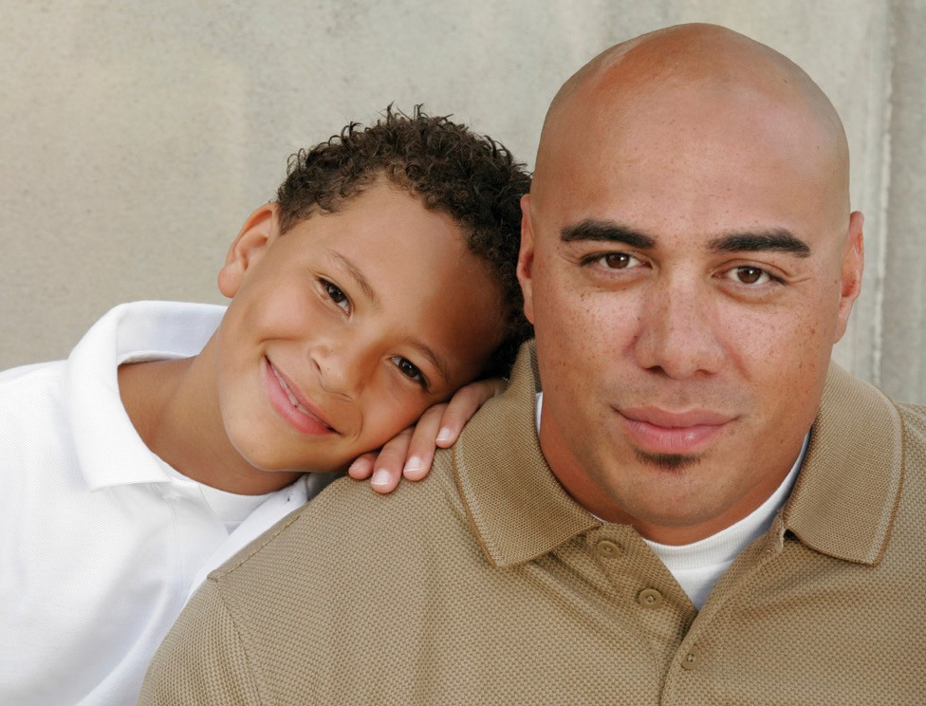
MASSHEALTH SERVICES FOR CHILDREN & YOUTH

MASSHEALTH PLAN CONTACT INFORMATION
Health Plan Name | Customer Service Phone | Behavioral Health Phone | Website
Be Healthy Partnership | (800) 786-9999 | (800) 495-0086 | www.behealthypartnership.org
Berkshire Fallon Health Collaborative | (800) 786-9999 | (888) 877-7184 | www.fallonhealth.org/Berkshires
BMC HealthNet Plan | (888) 566-0010 | (888) 217-3501 | www.bmchp.org
BMC HealthNet Plan Community Alliance | (888) 566-0010 | (888) 217-3501 | www.bmchp.org/community
BMC HealthNet Plan Mercy Alliance | (888) 566-0010 | (888) 217-3501 | www.bmchp.org/mercy
BMC HealthNet Plan Signature Alliance | (888) 566-0010 | (888) 217-3501 | www.bmchp.org/signature
BMC HealthNet Plan Southcoast Alliance | (888) 566-0010 | (888) 217-3501 | www.bmchp.org/southcoast
Community Care Cooperative (C3) | (866) 676-9226 | (800) 495-0086 | www.c3aco.org
Fallon 365 Care | (855) 508-3390 | (888) 877-7182 | www.fallonhealth.org/365care
Partners HealthCare Choice | (800) 231-2722 | (800) 495-0086 | http://www.partners.org/for-patients/ACO/Partners-HealthCare-Choice-Medicaid.aspx
Primary Care Clinician (PCC) Plan | (800) 841-2900 | (800) 495-0086 | https://www.mass.gov/service-details/primary-care-clinician-pcc-plan-for-masshealth-members
My Care Family | (800) 462-5449 | (800) 414-2820 | www.mycarefamily.org
Steward Health Choice | (855) 860-4949 | (800) 495-0086 | www.stewardhealthchoice.org
Tufts Health Together | (888) 257-1985 | (888) 257-1985 | http://www.TuftsHealthTogether.com
Tufts Health Together with Atrius Health | (888) 257-1985 | (888) 257-1985 | www.TuftsHealthTogether.com/AtriusHealth
Tufts Health Together with BIDCO | (888) 257-1985 | (888) 257-1985 | www.TuftsHealthTogether.com/BIDCO
Tufts Health Together with Boston Children’s ACO | (888) 257-1985 | (888) 257-1985 | www.TuftsHealthTogether.com/BCACO
Tufts Health Together with CHA | (888) 257-1985 | (888) 257-1985 | www.TuftsHealthTogether.com/CHA
Wellforce Care Plan | (855) 508-4715 | (888) 877-7183 | www.fallonhealth.org/wellforce

CBHI-MB (Rev. 6/18)
Did you know that MassHealth offers many services for children and youth up to age 21?
Most of the services in this brochure are home and community-based.
All of them can help families support their children in difficult times.
Read on to learn more about these services and how you can find providers.

Mobile Crisis Intervention *
MassHealth offers a Mobile Crisis Intervention service. A team trained to work with children and youth in crisis can meet you at your home, school, or another place in the community. An MCI team will show
up within an hour of your call. The team can guide you and your child through a crisis and connect you with other services.
Find your local team now so you have the information when you need it. Call (877) 382-1609, anytime, day or night. Once you dial this number, a recorded voice will ask you to enter your zip code. Based on your zip code, you will be given the phone number of the closest Mobile
Crisis Intervention team that serves you. Have a pen or pencil and piece of paper ready to write it down. Place the number in a location that is easy for you and your family to find when you need it.
Please note that calling MCI is not the same as calling 9-1-1.
If your child is in danger or is putting others in danger, call 9-1-1.

HOME- AND COMMUNITY-BASED SERVICES

Outpatient Therapy
Outpatient Therapy is often where families first look for help as this type of therapy can help with many kinds of challenges. A therapist will meet with your child, usually in an office setting. The therapist will work out a plan based on your child’s strengths and needs and can help you get your child other needed services.

In-Home Therapy*
In-Home Therapy works with your whole family, not just your child, in your own home and community setting to strengthen relationships and support your child. In-Home Therapy can help your child and family resolve conflicts, learn new ways to talk to and understand each other, create new helpful routines, and find community resources.

Intensive Care Coordination
Intensive Care Coordination may be the right service for you if your child or teen has serious emotional or behavioral needs or if you need help getting all the service providers in your child’s life to work together. A care coordinator helps bring everyone together to work toward common goals. You can choose who is on your team, including professionals such as therapists, social workers, teachers, and your personal supports, such as friends or relatives. You may also ask for a “Family Partner,” a parent trained to help you make sure that your voice is heard. Together, the team will help you and your child reach your goals for your family.
Other Services
If your child gets Outpatient Therapy, In-Home Therapy, or Intensive Care Coordination and needs more help, they may also be able to get the following services:
In-Home Behavioral Services Sometimes a child needs help changing behaviors that get in the way of their everyday life. An In-Home Behavioral team
will work with you and your child to create a behavior plan
that will help your child change these behaviors to improve their daily life.
Therapeutic Mentors Some children and teens want to get along with others but need help learning how to connect with people. A Therapeutic
Mentor can help your child learn social and communication
skills and practice them in everyday settings.
Family Support and Training (Family Partners)
Family Partners guide parents and caregivers in helping their children reach their treatment goals. They are parents or caregivers of children with special needs—they’ve “been there,” understand what families go through, and can share their experiences. Family Partners are not behavioral health professionals, but they understand child and family services
and they can coach you as you work to meet your child’s needs.

AUTISM SERVICES

Applied Behavior Analysis (ABA)
If your child has a diagnosis of autism, ABA helps by making a detailed behavior plan that you can use every day to help your child learn new behaviors that will help them in their daily life. Please note that your child cannot have ABA and In-Home Behavioral Services at the same time.

YOUTH SUBSTANCE-USE SERVICES

Structured Outpatient Addiction Program (SOAP)
Sometimes called Intensive Outpatient Program (IOP), SOAP is a day or evening substance-use treatment for people who don’t need 24-hour care. If your child or teen is in SOAP, they are able to stay at home and keep up with daily life in school and the community. SOAP offers counseling, education, case management, and onsite monitoring.

Residential Rehabilitation Services (RRS)
RRS can help if your child needs more structure as they recover from addiction. RRS will provide ongoing education, counseling and support in a 24 hour home-like setting, also known as halfway houses. When your child is ready to leave, RRS will help them get ready to re-enter their home and community.

Youth Stabilization Services (YSS)
YSS will provide even more structure for your child dealing with addiction issues. It offers treatment and counseling in a 24 hour setting for youth up to the age of 21. YSS includes nursing care and access to psychiatric services.

How can I find providers?
For Home- and Community-Based services, you can search for providers and get their contact information at www.mabhaccess.com. You can see if a provider is accepting new clients. If they are, make sure to call for an appointment.
For Youth Substance-Use Services, you can find a provider by
- going to www.mabhaccess.com,
- accessing https://helplinema.org, or
- calling (800) 327-5050.
For Outpatient Therapy and Applied Behavioral Analysis, call the Behavioral Health Customer Service line of your MassHealth Plan. See back page for phone numbers.
If you have questions or need help finding any of the services in this brochure, call the Behavioral Health Customer Service line of your MassHealth Plan.
For more information, go to www.mass.gov/masshealth/CBHI, where you can find guides and tip sheets and watch videos about some of the services described in this brochure.
What if my child doesn’t have MassHealth?
If your child is under 21 and doesn’t have health insurance, call MassHealth Customer Service at (800) 841-2900 and find out if they can get MassHealth. You can learn more about applying to MassHealth by visiting www.mass.gov/masshealth.

*Youth under 21 on MassHealth Family Assistance who are enrolled in managed care may be able to get this service if it is medically necessary. Youth on MassHealth Standard or CommonHealth can get ANY service that is medically necessary. Youth with a mental or physical disability can apply to get CommonHealth. Contact MassHealth Customer Service at (800) 841-2900 for more information.

