Commonwealth of Massachusetts
Executive Office of Health and Human Services

Virtual Gateway



CBHI CANS Consent Information and Faxing Guide
February 2015 R3.0 v1



CBHI CANS Consent Forms and Information Guide

Table of Content
Release 3.0 Updates 3
Consent FAQs 4
Other Change to CANS 7
Logon to Virtual Gateway 8
Print Consent Forms 8
Generating a Consent Information Sheet 9
Important Information Regarding Faxing Consent 12
Additional Training Resources 12
Questions or Need Assistance? 13

Release 3.0 Updates
The Commonwealth of Massachusetts and the Executive Office of Health and Human Services (EHHS) have made system enhancements to the Children's Behavioral Health Initiative (CBHI) Child and Adolescent Needs and Strengths (CANS) application (Release 3.0), which is now available to all users.
All documentation related to the CBHI CANS application ("Reference Guides" and "Learn How To" CBTs) has been updated and are posted on the CBHI website. Visit www.mass.gov/eohhs/gov/commissions-and-initiatives/cbhi/, click the Child and Adolescent Needs and Strengths (CANS) link, then select the Using the CANS Application on the Virtual Gateway link.
Below is a summary of the Release 3.0 improvements and new features.
New Consent Process
The new Consent Process permits a provider to enter the CANS on the Virtual Gateway (VG) and share the CANS with all other providers to whom the caregiver has given consent. Link to CANS Consent Forms: www.mass.gov/eohhs/gov/commissions-and-initiatives/cbhi/child-and-adolescent-needs-and-strengths-cans/cans-forms.html).This new process will allow all providers caring for the same child to have a clear picture of what is happening in the child and family’s life. This is particularly important when a child is cared for by multiple providers or requires treatment in different levels of care.
Sharing CANS across service providers who are caring for the same child helps build effective collaboration by ensuring that everyone is on the same page. Sharing CANS can also be a time saver for providers and families.
CANS users have long requested that the CANS Consent permits providers to be able to share the CANS through the Virtual Gateway (VG) with other providers caring for the same child. (Currently, with consent, the CANS may only be shared through the VG within a provider organization.) Sharing CANS across service provider caring for the same child helps build effective collaboration by ensuring that everyone is on the same page, while saving time, for both providers and families.
New Consent Forms
The new Consent Form explains to the caregiver that by signing the Consent Form, they are giving permission to a provider to enter the CANS on the VG and share the CANS with any other providers to whom the caregiver has given consent.
Link to CANS Consent Forms: www.mass.gov/eohhs/gov/commissions-and-initiatives/cbhi/child-and-adolescent-needs-and-strengths-cans/cans-forms.html).
To learn more about how the Consent process works in daily practice, please view the CANS Consent Step-by-Step Guide and Flowchart which can be found at http://www.mass.gov/eohhs/gov/commissions-and-initiatives/cbhi/child-and-adolescent-needs-and-strengths-cans/using-the-cans-application-on-the-virtual-gateway.html.
Talking to Caregiver’s about CANS Consent and its benefits
Explain to the caregiver that as the provider, you will ask for their permission, or consent, to enter the CANS ratings and comments into MassHealth’s secure online database, known as the CANS application. This means that the caregiver is allowing MassHealth and their child's managed-care plan to see the child’s CANS records. Consent does not allow other state agencies, such as the Department of Youth Services or Department of Children and Families, to see a child’s CANS record. To protect a child’s privacy, MassHealth keeps tight control over who has access to the database. Access to your CANS record is restricted and protected under state and federal privacy laws.
Explain to the caregiver that giving permission to you to enter their child’s CANS information into the database allows you to print a CANS report at any point in the child's treatment. The new consent process (effective February 2015), allows all providers with active consent, who are caring for the same child, to share the CANS online. As a provider, you will also need to talk to the caregiver about signing a new consent form.
Updating the CANS in the database is easy. You can simply edit the CANS that was done the last time. (Link to DEO and CA Reference Guides: http://www.mass.gov/eohhs/gov/commissions-and-initiatives/cbhi/child-and-adolescent-needs-and-strengths-cans/using-the-cans-application-on-the-virtual-gateway.html)
In the near future, CBHI expects to have a new CANS reporting tool that you will be able to print out to show the caregiver how their child has made progress.
Finally, MassHealth uses the CANS to understand how its services are helping families. Having this information allows MassHealth to improve services in ways that can help their child and others in the future.
Faxing CBHI Consent Forms
A signed consent form must be faxed by the organization along with the “Consent Information Sheet” (CIS) to 617-887-8708. (Read below on how to generate the CIS.)
The CIS is the Fax cover sheet; do NOT include an additional cover sheet. Once consent is received by the EOHHS CBHI IT System, the CA can enter CANS in VG for that client. The “Consent Information Sheet (Fax Cover)” along with the 4-page signed consent form must be faxed by the organization to the fax number listed on the Consent Information Sheet. The fax system only recognizes the CIS form as it contains pre-populated information about the Mass Health member entered by the CA in the Demographic section on the CANS application. The signed form must also be retained in the Client Medical Record by the organization.
Notes:
- Do not fax anything to CBHI if consent is ‘NO’. Enter only the SED and Demographic information into VG. CANS status will be ‘Documented on Paper’.
- When a caregiver cancels an existing consent, you must notify MassHealth by emailing a signed copy of the written cancellation letter to: CANS-CBHI@massmail.state.ma.us.

Consent FAQs
What do I need to know about the new Consent process?
The new Consent process permits a provider to enter the CANS on the Virtual Gateway (VG), and allows other providers, to whom the caregiver has given consent, to view and copy the CANS. This will allow all providers caring for the child to have a clear picture of what is happening in the child and families life. This is particularly important when a child is cared for by multiple providers or requires treatment in different levels of care.
What specific information does MassHealth require to be entered into the Virtual Gateway (VG), and does this information require client permission?
Information about member demographics and whether the child/youth meets the criteria for Serious Emotional Disturbance (SED) collected with CANS must be entered into the VG, and does not require client permission.
What information requires member permission to be entered into CANS application on the VG and what is the process of documenting consent in the application?
Member permission is granted by a caregiver or an emancipated youth under age 21, and is required to enter CANS ratings and narrative fields in the VG. The application includes features for documenting consent, as well as, features for the member to cancel consent. MassHealth requires provider organizations use the consent form created by EOHHS.
What is different about the new consent process?
The new Consent form, which is scheduled to go-live in February 2015, features more user-friendly language that makes it easier for both the provider and caregiver to understand the consent process, and explains how the information gathered is stored in a safe place.
The new consent process allows providers who have received consent, to view and copy CANS records entered by other providers on the VG. This permits all providers with active consent, who are caring for the same child to have a clear and timely picture of what is happening in the child and family’s life. This is particularly important when a child is cared for by multiple providers or requires treatment in different levels of care. For families, it means not having to repeat their stories. For new providers, it means that they will have immediate access to current information that affects their child’s care and will be able to view, copy and edit a CANS previously created by another provider. Copying and editing existing CANS will also save time and effort for providers.
What does the new language does the Consent form contain?
The new Consent form explains to the caregivers that signing the consent form gives permission to a provider to:
- Enter the CANS on the VG
- Such that any other providers, to whom the caregiver has given consent, will be able to view and copy the CANS record.
Please click to Read the new Consent form.
How will this work?
After the go-live date, all prior consent will no longer be valid as the Consent status in the CANS Application on the Virtual Gateway (VG) will be re-set to “no” for all members. You will be required to:
- Obtain new Consent from the caregiver when you next see them and then, you will need to enter “yes” in the ‘Manage Consent” tab on the CANS application on the VG.
- If the caregiver declines consent then, you will simply enter “no” in the Manage Consent tab. You are still required to enter the SED section on the CANS application on the VG but complete the CANS on paper and enter into the child’s medical record.
How will I know if another provider has completed a CANS on the same child?
When a new provider, with consent, enters a child’s CANS onto the CANS application on the VG for the first time, the new provider will automatically be able to see the child’s previous CANS from other providers.
The new provider will have the option to copy a previous CANS. The copy is now the new provider's CANS and can be edited as necessary, including the addition of Summary Comments at the end of each domain.
When a new provider copies a CANS, they are not altering in any way the previous CANS completed by another provider.
What do I need to tell members about the new consent process?
CBHI strongly encourage you to discuss the new consent form with caregivers prior to the go-live date so that you have signed consent forms on hand when the new process is active. On the go-live date, all existing consents, regardless of their stated end dates, will expire. We recommend that you throw away all blank copies of the old Consent form that you or a DEO in your organization may have on hand.
Will the faxing process change?
No. Current procedures for faxing in your signed consent forms will remain unchanged. Remember to generate a Fax Information Sheet (cover sheet) from the CANS application, just as you do now. (If the caregiver declines consent, the process remains the same. You should document this fact in the chart, but do not fax anything to MassHealth.)
Will there be “how to” support in the CANS Consent Resources and Guides?
We will revise all of the related information in the “How to use the CANS Application on the Virtual Gateway” page (www.mass.gov/masshealth/cans) in the CANS section of the CBHI website to offer updated information. Also, CBHI will offer a webinar on the new consent process prior to the start date for the new process.
The Consent Webinar will be posted on the CBHI website. Providers may also call the VG Customer Service Helpdesk at 800-421-0938 or (TTY) 617-847-6578 (for those with partial or total hearing loss) and ask for help with the new consent process. The call will be transferred to CBHI for assistance.
The revised CBHI CANS Consent Forms and Information Guide, also found on this page, will instruct users on how to manage consent, download the consent form, as well as how to fax the consent form. The Guide will also offer assistance on how to talk to families about the new Consent process.
What should I do with the signed consent form after I document consent in the application?
The 4-page signed consent form, combined with the Consent Information Sheet (fax cover sheet), must be faxed to MassHealth at 617-887-8708. The Consent Information Sheet (fax cover sheet) can be printed from the CANS application in VG, which will automatically print both member and provider information on the CANS Information Sheet (fax cover sheet). Do not use your organization’s regular fax cover sheet as it will not be accepted in the faxing system.
What do I do with the rest of the CANS information if the caregiver or member does not consent?
If the parent or guardian of a minor member (or the member if she or he is 18 or older) declines consent, then CANS should be completed on paper and included in the medical record. The CBHI system on the VG will not permit entry of CANS rating or narrative fields without consent.
Please remember that you must still enter SED and demographic information into the CANS application on the VG and you must complete a copy of CANS for the medical record regardless of member consent.
Can consent be cancelled?
Yes, members may cancel consent. The application allows the provider to change the consent status of a member at any time.
Does consent expire?
Consent will automatically expire after a specified period of time. The default length is one year, although the consent form and the application allow the member to specify a shorter or longer period of time if preferred. If you anticipate that the member will be in treatment for more than a year, you may want to suggest a longer expiration period for the consent.
What are the additional responsibilities of a provider regarding consent?
Providers have the independent responsibility to examine and comply with applicable federal and state privacy laws, regulations and rules as well as their own privacy policies and practices.
Who can access information from the online CANS application?
The VG is designed and extensively tested to be highly secure. The CBHI system does not include social security numbers or financial information that is most often the target of hackers. Consent gives MassHealth and the member’s managed care plan access to the member’s information. To protect a child’s privacy, MassHealth keeps tight control over who has access to the database. Access to your CANS record is restricted and protected under state and federal privacy laws.
What is the benefit of consenting to entering CANS data in the CANS application online?
In early 2015, all provider who care for the same child and have active consent from the child’s caregiver will be able to view and copy the child’s CANS on the CANS application on the VG. The benefits of consent include the ability to view and copy the CANS to share with the family, to easily update the CANS without needing to create multiple paper copies, and to share the CANS with other levels of care across provider organizations. Also, by sharing the CANS, the family may not have to repeat their entire story, over and over again. Another benefit is the ability of the member’s managed care entity (MCE) to see CANS in authorizing care—which may save time. Finally, the state uses CANS data entered into the application to gather general information about the delivery of CBHI services and in general to improve services for all youth and families using MassHealth.
Where can I get more information about faxing consents?
For more detailed instructions about faxing consents, please refer to the CBHI CANS Consent Forms and Information Guide. It is available on the CANS (www.mass.gov/masshealth/cans) Web page of the CBHI Web site along with other CBHI reference materials.
If you have any questions regarding faxing consents, please contact Virtual Gateway Customer Service at 1-800-421-0938 or (TTY) 617-847-6578 (for those with partial or total hearing loss).
Where can I get more information about the CANS application and consent?
More information about the consent process, including the consent forms and “how-to” Reference Guides, may be found at www.mass.gov/masshealth/cans. Click on “How to Use the CANS Application on the Virtual Gateway”.
You will also find the CANS Family Guide on the Clinical Guidance section of CANS page of the CBHI website. The three-page document that explains the “what” and the “why” of the CANS to family members, including consent. We encourage providers to share this with families during the initial assessment period. Go to www.mass.gov/masshealth/cans and click on “Clinical Guidance on the CANS”.

Other Change to CANS
- The Diagnoses module has been renamed as Diagnostic Factors and DCM diagnosis of the behavioral health condition is no longer part of the CANS. This change is a better fit for CANS as the CANS is not intended to be a diagnostic tool but rather a way to communicate needs and strengths, and help inform family-driven, collaborative care planning at the right level of care.
- Discontinuation of Axis I and Axis II.
- Renaming Axis III, Axis IV and Axis V
  - Axis III has been renamed as Physical Conditions defined as “Physical conditions which play a role in the development, continuance or exacerbation of a behavioral health condition.”
  - Axis IV has been renamed as Psychosocial Stressors defined as “Events in a person’s life, such as the death of a loved one, starting a new job, college, unemployment or even marriage can affect behavioral health condition.”
  - Axis V has been renamed as CGAS (Children’s Global Assessments scale) and selecting the “?” will bring up the scale.

Logon to Virtual Gateway
To Log in to the Virtual Gateway (VG), go to www.mass.gov/vg and select the link “Logon to Virtual Gateway”. Select the Children’s Behavioral Health Initiative (CBHI) business service to enter CANS in the VG.
Note: See the Login Assistance page at http://www.mass.gov/eohhs/provider/training-and-edu/vg/login-help-for-providers-and-state-agency-staff.html for more information on setting up a Virtual Gateway (VG) account.

Print Consent Forms
Consent is authorization for a provider to enter, view, and/or print CANS into the Virtual Gateway and share data within and across provider organizations, MassHealth and other providers with active consent. It needs to be validated for each CANS enter in the VG. Please view the CBHI CANS Consent Information and Faxing Guide (http://www.mass.gov/eohhs/gov/commissions-and-initiatives/cbhi/child-and-adolescent-needs-and-strengths-cans/using-the-cans-application-on-the-virtual-gateway.html) for detailed information on consent.
You will need the Adobe Acrobat reader to view and print these forms. If you do not have Adobe Acrobat currently installed you can download it for free at http://get.adobe.com/reader/ .
Consent forms are available in different languages under the ‘Print Blank Forms’ tab.
The Print Blank Forms tab in the Virtual Gateway will now host the New Consent Forms in English, Spanish, Russian, Portuguese, Chinese, Vietnamese, Khmer and Haitian Creole languages.
- From the Main Assessment Menu, select the [Print Blank Form] tab.
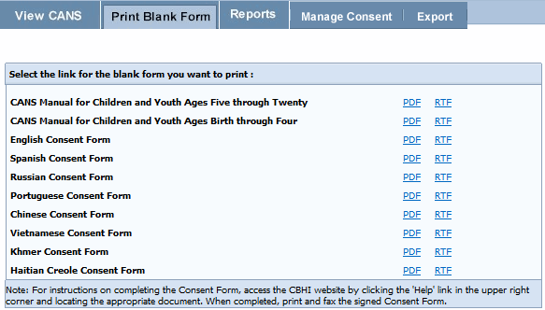
- Select the Consent Language option of your choice to print the Blank Form for the CANS tool documents:
- PDF (Portable Document Format – Adobe Acrobat)
- RTF (Rich Text Format)
The provider needs the caregiver’s signature on this form. If a Caregiver declines to give Consent to enter the CANS into the Virtual Gateway (VG), the provider is not required to notify CBHI (MassHealth). However, the SED and Demographic section must be completed online and the CANS must be completed on paper and then entered into the member’s medical record. The CANS status in VG, in this case, will be ‘Documented on Paper’.
If a caregiver decides to cancel an active Consent, please email a scanned, signed copy of the written cancellation to CBHI at: CANS-CBHIMailbox@state.ma.us.
- When completed, close the browser window ( ) and return to the CBHI application.

Generating a Consent Information Sheet
- From the Main Assessment Menu, click [Manage Consent].
- Click the [Manage Consent] tab.
- Enter the [MassHealth ID*].
- Click the [OK] button.
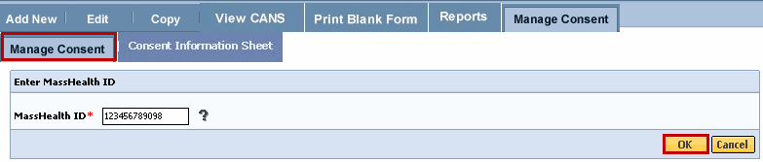
- Confirm Client Information. (If incorrect Client Information displays, click the [Cancel] button and type in the correct MassHealth ID).
- Click the [OK] button.
Complete all the questions on the Consent Information page.
- Select the *Yes or No radio button depending on whether consent was granted or denied.
- From the [Consenting Party Relationship to Client*] drop down menu, select appropriate answer.
- Enter the [Consent Effective Date*] based upon the date the form was signed.
- Enter the [Consent Expiration Date*] per the signed form or based upon the treatment plan the CA has identified.
- Click the [OK] button to submit this information to the EOHHS CBHI IT System.
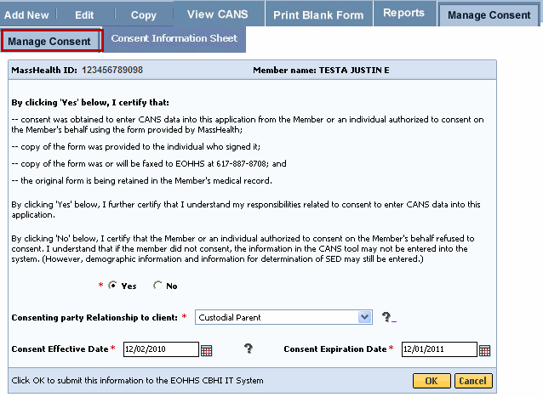
- Click the [OK] button to print the Consent Information Sheet. Click [Cancel] to continue without printing consent information sheet.
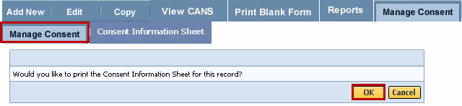
The Consent Information Sheet will display in a new screen. You can print the consent information sheet or save as a PDF file.
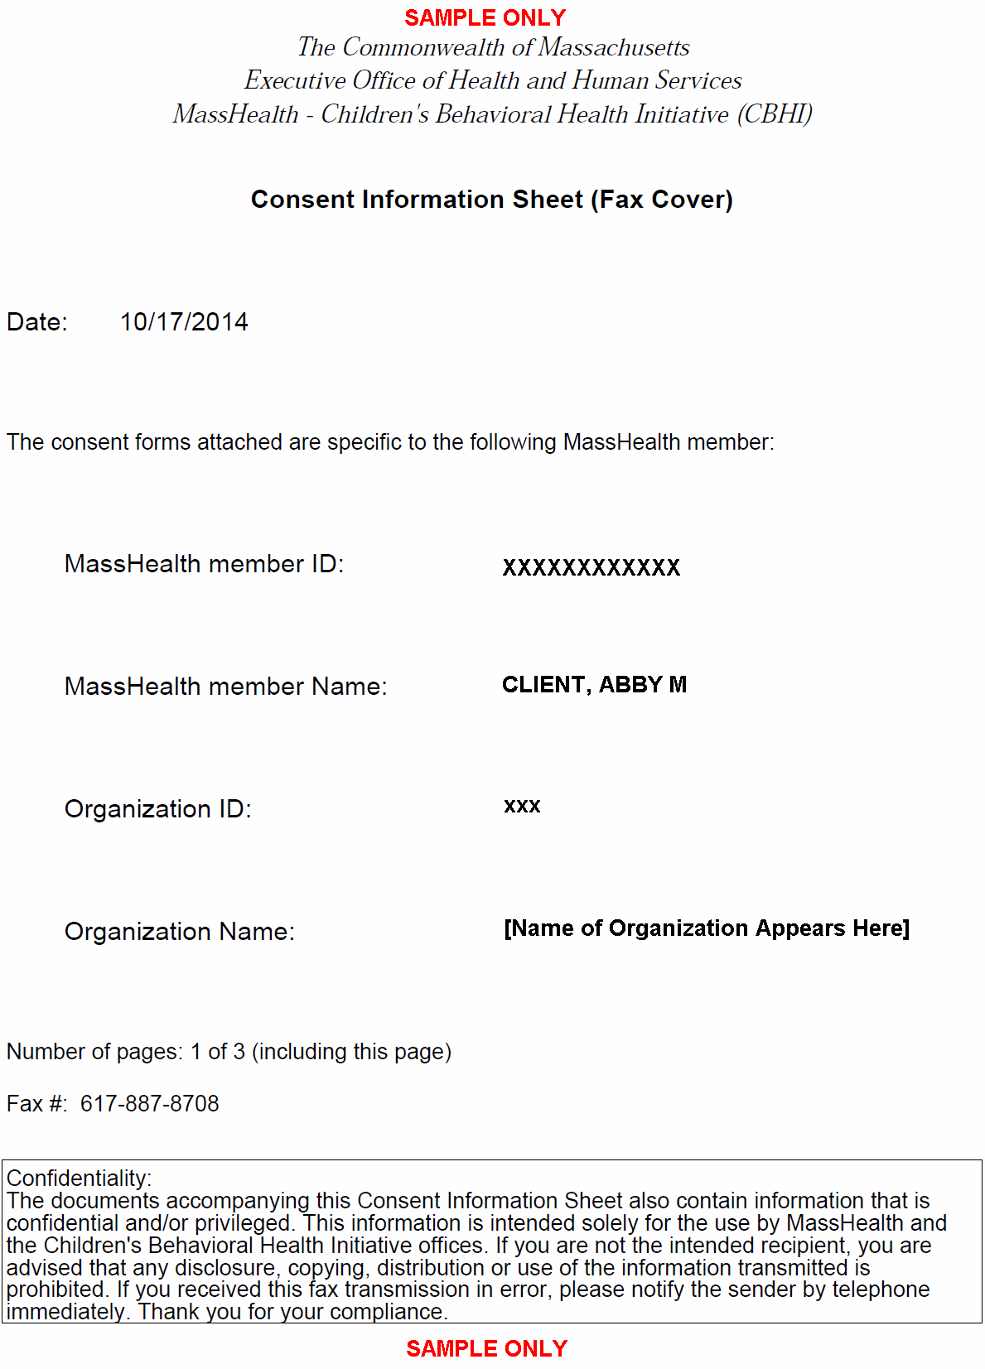
When completed, close the browser window ( ) and return to the CBHI application.

Important Information Regarding Faxing Consent
- The completed and signed Consent Form along with the Consent Information Sheet (CIS) are to be faxed to 617-887-8708.
- Blank Consent Forms can be found at www.mass.gov/eohhs/gov/commissions-and-initiatives/cbhi/child-and-adolescent-needs-and-strengths-cans/cans-forms.html.
- The Consent Information Sheet (CIS) is the Fax Cover Sheet; DO NOT include any additional cover sheet when faxing.
- Once consent is received by the EOHHS CBHI IT System, the CA or DEO can enter the CANS onto the VG for that client.
- Do not fax anything to CBHI (Mass Health) if consent is ‘NO’. Enter only the CANS SED and Demographic information onto the VG. The CANS status will be ‘Documented on Paper’.
Multiple Consent Information Sheet (Fax Cover) and Signed Consent forms may be faxed together, but each must be grouped and faxed by Member ID and have the Consent Information Sheet (Fax Cover) and the corresponding 4-page signed consent form together in order for the scanning software to work properly.
Example of faxing multiple consent forms:
Member A (Consent Information Sheet (Fax Cover) plus 4-page signed consent form)
Member B (Consent Information Sheet (Fax Cover) plus 4-page signed consent form)
Member C (Consent Information Sheet (Fax Cover) plus 4-page signed consent form)
Types of Faxes NOT Accepted by CBHI:
- An upside down fax.
- A fax that is missing the Consent Information Sheet (Fax Cover).
- A fax that is sent with an incorrect consent form (organization has an internal consent form instead of using the CBHI Consent form).
- A Fax that is missing the Consent Information Sheet (Fax Cover) and is sent using the provider organization’s internal cover sheet.
- A Fax that is sent using both, the provider organization’s internal fax cover sheet and the Consent Information Sheet (Fax Cover) – so 5 pages instead of 3 pages.

Additional Training Resources
Learn how a CBHI Certified Assessor edits a SED/CANS Assessment
This link provides Certified Assessor’s with an easy, interactive online lesson that steps them through activating their Certification Key and how to edit a CBHI SED/CANS Assessment.
Refer to the CBHI Certified Assessor Reference Guide for more information on using the CANS application.
Learn how a CBHI Data Entry Operator adds a SED/CANS Assessment
This link provides Data Entry Operator’s with an easy, interactive online lesson that steps them through adding a CBHI SED/CANS Assessment.
Refer to the CBHI Data Entry Operator Reference Guide for more information on using the CANS application.

Questions or Need Assistance?
Call Virtual Gateway Customer Service
1-800-421-0938 (617-847-6578 – TTY for those with complete or partial loss of hearing)
8:30 am to 5:00 pm Monday through Friday
Bookmark the Children's Behavioral Health Initiative Website:
http://www.mass.gov/masshealth/cans

