Commonwealth of Massachusetts
Executive Office of Health and Human Services
Virtual Gateway

CBHI Certified Assessor
Reference Guide
February 2015 R3.0 v1

CBHI Certified Assessor Reference Guide
Table of Contents
Release 3.0 Updates 3
Consent FAQs 3
Other Change to CANS 6
Logon to Virtual Gateway 7
Activating Your Certified Assessor Certification 7
Print Blank Form 7
Managing Consent 8
Important Information Regarding Faxing Consent 11
Add and Save a NEW CANS Assessment 11
Edit a CANS Assessment 13
Using Disputed Note Feature 14
View a CANS Record 14
Print to Screen (PDF) a CANS Record 15
Generating and Printing Reports 16
Copy a CANS 17
Delete a CANS Record 18
Auditing 19
Performance Tip 19
Additional Training Resources 19
CANS FAQs 19
Questions or Need Assistance? 20

Release 3.0 Updates
The Commonwealth of Massachusetts and the Executive Office of Health and Human Services (EHHS) have made system enhancements to the Children's Behavioral Health Initiative (CBHI) Child and Adolescent Needs and Strengths (CANS) application (Release 3.0), which is now available to all users.
All documentation related to the CBHI CANS application ("Reference Guides" and "Learn How To" CBTs) has been updated and are posted on the CBHI website. Visit http://www.mass.gov/eohhs/gov/commissions-and-initiatives/cbhi/, click the Child and Adolescent Needs and Strengths (CANS) link, then select the Using the CANS Application on the Virtual Gateway link.
Below is a summary of the Release 3.0 improvements and new features.
New Consent Process
The new Consent process permits a provider to enter the CANS on the Virtual Gateway (VG) account and share the CANS with all other providers to whom the caregiver has given consent. This will allow all providers caring for the child to have a clear picture of what is happening in the child and family’s life. This is particularly important when a child is cared for by multiple providers or requires treatment in different levels of care.
New Consent Forms
The new Consent Form explains to the caregiver that by signing the Consent Form, they are giving permission to a provider to enter the CANS on the VG and share the CANS with any other providers to whom the caregiver has given consent.
Link to CANS Consent Forms: www.mass.gov/eohhs/gov/commissions-and-initiatives/cbhi/child-and-adolescent-needs-and-strengths-cans/cans-forms.html).
To learn more about how the Consent process works in daily practice, please view the
CANS Consent Step-by-Step Guide and Flowchart which can be found at www.mass.gov/eohhs/gov/commissions-and-initiatives/cbhi/child-and-adolescent-needs-and-strengths-cans/using-the-cans-application-on-the-virtual-gateway.html.

Consent FAQs
What do I need to know about the new Consent process?
The new Consent process permits a provider to enter the CANS on the Virtual Gateway (VG), and allows other providers, to whom the caregiver has given consent, to view and copy the CANS. This will allow all providers caring for the child to have a clear picture of what is happening in the child and families life. This is particularly important when a child is cared for by multiple providers or requires treatment in different levels of care.
What specific information does MassHealth require to be entered into the Virtual Gateway (VG), and does this information require client permission?
Information about member demographics and whether the child/youth meets the criteria for Serious Emotional Disturbance (SED) collected with CANS must be entered into the VG, and does not require client permission.
What information requires member permission to be entered into CANS application on the VG and what is the process of documenting consent in the application?
Member permission is granted by a caregiver or an emancipated youth under age 21, and is required to enter CANS ratings and narrative fields in the VG. The application includes features for documenting consent, as well as, features for the member to cancel consent. MassHealth requires provider organizations use the consent form created by EOHHS.
What is different about the new consent process?
The new Consent form, which is scheduled to go-live in February 2015, features more user-friendly language that makes it easier for both the provider and caregiver to understand the consent process, and explains how the information gathered is stored in a safe place.
The new consent process allows providers who have received consent, to view and copy CANS records entered by other providers on the VG. This permits all providers with active consent, who are caring for the same child to have a clear and timely picture of what is happening in the child and family’s life. This is particularly important when a child is cared for by multiple providers or requires treatment in different levels of care. For families, it means not having to repeat their stories. For new providers, it means that they will have immediate access to current information that affects their child’s care and will be able to view, copy and edit a CANS previously created by another provider. Copying and editing existing CANS will also save time and effort for providers.
What does the new language does the Consent form contain?
The new Consent form explains to the caregivers that signing the consent form gives permission to a provider to:
- Enter the CANS on the VG
- Such that any other providers, to whom the caregiver has given consent, will be able to view and copy the CANS record.
Please click to Read the new Consent form.
How will this work?
After the go-live date, all prior consent will no longer be valid as the Consent status in the CANS Application on the Virtual Gateway (VG) will be re-set to “no” for all members. You will be required to:
- Obtain new Consent from the caregiver when you next see them and then, you will need to enter “yes” in the ‘Manage Consent” tab on the CANS application on the VG.
- If the caregiver declines consent then, you will simply enter “no” in the Manage Consent tab. You are still required to enter the SED section on the CANS application on the VG but complete the CANS on paper and enter into the child’s medical record.
How will I know if another provider has completed a CANS on the same child?
When a new provider, with consent, enters a child’s CANS onto the CANS application on the VG for the first time, the new provider will automatically be able to see the child’s previous CANS from other providers.
The new provider will have the option to copy a previous CANS. The copy is now the new provider's CANS and can be edited as necessary, including the addition of Summary Comments at the end of each domain.
When a new provider copies a CANS, they are not altering in any way the previous CANS completed by another provider.
What do I need to tell members about the new consent process?
CBHI strongly encourage you to discuss the new consent form with caregivers prior to the go-live date so that you have signed consent forms on hand when the new process is active. On the go-live date, all existing consents, regardless of their stated end dates, will expire. We recommend that you throw away all blank copies of the old Consent form that you or a DEO in your organization may have on hand.
Will the faxing process change?
No. Current procedures for faxing in your signed consent forms will remain unchanged. Remember to generate a Fax Information Sheet (cover sheet) from the CANS application, just as you do now. (If the caregiver declines consent, the process remains the same. You should document this fact in the chart, but do not fax anything to MassHealth.)
Will there be “how to” support in the CANS Consent Resources and Guides?
We will revise all of the related information in the “How to use the CANS Application on the Virtual Gateway” page (www.mass.gov/masshealth/cans) in the CANS section of the CBHI website to offer updated information. Also, CBHI will offer a webinar on the new consent process prior to the start date for the new process.
The Consent Webinar will be posted on the CBHI website. Providers may also call the VG Customer Service Helpdesk at 800-421-0938 or (TTY) 617-847-6578 (for those with partial or total hearing loss) and ask for help with the new consent process. The call will be transferred to CBHI for assistance.
The revised CBHI CANS Consent Information and Faxing Guide, also found on this page, will instruct users on how to manage consent, download the consent form, as well as how to fax the consent form. The Guide will also offer assistance on how to talk to families about the new Consent process.
What should I do with the signed consent form after I document consent in the application?
The 4-page signed consent form, combined with the Consent Information Sheet (fax cover sheet), must be faxed to MassHealth at 617-887-8708. The Consent Information Sheet (fax cover sheet) can be printed from the CANS application in VG, which will automatically print both member and provider information on the CANS Information Sheet (fax cover sheet). Do not use your organization’s regular fax cover sheet as it will not be accepted in the faxing system.
What do I do with the rest of the CANS information if the caregiver or member does not consent?
If the parent or guardian of a minor member (or the member if she or he is 18 or older) declines consent, then CANS should be completed on paper and included in the medical record. The CBHI system on the VG will not permit entry of CANS rating or narrative fields without consent.
Please remember that you must still enter SED and demographic information into the CANS application on the VG and you must complete a copy of CANS for the medical record regardless of member consent.
Can consent be cancelled?
Yes, members may cancel consent. The application allows the provider to change the consent status of a member at any time.
Does consent expire?
Consent will automatically expire after a specified period of time. The default length is one year, although the consent form and the application allow the member to specify a shorter or longer period of time if preferred. If you anticipate that the member will be in treatment for more than a year, you may want to suggest a longer expiration period for the consent.
What are the additional responsibilities of a provider regarding consent?
Providers have the independent responsibility to examine and comply with applicable federal and state privacy laws, regulations and rules as well as their own privacy policies and practices.
Who can access information from the online CANS application?
The VG is designed and extensively tested to be highly secure. The CBHI system does not include social security numbers or financial information that is most often the target of hackers. Consent gives MassHealth and the member’s managed care plan access to the member’s information. To protect a child’s privacy, MassHealth keeps tight control over who has access to the database. Access to your CANS record is restricted and protected under state and federal privacy laws.
What is the benefit of consenting to entering CANS data in the CANS application online?
In early 2015, all provider who care for the same child and have active consent from the child’s caregiver will be able to view and copy the child’s CANS on the CANS application on the VG. The benefits of consent include the ability to view and copy the CANS to share with the family, to easily update the CANS without needing to create multiple paper copies, and to share the CANS with other levels of care across provider organizations. Also, by sharing the CANS, the family may not have to repeat their entire story, over and over again. Another benefit is the ability of the member’s managed care entity (MCE) to see CANS in authorizing care—which may save time. Finally, the state uses CANS data entered into the application to gather general information about the delivery of CBHI services and in general to improve services for all youth and families using MassHealth.
Where can I get more information about faxing consents?
For more detailed instructions about faxing consents, please refer to the CBHI CANS Consent Information and Faxing Guide. It is available on the CANS (www.mass.gov/masshealth/cans) Web page of the CBHI Web site along with other CBHI reference materials.
If you have any questions regarding faxing consents, please contact Virtual Gateway Customer Service at 1-800-421-0938 or (TTY) 617-847-6578 (for those with partial or total hearing loss).
Where can I get more information about the CANS application and consent?
More information about the consent process, including the consent forms and “how-to” Reference Guides, may be found at www.mass.gov/masshealth/cans. Click on “How to Use the CANS Application on the Virtual Gateway”.
You will also find the CANS Family Guide on the Clinical Guidance section of CANS page of the CBHI website. The three-page document that explains the “what” and the “why” of the CANS to family members, including consent. We encourage providers to share this with families during the initial assessment period. Go to www.mass.gov/masshealth/cans and click on “Clinical Guidance on the CANS”.

Other Change to CANS
- The Diagnoses module has been renamed as Diagnostic Factors and DCM diagnosis of the behavioral health condition is no longer part of the CANS. This change is a better fit for CANS as the CANS is not intended to be a diagnostic tool but rather a way to communicate needs and strengths, and help inform family-driven, collaborative care planning at the right level of care.
- Discontinuation of Axis I and Axis II.
- Renaming Axis III, Axis IV and Axis V.
  - Axis III has been renamed as Physical Conditions defined as “Physical conditions which play a role in the development, continuance or exacerbation of a behavioral health condition.”
  - Axis IV has been renamed as Psychosocial Stressors defined as “Events in a person’s life, such as the death of a loved one, starting a new job, college, unemployment or even marriage can affect behavioral health condition.”
  - Axis V has been renamed as CGAS (Children’s Global Assessments scale) and selecting the “?” will bring up the scale.

Logon to Virtual Gateway
To log in to the Virtual Gateway (VG), go to www.mass.gov/vg and select the link “Logon to Virtual Gateway”. Select the Children’s Behavioral Health Initiative (CBHI) business service to enter CANS in the VG.
Note: See the Login Assistance page at www.mass.gov/eohhs/provider/training-and-edu/vg/login-help-for-providers-and-state-agency-staff.html for more information on setting up a Virtual Gateway (VG) account.

Activating Your Certified Assessor Certification
A Certified Assessor (CA) is a healthcare professional who is trained and certified to perform CANS behavioral health assessments for MassHealth clients. A Certification Key is provided to each CA upon successful completion of certification training. The CA must have an active certification to be able to access the CANS main assessment menu.
A CA needs to enter a valid certification key the first time they log in to the Children’s Behavioral Health Initiative (CBHI) application on the VG.
After successfully logging into the CBHI application on the VG, the CA needs to
- Enter [Last Name] and select the [OK] button.
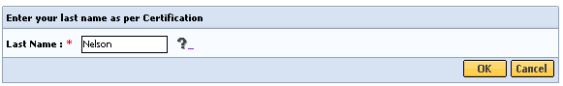
- Type [Certification Key] and select the [OK] button.
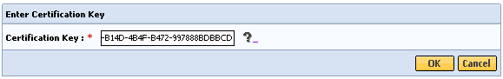
System Notes:
- The asterisk (*) symbol indicates a required field.
- You will know that your Certification Key was accepted if you are redirected to the Main Assessment Menu page.

Print Blank Form
The Print Blank Form tab is where the blank CANS and Consent (available in multiple languages) forms are available for printing in PDF or RTF format. The Certified Assessor (CA) works with the child and caregiver to complete these forms. The Data Entry Operator (DEO) does have the option to print these forms, if directed by the Certified Assessor (CA).
The Print Blank Forms tab in the Virtual Gateway will now host the New Consent Forms in English, Spanish, Russian, Portuguese, Chinese, Vietnamese, Khmer and Haitian Creole languages.
Blank forms are available under the Print Blank Form tab.
- From the Main Assessment Menu, select the [Print Blank Form] tab.
- Select the option of your choice to print the blank form:
- PDF (Portable Document Format – Adobe Acrobat)
- RTF (Rich Text Format)
The provider needs the caregiver’s signature on these forms.

Managing Consent
Consent is permission for a provider to add, edit, copy, and print CANS on the Virtual Gateway (VG). The consent process permits a provider to enter the CANS onto the VG and share the CANS with all other providers to whom the caregiver has granted consent. The CANS can be shared within the provider organization, MassHealth and other providers with active consent. Consent is validated for each CANS entered onto the VG. This allows all providers caring for the child to have a clear picture of what is happening in the child and families life. This is particularly important when a child is cared for by multiple providers or requires treatment in different levels of care.
If a caregiver declines consent to enter the CANS onto the VG the provider is not required to notify CBHI (MassHealth). The provider still needs to enter the Person Details, Child CANS Information, and the Serious Emotional Disturbances (SED) Part I and II sections onto the VG. The CANS Domains/Modules must be completed on paper and entered into the client’s medical record. The CANS status in VG, in this case, will be ‘Documented on Paper’.
If a Caregiver decides to cancel an active Consent, please e-mail a scanned, signed copy of the written cancellation to CBHI at: CANS-CBHIMailbox@state.ma.us.
Reminder Regarding Consent: When consent is saved by a Data Entry Operator (DEO) the CA they are working on behalf of will also be saved. Therefore, the report could have both the DEO and CA names appear.
- From the Main Assessment Menu, select [Manage Consent].
- Select the [Manage Consent] tab.
- Enter the [MassHealth ID] and select the [OK] button.
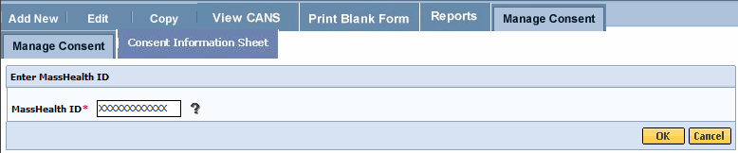
- Confirm client Information and select the [OK] button.
Note: If incorrect Client Information displays select the [Cancel] button and type in the correct MassHealth ID.
Complete all the questions on the Consent Information page.
- Select the [Yes or No] radio button depending on whether consent was granted or denied.
- Select the [Consenting Party Relationship to Client] from drop down menu.
- Enter the [Consent Effective Date] based on the date the consent form was signed.
- Enter the [Consent Expiration Date] per the signed Consent Form or based on the treatment plan the CA has identified.
- Select the [OK] button to submit this information.
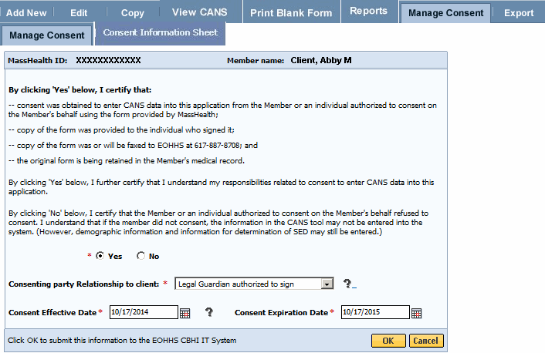
- Select the [OK] button to print the Consent Information Sheet. Select [Cancel] to continue without printing consent information sheet.
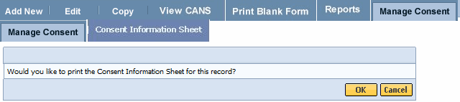
The Consent Information Sheet will display in a new screen. You can print the consent information sheet or save as a PDF file.

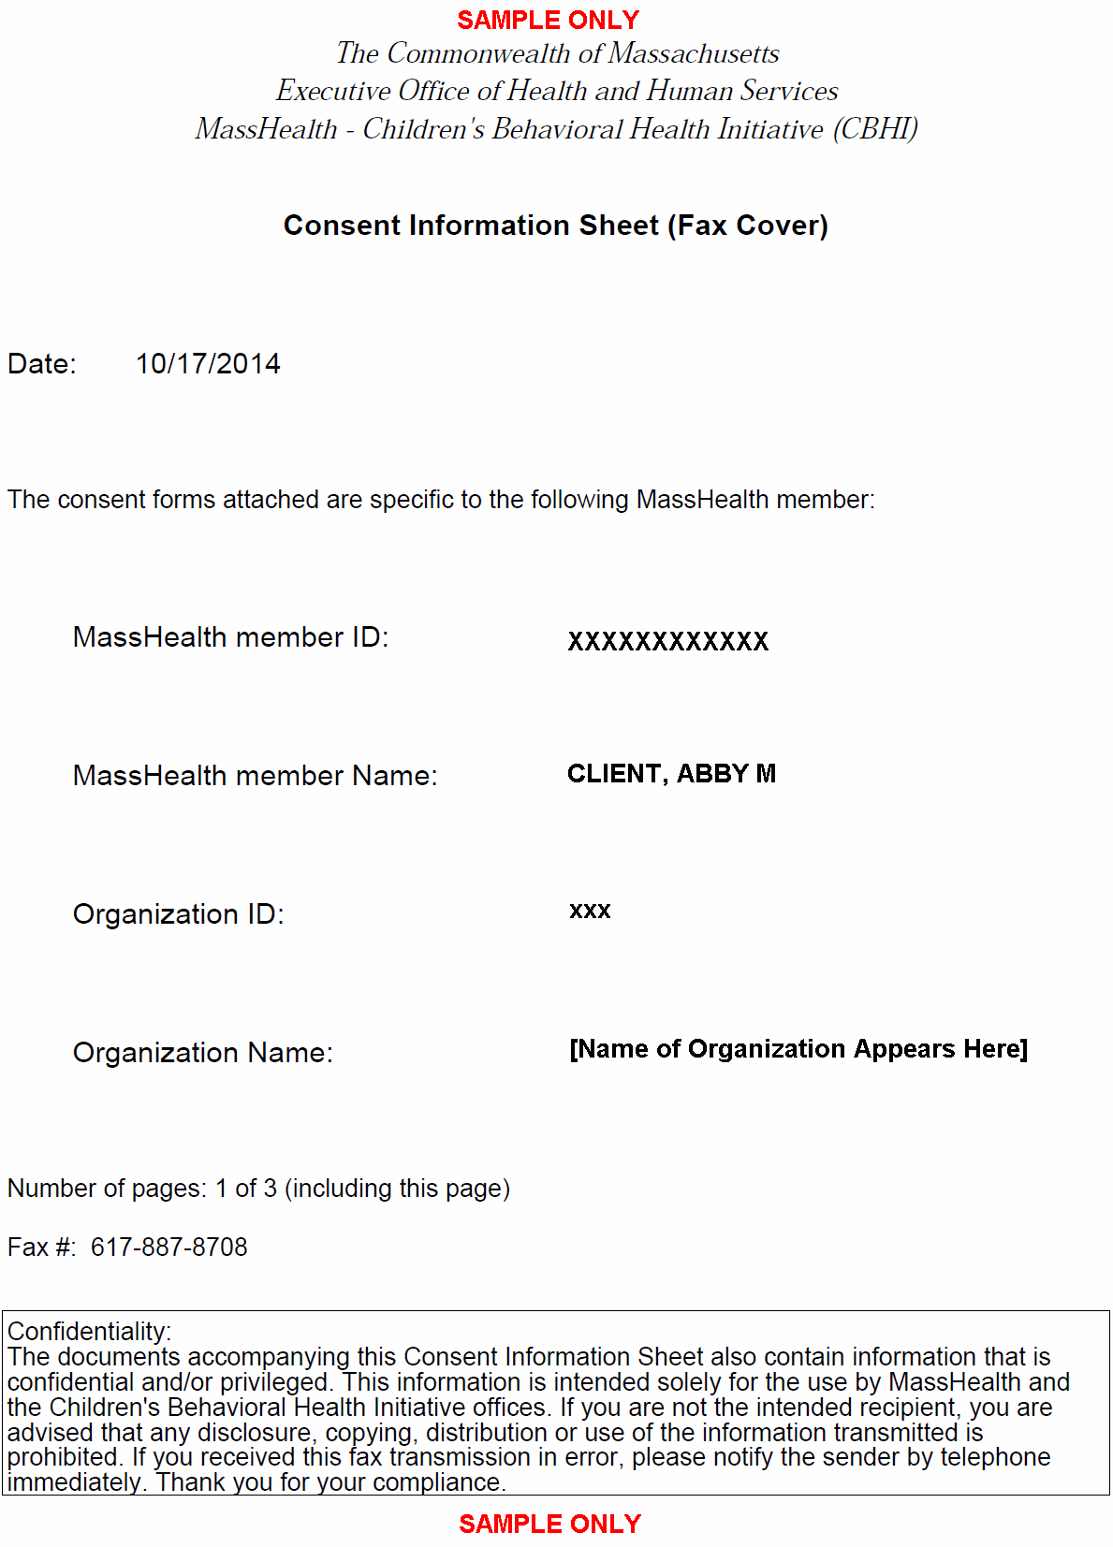

- When completed, close the browser window ( ) and return to the CBHI application.

Important Information Regarding Faxing Consent
- The completed and signed Consent Form along with the Consent Information Sheet (CIS) is to be faxed to 617-887-8708.
  - Blank Consent Forms can be found at www.mass.gov/eohhs/gov/commissions-and-initiatives/cbhi/child-and-adolescent-needs-and-strengths-cans/cans-forms.html.
- The Consent Information Sheet (CIS) is the Fax Cover Sheet; DO NOT includes any additional cover sheet when faxing.
- Once consent is received by the EOHHS CBHI IT System, the CA or DEO can enter the CANS onto the VG for that client.
- Do not fax anything to CBHI (Mass Health) if consent is ‘NO’. Enter only the CANS SED and Demographic information onto the VG. The CANS status will be ‘Documented on Paper’.
- Refer to the Reference Guide: CBHI CANS Consent Information and Faxing Guide for detailed information on consent (www.mass.gov/eohhs/gov/commissions-and-initiatives/cbhi/child-and-adolescent-needs-and-strengths-cans/using-the-cans-application-on-the-virtual-gateway.html).

Add and Save a NEW CANS Assessment
A Certified Assessor (CA) has the authority to add a new record for a client.
System Note: The asterisk (*) symbol indicates a required field.
- From the Main Assessment Menu, select [Add New].
- Enter the [MassHealth ID]; Select the [OK] button.
(If the incorrect MassHealth ID displays, select the [Cancel] button to enter another MassHealth ID.
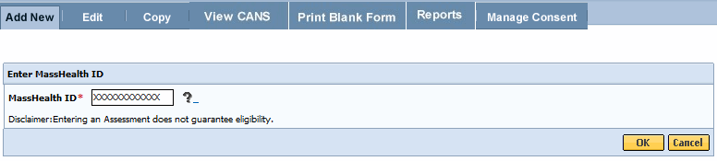
- Confirm Client Information. (If incorrect Client Information displays, select the [Cancel] button and type in the correct MassHealth ID).
- Enter the [Date of Assessment] (Format: MM/DD/YYYY).
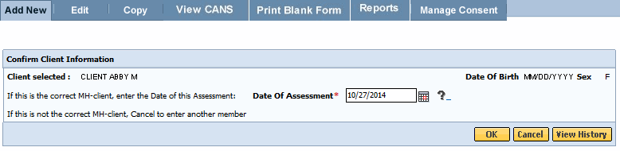

- Select the [OK] button.
Note Regarding View History:
- If a CA wants to review previously submitted CANS, select the View History button from the Confirm Client Information page.
Since client records are being accessed, the following consent page will appear.
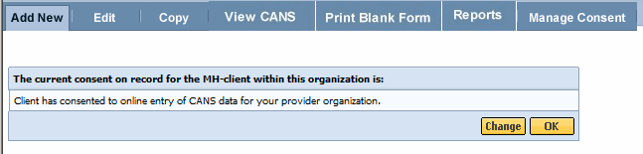
If Consent has already been granted, the system directs the user to the Person Details page. Complete the Person Details, CANS Information, SED Part I and SED Part II based on the hardcopy tool.
Please refer to the Reference Guide: CBHI Data Entry Operator (www.mass.gov/eohhs/gov/commissions-and-initiatives/cbhi/child-and-adolescent-needs-and-strengths-cans/using-the-cans-application-on-the-virtual-gateway.html) for guidance on entering CANS online.
Information on CANS Statuses:
Complete: If the client has consented to entering CANS online, and the CA has determined that all information entered for the MassHealth member is accurate, the CA can select ‘Complete’ to mark the status for this CANS as such..
Documented on Paper: If the client has not consented, the CANS must be completed on paper, and the SED information must still be entered into VG. The CANS status in this case will be 'Documented on Paper', to indicate that the CANS details are separately available in the Medical Record.
Incomplete but Final: 'Incomplete but Final' status indicates the CA’s determination that she or he will not be able to obtain sufficient clinical information to complete the CANS. The CA can give a reason for this or Select the 'Did Not Return' check-box.
In Progress: The CA can start a CANS and save it to be completed at a future date. In this case, the CANS status will be ‘In Progress’. A CANS entered by a DEO on behalf of a CA will be saved in ‘In Progress’ status till the CA finalizes it. Only an ‘In Progress’ CANS can be edited.
Reminder: Once a CANS assessment is in a ‘Complete’, ‘Documented on Paper’ or ‘Incomplete but final status’, it cannot be edited. A CA can add a disputed note to this CANS (see EDIT CANS Assessment section) if any information entered was incorrect.

Edit a CANS Assessment
The CA must review the CANS for accuracy and edit it, if necessary. The CA can also save a CANS and return later to finish it using the EDIT function. Edits can only be made to CANS that are in ‘In Progress’ status.
To Edit an ‘In Progress’ CANS:
- From the Main Assessment Menu, select the [Edit] tab.
- Enter the [Mass Health ID*] and select the [OK] button.
- Confirm client information; select the arrow to access the client record.
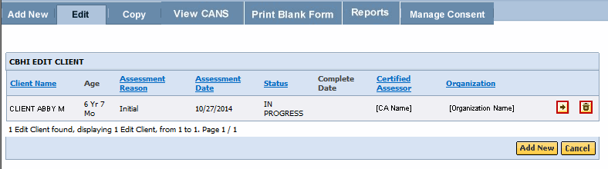
Understanding CANS Icons:
- The Arrow icon allows you to view (edit) a CANS record.
- The Trash can icon allows you to delete a CANS record.
When editing a CANS the Consent page will appear.
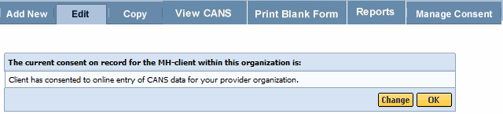
- If the client would like to change the status of their consent, select the [Change] button and change accordingly.
- If consent is unchanged, select the [OK] button.
- Review and update (if necessary) the Person Details, CANS Information, SED Part I and SED Part II based on hardcopy tool.
- Select the [Save and Next] or [Save] button to continue. The system will ask you to review each domain /module prior to saving the CANS assessment in ‘Complete’ or ‘Incomplete but Final’ status.

Using Disputed Note Feature
CANS cannot be edited if in a status of ‘Complete’ or ‘Incomplete but Final’ but, consistent with HIPAA requirements, the Add Disputed Notes feature provides users with a way to indicate that a member disputes information in the record. This field allows the CA to enter additional information, indicating what information is disputed by the member. HIPAA Disputed Notes can only be added to a finalized record (for records that are 'Complete', ‘Documented on Paper’, or 'Incomplete but Final').
To add a disputed note:
- From the Main Assessment Menu, select the [View CANS] tab.
- Enter the [Mass Health ID].
- Confirm client information; select the [OK] button.
- From the [View Client] tab, select the [Add Disputed Note] icon.
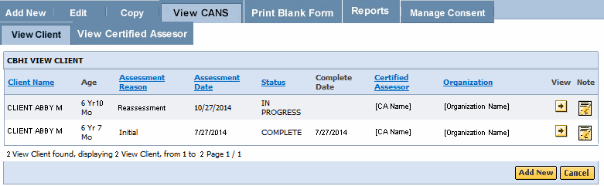
Note: A Disputed Note cannot be added to an ‘In Progress’ or ‘Expired’ CANS record. The user will receive an error message ‘Disputed Notes cannot be added to a record not finalized’.
- Enter text in the space provided. (Note: There is no spellcheck available in the CBHI CANS application.)
- Select the [Save] button
The CANS application returns you to the Enter MassHealth ID page. The message ‘Save Successful’ displays on page.

View a CANS Record
- Under the View CANS tab, select the [View Client] tab.
- Enter the [Mass Health ID] and select the [OK] button.
(If this is not the correct MH-client, select the [Cancel] button to enter another member.)
- Confirm client information; Select the [OK] button.
A list of the record(s) for the client will display (based upon your role and organization). You may sort the list by the column headings shown in bold and underlined. Multiple pages may appear with arrows at the bottom of the screen for navigation between pages. You also have the option to add a new record, if necessary.
- To view a specific assessment on the client, select the [View] button.

Print to Screen (PDF) a CANS Record
A CANS record may be printed via the Print-to-Screen (PDF) function under the View Client or Certified Assessor tabs. The View Clients tab requires a CA to type in the MH ID of the client in order to view the CANS. The View Certified Assessor tab allows a CA to view all CANS that are associated with their name (within the last six months).
- Under View CANS, select the [View Certified Assessor] tab.
- Enter the [Assessment Date] and select the [OK] button (Assessment Date defaults to six months prior).
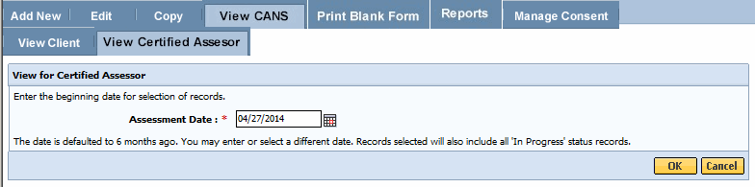
- Select the [View] icon to view the CANS for this client.
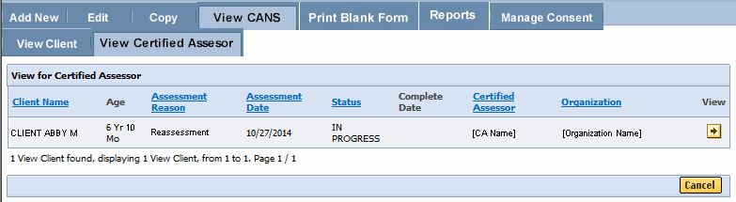
- Select the PDF icon to have the record displayed in a new screen.
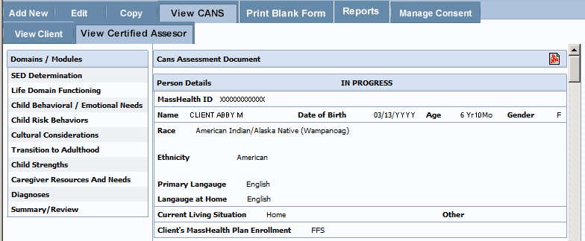
Important Notes:
- You may review, print, or save the record with Adobe Acrobat Reader.
  - If you do not have Adobe Acrobat Reader currently installed you can download it free at www.adobe.com.
- In the previous display, the SED details may appear grayed. In the Print-to-Screen the grayed out questions will not be displayed.
- When completed, close the browser window ( ) and return to the CBHI application.

Generating and Printing Reports
A Certified Assessor has the option to view and print reports.
- From the Reports menu, select the [Brief CANS Summary] report from the drop down menu.
- Select the [OK] button.
- Enter the [Mass Health ID]. (This field is 12 characters in length)
- Select the [OK] button.
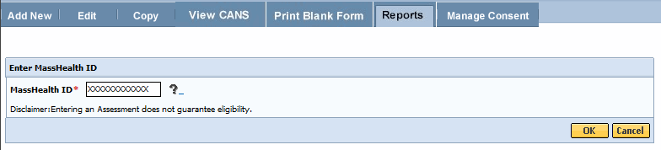
- The Brief CANS Summary report will be generated in PDF and can be viewed by selecting on the PDF icon.

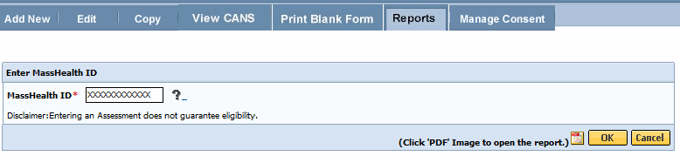
- When completed, close the browser window ( ) and return to the CBHI application.

Copy a CANS
The CBHI application allows a CA to create a copy of a previously ‘Complete’, ‘Incomplete but Final’ or ‘Documented on Paper’ CANS assessment. The application makes an exact copy of the CANS assessment chosen (excluding the Date of Assessment) and allows you to update the information based off the latest hardcopy tool. The CA is required to give this assessment a new assessment date.
Reminder: You cannot copy a CANS that is in an ‘In Progress’ status.
- From the Main Assessment Menu, select the [Copy] tab.
- Enter the [Mass Health ID] and select the [OK] button.
(If not the correct MH-client, Select the [Cancel] button to enter another member.)
- Confirm client information; Enter [Date of Assessment].
- Select the [OK] button.
A list of records with a status of ‘Documented on Paper’, ‘Complete’, and ‘Incomplete but Final’ for the client will display on the page.
- Locate the assessment that you wish to copy and select the [Copy] icon.
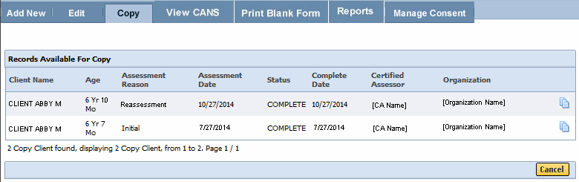
- Since client records are being accessed, the following consent page will appear:
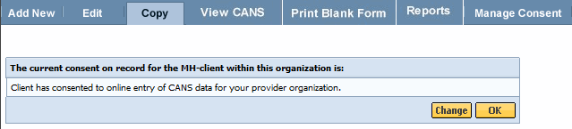
Important Note Regarding Consent: If the client has changed their Consent Form, you may change the Consent details by selecting the [Change] button and update accordingly. If consent is unchanged, select the [OK] button to continue.
The CANS Assessment will appear with data from the copied assessment. You must update the CANS per the latest hardcopy CANS.

Delete a CANS Record
If entered in error, a user can delete a CANS assessment that is in an ‘In Progress’ status. CANS that are in a status of ‘Incomplete but Final,’ ‘Documented on Paper’ or ‘Complete’ cannot be deleted.
- From the Main Assessment Menu, select the [Edit] tab.
- Enter the [Mass Health ID] and select the [OK] button.
(If not the correct MH-client, select the [Cancel] button to enter another member.)
- Confirm client information and select the [OK] button.
A list of CANS for the client with a status of ‘In Progress’ will display on the page.
- Locate the CANS to be deleted and select the [Delete] icon.
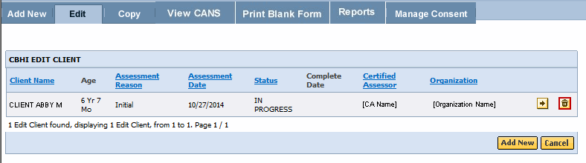
- A warning message will appear on the screen saying that by proceeding, the CANS assessment will be permanently deleted.
- Select the [OK] button.
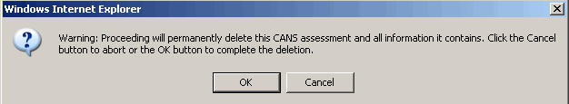
Before deleting an assessment, a reason must be chosen from the drop down menu.
- Select the [Deletion Reason*] from drop down menu.
- Select the [OK] button
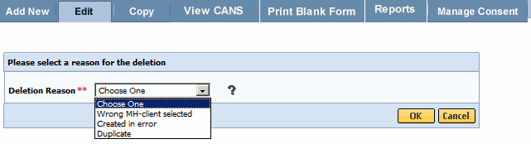
- A pop-up window will appear asking “Are you sure you want to delete?”
- Select the [OK] button if yes.
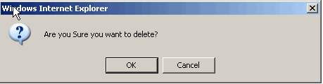
This returns you to the list of In Progress CANS for this client with the message:
“CANS Record has been successfully deleted.”

Auditing
All actions performed in the Massachusetts CANS are logged including action performed, user id, date and time. This enables administrators to have an audit trail of activities.

Performance Tip
If application performance appears to be slow, use browser options to clear cookies, history and/or cache. Please see individual browser instructions for specific steps.

Additional Training Resources
- Learn how a CBHI Certified Assessor edits a SED/CANS Assessment
This link provides Certified Assessor’s with an easy, interactive online lesson that walks them through the steps to activate their Certification Key and how to edit a CBHI SED/CANS Assessment.
- Learn how a CBHI Data Entry Operator adds a SED/CANS Assessment
This link provides Data Entry Operator’s with an easy, interactive online lesson that walks them through adding a CBHI SED/CANS Assessment.
- Refer to the CBHI Data Entry Operator Reference Guide for more information on using the CANS application with a Data Entry Operator role.

CANS FAQs
- Select the CANS FAQ link for updated information:

Questions or Need Assistance?
Call Virtual Gateway Customer Service
1-800-421-0938 (617-847-6578 - TTY for those with complete or partial loss of hearing)
8:30 am to 5:00 pm Monday through Friday
Bookmark the Children's Behavioral Health Initiative Website:
www.mass.gov/masshealth/cans

