Commonwealth of Massachusetts
Executive Office of Health and Human Services

Virtual Gateway



CBHI Data Entry Operator Reference Guide
February 2015 R3.0 v1

CBHI Data Entry Operator Reference Guide

Table of Contents
Release 3.0 Updates 3
Consent FAQs 3
Other Change to CANS 6
Logon to Virtual Gateway 7
Identify the Certified Assessor (CA) 7
Understanding Consent 8
Print Blank Consent Forms 8
Manage Consent 9
Important Information Regarding Faxing Consent 12
Add and Save a NEW CANS Assessment 12
Edit a CANS Assessment 17
View and Print a CANS Record (Print-to-Screen) 18
Viewing a CANS Record 18
Auditing 19
Printing a CANS Record 19
Copy 20
Delete a CANS Record 21
Performance Tip 22
Additional Training Resources 22
Questions or Need Assistance? 22

Release 3.0 Updates
The Commonwealth of Massachusetts and the Executive Office of Health and Human Services (EHHS) have made system enhancements to the Children's Behavioral Health Initiative (CBHI) Child and Adolescent Needs and Strengths (CANS) application (Release 3.0), which is now available to all users.
All documentation related to the CBHI CANS application ("Reference Guides" and "Learn How To" CBTs) has been updated and are posted on the CBHI website. Visit www.mass.gov/eohhs/gov/commissions-and-initiatives/cbhi/, click the Child and Adolescent Needs and Strengths (CANS) link, then select the Using the CANS Application on the Virtual Gateway link.
Below is a summary of the Release 3.0 improvements and new features.
New Consent Process
The new Consent Process permits a provider to enter the CANS on the Virtual Gateway (VG) account and share the CANS with all other providers to whom the caregiver has given consent. This will allow all providers caring for the child to have a clear picture of what is happening in the child and family’s life. This is particularly important when a child is cared for by multiple providers or requires treatment in different levels of care.
New Consent Forms
The new Consent Form explains to the caregiver that by signing the Consent Form, they are giving permission to a provider to enter the CANS on the VG and share the CANS with any other providers to whom the caregiver has given consent.
Link to CANS Consent Forms: www.mass.gov/eohhs/gov/commissions-and-initiatives/cbhi/child-and-adolescent-needs-and-strengths-cans/cans-forms.html).
To learn more about how the Consent process works in daily practice, please view the CANS Consent Step-by-Step Guide and Flowchart which can be found at www.mass.gov/eohhs/gov/commissions-and-initiatives/cbhi/child-and-adolescent-needs-and-strengths-cans/using-the-cans-application-on-the-virtual-gateway.html.

Consent FAQs
What do I need to know about the new Consent process?
The new Consent process permits a provider to enter the CANS on the Virtual Gateway (VG), and allows other providers, to whom the caregiver has given consent, to view and copy the CANS. This will allow all providers caring for the child to have a clear picture of what is happening in the child and families life. This is particularly important when a child is cared for by multiple providers or requires treatment in different levels of care.
What specific information does MassHealth require to be entered into the Virtual Gateway (VG), and does this information require client permission?
Information about member demographics and whether the child/youth meets the criteria for Serious Emotional Disturbance (SED) collected with CANS must be entered into the VG, and does not require client permission.
What information requires member permission to be entered into CANS application on the VG and what is the process of documenting consent in the application?
Member permission is granted by a caregiver or an emancipated youth under age 21, and is required to enter CANS ratings and narrative fields in the VG. The application includes features for documenting consent, as well as, features for the member to cancel consent. MassHealth requires provider organizations use the consent form created by EOHHS.
What is different about the new consent process?
The new Consent form, which is scheduled to go-live in February 2015, features more user-friendly language that makes it easier for both the provider and caregiver to understand the consent process, and explains how the information gathered is stored in a safe place.
The new consent process allows providers who have received consent, to view and copy CANS records entered by other providers on the VG. This permits all providers with active consent, who are caring for the same child to have a clear and timely picture of what is happening in the child and family’s life. This is particularly important when a child is cared for by multiple providers or requires treatment in different levels of care. For families, it means not having to repeat their stories. For new providers, it means that they will have immediate access to current information that affects their child’s care and will be able to view, copy and edit a CANS previously created by another provider. Copying and editing existing CANS will also save time and effort for providers.
What does the new language does the Consent form contain?
The new Consent form explains to the caregivers that signing the consent form gives permission to a provider to:
- Enter the CANS on the VG
- Such that any other providers, to whom the caregiver has given consent, will be able to view and copy the CANS record.
Please click to Read the new Consent form.
How will this work?
After the go-live date, all prior consent will no longer be valid as the Consent status in the CANS Application on the Virtual Gateway (VG) will be re-set to “no” for all members. You will be required to:
- Obtain new Consent from the caregiver when you next see them and then, you will need to enter “yes” in the ‘Manage Consent” tab on the CANS application on the VG.
- If the caregiver declines consent then, you will simply enter “no” in the Manage Consent tab. You are still required to enter the SED section on the CANS application on the VG but complete the CANS on paper and enter into the child’s medical record.
How will I know if another provider has completed a CANS on the same child?
When a new provider, with consent, enters a child’s CANS onto the CANS application on the VG for the first time, the new provider will automatically be able to see the child’s previous CANS from other providers.
The new provider will have the option to copy a previous CANS. The copy is now the new provider's CANS and can be edited as necessary, including the addition of Summary Comments at the end of each domain.
When a new provider copies a CANS, they are not altering in any way the previous CANS completed by another provider.
What do I need to tell members about the new consent process?
CBHI strongly encourage you to discuss the new consent form with caregivers prior to the go-live date so that you have signed consent forms on hand when the new process is active. On the go-live date, all existing consents, regardless of their stated end dates, will expire. We recommend that you throw away all blank copies of the old Consent form that you or a DEO in your organization may have on hand.
Will the faxing process change?
No. Current procedures for faxing in your signed consent forms will remain unchanged. Remember to generate a Fax Information Sheet (cover sheet) from the CANS application, just as you do now. (If the caregiver declines consent, the process remains the same. You should document this fact in the chart, but do not fax anything to MassHealth.)
Will there be “how to” support in the CANS Consent Resources and Guides?
We will revise all of the related information in the “How to use the CANS Application on the Virtual Gateway” page (http://www.mass.gov/masshealth/cans) in the CANS section of the CBHI website to offer updated information. Also, CBHI will offer a webinar on the new consent process prior to the start date for the new process.
The Consent Webinar will be posted on the CBHI website. Providers may also call the VG Customer Service Helpdesk at 800-421-0938 or (TTY) 617-847-6578 for those with partial or total hearing loss) and ask for help with the new consent process. The call will be transferred to CBHI for assistance.
The revised CANS Consent Reference Guide, also found on this page, will instruct users on how to manage consent, download the consent form, as well as how to fax the consent form. The Guide will also offer assistance on how to talk to families about the new Consent process.
What should I do with the signed consent form after I document consent in the application?
The 4-page signed consent form, combined with the Consent Information Sheet (fax cover sheet), must be faxed to MassHealth at 617-887-8708. The Consent Information Sheet (fax cover sheet) can be printed from the CANS application in VG, which will automatically print both member and provider information on the CANS Information Sheet (fax cover sheet). Do not use your organization’s regular fax cover sheet as it will not be accepted in the faxing system.
What do I do with the rest of the CANS information if the caregiver or member does not consent?
If the parent or guardian of a minor member (or the member if she or he is 18 or older) declines consent, then CANS should be completed on paper and included in the medical record. The CBHI system on the VG will not permit entry of CANS rating or narrative fields without consent.
Please remember that you must still enter SED and demographic information into the CANS application on the VG and you must complete a copy of CANS for the medical record regardless of member consent.
Can consent be cancelled?
Yes, members may cancel consent. The application allows the provider to change the consent status of a member at any time.
Does consent expire?
Consent will automatically expire after a specified period of time. The default length is one year, although the consent form and the application allow the member to specify a shorter or longer period of time if preferred. If you anticipate that the member will be in treatment for more than a year, you may want to suggest a longer expiration period for the consent.
What are the additional responsibilities of a provider regarding consent?
Providers have the independent responsibility to examine and comply with applicable federal and state privacy laws, regulations and rules as well as their own privacy policies and practices.
Who can access information from the online CANS application?
The VG is designed and extensively tested to be highly secure. The CBHI system does not include social security numbers or financial information that is most often the target of hackers. Consent gives MassHealth and the member’s managed care plan access to the member’s information. To protect a child’s privacy, MassHealth keeps tight control over who has access to the database. Access to your CANS record is restricted and protected under state and federal privacy laws.
What is the benefit of consenting to entering CANS data in the CANS application online?
In early 2015, all provider who care for the same child and have active consent from the child’s caregiver will be able to view and copy the child’s CANS on the CANS application on the VG. The benefits of consent include the ability to view and copy the CANS to share with the family, to easily update the CANS without needing to create multiple paper copies, and to share the CANS with other levels of care across provider organizations. Also, by sharing the CANS, the family may not have to repeat their entire story, over and over again. Another benefit is the ability of the member’s managed care entity (MCE) to see CANS in authorizing care—which may save time. Finally, the state uses CANS data entered into the application to gather general information about the delivery of CBHI services and in general to improve services for all youth and families using MassHealth.
Where can I get more information about faxing consents?
For more detailed instructions about faxing consents, please refer to the CBHI CANS Consent Information and Faxing Guide. It is available on the CANS (http://www.mass.gov/masshealth/cans) Web page of the CBHI Web site along with other CBHI reference materials.
If you have any questions regarding faxing consents, please contact Virtual Gateway Customer Service at 1-800-421-0938 or (TTY) 617-847-6578 for those with partial or total hearing loss).
Where can I get more information about the CANS application and consent?
More information about the consent process, including the consent forms and “how-to” Reference Guides, may be found at http://www.mass.gov/masshealth/cans. Click on “How to Use the CANS Application on the Virtual Gateway”.
You will also find the CANS Family Guide on the Clinical Guidance section of CANS page of the CBHI website. The three-page document that explains the “what” and the “why” of the CANS to family members, including consent. We encourage providers to share this with families during the initial assessment period. Go to http://www.mass.gov/masshealth/cans and click on “Clinical Guidance on the CANS”.

Other Change to CANS
- The Diagnoses module has been renamed as Diagnostic Factors and DCM diagnosis of the behavioral health condition is no longer part of the CANS. This change is a better fit for CANS as the CANS is not intended to be a diagnostic tool but rather a way to communicate needs and strengths, and help inform family-driven, collaborative care planning at the right level of care.
- Discontinuation of Axis I and Axis II.
- Renaming Axis III, Axis IV and Axis V.
  - Axis III has been renamed as Physical Conditions defined as “Physical conditions which play a role in the development, continuance or exacerbation of a behavioral health condition.”
  - Axis IV has been renamed as Psychosocial Stressors defined as “Events in a person’s life, such as the death of a loved one, starting a new job, college, unemployment or even marriage can affect behavioral health condition.”
  - Axis V has been renamed as CGAS (Children’s Global Assessments scale) and selecting the “?” will bring up the scale.

Logon to Virtual Gateway
To log on to the Virtual Gateway (VG), go to www.mass.gov/vg and select the link “Logon to Virtual Gateway”. Select the Children’s Behavioral Health Initiative (CBHI) business service to enter CANS in the VG.
Note: See the Login Assistance page at www.mass.gov/eohhs/provider/training-and-edu/vg/login-help-for-providers-and-state-agency-staff.html for more information on setting up a Virtual Gateway (VG) account.

Identify the Certified Assessor (CA)
A Data Entry Operator (DEO) is allowed to enter CANS data in the VG on behalf of a Certified Assessor (CA) within the same organization. Data Entry Operators must always identify the specific CA for whom they are entering the CANS by entering the CA’s User ID. The VG will validate that the DEO and CA are part of the same organization and that the CA’s certification is valid prior to allowing the DEO access to the Main Assessment Menu.
When a DEO enters CANS on behalf of a CA, they must follow the CANS on paper exactly as submitted by the CA. If any questions on the CANS on paper are left blank by the CA, the DEO should leave them blank in the CANS online. The DEO should never modify any of the data submitted on the CANS. If a question arises the DEO should see the CA for clarification.
After the DEO data enters the CANS online it will be marked in a status of ‘In Progress.’ The CA is the only person who can place CANS in either ’Complete’ or ‘Incomplete, but Final’ status.
The DEO should contact the Certified Assessor if the CA User Id was not provided or an error is presented.
- Enter the Virtual Gateway User ID for the Certified Assessor for whom you are authorized to enter assessment data for a specific MassHealth client and select the [OK] button.
The asterisk (*) symbol indicates a required field.
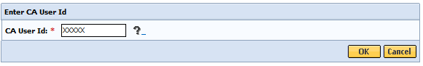
- Confirm the Certified Assessor; select the [OK] button. 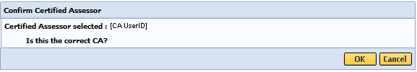
If incorrect Certified Assessor displays, select the [Cancel] button and type in the correct Certified Assessor User ID.
The DEO will be directed to the Main Assessment Menu if the CA information is accepted by the system.

Understanding Consent
Consent gives permission to a provider to enter, view, copy and print CANS into the Virtual Gateway (VG) and share data within and across provider organizations, MassHealth and other providers with active consent. Consent needs to be validated for all CANS data entered into the VG.
The Consent process permits a provider to enter the CANS on the VG and share the CANS with all other providers to whom the caregiver has given consent. The process will allow all providers caring for the same child to have a clear picture of what is happening in the child and families’ life. This is particularly important when a child is cared for by multiple providers or requires treatment in different levels of care.
Please view the Reference Guide: CBHI CANS Consent Information and Faxing Guide (www.mass.gov/eohhs/gov/commissions-and-initiatives/cbhi/child-and-adolescent-needs-and-strengths-cans/using-the-cans-application-on-the-virtual-gateway.html) for detailed information on consent.

Print Blank Consent Forms
The provider needs the caregiver’s signature on the Consent form. If a caregiver declines to give consent to enter the CANS into the Virtual Gateway (VG), the provider is not required to notify CBHI (MassHealth). However, the SED and Demographic section must be completed online and the CANS must be completed on paper and then entered into the member’s medical record. The CANS status in VG, in this case, will be ‘Documented on Paper’.
The consent form explains to the caregiver that by signing the consent form, they are giving permission to a provider to enter the CANS on the VG and share the CANS with any other providers to whom the caregiver has given consent.
If a caregiver decides to cancel an active Consent, please email a scanned, signed copy of the written cancellation to CBHI at: CANS-CBHIMailbox@state.ma.us.
Consent forms are available in different languages under the Print Blank forms tab.
The Print Blank Forms tab in the Virtual Gateway will now host the Consent Forms in English, Spanish, Russian, Portuguese, Chinese, Vietnamese, Khmer and Haitian Creole languages.
You will need the Adobe Acrobat reader to view and print these forms. If you do not have Adobe Acrobat currently installed you can download it for free at http://get.adobe.com/reader/.
- From the Main Assessment Menu, select the [Print Blank Form] tab.
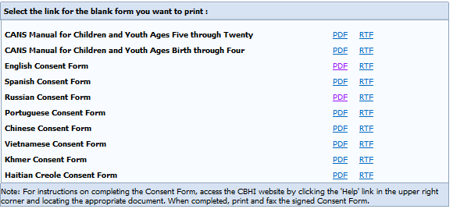
- Select the Consent Language option of your choice to print the blank form for the CANS tool documents:
- PDF (Portable Document Format – Adobe Acrobat)
- RTF (Rich Text Format)
- When completed, close the browser window ( ) and return to the CBHI application.

Manage Consent
When consent is given from the caregiver, they are giving permission to a provider to enter the CANS on the VG and share the CANS with any other providers to whom the caregiver has given consent. Consent must be entered in the VG in order for a provider to add, edit, copy or view CANS regarding a child. If prior consent was granted and the caregiver wants to end the consent, this also needs to be entered into the VG.
When a DEO is data entering CANS into the VG on behalf of a CA the consent information must be included with the CANS on paper. The DEO is required, by the VG, to enter in the consent before they can enter the CANS. Consent must be entered into the VG as either granted or denied.
From the Main Assessment Menu,
- Select the [Manage Consent] tab.
- Enter the [MassHealth ID] and select the [OK] button.
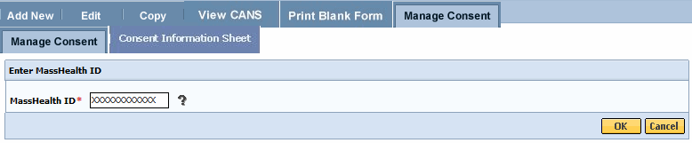
- Confirm Client Information. (If incorrect client information displays, select the [Cancel] button and type in the correct MassHealth ID).
- Select the [OK] button.
Complete all the questions on the Consent Information page.
- Select the Yes or No button depending on whether consent was granted or denied.
- Select the [Consenting Party Relationship to Client] from the pick list.
- Enter the [Consent Effective Date] based upon the date the form was signed.
- Enter the [Consent Expiration Date] per the signed form or based upon the treatment plan the CA has identified.
- Select the [OK] button to submit this information to the EOHHS CBHI IT System.
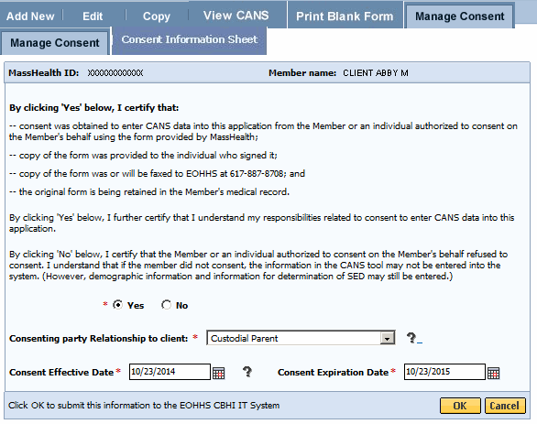
- Select the [OK] button to print the Consent Information Sheet (CIS).
If you do not need to print the CIS, select [Cancel] to continue without printing.
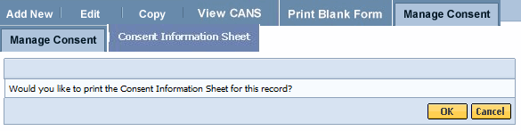
- Verify that you are viewing the correct client name and select the [OK] button.
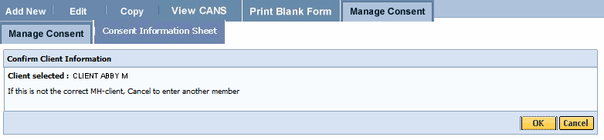
The Consent Information Sheet (CIS) will display in a new screen. You can print the consent information sheet or save as a PDF file.
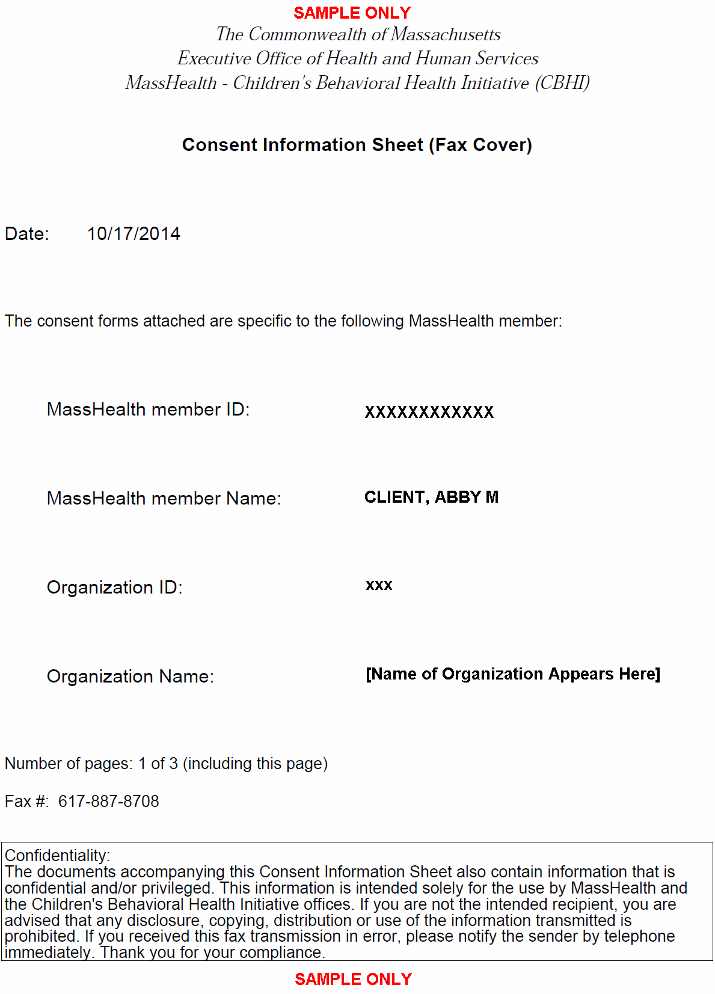
- When completed, close the browser window ( ) and return to the CBHI application.

Important Information Regarding Faxing Consent
- The completed and signed Consent Form along with the Consent Information Sheet (CIS) are to be faxed to 617-887-8708.
  - Blank Consent Forms can be found at www.mass.gov/eohhs/gov/commissions-and-initiatives/cbhi/child-and-adolescent-needs-and-strengths-cans/cans-forms.html.
- The Consent Information Sheet (CIS) is the Fax Cover Sheet; DO NOT include any additional cover sheet when faxing.
- Once consent is received by the EOHHS CBHI IT System, the CA or DEO can enter the CANS onto the VG for that client.
- Do not fax anything to CBHI (Mass Health) if consent is ‘NO’. Enter only the CANS SED and Demographic information onto the VG. The CANS status will be ‘Documented on Paper’.
- Refer to the Reference Guide: CBHI CANS Consent Information and Faxing Guide for detailed information on consent (www.mass.gov/eohhs/gov/commissions-and-initiatives/cbhi/child-and-adolescent-needs-and-strengths-cans/using-the-cans-application-on-the-virtual-gateway.html).

Add and Save a NEW CANS Assessment
The DEO is allowed to enter in CANS on behalf of a CA into the VG. The CA is required to complete the CANS on paper with the child. The CA can enter the CANS data into the VG or the DEO can enter the CANS data on their behalf.
- From the Main Assessment Menu, select the [Add New] tab.
- Enter the [Mass Health ID*] and select the [OK] button. (This field is 12 characters in length)
(If incorrect MH-client information displays, select the [Cancel] button to enter another member.)
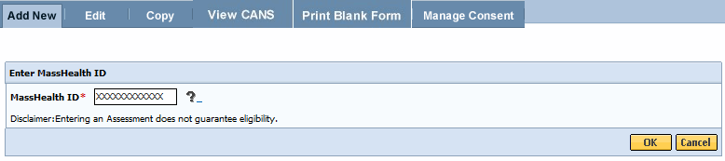
If Consent has not been entered in the VG the DEO will need to do this prior to adding in the CANS. Refer to the Managing Consent section in this reference guide.
- Confirm Client Information. (If incorrect Client Information displays; select the [Cancel] button and type in the correct MassHealth ID).
- Enter the [Date of Assessment*].
- Select the [OK] button.
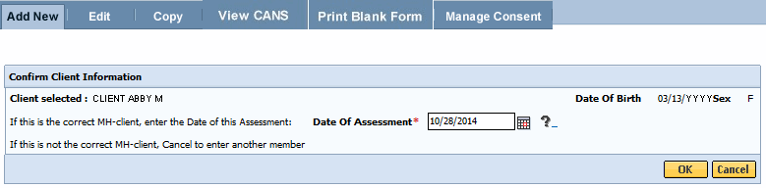
If consent is already on file in the VG the following consent page will appear.
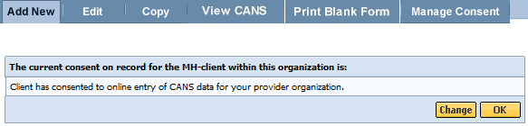
After verifying that consent has been granted, the system directs the DEO over to the Person Details page.
The DEO completes the Person Details, CANS Information, SED Part I and SED Part II based on the CANS hardcopy tool that the CA completed and gave to the DEO. The DEO can only save CANS records in an ‘In Progress’ status.
Under the Person Details section, (some fields may already be filled in from MassHealth)
- Choose [Race] from the Race pick list.
- Choose [Ethnicity] from the Ethnicity pick list.
- Choose [Language] from the Primary Language pick list.
- Choose [Language At Home] from the Language At Home pick list.
- Choose [Current Living Situation] from the Current Living Situation pick list.
Additional Race and Ethnicity fields can be entered for a member. If a member has more than one Race and/or Ethnicity, the CA would have included that on the CANS on paper and the DEO should include that when completing this section. The Specify field can be used to further clarify, if needed, the Race, Ethnicity, Primary Language and Language at Home fields.
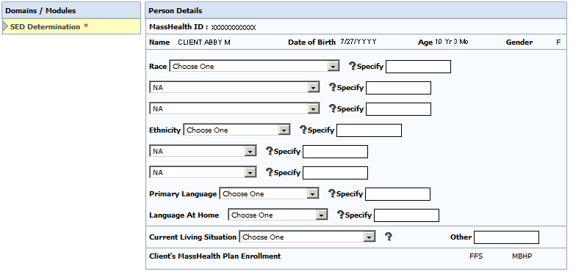
The asterisk symbol (*) indicates the field is required in order to save the CANS in a ‘Documented on Paper’ status.
Under the Child CANS Information section,
- Enter the [Assessor Phone Number**] (Must be 9 digits, no spaces, dashes or other characters).
- Enter the [NPI] for the CA or the Location/Clinic NPI. This is an optional field.
- From pick list, choose [Place of Assessment**].
- From pick list, choose [Level of Care**].
- The Referred By field can be used by the provider to enter the referral source. This is an optional field.
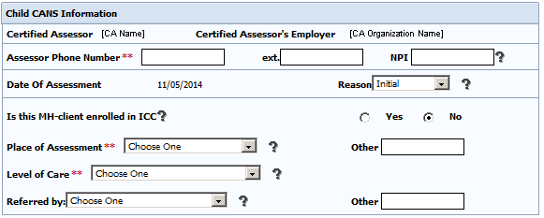
The double asterisk symbol (**) indicates the field is required in order to save the CANS in an ‘In Progress’ status.
Under the SED Determination section,
- Complete SED Part I and SED Part II per hardcopy tool.
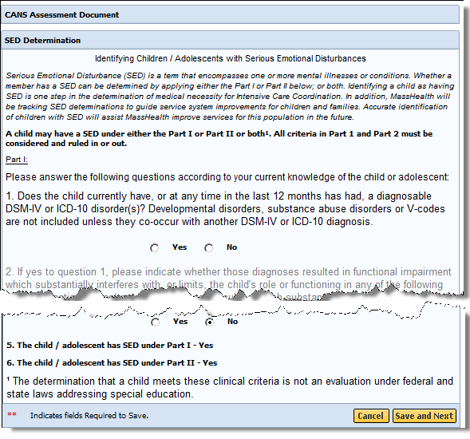
Things to Remember When Completing the SED Determination Section
- Questions 5 and 6 of the SED Determination are automatically determined based upon answers to previous questions.
- Questions will appear grayed if they are answered with “No”.
- There is no system warning if you select the [Cancel] button before saving; the application returns you to the “Enter MassHealth ID” page.
- The round Radio buttons are for Yes or No questions. Only one can be selected, indicated with a black dot.
At the bottom of the SED Part I and Part II you will see the [Save and Next] button, which will allow you to continue entering the remaining domains/modules of the CANS Assessment.
The [Save and Next] button places the record in an ‘In Progress’ status, which indicates that a Massachusetts CANS has been saved as a draft and can be accessed for additional edits, as needed.
- Select the [Save and Next] button to continue.
If Consent is granted the system will automatically direct you to the remaining Domains/Modules that are required to be completed.
Under the Domains/Modules sections the DEO can fill in these sections by following the CANS on paper document that was given to the DEO by the CA. The DEO should never deviate from the CANS on paper.
If Consent has not be granted the DEO will see the [Save] button at the bottom of the page. Since consent to enter the CANS was not given, the Domains/Modules sections must be completed on paper and filed accordingly at the organization.
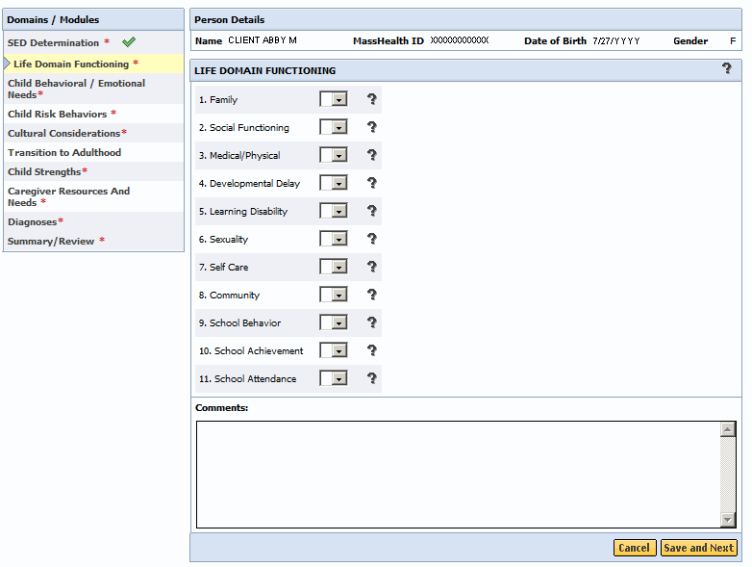
Notice that all of the Domains/Modules (which vary based on age of child) display an asterisk (*) denoted to the right. An asterisk (*) indicates that that domains/modules are required. The questions listed in each module correspond to the hardcopy tool given to the DEO from the CA and you select the pick list to the right of the question to select the answer (example: 0 1 2 3, and sometimes NA). The Comments field is also required. Always refer to the CANS on paper when filling in the Comments section.
Important Information About the Comment field:
- The date will automatically be added to Comments when you save the record.
- The Comments field can be used for a variety of purposes besides justifying CANS ratings. For example, it can be used, when appropriate, to document important complexity not captured in the ratings.
If you need assistance understanding the various codes, select the “?” icon next to the pick list arrow.
When the DEO has data entered all of the questions in the domain/module per the CANS on paper, select the [Save and Next] button to move on to the next section. If all required questions within the module have been answered, the system will place a green checkmark next to that module to indicate that it has been completed as required.
The DEO role does not give the DEO the ability to mark the CANS in a ‘Complete’ or ’Incomplete but Final’ status. The DEO role can only save records in an “In Progress” status. Only the CA can mark the CANS as ’Complete’ or ’Incomplete but Final’ status. Once the DEO enters all the required information per the hardcopy tool from the CA, the CANS will be in an ‘In Progress’ status until the CA reviews, updates (if necessary) and completes.

Edit a CANS Assessment
The DEO should always review the CANS details for accuracy and edit, if necessary, before giving it back to the CA. The DEO can also save the CANS and return later to finish it using the edit function.
Edits can only be made to CANS that are in ‘In Progress’ status.
- From the Main Assessment Menu, select the [Edit] tab.
- Enter the [Mass Health ID*]; select the [OK] button.
- Confirm client information; select the arrow to access the client record.
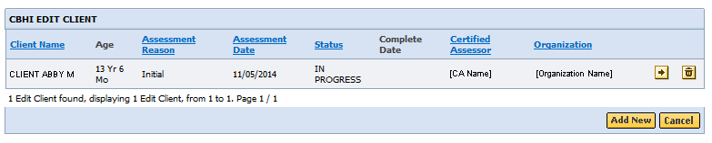
Understanding CANS Icons:
- The Arrow icon allows you to access a CANS record.
- The Trash can icon allows you to delete a CANS record.
Since you are accessing client records, the following consent page will appear.
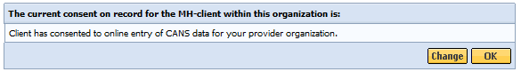
If the client would like to change the status of their consent, select the [Change] button.
If Consent is unchanged, select the [OK] button.
- Review and update, if necessary, the Person Details, Child CANS Information, SED Determination, and/or Domains/Modules based on hardcopy tool.
- Select the [Save and Next] button to continue.
Understanding CANS Records in In Progress status:
- The [Save and Next] and [Save] buttons will place the record in an “In Progress” status which indicates that a Massachusetts CANS has been saved as a draft and can be accessed for additional edits, as needed. The record will be saved, but will not be marked 'Complete' or ‘Incomplete but Final’ status until the Certified Assessor logs on and marks the record 'Complete’ or ‘Incomplete but Final’ (see Certified Assessor Reference Guide for more information).
Understanding CANS Records in ‘Complete’ and ‘Incomplete but Final’ status:
- For ‘Complete’ and ‘Incomplete but Final’ Records, edits cannot be made to the records, but, consistent with HIPAA requirements, the Add Disputed Notes feature provides users with a way to indicate that a member disputes information in the record. This field allows you to enter additional information, indicating what information is disputed by the member. A HIPAA Disputed Notes can only be added to a finalized record (for records that are 'Complete', ‘Documented on Paper’, or 'Incomplete but Final').
To add a disputed note:
- From the Main Assessment Menu, select the [View CANS] tab.
- Enter the [Mass Health ID*]. (This field is 12 characters in length)
- Confirm client information; select the [OK] button.
- Select the [Add Disputed Note] icon to add the disputed note.
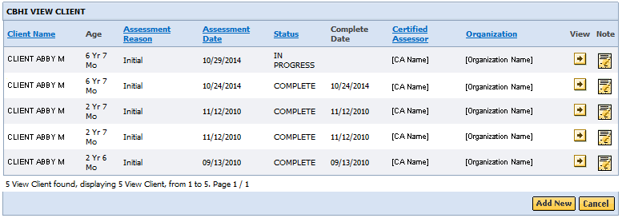
Information Regarding Disputed Notes:
- You can only add a Disputed Note to a Finalized CANS. You cannot add a Disputed Note to an ‘In Progress’ or ‘Expired’ CANS record. You will receive an error message ‘Disputed Notes cannot be added to a record not finalized’.
- Enter text in the space provided.
- Select the [Save] button.
The CANS application returns you to the Enter MassHealth ID page. The message ‘Save Successful’ displays on page.

View and Print a CANS Record (Print-to-Screen)

Viewing a CANS Record
- Under the View CANS tab, select the [View Client] tab.
- Enter the [Mass Health ID*]; Select the [OK] button.
(If not the correct MH-client, click the [Cancel] button to enter another member.)
- Confirm client information; Select the [OK] button.
A list of the record(s) for the client will display (based upon your role and organization). You may sort the list by the column headings shown in bold and underlined. Multiple pages may appear with arrows at the bottom of the screen for navigation between pages. You also have the option to add a new record, if necessary.
- To view a specific assessment on the client, select the [View] button.

Auditing
All actions performed in the Massachusetts CANS are logged including action performed, user ID, date and time. This enables administrators to have an audit trail of activities.

Printing a CANS Record
A CANS record may be printed via the Print-to-Screen function under the View Client tab. After searching with the client’s Mass Health ID,
- Select on the PDF icon to have the record displayed in a new screen.
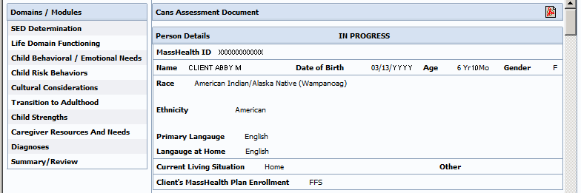
If you do not have Adobe Acrobat currently installed you can download it for free at http://get.adobe.com/reader/.
- You may review, print or save the record in Adobe Acrobat.
- In the previous display the SED details may appear grayed, in the Print-to-Screen the grayed out questions will not be displayed.
- When completed, close the browser window ( ) and return to the CBHI application.

Copy
The CANS application allows a DEO (when directed by the CA) to create a copy of a previously ‘Complete’, ‘Documented on Paper’, or ‘Incomplete but Final’ CANS assessment. The CANS application makes an exact copy of the assessment chosen (except for the Date of Assessment) and allows you to update the information based off the latest hardcopy tool provided to the DEO from the CA. CANS requires that you give this assessment a new assessment date.
- From the Main Assessment Menu, select the [Copy] tab.
- Enter the [Mass Health ID*]; Select the [OK] button.
(If not the correct MH-client, select the [Cancel] button to enter another member.)
- Confirm client information; Enter [Date of Assessment*]; Select the [OK] button.
A list of records with a status of ‘Complete’, ‘Documented on Paper’, or ‘Incomplete but Final’ for the client will display on the page. You cannot copy an assessment with a status of “In Progress”.
- Locate the assessment that you wish to copy and select the [Copy] icon.
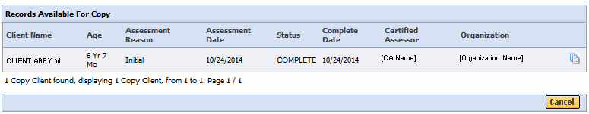
- Since client records are being accessed, the following consent page will appear:
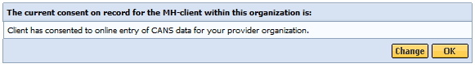
Information Regarding Consent:
- If the client has changed their Consent form, you may change the Consent details by selecting the [Change] button and update accordingly.
- If consent is unchanged, select the [OK] button to continue.
The CANS Assessment will appear with data from the copied assessment. The DEOs must update the CANS per the latest hardcopy from the CA.

Delete a CANS Record
If directed by the CA, the DEO can delete a CANS assessment that is in an ‘In Progress’ status, if entered in error. If an assessment is in ‘Complete’, ‘Documented on Paper’, or ‘Incomplete but Final’ status, they cannot be deleted.
To delete an ‘In Progress’ CANS:
- From the Main Assessment Menu, select the [Edit] tab.
- Enter the [Mass Health ID*]; select the [OK] button.
(If not the correct MH-client, select the [Cancel] button to enter another member.)
- Confirm client information; select the [OK] button.
A list of the records for the client with a status of ‘In Progress’ will display on the page.
- Locate the assessment that you wish to delete and select the [Delete] icon.
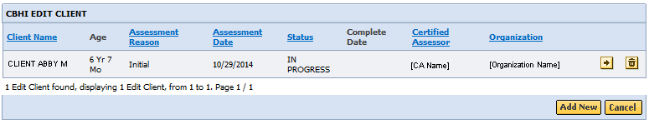
- A warning message will appear on the screen saying that by proceeding, the CANS assessment will be permanently deleted.
- Select the [OK] button.
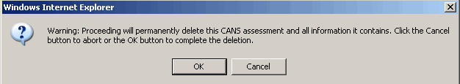
Before deleting an assessment, a reason must be chosen from the drop down menu.
- Select the [Deletion Reason*] from drop down menu.
- Select the [OK] button.
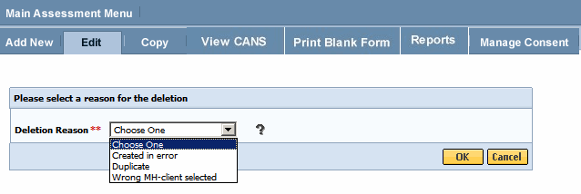
A pop-up window will appear asking “Are you sure you want to delete?”
- Select the [OK] button if yes.
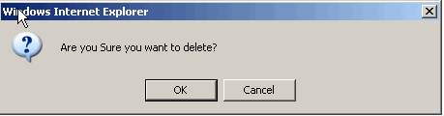
This returns you to the list of ‘In Progress’ assessments for this client with the message:
“CANS Record has been successfully deleted.”

Performance Tip
If application’s performance appears to be slow, use browser options to clear cookies, history and/or cache. Please see individual browser instructions for specific steps.

Additional Training Resources
- Learn how a CBHI Certified Assessor edits a SED/CANS Assessment
This link provides Certified Assessor’s with an easy, interactive online lesson that steps them through activating their Certification Key and how to edit a CBHI SED/CANS Assessment.
- Learn how a CBHI Data Entry Operator adds a SED/CANS Assessment
This link provides Data Entry Operator’s with an easy, interactive online lesson that steps them through adding a CBHI SED/CANS Assessment.
- Refer to the CBHI Data Entry Operator Reference Guide for more information on using the CANS application with a Data Entry Operator role.
- CANS FAQ: Select the following link to view the CANS FAQ: www.mass.gov/eohhs/gov/commissions-and-initiatives/cbhi/child-and-adolescent-needs-and-strengths-cans/using-the-cans-application-on-the-virtual-gateway.html.

Questions or Need Assistance?
Call Virtual Gateway Customer Service
1-800-421-0938 (617-847-6578 – TTY for those with complete or partial loss of hearing)
8:30 am to 5:00 pm Monday through Friday
Bookmark the Children's Behavioral Health Initiative Website:
www.mass.gov/masshealth/cans

