ISSUE 1 | VOLUME 2 | February 06, 2018

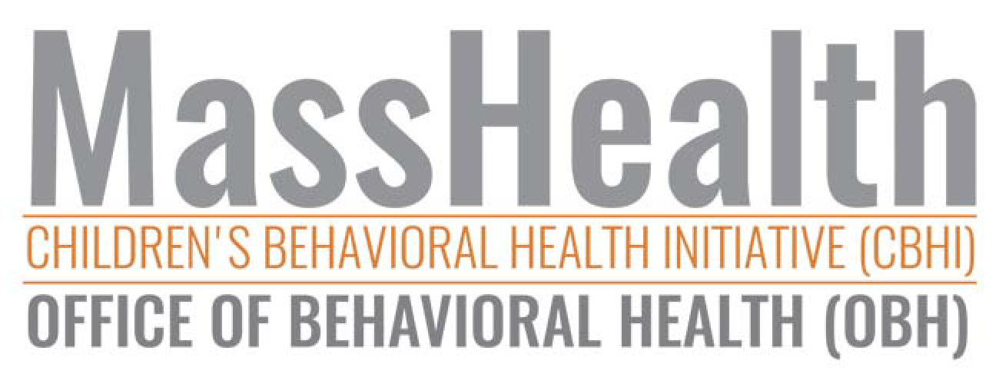News from MassHealth’s Office of Behavioral Health (OBH) and Children's Behavioral Health Initiative (CBHI)

IN THIS ISSUE: Recognizing Excellence | New Resources for IHT | $10,000 Grant Opportunity | Young Adult Peer Mentors | New Accessibility for CANS Training | Data Reports

Recognizing Excellence

The MassHealth CBHI team is happy to give a shout-out to Desiree Maldonado, an Intensive Care Coordinator (ICC) from Riverside CSA. We encountered Desiree's work
while conducting the annual Massachusetts Practice Review (MPR) in 2017. (See

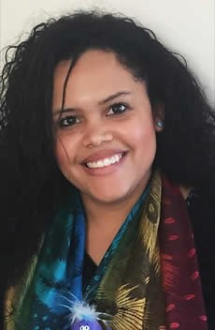

Summary of the MPR Report in this issue.)

Desiree received her MSW from Simmons in 2015, and was recruited to her current position at Riverside upon graduation. She has worked in human services for eight years, but says her work as an ICC has provided so much experience and understanding of different levels of care, and the other CBHI services, and the impact we can have on kids and families.

She returned to the Simmons Career Fair in 2017 to recruit rising grads to work at Riverside, and found a need for broader understanding of CBHI services and the opportunities our services create for social workers and other practitioners.

Desiree said that she always had a real interest in working primarily for and with children. She says her work as an ICC has opened her eyes to
recognizing that she needs to work with the adults in a child's life as well—parents, family members, and other providers who have experience in dealing with kids. I'll never stop learning here.

Her Program Director at Riverside, Merritt Smith, was effusive when asked about Desiree, praising her bilingual (English/Spanish) skills that allow her to communicate with clients and families and to produce reports in both languages. Desiree is a great social worker, and a great ICC.

If you know of someone who inspires clients and who provides excellent support for kids and families within the CBHI system, please nominate them by emailing Laura Conrad-Laberinto.
Know someone who inspires clients? Nominate them

New Resources for IHT

In-Home Therapy (IHT) continues to be one of CBHI's most heavily used services, with

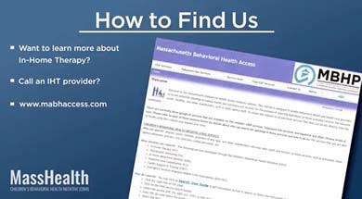

more than 17,000 clients enrolled. Despite its high utilization, IHT is not always well understood by other providers or the community at large. Is it outpatient therapy in the client's home? Do IHT providers work only with the child? How is it different from Wraparound? In order to answer those sorts of questions and to educate the wider community of referral sources (i.e., schools, state agencies, other service providers, and families), MassHealth has developed a video to better explain this unique service.

In addition to the video, a new IHT Supervisor Toolkit has been produced in conjunction with our colleagues at the CBH Knowledge Center. The Toolkit is intended to support supervisors implementing the detailed IHT Practice Profile that was produced last year.

These new resources are meant to support providers of In-Home Therapy and encourage fidelity in its implementation, while recognizing the important role the service plays in the array of CBHI services.

Watch the New IHT Video

2018 IHT Practice Profile Supervision Conference

Join MassHealth, the CBH Knowledge Center at DMH, the lead authors of the IHT Practice Profile, Susan Maciolek and Bonny Saulnier, and Scott Migdole from the Yale Program on Supervision for a one-day conference on improving supervision in IHT programs This exciting conference will review the IHT Practice Profile supervision strategies (Self-Assessment, Field Observation, and Behavioral Rehearsal) piloted in 2017 by a select group of IHT sites through the lens of Yale's supervision model.
You won't want to miss this incredible opportunity to build supervisor competency,

strengthen supervision procedures, increase staff satisfaction and retention while also improving the quality of care delivered to your IHT families

All IHT provider sites are required to send 1-2 staff to one of the 2 conferences. Attendees should be Program Directors and/or Supervisors. Identical content will be presented at both trainings, so please pick the date/location that works best for your program.

Registration: All IHT Program Directors will receive a registration link in February 2018.

2018 IHT Practice Profile Conferences

May 14th – Randolph, MA
May 17th – Sturbridge, MA
Refreshments and lunch will be provided.

2018 IHT Practice Profile Supervision Conference

Young Adult Peer Mentors

Peer Mentors can play a crucial role in behavioral health, and Young Adult Peer Mentors (YAPM) are increasingly being recognized as an important part of the therapeutic process, particularly for transition-aged youth.

YAPM is a specialty therapeutic expertise based on sharing with purpose and intent one's lived experience of mental health challenges to inspire hope and motivation in a young adult who is struggling with similar concerns.

MassHealth is working to sustain the roles of YAPMs within the current MassHealth CBHI service of Therapeutic Mentoring. MassHealth and its partners, the Children's Behavioral Health Knowledge Center and the Department of Mental Health, have created a formal work group to design supports for sustaining this position within the Therapeutic Mentoring and DMH Continuum.

The YAPM Practice Profile can be used to engage system partners, assist staff selection and recruitment activities, and support ongoing training and staff development activities. There is a three-day Core Elements training for those

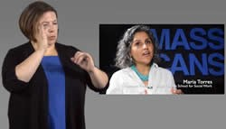

individuals interested in performing the role of a YAPM. The three-day training is co- facilitated with an in-state consultant to the peer workforce and with a YAPM. In addition, DMH has contracted with a national YAPM consultant, Vanessa Klodnick, to provide support to the supervisory staff of YAPMs through a one-day onsite training and three community practice calls.

If you would like more information on the YAPM role within Therapeutic Mentoring, please contact Jennifer Hallisey.
Email Jennifer Hallisey

New Accessibility for CANS Training

The CBHI CANS Training program is pleased to announce two new features to help clinicians of all abilities use our online training. The MassCANS training is designed for clinicians who provide behavioral health assessments to MassHealth-covered children and youth under the age of 21.

American Sign Language Interpreting

Users can easily switch between videos with and without American Sign Language.

Text-to-Speech

Users can listen to text, and have it highlighted as it is read
out loud. Just look for this button.

Other Accessibility Features

Our online training also includes the following accessibility features.

Hearing: closed captions, transcripts of voiceovers and videos
Vision: screen-reader compatibility, alternative text for images
Physical: page navigation without a mouse, interactive controls by keyboard

Note: Many of these accessibility features are great for users with learning disabilities.

The CANS Training program has always been committed to providing content accessible to people of all abilities. Please let us know how we can help For more information, please contact Sarah Rulnick, CANS Training Program, E.K. Shriver Center, University of Massachusetts.

Email Sarah Rulnick

Children's Behavioral Health Innovation Awards

Has your organization developed a new way of responding to one of these wicked problems facing children's behavioral health?

- Delivering behavioral health care services to children in school settings;
- Accessing children's behavioral health care services; OR
- Recruiting and retaining children's behavioral health care staff members

If so, consider submitting your innovative solution for a Massachusetts Children's Behavioral Health Innovation Award. Funded by Blue Cross Blue Shield of Massachusetts Foundation and the Massachusetts Association for Mental Health (MAMH), the Award recognizes a non-profit children's behavioral health or social service organization's efforts to fill an unmet need or gap in the children's behavioral health care delivery system.

Grant Opportunity Download the Application

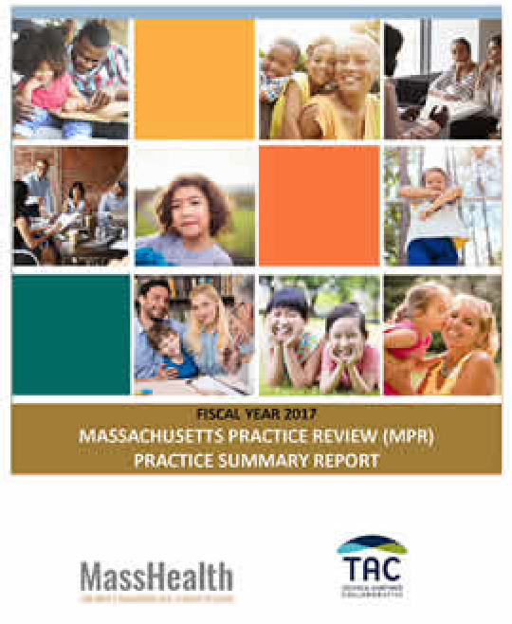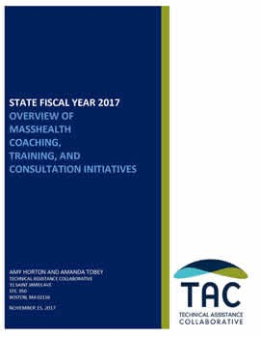

FY 2017 Massachusetts Practice Review (MPR) Summary Report

As part of our ongoing quality improvement efforts, and to continue monitoring of CBHI services across Massachusetts, the annual MPR was conducted in FY 2017. A Summary Report on the findings can be found at: The MPR is a qualitative case- review tool that is focused on both ICC and IHT. In FY 2017, we reviewed 261 cases. The FY 2018 MPR is currently underway.

Download the MPR Report

FY 2017 Coaching, Training, and Consultation Initiatives

The Technical Assistance Collaborative (TAC) has compiled a comprehensive summary of the FY 2017 Coaching, Training, and Consultation Initiatives In FY17, MassHealth invested heavily in the CBHI service system. This included strong investments in the professional skill development of the CBHI workforce to ensure that all youth receiving MassHealth-funded Children's Behavioral Health Initiative (CBHI) services receive the best possible care. Much of the skill- development focused on the crucial role that supervision plays in the quality of care families receive, clinical competency and professional growth of frontline staff, and staff retention and job satisfaction. Many of these programs and trainings are ongoing as a part of CBHI's commitment to supporting and retaining a strong, stable, and well-qualified workforce.

Read the Report

MassHealth
MassHealth Office of Behavioral Health Initiative (OBH) MassHealth Children's Behavioral Health Initiative (CBHI)

Follow us on Twitter @MassHealth | Follow us on YouTube.
Receive this OBH/CBHI newsletter as a forward? Sign up to receive our future emails and newsletters. Visit the CBHI website (www.mass.gov/masshealth/CBHI).

MassHealth CBHI CANS

To unsubscribe from receiving future OBH/CBHI newsletter.

