Commonwealth of Massachusetts
Executive Office of Health and Human Services
Virtual Gateway

CBHI Organization Reference Guide
February 2015 R3.0 v1

CBHI Organization Reference Guide

Table of Contents
Release 3.0 Updates 3
Consent FAQs 3
Other Change to CANS 7
Logon to Virtual Gateway 7
Viewing CANS Records 7
To view a CANS record 7
To Print a Record 9
To Add a Disputed Note 9
Print Blank Forms 10
Generating and Printing Reports 11
To Print a Report 12
Managing Consent 14
Important Information Regarding Faxing Consent 14
Export 16
Performance Tip 17
Questions or Need Assistance? 17

Release 3.0 Updates
The Commonwealth of Massachusetts and the Executive Office of Health and Human Services (EHHS) have made system enhancements to the Children's Behavioral Health Initiative (CBHI) Child and Adolescent Needs and Strengths (CANS) application (Release 3.0), which is now available to all users.
All documentation related to the CBHI CANS application ("Reference Guides" and "Learn How To" CBTs) has been updated and are posted on the CBHI website. Visit www.mass.gov/eohhs/gov/commissions-and-initiatives/cbhi/, click the Child and Adolescent Needs and Strengths (CANS) link, then select the Using the CANS Application on the Virtual Gateway link.
Below is a summary of the Release 3.0 improvements and new features.
New Consent Process
The new Consent Process permits a provider to enter the CANS on the Virtual Gateway (VG) account and share the CANS with all other providers to whom the caregiver has given consent. This will allow all providers caring for the child to have a clear picture of what is happening in the child and family’s life. This is particularly important when a child is cared for by multiple providers or requires treatment in different levels of care.
New Consent Forms
The new Consent Form explains to the caregiver that by signing the Consent Form, they are giving permission to a provider to enter the CANS on the VG and share the CANS with any other providers to whom the caregiver has given consent.
Link to CANS Consent Forms: www.mass.gov/eohhs/gov/commissions-and-initiatives/cbhi/child-and-adolescent-needs-and-strengths-cans/cans-forms.html).
To learn more about how the Consent process works in daily practice, please view the CANS Consent Step-by-Step Guide and Flowchart which can be found at http://www.mass.gov/eohhs/gov/commissions-and-initiatives/cbhi/child-and-adolescent-needs-and-strengths-cans/using-the-cans-application-on-the-virtual-gateway.html.

Consent FAQs
What do I need to know about the new Consent process?
The new Consent process permits a provider to enter the CANS on the Virtual Gateway (VG), and allows other providers, to whom the caregiver has given consent, to view and copy the CANS. This will allow all providers caring for the child to have a clear picture of what is happening in the child and families life. This is particularly important when a child is cared for by multiple providers or requires treatment in different levels of care.
What specific information does MassHealth require to be entered into the Virtual Gateway (VG), and does this information require client permission?
Information about member demographics and whether the child/youth meets the criteria for Serious Emotional Disturbance (SED) collected with CANS must be entered into the VG, and does not require client permission.
What information requires member permission to be entered into CANS application on the VG and what is the process of documenting consent in the application?
Member permission is granted by a caregiver or an emancipated youth under age 21, and is required to enter CANS ratings and narrative fields in the VG. The application includes features for documenting consent, as well as, features for the member to cancel consent. MassHealth requires provider organizations use the consent form created by EOHHS.
What is different about the new consent process?
The new Consent form, which is scheduled to go-live in February 2015, features more user-friendly language that makes it easier for both the provider and caregiver to understand the consent process, and explains how the information gathered is stored in a safe place.
The new consent process allows providers who have received consent, to view and copy CANS records entered by other providers on the VG. This permits all providers with active consent, who are caring for the same child to have a clear and timely picture of what is happening in the child and family’s life. This is particularly important when a child is cared for by multiple providers or requires treatment in different levels of care. For families, it means not having to repeat their stories. For new providers, it means that they will have immediate access to current information that affects their child’s care and will be able to view, copy and edit a CANS previously created by another provider. Copying and editing existing CANS will also save time and effort for providers.
What does the new language does the Consent form contain?
The new Consent form explains to the caregivers that signing the consent form gives permission to a provider to:
- Enter the CANS on the VG
- Such that any other providers, to whom the caregiver has given consent, will be able to view and copy the CANS record.
Please click to Read the new Consent form.
How will this work?
After the go-live date, all prior consent will no longer be valid as the Consent status in the CANS Application on the Virtual Gateway (VG) will be re-set to “no” for all members. You will be required to:
- Obtain new Consent from the caregiver when you next see them and then, you will need to enter “yes” in the ‘Manage Consent” tab on the CANS application on the VG.
- If the caregiver declines consent then, you will simply enter “no” in the Manage Consent tab. You are still required to enter the SED section on the CANS application on the VG but complete the CANS on paper and enter into the child’s medical record.
How will I know if another provider has completed a CANS on the same child?
When a new provider, with consent, enters a child’s CANS onto the CANS application on the VG for the first time, the new provider will automatically be able to see the child’s previous CANS from other providers.
The new provider will have the option to copy a previous CANS. The copy is now the new provider's CANS and can be edited as necessary, including the addition of Summary Comments at the end of each domain.
When a new provider copies a CANS, they are not altering in any way the previous CANS completed by another provider.
What do I need to tell members about the new consent process?
CBHI strongly encourage you to discuss the new consent form with caregivers prior to the go-live date so that you have signed consent forms on hand when the new process is active. On the go-live date, all existing consents, regardless of their stated end dates, will expire. We recommend that you throw away all blank copies of the old Consent form that you or a DEO in your organization may have on hand.
Will the faxing process change?
No. Current procedures for faxing in your signed consent forms will remain unchanged. Remember to generate a Fax Information Sheet (cover sheet) from the CANS application, just as you do now. (If the caregiver declines consent, the process remains the same. You should document this fact in the chart, but do not fax anything to MassHealth.)
Will there be “how to” support in the CANS Consent Resources and Guides?
We will revise all of the related information in the “How to use the CANS Application on the Virtual Gateway” page (www.mass.gov/masshealth/cans) in the CANS section of the CBHI website to offer updated information. Also, CBHI will offer a webinar on the new consent process prior to the start date for the new process.
The Consent Webinar will be posted on the CBHI website. Providers may also call the VG Customer Service Helpdesk at 800-421-0938 or (TTY) 617-847-6578 for those with partial or total hearing loss) and ask for help with the new consent process. The call will be transferred to CBHI for assistance.
The revised CANS Consent Reference Guide, also found on this page, will instruct users on how to manage consent, download the consent form, as well as how to fax the consent form. The Guide will also offer assistance on how to talk to families about the new Consent process.
What should I do with the signed consent form after I document consent in the application?
The 4-page signed consent form, combined with the Consent Information Sheet (fax cover sheet), must be faxed to MassHealth at 617-887-8708. The Consent Information Sheet (fax cover sheet) can be printed from the CANS application in VG, which will automatically print both member and provider information on the CANS Information Sheet (fax cover sheet). Do not use your organization’s regular fax cover sheet, as it will not be accepted in the faxing system.
What do I do with the rest of the CANS information if the caregiver or member does not consent?
If the parent or guardian of a minor member (or the member if she or he is 18 or older) declines consent, then CANS should be completed on paper and included in the medical record. The CBHI system on the VG will not permit entry of CANS rating or narrative fields without consent.
Please remember that you must still enter SED and demographic information into the CANS application on the VG and you must complete a copy of CANS for the medical record regardless of member consent.
Can consent be cancelled?
Yes, members may cancel consent. The application allows the provider to change the consent status of a member at any time.
Does consent expire?
Consent will automatically expire after a specified period of time. The default length is one year, although the consent form and the application allow the member to specify a shorter or longer period of time if preferred. If you anticipate that the member will be in treatment for more than a year, you may want to suggest a longer expiration period for the consent.
What are the additional responsibilities of a provider regarding consent?
Providers have the independent responsibility to examine and comply with applicable federal and state privacy laws, regulations and rules as well as their own privacy policies and practices.
Who can access information from the online CANS application?
The VG is designed and extensively tested to be highly secure. The CBHI system does not include social security numbers or financial information that is most often the target of hackers. Consent gives MassHealth and the member’s managed care plan access to the member’s information. To protect a child’s privacy, MassHealth keeps tight control over who has access to the database. Access to your CANS record is restricted and protected under state and federal privacy laws.
What is the benefit of consenting to entering CANS data in the CANS application online?
In early 2015, all provider who care for the same child and have active consent from the child’s caregiver will be able to view and copy the child’s CANS on the CANS application on the VG. The benefits of consent include the ability to view and copy the CANS to share with the family, to easily update the CANS without needing to create multiple paper copies, and to share the CANS with other levels of care across provider organizations. Also, by sharing the CANS, the family may not have to repeat their entire story, over and over again. Another benefit is the ability of the member’s managed care entity (MCE) to see CANS in authorizing care—which may save time. Finally, the state uses CANS data entered into the application to gather general information about the delivery of CBHI services and in general to improve services for all youth and families using MassHealth.
Where can I get more information about faxing consents?
For more detailed instructions about faxing consents, please refer to the CBHI CANS Consent Information and Faxing Guide. It is available on the CANS (www.mass.gov/masshealth/cans) Web page of the CBHI Web site along with other CBHI reference materials.
If you have any questions regarding faxing consents, please contact Virtual Gateway Customer Service at 1-800-421-0938 or (TTY) 617-847-6578 for those with partial or total hearing loss).
Where can I get more information about the CANS application and consent?
More information about the consent process, including the consent forms and “how-to” Reference Guides, may be found at www.mass.gov/masshealth/cans. Click on “How to Use the CANS Application on the Virtual Gateway”.
You will also find the CANS Family Guide on the Clinical Guidance section of CANS page of the CBHI website. The three-page document that explains the “what” and the “why” of the CANS to family members, including consent. We encourage providers to share this with families during the initial assessment period. Go to www.mass.gov/masshealth/cans and click on “Clinical Guidance on the CANS”.

Other Change to CANS
- The Diagnoses module has been renamed as Diagnostic Factors and DCM diagnosis of the behavioral health condition is no longer part of the CANS. This change is a better fit for CANS as the CANS is not intended to be a diagnostic tool but rather a way to communicate needs and strengths, and help inform family-driven, collaborative care planning at the right level of care.
- Discontinuation of Axis I and Axis II.
- Renaming Axis III, Axis IV and Axis V.
  - Axis III has been renamed as Physical Conditions defined as “Physical conditions which play a role in the development, continuance or exacerbation of a behavioral health condition.”
  - Axis IV has been renamed as Psychosocial Stressors defined as “Events in a person’s life, such as the death of a loved one, starting a new job, college, unemployment, or even marriage can affect behavioral health condition.”
  - Axis V has been renamed as CGAS (Children’s Global Assessments scale) and selecting the “?” will bring up the scale.

Logon to Virtual Gateway
To log on to the Virtual Gateway (VG), go to www.mass.gov/vg and select the link “Logon to Virtual Gateway”. Select the Children’s Behavioral Health Initiative (CBHI) business service to enter CANS in the VG.
Note: See the Login Assistance page at www.mass.gov/eohhs/provider/training-and-edu/vg/login-help-for-providers-and-state-agency-staff.html for more information on setting up a Virtual Gateway (VG) account.

Viewing CANS Records
A user with a designated organizational role may view CANS with the login id associated with the organization. Functionality within the CANS system is limited to view-only. Examples of staff in this role are Case Manager, Clinic Supervisor, Administrator, etc.

To view a CANS record
- Under the View CANS tab, select the [View Client] tab.
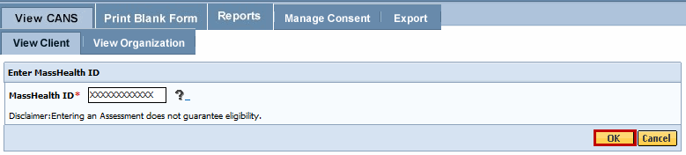
- Enter the [Mass Health ID*]; select the [OK] button.
(If this is not the correct MH-client, select the [Cancel] button to enter another MassHealth ID.)
- Confirm client information; select the [OK] button.
The page displays a list of the record(s) for the client (based on your role and organization). You may sort the list by the column headings shown in bold and underlined. Multiple pages may appear with arrows at the bottom of the screen for navigation between pages.
- To view specific CANS on the client, select the [View] button.
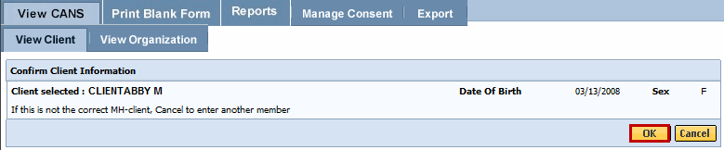
This page will list all of the CANS that have been conducted for the client.
- To view the CANS, select the [View] arrow.
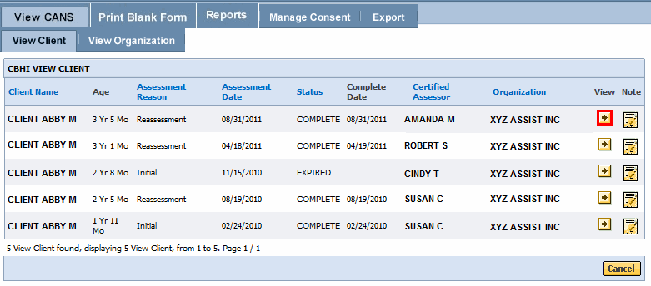
The record will appear with a left pane menu and scroll bar on the right to view the record.
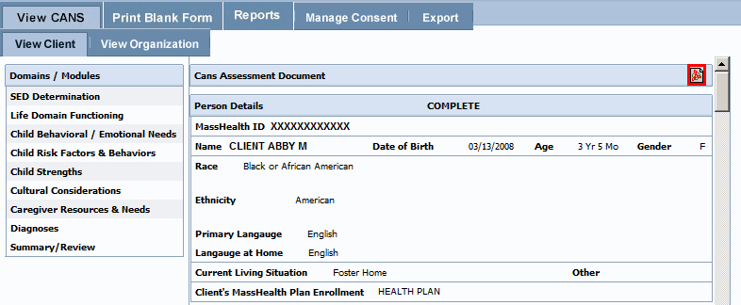
The CANS record can be downloaded by selecting the PDF icon and printed via the Print-to-Screen (PDF) function, if needed.
Auditing: All actions performed in the Massachusetts CANS system are logged including actions performed, user id, date and time. This enables administrators to have an audit trail of activities.

To Print a Record
- Go to View Client, enter the MassHealth ID and confirm the client.
- Select the CANS record you wish to print and select the PDF icon to have the record display in a new window.
- You may review, print or save the record in Adobe Acrobat Reader.
  - If you do not have Adobe Acrobat Reader currently installed you can download it for free at http://get.adobe.com/reader/.
- In the previous display the SED details may appear grayed, in the Print-to-Screen the grayed out questions will not be displayed.
- When completed, close the browser window ( ) and return to the CBHI application.

To Add a Disputed Note
A disputed note can ONLY be added to a finalized record (for records that are 'Complete', ‘Documented on Paper’, or 'Incomplete but Final').
A Disputed Notes can be entered by a person in the Organization role.
- From the Main CANS Menu, select the [View CANS] tab.
- Enter the [Mass Health ID]. (This field is 12 characters in length.)
- Confirm client information; select the [OK] button.
- From the View Client tab, select the [Add Disputed Note] icon to add the disputed note.
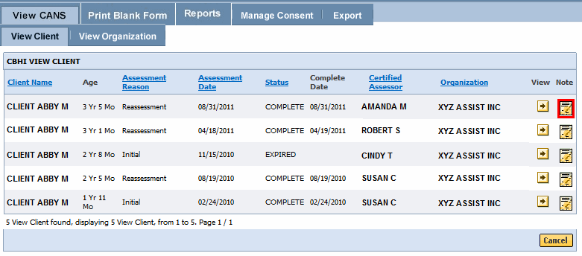

You cannot add a Disputed Note to an ‘In Progress’ or ‘Expired’ CANS record. You will receive an error message ‘Disputed Notes cannot be added to a record not finalized’.
- Enter text in the space provided.
- Select the [Save] button.
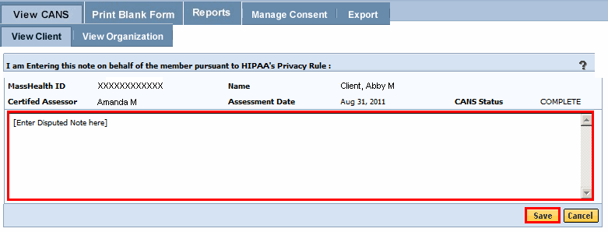
The CANS application returns you to the Enter MassHealth ID page. The message ‘Save Successful’ displays on the page.

Print Blank Forms
The provider needs the caregiver’s signature on the Consent form. If a caregiver declines to give consent to enter the CANS into the Virtual Gateway (VG), the provider is not required to notify CBHI (MassHealth). However, the SED and Demographic section must be completed online and the CANS must be completed on paper and then entered into the member’s medical record. The CANS status in VG, in this case, will be ‘Documented on Paper’.
The consent form explains to the caregiver that by signing the consent form, they are giving permission to a provider to enter the CANS on the VG and share the CANS with any other providers to whom the caregiver has given consent.
If a caregiver decides to cancel an active Consent, please email a scanned, signed copy of the written cancellation to CBHI at: CANS-CBHIMailbox@state.ma.us.
The Print Blank Forms tab in the Virtual Gateway will now host the New Consent Forms in English, Spanish, Russian, Portuguese, Chinese, Vietnamese, Khmer and Haitian Creole languages. Consent forms are available in different languages under the Print Blank forms tab.
- From the Main CANS Menu, select the [Print Blank Form] tab.
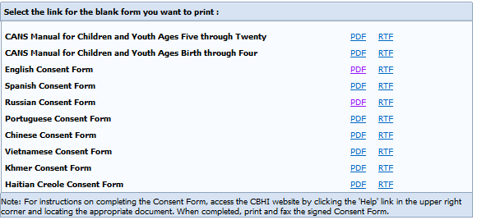
- Select the option of your choice to print the blank form for the CANS tool documents:
  - PDF (Portable Document Format – Adobe Acrobat)
  - RTF (Rich Text Format)
- When completed, close the browser window ( ) and return to the CBHI application.

Generating and Printing Reports
A user with the designated organizational role has reports that can be run to manage CANS at the CA by Client and Organization levels. The reports can be generated using either Adobe Acrobat or MS Excel.
- From the Main CANS Menu, select the [Reports] tab.
- Select a report from the [Select A Report] drop down menu.
- Select the [OK] button.
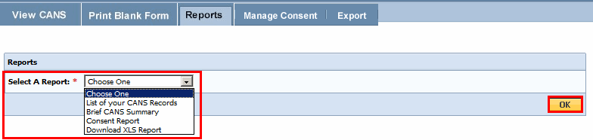
From the Select Date Range (depending on type of report you are running),
- Enter the [From Date*] (mm/dd/yyyy).
- Enter the [To Date*] (mm/dd/yyyy).
- Select the [OK] button.

Based on the report you are generating, you may need to select additional criteria. Refer to individual reports for additional criteria to include when running a report in CANS.
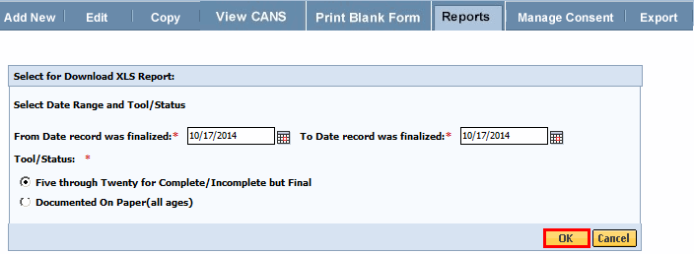
The results from the search will display on the page below the criteria. You have the option of viewing the report information in either Excel or Adobe Acrobat (PDF) format, depending on the report.
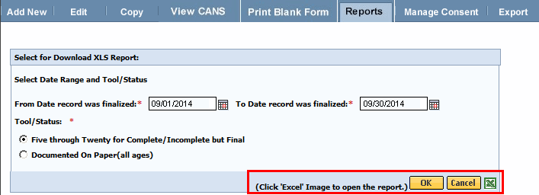
Available Reports:
List of your CANS Records: This report is used by CAs and organizations, and replaced the “CA Detailed Report by Client” and “Organization Report”. Choose the date range, status, and the application number, and the report will provide you with multiple members' SED/demographic details in a spreadsheet.
Download XSL Report: This report allows for multiple records to be downloaded into Excel for research and statistics. This report makes it much simpler than the previous data export / import to Excel. Choose whether you want to see records with ‘Documented on Paper’ status (just demographics and SED) or completed records with the Five through Twenty version of the tool.

To Print a Report
- From the Main CANS Menu, select the [Reports] tab.
- Select a report from the [Select A Report] drop down menu.
- Select the [OK] button.
- Enter the [Mass Health ID*]. (This field is 12 characters in length.)
- Select the [OK] button.
The results from the search will display on the page below the criteria. You have the option of viewing the report information in either Excel or Adobe Acrobat (PDF) format.
Sample of Download XLS Report
- Select the [Excel] or [PDF] icon.
Sample Report
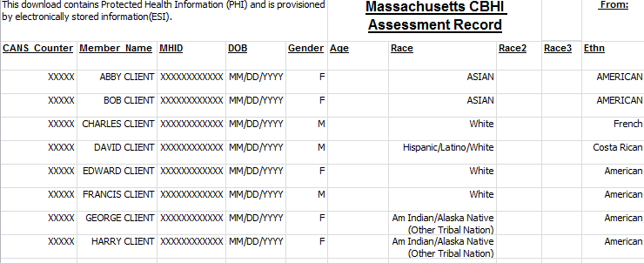
When completed, close the browser window ( ) and return to the CBHI application.

Managing Consent
The Certified Assessor (CA), or the Data Entry Operator (DEO) on their behalf, is required to document “Consent” authorization (Yes or No) in the CBHI application for a MH-client within the organization.

Important Information Regarding Faxing Consent
- The completed and signed Consent Form along with the Consent Information Sheet (CIS) are to be faxed to 617-887-8708.
  - Blank Consent Forms can be found at www.mass.gov/eohhs/gov/commissions-and-initiatives/cbhi/child-and-adolescent-needs-and-strengths-cans/cans-forms.html.
- The Consent Information Sheet (CIS) is the Fax Cover Sheet; DO NOT include any additional cover sheet when faxing.
- Once consent is received by the EOHHS CBHI IT System, the CA or DEO can enter the CANS onto the VG for that client.
- Do not fax anything to CBHI (Mass Health) if consent is ‘NO’. Enter only the CANS SED and Demographic information onto the VG. The CANS status will be ‘Documented on Paper’.
- Refer to the Reference Guide: CBHI CANS Consent Information and Faxing Guide for detailed information on consent (www.mass.gov/eohhs/gov/commissions-and-initiatives/cbhi/child-and-adolescent-needs-and-strengths-cans/using-the-cans-application-on-the-virtual-gateway.html).
Upon entering the consent in the CBHI application, a ‘Consent Information Sheet’ (CIS) is generated by the application.
To print the CIS:
- From the Main CANS Menu, select the [Manage Consent] tab.
- Select the [Consent Information Sheet] tab.
- Enter the [MassHealth ID*].
- Select the [OK] button.
- Confirm client information; and select the [OK] button.
Information regarding Consent Information Sheets (CIS):
Multiple Consent Information Sheet (Fax Cover) and Signed Consent forms may be faxed together, but each must be grouped and faxed by Member ID and have the Consent Information Sheet (Fax Cover) and the corresponding 4-page signed consent form together in order for the Consent form to be recognized and accepted.
Example of faxing multiple consent forms:
Member A (Consent Information Sheet (Fax Cover) plus 4-page signed consent form)
Member B (Consent Information Sheet (Fax Cover) plus 4-page signed consent form)
Member C (Consent Information Sheet (Fax Cover) plus 4-page signed consent form)
The CBHI Organization role only allows access to the Consent Information Sheet. If consent has not been entered by the CA or DEO, a Consent Information Sheet cannot be printed.
The Consent Information Sheet will display in a new screen. You can print the Consent Information Sheet or save it as a PDF file.
When completed, close the browser window ( ) and return to the CBHI application.
Consent Information Sheet
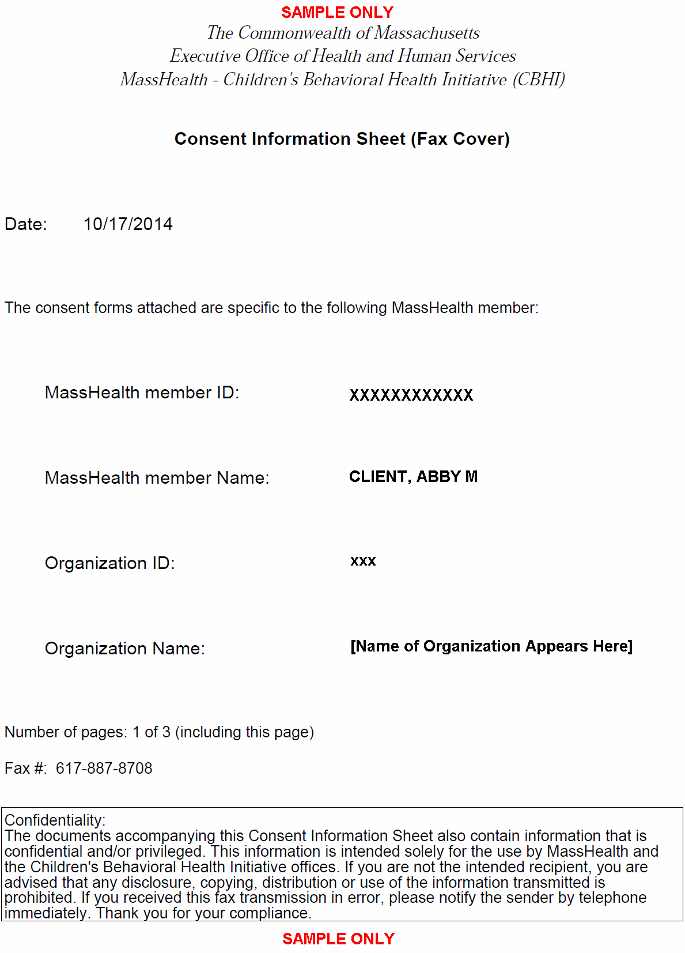

Export
The CBHI Organization role allows users to export Client/CANS data from the CBHI application to other applications such as, but not limited to, MS Excel or MS Access.
- From the Main CANS Menu, select the [Export] button.
There are three types of files that can be exported:
- Export Completed CANS File (Data)
- Export Layout (Fields names)
- Export Limited CANS data with Agency Details (EOHHS Agency staff Only)
- Select [Export Completed CASNS File] or [Export Layout] by selecting the Radio button. (Only one may be selected at a time.)
- Enter the [Export From] date. (Format: MM/DD/YYYY)
- Enter the [Export To] date. (Format: MM/DD/YYYY)
- Select the [OK] button.
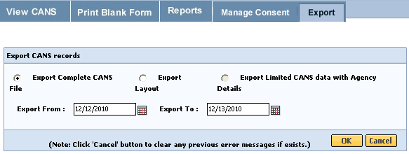
Based on the type of export that you selected, you will see one of the following File Download pop-up boxes.
- Sample of Export File - - Sample of Export Layout -
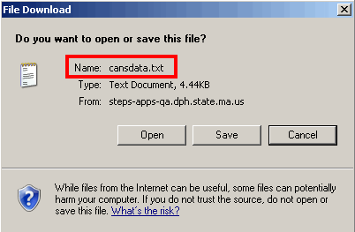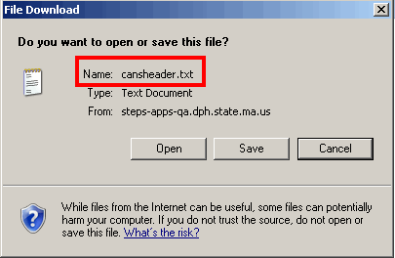
From this point we recommend you follow the normal procedures for downloading files within your organization.
Refer to Reference Guide: Export/File Import to MS Excel for information on how to use your CANS data with MS Excel.

Performance Tip
If application performance appears to be slow, use browser options to clear cookies, history and/or cache. Please see individual browser instructions for specific steps.

Questions or Need Assistance?
Call Virtual Gateway Customer Service
1-800-421-0938 (617-847-6578 – TTY for those with complete or partial loss of hearing)
8:30 am to 5:00 pm Monday through Friday
Bookmark the Children's Behavioral Health Initiative Website:
www.mass.gov/masshealth/cans

