**CCFA Billing Process for Child Care Resource and Referral Agencies**

**This guide will assist CCR&Rs with the first CCFA Billing cycle in August 2016 (for July 2016 services). Attendance for all months must be complete in order to bill in CCFA. The CCFA Billing process has three steps and validations:**

1. **FCC Systems, Contract Providers, Independent Family Child Care Providers, and In Home Providers are to Complete Attendance, “Generate Ledgers” Approve and Submit Pending Invoices for the service month of July 2016.**
2. **View and "Approve" CCR&R Pending Billing:**
   * Select “Billing+”

* Select "CCR&R Pending Billing"

|  |  |
| --- | --- |
| * Click on the "+" or access the CSV file for each provider as needed. CSV is a "Comma Separated Value" format type that can be opened with Microsoft Excel. Look for this symbol:   + Or click on the **“+”** as displayed below   + Note: The provider relationship displayed is the current relationship.     - For example, if the provider moved from being a Family Child Care Provider in a System (FCS) to an Independent Family Child Care Provider (IFC), IFC will be displayed. * Click on the **√** if the billing totals are correct. |  |

* Click on the **X** if you need to make corrections or push back to the provider. This will move the billing into a "Rejected" status for all the service months billed by the provider.

**Below is a screenshot of the CCR&R Pending Invoice page in CCFA where you can review and "Approve" provider invoices:**

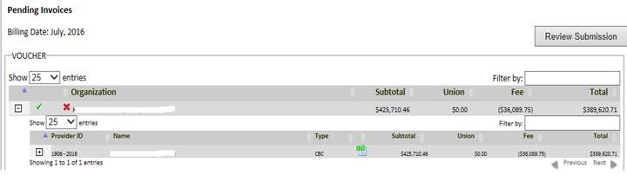

* After approving the invoices you can “Review Submission”.
  + Payment Voucher will be available as “DRAFT”.

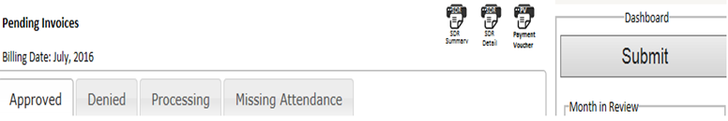

* There are up to 5 tabs that will provide you with the pending invoice status:
  1. ***Processing*** – Lists the providers whose billing is still being processed by CCFA.
  2. ***Pending*** -- Lists the invoices that you did not approve.

**CCFA Billing Process for Child Care Resource and Referral Agencies (continued)**

* 1. ***Denied*** – Lists the rejected invoices.
  2. ***Approved*** – Lists the invoices that have been approved but not yet submitted to EEC.
  3. ***Hold*** -- Lists the invoices that EEC has put on hold for submitting after the billing deadline.

1. **SUBMIT BILLING: Click on the “Submit” Button when you have approved the invoices for the current billing period.**

* If you have not approved all your providers you will receive a notice indicating the following:

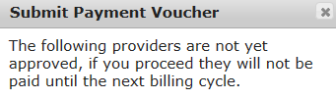

* If you answer YES, the providers listed will not be included in your payment from EEC.
  + - 1. If you answer NO, you can continue to approve additional providers.
* After you “Submit” you can view the Submitted Invoices
  + Select "Billing+"
    - Select "Submitted Invoices"
  + Choose the Date you would like to view
    - ***Billing Date*** -- the month you submitted your invoice in CCFA
    - ***Submission Date*** -- the month you submitted to EEC
      * Payment Voucher and Batching Sheet Icons are available to view and print.
    - ***Invoice Date*** -- the month EEC approved the CCRR invoice in CCFA
      * Export Check File Icon is visible and when selected the file can be downloaded.
  + There are up to four (4) tabs that will provide you with the approved invoice status:
    - **CCRRD** -- Invoices with Status of "CCR&R Denied"
    - **CCRRS** - Submitted by CCRR to EEC
    - **Invoiced** – Approved by EEC
    - **Hold** – Indicates if EEC has put your invoice on Hold for submitting after the billing deadline.
  + The Payment Voucher moves from “Draft” to “Final” status. Once Final, “Draft” is removed from the Payment Voucher.

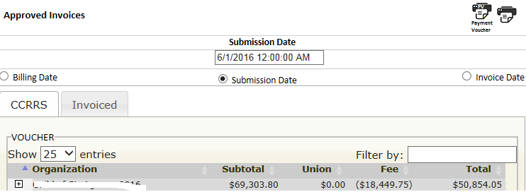

* + Print PV(s), sign and submit hard copy with “Wet Signature” to EEC by the billing deadline (on or before August 19, 2016).
    - Separate PV(s) are generated for each contract (Income Eligible, Supportive and DTA).

Note: CCFA does not capture payments for Special Needs. Please submit separate PVs and backup.

**CCFA Billing Guidance**

1. **What is my billing deadline in August 2016?** 
   * The FY2017 CCFA August Billing Deadline (July Only Services ) is August 19, 2016.
2. **What is the deadline for me to submit my Payment Voucher to EEC?**
   * The Payment Voucher must be received by Friday, August 19, 2016.
3. **What if the CCR&Rs do not have time to make all my FY2016 adjustments to attendance, placements and authorizations**?
   * Once you complete your attendance for FY16, you will have the opportunity to make adjustments in CCFA on behalf of the providers from September through November. The adjusted dollar amount will be applied in the following month's billing as a prior period adjustment. For example, if you make a change in September 2016 that results in EEC owing you $1000, this amount will be added to your October Invoice for September Services.
4. **Why are the billing rates not correct?** 
   * Check the provider’s published private rates to see if they align with the rates certified. If the published private rates do not align with your certifications you can modify the rates associated with your providers by following these steps:

* Go to the Provider Detail page
* In the Action drop down, select "Manage Private Published Rates"
* Input the Published Private Rate and enter the Effective Date
* Select Save

Note: The effective date should be backdated to the date the Private Published rate was put into effect.

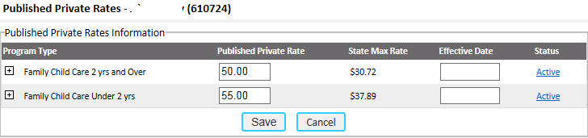

Note: The rates and effective date need to align with your rate certification.

1. **If I change the published private billing rates after I generated ledgers do I need to reject billing to see the amount change?**
   * Yes, if you want the change captured in the reconciliation.
   * No, if you can wait to receive the payment for the rate change, it will be applied to the next billing month.
2. **Why are the providers not being paid the correct rate for a holiday for a school age child or not being paid for the holiday?**

* *Look to see if the child is set up correctly: Regular vs. intermittent?*
  + Regular for holidays pays to schedule
  + Intermittent provides you additional attendance codes to be reimbursed the FT rate.
* *Does the child have a school closure placement?*
  + School Closure only placements do not get paid for the holiday.
  + If the child is in care Full Time during the summer you are entitled to the July 4th holiday and Labor Day holiday if the child's placements extend past Labor Day.
    - The placement should be set up as regular for the summer only.
* *Does the child receive care from 2 providers?*
  + The primary care provider is reimbursed for the holiday if both providers are closed.
  + If the primary is closed and the second provider is open EEC pays the provider who provided care.

1. **Why are the providers not receiving the QRIS Infant/Toddler 3% rate increase?** 
   * Look to see if the provider has a QRIS Level 2 rating or higher.
   * Ask the provider if it submitted a QRIS application.
   * The QRIS rate is applied the month after the provider submits a self-assessed rating of level 2 or higher.
     1. For example, if the provider submits the QRIS application with Level 2 or higher on May 1, 2016, the effective date of the rate increase will be for the June 2016 service month which will be paid in July 2016.
2. **How do I know if a provider has joined SEIU?**

|  |  |
| --- | --- |
| * + Go to the Provider Detail page   + On the right hand side of the page the following is displayed indicating Union Status and COPE election. |  |
| * + A report is available for you to view for all your providers.     - Go to Reports+     - Select SEIU Dues Providers     - Select Generate Report |  |
| * + - The report will display the following information by provider * Payer Types   + - * + 509WD -Withdrawn         + 509DP – Dues payer |  |

1. **What do I do if I receive the following notification on behalf of a provider?**

|  |  |
| --- | --- |
|  | * + 1. Go to the Family Authorization page     2. View the authorization and child placements     3. CCFA will not allow two providers to bill EEC for the same child on the same day except if the child has separate Before School and After School placement        - Work with the provider’s to resolve        - If you are unable to resolve contact [Alicia.Wells@massmail.state.ma.us](mailto:Alicia.Wells@massmail.state.ma.us) |

1. **Can I revert back a providers invoice after I approved it?**
   * Yes, you can revert the invoice as long as you have not Submitted to EEC by clicking on the back arrow.

