CCFA Billing Process for Family Child Care (FCC) Systems and Contract Providers
This guide will assist FCC Systems and Contract Providers with the first CCFA Billing cycle in August 2016 (for July 2016 services). Attendance for all months must be complete in order to bill in CCFA. The CCFA Billing process has three steps and validations:

- Complete Attendance and "Generate Ledgers" for the service month of July 2016.
  - After you generate ledgers, the provider(s) with active placements within your organization will be in one of the following statuses:
- Rejected
  - If rejected please view the Notifications on the HOME page in CCFA to determine why the billing validation was rejected
  - Resolve the placements and/or attendance
  - Generate Ledgers
- Billed
  - Once in the Billed status you can move forward to the next Billing step in CCFA

Note: You must refresh the page to view the change in status from "In Progress" to "Billed".

- View and “Approve” Pending Invoices
  - Select Billing+
- Select Pending Invoices
- Review the CSV file for each provider (location of care), or click on the "+" as displayed below.
  - Contract and Vouchers are listed separately
  - Note: The provider relationship displayed is the current relationship
  - For example if the provider moved from being a Family Child Care Provider in a System (FCS) to an Independent Family Child Care Provider (IFC), IFC will be displayed.
- Click on the √ if attendance is complete and billing totals are correct.
- Click on the X if you need to make corrections. This will move the billing into a “Rejected” status for all the service months you billed.

Below is a screenshot of the Pending Invoice page in CCFA where you will review and "Approve" your invoices:
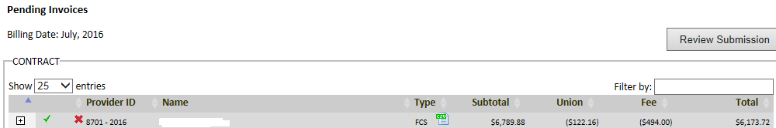
- After approving the invoices you can “Review Submission”.
  - The SDR reports and Payment Voucher will be available as “DRAFT”
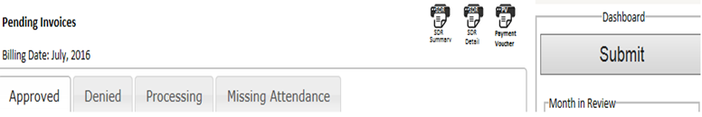

CCFA Billing Process for FCC Systems and Contract Providers (continued)

- There are up to 5 tabs that will provide you with the pending invoice status:
  - Processing – Indicates your submission is in process
  - Denied – Indicates if the invoice was rejected by EEC, the CCRR or you rejected it back to yourself
  - Missing Attendance – Indicates ledgers have not been generated
  - Approved – Indicates approved by provider but not yet submitted to EEC and/or CCRR
  - Hold – Indicates that EEC has put your invoice on Hold for submitting after the billing deadline

- SUBMIT Billing: Click on the “Submit” Button when you have approved the invoices for the current billing period.
  - If you have not approved all your providers you will receive a notice indicating the following:
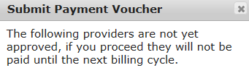
- If you answer YES, the providers listed will not be included in your payment from EEC or the CCRRS
    - The Contract Billing will be submitted to EEC.
    - The Voucher Billing will be submitted to the CCRRs.
    - If you answer NO, you can continue to approve additional providers.
- After you “Submit” you can view the Submitted Invoices
  - Select Billing+
    - Select Submitted Invoices
  - Choose the Date you would like to view
    - Billing Date -- the month you submitted your invoice in CCFA
    - Submission Date -- the month you submitted to EEC and the CCRR
    - Invoice Date -- the month EEC approved the invoice in CCFA
  - There are up to 4 tabs that will provide you the approved invoice status
    - CPA (submitted to EEC )
    - CCRRS (submitted by CCRR to EEC)
    - Invoiced – Approved by EEC
    - Hold – This will indicate if EEC has put your invoice on Hold for submitting after the billing deadline
  - The SDR and Payment Voucher move from “Draft” to “Final” status. Once Final, "Draft" is removed from the SDR report.
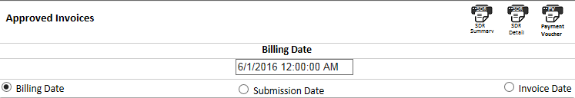
  - Print PV(s), sign and submit Hard Copy with "Wet Signature" to EEC by the billing deadline (on or before August 19, 2016)
    - Separate PV(s) are generated for each contract type (Income Eligible, Supportive, Teen Parent, and Homeless)
      - By Region
      - By Flex Pool Type (Income Eligible or Supportive)
    - Do not submit the PV for vouchers to EEC or the CCRR

Note: CCFA does not capture payments for Special Needs or 3rd Trimester. Please submit separate PVs and backup.

CCFA Billing Guidance

- What are the billing deadlines in August 2016?
  - The deadline to submit billing to CCRRs for voucher placements is August 12, 2016.
  - The FY2017 CCFA August Billing Deadline (July Only Services ) is August 19, 2016.

- When should I Submit my billing in CCFA?
  - Voucher Only providers and Contract Providers (including Family Child Care Systems) that have both Vouchers and Contract Slots, must submit billing for July 2016 services in CCFA to both their CCR&R and EEC by August 12, 2016.

- What is the deadline for me to submit my Payment Voucher to EEC?
  - The Payment Voucher must be received by Friday, August 19, 2016

- What if I do not have time to make all my FY2016 adjustments to placements or rates prior to the August 12, 2016 billing deadline if I have vouchers, or prior to the August 19, 2016 deadline if I am a Contract Only Provider?
  - Once you complete your attendance for FY16, you will have the opportunity to make adjustments in CCFA from September through November. The adjusted dollar amount will be applied in the following month's billing as a prior period adjustment. For example if you make a change in September 2016 that results in EEC owing you $1000, this amount will be added to your October Invoice for September Services.

- Why are my billing rates not correct?
  - Check your published private rates to see if they align with the rates you certified with the CCRR for vouchers or with EEC for your contracts. If the published private rates do not align with your certifications you can modify the rates associated with your contracts by taking the following steps:
- Go to the Provider Detail page  - In the Action drop down, select "Manage Private Published Rates"  - Input the Published Private Rate and enter the Effective Date  - Select Save | 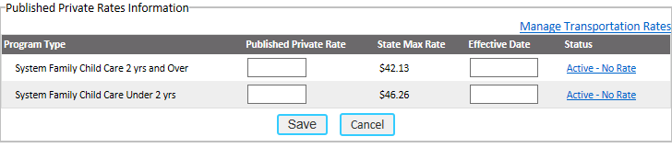

Note: The effective date should be backdated to the date the Private Published rate was put into effect. The rates and effective date need to align with your rate certification.

- If I change my billing rates after I generated ledgers do I need to reject billing to see the billing total change?
  - Yes, if you want the change captured in the reconciliation.
  - No, if you can wait to receive the payment for the rate change, it will be applied to the next billing month.

- Why am I not being paid the correct rate for a holiday for a school age child or not being paid for the holiday?
- Look to see if the child is set up correctly: Regular vs. intermittent?
  - Regular for holidays pays to schedule
  - Intermittent provides you additional attendance codes to be reimbursed the FT rate.
- Does the child have a school closure placement?
  - School Closure only placements do not get paid for the holiday.
  - If the child is in care Full Time during the summer you are entitled to the July 4th holiday and Labor Day holiday if the child's placements extend past Labor Day.
    - The placement should be set up as regular for the summer only.

CCFA Billing Guidance (Continued)
- Does the child receive care from 2 providers?
  - The primary care provider is reimbursed for the holiday if both providers are closed.
  - If the primary is closed and the second provider is open EEC pays the provider who provided care.

- Why am I not receiving the QRIS Infant/Toddler 3% rate increase?
  - Look to see if the provider has a QRIS level 2 rating or higher.
  - Check to see if you submitted a QRIS application.
  - The QRIS rate is applied the month after you submit a self-assessed rating of level 2 or higher.
    - For example, if you submit the QRIS application with level 2 or higher on May 1, 2016, the effective date of the rate increase will be for the June 2016 service month which will be paid in July 2016.

- How do I know if a provider has joined SEIU?
- Go to the Provider Detail page  - On the right hand side of the page the following is displayed indicating Union Status and COPE election. | 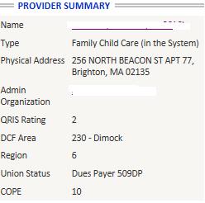
- A report is available for you to view for all your providers.  - Go to Reports+  - Select SEIU Dues Providers  - Select Generate Report | 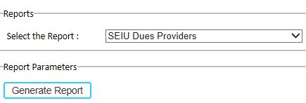
- The report will display the following information by provider  - Payer Types  - 509WD -Withdrawn  - 509DP – Dues payer | 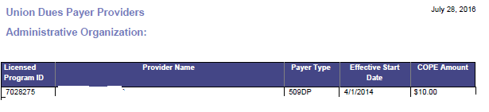

- What do I do if I receive the following notification?

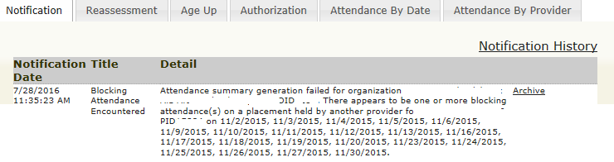 | - Go to the Family Authorization page  - View the authorization and child placements  - CCFA will not allow two provider to bill EEC for the same child on the same day except if the child has separate before School and After School placements  - Work with the CCRR for vouchers or the other Contract provider to resolve  If you are unable to resolve contact Alicia.Wells@massmail.state.ma.us

- What do I do if I receive a notification that a child could not be aged up because I did not have any slots available?
  - Child should not be terminated
  - EEC supports continuity of care; please contact the CCRR to arrange for the family/child to be given a voucher.

