CCFA Billing Process for Independent Family Child Care (IFC or FDC) and In Home Child Care (ICC) Providers

This guide will assist IFCs/FDCs and In-Home Care Providers with the first CCFA Billing cycle in August 2016 (for July 2016 services). Attendance for all months must be complete in order to bill in CCFA. The CCFA Billing process has three steps and validations:

- Complete Attendance and "Generate Ledgers" for the service month of July 2016.
  - After you generate ledgers the provider(s) with active placements within your organization will be in one of the following statuses:
- Rejected
  - Please contact your CCRR for guidance.
- Billed
  - Once in the Billed status you can move forward to the next Billing step in CCFA.
  - Before you “Approve” you can view and review your Billing Total by following these steps:
      - Select “Provider+”
      - Select "View Monthly Billing History”
        - The monthly billing page will display your billing total by Service Month
        - When you “Submit” billing the Invoice Amount will be added to the page.
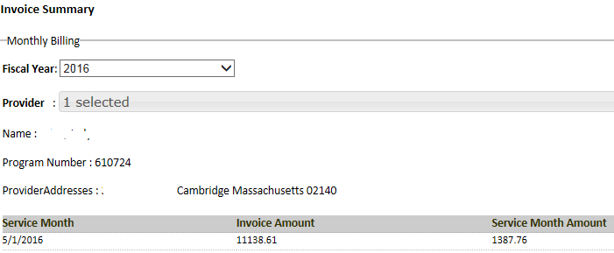

Note: You must refresh the page to view change in status from “In Progress” to Billed”.

- View and “Approve” Pending Invoices
  - Select “Billing+”
- Select Pending Invoices
- Review the CSV file for your billing for the month, under "Type". CSV is a "Comma Separated Value" format type file that can be opened with Microsoft Excel. Look for this symbol  - Or click on the “+” as displayed below  - Click on the √ if attendance is complete and billing totals are correct. | 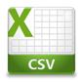
- Click on the X if you need to make corrections.

Below is a screenshot of the Pending Invoice page in CCFA where you will review and "Approve" your invoices:
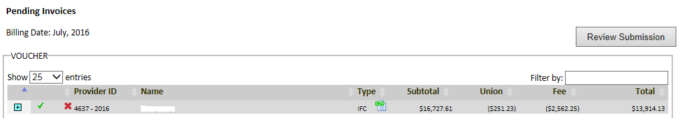

CCFA Billing Process for Independent Family Child Care (IFC or FDC) and In Home Child Care (ICC) Providers (continued)

- After approving the invoices you can “Review Submission”.
  - The SDR reports and Payment Voucher will be available as “DRAFT”.

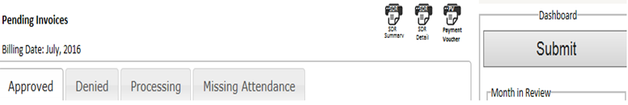

- There are 4 tabs that will provide you with the pending invoice status:
  - Processing – Indicates your submission is in process.
  - Denied – Indicates if the invoice was rejected by CCRR, or you rejected it back to yourself.
  - Missing Attendance – Indicates ledgers have not been generated.
  - Approved – Invoices approved but not submitted to CCRR.

- SUBMIT BILLING: Click on the “Submit” Button when you have approved the invoices for the current billing period.
- If you answer YES, your Billing will be submitted to the CCRRs.
- After you “Submit” you can view the Submitted Invoices
  - Select Billing+
    - Select "Submitted Invoices"
  - Choose the Date you would like to view
    - Billing Date -- the month you submitted your invoice in CCFA
    - Submission Date -- the month the CCRR submitted to EEC
    - Invoice Date -- the month EEC approved the CCRR invoice in CCFA

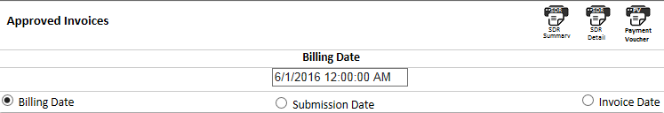

  - There are two tabs that will provide you with the approved invoice status:
    - CCRRS - Submitted by CCRR to EEC
    - Invoiced – Approved by EEC
    - CPA – indicates you submitted to CCRR
  - The SDR and Payment Voucher move from “Draft” to “Final” status. Once Final, “Draft” is removed from the SDR report.
  - Do not submit the PV to the CCRR; you can print it for your records.
    - The CCRR does not require you to provide a signed payment voucher for you to receive payment.

CCFA Billing Guidance

- What is my billing deadline in August 2016?
  - The deadline to submit billing to CCRRs for voucher placements is August 12, 2016.

- What if something is wrong with my billing?
  - Contact your CCRR to discuss how this can be fixed or resolved.

- What should I do if my billing rates do not look correct?
  - Contact your CCRR to discuss how they can be fixed.

- Why am I not receiving the QRIS Infant/Toddler 3% rate increase?
  - Look to see if your program has a QRIS Level 2 rating or higher.
  - Check to see if you submitted a QRIS application.
  - The QRIS rate is applied the month after you submit a self-assessed rating of level 2 or higher.
    - For example, if you submit the QRIS application with level 2 or higher on May 1, 2016, the effective date of the rate increase will be for the June 2016 service month which will be paid in July 2016.

- How do I know if CCFA has my correct Union status?  - Go to the Provider Detail page  - On the right hand side of the page the following is displayed indicating Union Status and COPE election. | 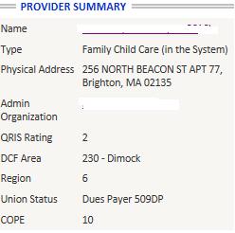
- A report is available for you to view.  - Go to Reports+  - Select SEIU Dues Providers  - Select Generate Report | 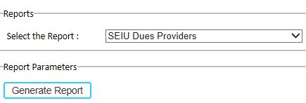
- The report will display the following information by provider  - Payer Types  - 509WD -Withdrawn  - 509DP – Dues payer | 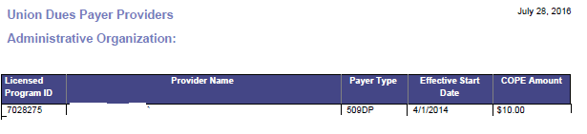

- What do I do if I receive the following notification?
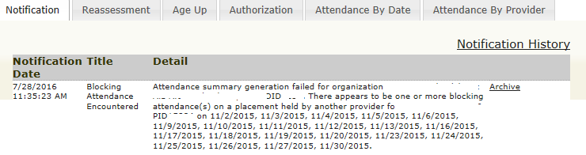 | - Contact your CCRR to discuss how your Blocking Attendance can be fixed.

- What do I do if I receive a notification that a child could not be aged up?
  - Contact your CCRR to discuss how the issue can be fixed.

