CCFA Project Review

Fiscal and Oversight Committee
February 6, 2018

Prepared by Chuck Welti

CCFA FY18/19 Capital Projects 1/24/18

Project Status
Project | Scope | Status / Issues | Key Metrics
Comply with New Federal Regulations  RED | EEC Legal will derive policy from new federal regulations which will then be used to scope and define a set of IT changes. This will include deeper changes to CCFA requiring a re-factoring of the rules layer. | Delay in requirements has put delivery at risk. Andrea has taken the lead on drafting requirements and getting the scope from legal. | Requirements Complete: 5%  Code complete: 0%  QA complete: 0%  UAT complete: 0%  Deadline: 09/01/18
Contract Manager Re-write  GRN | Rewrite the legacy Contract Manager VB application in CCFA and improve the business workflows and streamline the process. Includes data migration, voucher rate changes, new CCFA and ECIS reports | Development is well underway and there are no blocking issues. | Requirements Complete: 75%  Code complete: 30%  QA complete: 20%  UAT complete: 0%  Deadline add contract: 03/31/18  Deadline all features: 06/31/18
MMARS Integration  GRN | Allow CCFA to interface with MMARS so that provider payments can be automatically processed. Key features include: (1) EEC adjustments for scheduled payments, (2) Data integration with MMARS via Exchange, and, (3) workflow screens for CCFA to balance accounting lines and review. | CCFA MMARS adjustment UI has been deployed. Integration meeting with Comptroller was held. The basic outbound file has been developed. The next step is to define the Workflow requirements. | Requirements Complete: 30%  Code complete: 30%  QA complete: 30%  UAT complete: 30%  Target: 05/31/18
General Substitute Care  GRN | Complete substitute care module to finalize earned sick time functionality for non-EST days. Requires changes to billing. Functionality from EST will be leveraged. | Deployed | 100%
SEIU Enhancements  GRN | Complete and enhance functionality related to SEIU bargaining agreement. Key features include: (1) Improved uploads of union status, (2) UI changes to show additional data, and (3) two new reports. | Deployed  Waiting on training to the field before turning on these features to the users. | Requirements Complete: 100%  Code complete: 100%  QA complete: 100%  UAT complete: 100%
Audit  GRN | Expand the capabilities of CCFA to automate Fiscal Audit processes. FY18 will be requirements only and FY19 will be implementation. | Requirements phase in progress. | Requirements Complete: 40%  Code complete: 0%  QA complete: 0%  UAT complete: 0%  Target: 10/30/18
Legal Review  GRN | Expand the capabilities of CCFA to automate the Legal Review process. FY18 will be requirements only and FY19 will be implementation. | Preliminary discussions were held. | Requirements Complete: 2%  Code complete: 0%  QA complete: 0%  UAT complete: 0%  Target: 12/20/18
Document Management  GRN | Do the analysis and product selection for an electronic document repository for CCFA. | Not started. | Requirements Complete: 0%  Code complete: 0%  QA complete: 0%  UAT complete: 0%  Target: 05/31/18

Project Schedule

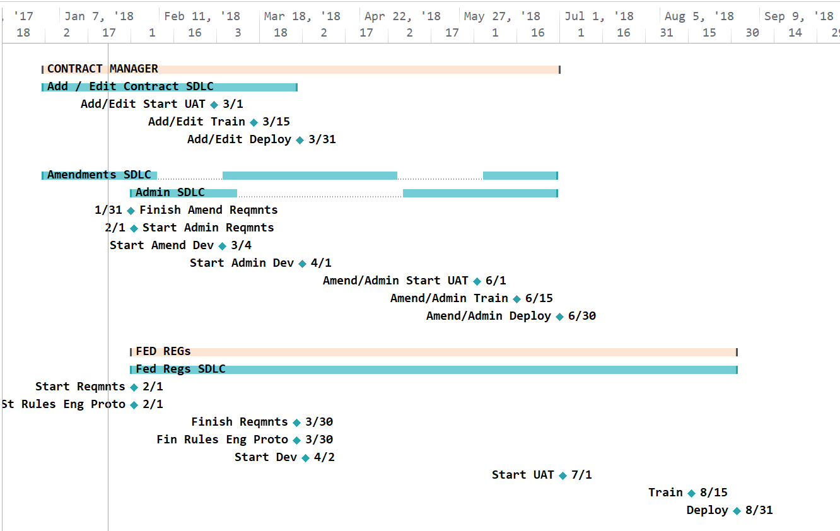

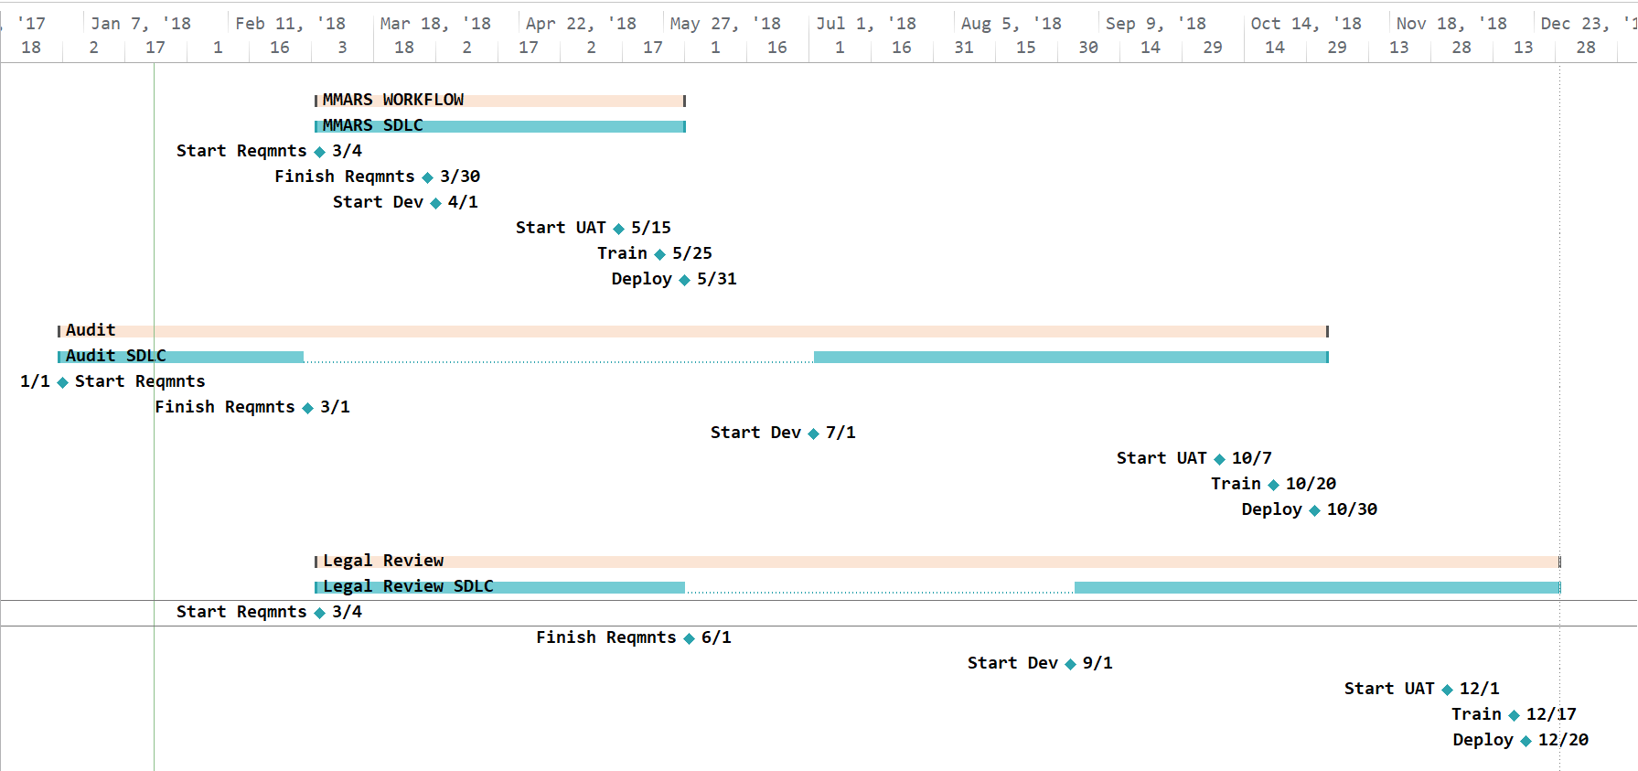
Audit

CCFA Capital Team Hours (as of 1/20)

FY 18 Utilization | Plan | Spend
Support & Maintenance | 2,367 | 3,564
AWS | 300 | 60
Fed Regulations | 6,000 | 52
Cont. Mgr. | 11,000 | 6,407
MMARS | 1,600 | 1,186
Sub. Care | 563 | 563
SEIU | 1,188 | 1,188
Audit requirements | 402 | 275
Legal Act. requirements | 640 | 17
Document Management | 240 | -
AWS migrations | 300 | 60
 | 24,600 | 13,372

Spend Plan

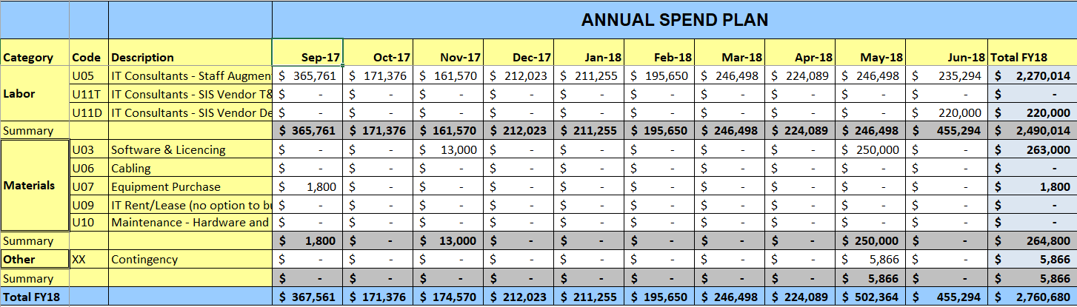
Q1

