CCFA User Guides: Temporary and Non-Temporary Changes
Table of Contents
Temporary Changes 1
Non-Temporary Changes 4
Appendix A: Service Needs and Activities 7

Temporary Changes

This guide will assist CCFA users on adding Temporary Changes to authorizations. Temporary changes can be added to the following authorizations: IE, DTA, DTA-T, and DTA-PT. For more information about Temporary changes, please refer to both the Policy Guide and the Procedures Manual.

Below are the steps to add a Temporary Change to an authorization. Note: before you can add a Temporary Change, you’ll need to end any placements tied to the sub authorization.

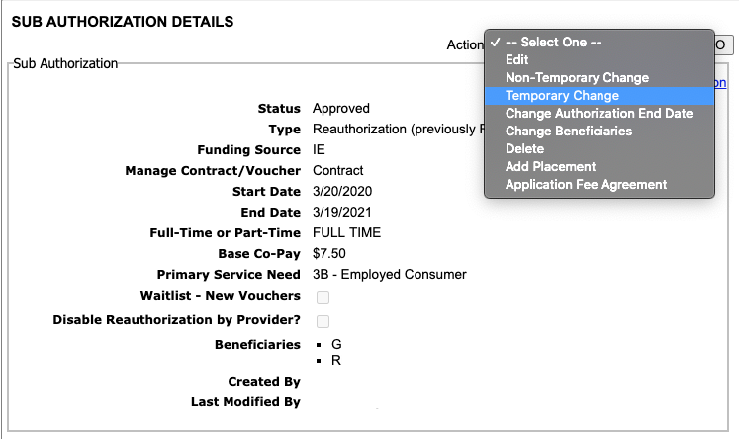
- Select “Temporary Change” from the Action Drop Down menu on the Sub Authorization Details page.

- Fill in the “Start Date” and “End Date” for the Change and click “next.”
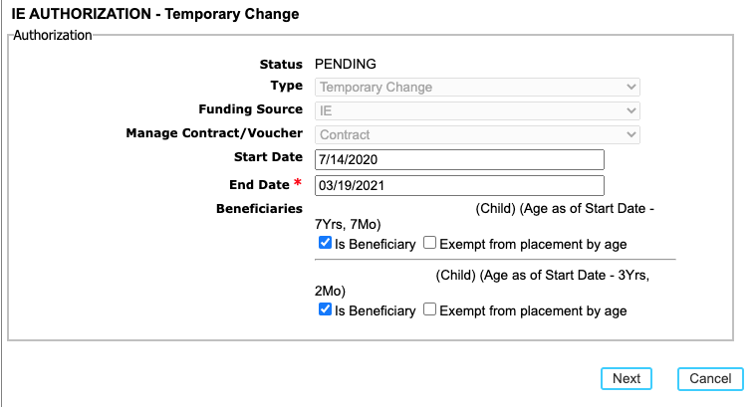
  - Temporary Changes can be backdated up to 14 calendar days

- Click the “add” link to enter the service need, activity, and document for the parent(s)/guardian(s)
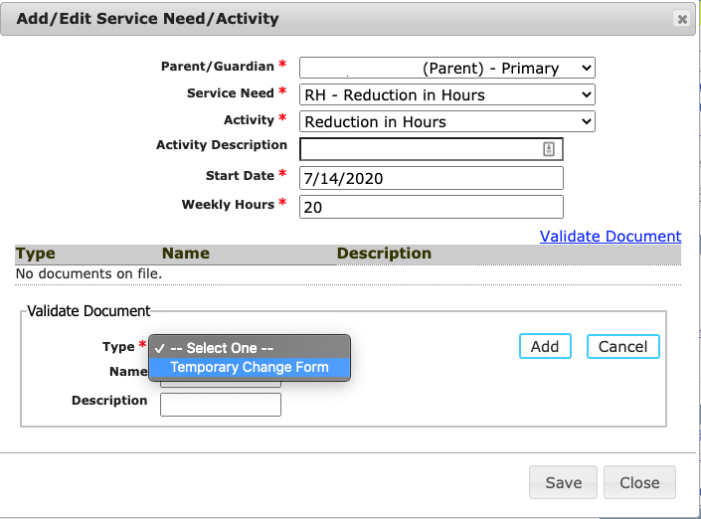
  - The available Temporary Change Service needs and associated activities are as follows:
6M – Maternity/ Paternity Leave | Maternity/ Paternity Leave
PML – Parent’s Medical Leave | Parent’s Medical Leave
FL – Family Leave | Family Leave
SE – Seasonal Employment | Seasonal Employment
RH – Reduction in Hours | Reduction in Hours
OB – Other Break | Other Break
CR – COVID Related | COVID Related

- Add the income.
  - See the CCFA User Guide on Income Detail for more information on adding income to authorizations.
- Click “next” to go to the Review and Submit page.
- Review the information entered before submitting to the rules engine.
- The Sub Authorization Details with the result will show.
  - The start and end dates will reflect those entered.
  - If applicable, the base co-pay will recalculate.
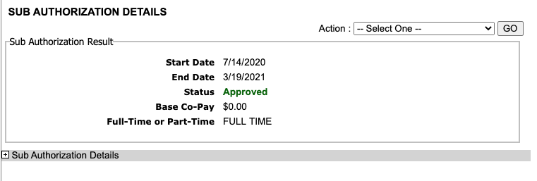
    - Note: The co-pay will never be higher than the co-pay on the Master Authorization.
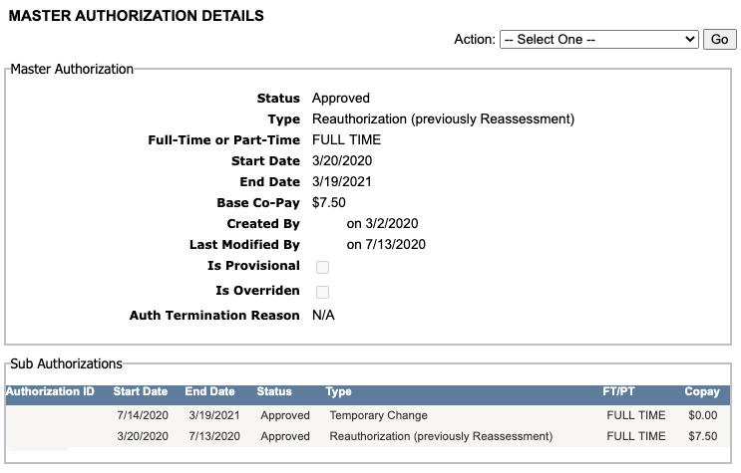
- The Non-Temporary Change Sub Authorization will appear under the Master Authorization on both the Master Authorization Details page and Family Details page.

Non-Temporary Changes
This guide will assist CCFA users on adding non-temporary changes to authorizations. Non-temporary changes can be added to the following authorizations: IE, DTA, DTA-T, DTA-PT, Homeless referrals. For more information about Non-temporary changes, please refer to both the Policy Guide and the Procedures Manual.
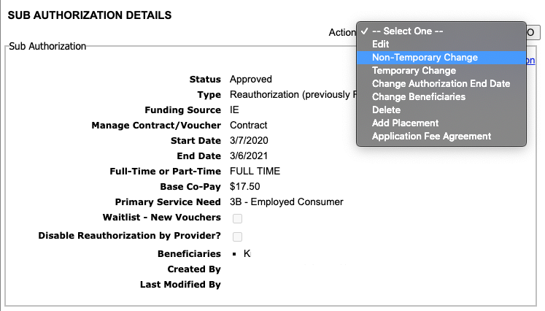
- Select “Non-Temporary Change” from the Action Drop Down menu on the Sub Authorization Details page.

- Fill in the “Start Date” for the change and click “next.”

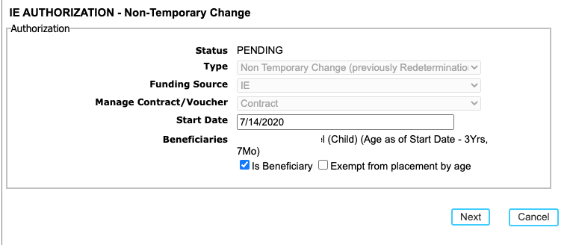
  - Non-Temporary Changes can be backdated up to 14 calendar days

- Click the “add” link to enter the service need, activity, and document for the parent(s)/guardian(s)
  - The available Non-Temporary Change Service needs and associated activities for Income Eligible are as follows:
Service Need | Activities
3B – Employed Consumer | Employment  New Employment  Self Employment  New Self Employment  Travel Time
3M – Military | Employment  Military Service  Travel Time
6A – Education & Training | Education/Training/GED (Approved)  Education/High School/College Coursework (Approved)  Travel Time
6C – Special Need of Parent | Activity not required for Special Need of Parent
6M – Materinty/Paternity | Maternity  Paternity
4I – Non TANF Teen Parent | Employment  New Employment  Self Employment  New Self Employment  Job Search  Education/Training/GED (Approved)  Education/High School/College Coursework (Approved)  Travel Time
3R – Retirement | Activity not required for SR Guardian/Relative
3H – Homeless | Homeless
6B – Seeking Approved Activity | Seeking Approved Activity
  - See Appendix A for a list of services needs associated with other funding sources
- Add the income.
  - See the CCFA User Guide on Income Detail for more information on adding income to authorizations.
- Click “next” to go to the Review and Submit page.
- Review the information entered before submitting to the rules engine.

- The Sub Authorization Details with the result will show.
  - If applicable, the base co-pay will recalculate.
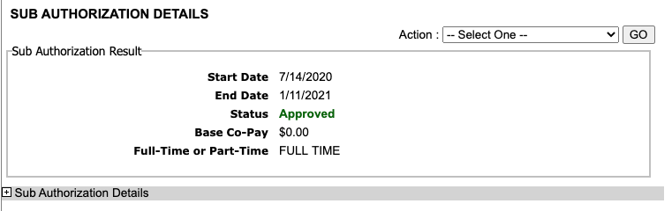
    - Note: The co-pay will never be higher than the co-pay on the Master Authorization.

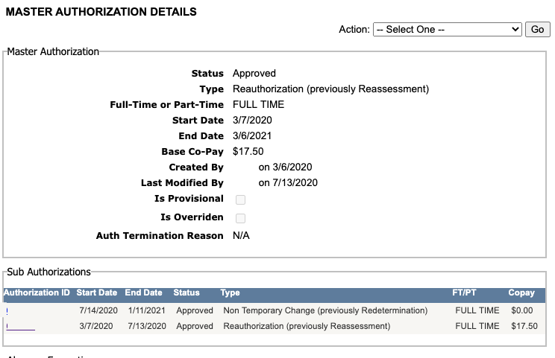
- The Non-Temporary Change Sub Authorization will appear under the Master Authorization on both the Master Authorization Details page and Family Details page.

Appendix A: Service Needs and Activities
DTA
Service Need | Activities
SAA – Seeking Approved Activity | Seeking Activity/ Employment Planning
ESP – Approved ESP Activity | Approved ESP Activity
RC – Relative Caregiver | Relative Caregiver

DTA-T
Service Need | Activities
2A – Transitional | Employment  New Employment  Self Employment  New Self Employment  Job Search  Education/Training/GED (Approved)  Education/High School/College Coursework (Approved)  Travel Time
3H – Homeless | Homeless
Change of Household Composition | No Service Need

DTA-PT
Service Need | Activities
3A – Post Transitional Employed Consumer (DTA Funded) | Employment  New Employment  Self Employment  New Self Employment  Job Search  Education/Training/GED (Approved)  Education/High School/College Coursework (Approved)  Travel Time
3H – Homeless | Homeless
Change of Household Composition | No Service Need

Income Eligible: Refer to page 5

