CCFA User Guides: Terminations
This guide will assist CCFA users on how to enter terminations into CCFA. Subsidy administrators may continue to receive payment for services for up to two weeks or ten calendar days upon terminating a placement. Subsidy administrators must be sure they understand EEC policy surrounding denials, terminations, and reductions of child care subsidies and placements. The below guide will only address terminations from a functional standpoint.

Table of Contents
Termination Reasons 1
Steps to Terminate a Placement 2

Termination Reasons

Termination Reason | Ends Sub Authorization | Ends Master Authorization
Approved Break in Service
Behavior
COVID June-July 2020 Change of Provider*
Excessive Unexplained Absences | X | X **
IPV – Failure to report a non-temporary change | X | X
Immediate Term by Parent (Health/Safety)
Immediate Termination by Provider (Health/Safety)
IPV – Failure to Report Income Accurately | X | X
IPV – Non-payment of fees | X
Residency Outside the Commonwealth | X | X
Voluntary Termination/ No longer in need of subsidy |  | X
Violation of Provider Policies
Santioned by EEC | X | X
Substantiated Fraud | X | X
IPV – Failure to Respond to EEC Request for Information | X | X
Voluntary Termination/Change of Provider
* New termination reason for COVID-related provider changes. This reason is only to be used if the child moves to another provider
AND the end date of the placement is between 6/22/2020 and 7/31/2020.
** Master auth is brought in only if child is only placement receiving the subsidy

Steps to Terminate a Placement

- Open the Placement Details page, select “terminate placement” from the action drop down, and click “go.”
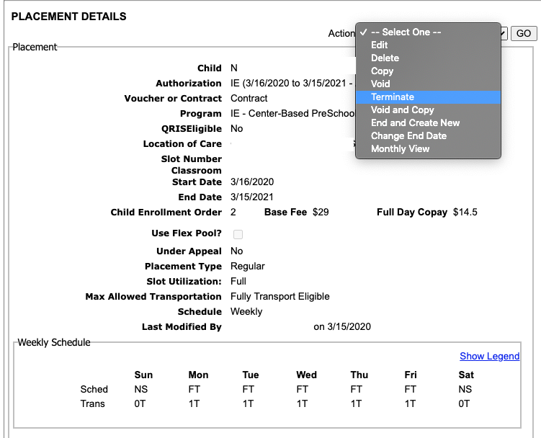

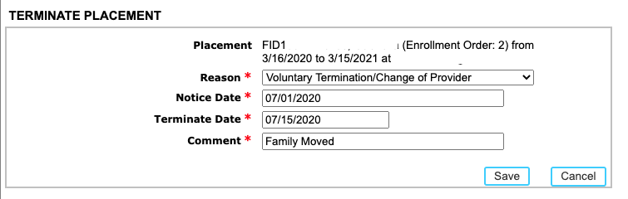
- Fill in the required information, including:
  - Reason: see section on termination reasons above
  - Notice Date: the date the subsidy administrator notified the family of the termination. This date should be at least two weeks before the child’s last day in care
  - Termination Date: pre-populates with the current date. This is the last day the child will attend care. CCFA will automatically update the placement end date to reflect the termination date.
  - Comment: any suggested language?
- Click “Save.”
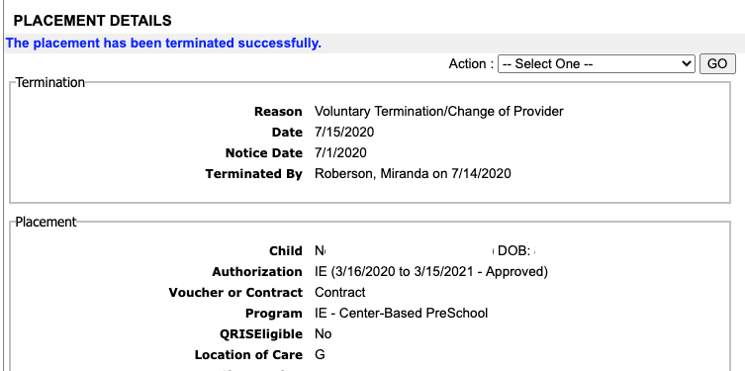
- A success message will appear along with termination details.

