M E N T A L H E A L T H A N D P O T E N T I A L S T R E S S O R S A M O N G W O R K E R S
F I N D I N G S F R O M T H E C O V I D - 1 9 C O M M U N I T Y I M P A C T S U R V E Y ( C C I S )

C o - A ut h o rs : K a t h l een F i t z s i m mon s , Ph D ; E m i ly S pa r e r - Fi n e , S cD ; A lis o n C e lig o i , M PH ; M PH ; L a ure n C a r d os o, Ph D ; W . W . S a n o uri U rs p run g , Ph D

F R A M I N G
M A T T E R S

- Employment is good for health, in general
  - Income, benefits(e.g., health insurance), psychosocial support

- Type and quality of work matter
  - Conditions/exposures - toxic chemicals, heat/cold, infectious disease, dangerous equipment, heavy lifting, violence, stress
  - Organizational - shift work, long hours, high demand/low control

- Burden of occupational risks is not borne equally
  - Low wage workers, including many immigrants and workers of color, disproportionately employed in physically demanding, high risk, high-stress jobs

- COVID-19 has highlighted the role that work plays on health and healthcare access
  - Throughout the pandemic many workers have had to leave home to do their jobs, facing increased risk of COVID-exposure and other stressors related to their work. Those unable to work remotely were also more susceptible to disruptions to employment during the pandemic
  - Increasingly, the indirect impact of COVID-19 on health and the role that work plays has come to light (e.g., mental health impacts)

C O V I D - 1 9
C O M M U N I T Y
I M P A C T
S U R V E Y
( C C I S )

- Online survey of Massachusetts residents administered September – November 2020
- Adult and Youth versions, 11 languages
- Goal: to understand specific needs of populations disproportionately impacted by the pandemic
- Hard-to-reach subpopulations who are typically underrepresented in surveillance

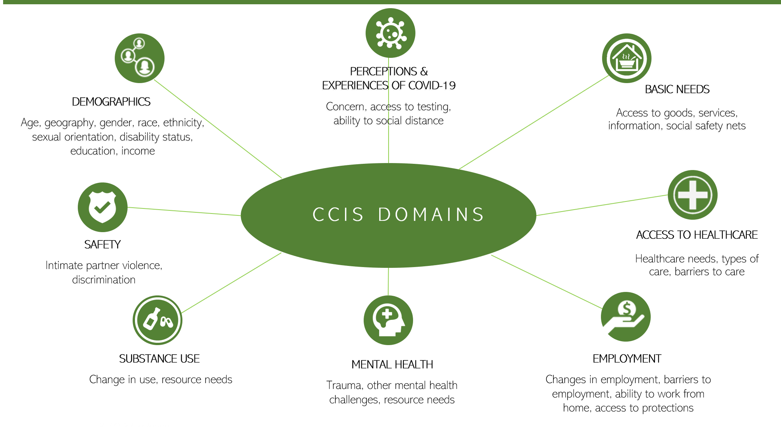
Sample:
  - 33,800 respondents aged ≥25 years

Of those, 23,098 were employed in the past year

M E N T A L
H E A L T H
A M O N G
W O R K E R S

“15 or more days of poor mental health” - Respondents were asked how many days during the past 30 days their mental health was
not good, which includes stress, depression, and problems with emotions.

Standard item from CDC Behavioral Risk Factor Surveillance System*

“3 or more PTSD-like reactions” - Respondents were asked how many PTSD related reactions to the pandemic they had experienced in the past month from a validated list of reactions.

Adapted from “Primary Care PTSD Screen for DSM-5 (PC-PTSD-5)**”

- Overall, 1 in 3 (34%) employed respondents reported 15 or more days of poor mental health in the past 30 days.
  - 4% of these workers thought that suicide prevention and crisis management resources would be helpful.
- More than 1 in 4 (28%) employed respondents reported 3 or more PTSD-like reactions.

* Reference: Centers for Disease Control and Prevention (CDC). Behavioral Risk Factor Surveillance System Survey Questionnaire. Atlanta, Georgia: U.S. Department of Health and Human Services, CDC.
** See Appendix for more details; Reference: Prins, A., Bovin, M. J., Kimerling, R., Kaloupek, D. G, Marx, B. P., Pless Kaiser, A., & Schnurr, P. P. (2015). Primary Care PTSD Screen for DSM-5 (PC-PTSD-5) [Measurement instrument]. Available from https://www.ptsd.va.gov

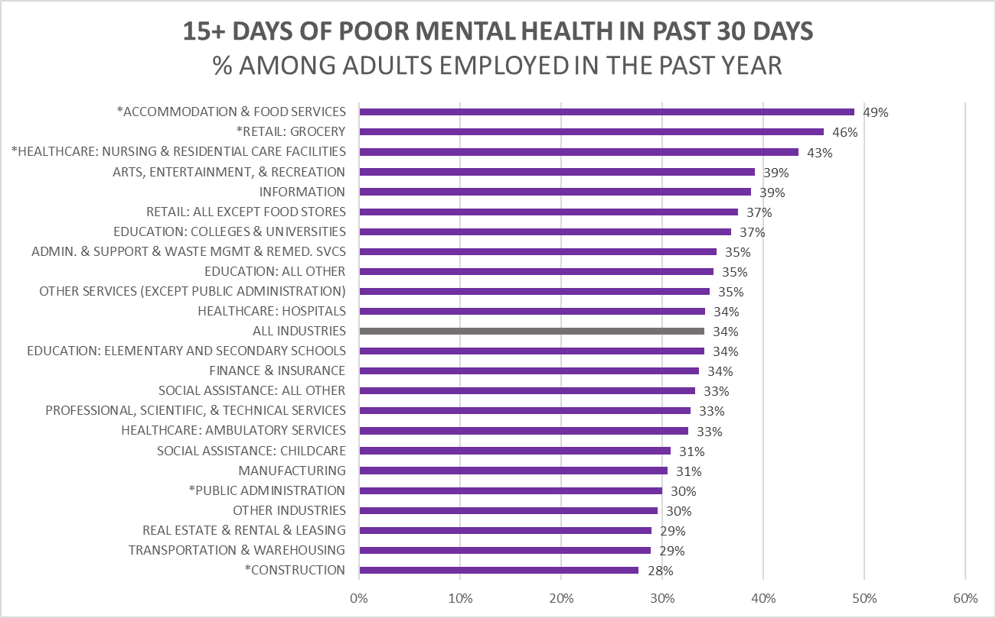EMPLOYED RESPONDENTS IN CERTAIN INDUSTRY GROUPS WERE MORE LIKELY TO EXPERIENCE POOR MENTAL HEALTH

2 of these same 3 industry groups were also more likely to report 3 or more PTSD-like reactions.

Notes: 1) "Retail: Grocery" = CIC 4970 Grocery Stores, 4980 Specialty Food Stores, 5090 Gas Stations [includes those with convenient stores]; "Other Industries" = Mining; Agriculture, Forestry, Fishing and Hunting; Utilities; Wholesale Trade; Management of Companies and

2 0 2 0
P O T E N T I A L
W O R K - R E L A T E D
S T R E S S O R S

WORKING OUTSIDE THE HOME (i.e., frontline workers)

  - EMPLOYER-PROVIDED PROTECTIVE MEASURES:
    - paid sick leave
    - personal protective equipment (PPE)
    - implemented social distancing
    - additional health and safety training

EMPLOYMENT DISRUPTION DUE TO THE PANDEMIC:
    - job loss (e.g., layoffs)
    - reduced hours or took leave (e.g., needed to provide childcare)

2 0 2 2
P O T E N T I A L
W O R K - R E L A T E D
S T R E S S O R S

WORKING OUTSIDE THE HOME (i.e., frontline workers)

  - EMPLOYER-PROVIDED PROTECTIVE MEASURES:
    - paid sick leave
    - personal protective equipment (PPE)
    - implemented social distancing
    - additional health and safety training
    - ventilation
    - vaccine resources and/or mandates

EMPLOYMENT DISRUPTION DUE TO THE PANDEMIC:
    - job loss (e.g., “great resignation”)
    - reduced hours or took leave (e.g., needed to provide childcare)

POTENTIAL STRESSOR:
WORKING OUTSIDE THE HOME

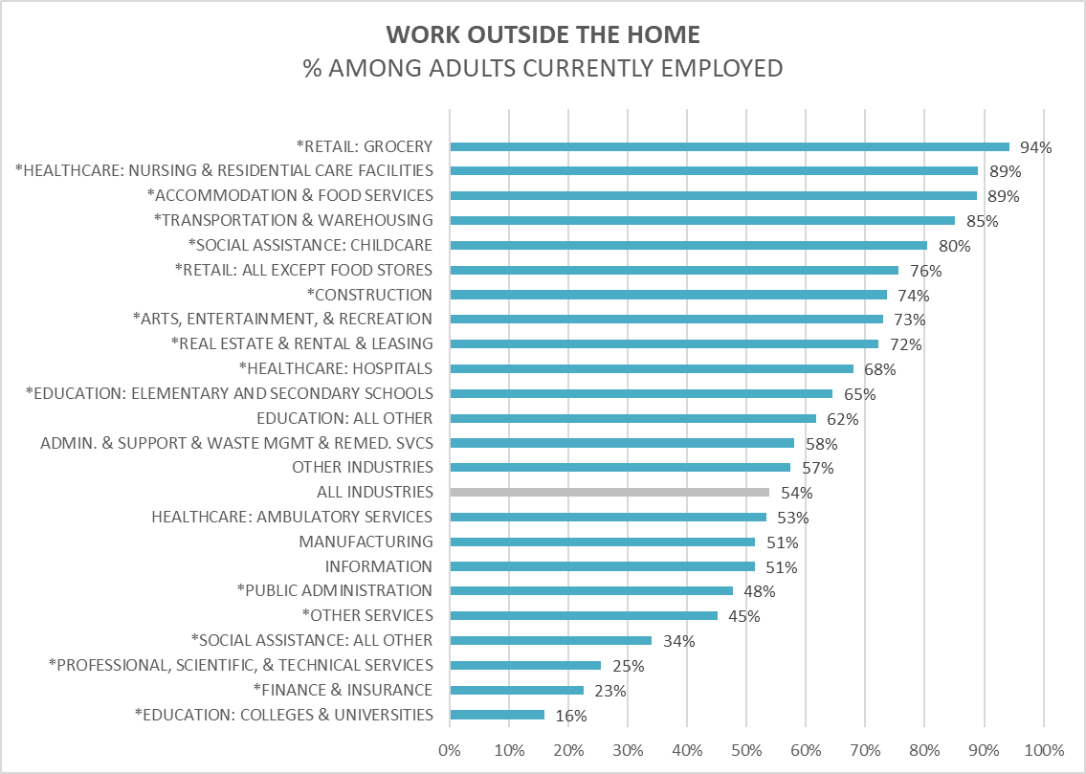Overall, 1 in 2, employed respondents were frontline workers, facing increased risk of COVID-19 exposure.

The percentages varied widely across industries.

Even within certain industries, the percentage who worked outside the home varied by subgroup.

3.9.2022 release
The three industry groups with the highest percentage of workers experiencing poor mental health, also had the highest percentages working outside the home.
Notes: 1) "Retail: Grocery" = CIC 4970 Grocery Stores, 4980 Specialty Food Stores, 5090 Gas Stations [includes those with convenient stores]; "Other Industries" = Mining; Agriculture, Forestry, Fishing and Hunting; Utilities; Wholesale Trade; Management of Companies and Enterprises; Military;
- Currently employed refers to employed full-time, part-time or self employed at the time of the survey in fall of 2020;
- Sample N=19,408 7

POTENTIAL STRESSOR:
EMPLOYER- PROVIDED PROTECTIVE MEASURES

Overall, among those working outside the home:
Healthcare: Nursing and Residential Care

77%^

90%

65%^

64%
Accommodation & Food Services | Retail: Grocery
40% | 57%
53% | 73%^
54% | 60%^
31% | 37%

77% reported having paid sick leave.
76% worked in places that

provided personal protective equipment (PPE).

66% worked in places that implemented social distancing.

44% worked in places that

provided additional health & safety training.

Notes: 1) Full industry breakdowns are available upon request; 2)^ denotes estimate is not statistically significantly different from the average for all occupations; 3) Sample Ns: N=7,722 (sick leave), N=7,771 (other protections)

POTENTIAL STRESSOR:
EMPLOYMENT DISRUPTION DUE TO THE PANDEMIC

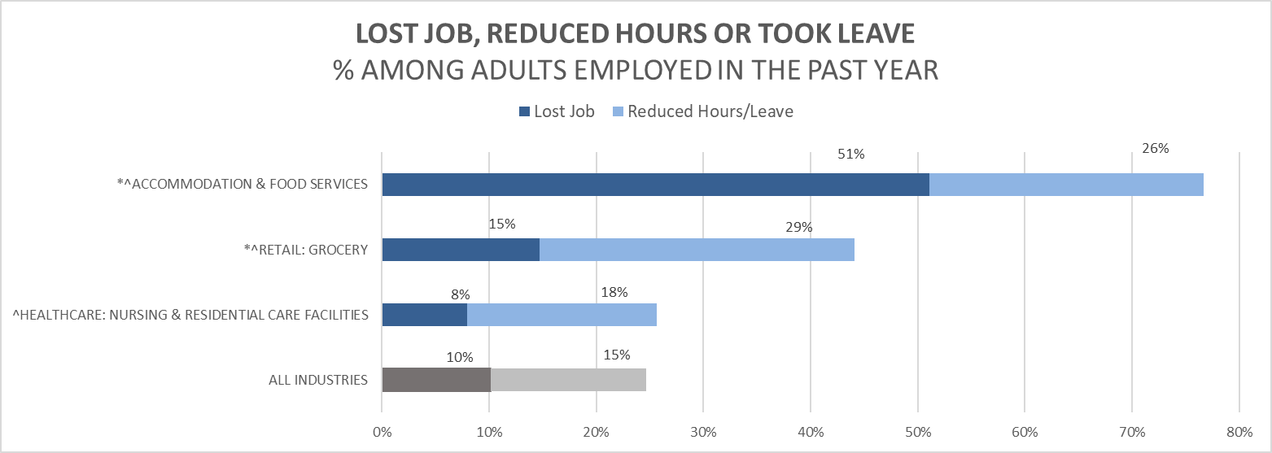

Notes: 1) "Retail: Grocery" = CIC 4970 Grocery Stores, 4980 Specialty Food Stores, 5090 Gas Stations [includes those with convenient stores]; 2) Employed refers to employed in the year prior to the survey completion in fall of 2020; 3) Sample N=18,992

POTENTIAL STRESSORS (HEALTHCARE WORKERS):
FACTORS RELATED TO POSSIBLE CONTACT WITH COVID- 19 PATIENTS

Not being able to distance from others because of work
  - 9 in 10 (89%) frontline workers in Healthcare listed work-related reasons for not being able to socially distance (i.e. maintain 6 ft. of distance from others), which was higher than the average for all frontline workers.

Testing positive (among respondents who had ever been tested)
  - Those working outside the home were nearly 2X more likely to report testing positive than those working from home.
  - Workers in Healthcare: Hospitals were nearly 3X more likely and those in Healthcare: Nursing & Residential Care Facilities were nearly 4X more likely than those working from home.

Knowing someone who died from COVID-19
  - Nearly 1 in 5 workers in Healthcare: Nursing & Residential Care Facilities reported that someone close to them died from COVID-19

3.9.2022 release

K E Y
T A K E A W A Y S

- The CCIS captured important information on the disparate impact of the pandemic on subgroups of Massachusetts’ workers. Findings suggest that work may contribute to observed inequities related to COVID-19.
- Industries with among the highest proportions of frontline workers were most likely to report poor mental health outcomes. This might reflect differences in stressors related to working outside of the home, employer-provided protective measures, and/or disruptions to employment.

Frontline workers in accommodation and food services and grocery stores were less likely to have paid sick leave and employer provided protections. They were also more likely to report losing jobs, reduced hours or taking leave.
  - Frontline workers in healthcare were more likely to report testing positive for COVID, and those in nursing and residential care were more likely to report someone close to them dying of COVID, suggesting additional
stressors for healthcare workers whose work may have involved working directly with COVID-positive patients.
- While some of these work-related stressors might have changed from 2020 to 2022, the experiences felt in 2020 are still likely impacting the workforce now. There are also newer work-related stressors not captured in the CCIS that may be impacting the mental health of frontline workers today.
12

C U R R E N T
H E A L T H A N D R E L A T E D
E F F O R T S T O
R E S O U R C E S
S U P P O R T M E N T A L

Vaccine Equity Initiative (VEI): Employer and employee workstream
  - Providing resources to employers and workers to assist with vaccination and broader COVID-19 mitigation
  - Promoting “COVID-19 Temporary Emergency Paid Sick Leave Program” – Requires employers to make paid leave time available to employees for COVID-related illnesses, quarantine, and vaccinations and provides employers with an opportunity to apply for reimbursement from the state

Trainings and other resources
  - Injury Prevention & Control Program: Conducted an assessment on the impact of COVID-19 on social service and Emergency Medical Service providers, with a specific focus on burnout. Based on the findings, developed trainings/resources on self-care, and trauma-informed practices, and developed an awareness campaign with Riverside Trauma Center. Moving forward, the team is building trauma-informed practices, self-care, and suicide prevention into training for home visitors, community health workers, and youth-serving providers.
  - Suicide Prevention Program: Promoting National Suicide Prevention Hotline 1-800-273-8255 (e.g., collaborating with MBTA to advertise this number) and related programs, including suicide prevention trainings
    - As of July 16, the NSPL the 10-digit number will be available as a three-digit 988 number
    - The new Behavioral Health Help Line (BHHL) will launch in January 2023 and will be a centralized access point for all Behavioral Health needs, including crisis, urgent, & routine
  - Mental Health Resources for Healthcare Workers Experiencing Stress, Anxiety and Trauma – DPH website: www.mass.gov/resource/mental-health-resources-for-healthcare-workers-experiencing-stress-anxiety-and-trauma

C U R R E N T
H E A L T H A N D R E L A T E D
E F F O R T S T O
R E S O U R C E S
S U P P O R T M E N T A L

Other state-wide programs to support workers
  - COVID-19 Essential Employee Premium Pay provides $500 payments to 500,000 low-income workers
  - Paid Family and Medical Leave (PFML) (Chapter 121 of the Acts of 2018) provides resources to help people in Massachusetts take paid time off for work for family or medical reasons
  - Complaint lines established at different agencies throughout the Commonwealth at various points of the pandemic to address concerns about COVID exposure/enforcement, as well as experiences in nursing homes/health care facilities
  - MEMA and DPH facilitating mask and other PPE distribution to targeted entities across the Commonwealth.

DPH’s planned analytic work
  - Topics raised in this presentation will inform a future survey on the COVID-19 impact (“CCIS2.0”)
  - Multiple programs within DPH are collaborating on an in-depth “COVID-19 Healthcare Worker Trauma Study”

C U R R E N T
H E A L T H A N D R E L A T E D
E F F O R T S T O
R E S O U R C E S
S U P P O R T M E N T A L

Efforts to support the substance use disorder workforce:
- Bureau of Substance Addiction Services (BSAS) implemented the following staffing-related flexibilities to better support substance use disorder (SUD) providers and staff who were already facing ongoing workforce shortages:
  - Withdrew staffing guidelines requiring licensed SUD facilities to staff to their licensed capacity, allowing programs to staff according to daily census of patients providing needed flexibility to programs and staff
  - Allowed LPNs or other Qualified Health Care Professionals (as defined by 105 CMR 164.006) to supervise nursing staff, provided supervisor educationally prepared at or above the level of the nursing staff under their supervision.
  - Allowing Opioid Treatment Programs to close one day per week in alignment with federal regulations.
  - Due to persistent nature of the workforce shortage, BSAS intends to maintain these flexibilities and identify other opportunities to support staff recruitment, retention and wellness particularly for staff with lived experience who may be at higher risk for relapse due to the ongoing stress and trauma associated with COVID.

C U R R E N T
H E A L T H A N D R E L A T E D
E F F O R T S T O
R E S O U R C E S
S U P P O R T M E N T A L

Select efforts to support healthcare workers (not exhaustive):
- Bureau of Health Care Safety and Quality (BHCSQ) and epidemiologists from the Bureau of Infectious Disease and Lab Sciences (BIDLS) conducted regular calls with facilities to provide clinical and regulatory guidance, link facilities to resources rapidly, and provide collaborative problem solving for facilities managing active outbreaks.
  - BHCSQ conducted a qualitative study among workers in long-term care facilities (LTCF) to understand their experiences participating in the COVID-19 Outreach Project.
- The results indicated that most LTCFs found the Outreach Project to be a source of information and resources, as well as emotional support for LTCF staff, opening opportunities for more collaborative relationships between facilities and DPH. However, facilities also felt that there could have been improvements in communication of expectations and streamlining data collection efforts across regulatory entities. All participants expressed feeling overwhelmed and emotionally drained during the course of the pandemic.
- Pursuant to an Order issued by the Commissioner of Public Health to focus health care personnel resources on responding to COVID- 19, DPH directed all MA healthcare facilities to implement their policies and procedures for expedited provider credentialing in their emergency management plan and transfer of licensed and certified clinical staff between healthcare facilities.
- To help nursing homes address staffing shortages during the pandemic, CMS provided a blanket waiver for the nurse aide training and certification requirements to permit nurse aides to work for longer than four months without having completed their training.
- DPH provided PPE, COVID-19 testing supplies, and COVID-19 vaccine clinics to facilities.
- DPH coordinated and deployed clinical staffing support to facilities through the MA National Guard and Rapid Response Teams.

Thank you!

Kathleen.Fitzsimmons@mass.gov Emily.sparer-fine@mass.gov

